SUPPLEMENT CONTENTS

Supplemental Figure S1. Algorithm for weaning anakinra in MIS-C patients.

Supplemental Table S1. Normal ranges for laboratory tests in MIS-C patients included in the study.

Supplemental Table S2. Available cytokine results from MIS-C patients included in the study.

Supplemental Table S3. Comparison of MIS-C patients in the IVIG monotherapy and IVIG+anakinra groups (continued).

Supplemental Table S4. Comparison of MIS-C patients in the IVIG+anakinra group presenting with or without CV shock (continued).

Supplemental Figure S2. Clinical outcomes of MIS-C patients.

Supplemental Figure S3. Timing of initial and follow-up echocardiograms in children diagnosed with MIS-C.

Supplemental Table S5. Adverse events of severity of neutropenia and elevated LFTs stratified by severity according to CTCAE.

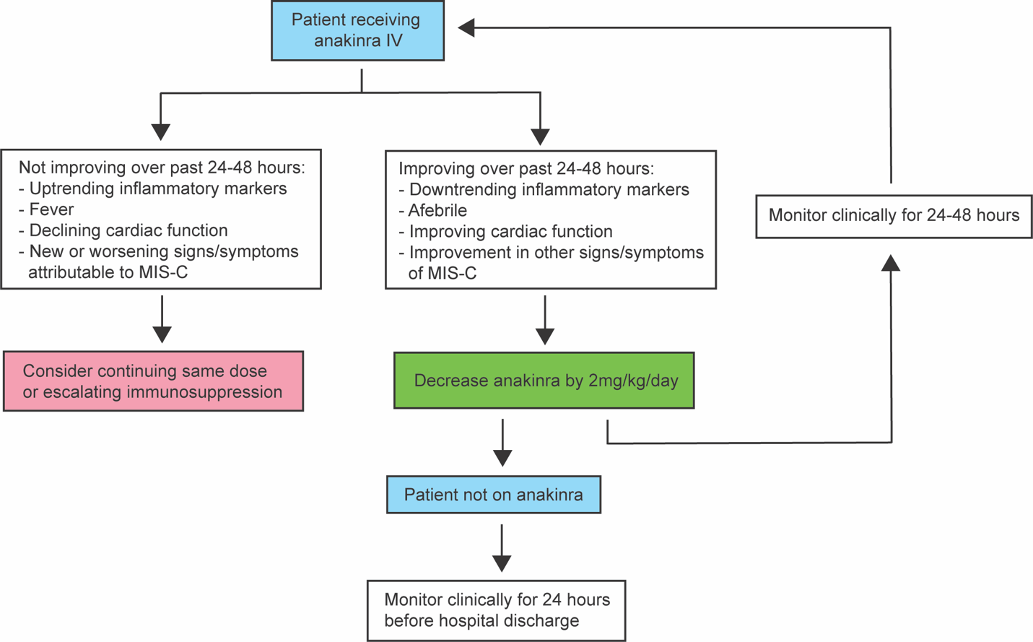

Supplemental Figure S1. Algorithm for weaning anakinra in MIS-C patients. The weaning algorithm for MIS-C patients treated with anakinra is shown. In MIS-C patients treated with anakinra who demonstrated objective evidence of clinical improvement, anakinra was decreased by 2mg/kg/day in 24-48 hour increments with continued clinical monitoring until its discontinuation.

Laboratory test | Units | Normal range | Cut-off for abnormal
Albumin | g/dL | 3.5 – 5.6 | < 3.5
ALT | units/L | 24 – 59 | > 59
AST | units/L | 16 – 57 | > 57
BNP | pg/mL | < 1157 | > 1158
Cr | mg/dL | 0.2 – 0.79 | > 0.79
CRP | mg/dL | 0.05 – 1.00 | > 1.00
D-dimer | mg/mL | <0.57 | > 0.57
Ferritin | ng/mL | 10 – 500 | > 500
Fibrinogen | mg/dL | 179 – 469 | > 469
Hgb | g/dL | 10.2 – 13.4 | < 9
INR | N/A | 0.91 – 1.09 | > 1.09
LDH | units/L | 155-280 | > 280
Lymphocytes (ALC) | K/mcL | 1.25 – 5.77 | Lymphopenia <1.2
Neutrophils (ANC) | K/mcL | 1.54 – 8.29 | Neutropenia < 1.5  Neutrophilia > 7.7
Platelets | K/mcL | 189 - 459 | Thrombocytopenia < 150  Neutrophilia > 450
Troponin | ng/mL | < 0.04 | 0.04
WBC | K/mcL | 3.84 – 13.38 | Leukopenia < 3.5  Leukocytosis > 15

Supplemental Table S1. Normal ranges for laboratory tests in MIS-C patients included in the study. All laboratory tests analyzed for the study are shown with units, and the defined cut-offs for abnormal values are indicated.

Parameter | All MIS-C | All KD-like | All CV shock
Patients (n, %) | 46 (100%) | 20 (44%) | 22 (48%)
TNFα (n, %) | 34 (76%) | 15 (83%) | 18 (82%)
IL-2 (n, %) | 34 (76%) | 15 (83%) | 18 (82%)
sIL-2R (n, %) | 25 (56%) | 8 (44%) | 13 (59%)
IL-12 (n, %) | 26 (58%) | 8 (44%) | 13 (59%)
IFNγ (n, %) | 34 (76%) | 15 (83%) | 18 (82%)
IL-4 (n, %) | 35 (78%) | 15 (83%) | 18 (82%)
IL-5 (n, %) | 35 (78%) | 15 (83%) | 18 (82%)
IL-10 (n, %) | 34 (76%) | 15 (83%) | 18 (82%)
IL-13 (n, %) | 25 (56%) | 8 (44%) | 13 (59%)
IL-17 (n, %) | 25 (56%) | 8 (44%) | 13 (59%)
IL-1β (n, %) | 35 (78%) | 15 (83%) | 18 (82%)
IL-6 (n, %) | 37 (82%) | 17 (94%) | 19 (86%)
IL-8 (n, %) | 33 (73%) | 14 (78%) | 18 (82%)

Supplemental Table S2. Available cytokine results from MIS-C patients included in the study. The available cytokine results for MIS-C patients are indicated as the absolute number and percentage.

Parameter | All MIS-C patients | IVIG monotherapy | All IVIG+anakinra | p-value
Patients (n, %) | 46 (100%) | 14/46 (30%) | 32/46 (70%) | N/A
Anakinra treatment characteristics
Starting dose, mg/kg/day [IQR] | N/A | N/A | 7.9 [7.5 – 8.2] | N/A
Initiation, hospitalization day, [IQR] | N/A | N/A | 2.0 [1.3 – 3.0] | N/A
Max dose, mg/kg/day [IQR] | N/A | N/A | 9.5 [7.7 – 10.0] | N/A
Max dose, mg/dose [IQR] | N/A | N/A | 51 [40 – 99] | N/A
Treatment duration, days [IQR] | N/A | N/A | 9.8 [7.0 – 11.3] | N/A
Laboratory findings on admission
D-dimer, mg/mL [IQR] | 3.1 [1.7 – 4.8] | 2.9 [1.2 – 3.2] | 3.1 [1.7 – 5.5] | 0.41
Albumin, g/dL [IQR] | 3.0 [2.6 – 3.5] | 3.0 [2.6 – 3.6] | 2.0 [2.6 – 3.5] | 0.69
Fibrinogen, mg/dL [IQR] | 518 [409 – 617] | 495 [387 – 598] | 520 [426 – 620] | 0.44
LDH, units/L [IQR] | 286 [232 – 345] | 246 [185 – 409] | 292 [256 – 345] | 0.30
INR, units [IQR] | 1.2 [1.1 – 1.3] | 1.3 [1.1 – 1.4] | 1.2 [1.1 - 1.3] | 0.91
ALT, units/L [IQR] | 37 [18 – 70] | 23 [14 – 62] | 42 [20 – 71] | 0.28
AST, units/L [IQR] | 39 [25 – 59] | 32 [23 – 55] | 43 [27 – 60] | 0.29
Cr, mg/dL [IQR] | 0.49 [0.39 – 0.66] | 0.49 [0.30 – 0.68] | 0.49 [0.40 – 0.68] | 0.56
Cytokine measurements
IL-4 [fold Δ, IQR] | 0.88 [0.88 – 1.0] | 0.88 [0.88 – 0.94] | 0.94 [0.88 – 1.0] | 0.23
IL-5 [fold Δ, IQR] | 1.0 [1.0 – 1.0] | 1.0 [1.0 – 1.0] | 1.0 [1.0 – 1.2] | 0.62
IL-10 [fold Δ, IQR] | 18.3 [3.4 – 40.1] | 6.6 [1.6 – 34.2] | 22.9 [5.9 – 40.5] | 0.17
IL-13 [fold Δ, IQR] | 0.7 [0.3 – 1.5] | 0.8 [0.3 – 1.5] | 0.7 [0.3 – 1.6] | 0.72

Supplemental Table S3. Comparison of MIS-C patients in the IVIG monotherapy and IVIG+anakinra groups (continued). Statistical significance between IVIG monotherapy and IVIG+anakinra groups was determined by two-tailed Mann-Whitney test for continuous variables or by Fisher’s exact test where appropriate, and p-values <0.05 were considered significant. The IVIG+anakinra group includes patients who were treated both with CS and without CS. CV shock= cardiovascular, KD-like= Kawasaki disease-like, IQR= interquartile range, LDH= lactate dehydrogenase, INR= international normalized ratio, ALT= alanine aminotransferase, AST= aspartate aminotransferase, Cr= creatinine.

Parameter | + CV shock | - CV shock | p-value
Patients (n, %) | 20/32 (63%) | 12/32 (38%) | N/A
MIS-C clinical features
Non-specific (n, %) | 0/20 (0%) | 6/12 (50%) | N/A
CV shock (n, %) | 20/20 (100%) | 0/12 (0%) | N/A
KDSS-like (n, %) | 11/20 (55%) | 0/12 (0%) | N/A
Laboratory findings on admission
D-dimer, mg/mL [IQR] | 3.5 [2.1 – 4.1] | 3.3 [1.6 – 7.6] | 0.98
Albumin, g/dL [IQR] | 2.9 [2.3 – 3.4] | 3.1 [2.9 – 3.7] | 0.11
Fibrinogen, mg/dL [IQR] | 559 [433 – 672] | 516 [378 – 546] | 0.16
LDH, units/L [IQR] | 286 [267 – 322] | 330 [225 – 366] | 0.63
INR, units [IQR] | 1.2 [1.1 – 1.3] | 1.3 [1.2 – 1.4] | 0.02
ALT, units/L [IQR] | 41 [17 – 75] | 38 [26 – 73] | 0.56
AST, units/L [IQR] | 44 [23 – 60] | 42 [31 – 61] | 0.63
Cr, mg/dL [IQR] | 0.50 [0.39 – 0.88] | 0.45 [0.41 – 0.57] | 0.56

Supplemental Table S4. Comparison of MIS-C patients in the IVIG+anakinra group presenting with or without CV shock (continued). Statistical significance between - CV shock and + CV shock groups was determined by two-tailed Mann-Whitney test for continuous variables or by Fisher’s exact test where appropriate, and p-values <0.05 were considered significant and shown in bold. The IVIG+anakinra group includes patients who were treated both with and without steroid. CV shock= cardiovascular, KD-like= Kawasaki disease-like, IQR= interquartile range, LDH= lactate dehydrogenase, INR= international normalized ratio, ALT= alanine aminotransferase, AST= aspartate aminotransferase, Cr= creatinine.

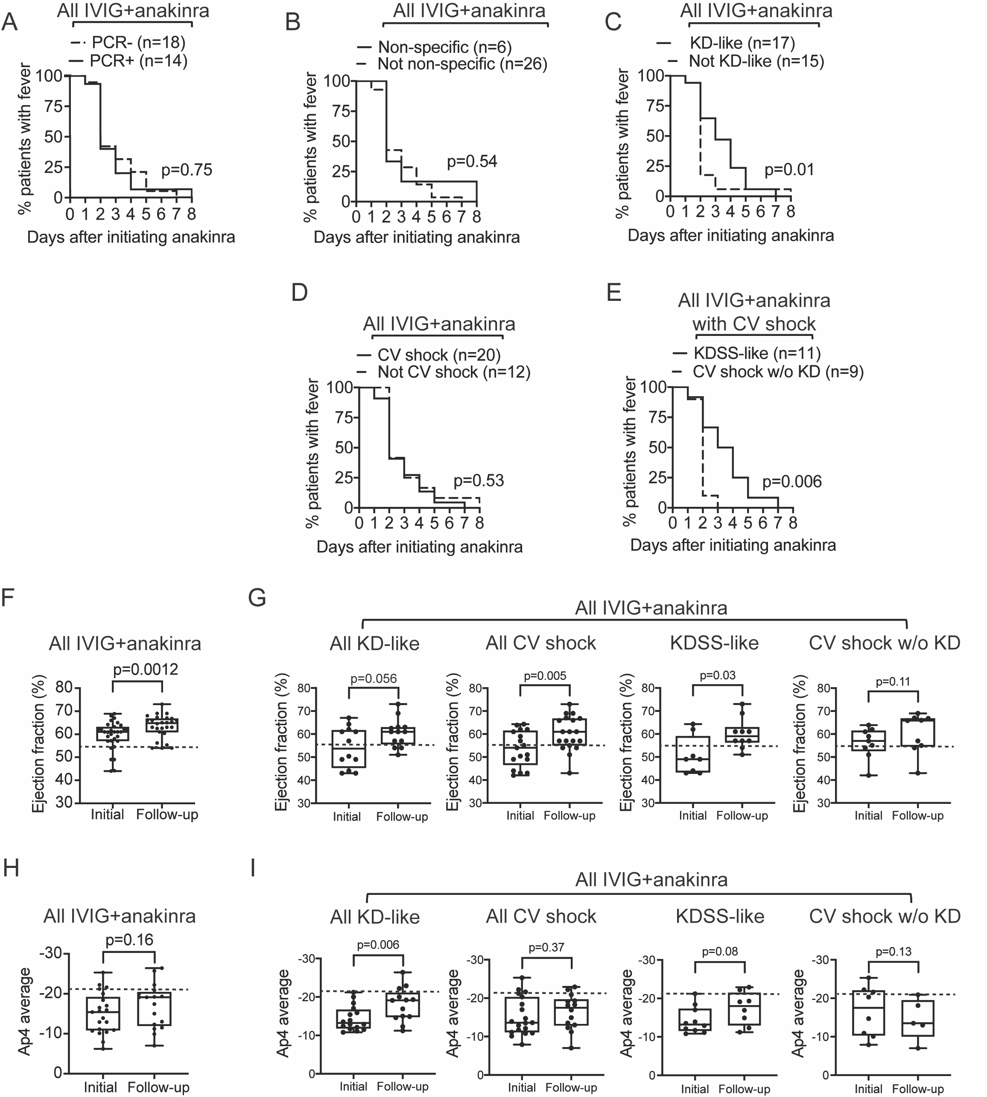
Supplemental Figure S2. Clinical of MIS-C patients in the IVIG+anakinra group stratified by COVID PCR status and clinical phenotype. Resolution of fever in all MIS-C patients in the IVIG+anakinra group discriminated by SARS-CoV-2 PCR status (A) or non-specific features (B), KD-like features (C), CV shock (D), and KDSS-like features (E) are shown. LVEF (F) and cardiac strain (H) at admission (initial) and follow-up of all MIS-C patients IVIG+anakinra group are shown, and subgroup analyses by clinical phenotypes are shown in G and I, respectively. The IVIG+anakinra group includes patients who were treated both with CS and without CS. The dotted lines denote the cut-off range for normal LVEF (55%) (F and G) and cardiac strain (Ap4 of -21.4) (H and I).

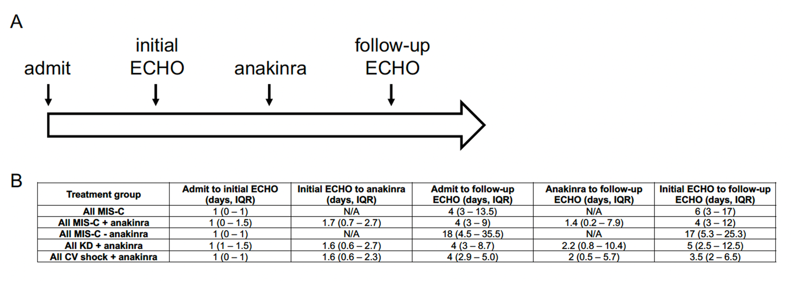
Supplemental Figure S3. Timing of initial and follow-up echocardiograms in MIS-C patients. A scheme of the various time measurements between admission and the follow-up echocardiograms (ECHO) are depicted in A. In B, the time intervals in days [median +/- IQR] of the ECHOs relative to admission and initiation of anakinra in the various clinical phenotypes of MIS-C are shown. IQR= interquartile range.

Adverse event | IVIG monotherapy  (n = 14) | IVIG+anakinra without CS  (n = 25) | IVIG+anakinra with CS (n = 9) | p-value
Neutropenia | 7% (1/14) | 20% (5/25) | 33% (3/9) | 0.36
Grade 1 | 0% (0/14) | 8% (2/25) | 0% (0/9) | 0.41
Grade 2 | 7% (1/14) | 4% (1/25) | 22% (2/9) | 0.25
Grade 3 | 0% (0/14) | 8% (2/25) | 11% (1/9) | 0.54
Grade 4 | 0% (0/14) | 0% (0/25) | 0% (0/9) | N/A
Rash | 0% (0/14) | 8% (2/25) | 0% (0/9) | 0.42
Elevated LFTs | 14% (2/14) | 24% (6/25) | 78% (7/9) | 0.008
< Grade 2 | 7% (1/14) | 8% (2/25) | 44% (5/9) | 0.02
Grade 2 | 0% (0/14) | 8% (2/25) | 0% (0/9) | 0.41
Grade 3 | 7% (1/14) | 8% (2/25) | 22% (2/9) | 0.47
Grade 4 | 0% (0/14) | 0% (0/25) | 0% (0/9) | N/A

Supplemental Table S5. Adverse events of severity of neutropenia and elevated LFTs stratified by severity according to CTCAE. The IVIG+anakinra group includes patients who were treated both with CS and without CS.

