SUPPORTING INFORMATION
VOLTAMMETRIC STUDY IN AQEUOUS MEDIA OF TWO NEW SULFONYLHYDRAZONE DERIVATIVES WITH POTENTIAL ANTI-CHAGAS ACTIVITY
Lígia Scandoglieri de Almeida¹; Luísa Donatto Chiavassa²; Charles de Lima Brito³; Fernando de Moura Gatti³, Gustavo Henrique Goulart Trossini³,
Mauro Aquiles La-Scalea¹
1. Departament of Chemistry, Institute of Environmental, Chemical and Pharmaceutical Sciences, Federal University of São Paulo, Diadema, SP, Brazil
2. Department of Chemical Engineering, Center of Structural Chemistry, Higher Technical Institute, University of Lisbon, Lisbon, Portugal
3. Department of Pharmacy, Faculty of Pharmaceutical Sciences, University of São Paulo, São Paulo, Brazil

Spectral data for the studied compounds
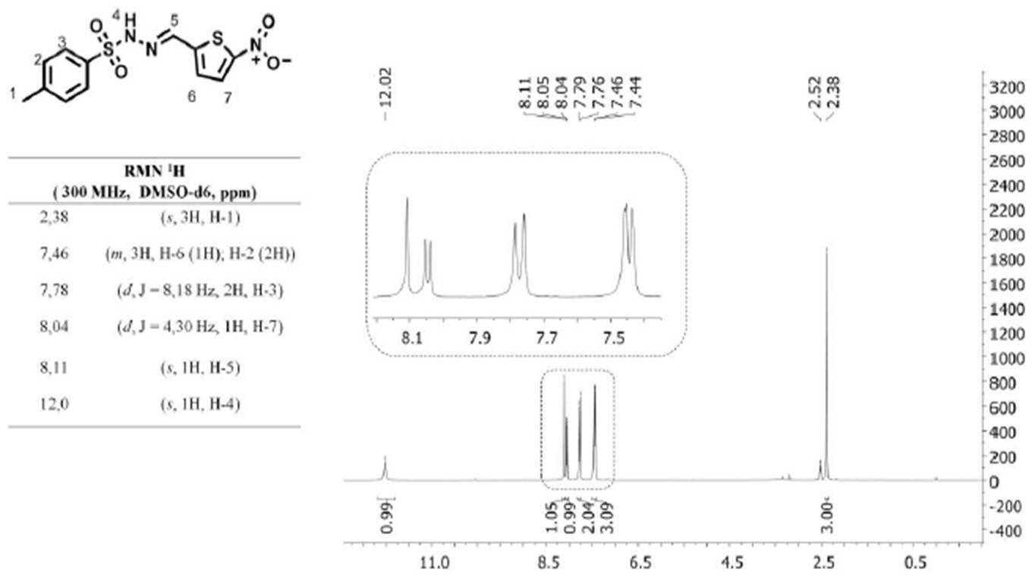
Figure 1S. NMR ¹H spectral data for NTBS (4-methyl-N-[(E)-(5-nitro-2-thien) methyleneamino] benzenesulfonamide).
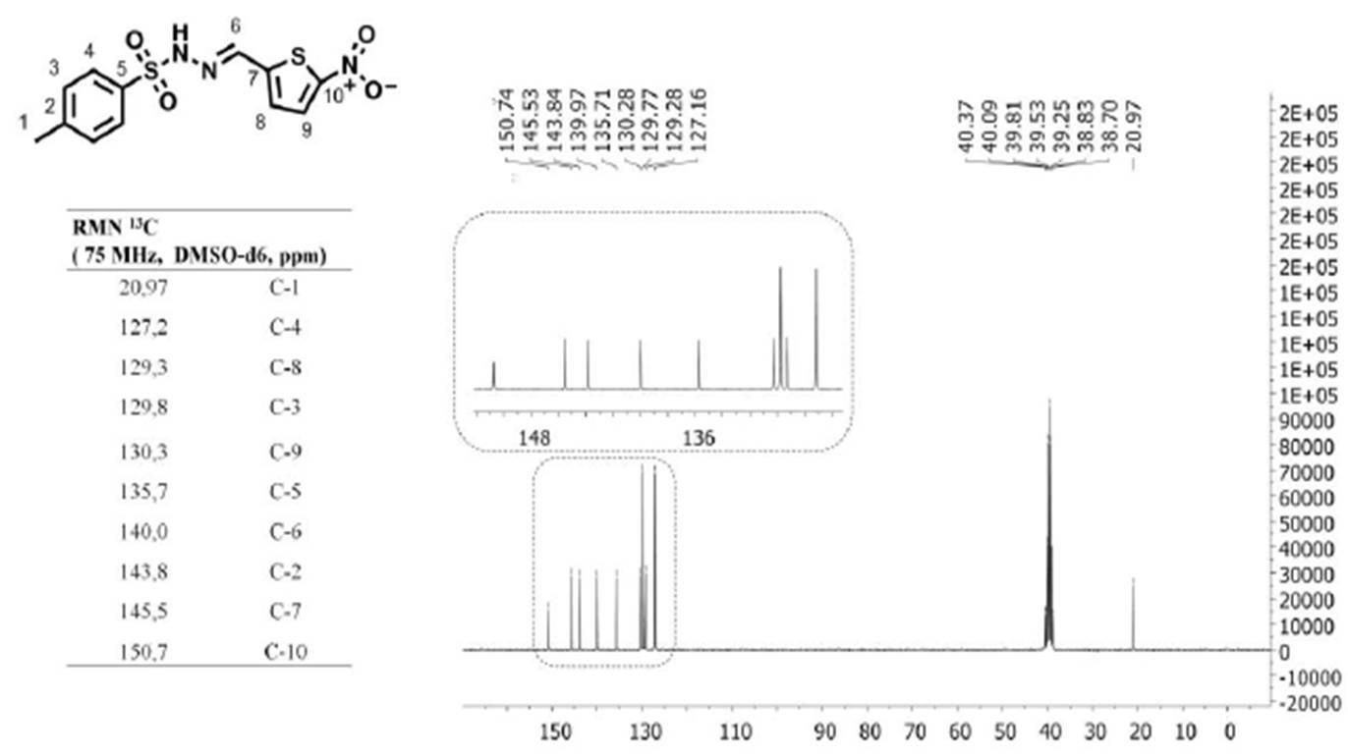
Figure 2S. NMR ¹³C spectral data for NTBS (4-methyl-N-[(E)-(5-nitro-2-thien) methyleneamino] benzenesulfonamide).

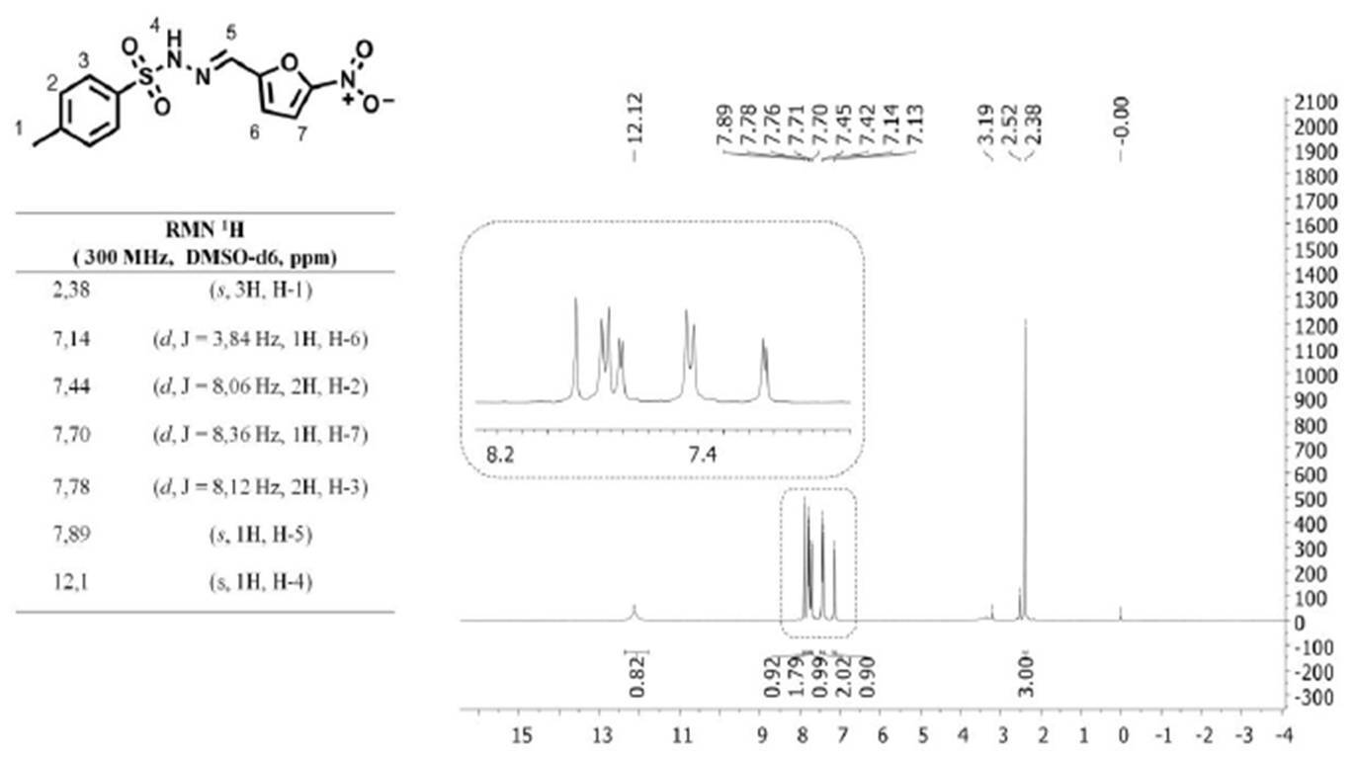
Figure 3S. NMR ¹H spectral data for NFBS (4-methyl-N-[(Z)-(5-nitro-2-furyl) methyleneamino] benzenesulfonamide).
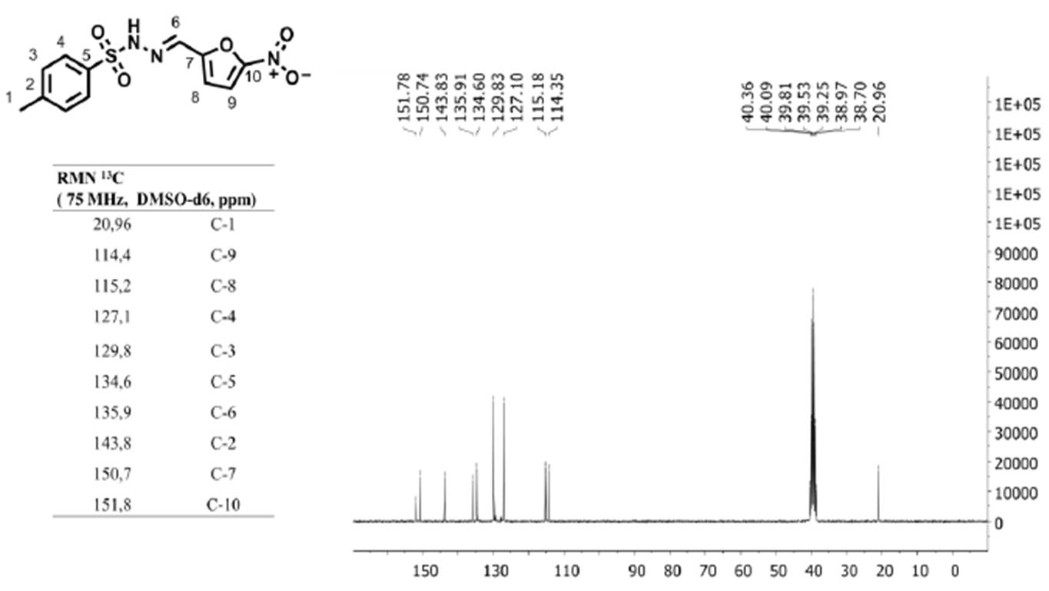
Figure 4S. NMR ¹³C spectral data for NFBS (4-methyl-N-[(Z)-(5-nitro-2-furyl) methyleneamino] benzenesulfonamide).

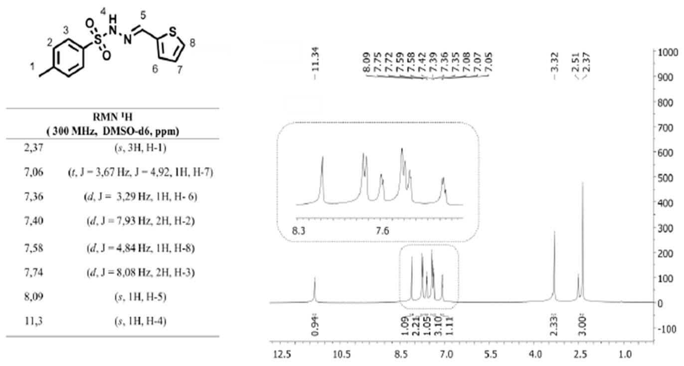
Figure 5S. NMR ¹H spectral data for NTBS without nitro group (4-methyl-N-[(E)-(2-thien) methyleneamino] benzenesulfonamide).
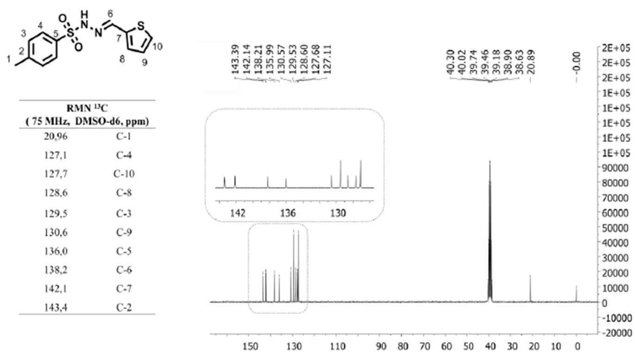
Figure 6S. NMR ¹³C spectral data for NTBS without nitro group (4-methyl-N-[(E)-(2-thien) methyleneamino] benzenesulfonamide).

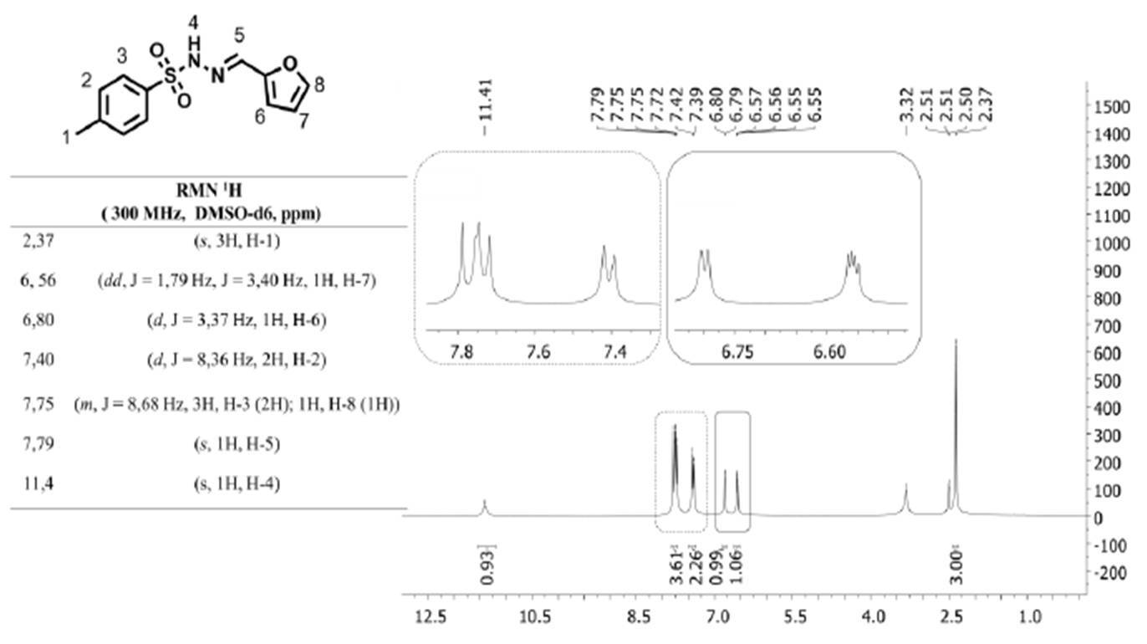
Figure 7S. NMR ¹H spectral data for NFBS without nitro group (4-methyl-N-[(Z)-(2-furyl) methyleneamino]benzenesulfonamide).
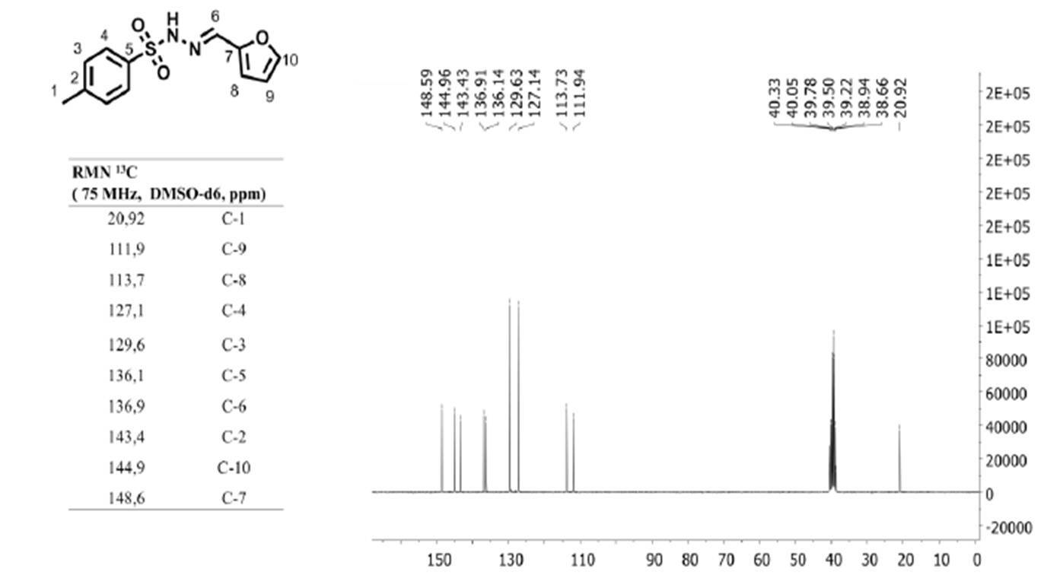
Figure 8S. NMR ¹³C spectral data for NFBS without nitro group (4-methyl-N-[(Z)-(2-furyl) methyleneamino] benzenesulfonamide).

Biological assay of cell growth inhibition of epimastigotes forms of T. cruzi
Cell growth inhibition assays were performed following the methodology described by Magdaleno and co-authors [1]. The in vitro assay was performed against epimastigotes in exponential growth phase (around 50×10⁶ cells/mL). These cells were washed and resuspended in phosphate buffer. Subsequently, they were cultivated in liver infusion tryptose culture medium containing or not the inhibitors in three concentrations: 70, 100 and 150 μmol/L at 28º C. 2.5×10⁶ cells/mL were inoculated in 200 μL of culture medium by using 96-wells plates. The cell growth was estimated by absorbance (reading at 620 nm for 10 days) and this value was transformed into cell density (cells/mL) in combination with a linear calibration curve previously obtained under the same conditions, where R² = 0.9981 and p < 0.05. Rotenone 200 μmol/L and antimicine 0.5 μmo/L were added in the culture medium as a control of the cell growth inhibition.
Reference
1. A. Magdaleno, Il-Y. Ahn, L.S. Paes, A.M. Silber. Actions of a proline analogue, L-thiazolidine-4- carboxylic acid (T4C), on Trypanosoma cruzi. Plos One 4 (2009) e4534. doi: 10.1371/journal.pone.0004534.

