Synthesis of new 1,5-diarylpyrazole/oxime hybrids as antiproliferative agents targeting EGFR and JNK-2
Kamal S. Abdelrahmanª, Heba A. Hassan^{b*}, Salah A. Abdel-Aziz^{,ac}, Adel A. Marzouk^{ad}, Raef shams^{e} ,Keima Oswa^{f}, Mohamed Abdel-Aziz^{b}. Hiroyuki Konno^{f}

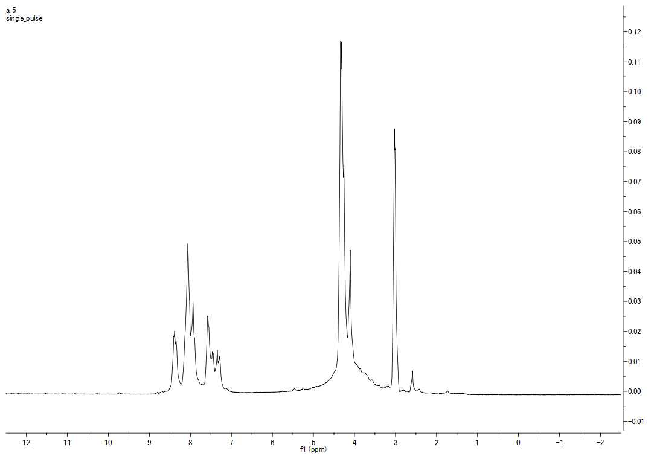

Fig. 1: ¹H-NMR of compound 6e in DMSO-d6.
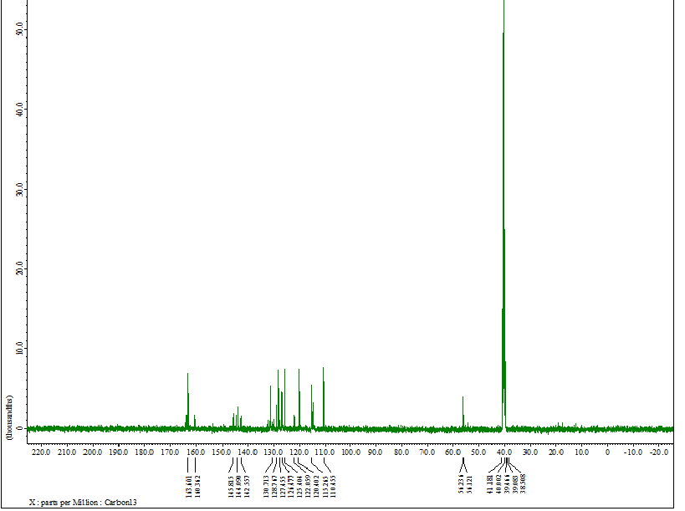

Fig. 2: ¹³C-NMR of Compound 6e in DMSO-d6.
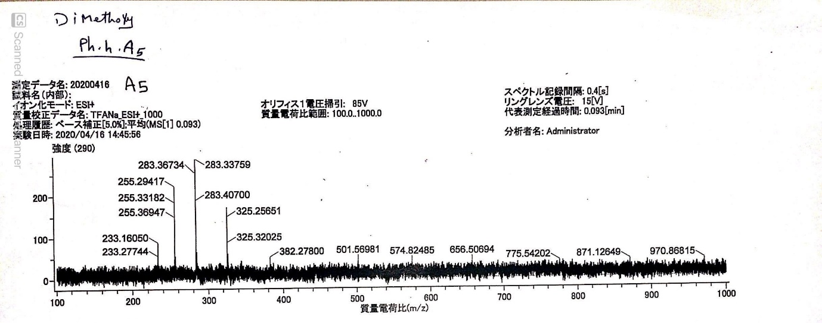

Fig. 3: ESI of compound 6e.

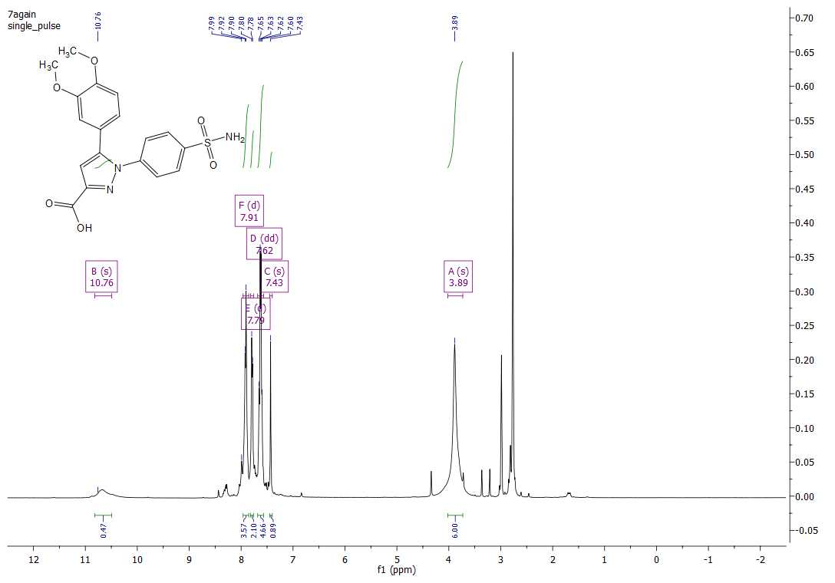

=

5-

Fig. 4: ¹H-NMR of compound 6j in DMSO-d6.

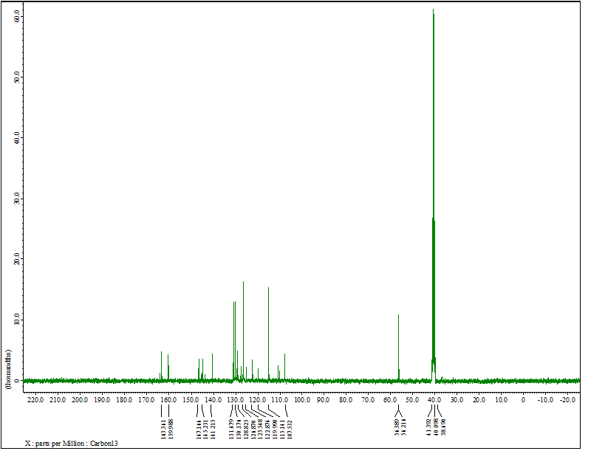

Fig. 5: ¹³C-NMR of Compound 6j in DMSO-d6.

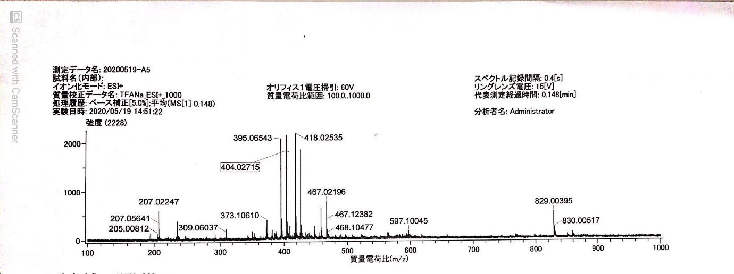

Fig. 6: ESI of compound 6j.

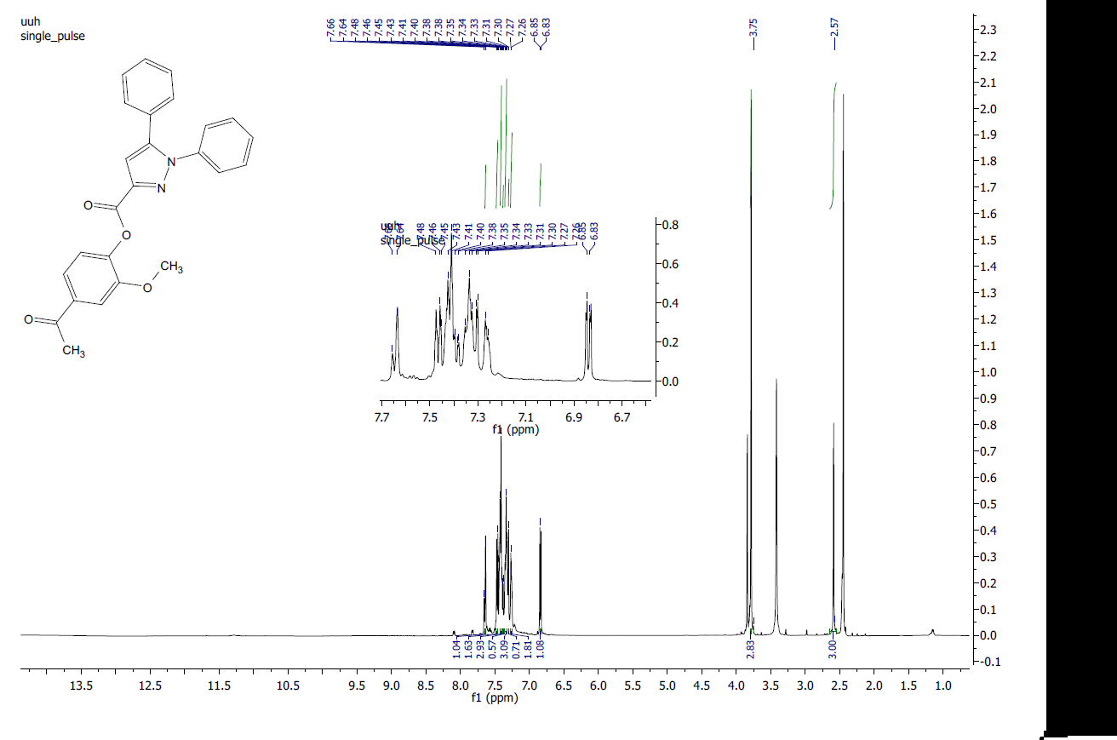

Fig. 7: ¹H-NMR of compound 7a in DMSO-d6.
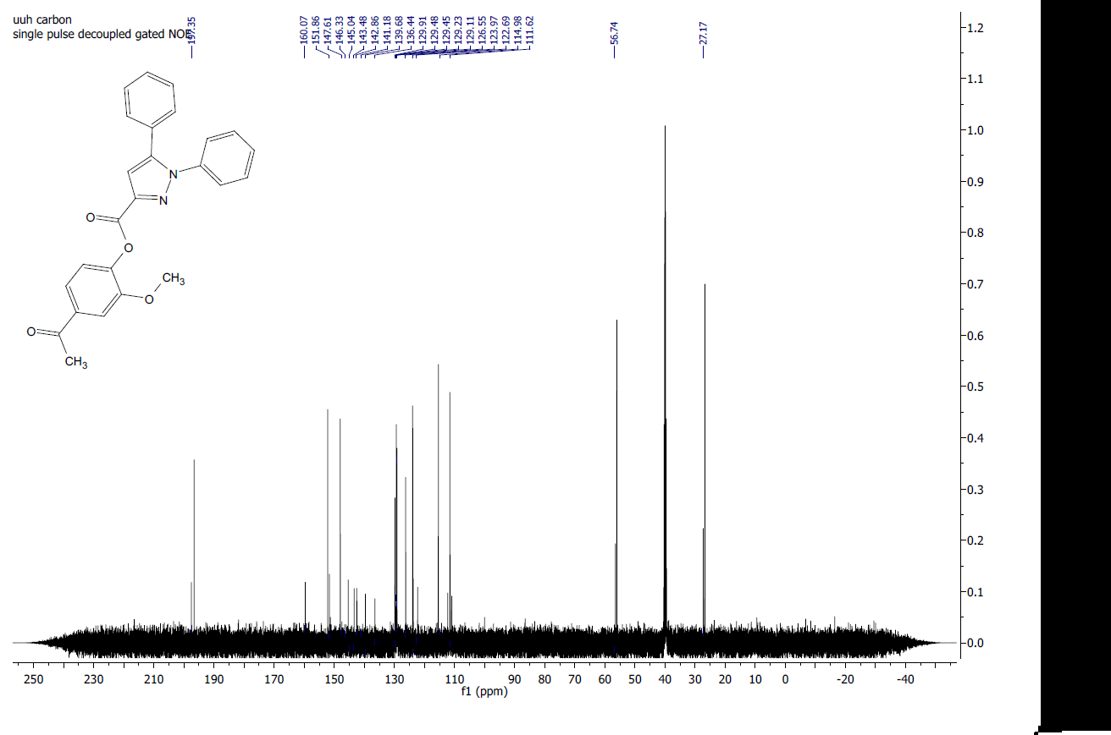

Fig. 8: ¹³C-NMR of Compound 7a in DMSO-d6.
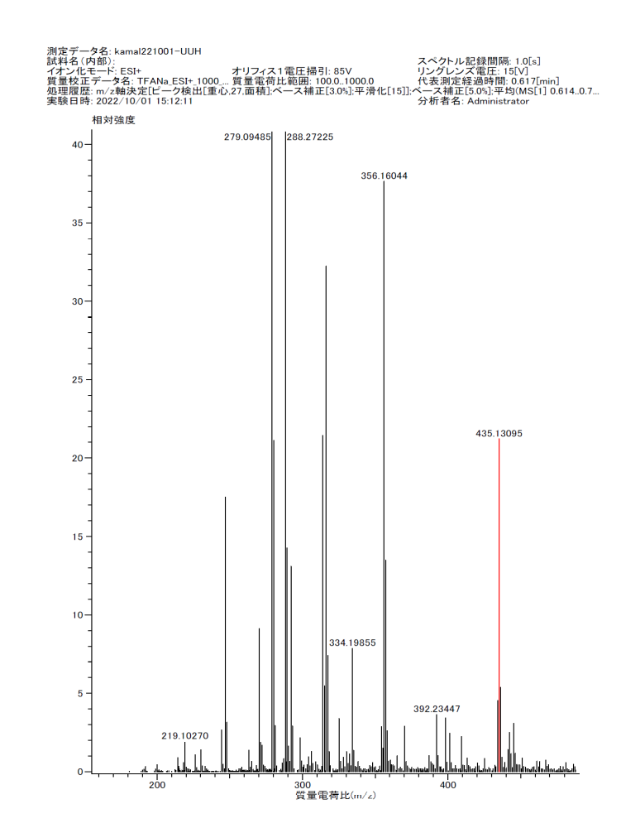
Fig. 9: HRMS of compound 7a.

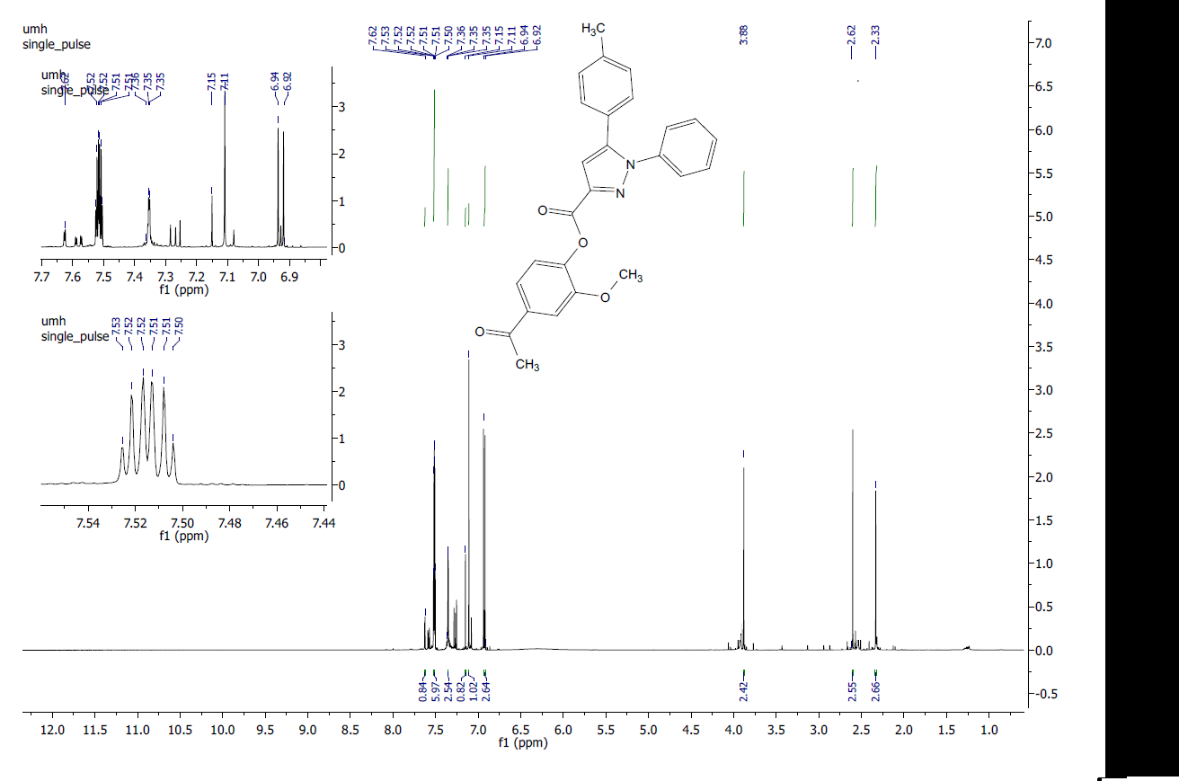
7

\\\\\\\\\

Fig. 10: ¹H-NMR of compound 7b in CDCl₃.
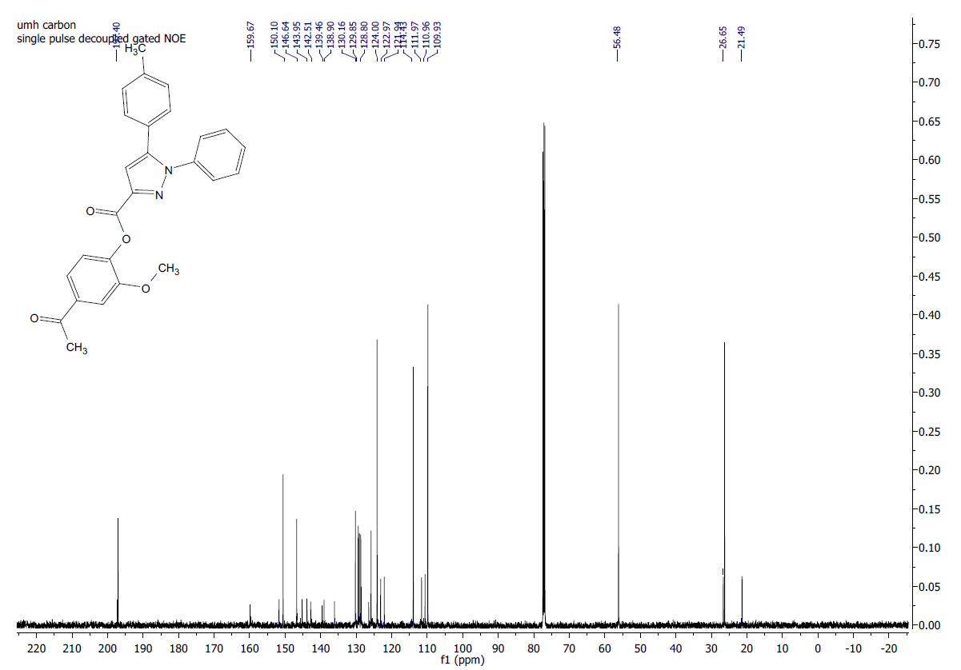

Fig. 11: ¹³C-NMR of Compound 7b in CDCl₃.

Fig. 12: HRMS of compound 7b.

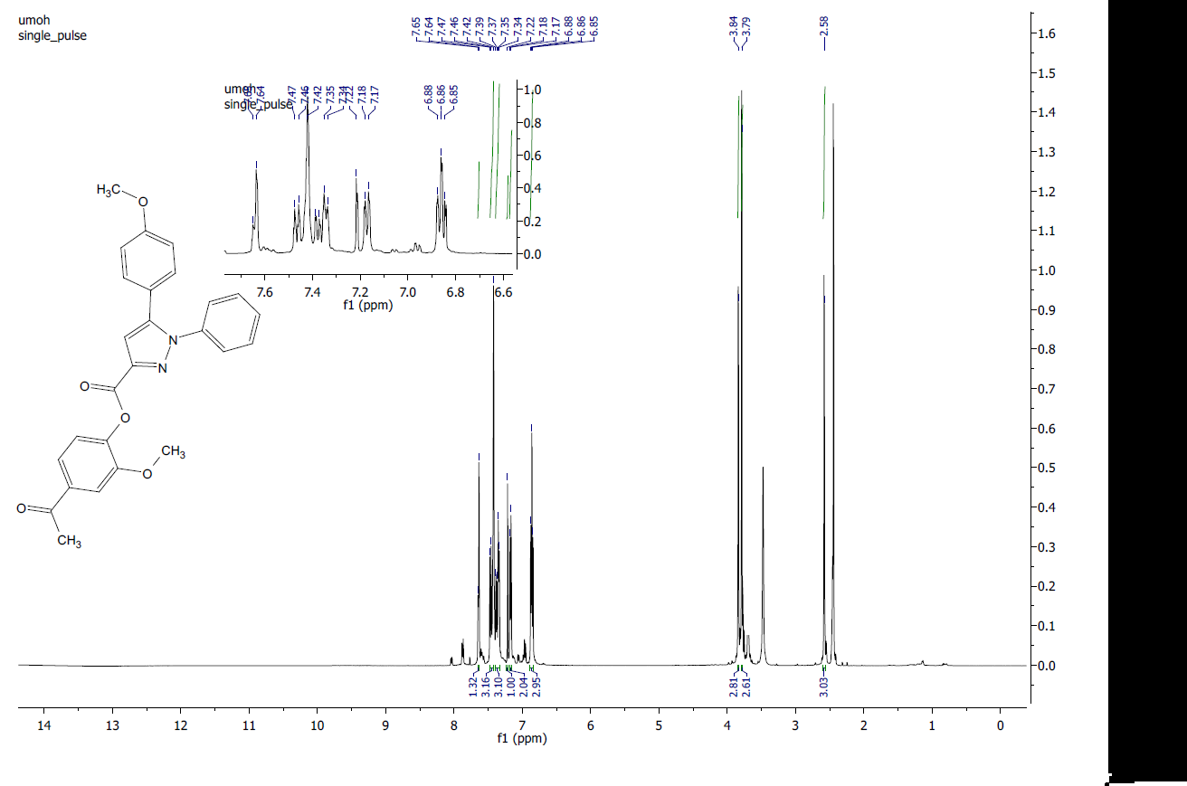
7c

Fig. 13: ¹H-NMR of compound 7c in DMSO-d6.
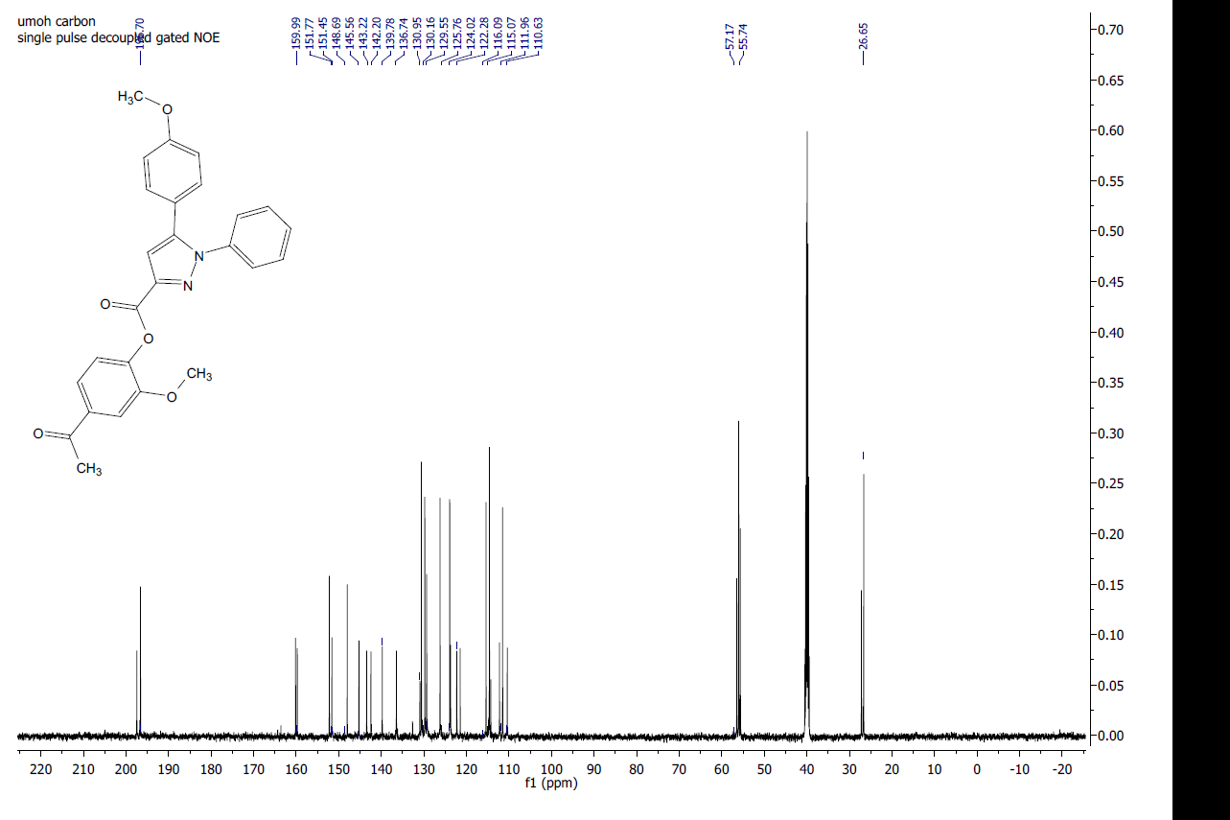

Fig. 14: ¹³C-NMR of Compound 7c in DMSO-d6.

Fig. 15: HRMS of compound 7c.

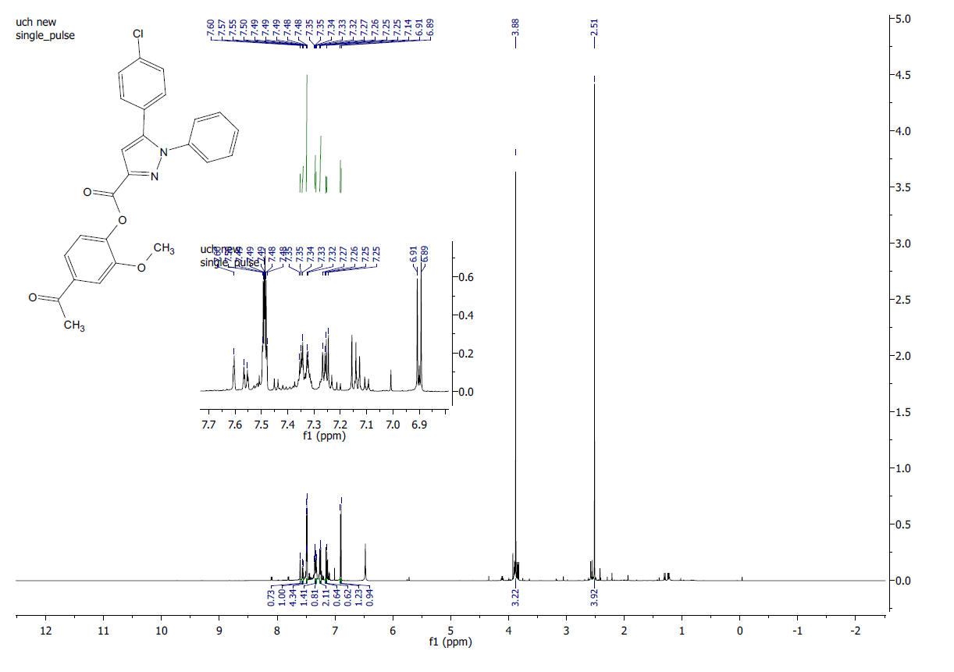
7d

Fig. 16: ¹H-NMR of compound 7d in CDCl₃.

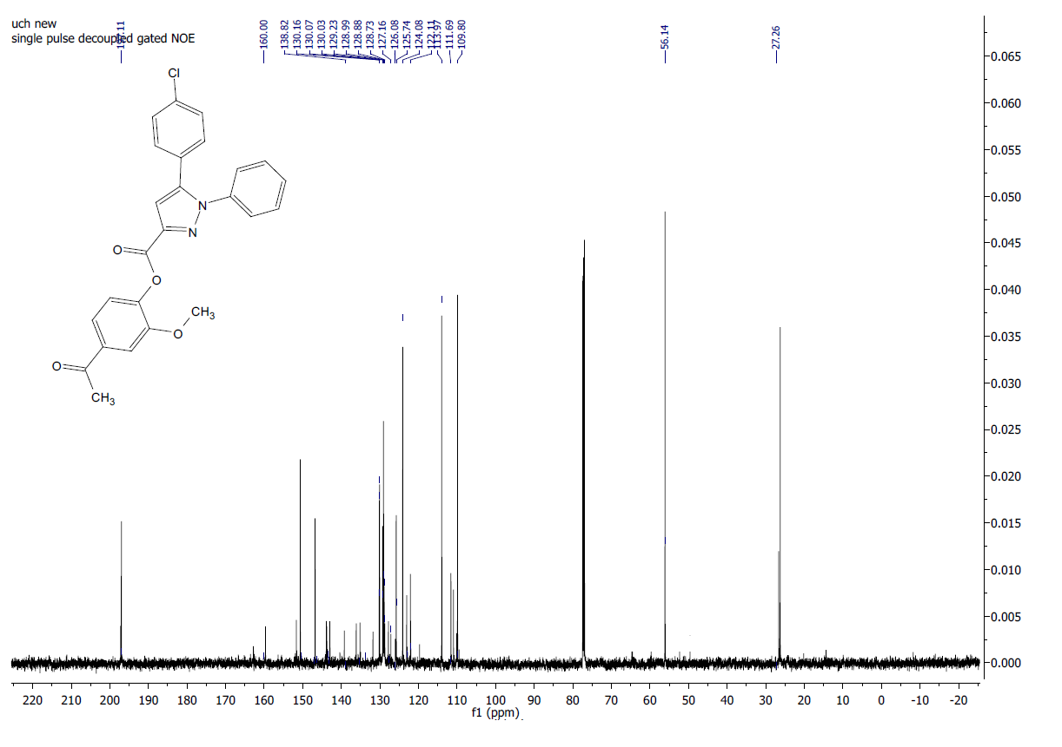

Fig. 17: ¹³C-NMR of Compound 7d in CDCl₃.

Fig. 18: HRMS of compound 7d.

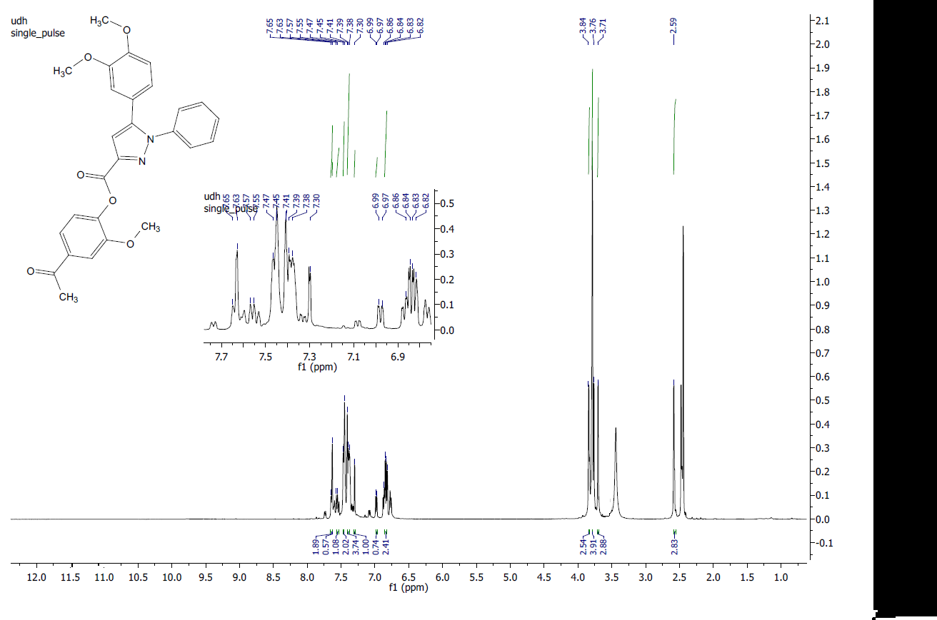
7e

Fig. 19: ¹H-NMR of compound 7e in DMSO-d6.
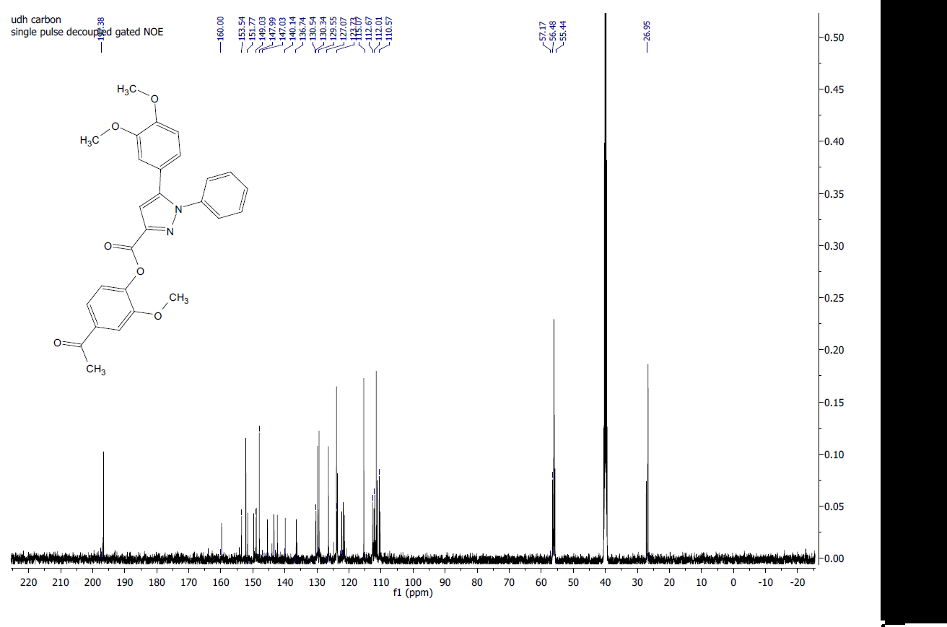

Fig. 20: ¹³C-NMR of Compound 7e in DMSO-d6.

Fig. 21: HRMS of compound 7e.

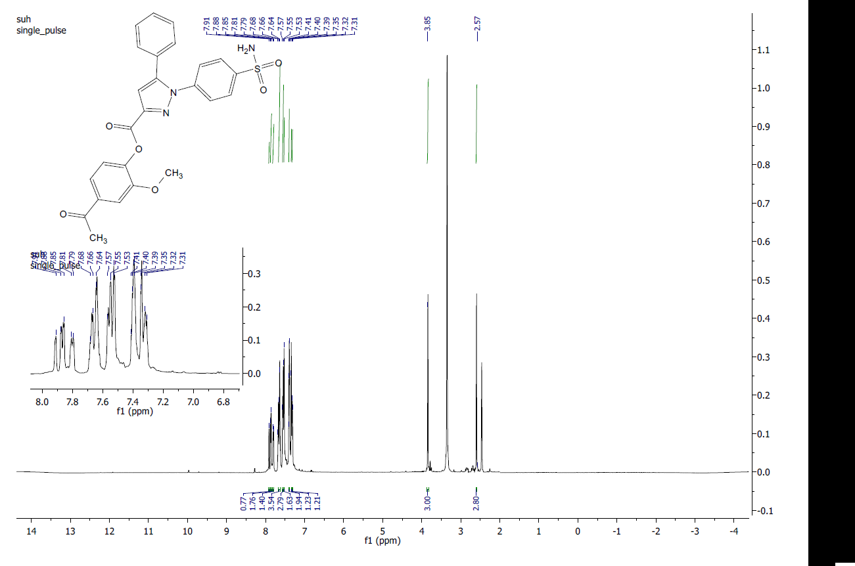
7f

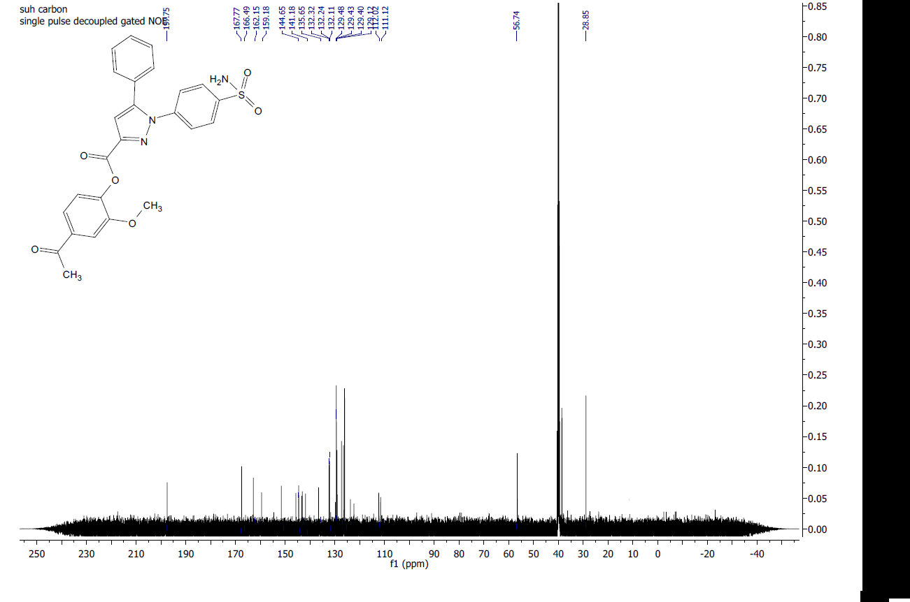
Fig. 22: ¹H-NMR of compound 7f in DMSO-d6.

Fig. 23: ¹³C-NMR of Compound 7f in DMSO-d6.
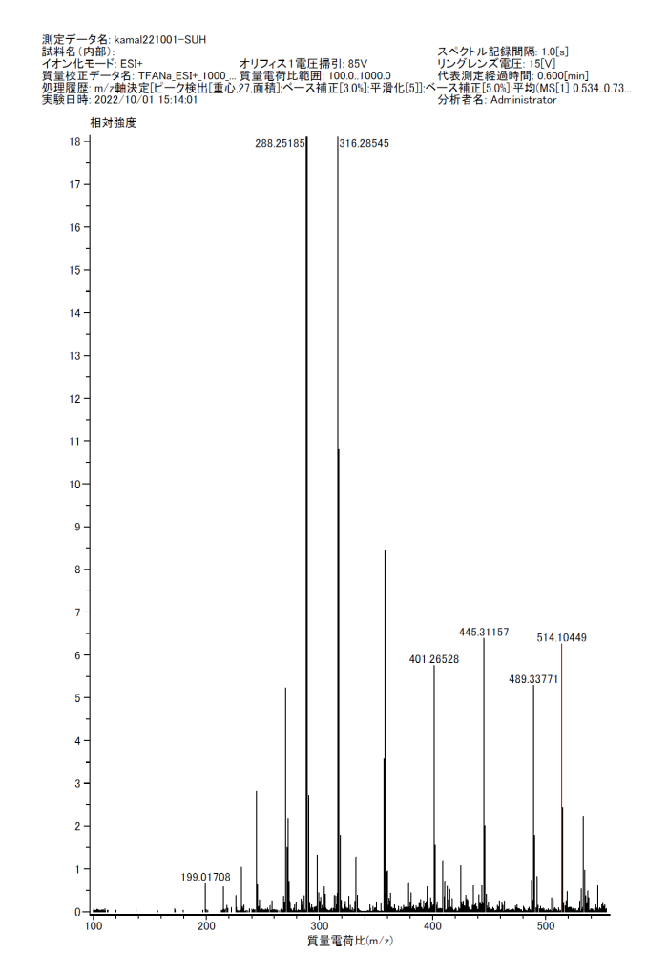
Fig. 24: HRMS of compound 7f.
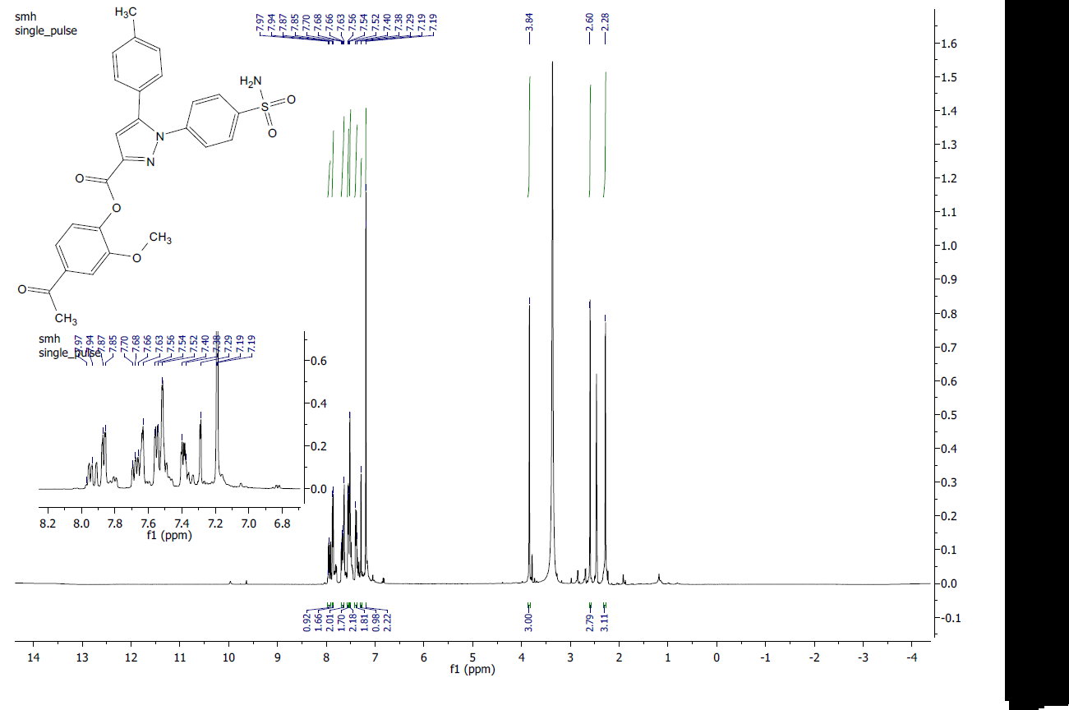
7g

Fig. 25: ¹H-NMR of compound 7g in DMSO-d6.
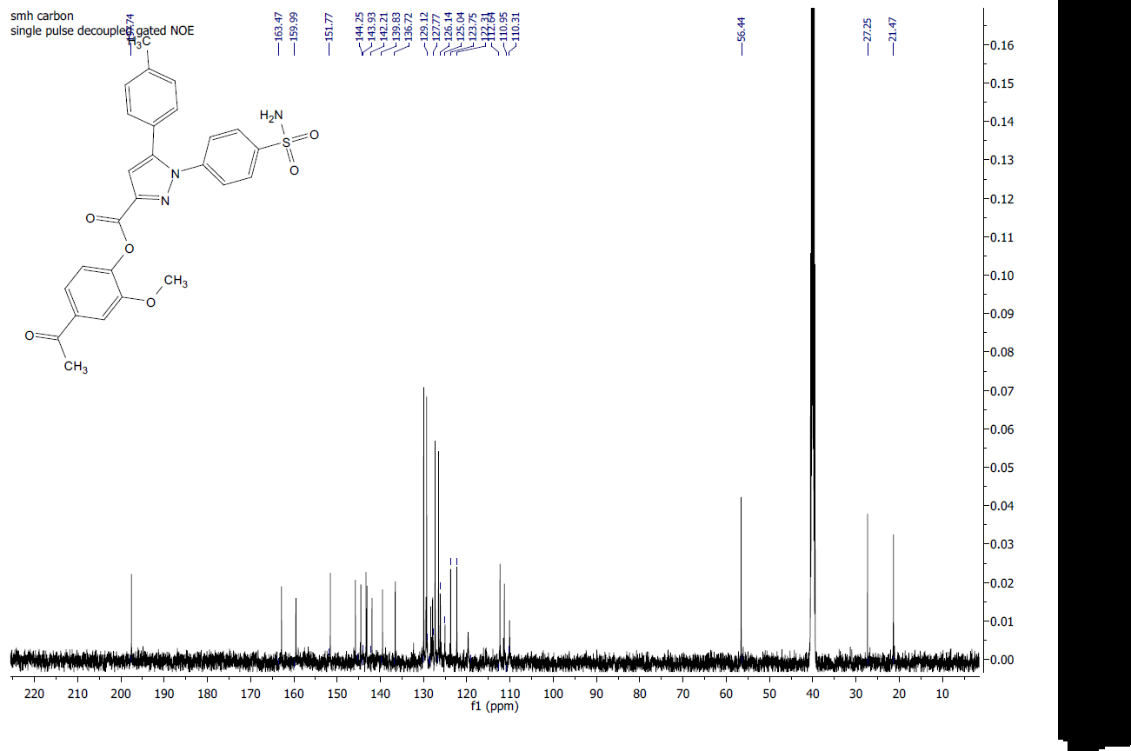

Fig. 26: ¹³C-NMR of Compound 7g in DMSO-d6.

Fig. 27: HRMS of compound 7g.
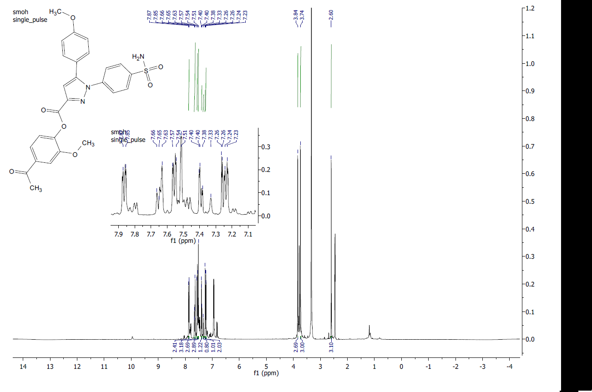
7h

Fig. 28: ¹H-NMR of compound 7h in DMSO-d6.
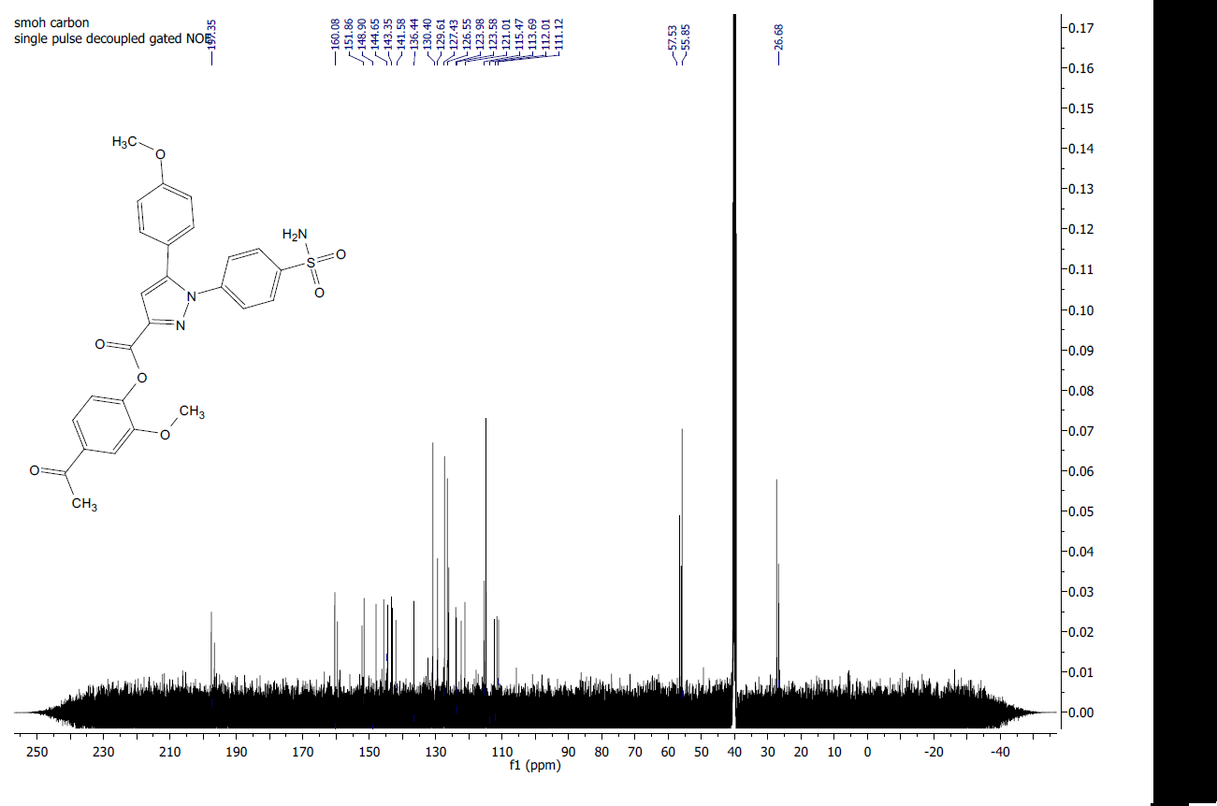

Fig. 29: ¹³C-NMR of Compound 7h in DMSO-d6.

Fig. 30: HRMS of compound 7h.

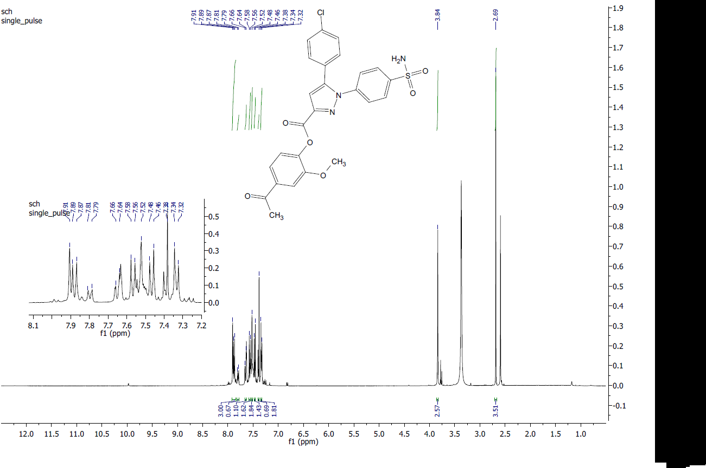
7i

Fig. 31: ¹H-NMR of compound 7i in DMSO-d6.
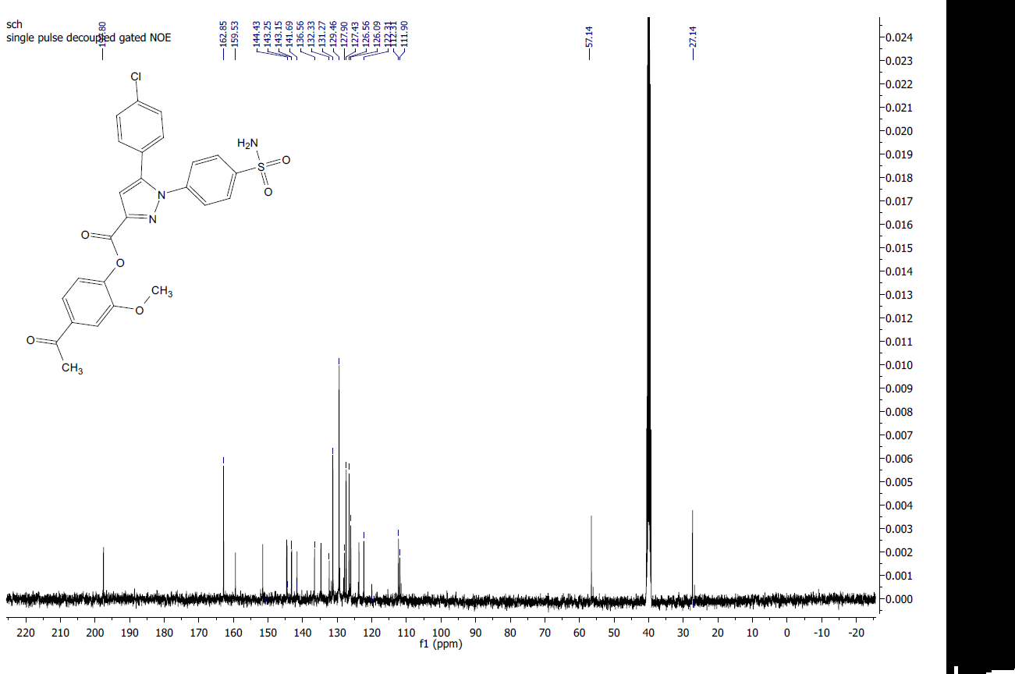

Fig. 32: ¹³C-NMR of Compound 7i in DMSO-d6.
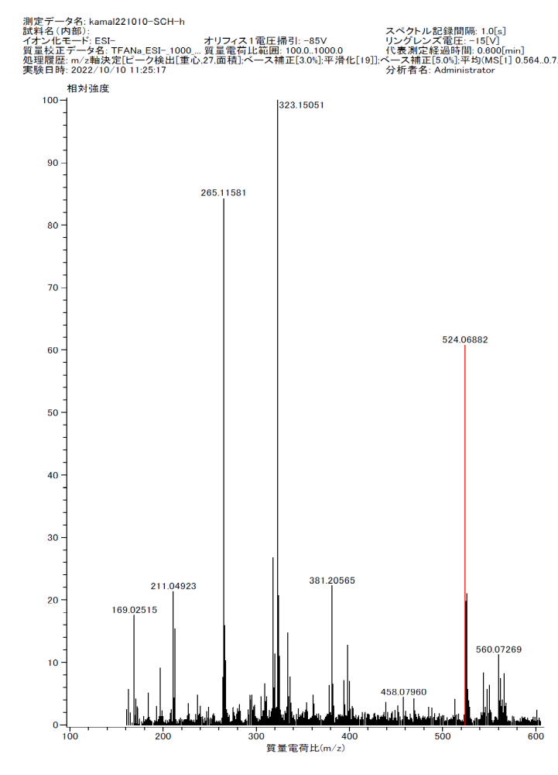

Fig. 33: HRMS of compound 7i.

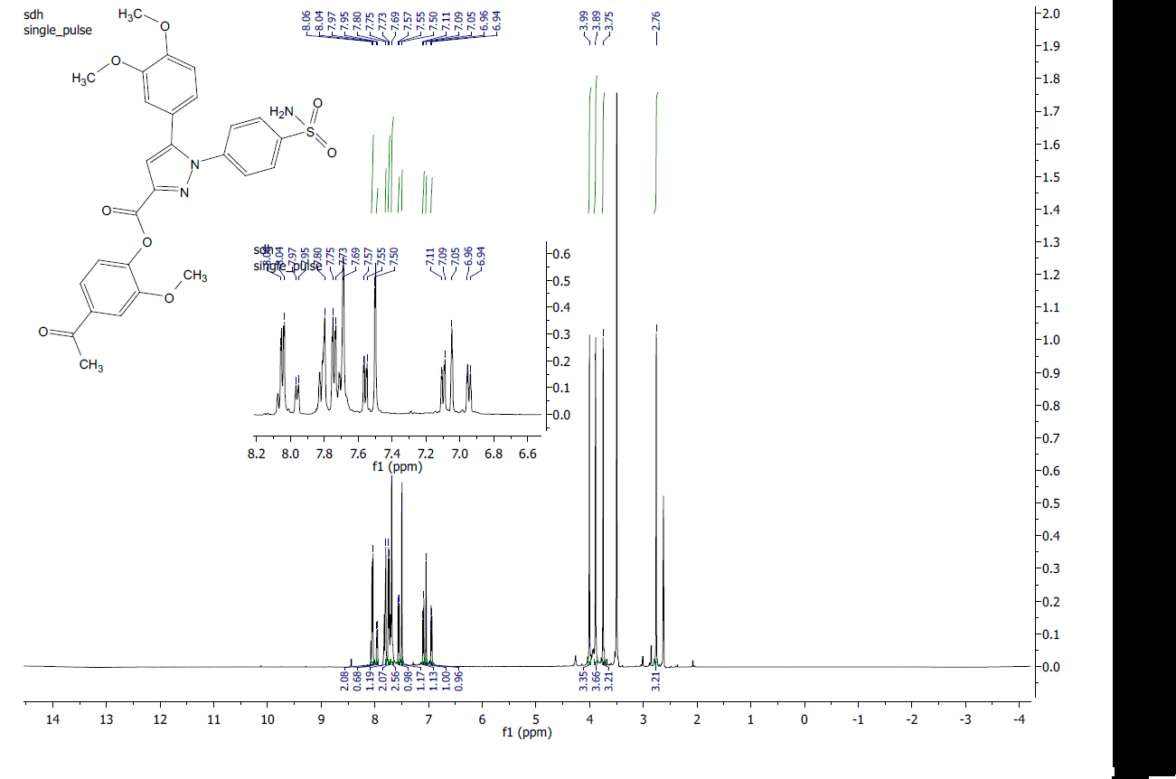
7j
77

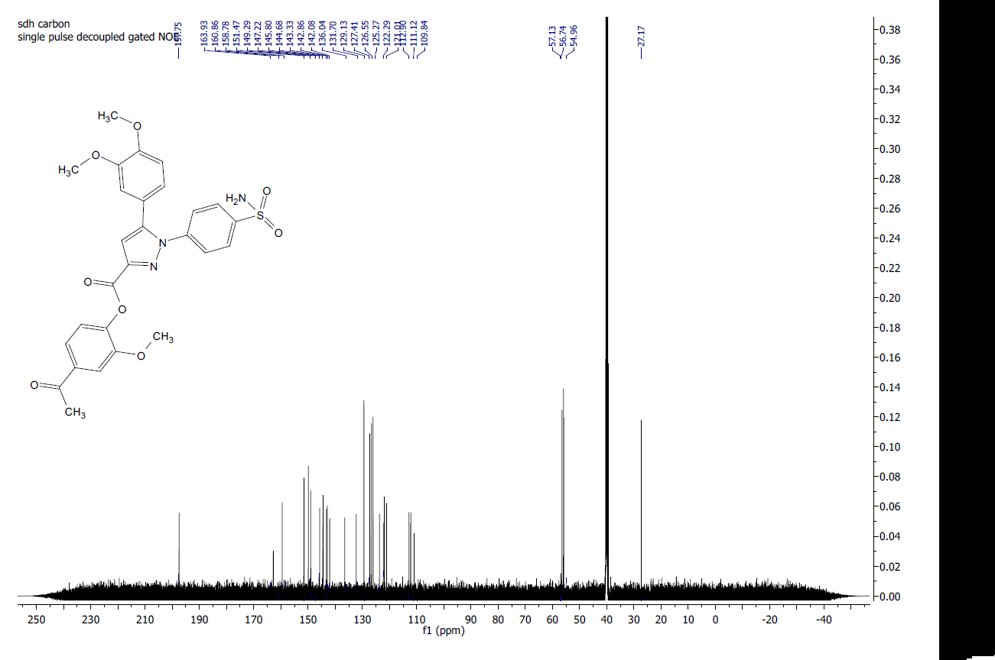
Fig. 34: ¹H-NMR of compound 7j in DMSO-d6.

Fig. 35: ¹³C-NMR of Compound 7j in DMSO-d6.

Fig. 36: HRMS of compound 7j.

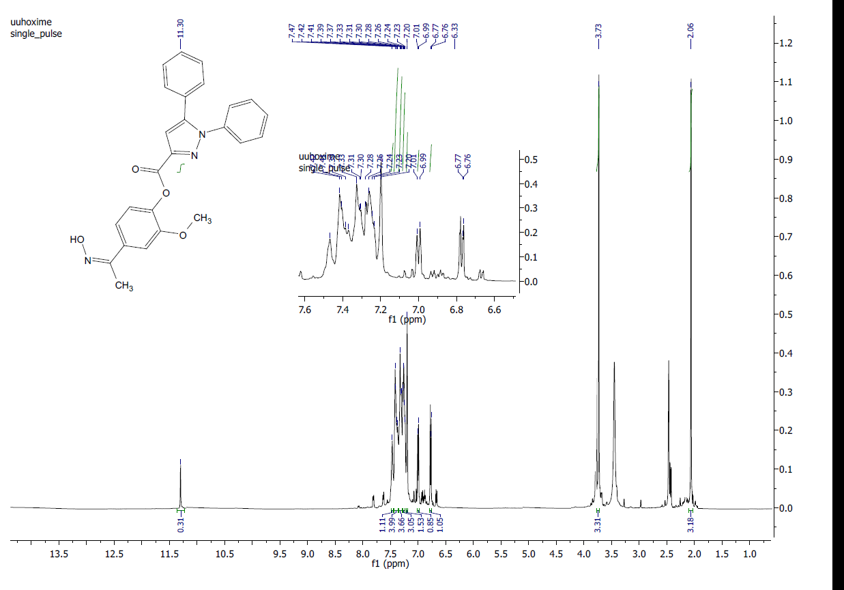
8a

Fig. 37: ¹H-NMR of compound 8a in DMSO-d6
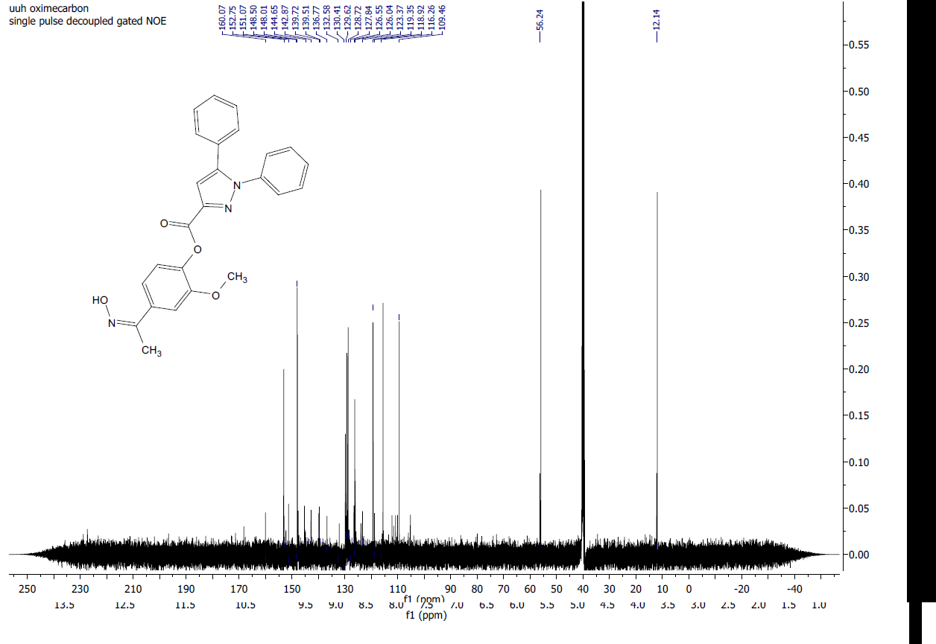

Fig. 38: ¹³C-NMR of Compound 8a in DMSO-d6.

Fig. 39: HRMS of compound 8a.

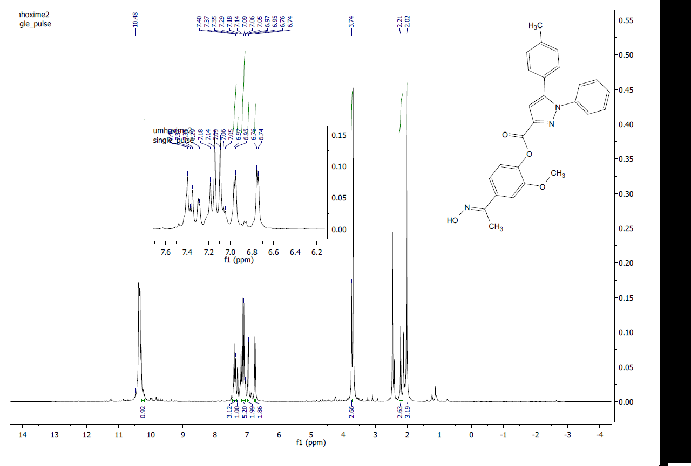
8b

Fig. 40: ¹H-NMR of compound 8b in DMSO-d6.

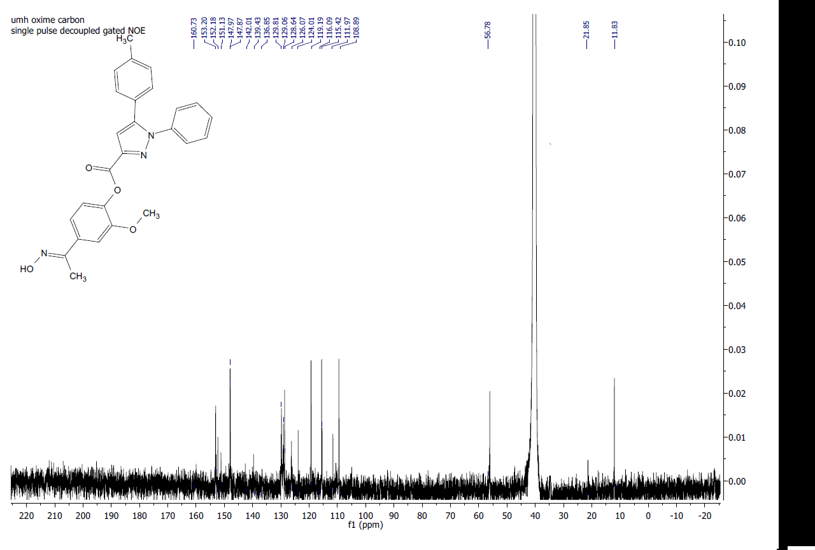

Fig. 41: ¹³C-NMR of Compound 8b in DMSO-d6.

Fig. 42: HRMS of compound 8b.

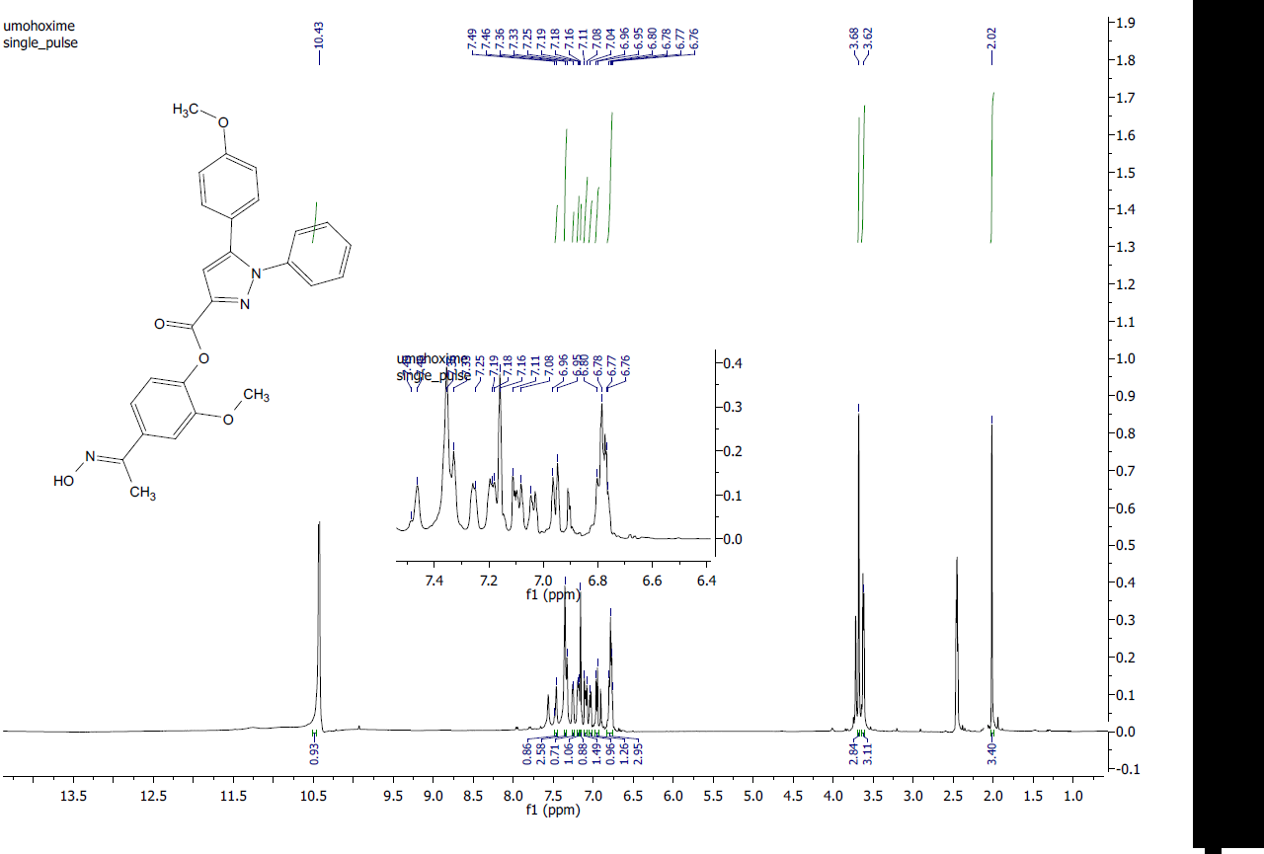
8c

Fig. 43: ¹H-NMR of compound 8c in DMSO-d6.
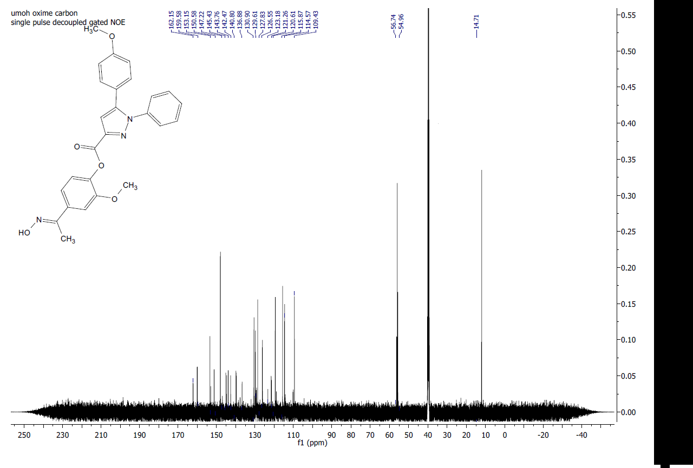

Fig. 44: ¹³C-NMR of Compound 8c in DMSO-d6.

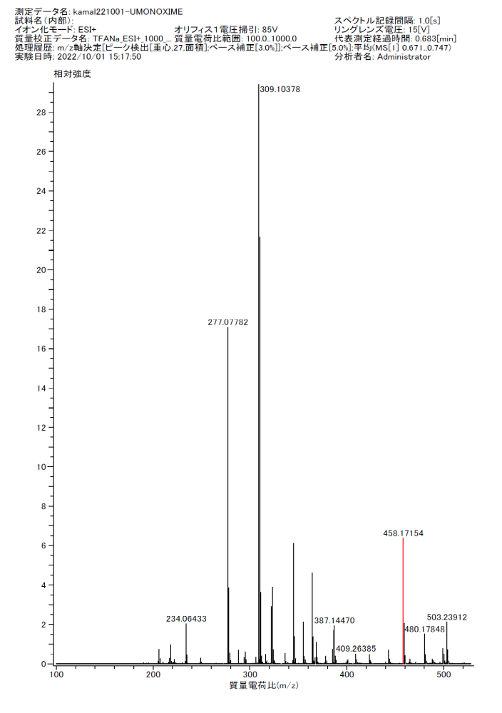
Fig. 45: HRMS of compound 8c.
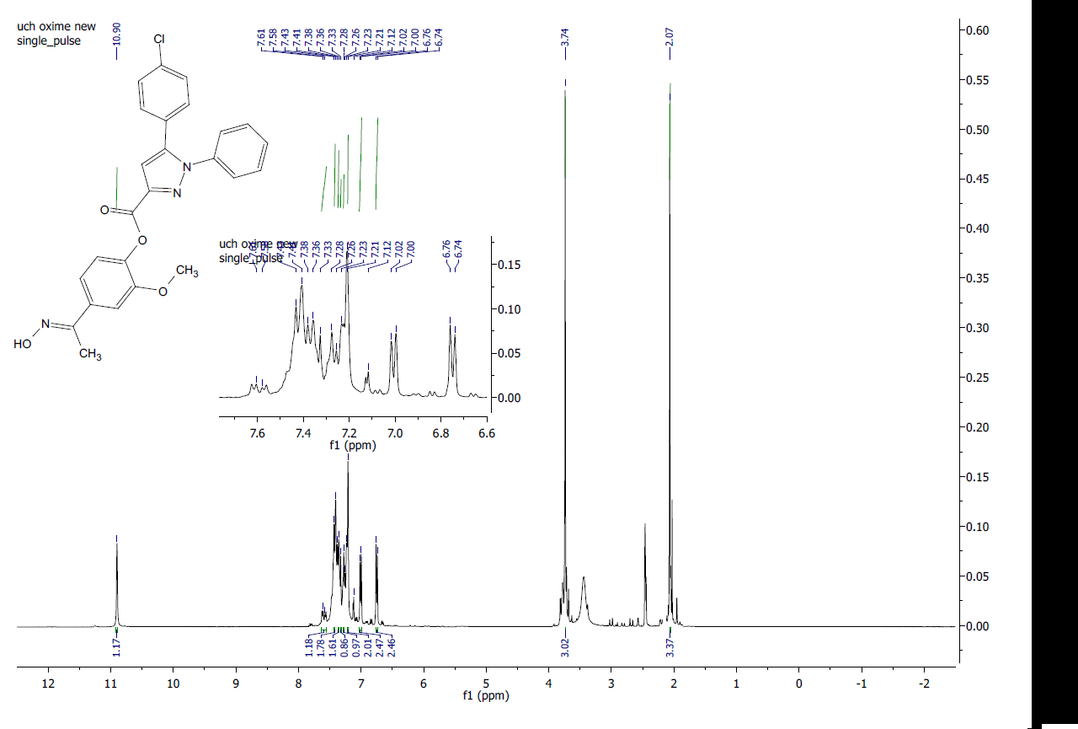
8d

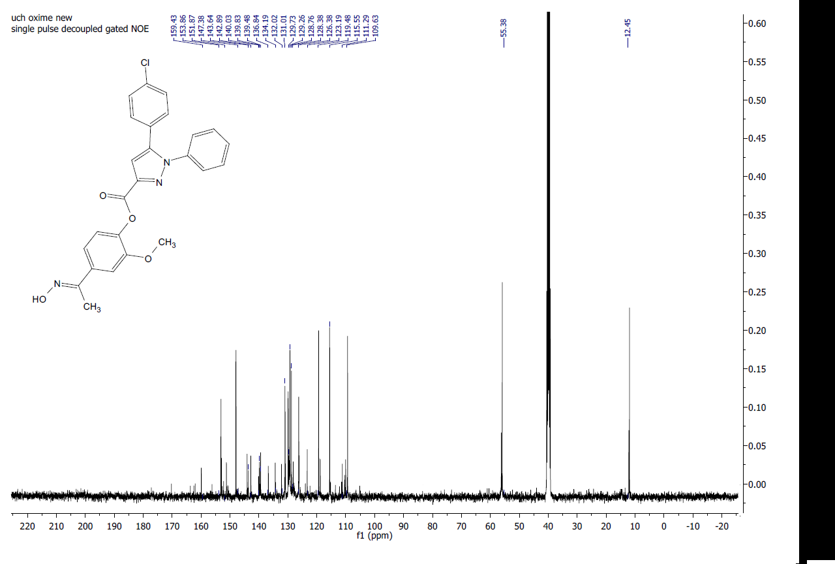
Fig. 46: ¹H-NMR of compound 8d in DMSO-d6.

Fig. 47: ¹³C-NMR of Compound 8d in DMSO-d6.

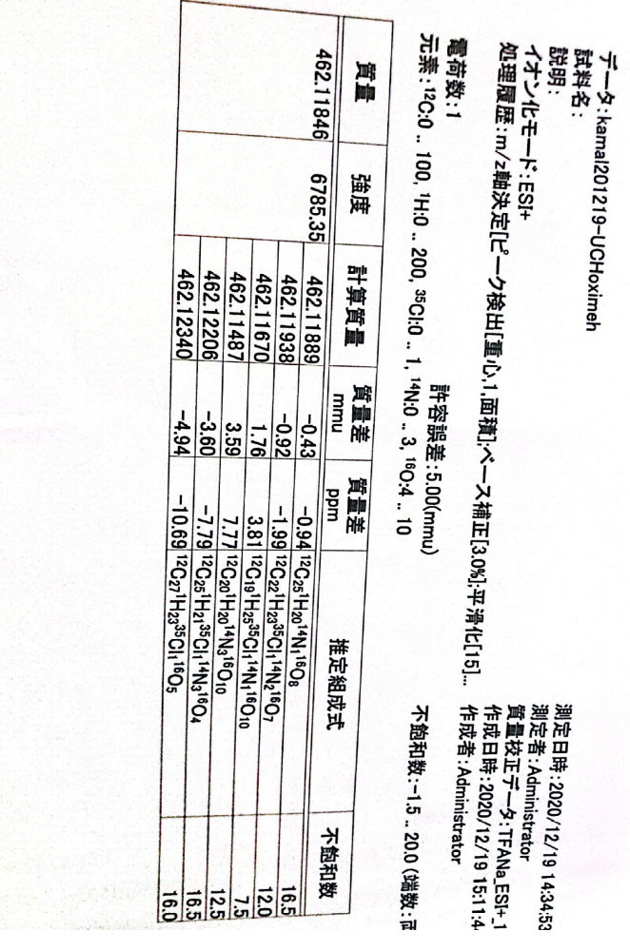

Fig. 48: HRMS of compound 8d.

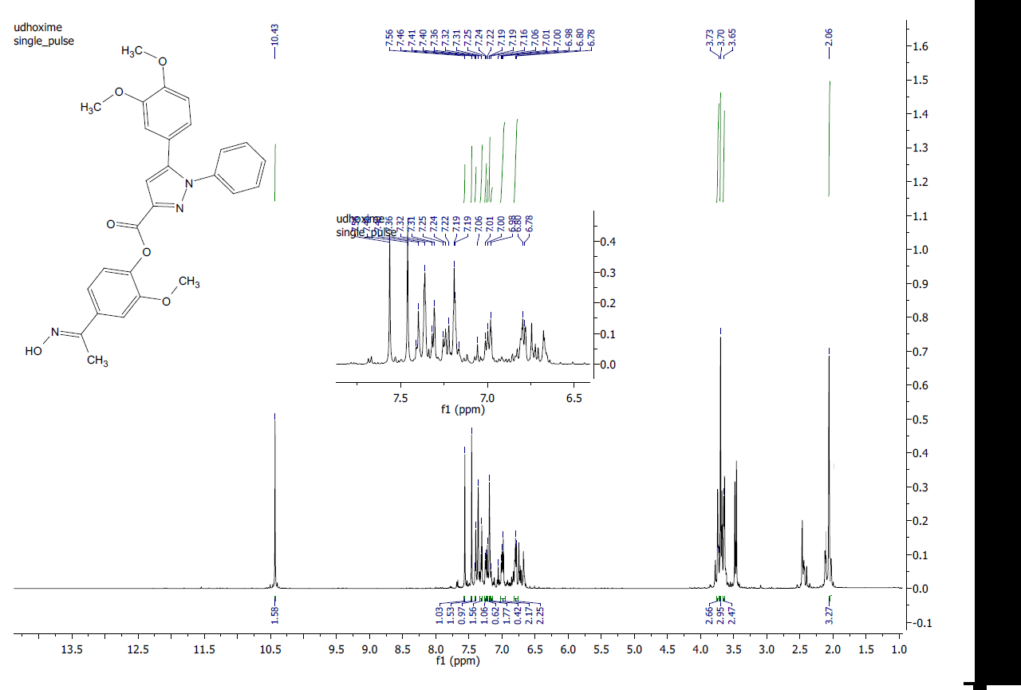
8e

Fig. 49: ¹H-NMR of compound 8e in DMSO-d6.
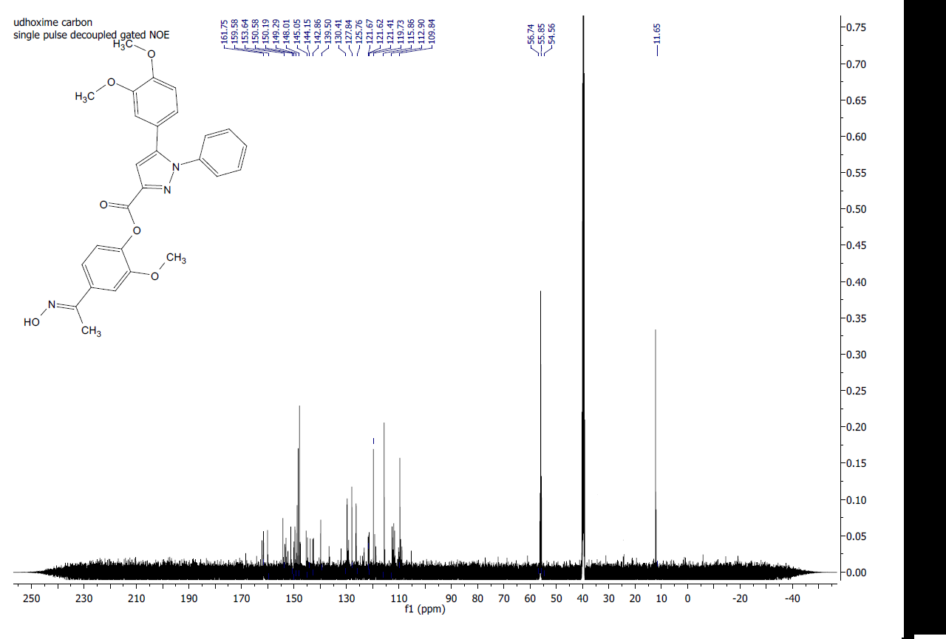

Fig. 50: ¹³C-NMR of Compound 8e in DMSO-d6.

Fig. 51: HRMS of compound 8e.

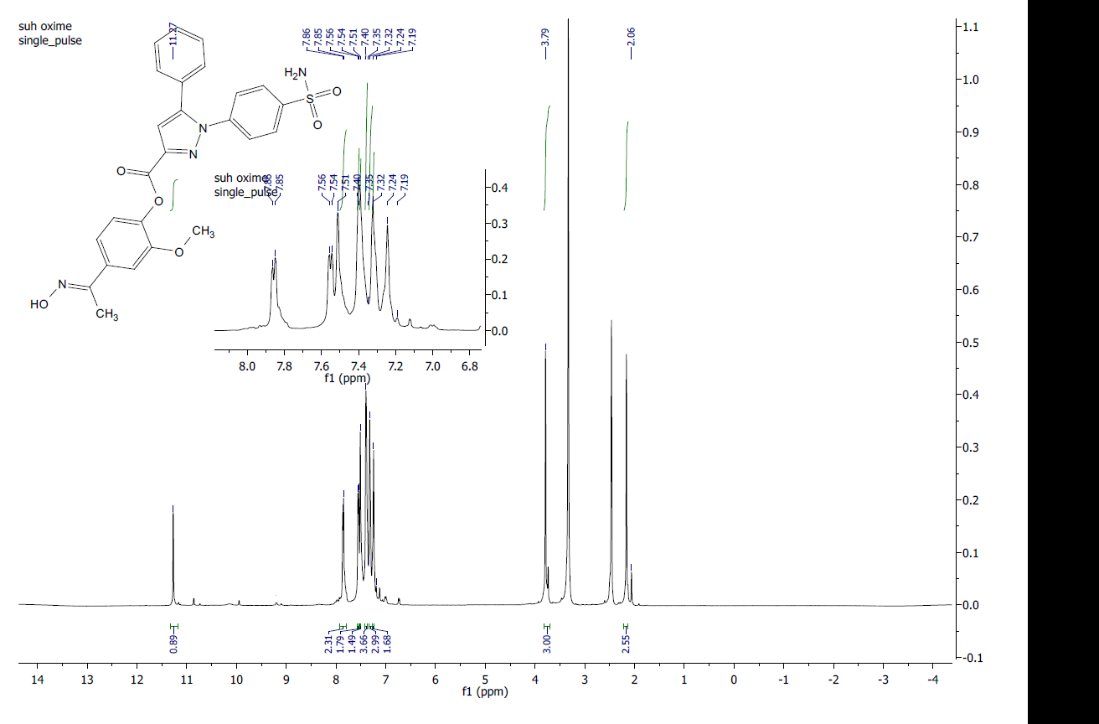
8f

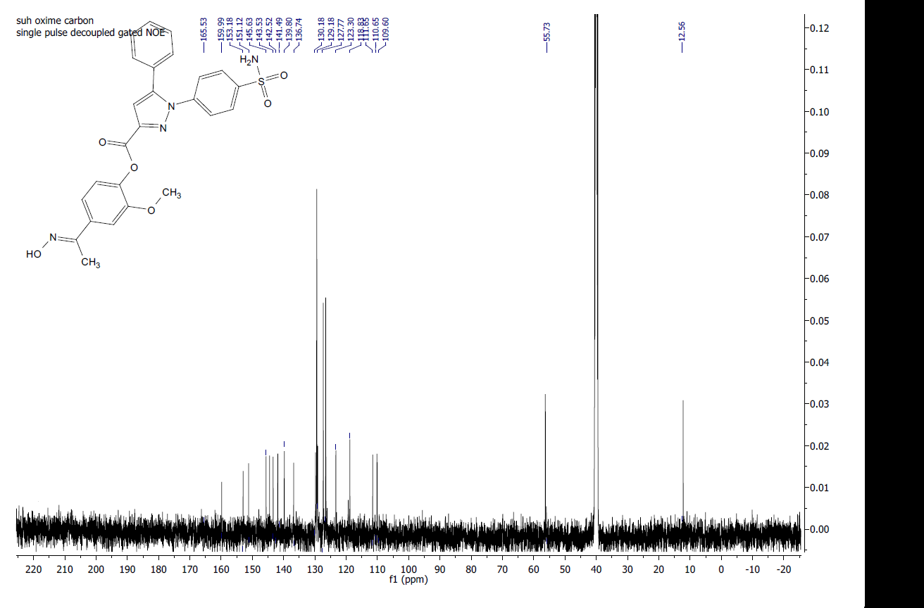
Fig. 52: ¹H-NMR of compound 8f in DMSO-d6.

Fig. 53: ¹³C-NMR of Compound 8f in DMSO-d6.

Fig. 54: HRMS of compound 8f.

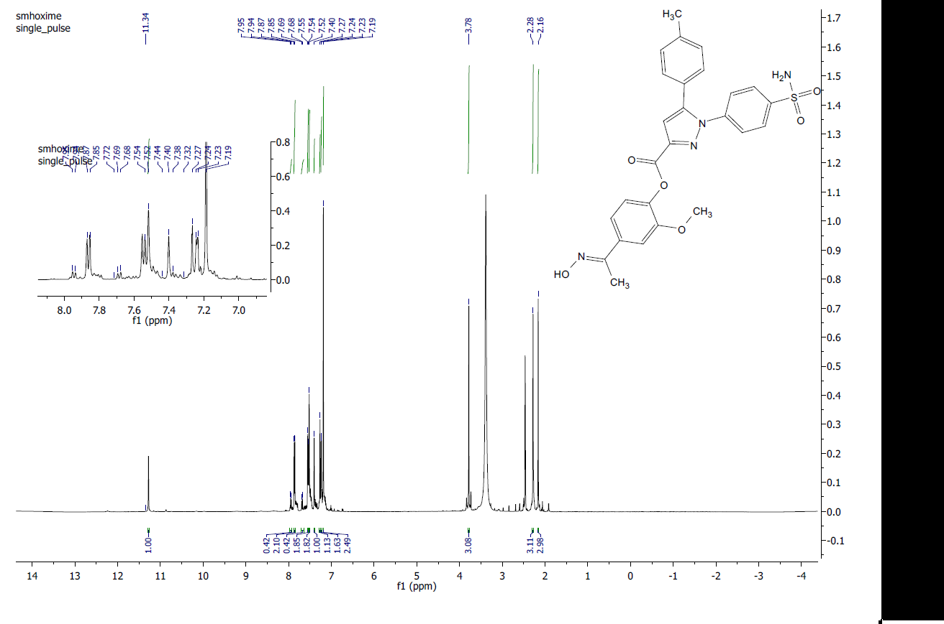
8g
8g

Fig. 55: ¹H-NMR of compound 8g in DMSO-d6.
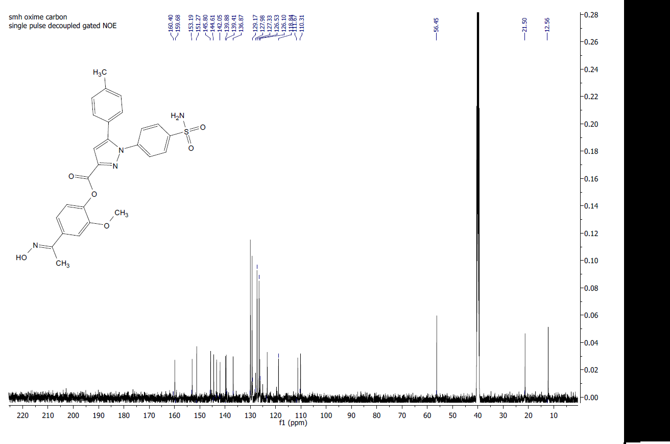

Fig. 56: ¹³C-NMR of Compound 8g in DMSO-d6.

Fig. 57: HRMS of compound 8g.

8h
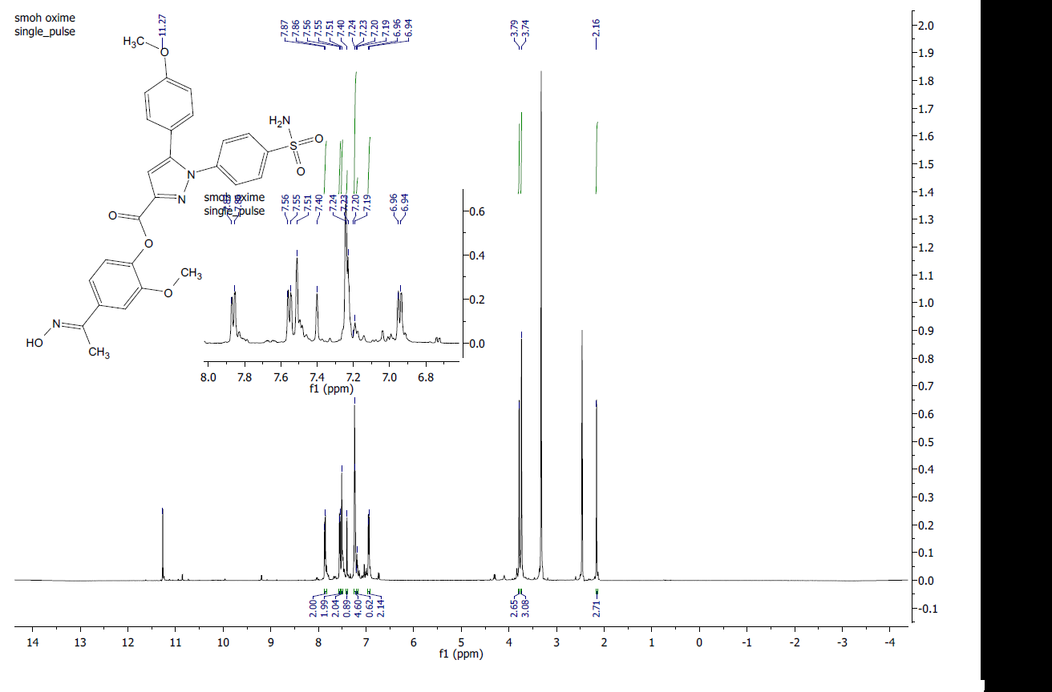

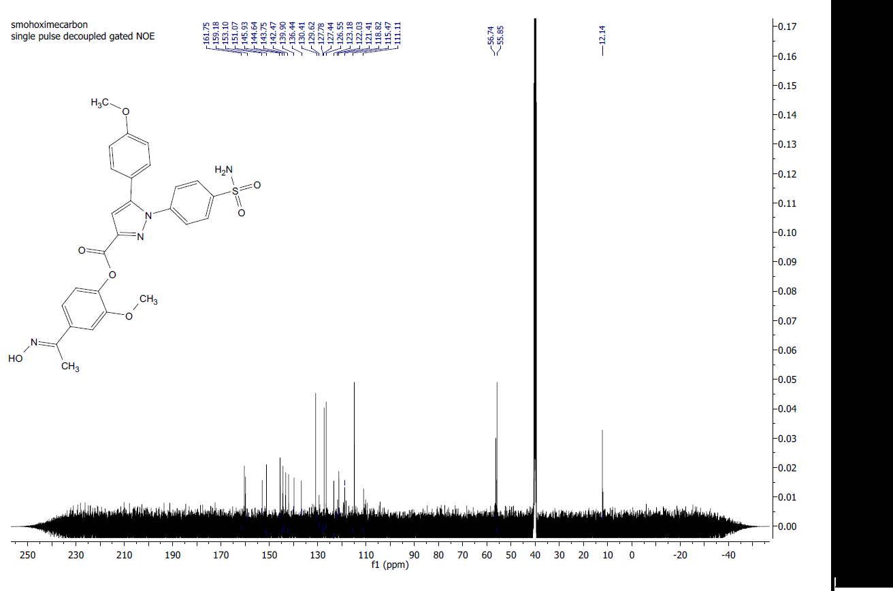
Fig. 58: ¹H-NMR of compound 8h in DMSO-d6.

Fig. 59: ¹³C-NMR of Compound 8h in DMSO-d6.

Fig. 60: HRMS of compound 8h.

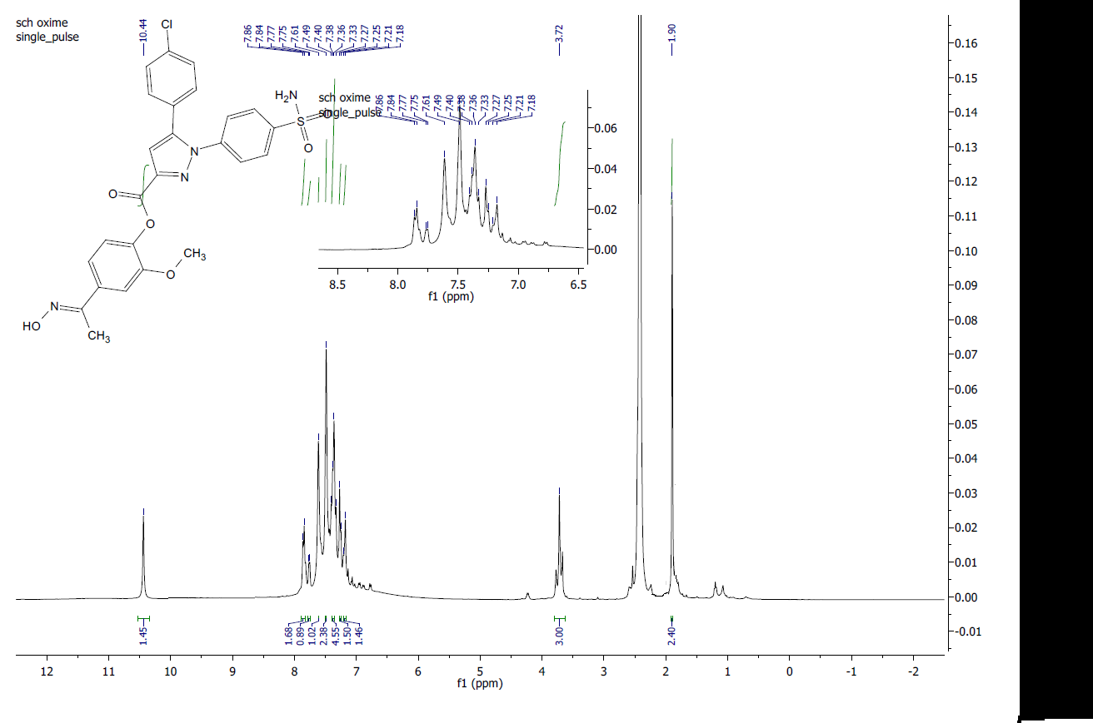
8i

Fig. 61: ¹H-NMR of compound 8i in DMSO-d6.
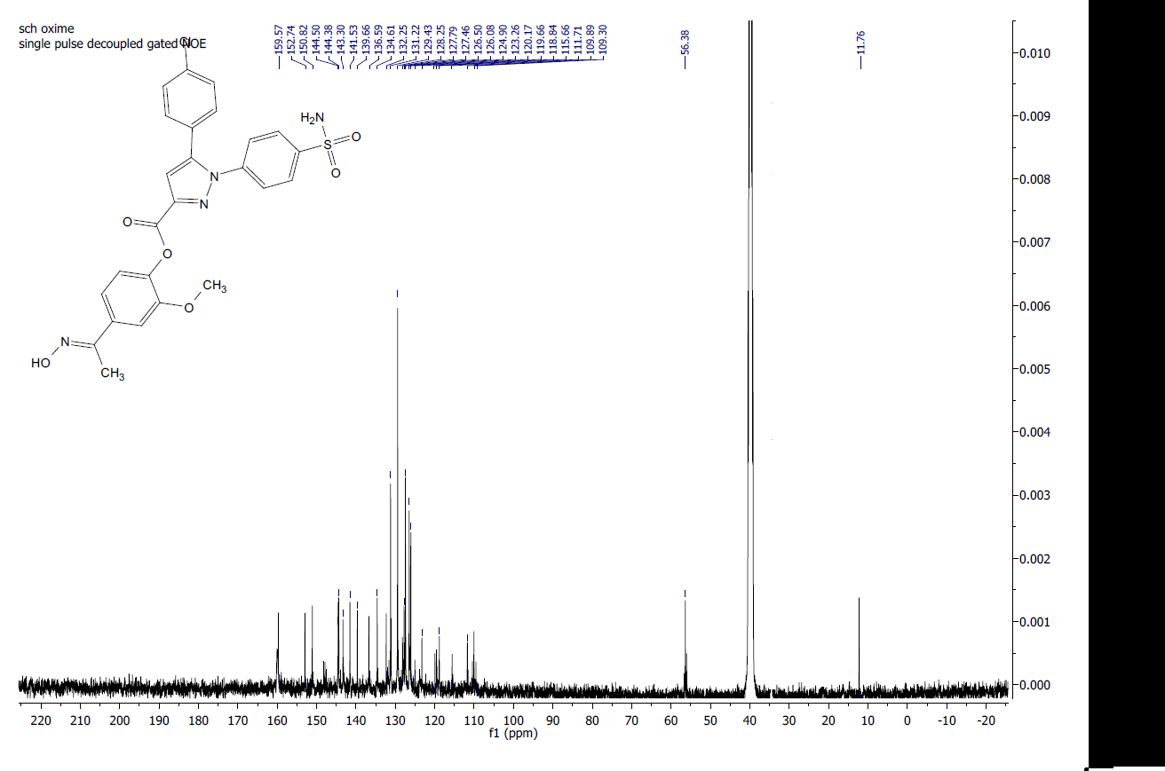

Fig. 62: ¹³C-NMR of Compound 8i in DMSO-d6.

Fig. 63: HRMS of compound 8i.

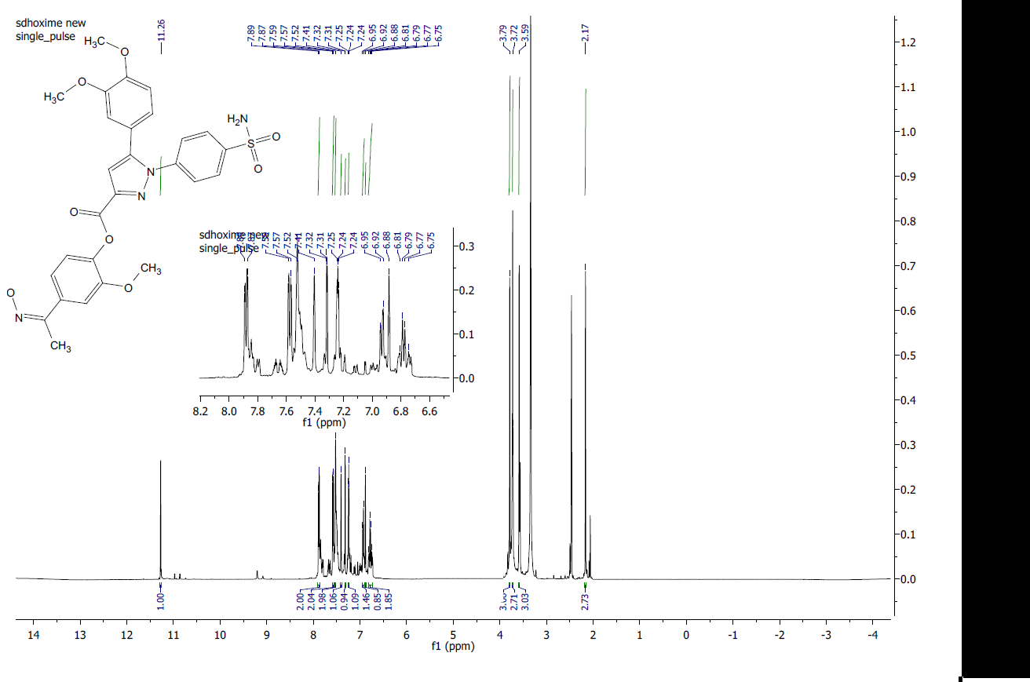
8j

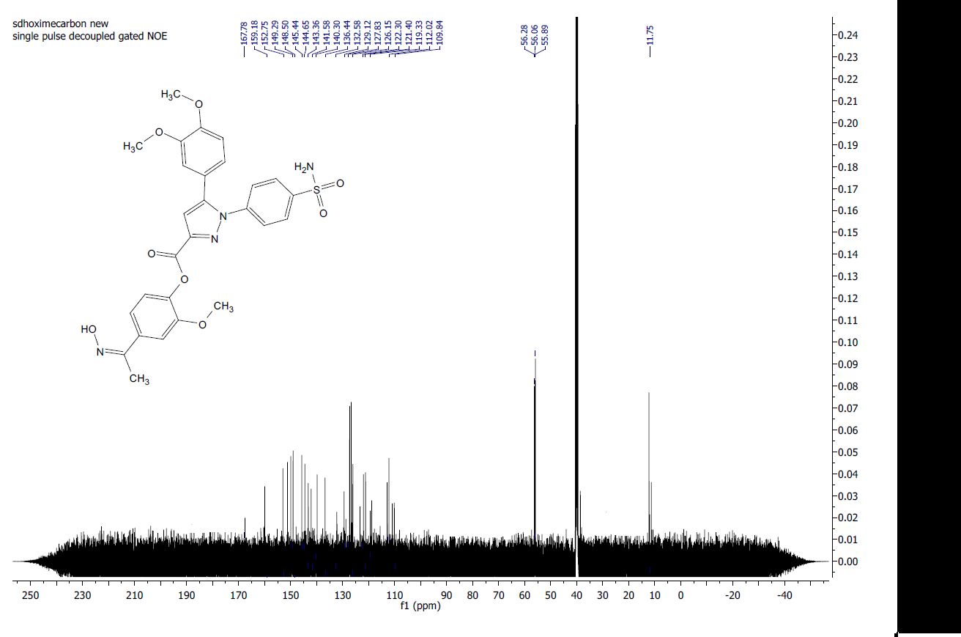
Fig. 64: ¹H-NMR of compound 8j in DMSO-d6.

Fig. 65: ¹³C-NMR of Compound 8j in DMSO-d6.

Fig. 66: HRMS of compound 8j.

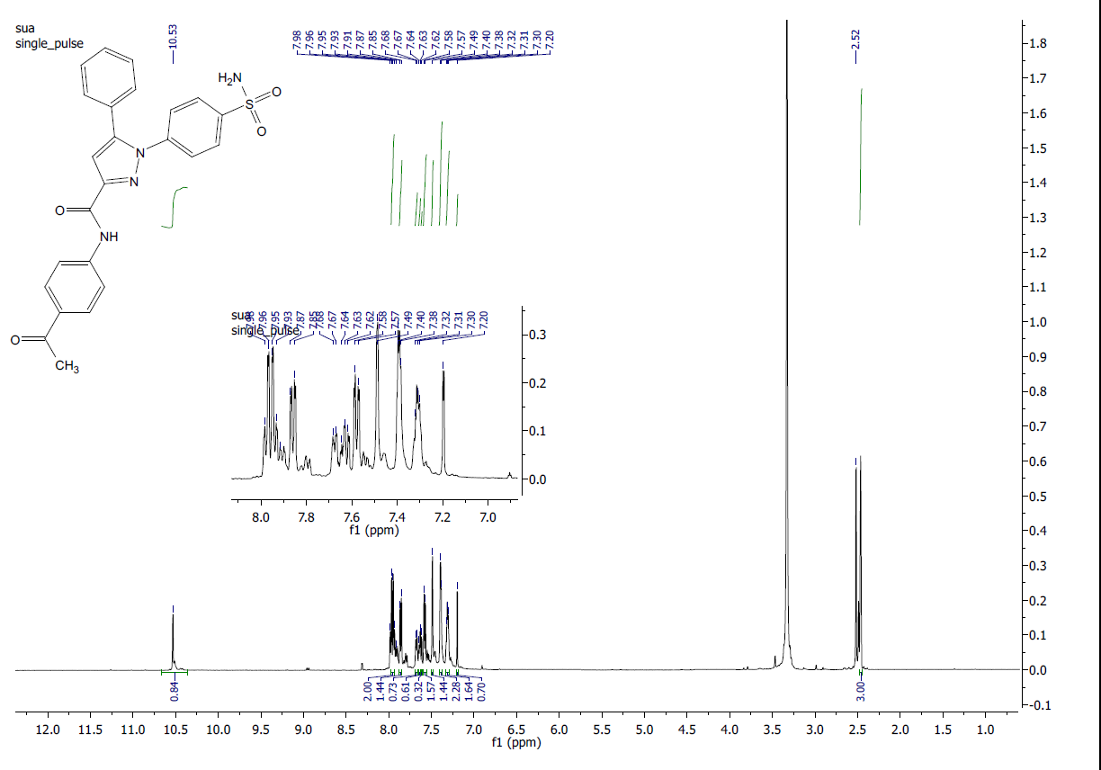
9a

Fig. 67: ¹H-NMR of compound 9a in DMSO-d6.
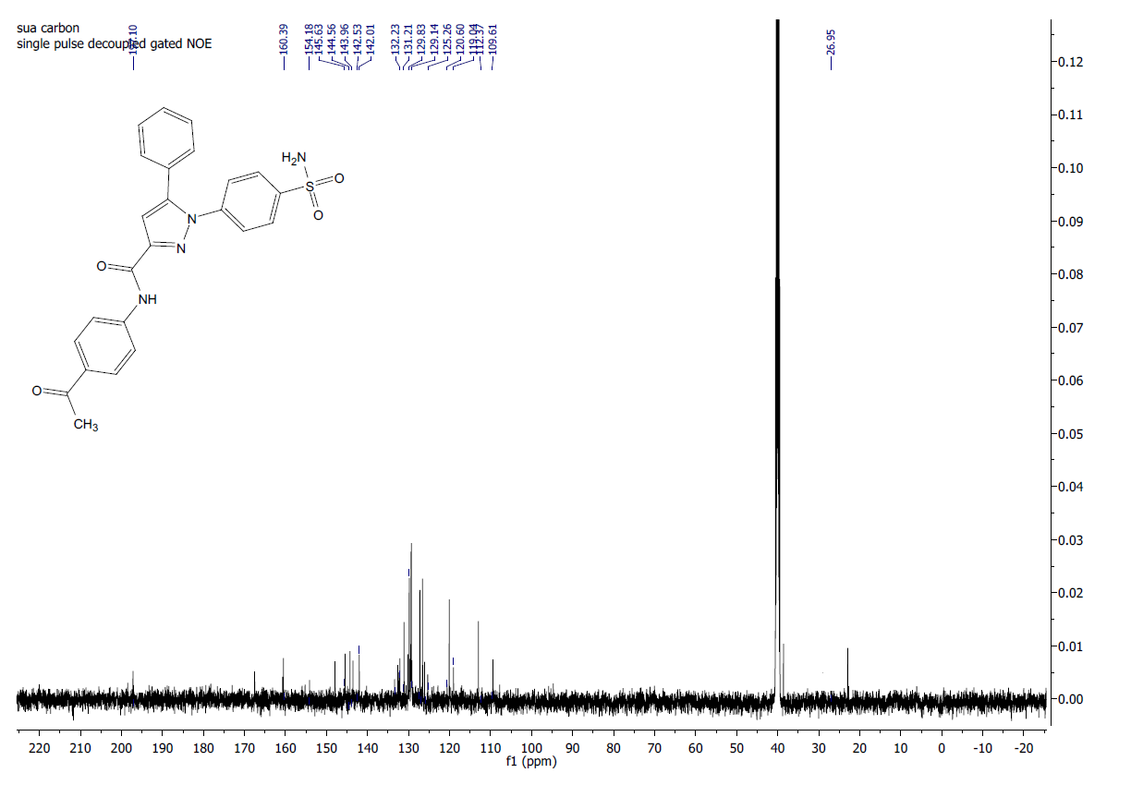

Fig. 68: ¹³C-NMR of Compound 9a in DMSO-d6.
Fig. 69: HRMS of compound 9a.

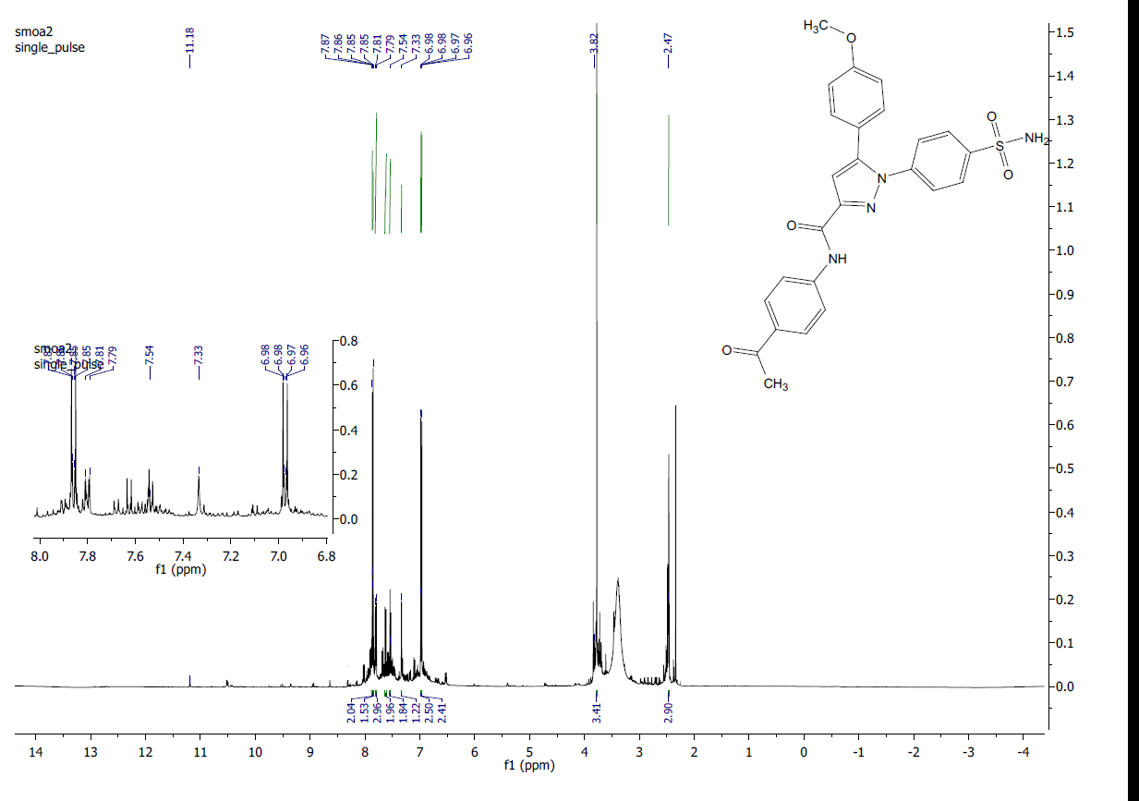
9b
9b

Fig. 70: ¹H-NMR of compound 9b in DMSO-d6.
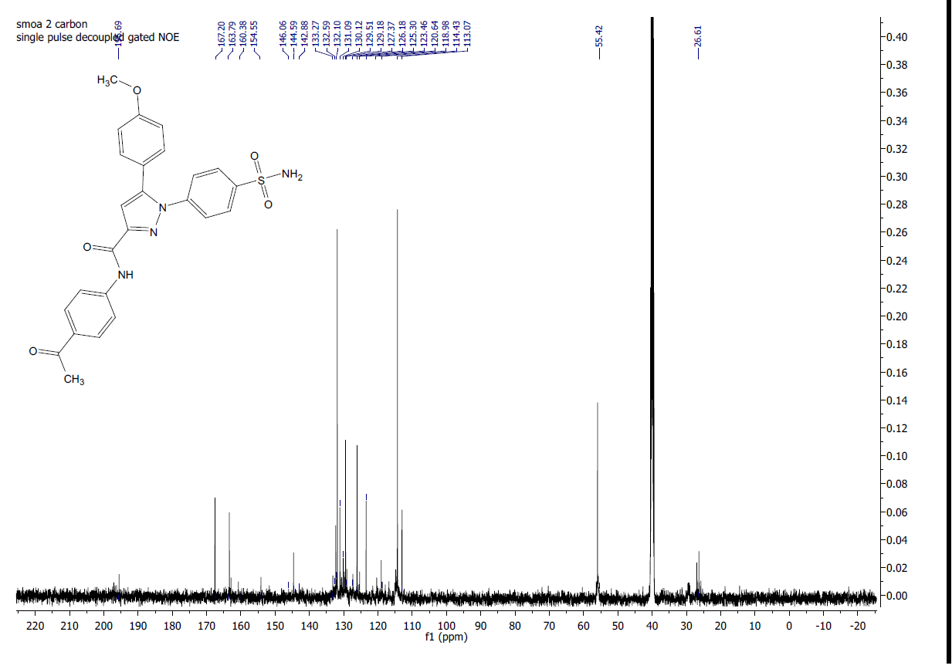

Fig. 71: ¹³C-NMR of Compound 9b in DMSO-d6.

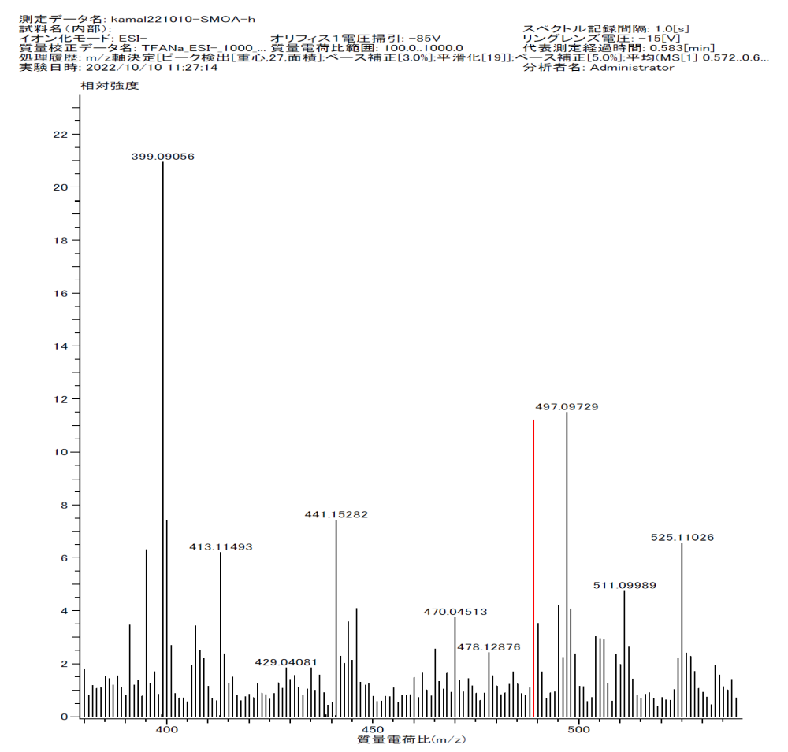

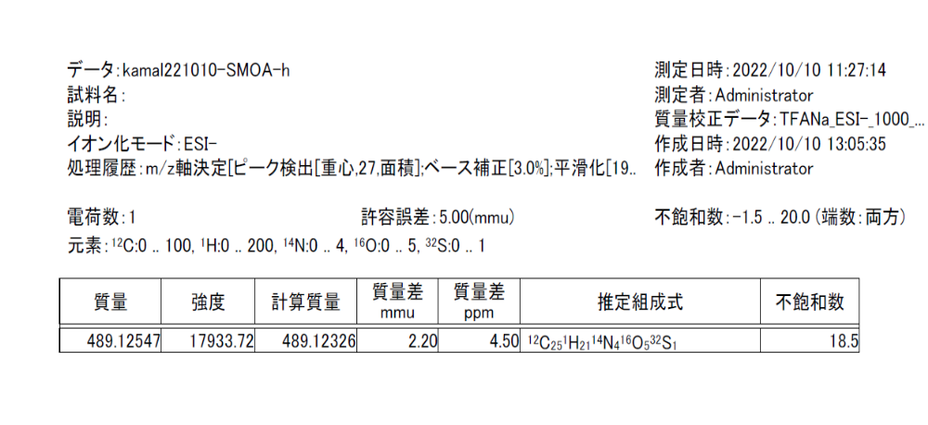
Fig. 72: HRMS of compound 9b.
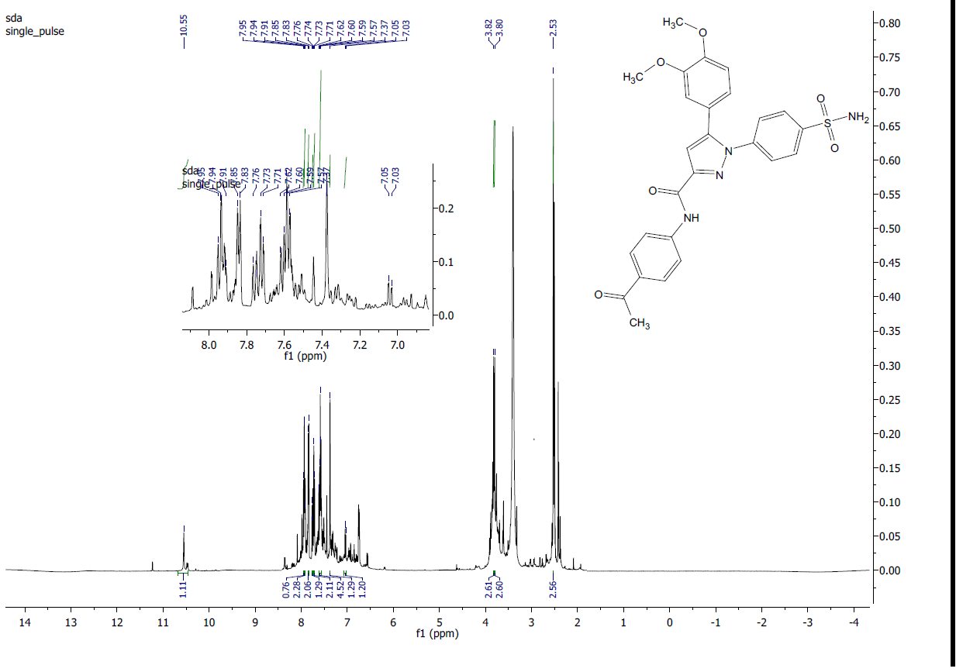
9c

Fig. 73: ¹H-NMR of compound 9c in DMSO-d6.
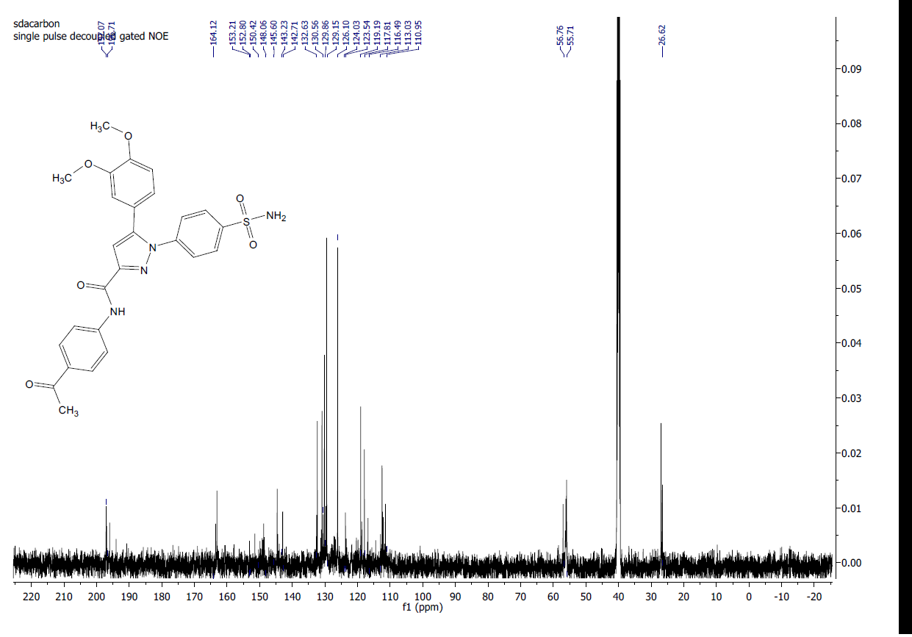

Fig. 74: ¹³C-NMR of Compound 9c in DMSO-d6.

Fig. 75: HRMS of compound 9c.

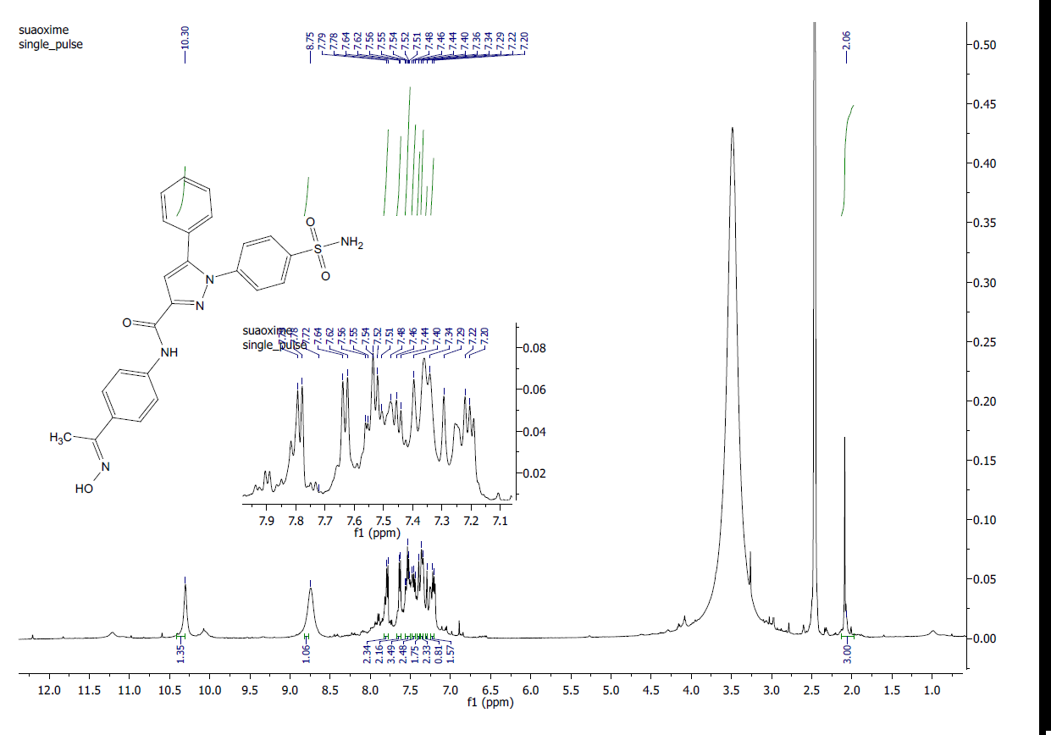
10a

Fig. 76: ¹H-NMR of compound 10a in DMSO-d6.
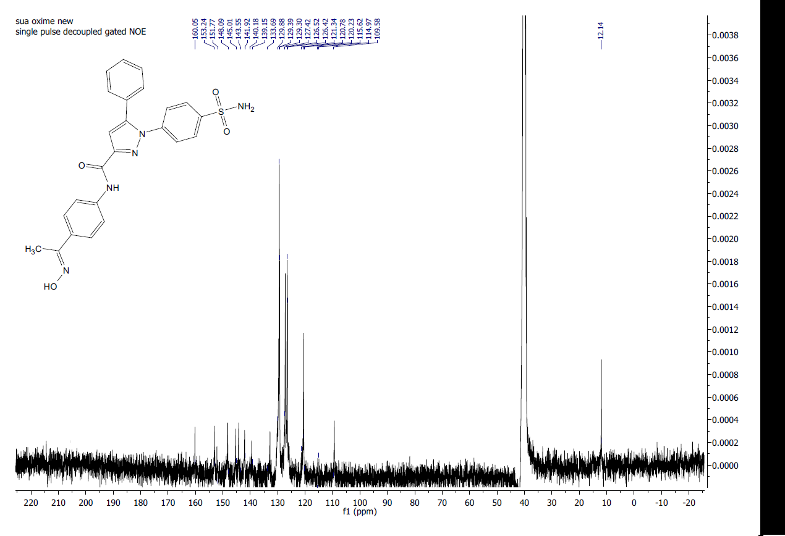

Fig. 77: ¹³C-NMR of Compound 10a in DMSO-d6.

Fig. 78: HRMS of compound 10a.

10b
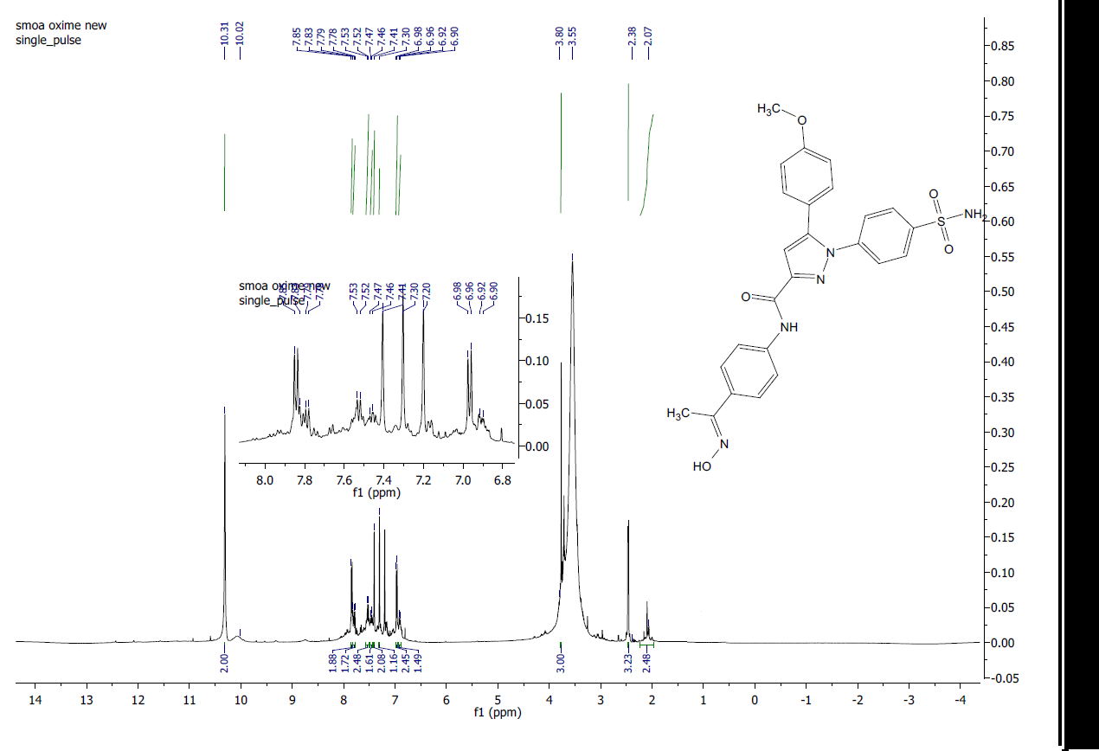

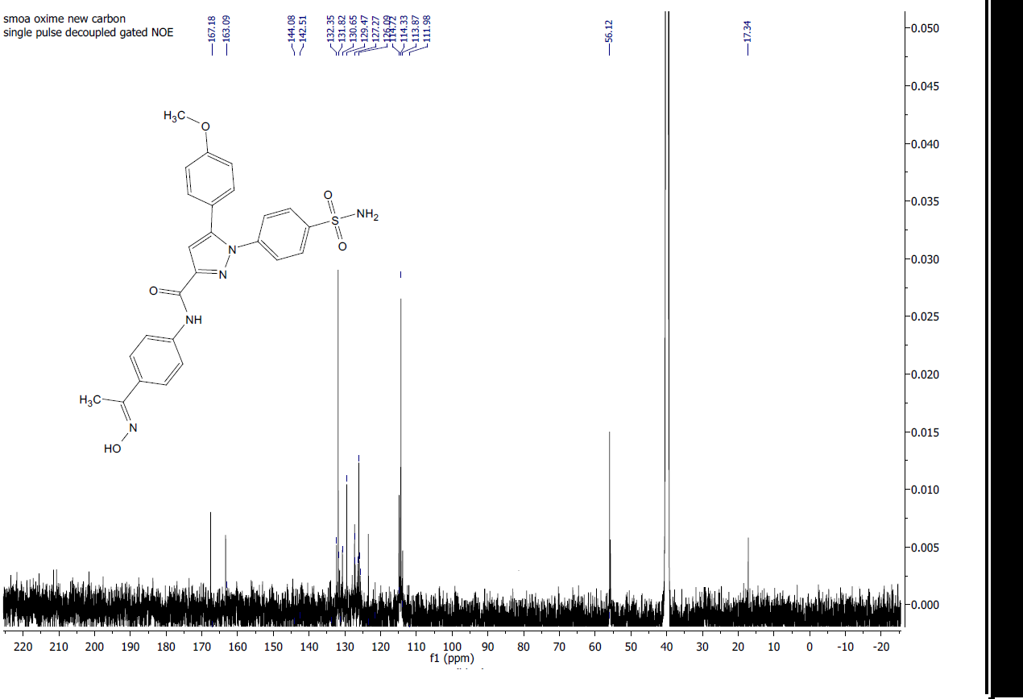
Fig. 79: ¹H-NMR of compound 10b in DMSO-d6.

Fig. 80: ¹³C-NMR of Compound 10b in DMSO-d6.
Fig. 81: HRMS of compound 10b.

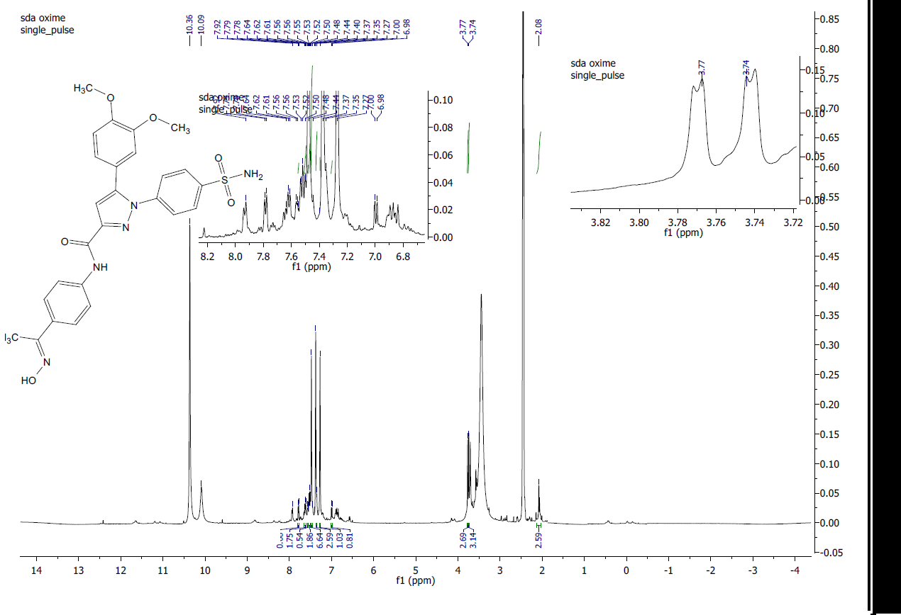
10c

Fig. 82: ¹H-NMR of compound 10c in DMSO-d6
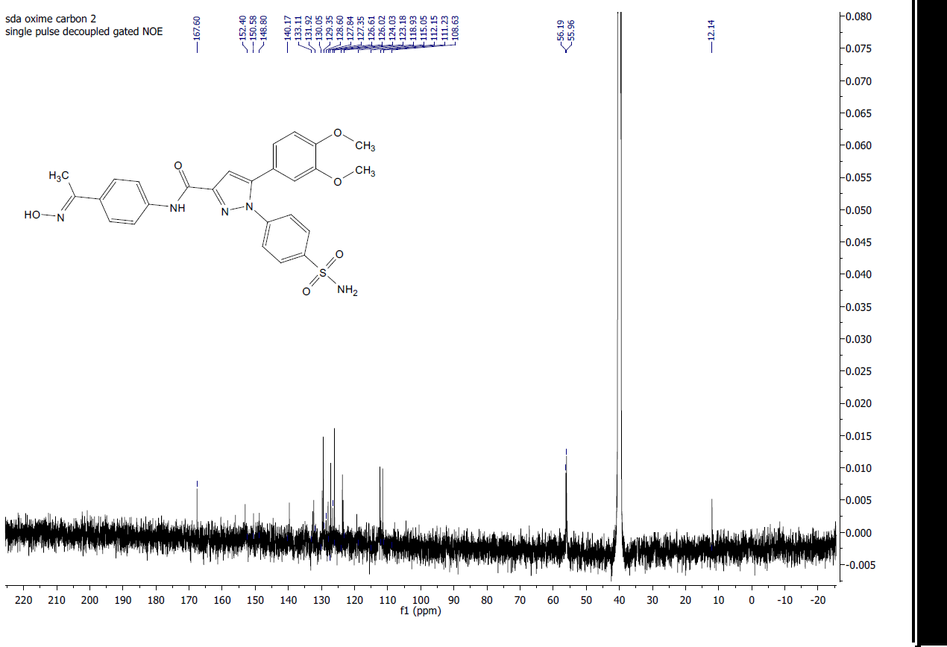

Fig. 83: ¹³C-NMR of Compound 10c in DMSO-d6.
Fig. 84: HRMS of compound 10c.

EGFR Data

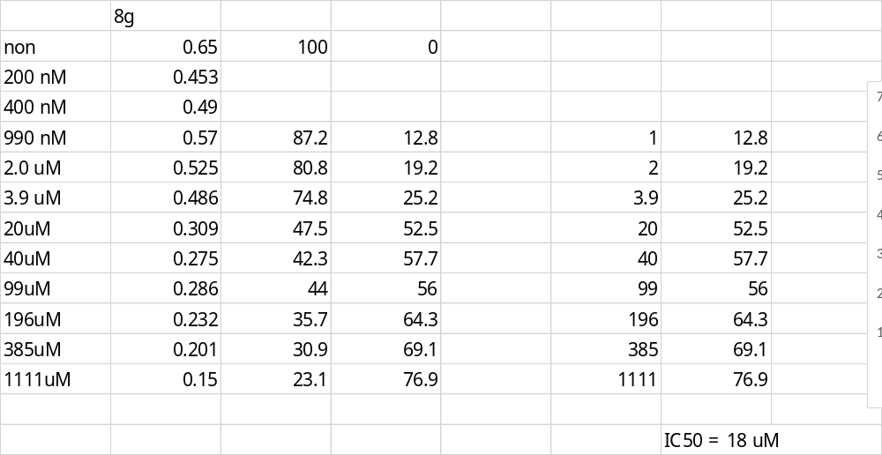

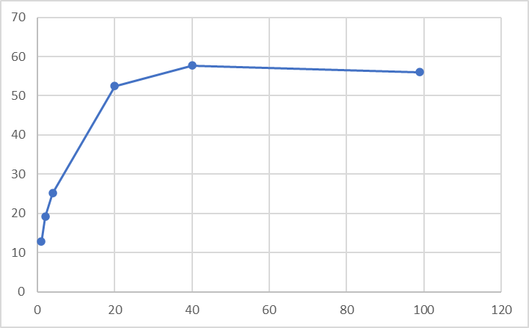

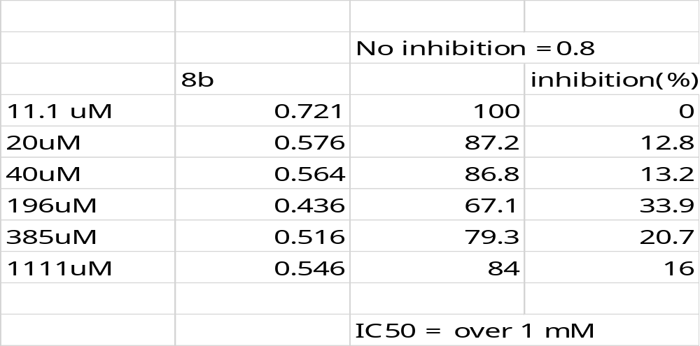
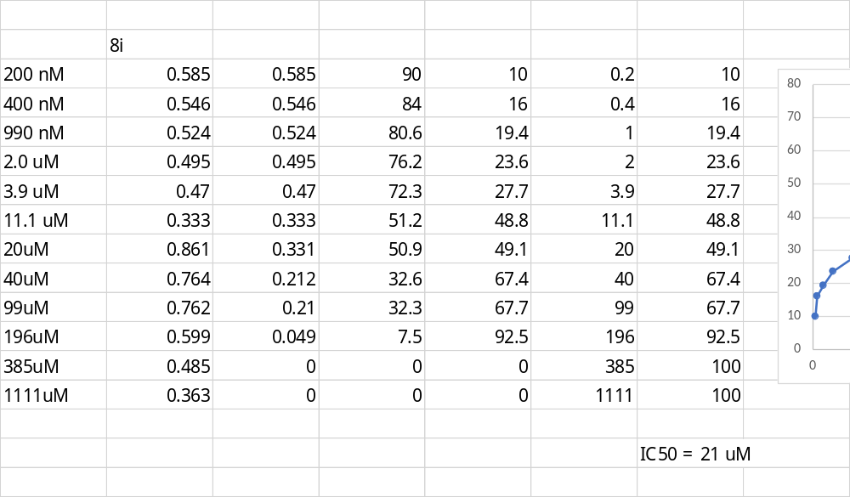
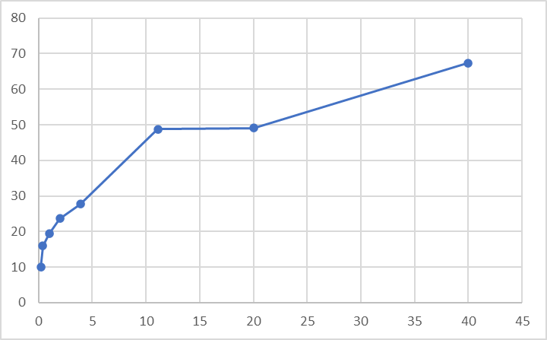

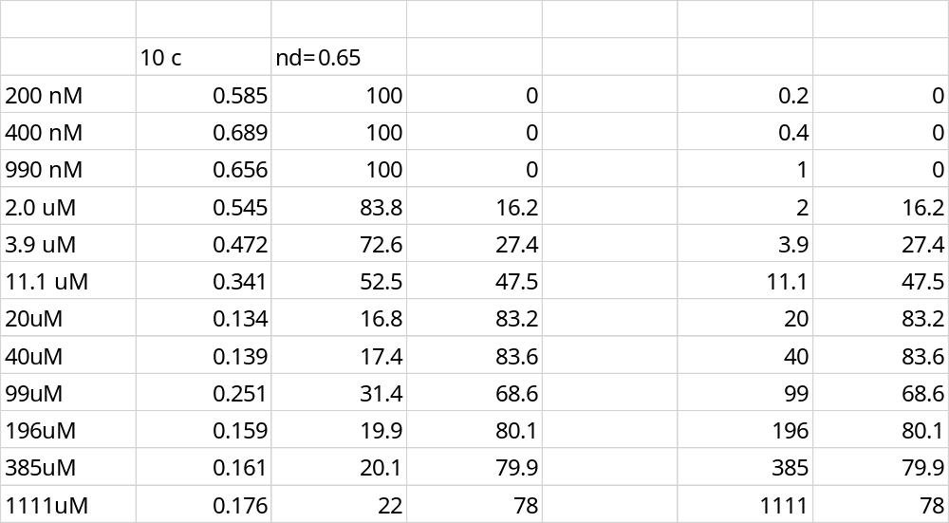

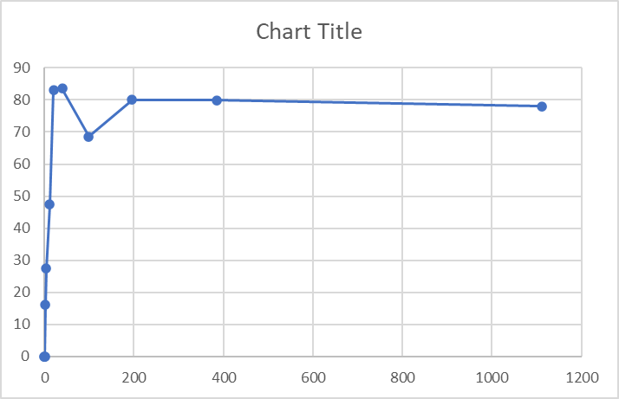

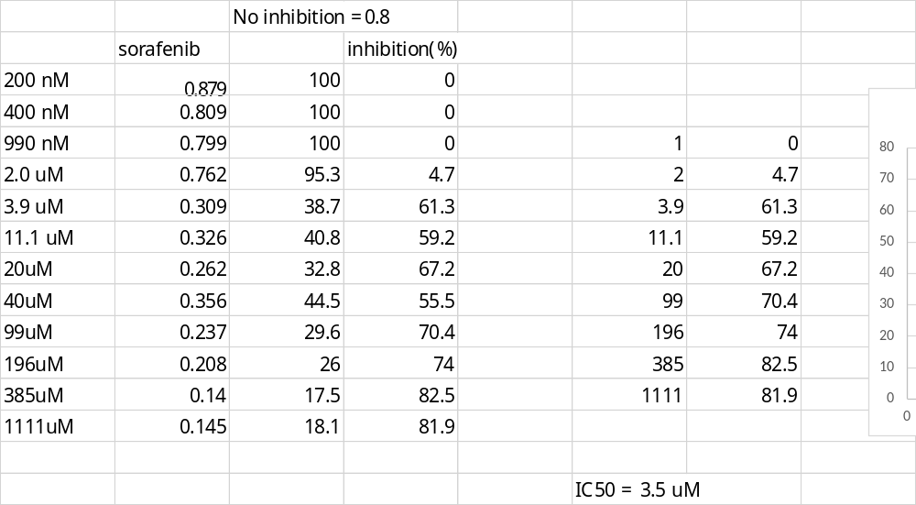

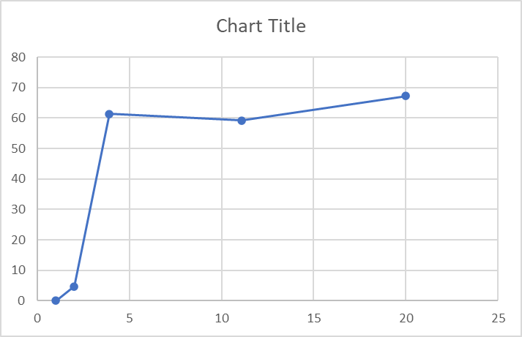

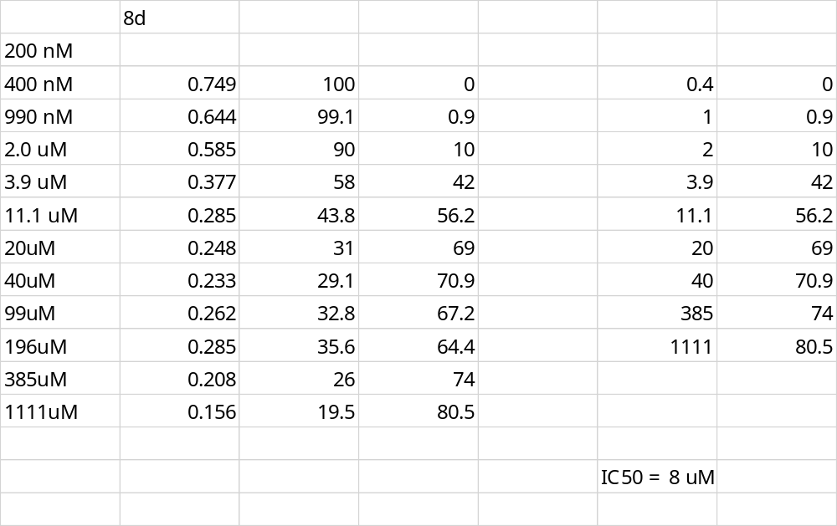

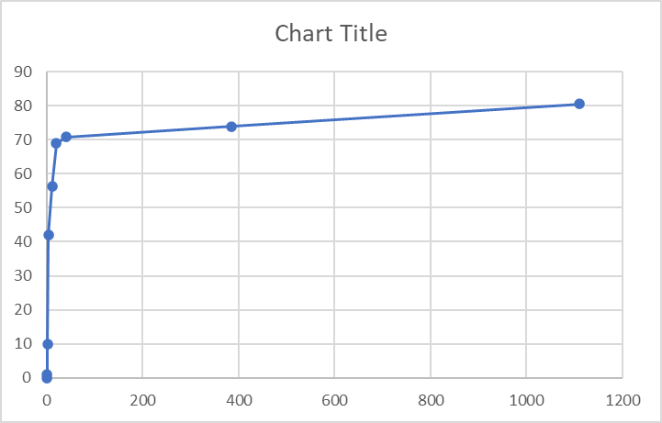

JNK-2 Data

