Supporting Information:
Introducing MR-TADF Emitters into Light-Emitting Electrochemical Cells for Narrowband and Efficient Emission

Shi Tang¹, John Marques dos Santos², Jia Wang ¹, Eli Zysman-Colman²* and Ludvig Edman¹*

¹ The Organic Photonics and Electronics Group, Department of Physics, Umeå University, SE-90187 Umeå, Sweden. E-mail: ludvig.edman@umu.se
² Organic Semiconductor Centre, EaStCHEM School of Chemistry, University of St Andrews, St Andrews, KY16 9ST, UK. E-mail: eli.zysman-colman@st-andrews.ac.uk

Figure S1. The ¹H NMR spectrum (400 MHz, CDCl₃) of DtBuCzB.

Figure S2. The ¹³C NMR spectrum (126 MHz, CDCl₃) of DtBuCzB.

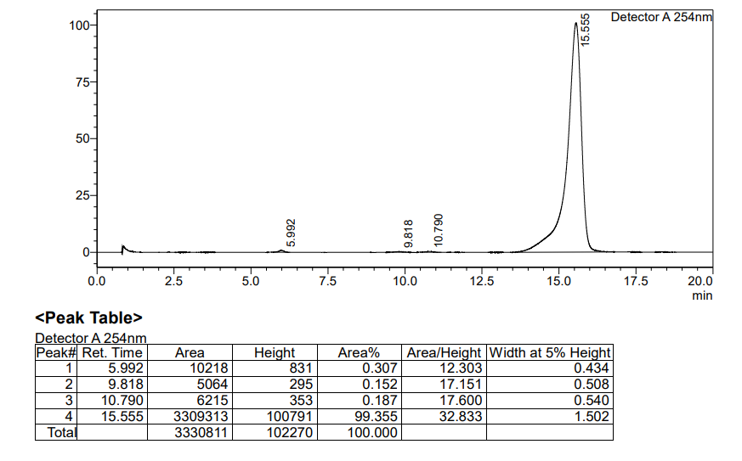
Figure S3. The HPLC trace and tabulated thermal transitions of DtBuCzB.

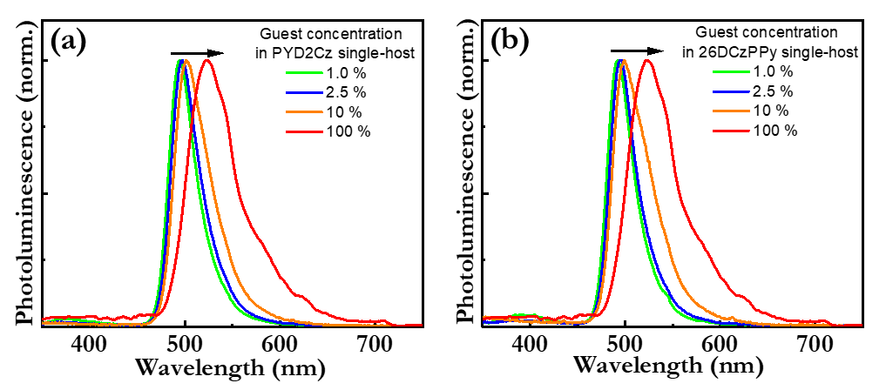
Figure S4. The PL spectrum of the single-host:guest film at different DtBuCzB guest concentration, with the single host being (a) PYD2Cz and (b) 26DCzPPy. The excitation wavelength was 300 nm. The inset identifies the guest concentration, and the arrow indicates increasing guest concentration.

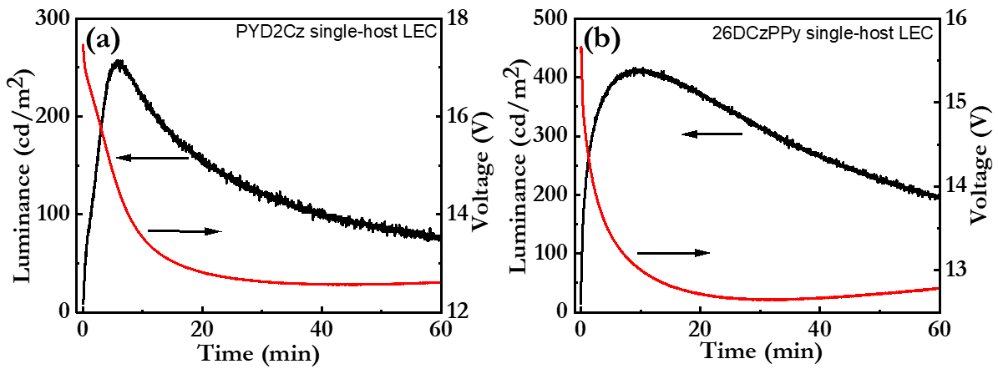
Figure S5. The temporal evolution of the luminance (black line, left y-axis) and the voltage (red line, right y-axis) for the optimized single-host:guest LECs, with the host being (a) PYD2Cz and (b) 26DCzPPy.

