Electronic Supplementary Information

Furan-Dihydroquinazolinone based Fluorescent Nanoprobe for Selective Recognition of 4-nitrophenol: A Spectofluorimetric Approach

Saubai B. Wakshe^{a,1}, Pravin R. Dongare^{a,1}, Anil H. Gore^{b}, Gurunath V. Mote^{c}, Prashant V. Anbhuleª, Govind B. Kolekarª*

ªFluorescence Spectroscopy Research Laboratory, Department of Chemistry, Shivaji University, Kolhapur, 416004, MS, India

^{b}Tarsadia Institute of Chemical Science, Uka Tarsadia University, Bardoli, 394350, Gujarat, India

^{c}D. Y. Patil Agriculture and Technical University, Talsande, Kolhapur, 416112, MS, India

*For Correspondence
Govind B. Kolekar, Fluorescence Spectroscopy Research Laboratory, Department of Chemistry, Shivaji University, Kolhapur, 416004, MS, India
Email: gbkolekar@yahoo.co.in
¹ Saubai B. Wakshe and Pravin R. Dongare equally contributed to this work.

Figure Captions
Fig. S1: ¹H NMR spectrum of FDHQ.
Fig. S2: ¹³C NMR spectrum of FDHQ.
Fig. S3: Zeta potential curve of FDHQNPs.
Table S1: The analytical performance of the various types of fluorophores reported in the literature for 4-nitrophenol detection.

Fig. S1: ¹H NMR spectrum of FDHQ.

Fig. S2: ¹³C NMR spectrum of FDHQ.

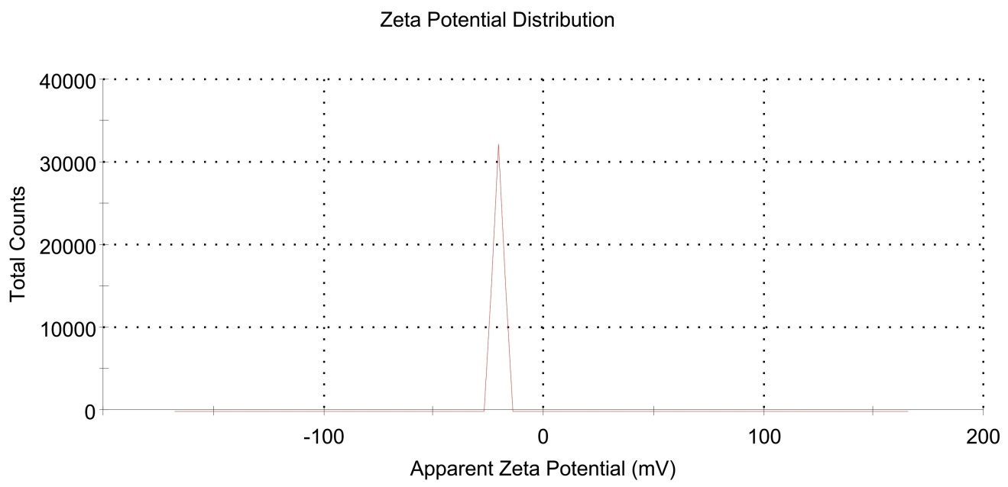
Fig. S3: Zeta potential curve of FDHQNPs.

Table S1: The analytical performance of the various types of fluorophores reported in the literature for 4-nitrophenol detection.
Sr. No. | Probe used for the detection | Linear Range | Detection limit | Real Sample | Ref. No.
1 | N-GQDs | 0-20 μM | 0.29 μM | Water sample | 1
2 | FL-MIPIL | 0.001-7.5 μM | 0.5 nM | Lake, rain and waste water, urine samples | 2
3 | C-dot | 0.1-50 μM | 0.028 μM | Spiked river and sea water | 3
4 | GNCs@BSA | 50-5000 nM | 0.013 μM | Tap and river water | 4
5 | MF-MIPs | 0.08-10 μM | 0.023 μM | Food samples | 5
6 | FDHQNPs | 0-36 μg.mL⁻¹ | 0.016 μM | River and Industrial waste water | This work

References
- F. Wang, X. Fu, X. Chai, Q. Han, H. Wang, Q. Hao, Microchem. J., 168, (2021), 106389.
- H. Dai, Z. Deng, Y. Zeng, J. Zhang, Y. Yang, Q. Ma, W. Hu, L. Guo, L. Li, S. Wan, H. Liu, J. Hazard. Mater., 398, (2020), 122854.
- G. H. G. Ahmed, R. B. Laíño, J. A. G. Calzón, M. E. D. García, Microchim. Acta., 182, (2015), 51.
- T. Shu, J. Wang, X. Lin, Z. Zhou, F. Liang, L. Su, X. Zhang, J. Mater. Chem. C., 6, (2018), 5033.
- W. Zhu, Y. Zhou, S. Liu, M. Luo, J. Du, J. Fan, H. Xiong, H. Peng, Food Chem., 348, (2021), 129126.

