Supplementary Information

Enabling giant thermopower by heterostructure engineering of hydrated vanadium pentoxide for zinc ion thermoelectrochemical cells

Zhiwei Li, Yinghong Xu, Langyuan Wu, Jiaxin Cui, Hui Dou, Xiaogang Zhang*

Jiangsu Key Laboratory of Electrochemical Energy Storage Technologies, College of Material Science and Technology, Nanjing University of Aeronautics and Astronautics, Nanjing 211106, China

∗Correspondence to X. Z. (azhangxg@nuaa.edu.cn)

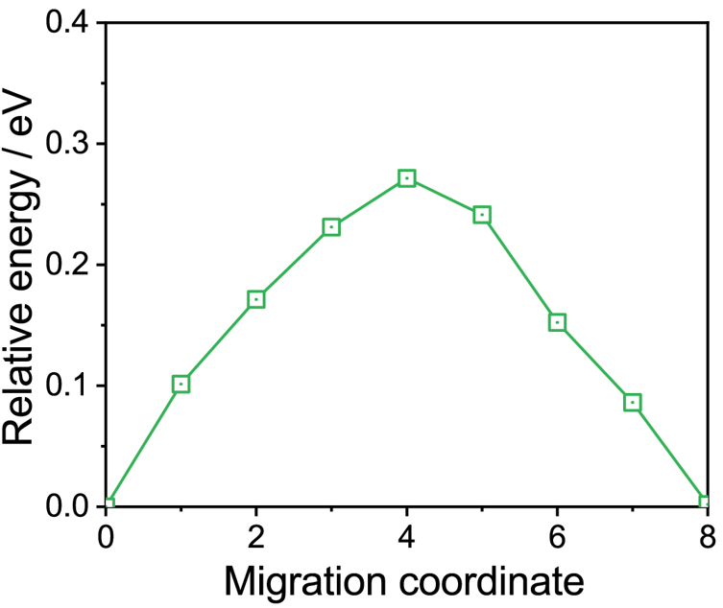
Supplementary Fig. 1 Energy barrier for ions diffusion in V₂O₅@rGO.

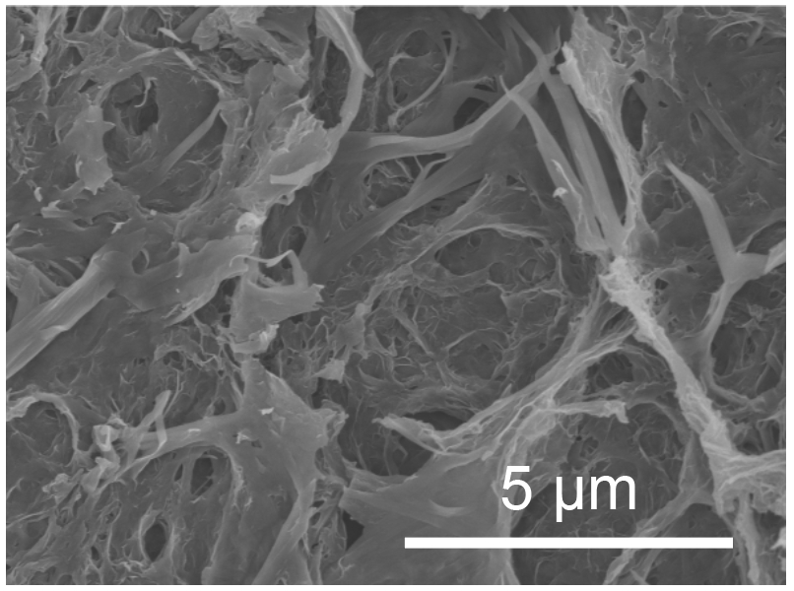
Supplementary Fig. 2 FESEM image of V₂O₅@rGO-1.5.

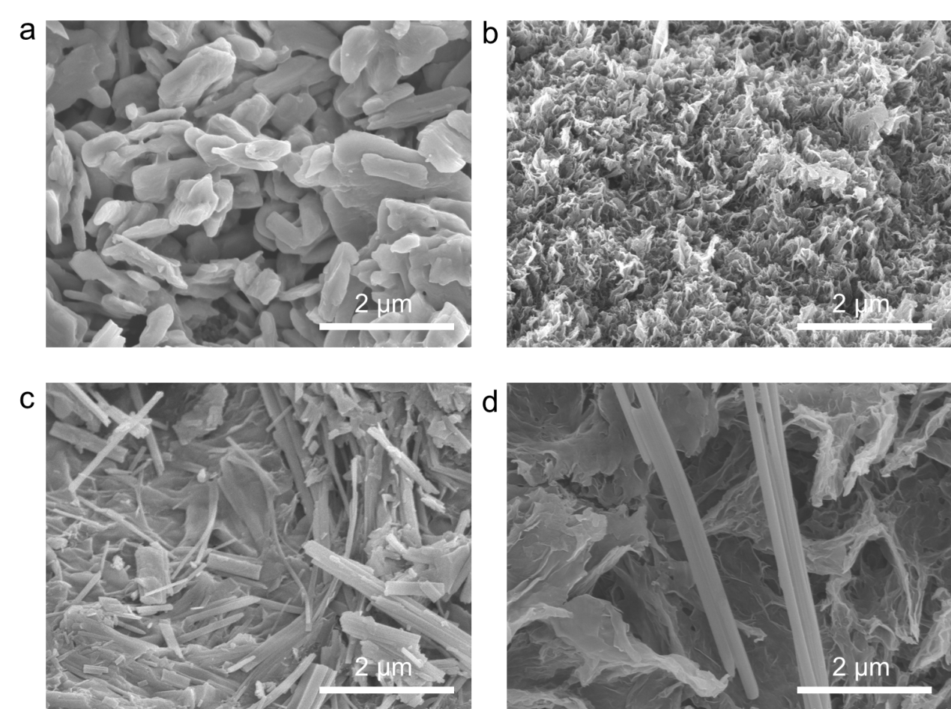
Supplementary Fig. 3 FESEM images of a V₂O₅, b rGO, c V₂O₅@rGO-1.0, and d V₂O₅@rGO-2.0.

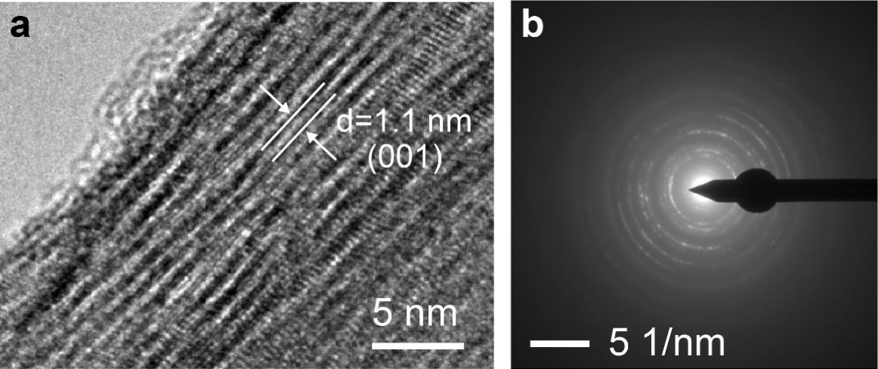
Supplementary Fig. 4 a HRTEM image and SAED pattern of V₂O₅@rGO-1.5.

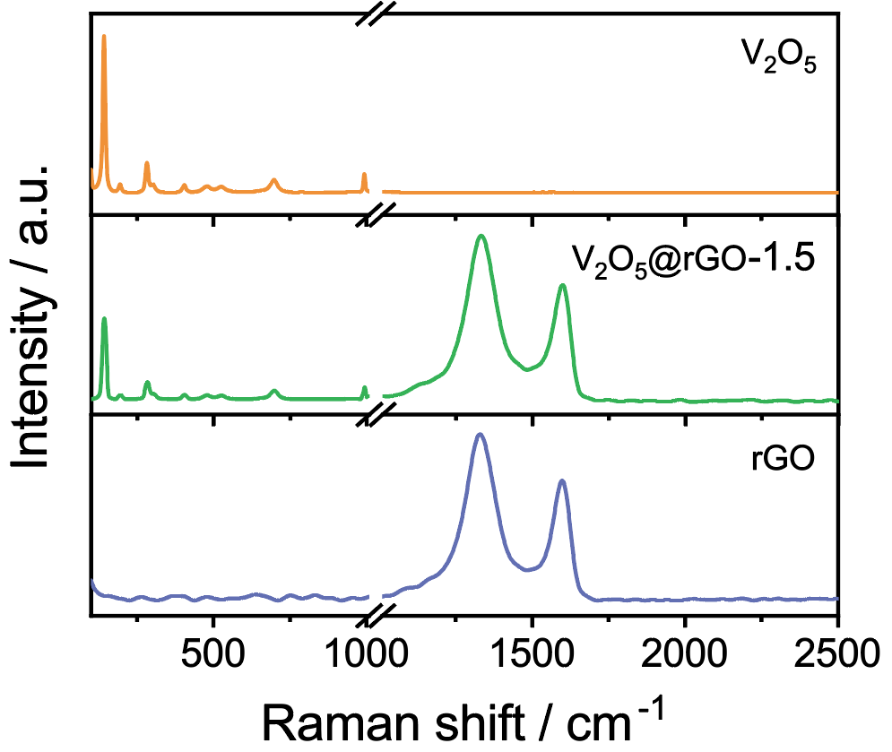
Supplementary Fig. 5 Raman spectra of V₂O₅, rGO, and V₂O₅@rGO-1.5.

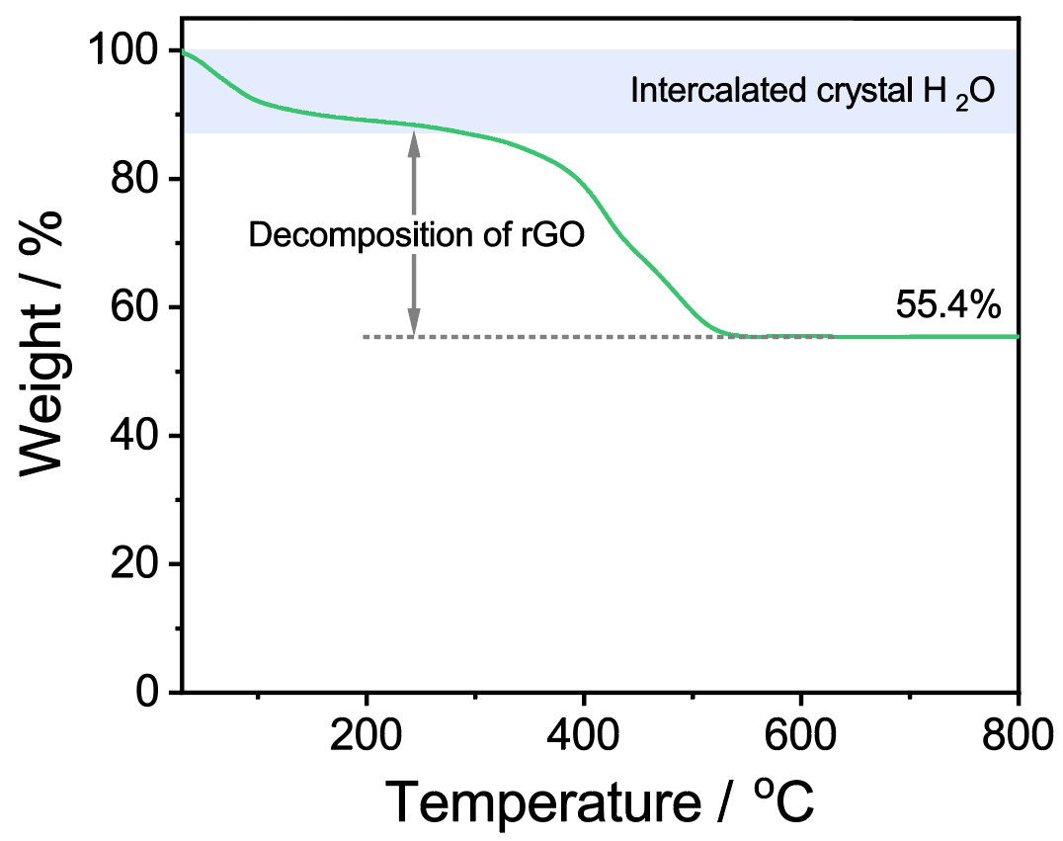
Supplementary Fig. 6 TGA curve of V₂O₅@rGO-1.5.

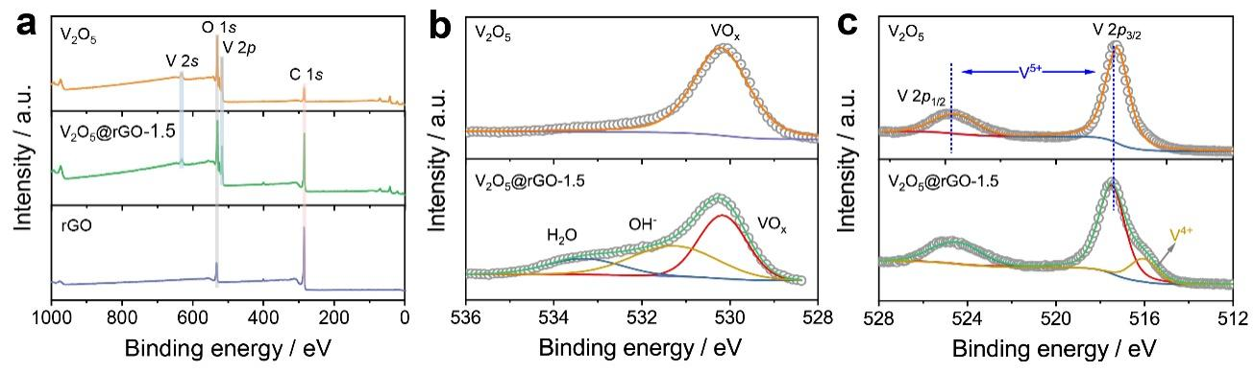
Supplementary Fig. 7 a XPS survey of V₂O₅, rGO, and V₂O₅@rGO-1.5. High-resolution XPS spectra of b O 1s and c V 2p for V₂O₅ and V₂O₅@rGO-1.5.

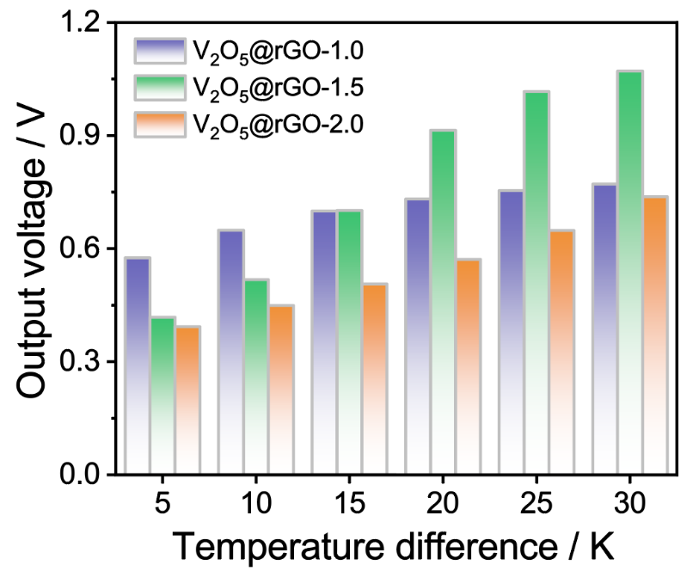
Supplementary Fig. 8 Output voltage under various temperature differences for V₂O₅@rGO-x.

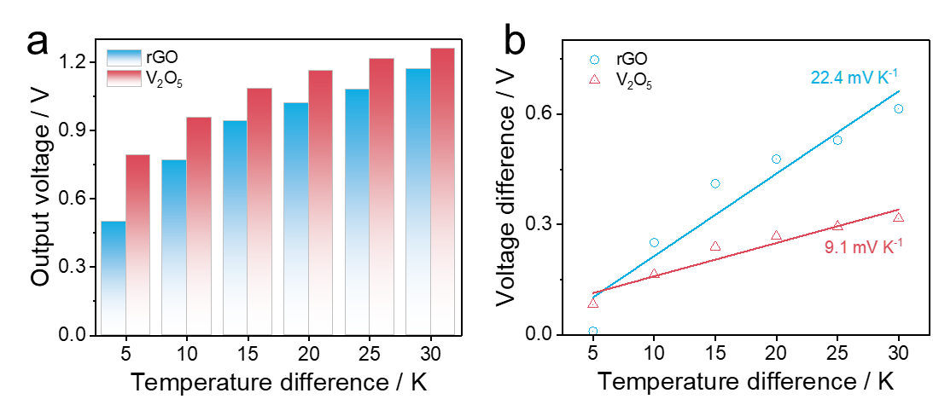
Supplementary Fig. 9 (a) Output voltage under various temperature differences, and (b) Seebeck coefficient for V₂O₅ and rGO.

Supplementary Fig. 10 Self-charging curves of various systems.

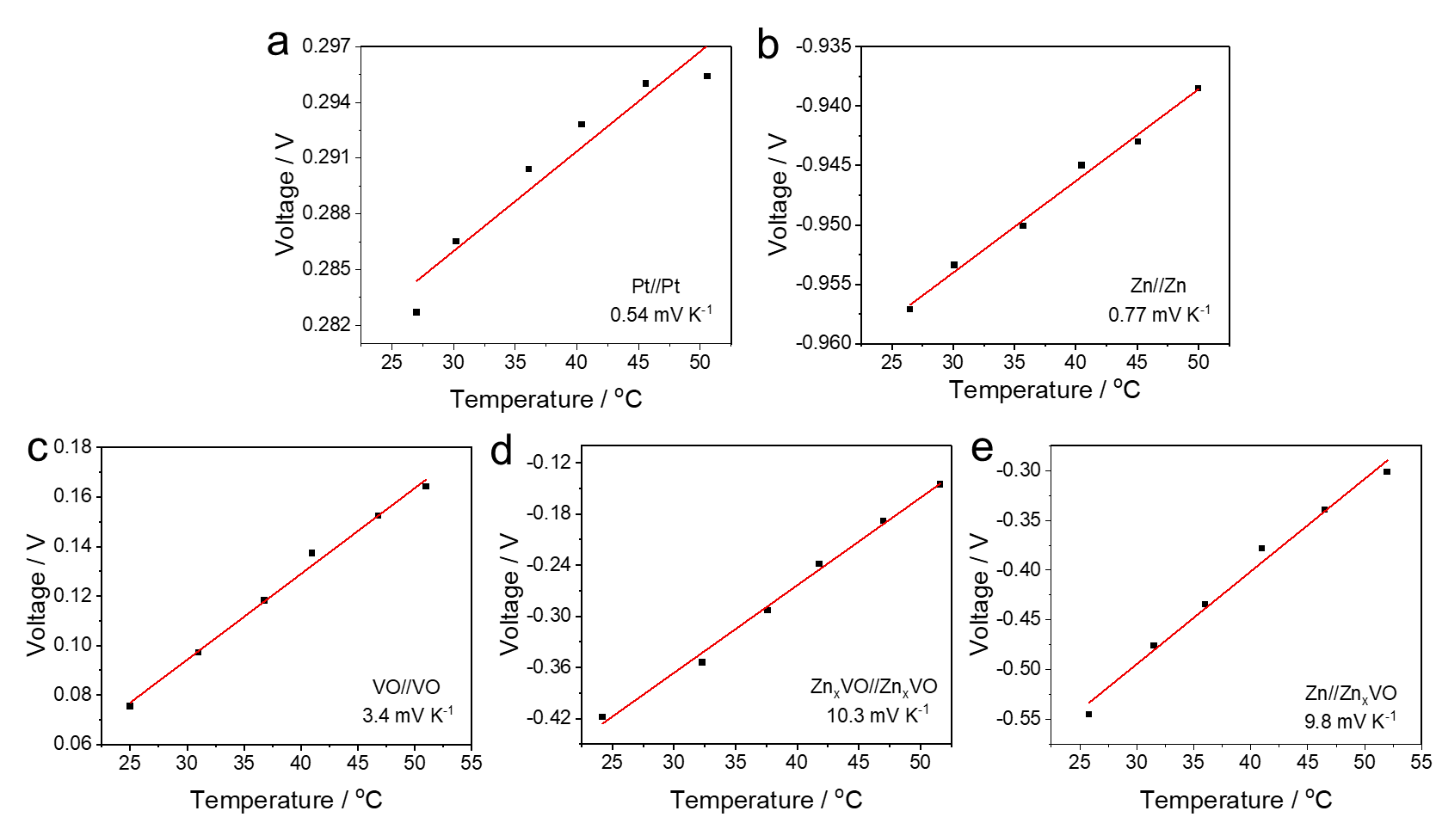
Supplementary Fig. 11 Temperature dependence of the open-circuit voltage for various systems.

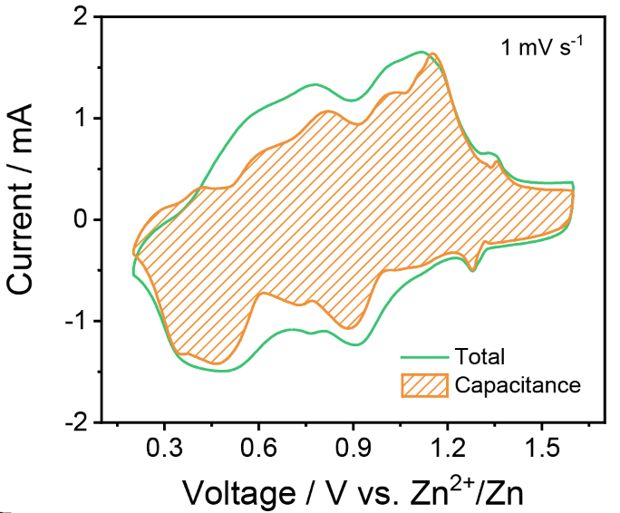
Supplementary Fig. 12 CV curve with capacitance dominating contribution at 1.0 mV s⁻¹ of V₂O₅@rGO-1.5.

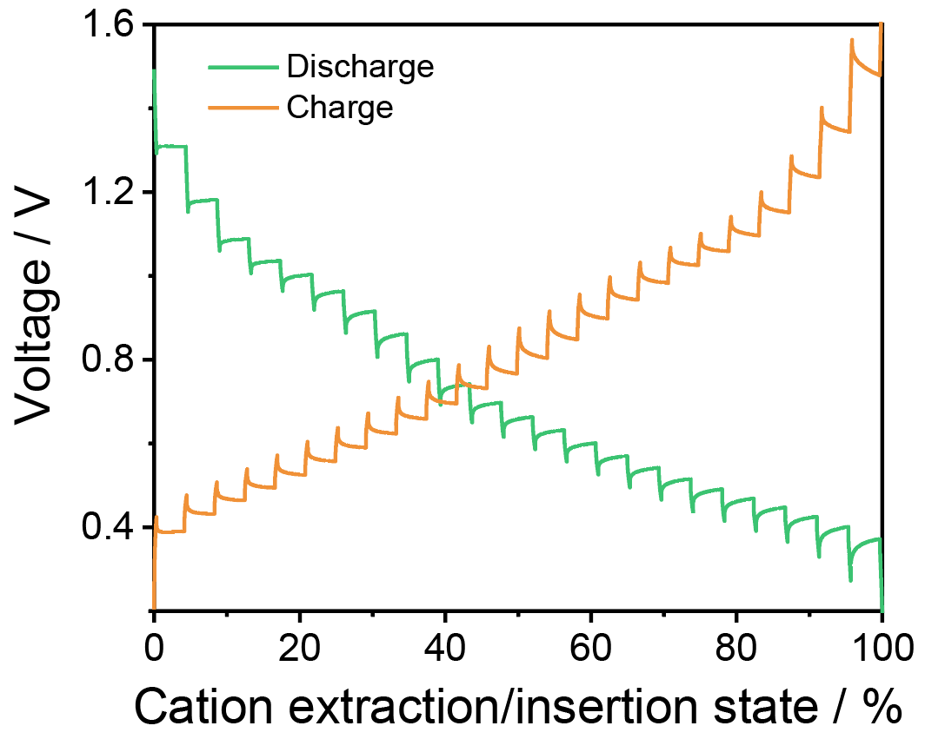
Supplementary Fig. 13 GITT curves of V₂O₅@rGO-1.5.

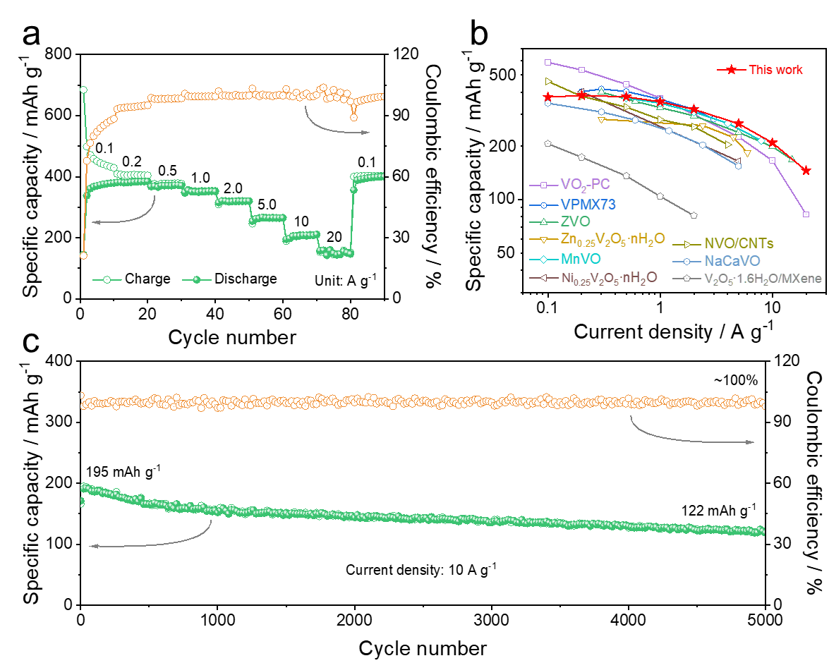
Supplementary Fig. 14 a Rate capability of V₂O₅@rGO-1.5 based ZIB. b Performances comparation with other reported results. c Cyclic stability under 10 A g⁻¹.

Supplementary Table 1. Thermoelectrochemical performances comparison of V₂O₅@rGO-1.5 based solid-state ZTEC with other systems.
System | ΔTª | |S|^{b} | P_{max}/(A×ΔT²)^{c} | Ref.
Zn-G//V₂O₅@rGO-1.5 | 7.5 | 11.1 | 2.7 | This work
PAAm based TC | 10 | ~3 | 0.66 | Adv. Energy Mater. 12, 2201542 (2022)
UGdmCl based TGC | 10 | 4.2 | 1.1 | Nat. Commun. 9, 5146 (2018)
3D Au/Cu based i-TE | 10 | 17 | 0.16 | Adv. Energy Mater. 12, 2103666 (2022)
Au/Cu based i-TE | ~10 | 12.7 | 0.66 | Science 368, 1091-1098 (2020)
i-PVA based TC | 40 | - | 0.22 | ACS Nano 16, 8347-8357 (2022)
BST/FeCN^{3-/4-} based TC | 30.7 | 4.11 | 0.96 | Nano Energy 103, 107826 (2022)
BC-based TEC | 10 | ~4.5 | 0.024 | Chem. Eng. J. 433, 134550 (2022)
ª Temperature difference (K).
^{b} Seebeck coefficient (mV K⁻¹).
^{c} Normalized power density (mW m⁻² K⁻²).

