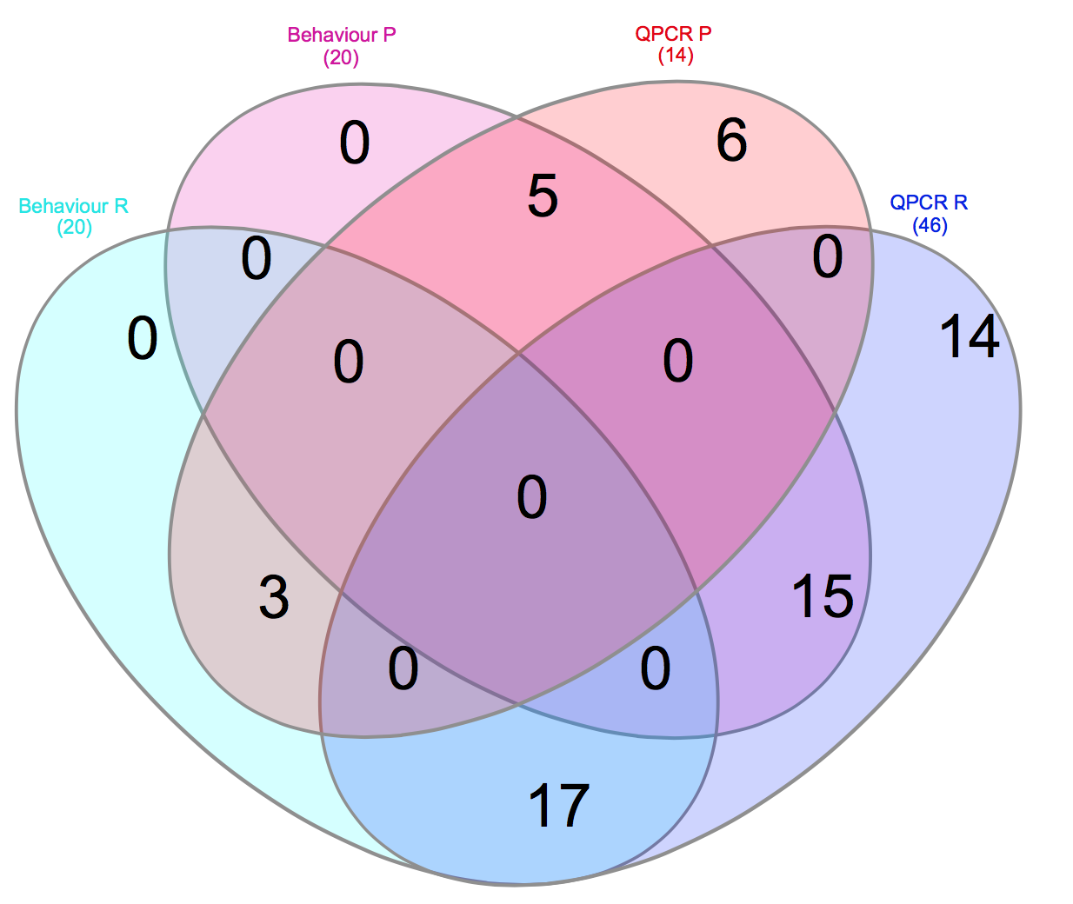
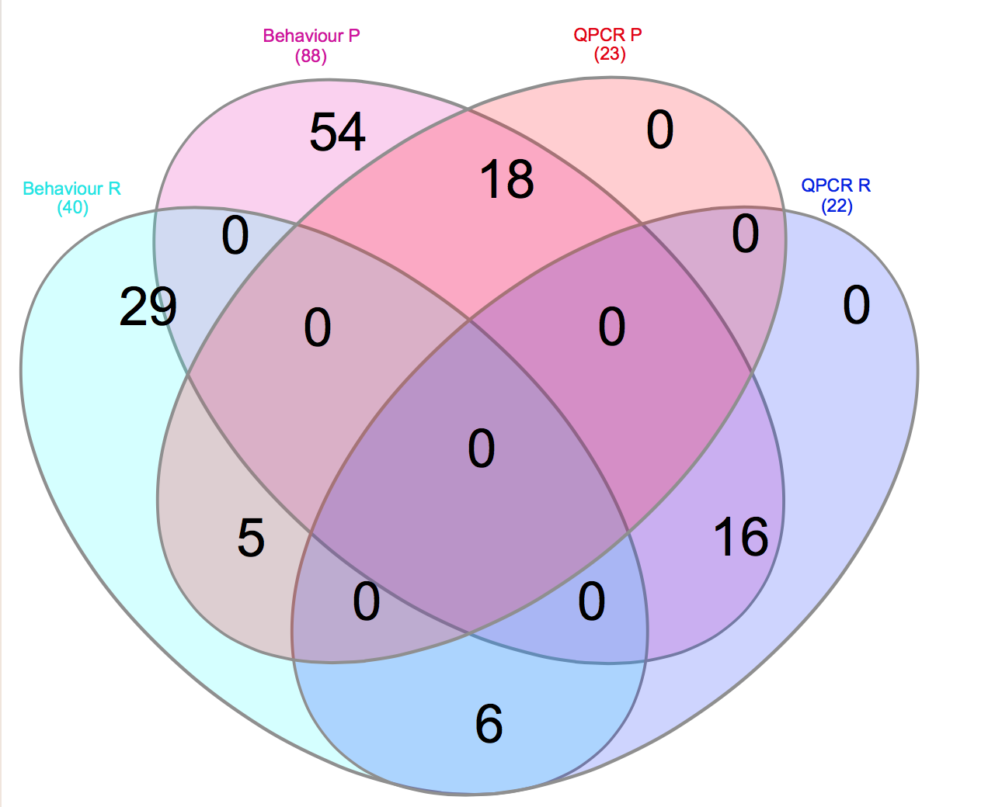
b)
a)

Supporting_Figure1. Individual personality identification by both behavior test and QPCR assay. Unique individual running number were used to identified proactive animals with both behavior boldness and behavior gene markers positive. a) S.salar proactive individuals N=18; b) D.labrax proactive individuals N= 5.

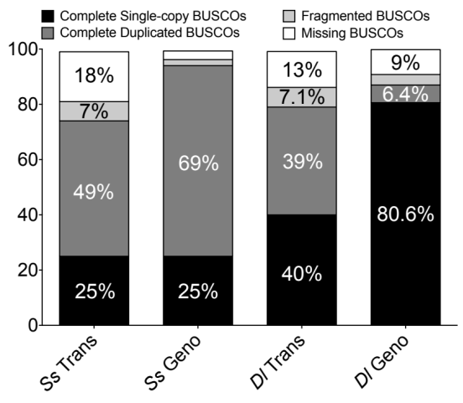
Supporting_Figure2. Completeness estimation of Trinity assemblies of Illumina RNA-Seq by BUSCO. Abbreviation: Ss: S.salar; Dl: D.labrax; Trans: transcriptome; Geno: Genome.

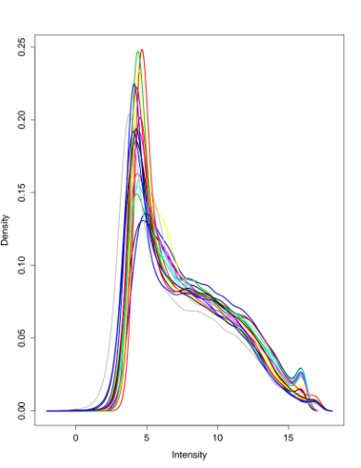
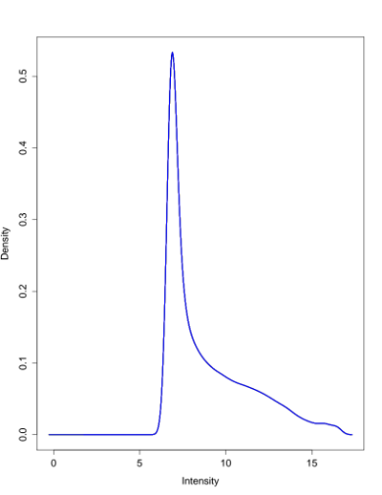
a-ii)
a-i)

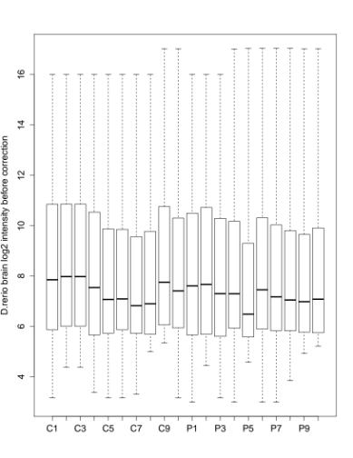
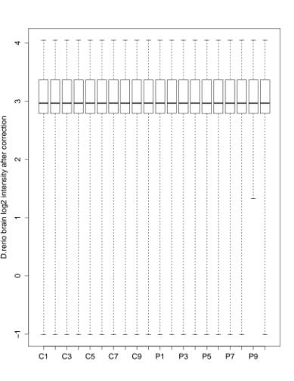
b-ii)
b-i)

Supporting_Figure3. Between-microarrays normalization of D.rerio brain transcriptome. a) Distribution densities of probe intensities were compared before- (a-i) and after (a-ii) normalization; b) Log2-transformed intensities of each microarray were shown before before- (b-i) and after (b-ii) normalization.

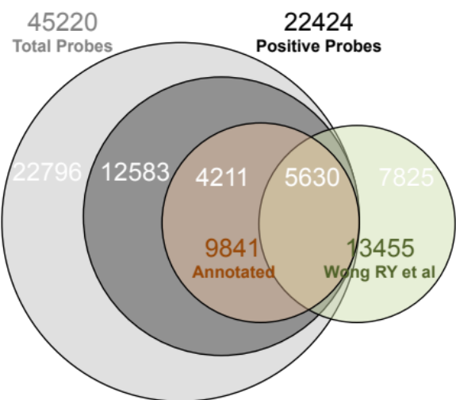
Supporting_Figure4. Transcriptomic gene list of D.rerio brain with annotations. The numbers of annotated genes obtained by Microarray approach (Rey, Boltana et al. 2013) were shown in orange; while the ones obtained by Illumina RNA-Seq (Wong, McLeod et al. 2014) were shown in Dark Green.

References

Rey, S., S. Boltana, R. Vargas, N. Roher and S. MacKenzie (2013). "Combining animal personalities with transcriptomics resolves individual variation within a wild-type zebrafish population and identifies underpinning molecular differences in brain function." Molecular Ecology 22(24): 6100-6115.
Wong, R. Y., M. M. McLeod and J. Godwin (2014). "Limited sex-biased neural gene expression patterns across strains in Zebrafish (Danio rerio)." BMC Genomics 15(1): 1-9.

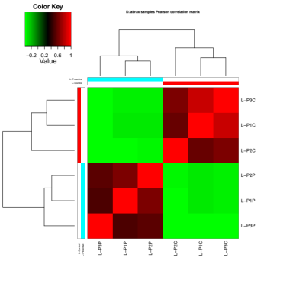
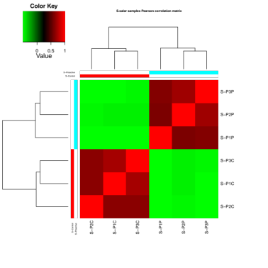
b
a

Supporting_Figure 5. Spearman Correlation estimation of DEGs within each species sequenced by Illumina platform.
Heat map showing the hierarchically clustered Spearman correlation matrix resulting from comparing the transcript expression values (TMM-normalized FPKM) for each pair of samples from both species: i.e. a) S.salar; b) D.labrax.

