Supplementary Material
Discovery and evaluation of active compounds from Xuanfei Baidu formula against COVID-19 via SARS-Cov-2 M^{pro}
Min Zhang^{1,4,5, †}, Liting Liu^{1, †}, Yao Zhao⁶, Yipeng Cao⁷, Yan Zhu⁶, Lifeng Han^{1,3,5}, Qi Yang⁸, Yu Wang^{1,4}, Ruoyu Dang⁹, Changjian Wang¹, Han Zhang^{1,4,5, *}, Yuefei Wang^{1,3,5, *}, Junhua Zhang^{1,2,5, *}
¹ State Key Laboratory of Component-Based Chinese Medicine, Tianjin University of Traditional Chinese Medicine, Tianjin 301617, China
² Evidence-Based Medicine Center, Tianjin University of Traditional Chinese Medicine, Tianjin 301617, China
³ Tianjin Key Laboratory of TCM Chemistry and Analysis, Tianjin University of Traditional Chinese Medicine, Tianjin 301617, China
⁴ Key Laboratory of Pharmacology of Traditional Chinese Medical Formulae (Ministry of Education), Tianjin University of Traditional Chinese Medicine, Tianjin 301617, China
⁵ Haihe Laboratory of Modern Chinese Medicine, Tianjin 301617, China
⁶ Shanghai Institute for Advanced Immunochemical Studies and School of Life Science and Technology, ShanghaiTech University, Shanghai, 200031, China
⁷ National Supercomputer Center in Tianjin, Tianjin, 300457, China
⁸ Guangzhou Laboratory, Guangzhou 510005, China
⁹ State Key Laboratory of Medicinal Chemical Biology, College of Pharmacy and Tianjin Key Laboratory of Molecular Drug Research, Nankai University, Tianjin, 300071, China

* Correspondence: zhanghan0023@126.com (H. Zhang), wangyf0622@tjutcm.edu.cn (Y. Wang), zjhtcm@foxmail.com (J. Zhang).
Tel: +86-22-59596366, Address: Tianjin University of Traditional Chinese Medicine, 10 Poyanghu Road, West Area, Tuanbo New Town, Jinghai District, Tianjin 301617, PR China.
† These authors contributed equally to this work.

1 The herbs of Xuanfei Baidu formula
Xuanfei Baidu formula (XFBD), which derived from the classical formulae, consists of 13 herbs, as shown in table S1.
Table S1 The composition of XFBD
Number | Latin name | English name | Chinese name | Abbreviation
1 | Ephedrae Herba | Ephedra | Shengmahuang | SMH
2 | Armeniacae Semen Amarnm | Bitter Apricot Seed | Kuxingren | KXR
3 | Gypsum Fibrosum | Gypsum | Shengshigao | SSG
4 | Coicis Semen | Coix Seed | Shengyiyiren | SYYR
5 | Atractylodis Rhizoma | Rhizoma Atractylodis | Maocangzhu | MCZ
6 | Pogostemonis Herba | Cablin Patchouli Herb | Guanghuoxiang | GHX
7 | Artemisiae Annuae Herba | Sweet Wormwood Herb | Qinghaocao | QHC
8 | Polygoni Cuspidati Rhizoma et Radix | Giant Knotweed Rhizome | Huzhang | HZ
9 | Verbenae Herba | European Verbena Herb | Mabiancao | MBC
10 | Imperatae Rhizoma | Lalang Grass Rhizome | Ganmaogen | GMG
11 | Descurainiae Eemen Lepidii Semen | Pepperweed Seed, Tansymustard Seed | Tinglizi | TLZ
12 | Citri Grandis Exocarpium | Tomentose Pummelo Peel | Huajuhong | HJH
13 | Glycyrrhizae Radix et Rhizoma | Licorice Roots Northwest Origin | Shenggancao | SGC

2 Prediction of the potential compounds in XFBD against COVID-19 by network pharmacology
Except for gypsum, the components of 12 TCM herbs in XFBD (Table S1) were collected from traditional Chinese medicine systems pharmacology database (TCMSP, https://old.tcmsp-e.com/tcmsp.php). The protein was retrieved from the Uniprot database (https://www.uniprot.org/). The targets of COVID-19 were obtained from the human genecards database (https://www.genecards.org/). The network of herbs-components-targets-disease and the protein-protein interaction (PPI) network were visualized by the software cytoscape 3.8.1. By gene ontology (GO) and kyoto encydopedia of genes and genomes (KEGG) analysis, the effective clustering of functional can be obtained.
A total of 186 compounds in XFBD were screened out with oral availability (OB) ≥30% and drug-likeness (DL) ≥0.18. As shown in Fig. S1a, the network of herbs-components-targets displayed 413 nodes and 2161 edges. The intersection of active compounds targets and disease targets obtained 57 core targets (VEGFA, CASP3, IL-6, and so on) (Fig. S2), which were employed to construct the herbs-components-targets-disease network and the protein-protein interaction (PPI) network. As shown in Fig. S1, VEGFA, CASP3, IL6, MAPK3, STAT3, MAPK1 may be the key targets of XFBD for the treatment of COVID-19. The analysis of GO and KEGG enrichment showed that the pathways of inflammation, and viral transcription, replication and translation are involved in treatment of COVID-19 by XFBD, including cytokine receptor binding, RNA polymerase II-specific DNA-binding transcription factor binding and DNA-binding transcription factor binding.
Base on the results of network pharmacology, we built the compounds library including 83 compounds (Table S6), which are available in the market.
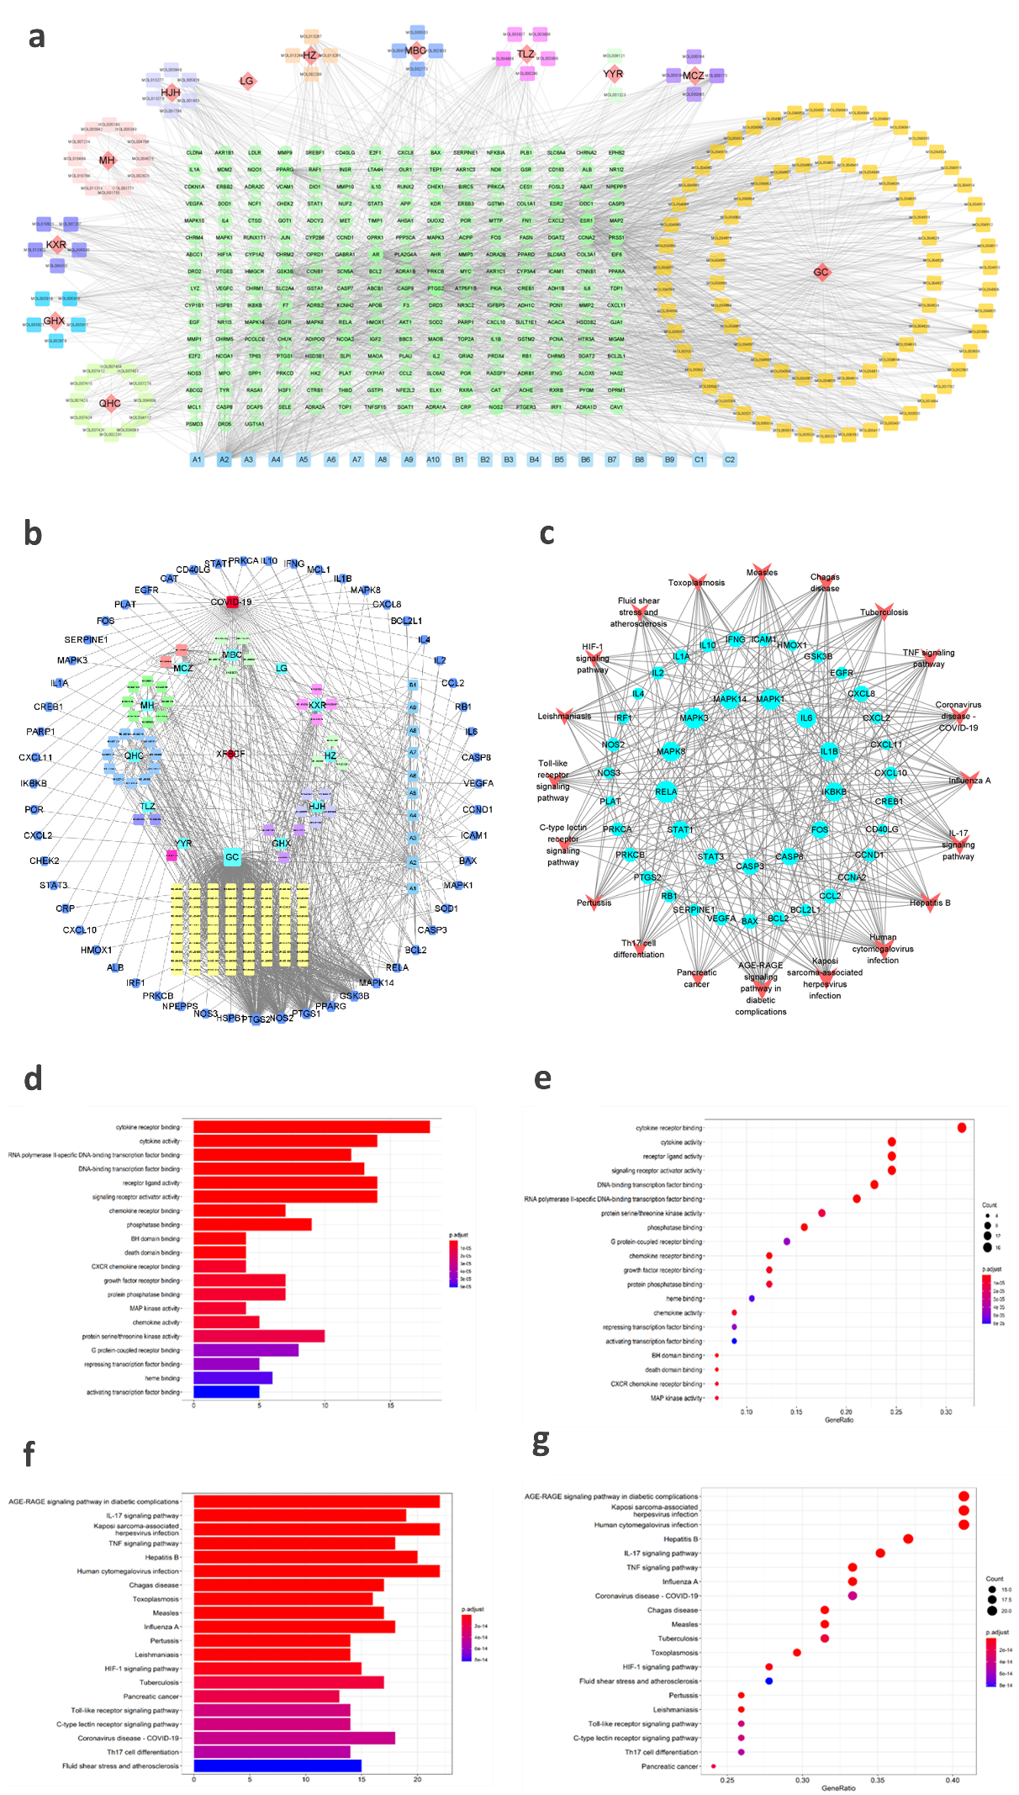
Fig. S1. Analysis of network pharmacology of XFBD against COVID-19. (a) The herbs-components-targets network; (b) The herbs-components-core targets-disease network; (c) The targets-pathways network; (d) Bubble plots and (e) histogram for GO enrichment analysis; (f) Bubble plots and (g) histogram for KEGG enrichment analysis.
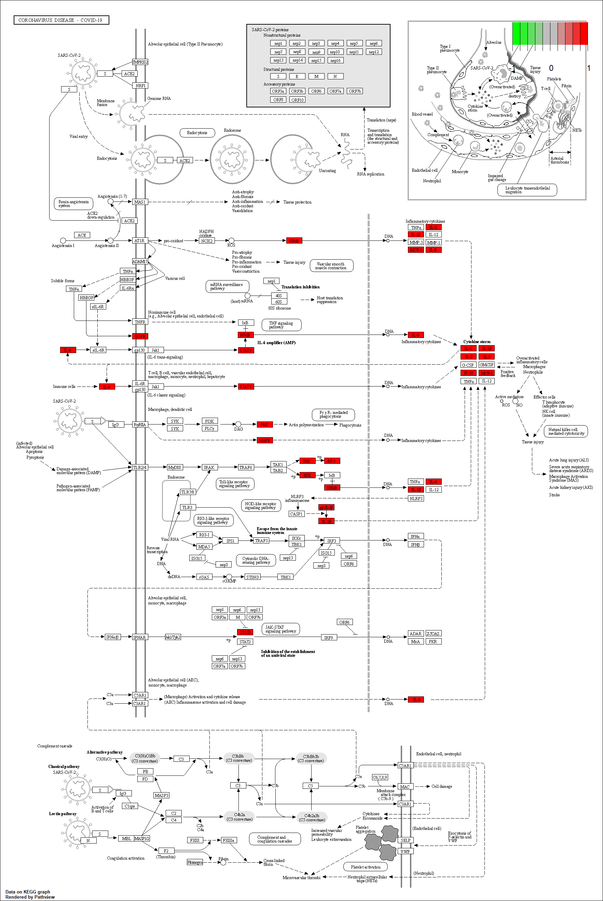
Fig. S2. The pathways of COVID-19 infection and the key targets marked as a red square for XFBD in treatment of COVID-19.
Table S2 Basic informations of herbs-components-core targets-disease network
Herb | Active component | Target
Mahuang | 17 | 22
Yiyiren | 3 | 2
Kuxingren | 11 | 23
Cangzhu | 2 | 16
Huoxiang | 6 | 13
Qinghao | 16 | 46
Lugen | 1 | 2
Huajuhong | 8 | 22
Huzhang | 7 | 10
Mabiancao | 11 | 21
Tinglizi | 5 | 11
Gancao | 84 | 348
Fig. S3. The intersection of active compounds targets and disease targets by Venn diagram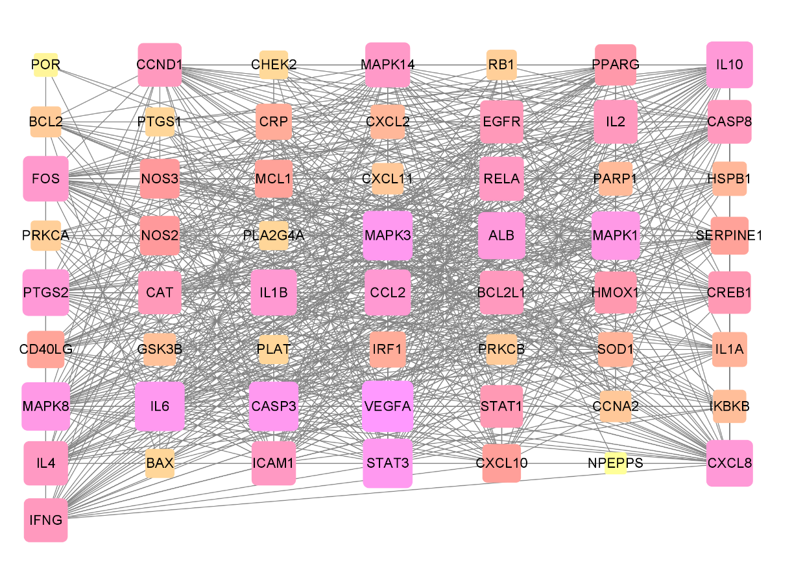
Fig. S4. The network of protein-protein interaction (PPI)

Fig. S5. Degree values of core targets.
Table S3 Basic Informations of Core Targets
Gene | Protein | Degree value
VEGFA | Vascular endothelial growth factor A | 51
CASP3 | Caspase-3 | 48
IL-6 | Interleukin-6 | 48
MAPK3 | Mitogen-activated protein kinase 3 | 48
STAT3 | Signal transducer and activator of transcription 3 | 48
MAPK1 | Mitogen-activated protein kinase 1 | 46
MAPK8 | Mitogen-activated protein kinase 8 | 46
ALB | Serum albumin | 44
CXCL8 | Interleukin-8 | 43
IL10 | Interleukin-10 | 43
PTGS2 | Prostaglandin G/H synthase 2 | 43
CCL2 | C-C motif chemokine 2 | 42
IL-1β | Interleukin-1 beta | 42
FOS | Proto-oncogene c-Fos | 41
MAPK14 | Mitogen-activated protein kinase 14 | 40

Table S4 Informations of GO enrichment pathways
ID | Description
GO:0005126 | cytokine receptor binding
GO:0005125 | cytokine activity
GO:0061629 | RNA polymerase II-specific DNA-binding transcription factor binding
GO:0140297 | DNA-binding transcription factor binding
GO:0048018 | receptor ligand activity
GO:0030546 | signaling receptor activator activity
GO:0042379 | chemokine receptor binding
GO:0019902 | phosphatase binding
GO:0051400 | BH domain binding
GO:0070513 | death domain binding
GO:0045236 | CXCR chemokine receptor binding
GO:0070851 | growth factor receptor binding
GO:0019903 | protein phosphatase binding
GO:0004707 | MAP kinase activity
GO:0008009 | chemokine activity
GO:0004674 | protein serine/threonine kinase activity
GO:0001664 | G protein-coupled receptor binding
GO:0070491 | repressing transcription factor binding
GO:0020037 | heme binding
GO:0033613 | activating transcription factor binding

Table S5 The informations of KEGG enrichment pathways
ID | Description
hsa04933 | AGE-RAGE signaling pathway in diabetic complications
hsa04657 | IL-17 signaling pathway
hsa05167 | Kaposi sarcoma-associated herpesvirus infection
hsa04668 | TNF signaling pathway
hsa05161 | Hepatitis B
hsa05163 | Human cytomegalovirus infection
hsa05142 | Chagas disease
hsa05145 | Toxoplasmosis
hsa05162 | Measles
hsa05164 | Influenza A
hsa05133 | Pertussis
hsa05140 | Leishmaniasis
hsa04066 | HIF-1 signaling pathway
hsa05152 | Tuberculosis
hsa05212 | Pancreatic cancer
hsa04620 | Toll-like receptor signaling pathway
hsa04625 | C-type lectin receptor signaling pathway
hsa05171 | Coronavirus disease - COVID-19
hsa04659 | Th17 cell differentiation
hsa05418 | Fluid shear stress and atherosclerosis

Table S6 The informations of the tested compounds
No. | English name | Molecular formula | Molecular Weight | PubChem CID
Positive Control | Ebselen | C₁₃H₉NOSe | 274.19 | 3194
1 | Hordenine | C10H15NO | 165.23 | 68313
2 | Herbacetin | C15H10O7 | 302.23 | 5280544
3 | Kaempferol | C15H10O6 | 286.24 | 5280863
4 | Quercetin | C15H10O7 | 302.23 | 5280343
5 | Naringenin | C15H12O5 | 272.25 | 932
6 | Hesperidin | C28H34O15 | 610.6 | 10621
7 | Tricin | C17H14O7 | 330.29 | 5281702
8 | Swertisin | C22H22O10 | 446.4 | 124034
9 | Vitexin | C21H20O10 | 432.4 | 5280441
10 | 4-Hydroxybenzoic acid | C7H6O3 | 138.12 | 135
11 | Syringic acid | C9H10O5 | 198.17 | 10742
12 | Ferulic acid | C10H10O4 | 194.18 | 445858
13 | Cis-p-Coumaric acid | C9H8O3 | 164.16 | 1549106
14 | Caffeic Acid | C9H8O4 | 180.16 | 689043
15 | Sinapic acid | C11H12O5 | 224.21 | 637775
16 | 2-Hydroxyphenylacetic acid | C8H8O3 | 152.15 | 11970
17 | Amygdalin | C20H27NO11 | 457.4 | 656516
18 | Atractyloside A | C21H36O10 | 448.5 | 71307451
19 | AtractylenolideⅠ | C15H18O2 | 230.3 | 5321018
20 | Aractylenolide Ⅱ | C15H20O2 | 232.32 | 14448070
21 | Atractylenolide Ⅲ | C15H20O3 | 248.32 | 155948
22 | Atractylon | C15H20O | 216.32 | 3080635
23 | Atractylodin | C13H10O | 182.22 | 5321047
24 | Pachypodol | C18H16O7 | 344.3 | 5281677
25 | Kumatakenin | C17H14O6 | 314.29 | 5318869
26 | Hyperoside | C21H20O12 | 464.4 | 5281643
27 | Epifriedelanol | C30H52O | 428.7 | 119242
28 | Friedelin | C30H50O | 426.7 | 91472
29 | Oleanolic acid | C30H48O3 | 456.7 | 10494
30 | Methyl oleanolate | C31H50O3 | 470.7 | 92900
31 | Artemisine | C15H22O5 | 282.33 | 68827
32 | Artemisitene | C15H20O5 | 280.32 | 11000442
33 | Dihydroartemisinic acid | C15H24O2 | 236.35 | 11020893
34 | Artemisinic acid | C15H22O2 | 234.33 | 10922465
35 | Chrysosplenol D | C18H16O8 | 360.3 | 5280699
36 | Chrysosplenetin | C19H18O8 | 374.3 | 5281608
37 | Blumeatin | C16H14O6 | 302.28 | 70696494
38 | Scopoletin | C10H8O4 | 192.17 | 5280460
39 | Scoparone | C11H10O4 | 206.19 | 8417
40 | Beta-Sitosterol | C₂₉H₅₀O | 414.7 | 222284
41 | Physcion | C₁₆H₁₂O₅ | 284.26 | 10639
42 | 4-Hydroxybenzaldehyde | C₇H₆O₂ | 122.12 | 126
43 | 5-Hydroxymethylfurfural | C6H6O3 | 126.11 | 237332
44 | Gentisuric acid | C9H9NO5 | 211.17 | 161488
45 | Coixol | C8H7NO3 | 165.15 | 10772
46 | Myrcene | C10H16 | 136.23 | 31253
47 | Linalool | C10H18O | 154.25 | 6549
48 | Naringin | C27H32O14 | 580.5 | 442428
49 | Rhoifolin | C27H30O14 | 578.5 | 5282150
50 | Isoimperatorin | C16H14O4 | 270.28 | 68081
51 | Meranzin | C15H16O4 | 260.28 | 1803558
52 | Isomeranzin | C15H16O4 | 260.28 | 473252
53 | Chrysophanol | C15H10O4 | 254.24 | 10208
54 | Physcion 1-glucoside | C22H22O10 | 446.4 | 168938
55 | Aloe-emodin | C15H10O5 | 270.24 | 10207
56 | Catechin | C15H14O6 | 290.27 | 9064
57 | Hesperetin | C16H14O6 | 302.28 | 72281
58 | Genistein | C15H10O5 | 270.24 | 5280961
59 | Gallic Acid | C7H6O5 | 170.12 | 370
60 | Hastatoside | C17H24O11 | 404.4 | 92043450
61 | Gentiopicroside | C16H20O9 | 356.32 | 88708
62 | Aucubin | C15H22O9 | 346.33 | 91458
63 | Kaempferide | C16H12O6 | 300.26 | 5281666
64 | Quercitrin | C21H20O11 | 448.4 | 5280459
65 | Oxalic Acid | C2H2O4 | 90.03 | 971
66 | 3-Epioleanolic acid | C30H48O3 | 456.7 | 11869658
67 | Verbenone | C10H14O | 150.22 | 92874
68 | Myristic acid | C14H28O2 | 228.37 | 11005
69 | Arachidic acid | C20H40O2 | 312.5 | 10467
70 | Linoleic Acid | C18H32O2 | 280.4 | 5280450
71 | Erucic acid | C22H42O2 | 338.6 | 5281116
72 | Isoquercitrin | C21H20O12 | 464.4 | 5280804
73 | Licochalcone D | C21H22O5 | 354.4 | 10473311
74 | Licochalcone C | C21H22O4 | 338.4 | 9840805
75 | Licochalcone B | C16H14O5 | 286.28 | 5318999
76 | Licochalcone E | C21H22O4 | 338.4 | 46209991
77 | Taxifolin | C15H12O7 | 304.25 | 439533
78 | Liquiritigenin | C15H12O4 | 256.25 | 114829
79 | Isoliquiritigenin | C15H12O4 | 256.25 | 638278
80 | Glabridin | C20H20O4 | 324.4 | 124052
81 | Glycyrrhizic acid | C42H62O16 | 822.9 | 14982
82 | Acteoside | C₂₉H₃₆O₁₅ | 624.6 | 5281800
83 | Physcion | C₁₆H₁₂O₅ | 284.26 | 10639

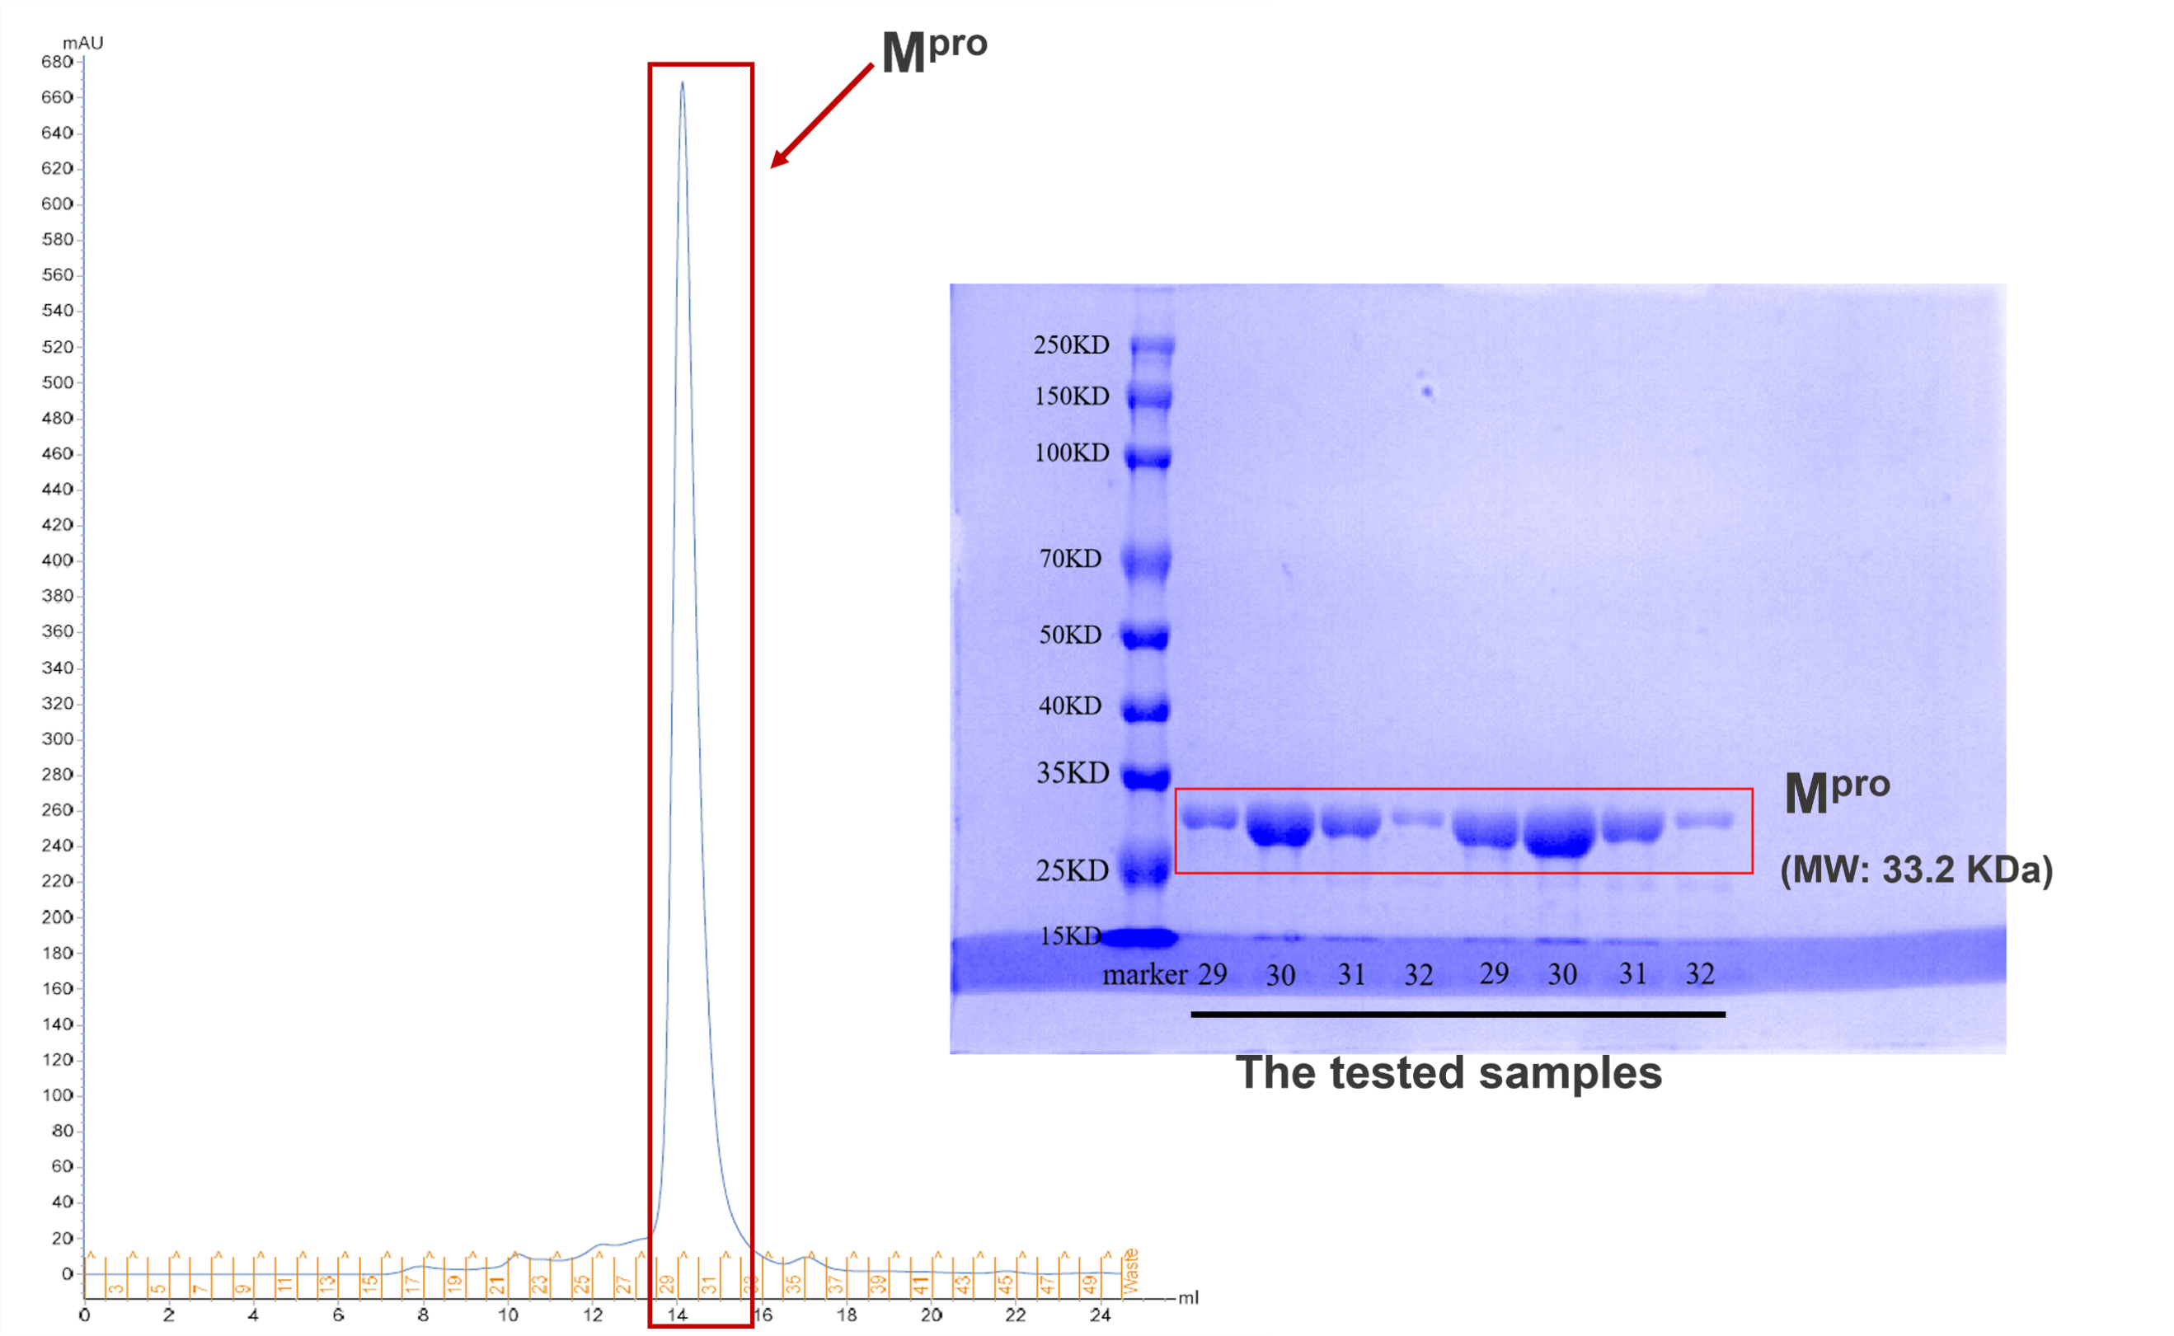
Fig. S6. The purified M^{pro} with the purity above 95%.

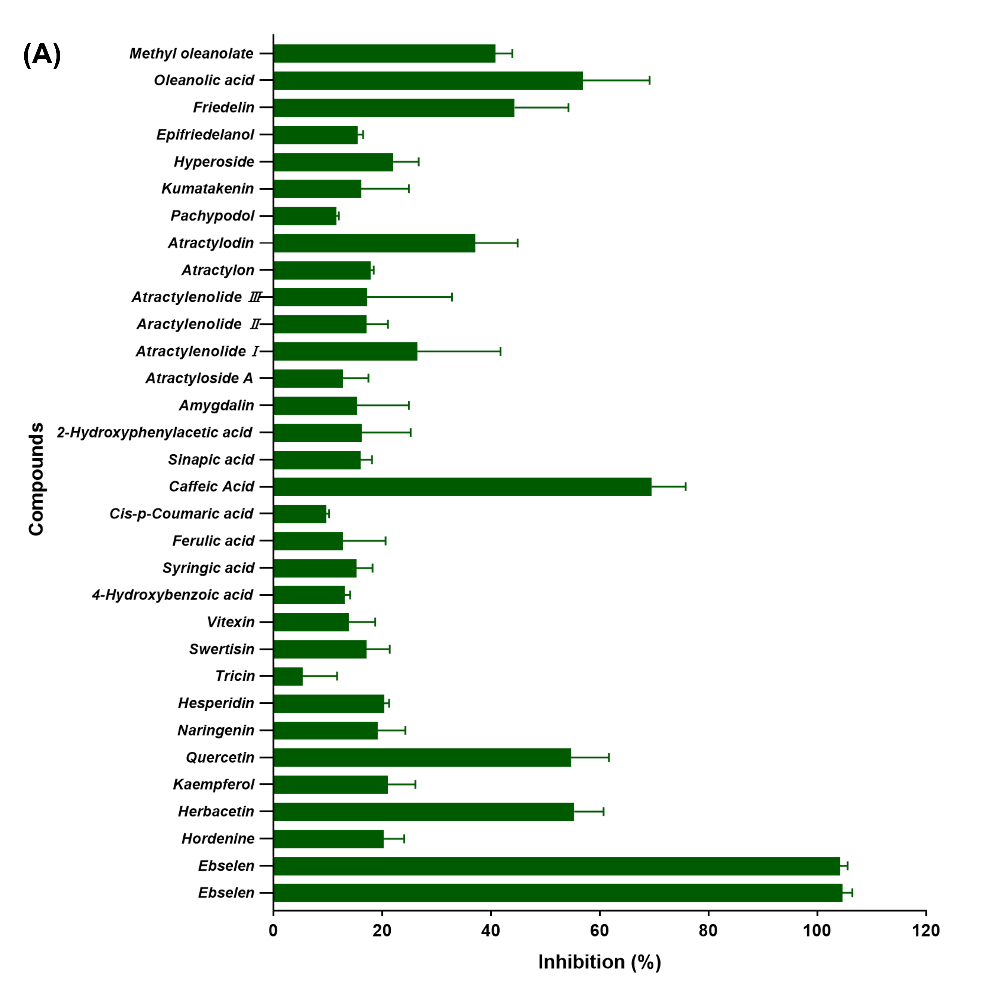
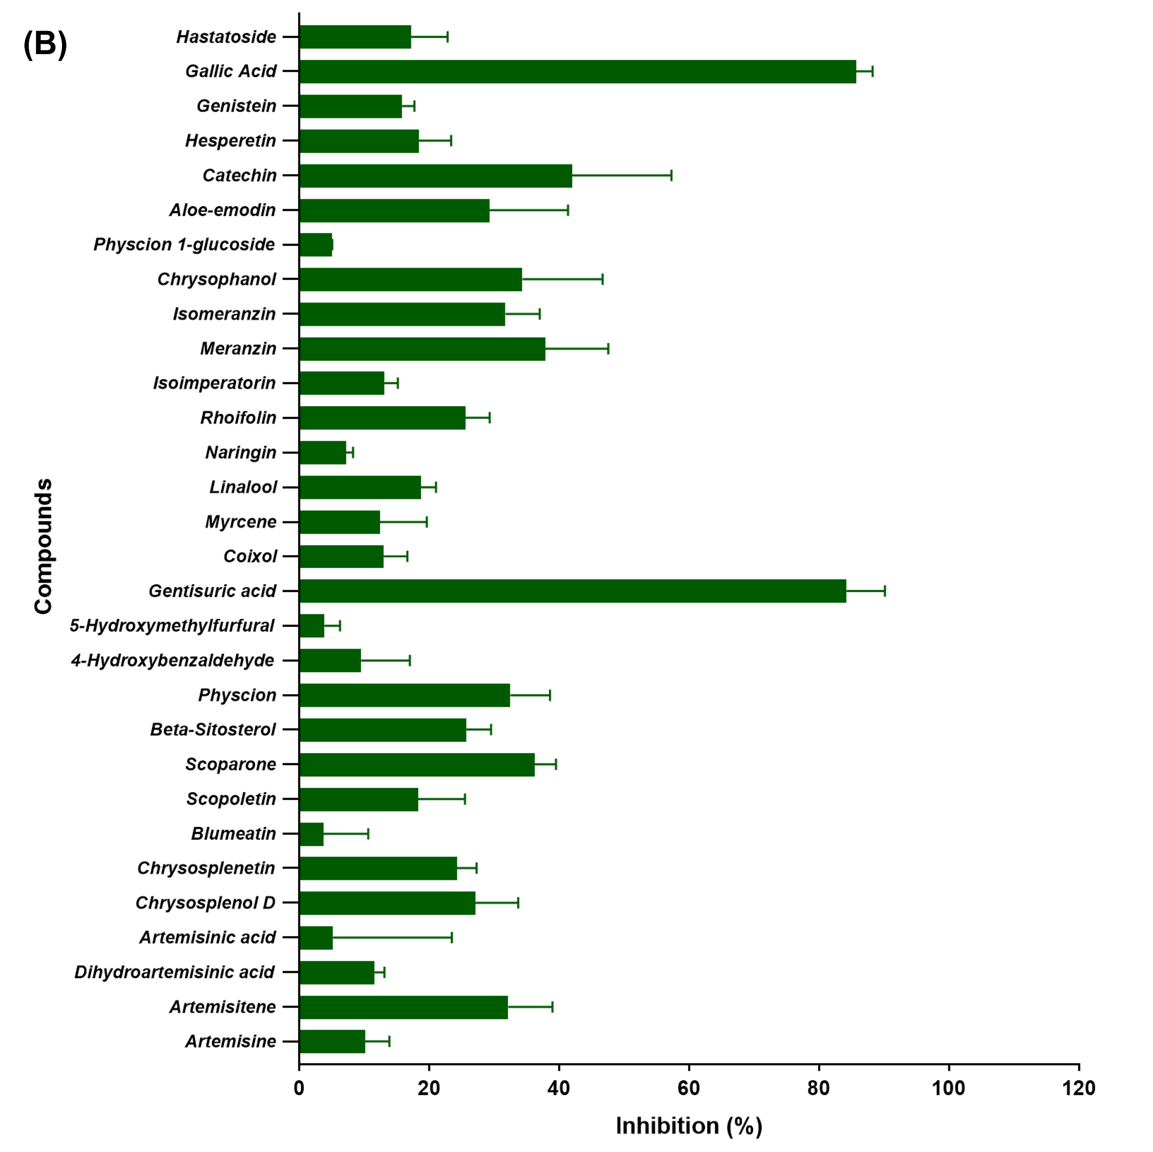
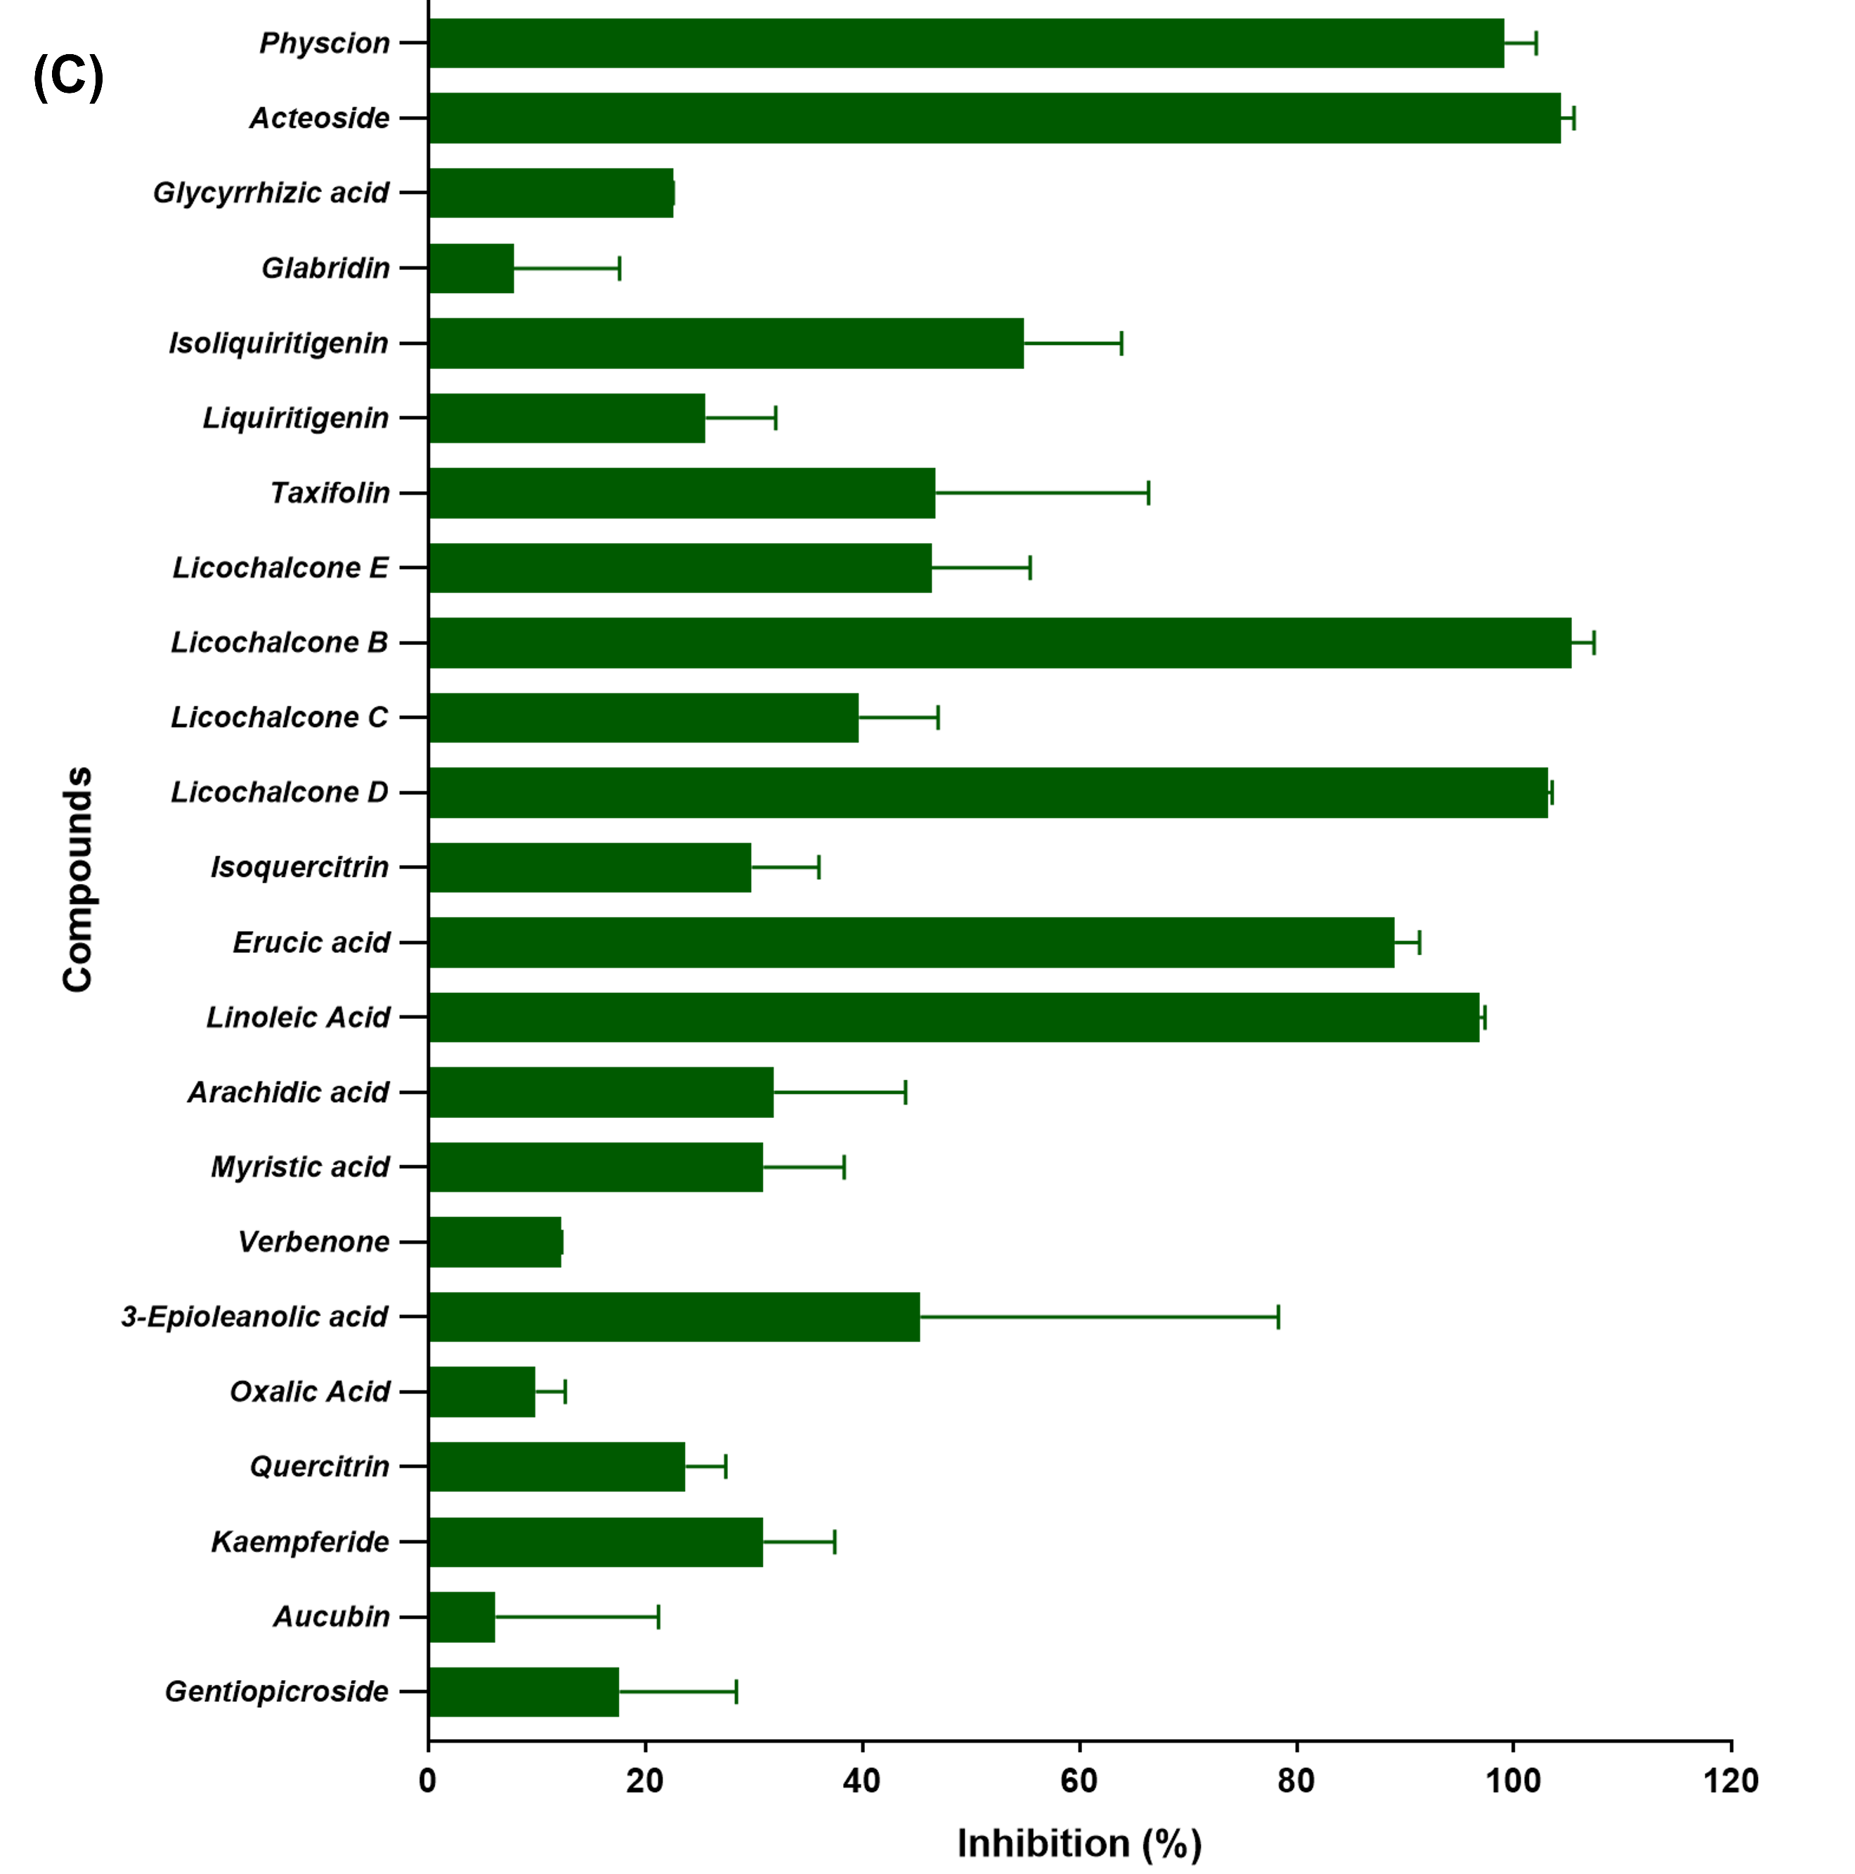
Fig. S7. The inhibition activity of the tested compounds on M^{pro} at 40 µM
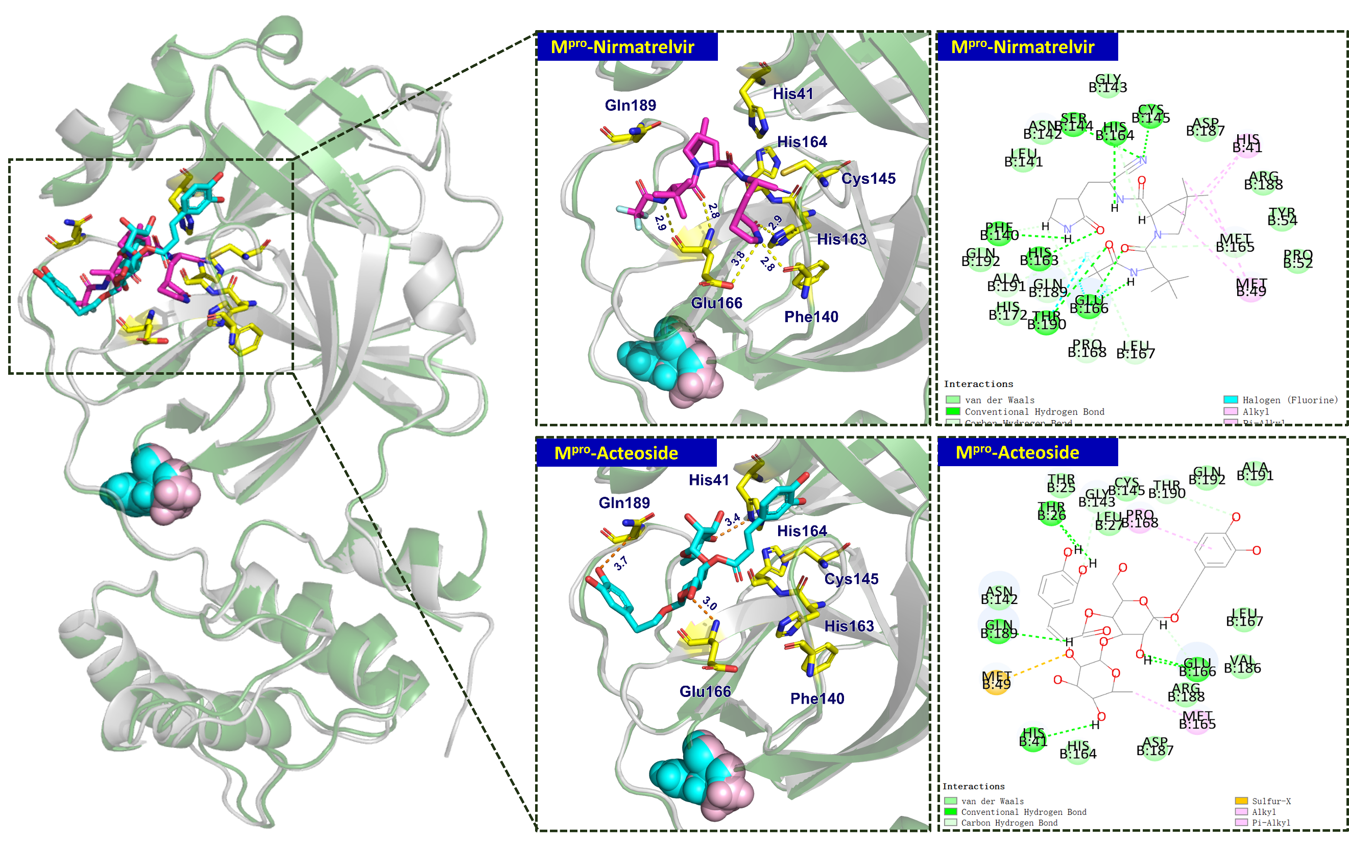
Fig. S8. The predicted structure of the acteoside-M^{pro} (P1321H) and Nirmatrelvir-M^{pro} (P132H) complexes. WT M^{pro} (gray and blue) and P132H M^{pro} (green and pink) are superposed.
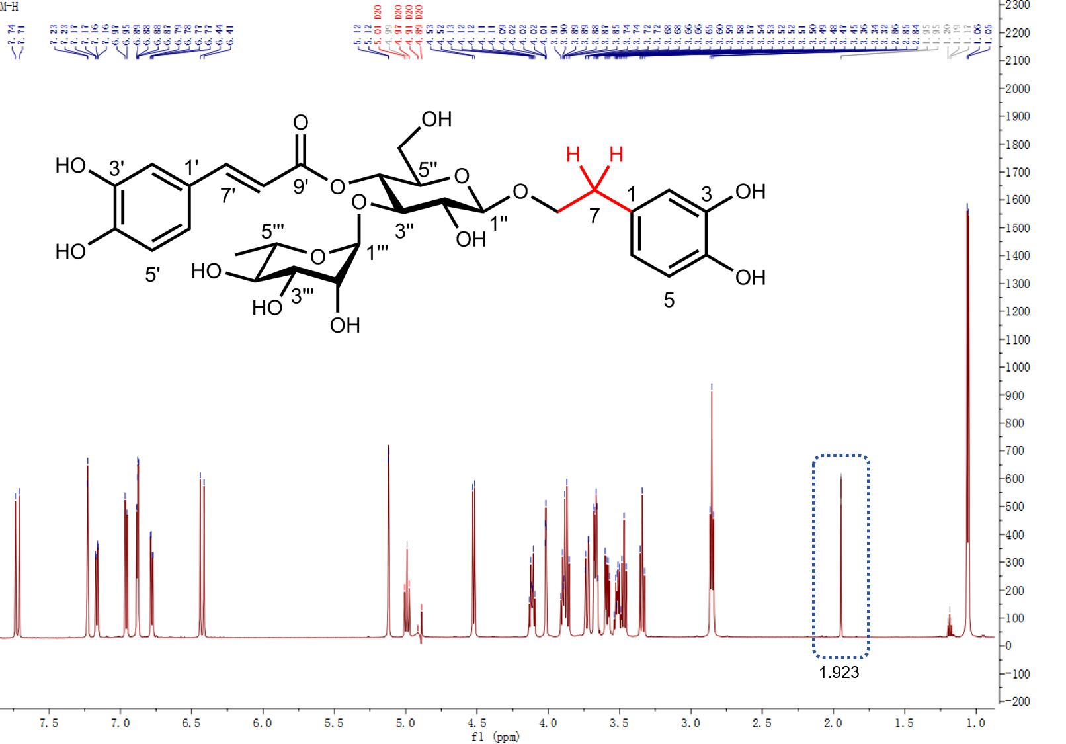
Fig. S9. ¹H NMR spectrum of acteoside

