Supplementary Materials
Title
Leaf litter contributes to the obstacles of Cynanchum auriculatum Royle ex Wight continuous cropping
Authors
Min Shen ^{abc}, Limeng Wu ^{b}, Yanzhou Zhang ª, Huanli Wang ª, Jiaxin Xiao ^{b}, Yijun Kang ^{a,c*}
ª College of Life Sciences, Anhui Normal University, Wuhu, Anhui, China
^{b} Jiangsu Key Laboratory for Bioresources of Saline Soils, Yancheng Teachers University, Yancheng, Jiangsu, China
^{c} Jiangsu Key Laboratory for Bioresources of Saline Soils, Jiangsu Provincial Key Laboratory of Coastal Wetland Bioresources and Environmental Protection, Yancheng Teachers University, Yancheng, China
Running title
Leaf litter contributes to CCO
Corresponding author
Yijun Kang
Mailing address: 2 South Hope Avenue, Yancheng Teachers University, Yancheng, Jiangsu, P. R. China, 224007
E-mail: yjkang@yctu.edu.cn
Tel/Fax: +86 (0) 515 88233660

Fig. S1
(A)

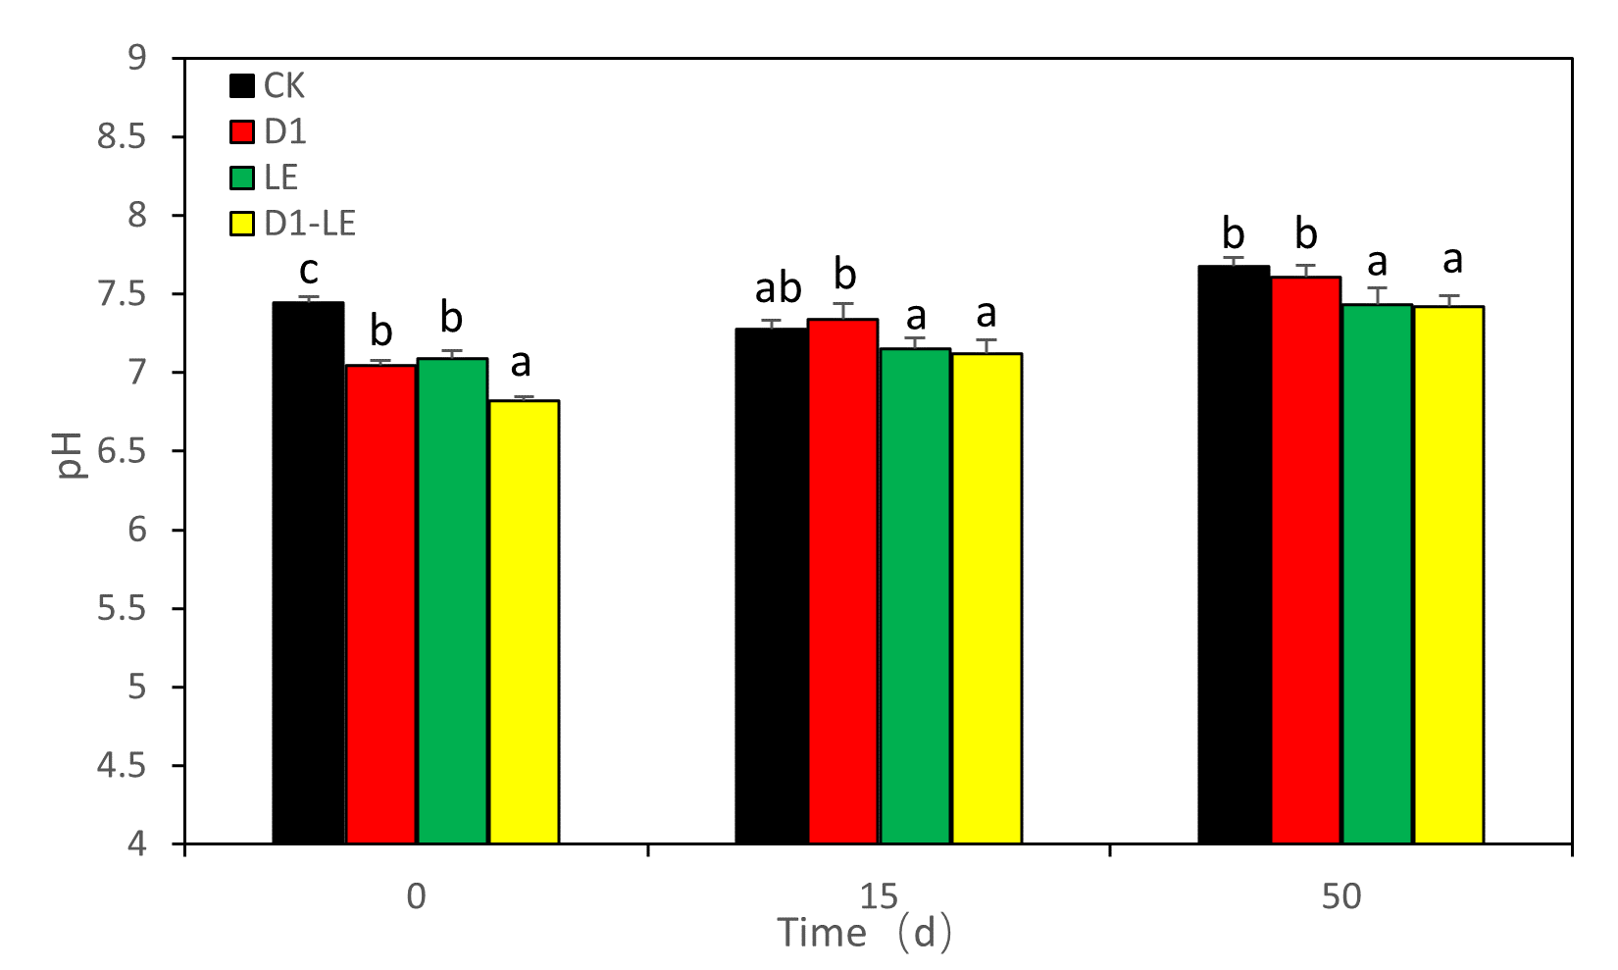
(B)

Fig. S2

(A)
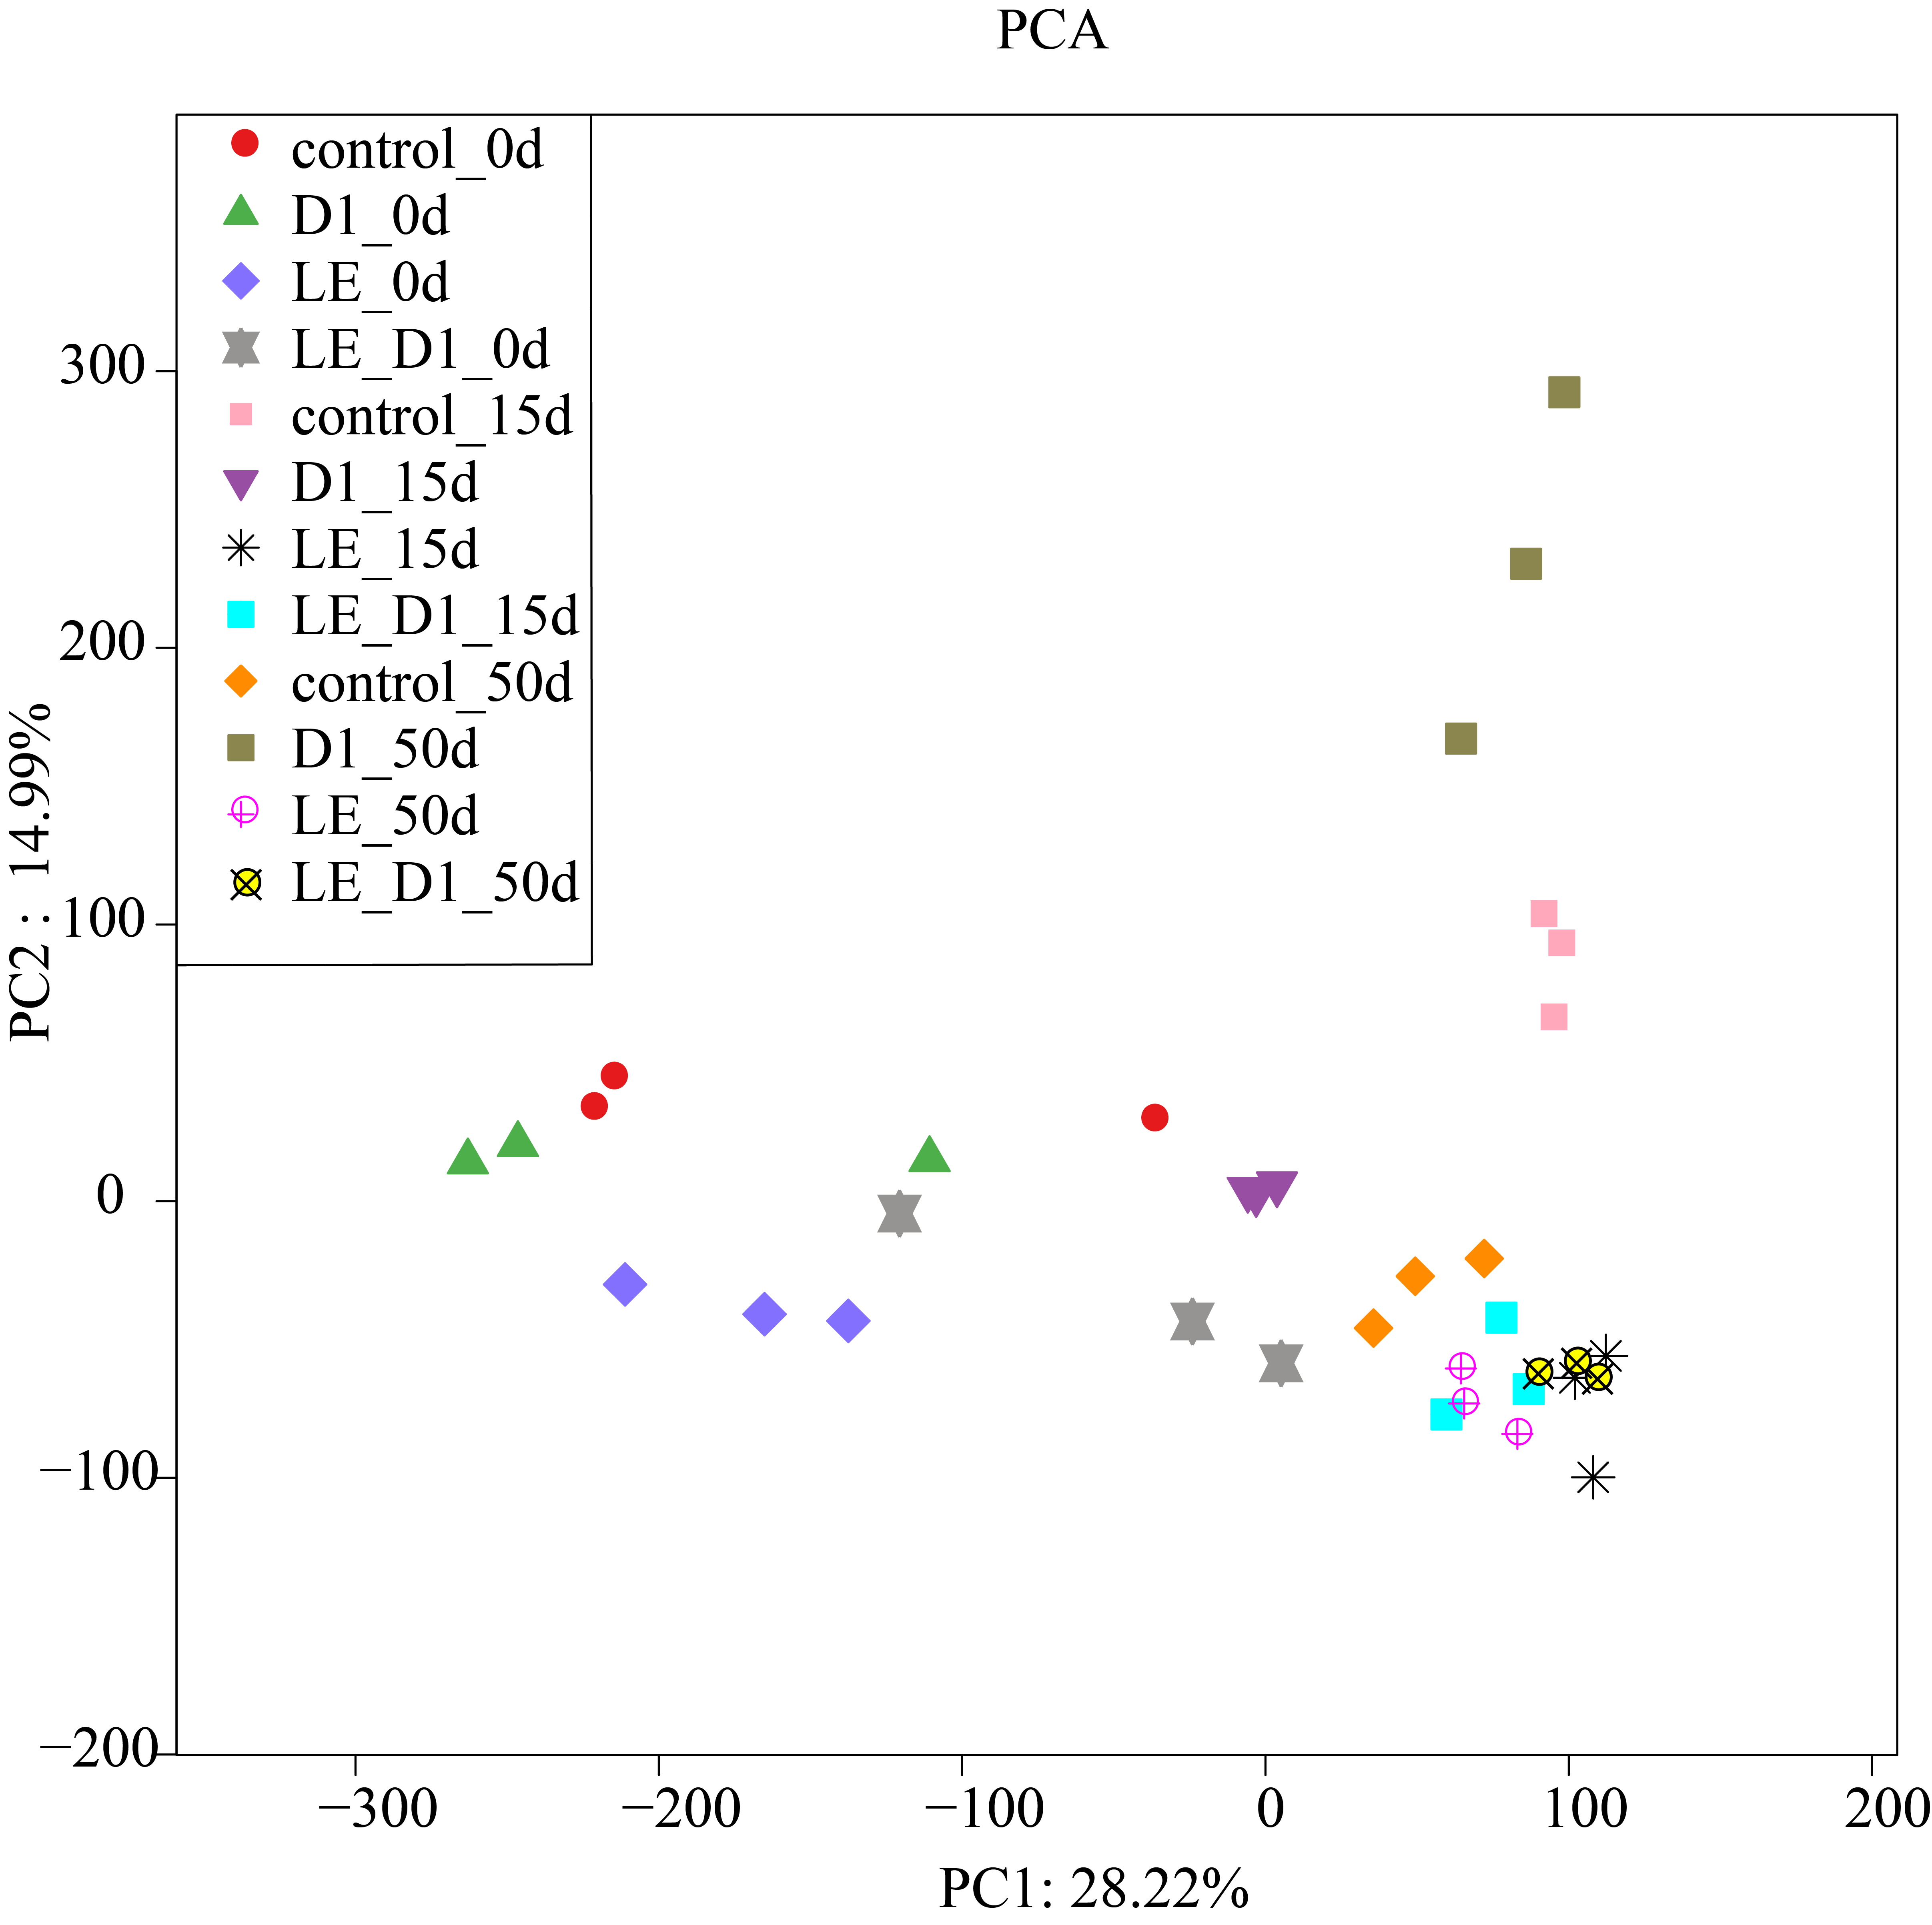
(B)

Fig. S3

Figure legends:
Fig. S1 Changes in pH of soils planting of CA with different continuous cropping histories (A), and comparisons of soil pH with different treatments (B). 0 a, 2 a, and 3 a indicated that soils have been planted with CA for 0, 2, and 3 years, respectively. Different letters at one sampling time indicates significant differences among treatments (Duncan’s multiple range test, P≤0.05).

Fig. S2 Effects of LE and/or strain D1 on the bacterial community with time (A), and the changes in bacterial composition among different treatments during 50 days using Principal component analysis (PCA) (B). 0d represents the initial bacterial community, 15d and 50d represents day 15 and day 50, respectively. Those relative abundance lower than 1% were categorized to “others”.

Fig. S3 The top 30 dominant taxonomies at the genus level. Different colors represent different phylum for each genus.

