Supplementary Table S1
The siRNA sequences of IRS1 gene.
Name | Sense sequence(5'-3) |  | Antisense sequence( 3'-5')
NC |  | UUCUCCGAACGUGUCACGUTT | ACGUGACACGUUCGGAGAATT
miR-487b-3p mimics |  | AAUCGUACAGGGUCAUCCACUU | GUGGAUGACCCUGUACGAUUUU
siNC |  | UUCUCCGAACGUGUCACGUTT | ACGUGACACGUUCGGAGAATT
siIRS1 |  | GCAUGCACAAGCGAUUCUUTT | AAGAAUCGCUUGUGCAUGCTT

Supplementary Table S2
PCR primers for the potential off target sites detection.
Off-target site | Primer sequence (5’ to 3’) | Amplicon(bp)
OT1-F | GTGGCTCAGTGGTAAAGAATCC | 690
OT1-R | CTTACTAGCCAGTTGACTACCCAC | 690

Supplementary Figure 1
Primary goat myoblasts cells treated with 0 µg/mL, 0.5 µg/mL, 0.75 µg/mL and 1.0 µg/mL puromycin for 72 hours and the cell death condition was examined by microscope.

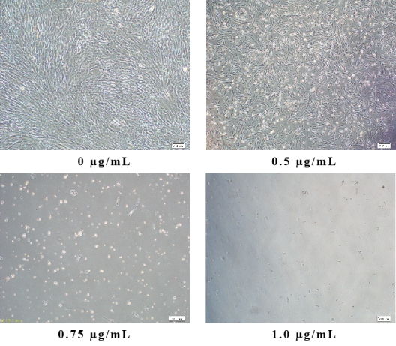
Supplementary Figure 2
The sequencing results of the sgRNA-2 target site. The red arrow indicated the locus of deletion.

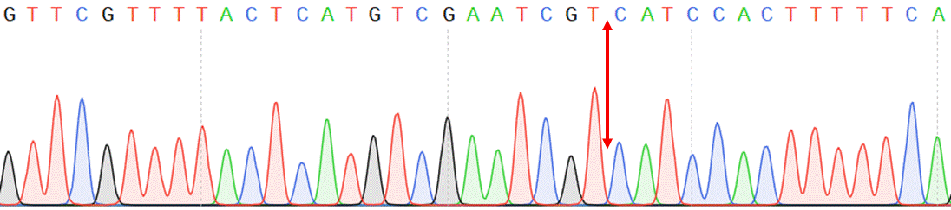
Supplementary Figure 3
Sequences of the genomic locus of the potential off-target site. The red boxes are indicative of the off-target loci.

