Supplementary materials

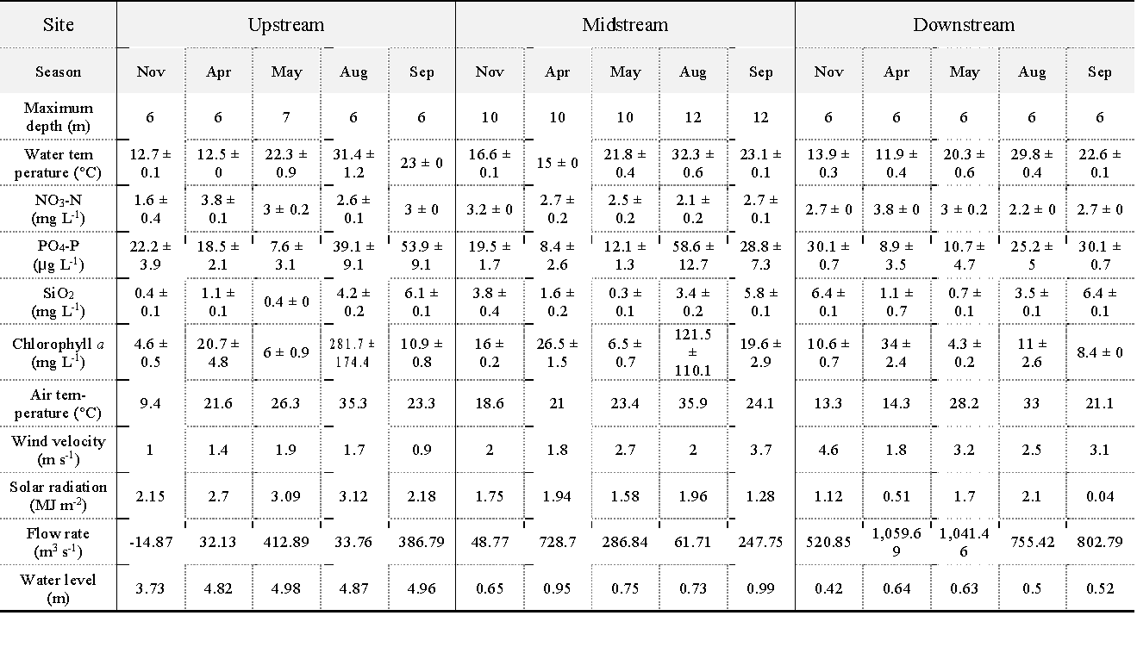
Table S1: Depth-averaged water characteristics and environmental factors of three sites during the study period (n = 3, mean ± S.E.).

 | Seasonal |  |  |  | Diel
 | PC1 | PC2 | r² | P-value | PC1 | PC2 | r² | P-value
RWCS | 0.684 | -0.729 | 0.729 | 0.002 | 0.515 | 0.857 | 0.758 | 0.001
S | 0.895 | -0.447 | 0.501 | 0.011 | -0.874 | 0.486 | 0.777 | 0.001
Max | 0.561 | -0.828 | 0.682 | 0.003 | 0.414 | 0.910 | 0.779 | 0.001
AT | 0.964 | -0.268 | 0.699 | 0.002 | -0.144 | 0.990 | 0.921 | 0.001
SR | 0.330 | -0.944 | 0.743 | 0.002 | 0.242 | 0.970 | 0.864 | 0.001
WV | -0.102 | 0.995 | 0.285 | 0.141 | -0.103 | 0.995 | 0.694 | 0.001
FR | -0.641 | 0.768 | 0.252 | 0.184 | -0.672 | -0.741 | 0.593 | 0.002
WL | 0.246 | -0.969 | 0.413 | 0.052 | 1.000 | -0.014 | 0.970 | 0.001
WT0 | 0.997 | -0.079 | 0.875 | 0.001 | -0.060 | 0.998 | 0.848 | 0.001
WT3 | 1.000 | 0.031 | 0.893 | 0.001 | -0.885 | 0.466 | 0.415 | 0.015
WTB | 0.998 | 0.064 | 0.878 | 0.001 | -0.998 | 0.057 | 0.734 | 0.001
Chl0 | 0.884 | -0.467 | 0.658 | 0.003 | 0.468 | 0.884 | 0.538 | 0.002
Chl3 | 0.828 | -0.561 | 0.361 | 0.066 | 0.686 | 0.728 | 0.646 | 0.001
ChlB | -0.949 | -0.315 | 0.082 | 0.619 | 0.993 | -0.122 | 0.471 | 0.005
NO0 | -0.977 | -0.215 | 0.143 | 0.376 | 0.914 | -0.406 | 0.179 | 0.251
NO3 | -0.993 | -0.116 | 0.231 | 0.184 | 0.653 | 0.757 | 0.267 | 0.108
NOB | -0.806 | 0.593 | 0.136 | 0.4 | -0.546 | 0.838 | 0.022 | 0.855
PO0 | 1.000 | 0.009 | 0.673 | 0.002 | -0.547 | 0.837 | 0.254 | 0.109
PO3 | 0.902 | 0.432 | 0.552 | 0.007 | -0.869 | 0.495 | 0.147 | 0.325
POB | 0.864 | 0.503 | 0.629 | 0.004 | -0.969 | 0.246 | 0.533 | 0.004
SI0 | 0.536 | 0.844 | 0.862 | 0.001 | 0.917 | -0.400 | 0.881 | 0.001
SI3 | 0.447 | 0.894 | 0.803 | 0.001 | 0.934 | -0.356 | 0.888 | 0.001
SIB | 0.551 | 0.835 | 0.878 | 0.002 | 0.753 | -0.658 | 0.744 | 0.001

Table S2: Pearson correlation coefficient of determination (r²) and P-values based on random permutations between the environmental variables and the PC coordinates at seasonal and diel scales (n = 15: seasonal, 18: diel). The bold values statistical significance (P < 0.05

