Supplementary Tables and Figures

Supplementary Table 1: Details of polymorphic microsatellite markers (Name, Repeat Motif, Chromosome number, Marker Position, Chromosome Arm) used for background analysis.

Sl. No. | Marker Name | Repeat Motifs | Chromosome Number | Marker Position (bp) | Chromosome Arm
1 | RM10037 | (AT)25 | 1 | 5,62,780- 5,63,070 | Short
2 | RM10552 | (AG)13 | 1 | 87,03,888- 87,04,076 | Short
3 | RM11258 | (AAT)29 | 1 | 2,29,96,745- 2,29,96,911 | Long
4 | RM1067 | (AC)20 | 1 | 4,29,23,261- 4,29,23,549 | Long
5 | RM12469 | (ATA)38 | 2 | 27,54,646- 27,55,081 | Short
6 | RM12748 | (ATTA)7 | 2 | 70,79,716- 70,79,858 | Short
7 | RM13133 | (CT)10 | 2 | 1,45,03,368- 1,45,03,539 | Long
8 | RM13910 | (AG)29 | 2 | 3,00,52,310- 3,00,52,498 | Long
9 | RM14272 | (TTCC)7 | 3 | 4,69,156- 4,69,279 bp | Long
10 | RM14810 | (GGT)7 | 3 | 1,06,50,398- 1,06,50,539 | Long
11 | RM15630 | (GA)55 | 3 | 2,60,73,971- 2,60,74,256 | Short
12 | RM16236 | (AG)21 | 3 | 3,62,42,860- 3,62,42,958 | Short
13 | RM16597 | (AT)30 | 4 | 1,13,70,018- 1,13,70,411 | Long
14 | RM17677 | (CCG)7 | 4 | 3,49,12,612- 3,49,12,911 | Long
15 | RM16285 | (GTC)7 | 4 | 5,51,663- 5,51,763 | Short
16 | RM16519 | (CCT)7 | 4 | 74,99,234- 74,99,491 | Short
17 | RM17736 | (CCG)8 | 5 | 2,50,723- 2,50,878 | Short
18 | RM18076 | (GGC)9 | 5 | 63,32,938- 63,33,101 | Short
19 | RM18356 | (AT)21 | 5 | 1,39,82,815- 1,39,82,963 | Long
20 | RM19116 | (GA)11 | 5 | 2,80,58,786- 2,80,58,960 | Long
21 | RM8226 | (AAG)14 | 6 | 93,20,821- 93,21,095 | Short
22 | RM19250 | (ACGT)5 | 6 | 4,84,581- 4,84,954 | Short
23 | RM20773 | (TAA)32 | 6 | 3,12,07,214- 3,12,07,614 | Long
24 | RM20233 | (TCT)7 | 6 | 2,10,62,954- 2,10,63,224 | Long
25 | RM21320 | (AT)31 | 7 | 87,76,475- 87,76,647 | Short
26 | RM20879 | (CAG)8 | 7 | 12,97,554- 12,97,645 | Short
27 | RM21764 | (TGG)7 | 7 | 2,09,00,502- 2,09,00,598 bp | Long
28 | RM22156 | (GA)20 | 7 | 2,91,45,351- 2,91,45,437 | Long
29 | RM22263 | (TTTC)5 | 8 | 7,47,835- 7,47,952 | Short
30 | RM22571 | (AAG)14 | 8 | 58,44,242- 58,44,336 | Short
31 | RM22914 | (GA)29 | 8 | 1,54,33,651- 1,54,33,813 | Long
32 | RM23408 | (TA)47 | 8 | 2,50,79,661- 2,50,79,957 | Long
33 | RM5688 | (AAT)17 | 9 | 17,15,785- 17,15,934 | Short
34 | RM24089 | (AG)10 | 9 | 1,08,47,574- 1,08,47,695 | Long
35 | RM24613 | (AAAG)5 | 9 | 1,95,27,114- 1,95,27,203 | Long
36 | RM24765 | (AT)33 | 9 | 2,18,89,939- 2,18,90,254 | Long
37 | RM24874 | (AT)21 | 10 | 2,92,472- 2,92,712 | Short
38 | RM24999 | (AT)26 | 10 | 30,07,026- 30,07,447 | Short
39 | RM25406 | (TGG)8 | 10 | 1,39,19,901- 1,39,20,089 | Long
40 | RM25766 | (GA)15 | 10 | 2,05,47,740- 2,05,47,871 | Long
41 | RM26094 | (AT)46 | 11 | 27,07,556- 27,07,864 | Short
42 | RM26393 | (AG)21 | 11 | 88,33,646- 88,34,045 | Short
43 | RM26652 | (TTC)9 | 11 | 1,50,68,001- 1,50,68,170 | Long
44 | RM27280 | (AAT)9 | 11 | 2,66,68,627- 2,66,68,994 | Long
45 | RM27487 | (AG)22 | 12 | 16,11,861- 16,12,028 | Short
46 | RM27805 | (CAG)7 | 12 | 73,31,675- 73,31,862 | Short
47 | RM28100 | (CGG)8 | 12 | 1,58,55,221- 1,58,55,815 | Long
48 | RM28367 | (AG)21 | 12 | 2,11,73,248- 2,11,73,360 | Long

Supplementary Table 2: Agro-morphological data of BLs, parents and checks under irrigated (control) and drought (stress) conditions.
Sl. No. | Genotype |  | DTF | PH  (in cm) | PL  (in cm) | FLL  (in cm) | FLW  (in cm) | 2LL  (in cm) | ETN | FGPP | SGPP | SF% | FGW  (in gms) | TGW  (in gms) | GY  (in kg/Ha) | RYR%
1 | Way Rarem | N  S | 89.00  94.50 | 105.70  71.20 | 22.80  17.90 | 38.90  31.43 | 1.48  0.84 | 35.90  17.21 | 6.20  4.00 | 81.60  8.30 | 46.20  109.20 | 63.84  6.99 | 1.597  0.162 | 19.56  19.42 | 3270.0  220.50 | 93.26
2 | CRMAS-2620-1 | N  S | 64.50  70.00 | 100.40  70.20 | 22.20  17.50 | 36.70  29.49 | 1.57  0.88 | 36.41  16.00 | 6.90  3.80 | 71.45  9.65 | 47.60  100.45 | 60.03  8.76 | 1.379  0.185 | 19.30  19.18 | 3140.00  235.40 | 92.50
3 | N22 | N  S | 62.50  59.00 | 111.10  104.60 | 21.70  20.26 | 30.70  26.30 | 1.26  0.93 | 21.53  20.13 | 6.50  4.80 | 76.80  33.15 | 60.90  99.45 | 55.78  25.01 | 1.421  0.611 | 18.51  18.44 | 3048.50  970.80 | 68.15
4 | BL-1 | N  S | 63.50  61.00 | 105.50  98.60 | 21.15  20.54 | 33.50  28.87 | 1.38  0.99 | 28.60  23.97 | 6.50  4.95 | 78.85  56.60 | 51.30  67.60 | 60.57  45.58 | 1.461  1.045 | 18.52  18.45 | 3127.90  1708.00 | 45.39
5 | BL-2 | N  S | 63.00  60.00 | 105.00  99.80 | 22.90  21.94 | 34.70  29.95 | 1.33  0.97 | 26.35  21.60 | 6.40  4.90 | 79.95  56.75 | 56.90  73.55 | 58.38  43.56 | 1.482  1.050 | 18.54  18.49 | 3120.60  1702.10 | 45.46
6 | BL-3 | N  S | 65.00  62.00 | 99.00  85.40 | 22.00  21.16 | 39.10  33.90 | 1.27  0.94 | 27.00  21.80 | 6.80  5.20 | 79.80  52.15 | 50.50  75.35 | 61.20  40.91 | 1.474  0.960 | 18.47  18.40 | 3295.10  1645.20 | 50.07
7 | BL-4 | N  S | 62.00  60.00 | 105.60  99.70 | 22.10  21.16 | 38.10  33.48 | 1.32  0.96 | 28.26  23.64 | 6.20  4.80 | 82.35  57.30 | 48.60  67.10 | 62.90  46.11 | 1.531  1.063 | 18.59  18.56 | 3129.10  1682.60 | 46.23
8 | BL-5 | N  S | 62.50  59.00 | 104.70  99.40 | 21.37  20.52 | 35.30  30.32 | 1.34  0.97 | 25.09  20.11 | 6.30  4.85 | 81.45  57.60 | 50.95  69.70 | 61.52  45.25 | 1.501  1.058 | 18.42  18.36 | 3117.00  1694.40 | 45.64
9 | BL-6 | N  S | 64.00  61.00 | 108.00  101.70 | 21.50  20.60 | 34.50  29.69 | 1.38  0.99 | 26.37  21.56 | 6.50  4.95 | 79.45  56.80 | 56.10  72.50 | 58.59  43.94 | 1.475  1.049 | 18.56  18.48 | 3155.60  1713.90 | 45.69
10 | BL-7 | N  S | 65.00  63.00 | 98.60  85.10 | 21.80  20.94 | 32.90  27.74 | 1.30  0.95 | 25.37  20.21 | 6.70  5.00 | 80.65  53.70 | 56.90  81.00 | 58.64  39.89 | 1.493  0.991 | 18.51  18.46 | 3293.60  1638.40 | 50.26
11 | BL-8 | N  S | 64.50  62.00 | 98.00  82.80 | 21.15  20.20 | 33.50  28.85 | 1.35  0.98 | 24.93  20.28 | 6.60  5.00 | 81.05  53.30 | 52.55  77.40 | 60.71  40.78 | 1.506  0.985 | 18.58  18.49 | 3284.70  1634.50 | 50.24
12 | BL-9 | N  S | 63.50  60.50 | 104.80  98.20 | 21.40  20.80 | 34.90  30.32 | 1.42  1.01 | 20.61  18.03 | 6.40  4.90 | 80.10  56.85 | 51.45  68.95 | 60.88  45.26 | 1.479  1.047 | 18.46  18.41 | 3119.50  1704.30 | 45.37
13 | BL-10 | N  S | 64.50  62.50 | 97.60  84.70 | 21.80  21.10 | 33.20  28.43 | 1.31  0.96 | 24.43  21.66 | 6.60  5.00 | 81.05  53.20 | 57.45  72.10 | 58.53  42.45 | 1.508  0.986 | 18.60  18.54 | 3281.60  1632.00 | 50.27

Supplementary Table 2 (contd)
Sl. No. | Genotype |  | DTF | PH  (in cm) | PL  (in cm) | FLL  (in cm) | FLW  (in cm) | 2LL  (in cm) | ETN | FGPP | SGPP | SF% | FGW  (in gms) | TGW  (in gms) | GY  (in kg/Ha) | RYR%
14 | BL-11 | N  S | 64.00  61.00 | 107.60  102.20 | 22.00  21.14 | 35.30  30.17 | 1.42  1.01 | 24.14  20.14 | 6.50  4.95 | 79.40  56.75 | 51.20  67.95 | 60.81  45.53 | 1.469  1.045 | 18.50  18.42 | 3149.60  1709.90 | 45.71
15 | BL-12 | N  S | 62.50  60.00 | 104.70  99.20 | 21.20  20.32 | 33.90  29.00 | 1.31  0.96 | 23.69  21.30 | 6.20  4.85 | 82.65  57.40 | 50.70  69.35 | 61.97  45.35 | 1.525  1.055 | 18.46  18.39 | 3117.60  1690.40 | 45.78
16 | BL-13 | N  S | 62.00  59.00 | 105.90  98.60 | 21.60  20.95 | 34.60  29.76 | 1.33  0.97 | 25.27  20.43 | 6.20  4.80 | 83.05  57.90 | 53.30  72.20 | 60.93  44.53 | 1.532  1.063 | 18.45  18.36 | 3133.00  1686.50 | 46.17
17 | BL-14 | N  S | 64.50  62.00 | 98.40  85.70 | 21.20  20.46 | 35.40  30.72 | 1.44  1.02 | 25.48  20.80 | 6.60  5.00 | 82.10  53.75 | 54.20  79.80 | 60.21  40.27 | 1.516  0.989 | 18.46  18.41 | 3290.50  1636.40 | 50.27
18 | BL-15 | N  S | 64.00  61.00 | 105.30  101.10 | 21.40  20.80 | 35.70  31.28 | 1.37  0.99 | 25.30  20.88 | 6.50  4.95 | 79.60  57.10 | 53.35  69.65 | 59.82  45.05 | 1.462  1.045 | 18.37  18.31 | 3121.40  1712.00 | 45.15
19 | BL-16 | N  S | 62.00  59.50 | 106.90  101.20 | 22.90  21.88 | 35.10  30.51 | 1.38  0.95 | 24.75  20.16 | 6.20  4.80 | 83.50  58.35 | 49.15  67.90 | 62.96  46.21 | 1.535  1.068 | 18.38  18.30 | 3140.20  1684.40 | 46.36
20 | BL-17 | N  S | 63.00  60.50 | 105.70  99.90 | 21.40  20.50 | 30.50  26.13 | 1.36  0.92 | 32.10  23.13 | 6.40  4.90 | 79.55  56.45 | 52.05  68.15 | 60.45  45.31 | 1.484  1.049 | 18.65  18.58 | 3130.60  1700.30 | 45.69
21 | BL-18 | N  S | 63.00  61.00 | 104.30  99.30 | 21.80  20.92 | 30.50  25.80 | 1.44  1.02 | 29.50  21.60 | 6.30  4.85 | 81.60  57.60 | 47.80  66.00 | 63.16  46.61 | 1.506  1.059 | 18.46  18.39 | 3114.80  1696.30 | 45.54
22 | BL-19 | N  S | 65.00  62.00 | 98.20  85.80 | 21.50  20.86 | 30.10  25.47 | 1.35  0.98 | 26.70  20.87 | 6.90  5.20 | 78.70  52.40 | 57.40  81.15 | 57.84  39.25 | 1.445  0.959 | 18.36  18.31 | 3287.50  1647.40 | 49.89
23 | BL-20 | N  S | 62.50  59.00 | 107.80  101.60 | 22.70  21.72 | 39.10  33.75 | 1.34  0.92 | 24.05  20.70 | 6.30  4.85 | 82.70  57.60 | 46.55  66.15 | 64.00  46.54 | 1.519  1.055 | 18.37  18.32 | 3151.80  1692.20 | 46.31
24 | BL-21 | N  S | 64.00  61.50 | 98.40  83.50 | 21.50  20.62 | 37.50  32.91 | 1.38  0.96 | 25.58  20.99 | 6.50  5.00 | 83.00  53.35 | 54.50  81.60 | 60.37  39.60 | 1.536  0.984 | 18.50  18.43 | 3293.00  1627.60 | 50.57
25 | BL-22 | N  S | 65.00  62.50 | 97.20  83.70 | 21.60  20.73 | 36.90  32.36 | 1.30  0.95 | 28.98  24.44 | 6.80  5.10 | 79.25  52.95 | 53.30  76.70 | 59.78  40.86 | 1.463  0.974 | 18.47  18.39 | 3280.40  1642.90 | 49.92
26 | BL-23 | N  S | 64.50  62.50 | 98.90  86.80 | 22.20  21.60 | 36.60  31.85 | 1.39  0.95 | 29.42  24.67 | 6.60  5.00 | 82.55  54.05 | 52.15  78.05 | 61.25  40.94 | 1.518  0.990 | 18.39  18.31 | 3295.30  1629.90 | 50.54

Supplementary Table 2 (contd)
Sl. No. | Genotype |  | DTF | PH  (in cm) | PL  (in cm) | FLL  (in cm) | FLW  (in cm) | 2LL  (in cm) | ETN | FGPP | SGPP | SF% | FGW  (in gms) | TGW  (in gms) | GY  (in kg/ha) | RYR%
27 | BL-24 | N  S | 63.00  60.50 | 104.20  97.80 | 21.50  21.00 | 35.90  31.40 | 1.44  0.97 | 25.45  20.95 | 6.40  4.90 | 80.50  57.40 | 55.80  73.15 | 59.07  44.00 | 1.478  1.050 | 18.36  18.29 | 3111.60  1698.60 | 45.41
28 | BL-25 | N  S | 65.00  62.50 | 98.30  85.10 | 22.60  21.42 | 38.90  34.47 | 1.38  0.94 | 22.77  18.34 | 6.70  5.10 | 81.30  53.55 | 51.55  76.90 | 61.31  41.09 | 1.494  0.980 | 18.37  18.31 | 3289.50  1640.80 | 50.12
29 | BL-26 | N  S | 62.50  59.50 | 106.50  99.70 | 21.70  21.08 | 37.40  31.76 | 1.40  0.95 | 21.85  19.60 | 6.20  4.85 | 83.40  57.35 | 54.20  74.00 | 60.60  43.70 | 1.534  1.052 | 18.40  18.35 | 3135.80  1688.20 | 46.16
30 | BL-27 | N  S | 63.50  60.50 | 106.70  99.60 | 22.80  21.62 | 35.70  30.50 | 1.42  0.91 | 26.50  21.30 | 6.50  4.95 | 80.00  57.05 | 54.40  72.60 | 59.57  44.02 | 1.471  1.045 | 18.38  18.32 | 3137.60  1706.40 | 45.61
31 | IR-20 | N  S | 87.50  97.00 | 105.70  71.60 | 27.60  20.54 | 43.80  31.79 | 1.53  0.87 | 27.37  16.85 | 8.20  3.40 | 96.45  7.20 | 37.45  115.50 | 72.07  5.87 | 1.801  0.134 | 18.67  18.55 | 4871.90  150.50 | 96.91
32 | IR-64 | N  S | 91.00  100.5 | 109.60  74.50 | 28.20  20.92 | 41.70  30.18 | 1.54  0.87 | 30.20  15.65 | 8.60  3.80 | 92.65  5.30 | 32.35  110.80 | 74.15  4.59 | 1.826  0.104 | 19.70  19.60 | 5178.60  130.80 | 97.47
33 | CR-143-2-2 | N  S | 58.50  56.00 | 85.30  73.20 | 23.60  21.66 | 27.40  23.70 | 1.28  0.89 | 30.32  19.30 | 5.80  5.00 | 70.75  29.15 | 53.45  90.45 | 57.04  24.39 | 1.339  0.549 | 18.93  18.84 | 2558.00  905.70 | 64.59
34 | Sahabhagi Dhan | N  S | 67.00  63.00 | 98.40  86.70 | 24.00  22.68 | 30.60  26.34 | 1.52  1.01 | 28.56  21.10 | 6.90  5.20 | 81.40  39.90 | 55.75  94.85 | 59.36  29.61 | 1.529  0.746 | 18.78  18.70 | 3477.50  1280.40 | 63.18
 | CV @ 5% | N  S | 3.25  3.26 | 1.69  3.04 | 4.56  4.62 | 5.42  4.90 | 4.61  4.82 | 4.79  4.65 | 4.12  4.93 | 3.16  3.29 | 4.40  5.30 | 4.73  4.84 | 5.03  3.28 | 0.32  0.54 | 4.17  5.08
 | CD @ 5% | N  S | 4.28  4.35 | 3.49  5.55 | 2.04  2.42 | 3.82  3.34 | 0.13  0.23 | 6.31  6.18 | 0.94  1.84 | 8.38  8.47 | 8.69  8.97 | 5.78  5.63 | 0.15  0.05 | 0.12  0.20 | 273.74  522.90
N: Non-stress; S: Drought Stress; DTF: Days to 50% Flowering; PH: Plant Height ; PL: Panicle Length; FLL: Flag Leaf Length; FLW: Flag Leaf Width; 2LL: Second Leaf Length; ETN: Effective Tiller Number; FGPP: No. of Fertile Grains Per Panicle; SGPP: No. of Sterile Grains Per Panicle; SF%: Spikelet Fertility Percentage; FGW: Fertile Grain Weight; TGW: Thousand Grain Weight; GY: Grain Yield; RYR%: Relative Yield Reduction Percentage; CV: Coefficient of Variation; CD: Critical Difference; cm: centimetre; gms: grams; kg: kilogram; Ha: Hectare

Supplementary Figure 1: Foreground Analysis of F₁ plants for Pi9.
L= 50bp Ladder; C= CRMAS-2620-1; W= Way Rarem;1-23= F₁ samples

Supplementary Figure 2: Foreground Analysis of F₁’ plants for Pi9.
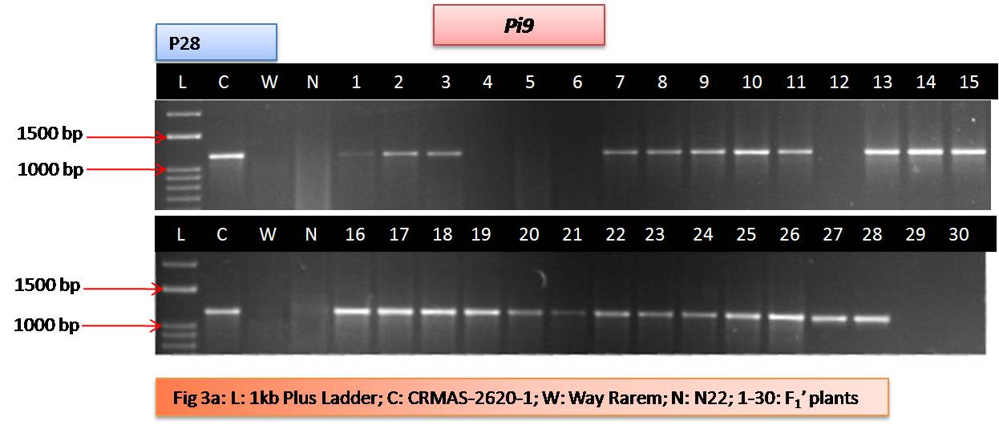
L= 50bp Ladder; C= CRMAS-2620-1; W= Way Rarem; N= N-22; 1-30= F₁’ samples

Supplementary Figure 3: Foreground Analysis of F₁’ plants for qDTYs.
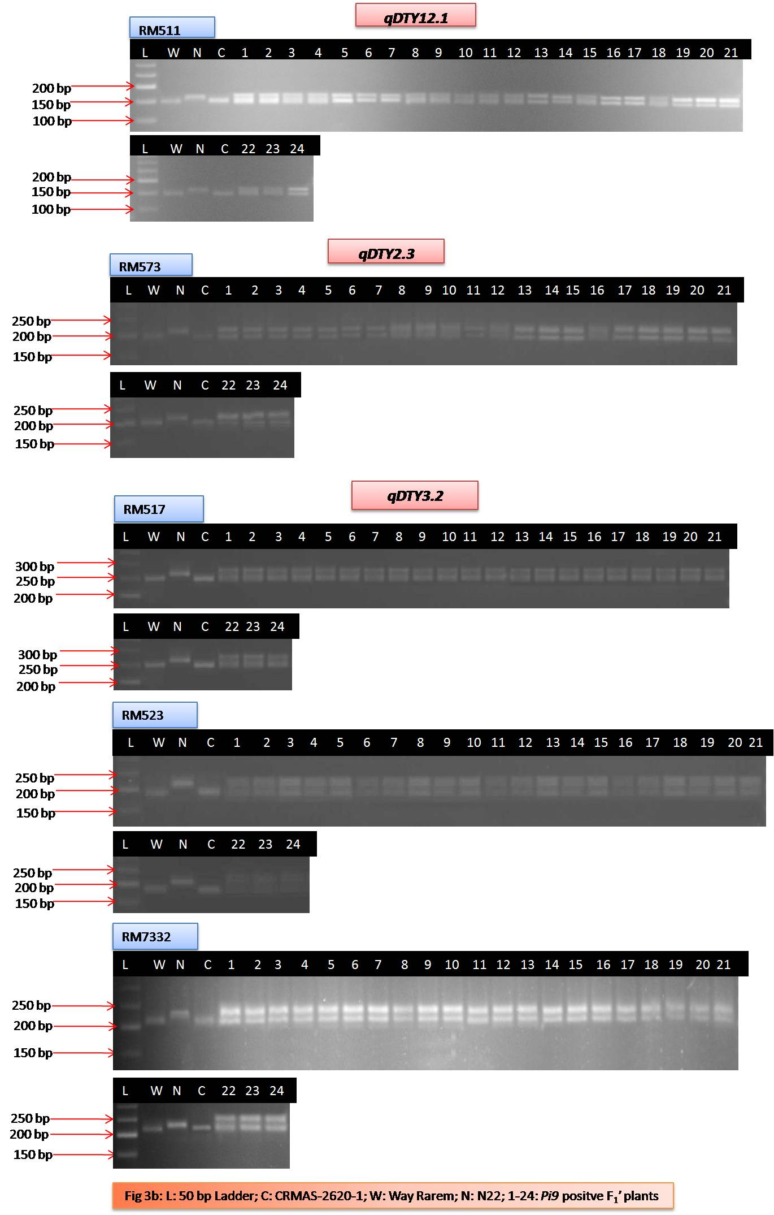
L= 50bp Ladder; C= CRMAS-2620-1; W= Way Rarem; N= N-22; 1-24= Pi9 positive F₁’ samples

Supplementary Figure 4: Representative gel photos of background analysis of BC₁F₁ plants.
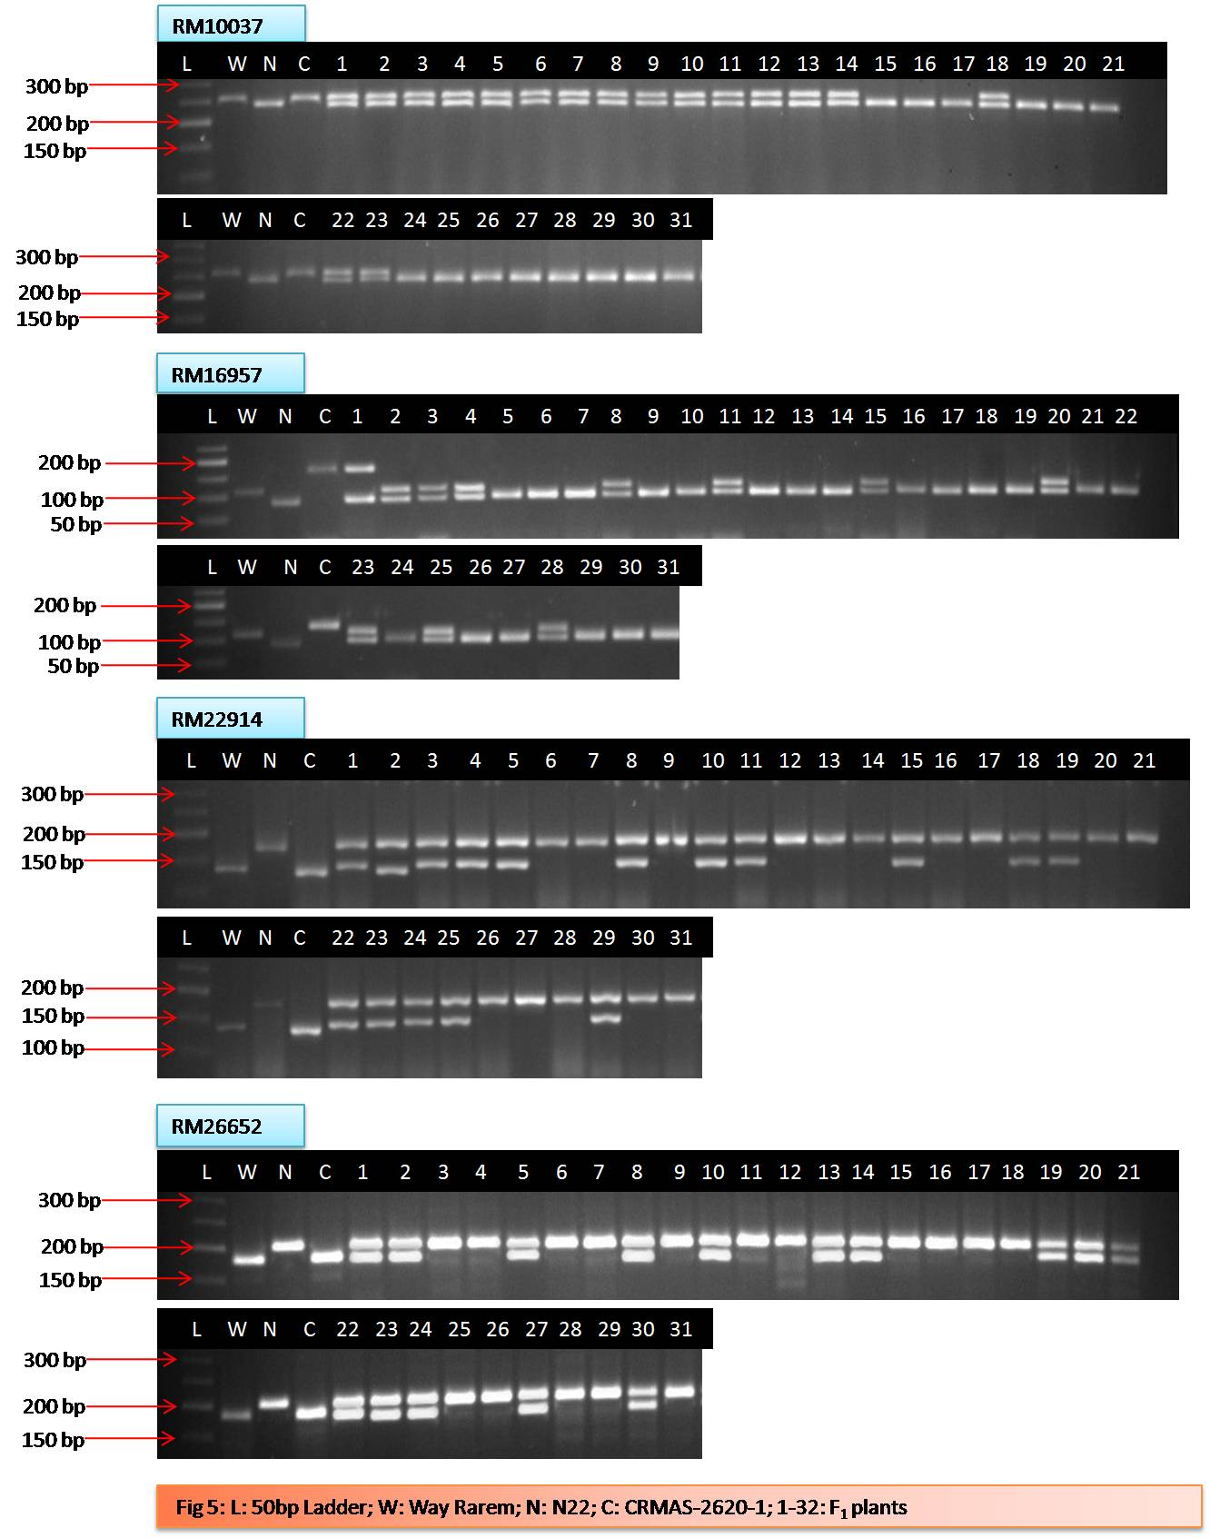
L= 50bp Ladder; C= CRMAS-2620-1; W= Way Rarem; N= N-22; 1-31= BC₁F₁ samples

Supplementary Figure 5: Screening of BILs, donors, RP and check genotypes against blast disease.
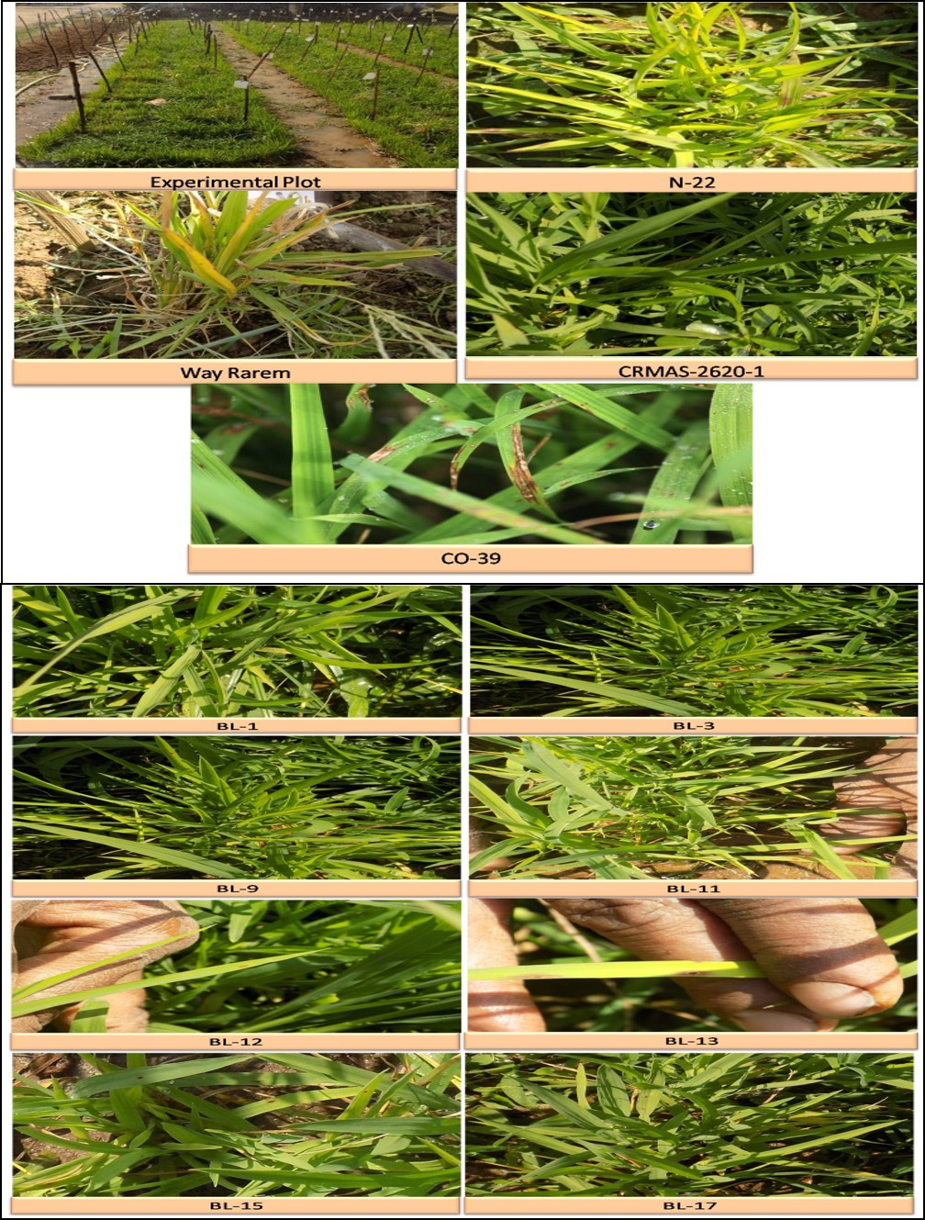
Supplementary Figure 6: Screening for qDTY1.1 using linked SSR marker (RM431).
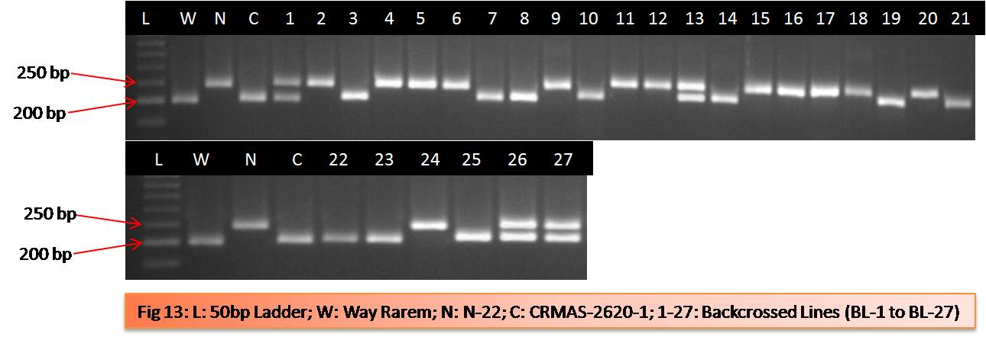
L= 50bp Ladder; W= Way Rarem; N= N-22; C= CRMAS-2620-1; 1-27= BC₂F₃ samples

