CuS Doped TiO₂ Nanotubes Synthesized from Ilmenite Concentrate for Degradation of Organic Dyes
Farhad Abbaspour ª, Mehdi Nasiri Sarvi ^{a, *}, Ebrahim Azimi ª
ª Department of Mining Engineering, Isfahan University of Technology, Isfahan 84156-83111, Iran.
∗ Corresponding author: Mehdi Nasiri Sarvi, email: mnsarvi@iut.ac.ir & mehdi.nasiri.sarvi@gmail.com, tel: +98 31 3391 5174, fax: +98 31 3391 2776.

Figure S 1. XRD pattern of the ilmenite sample after 3 times of leaching with 20 W:W% of HCl.

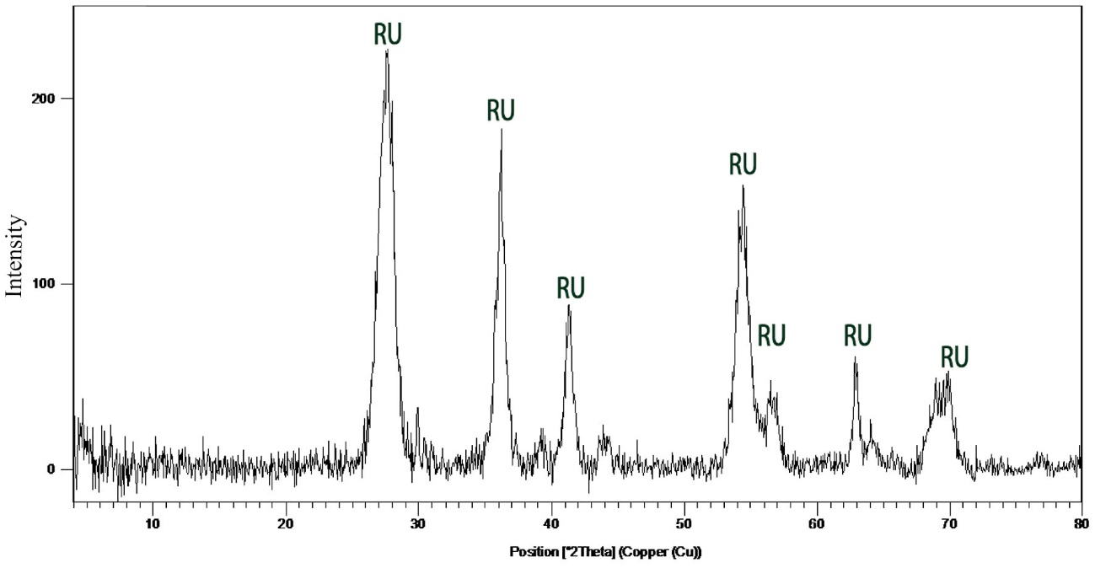
Figure S 2. XRD pattern of residual solid in one-step leaching process of ilmenite in presence of Fe powder with 20 W:W% of HCl at 95 °C
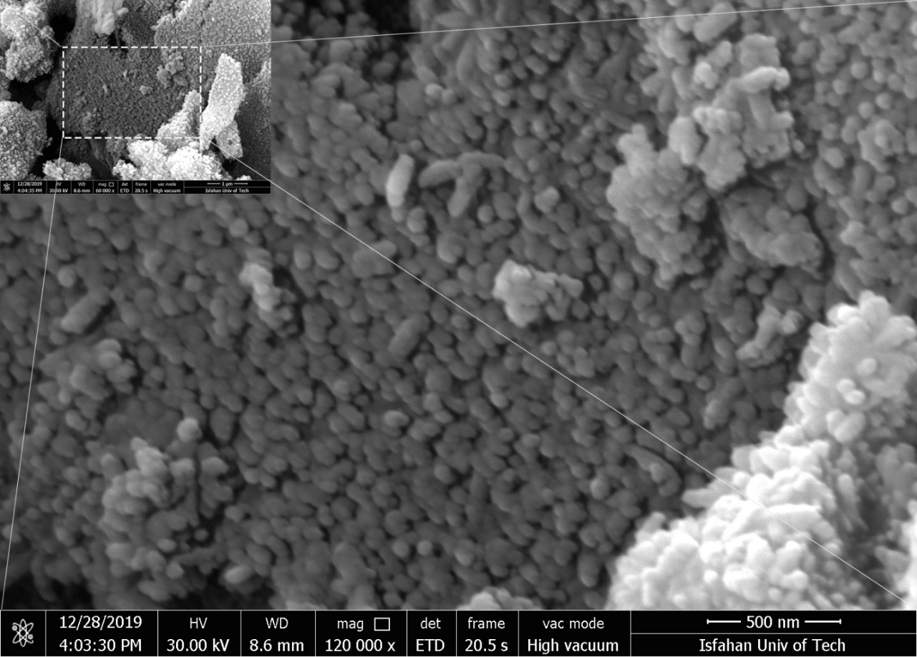
Figure S3. SEM image of TiO2 nanoparticles prepare after leaching of ilmenite using 20 W:W % of HCl in assistance of Fe powder
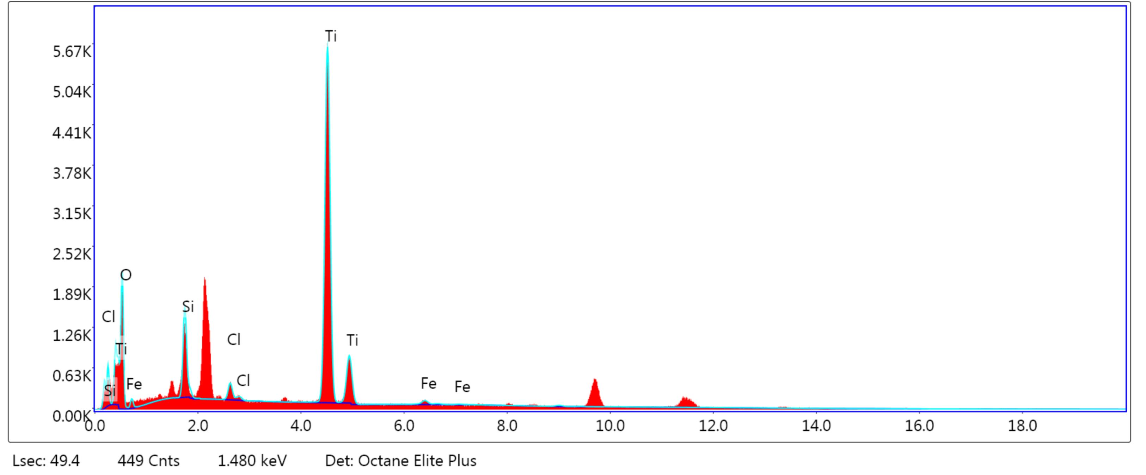
Figure S4. EDS analysis of the TiO2 nanoparticles prepare after leaching of ilmenite using 20 W:W % of HCl in assistance of Fe powder

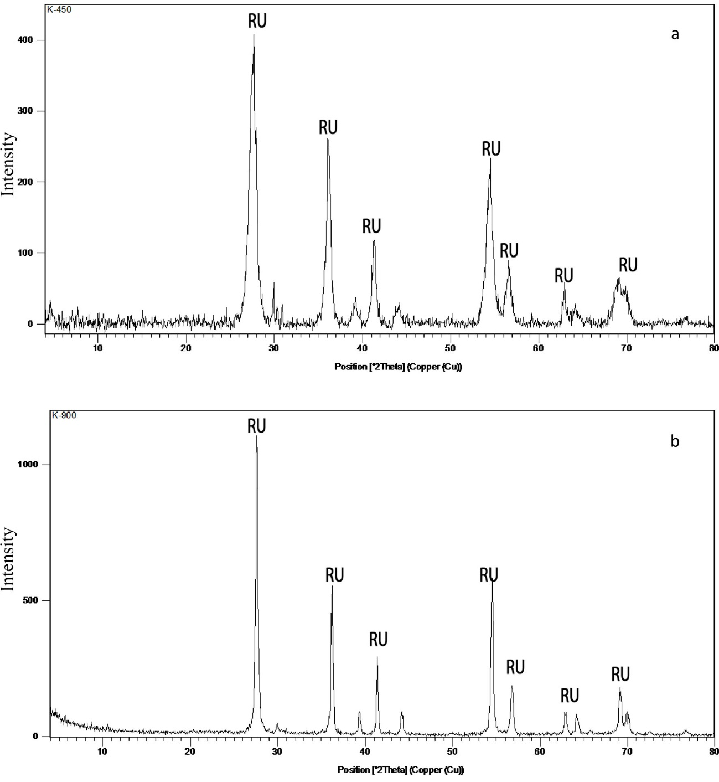
Figure S 5. XRD patterns of TiO₂ remained from ilmenite leaching using Fe powder after calcination at 350 °C (a) and 900 °C (b)

