SUPPLEMENTARY MATERIALS

Supplementary Table S1. Values of the coefficient “a” in Equation 1 and the R² and p-value of the standard curve for each gene region.

 | a | R² | p-value
RALYL | 0.59 | 0.99 | p < 0.001
TET2 | 0.47 | 0.95 | p < 0.001

Supplementary Table S2. Summary of sample information (n = 53).
Individual | Sex | Sampling date | Age (years) | Age class (years)¹ | Major age class¹
1 | M | 2008/01/20 | 0.25 | 0–1 | Calf
1 | M | 2008/01/31 | 0.25 | 0–1 | Calf
1 | M | 2008/03/02 | 0.417 | 0–1 | Calf
1 | M | 2008/07/23 | 0.75 | 0–1 | Calf
1 | M | 2009/03/16 | 1.5 | 1–5 | Juvenile
1 | M | 2010/02/04 | 2.583 | 1–5 | Juvenile
1 | M | 2010/05/26 | 2.75 | 1–5 | Juvenile
1 | M | 2011/06/13 | 3.67 | 1–5 | Juvenile
2 | M | 2018/05/28 | 6.583 | 5 –15 | Sub-adult
3 | M | 2022/01/01 | 17.583 | 15–20 | Adult
4 | F | 2004/08/26 | 0.417 | 0–1 | Calf
 |  | 2004/09/04 | 0.5 | 0–1 | Calf
 |  | 2004/09/21 | 0.5 | 0–1 | Calf
5 | F | 2017/10/21 | 9.583 | 5–15 | Sub-adult
5 | F | 2018/05/07 | 10.167 | 5–15 | Sub-adult
5 | F | 2018/05/09 | 10.167 | 5–15 | Sub-adult
5 | F | 2018/05/20 | 10.167 | 5–15 | Sub-adult
5 | F | 2019/05/19 | 11.167 | 5–15 | Sub-adult
6 | F | 2018/05/24 | 7.83 | 5–15 | Sub-adult
 |  | 2019/05/19 | 8.83 | 5–15 | Sub-adult
 |  | 2019/05/20 | 8.83 | 5–15 | Sub-adult
7 | F | 2016/08/30 | 6.417 | 5–15 | Sub-adult
7 | F | 2019/05/14 | 9.167 | 5–15 | Sub-adult
8 | F | 2006/08/27 | 16.33 | 15–20 | Adult
 |  | 2008/10/26 | 18.5 | 15–20 | Adult
9 | F | 2010 | 30 | 20–30 | Adult
 |  | 2021/11/07 | 40.83 | 40–50 | Adult
10 | F | 2010 | 29.83 | 20–30 | Adult
 |  | 2022/01/27 | 40.25 | 40–50 | Adult
11 | F | 2009/05/08 | 38 | 30–40 | Adult
11 | F | 2013/10/28 | 42 | 40–50 | Adult
11 | F | 2018/05/09 | 47.167 | 40–50 | Adult
11 | F | 2019/05/14 | 48 | 40–50 | Adult
11 | F | 2019/10/27 | 48 | 40–50 | Adult
12 | F | 2009 | 32.25 | 30–40 | Adult
 |  | 2009 | 32.25 | 30–40 | Adult
 |  | 2022/03/12 | 43.83 | 40–50 | Adult
13 | F | 2008/04/04 | 57 | > 50 | Adult
13 | F | 2008/04/07 | 57 | > 50 | Adult
13 | F | 2008/04/08 | 57 | > 50 | Adult
13 | F | 2008/04/09 | 57 | > 50 | Adult
14 | F | 2021/12/02 | 6.417 | 5–15 | Sub-adult

15 | F | 2022/01/10 | 8.917 | 5–15 | Sub-adult
16 | F | 2021/12/02 | 10.75 | 5–15 | Sub-adult
17 | F | 2009/06/25 | 11 | 5–15 | Sub-adult
18 | F | 2009/06/24 | 15 | 5–15 | Sub-adult
19 | F | 2022/01/07 | 20.167 | 20–30 | Adult
20 | F | 2021/12/09 | 30.33 | 30–40 | Adult
21 | F | 2009/06/29 | 32 | 30–40 | Adult
22 | F | 2023/03 | 38 | 30–40 | Adult
23 | F | 2009/07/17 | 39 | 30–40 | Adult
24 | F | 2010/06/07 | 42 | 40–50 | Adult
25 | F | 2021/12/09 | 44 | 40–50 | Adult
Supplementary Table S2. (continued)
¹ Categorizing Asian elephant individuals into respective age class and major age class was referred to Arivazhagan, C., and Sukumar, R. (2008).

Supplementary Table S3. Primer information and PCR conditions that was tested with other genes but amplification and dissociation results from real-time PCR were not satisfactory.

Gene | Primers | Length | n(CpGs) | NCBI sequence ID: position | References
TET2 | F: ggaagggTgTagTTagagagTTTagaa  R: tgtggagaggttattgagaagaaag  R: gggtatttggatttatagggagtg | 218  283 | 4  11 | NC_064833.1:  46696760–46696879 | Polanowski et al., (2014); Wright et al., (2018)
ELOVL2 | F: ggCgtttggTTagTagggT  R: tggtcttggtggttttcaaaca  R: tggtcttggtggttttcaaaca | 204  208 | 14  29 | NC_064833.1:  54556091–54556299 | Bekaert et al., (2015); Qi et al., (2021a)
ZFHX3 | F: ctggcagctggggctacTtt  R: tgtgcttgcaaaggatggag  F: gggtagagTagTagTTTatTtggag  R: agagctgtgtgtgggacctgag  F: gagagTtgtgtgtgggaTTtgag  R: gggaaggacaatgggtgC  R: gggcccctggacagcctgaggg | 139  238  192  311 | 4  6  7  11 | NC_064833.1:  37563009–37563698 | Prado et al., (2021)
Capital letter: bisulfite-converted letter (F: c → T, R: g → A)

Supplementary Table S4. Optimised parameters of support vector regression (SVR) models.

 | Cost | Gamma | Epsilon
Final age estimation model (RALYL, TET2) | 316.23 | 0.5 | 0.2
RALYL model | 100 | 1 | 0.5
TET2 model | 158.49 | 1 | 0.5

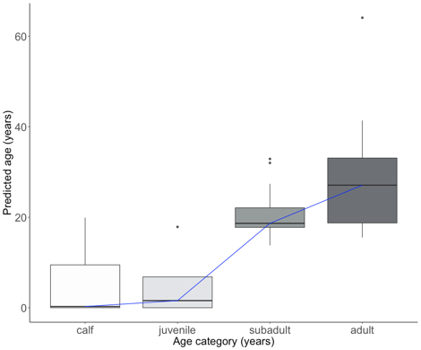
(b) TET2
- RALYL
(c) RALYL, TET2
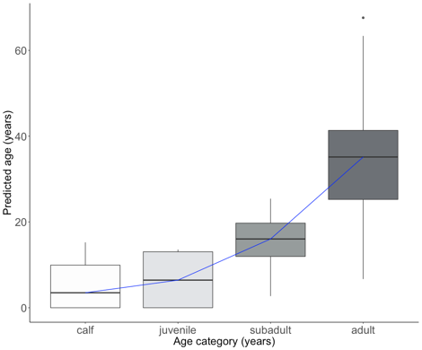
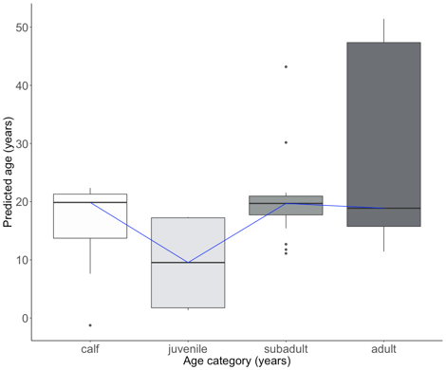

Supplementary Figure S1. Box plots representing the predicted age of Asian elephants and categorised into major age classes – calf, juvenile, subadult, and adult – of known age in three different regions: (a) RALYL, (b) TET2, and (c) RALYL and TET2. The boxplots show group medians (solid line), inter-quartile range (box outline) and spread of data with outliers (whiskers) for each group. The blue line connects the median from each age category. This shows the importance of the need to further break down and categorise each age class.

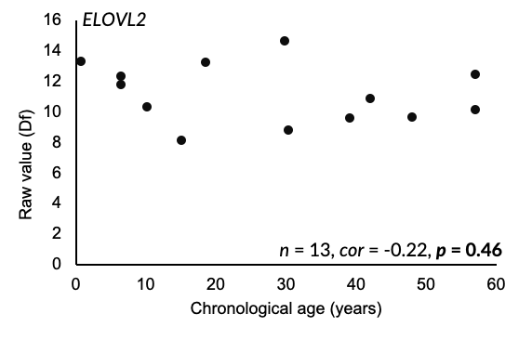

Supplementary Figure S2. Unsuccessful examples from attempts in ELOVL2. 13 blood DNA samples were analyzed, however there was no correlation between the Df values and chronological age.

