SUPPORTING INFORMATION:
Synthesis and screening of Clerodane Diterpene analogues from 16 hydroxycleroda 3,13(14)-Zdien 15,16-olide for potential anti-mycobacterial activity

Sony P. Kurati¹, Sruthi S. Bothsa¹, Patrick F. Kimariyo¹, Sangeetha Guruvelli¹, Suvarna B. Perupogu¹, Murali Krishna K. Muthyala¹*
1 Pharmaceutical chemistry research laboratory, Andhra university, Visakhapatnam, AP, INDIA
¹* Corresponding author email: profmmkau@gmail.com

LIST OF CONTENTS

Title page...........................................................................................................S1
CHARACTERIZATION OF COMPOUNDS (1-5)………………………………………………………..S2-S21

Characterisation of compound 1:
The Compound 1, white crystalline powder, m.p.,100-101°C. TLC mobile phase: 20% EtoAc: Hexane, R_{f} = 0.6. IR spectrum (in KBr) showed bands at 3435, 2922, 1751(C=O), 1650(C=C); ¹H NMR (400 MHz, CDCl₃, δ ppm); δ_{H} .45 (2H, m, H1), 2.04 (2H, m, H2), 5.19 (1H, m, H3), 1.15 (1H, m, H6), 1.467 (2H, m, H7), 1.452 (1H, m, H8), 1.45 (2H, m, H10), 1.50 (1H, m, H11), 2.28-2.36 (2H, m, H12), 5.83 (1H, s, H14), 6.02 (1H, s, H16), 0.82 (3H, d, J=5.1Hz, H17), 1.60 (3H, s, H18), 1.01 (3H, s, H19), 0.78 (3H, s, H20), ¹³C NMR (100 MHz, CDCl₃, δ ppm), 18.2 (C1), 26.8 (C2), 120.4 (C3), 144.2 (C4), 38.1 (C5), 36.7 (C6), 27.3 (C7), 36.3 (C8), 38.6 (C9), 46.4 (C10), 34.7 (C11), 21.3 (C12), 171.5 (C13), 116.8 (C14), 172.0 (C15), 99.4 (C16), 16.0 (C17), 18.1 (C18), 19.9 (C19), 18.2 (C20); It was found to have a molecular formula of C₂₀H₃₁O₃ by ESIMS m/z [M]⁺ 325.2.
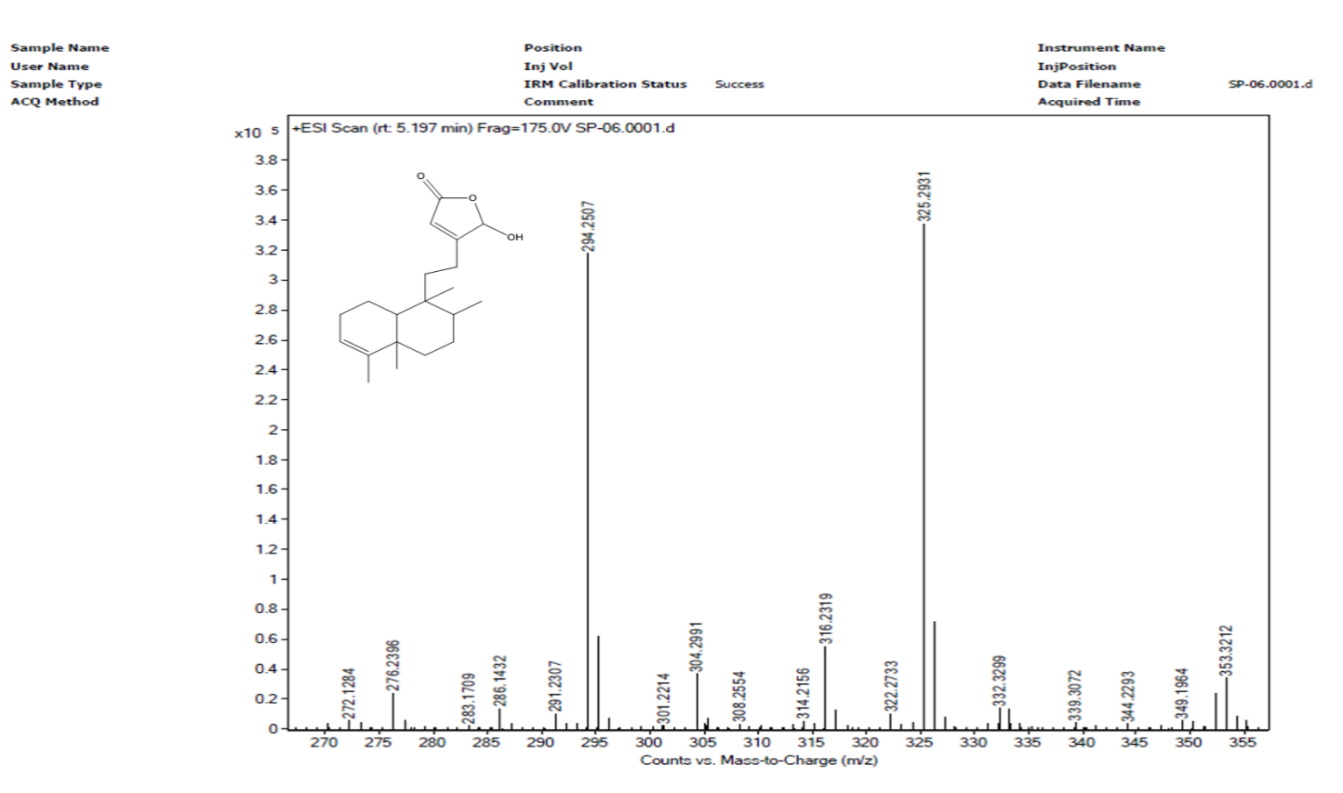
Fig1 Mass Spectrum of Compound 1

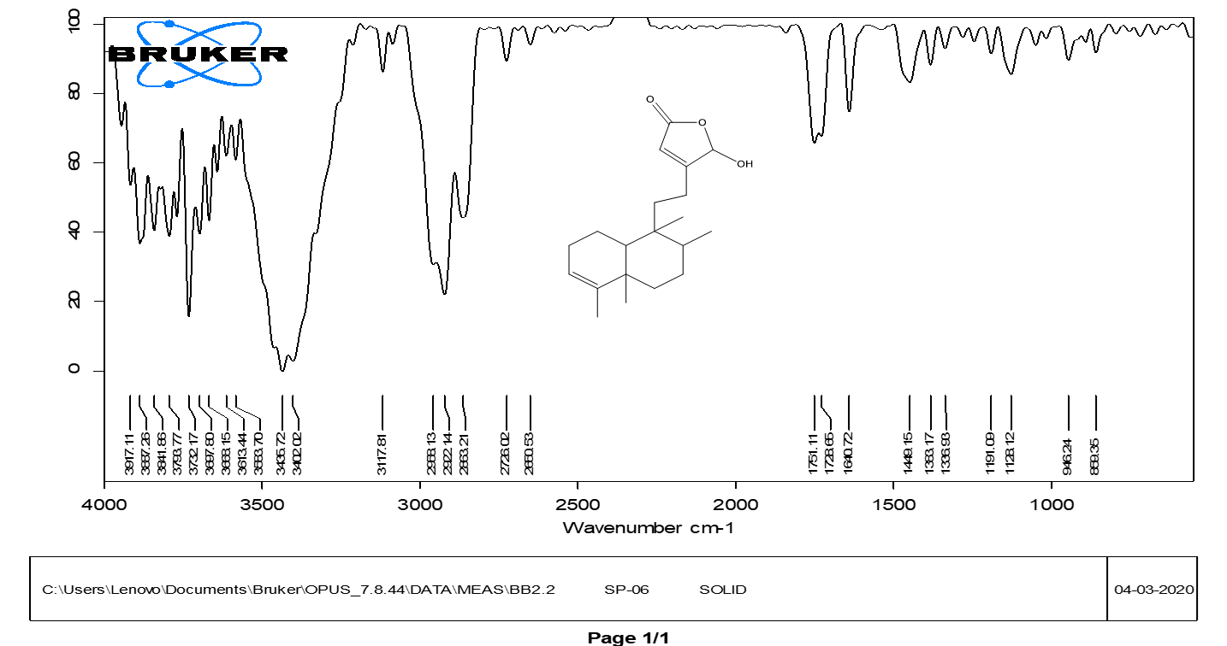
Fig2 IR Spectrum of Compound 1

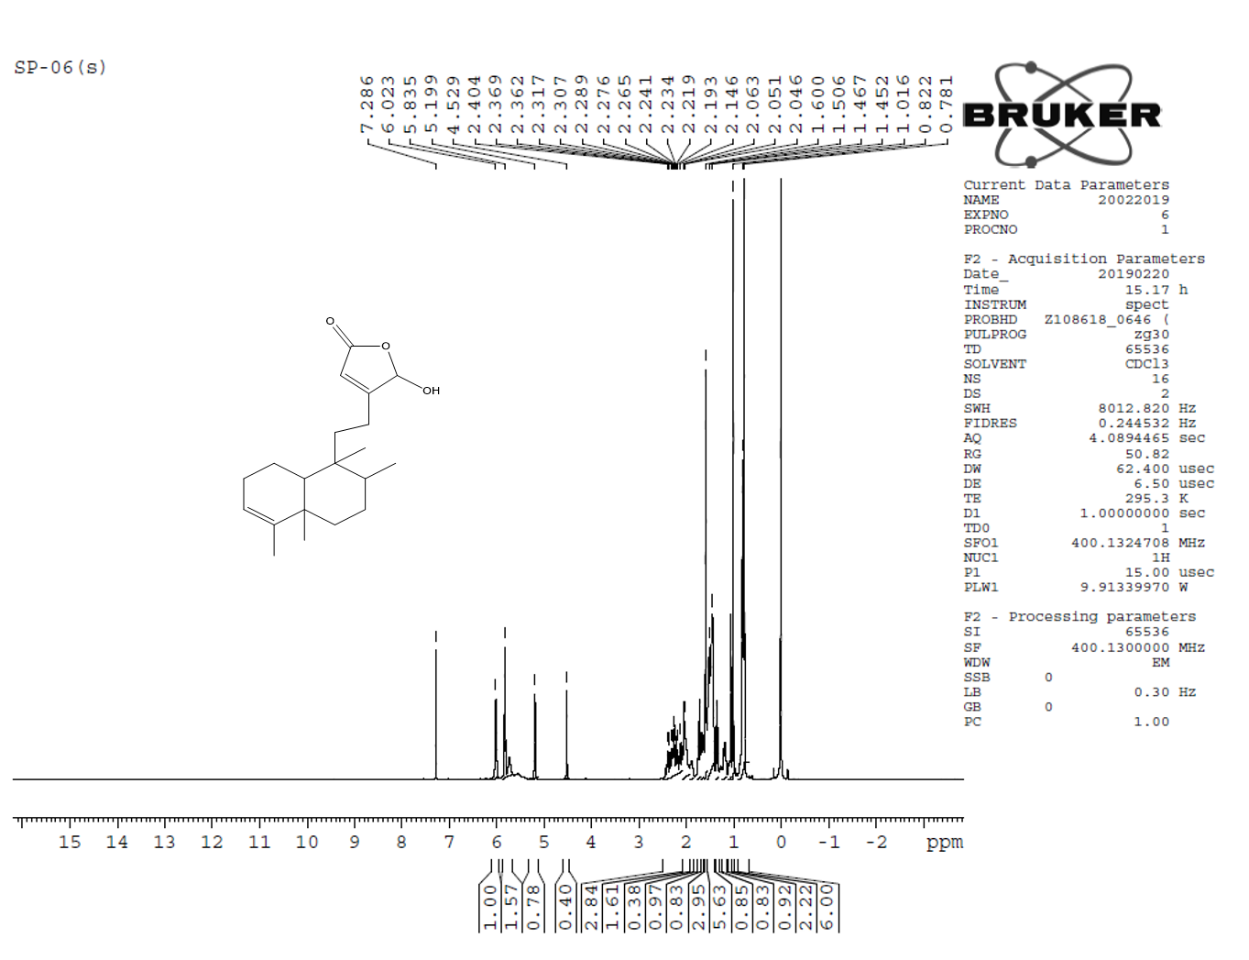
Fig3 ¹H NMR Spectrum of Compound 1

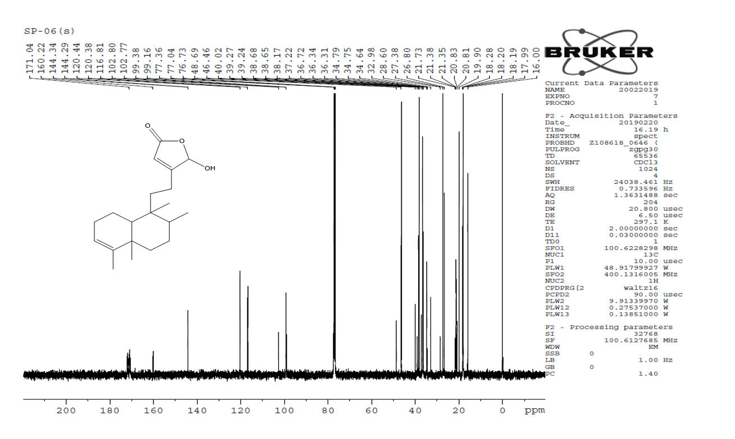
Fig4 ¹³C NMR Spectrum of Compound 1

Characterisation of compound 2:
The Compound 2, Oily yellow gum, m.p. 168-170˚C. TLC mobile phase: 20% EtoAc: Hexane, R_{f} = 0.5. IR spectrum (in KBr) showed bands at 1695(C=O str),1640(C=C), 2957 (C-H str); ¹H NMR (400 MHz, CDCl₃, δ ppm); δ_{H} .38-1.46 (2H, m, H1), 2.05-2.10 (2H, m, H2), 5.20 (1H, m, H3), 1.71 (1H, m, H6), 1.38-1.46 (2H, m, H7), 1.68-1.71 (1H, m, H8), 1.41 (2H, m, H10), 1.25-1.26 (1H, m, H11), 2.53-2.60 (2H, m, H12), 6.45 (1H, s, H14), 9.49 (1H, s, H16, 1-CHO), 0.84 (3H, d, J=5.1Hz, H17), 1.60 (3H, s, H18), 0.98 (3H, s, H19), 0.68 (3H, s, H20). ¹³C NMR (100 MHz, CDCl₃, δ ppm), 18.2 (C1), 26.8 (C2), 120.9 (C3), 143.8 (C4), 38.0 (C5), 36.7 (C6), 27.5 (C7), 36.2 (C8), 39.1 (C9), 46.4 (C10), 37.1 (C11), 19.6 (C12), 153.5 (C13), 137.6 (C14), 170.8 (C15), 196.5 (C16), 14.5 (C17), 17.9 (C18), 20.02 (C19), 18.2 (C20); It was found to have a molecular formula of C₂₀H₃₁O₃ by the negative mode of ESI [M]+ m/z 318.
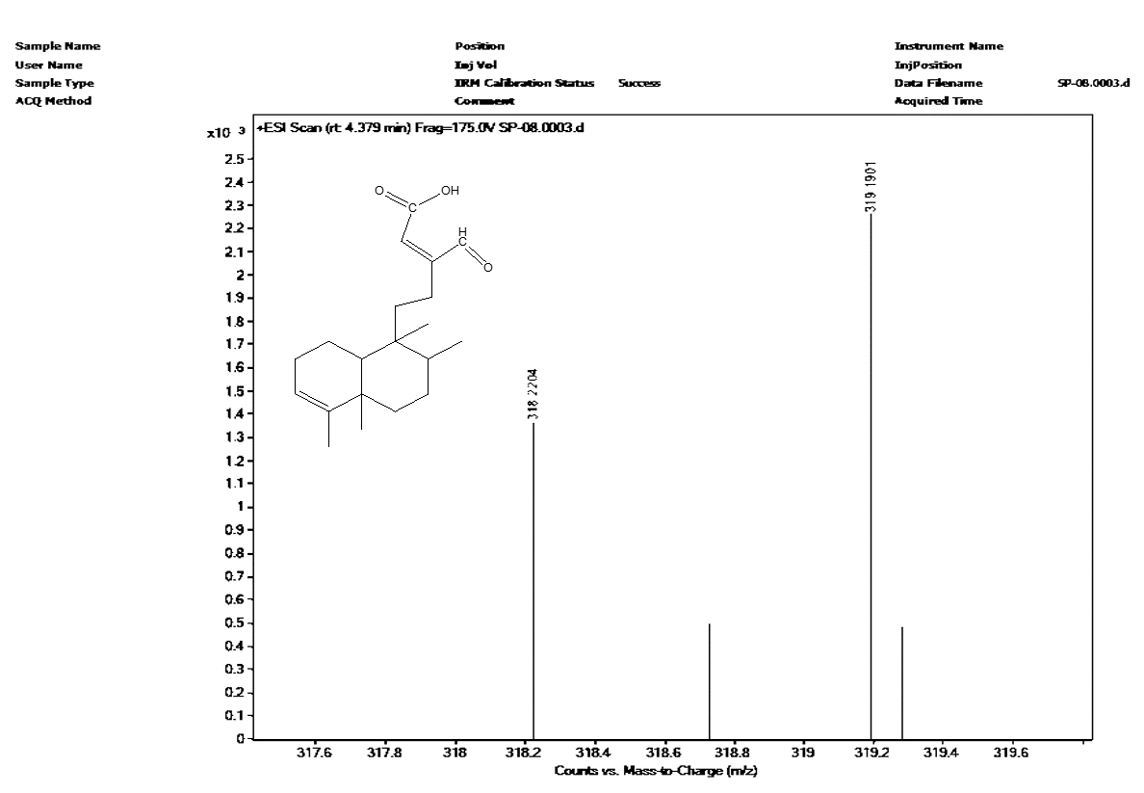

Fig5 Mass Spectrum of Compound 2

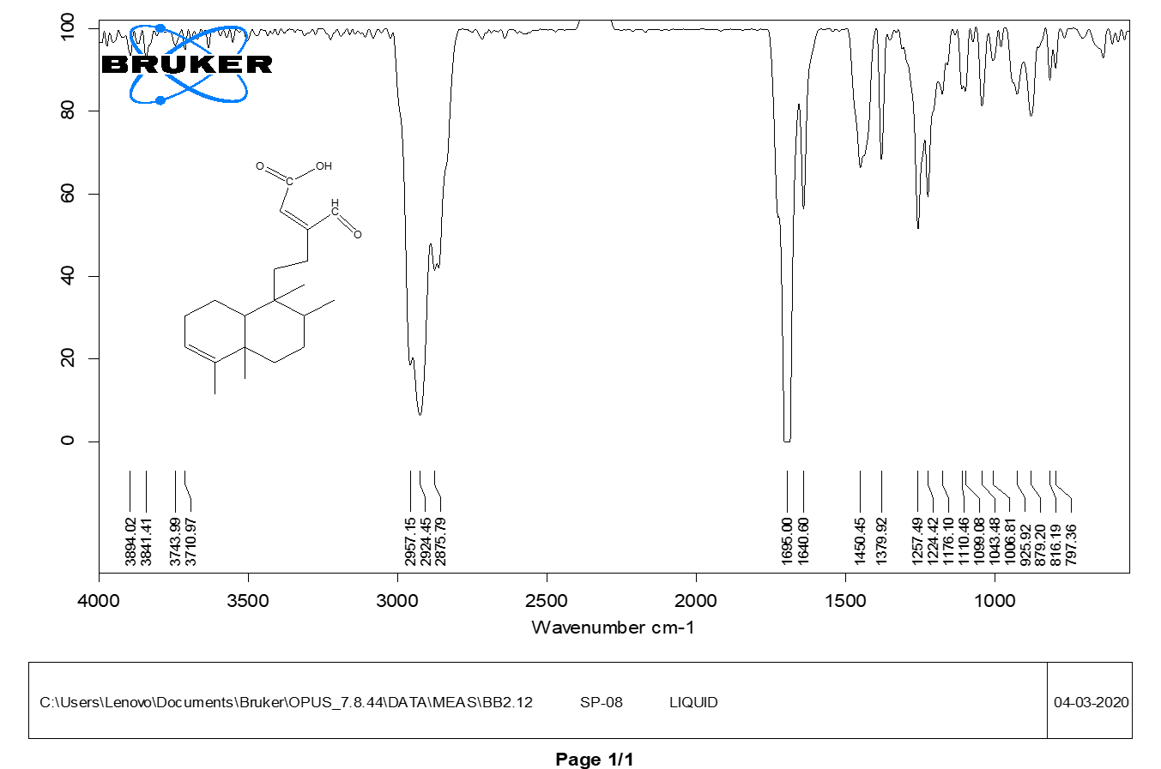
Fig6 IR Spectrum of Compound 2
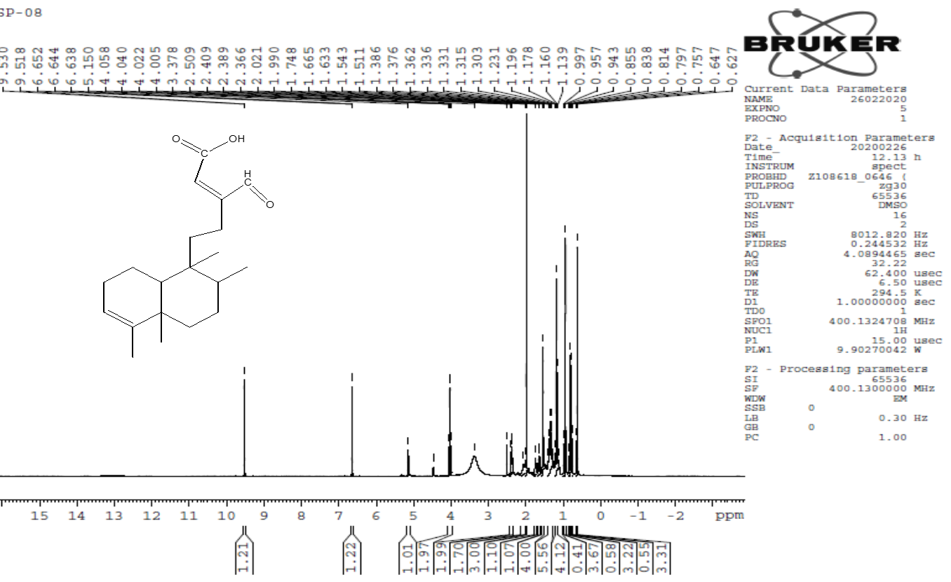
Fig7 ¹H NMR Spectrum of Compound 2

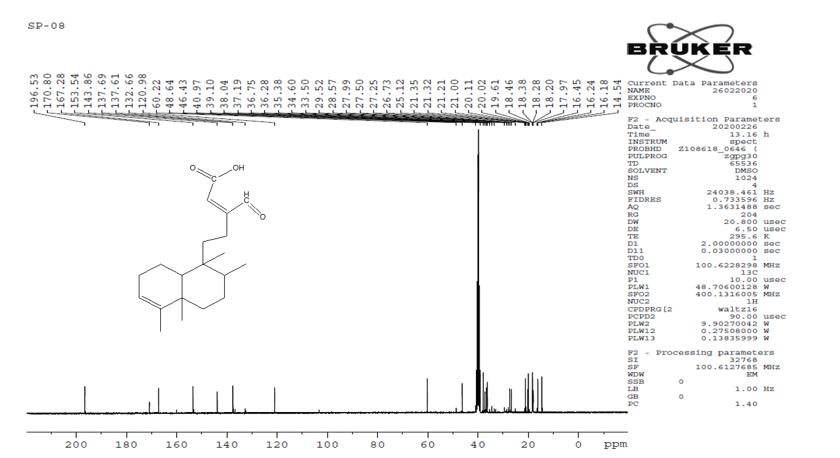
Fig8 ¹³C NMR Spectrum of Compound 2

Characterisation of compound 3:
The Compound 3, white crystalline powder, m.p. 195-197˚C, TLC mobile phase: 30% EtoAc: Hexane, R_{f} = 0.5; IR spectrum (in KBr) showed bands at 3575(N-H stretching), 2958(O-H stretching), 1676(C=O), 1603(C=C); ¹H NMR (400 MHz, CDCl₃, δ ppm); δ_{H} 1.43 (2H, m, H1), 2.05 (2H, m, H2), 5.22(1H, m, H3), 1.27-37 (1H, m, H6), 1.41 (2H, m, H7), 1.40 (1H, m, H8), 1.38 (2H, m, H10), 1.50-1.52 (1H, m, H11), 2.50 (2H, m, H12), 6.71 (1H, s, H14), 11.20 (1H, s, H15), 7.65 (1H, s, H16), 0.78 (3H, d, J=5.1Hz, H17), 1.64 (3H, s, H18), 1.03 (3H, s, H19), 0.86 (3H, s, H20) ¹³C NMR (100 MHz, CDCl₃, δ ppm), 18.31 (C1), 27.2 (C2), 120.2 (C3), 139.5 (C4), 38.1 (C5), 37.5 (C6), 26.78 (C7), 36.6 (C8), 38.9 (C9), 46.5 (C10), 36.3 (C11), 19.8 (C12), 126.3 (C13), 149.5 (C14), 161.5 (C15), 139.3 (C16), 16.1 (C17), 18.3 (C18), 20.6(C19), 19.6 (C20).
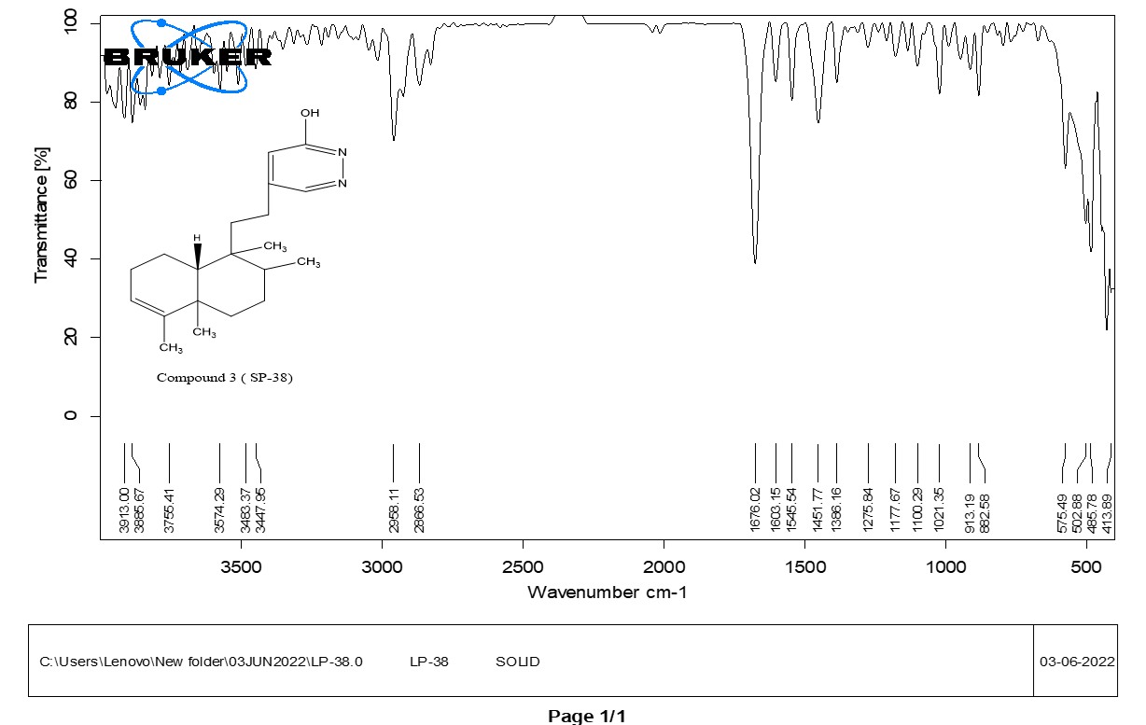

Fig9 IR Spectrum of Compound 3
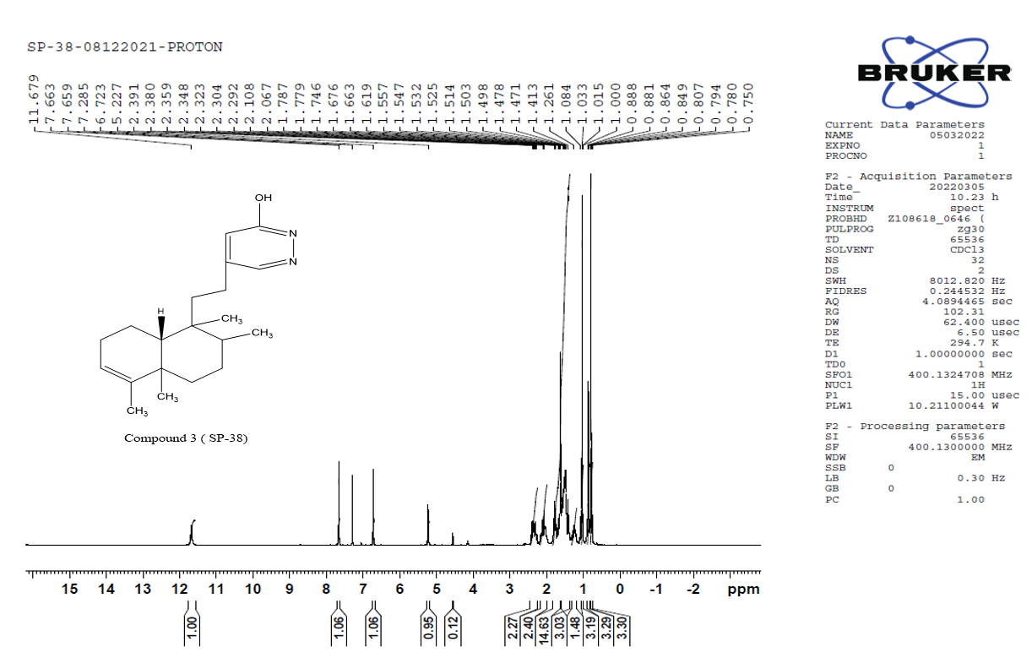

Compound 5 (SP-38)
Fig10 ¹H NMR Spectrum of Compound 3

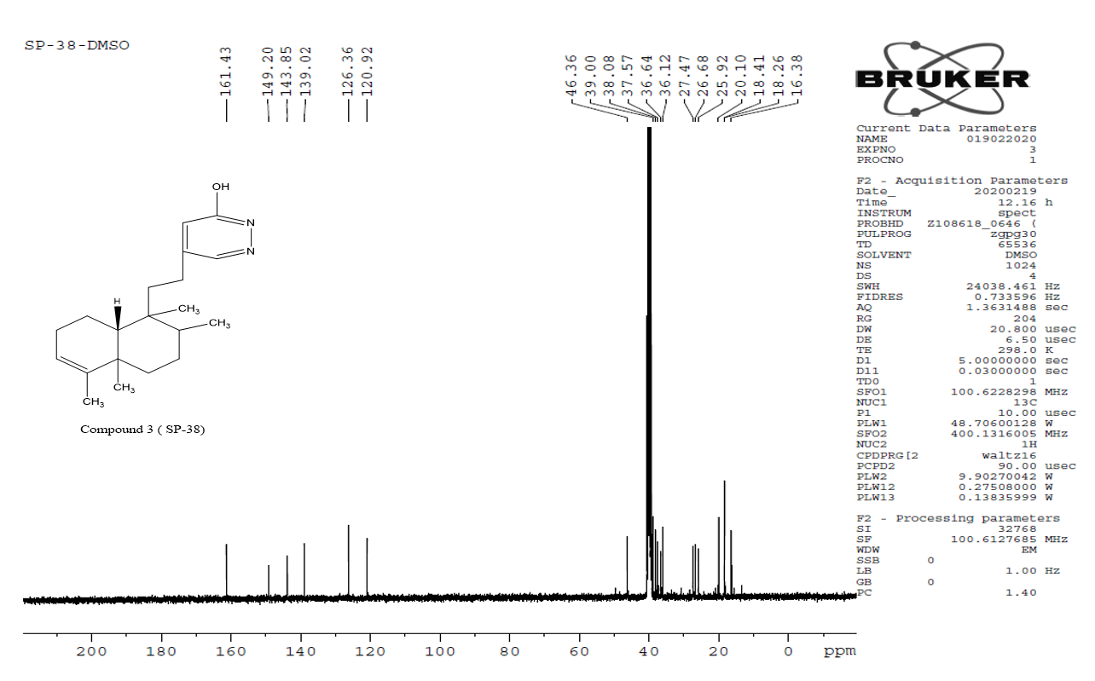

Compound 5 (SP-38)
Fig11 ¹³C NMR Spectrum of Compound 3
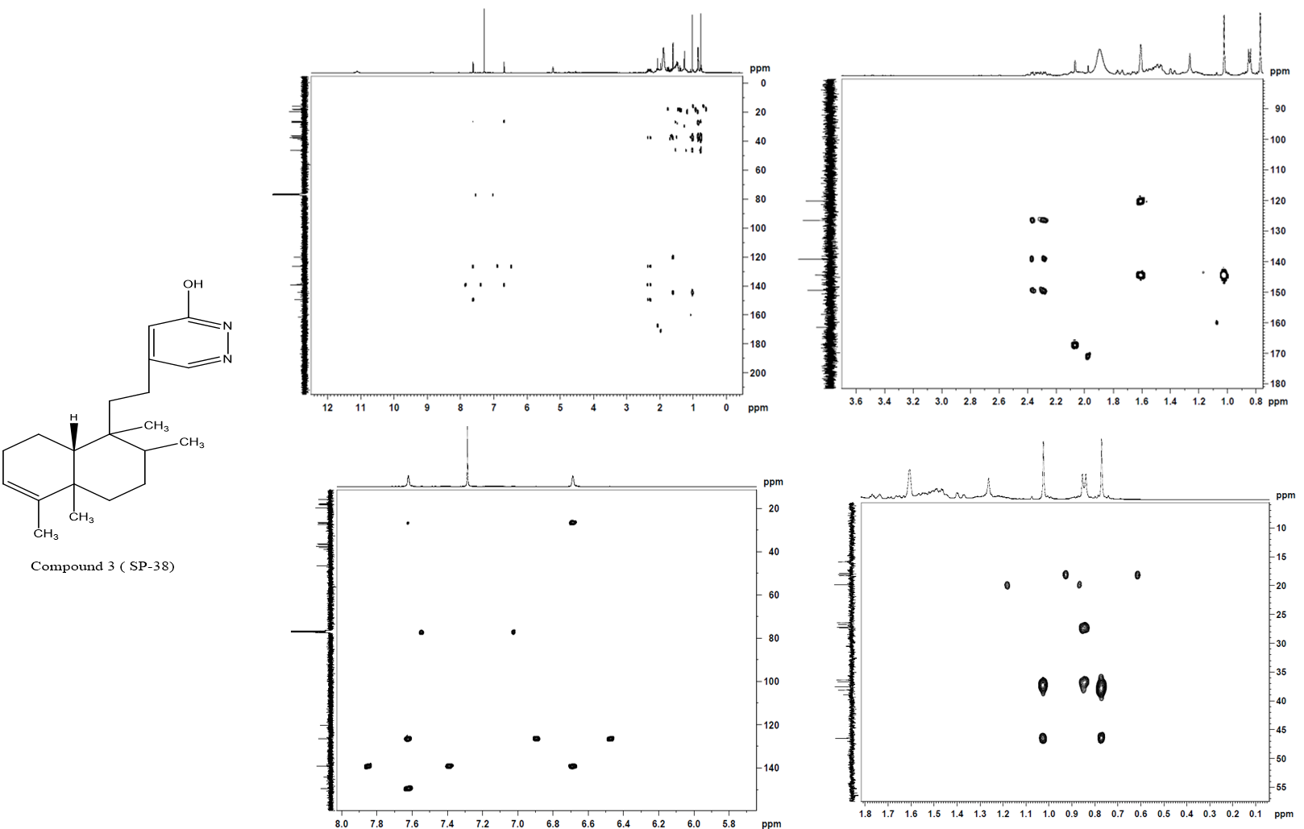

Compound 5 (SP-38)
Fig12 HMBC Spectrum of Compound 3
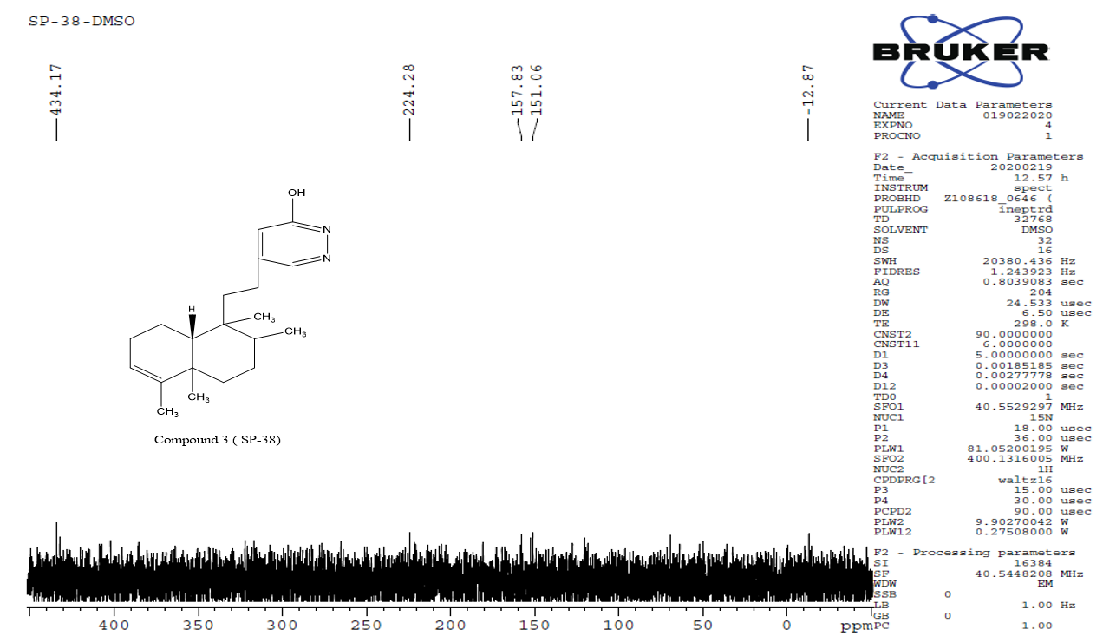

Compound 5 (SP-38)
Fig13 INEPT Spectrum of Compound 3

Characterisation of compound 4:
The Compound 4, pale-yellow crystalline powder, m.p. 189-190˚C, TLC mobile phase: 10% EtoAc: Hexane, R_{f} = 0.5, IR spectrum (in KBr) showed bands at 3857 (N-H stretching), 2925 (O-H stretching), 1707 (C=O), 1640 (C=C) 1463 (C-H) ; ¹H NMR (400 MHz, CDCl₃, δ ppm); δ_{H} 1.39 (2H, m, H1), 1.43 (2H, m, H2), 1.41 (1H, m, H6), 1.44-1.47 (2H, m, H7), 1.60 (1H, m, H8), 1.32 (2H, m, H10), 1.50-1.51 (1H, m, H11), 1.62 (2H, m, H12), 6.62 (1H, s, H14), 12.84 (1H, s, H15), 7.76 (1H, s, H16), 0.70 (3H, d, 1Hz, H17), 1.54 (3H, s, H18), 1.01 (3H, s, H19), 0. 82 (3H, s, H20), ¹³C NMR (100 MHz, CDCl₃, δ ppm), 28.7 (C1), 27.0 (C2), , 31.4 (C4), 29.3 (C5), 36.4 (C6), 25.9 (C7), 37.2 (C8), 39.9 (C9), 49.4 (C10), 35.9 (C11), 31.4 (C12),126.3 (C13), 124.25 (C14), 141.59 (C15), 138.19 (C16), 0.70 (3H, d, 1Hz, H17), 1.54 (3H, s, H18), 1.01 (3H, s, H19), 0. 82 (3H, s, H20).

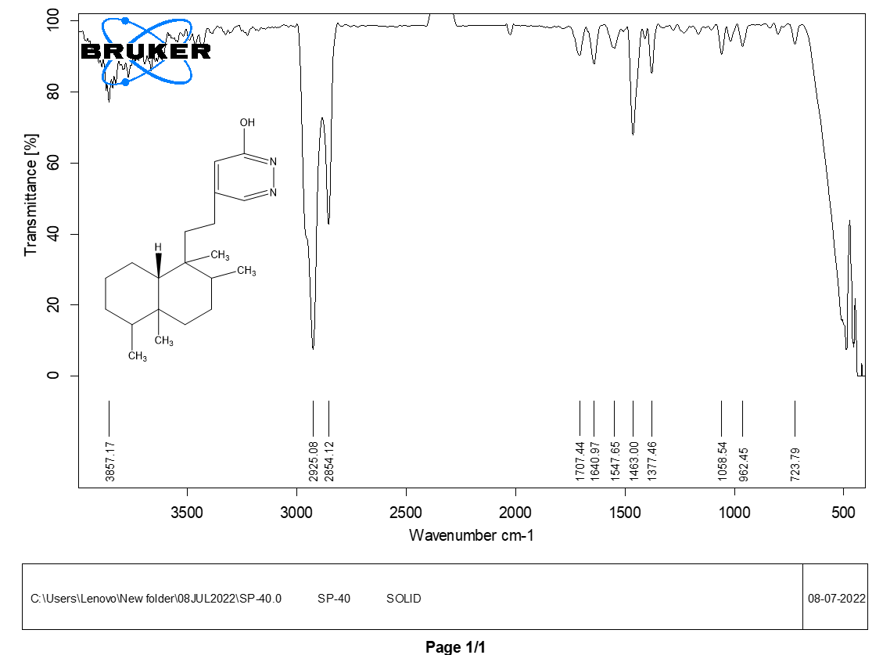

Fig14 IR Spectrum of Compound 4

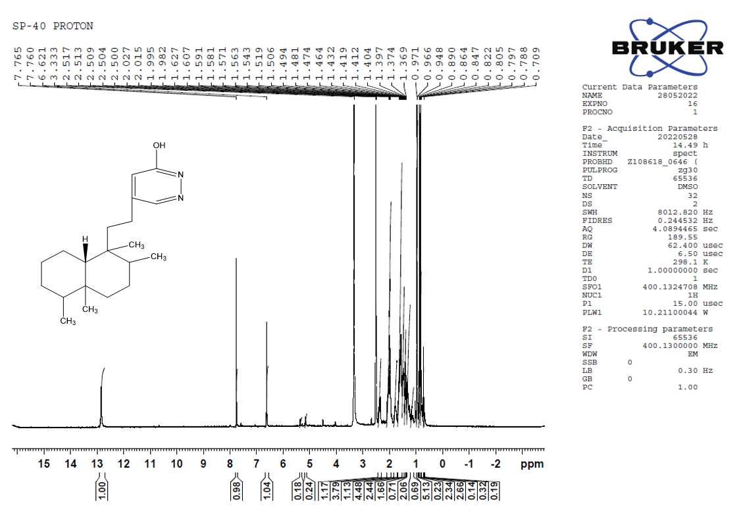

Fig15 ¹H NMR Spectrum of Compound 4

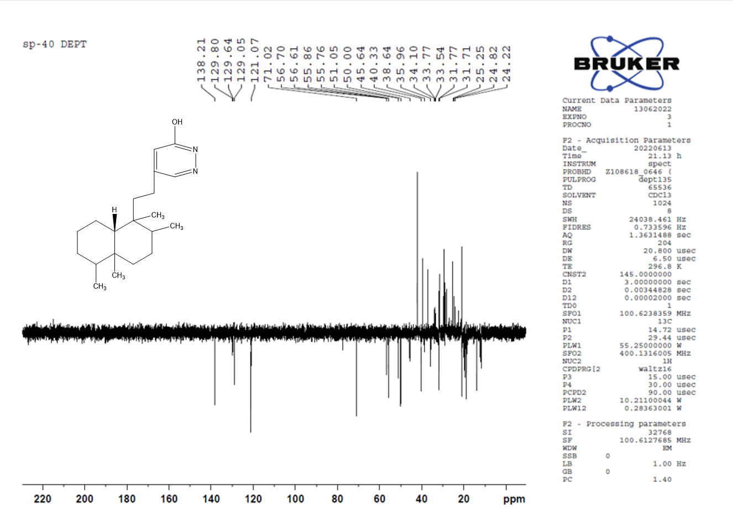

Fig16 ¹³C NMR Spectrum of Compound 4

Characterisation of compound 5:
The Compound 5, white crystalline powder, m.p. 190-205˚C, TLC using 40% EtoAc: Hexane, R_{f} = 0.5, IR spectrum (in KBr) showed bands at 3266(N-H stretching), 2958(O-H stretching), 1681(C=O), 1641(C=C); ¹H NMR (400 MHz, CDCl₃, δ ppm); δ_{H} 1.38 (2H, m, H1), 1.46 (2H, m, H2), 5.14 (1H, m, H3), 1.42 (1H, m, H6), 1.43-1.46 (2H, m, H7), 1.63 (1H, m, H8), 1.0 (2H, m, H10), 11.50-1.52 (1H, m, H11), 1.99 (2H, m, H12), 6.05 (1H, s, H14), 11.425 (1H, s, H15), 8.27 (1H, s, H16), 1.01 (3H, d, J=5.1Hz, H17), 1.54 (3H, s, H18), 1.03 (3H, s, H19), 0.83 (3H, s, H20), ¹³C NMR (100 MHz, CDCl₃, δ ppm), 28.3 (C1), 26.73 (C2), 120.79 (C3), 143.99 (C4), 38.04 (C5), 36.66 (C6), 27.41 (C7), 38.04 (C8), 38.85 (C9), 46.44 (C10), 36.19 (C11), 32.28 (C12), 122.55 (C13), 149.56 (C14), 170.59 (C15), 152.27 (C16), 16.0 (C17), 18.1 (C18), 19.9(C19), 18.2 (C20).
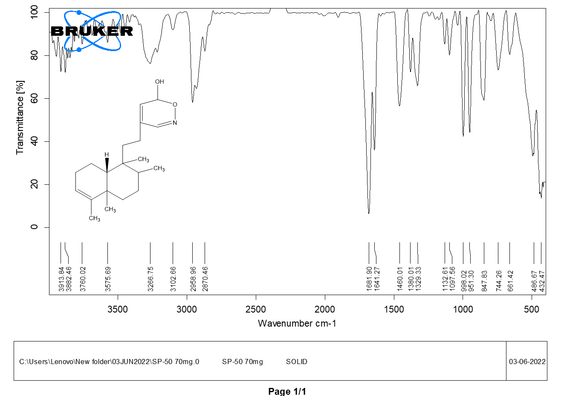

Fig17 IR Spectrum of Compound 5
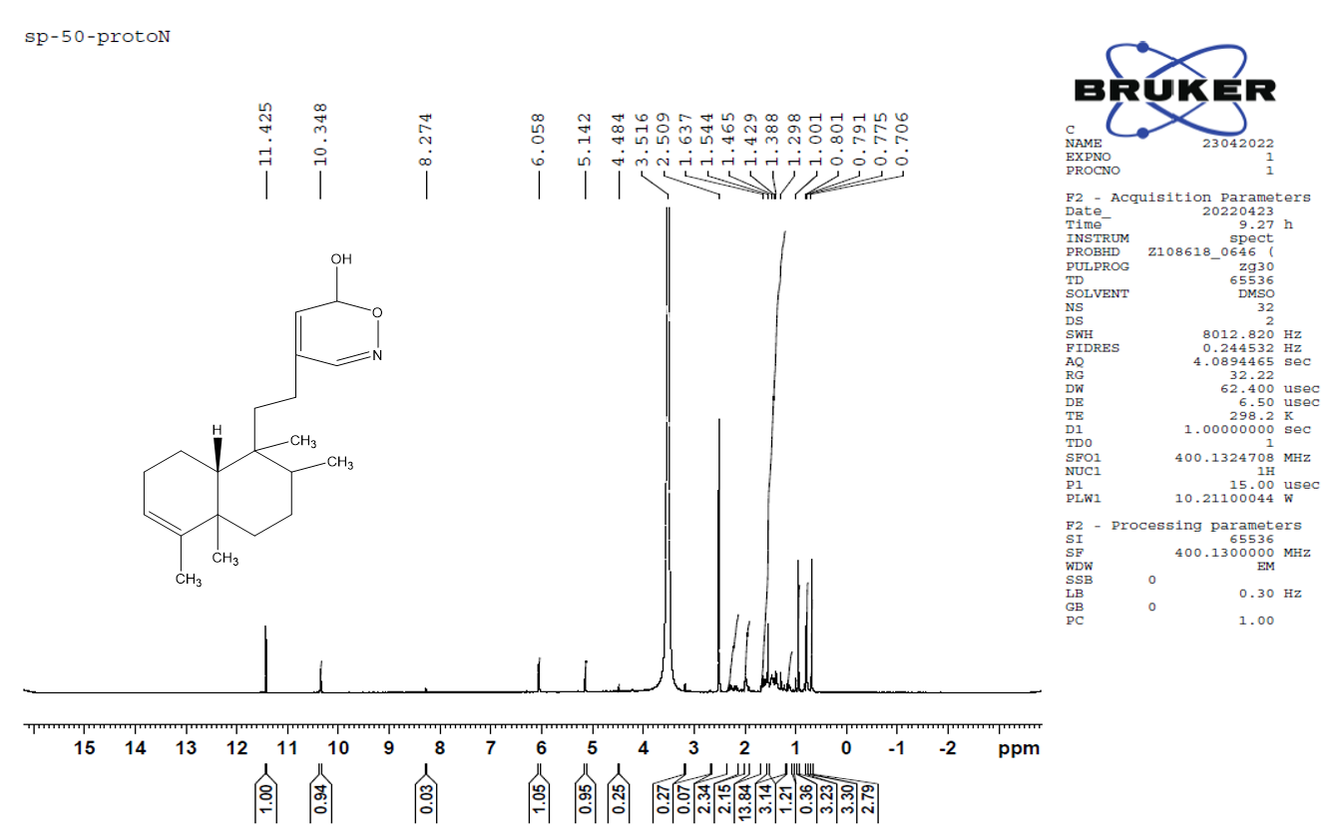

Fig18 ¹H NMR Spectrum of Compound 5

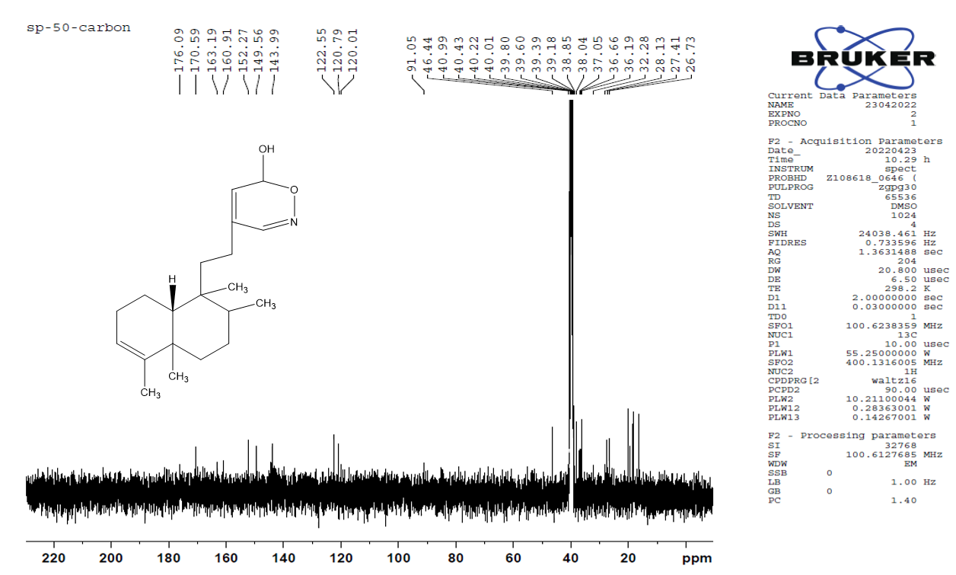

Fig19 ¹³C NMR Spectrum of Compound 5
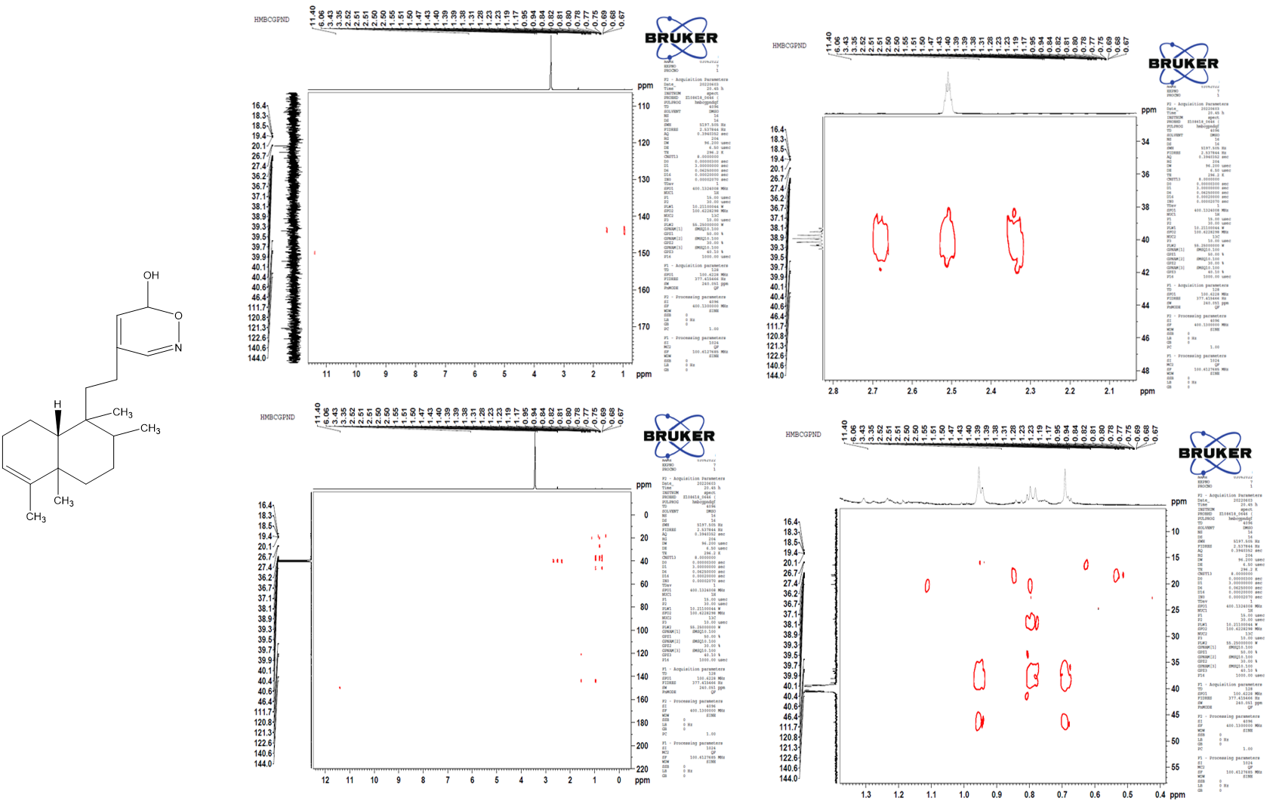

Fig20 HMBC Spectrum of Compound 5

