A negative feedback on El Niño events caused by extreme fire activity in equatorial Asia
Matthew Kasoar, Clara Bayley, Christopher Wells, and Apostolos Voulgarakis
Supplementary information

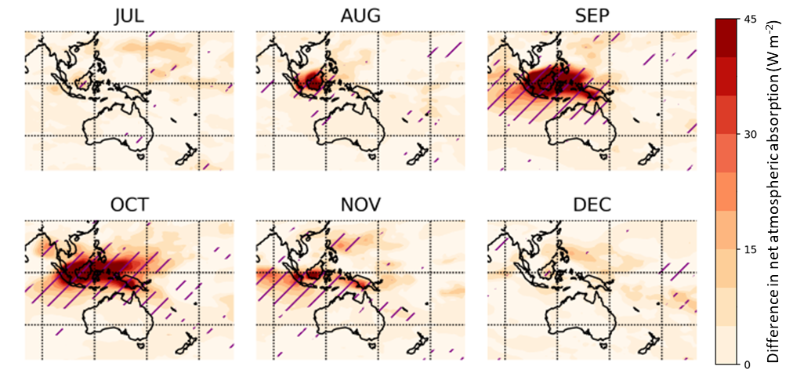
Supplementary Figure 1 | Monthly ensemble mean difference in atmospheric absorption between the BB97 ensemble and the Control13 ensemble. Atmospheric absorption is calculated as the difference in net down (all-sky shortwave + longwave) radiative flux between the top of atmosphere and the surface. Purple hashing denotes that the change is significant at the 95% level using a paired Student’s t-test.

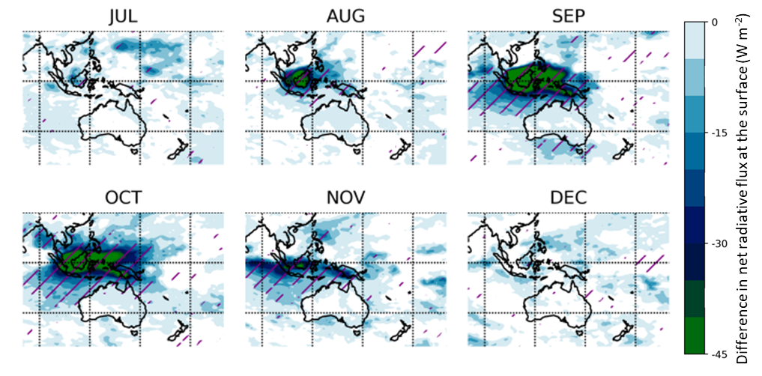
Supplementary Figure 2 | Monthly ensemble mean difference in net surface radiative flux, between the BB97 ensemble and the Control13 ensemble. The radiative flux change is calculated as the difference in net down (all-sky shortwave + longwave) radiative flux at the surface, between the two ensembles. Purple hashing denotes that the change is significant at the 95% level using a paired Student’s t-test.

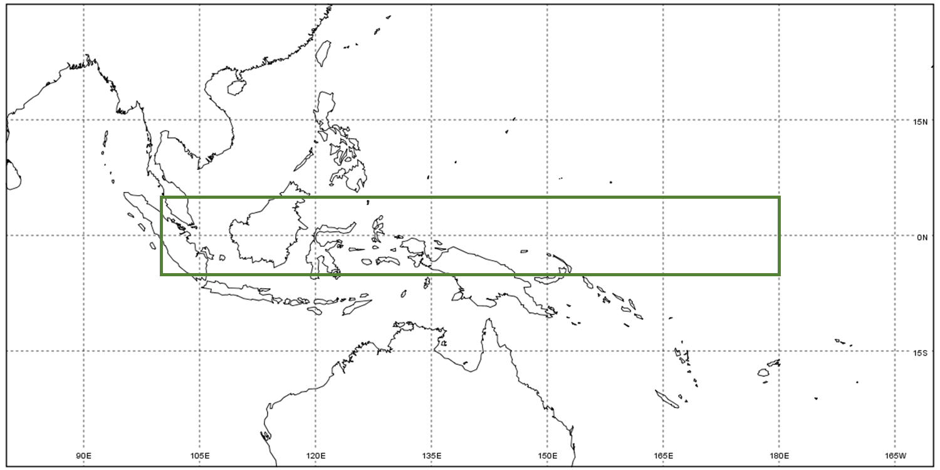
Supplementary Figure 3 | Map showing the Maritime Continent and western Pacific Ocean. The green box indicates the horizonal area that is represented in all the longitude-height figures (main text Figures 3, 4, & 5; Supplementary Figures 6 & 8)

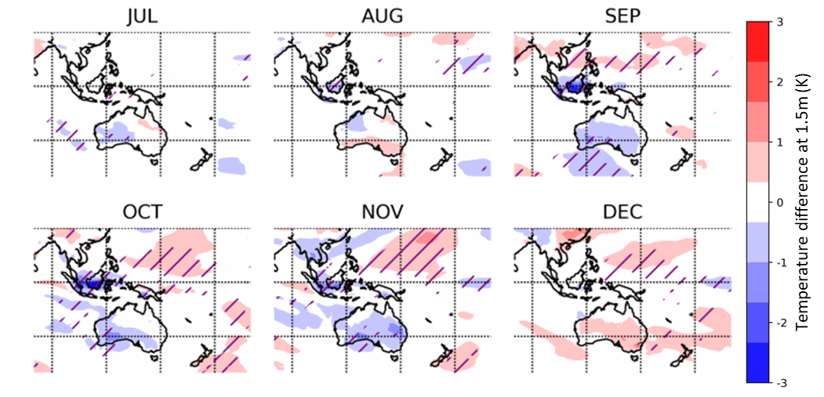
Supplementary Figure 4 | Monthly ensemble mean difference in near-surface air temperature between the BB97 ensemble and the Control13 ensemble. Each ensemble was run for 24 months starting from January 1997 or 2013 respectively, with the El Niño event peaking in autumn-winter of the first year, and monthly differences are shown here from July of the first year, through to March of the second year. Purple hashing denotes that the change is significant at the 95% level using a paired Student’s t-test.

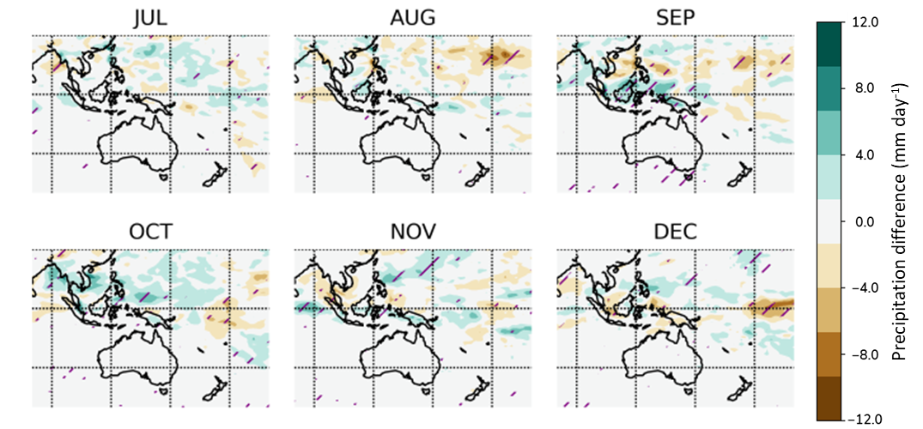
Supplementary Figure 5 | Monthly ensemble mean difference in total precipitation between the BB97 ensemble and the Control13 ensemble. Each ensemble was run for 24 months starting from January 1997 or 2013 respectively, with the El Niño event peaking in autumn-winter of the first year, and monthly differences are shown here from July of the first year, through to March of the second year. Purple hashing denotes that the change is significant at the 95% level using a paired Student’s t-test.

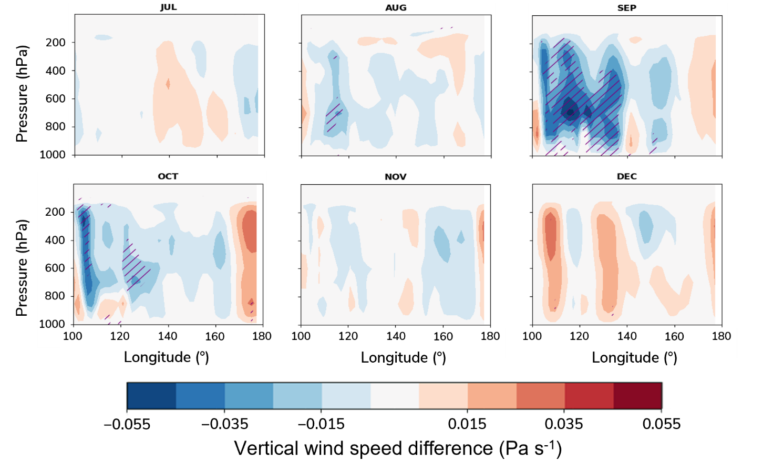
Supplementary Figure 6 | Monthly ensemble mean difference in equatorial vertical pressure velocity, between the BB97 ensemble and the Control13 ensemble. Pressure velocity (ω) is diagnosed on pressure levels and averaged from 5°S to 5°N, and plotted here for 100°E - 180°E. Purple hashing denotes the change is significant at the 95% level using a paired Student’s t-test. For reference, the horizontal region represented is shown in Supplementary Figure 3.

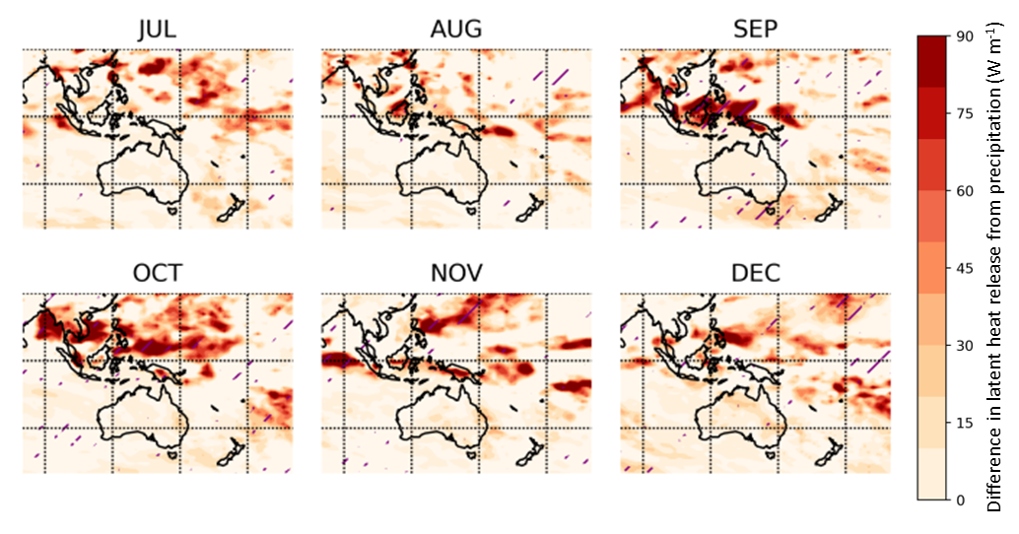
Supplementary Figure 7 | Monthly ensemble mean difference in latent heat release from precipitation, between the BB97 ensemble and the Control13 ensemble. Atmospheric latent heating is estimated from the monthly precipitation change (Supplementary Figure 5), multiplied by the latent heat of vaporization for water. Purple hashing denotes that the change is significant at the 95% level using a paired Student’s t-test. Note that the contour range is double that of Supplementary Figure 1.

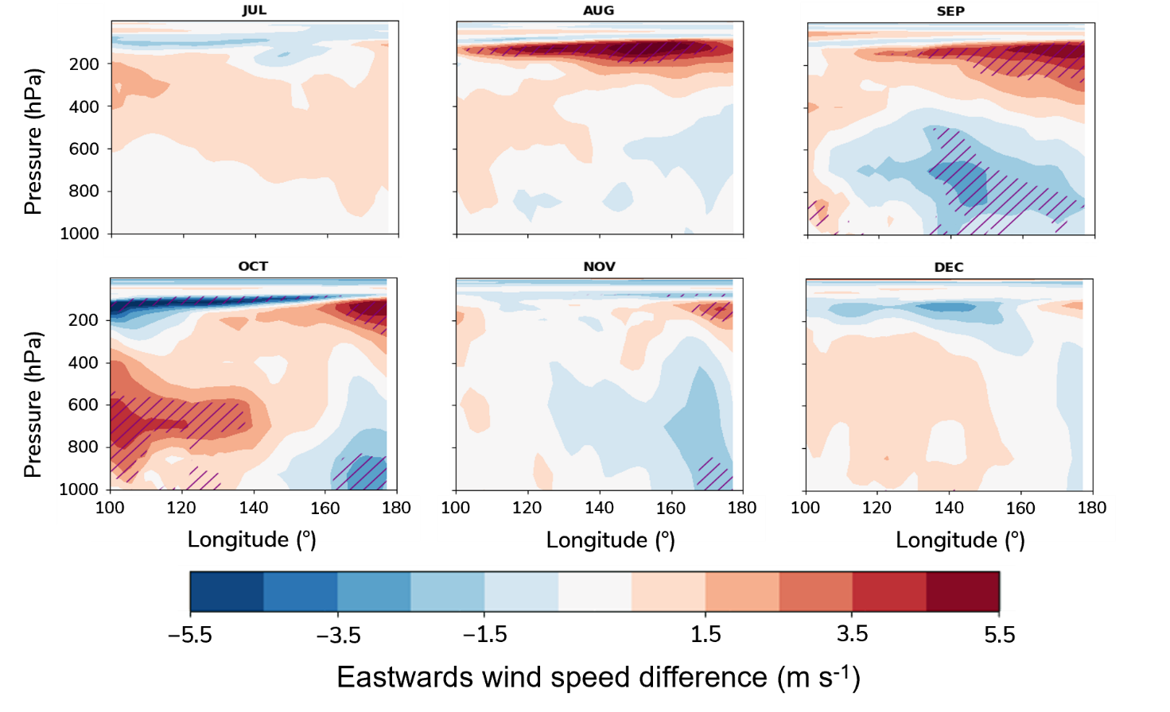
Supplementary Figure 8 | Monthly ensemble mean difference in equatorial eastward wind velocity, between the BB97 ensemble and the Control13 ensemble. Zonal wind velocity (u) is diagnosed on pressure levels and averaged from 5°S to 5°N, and plotted here for 100°E - 180°E. Purple hashing denotes the change is significant at the 95% level using a paired Student’s t-test. For reference, the horizontal region represented is shown in Supplementary Figure 3.

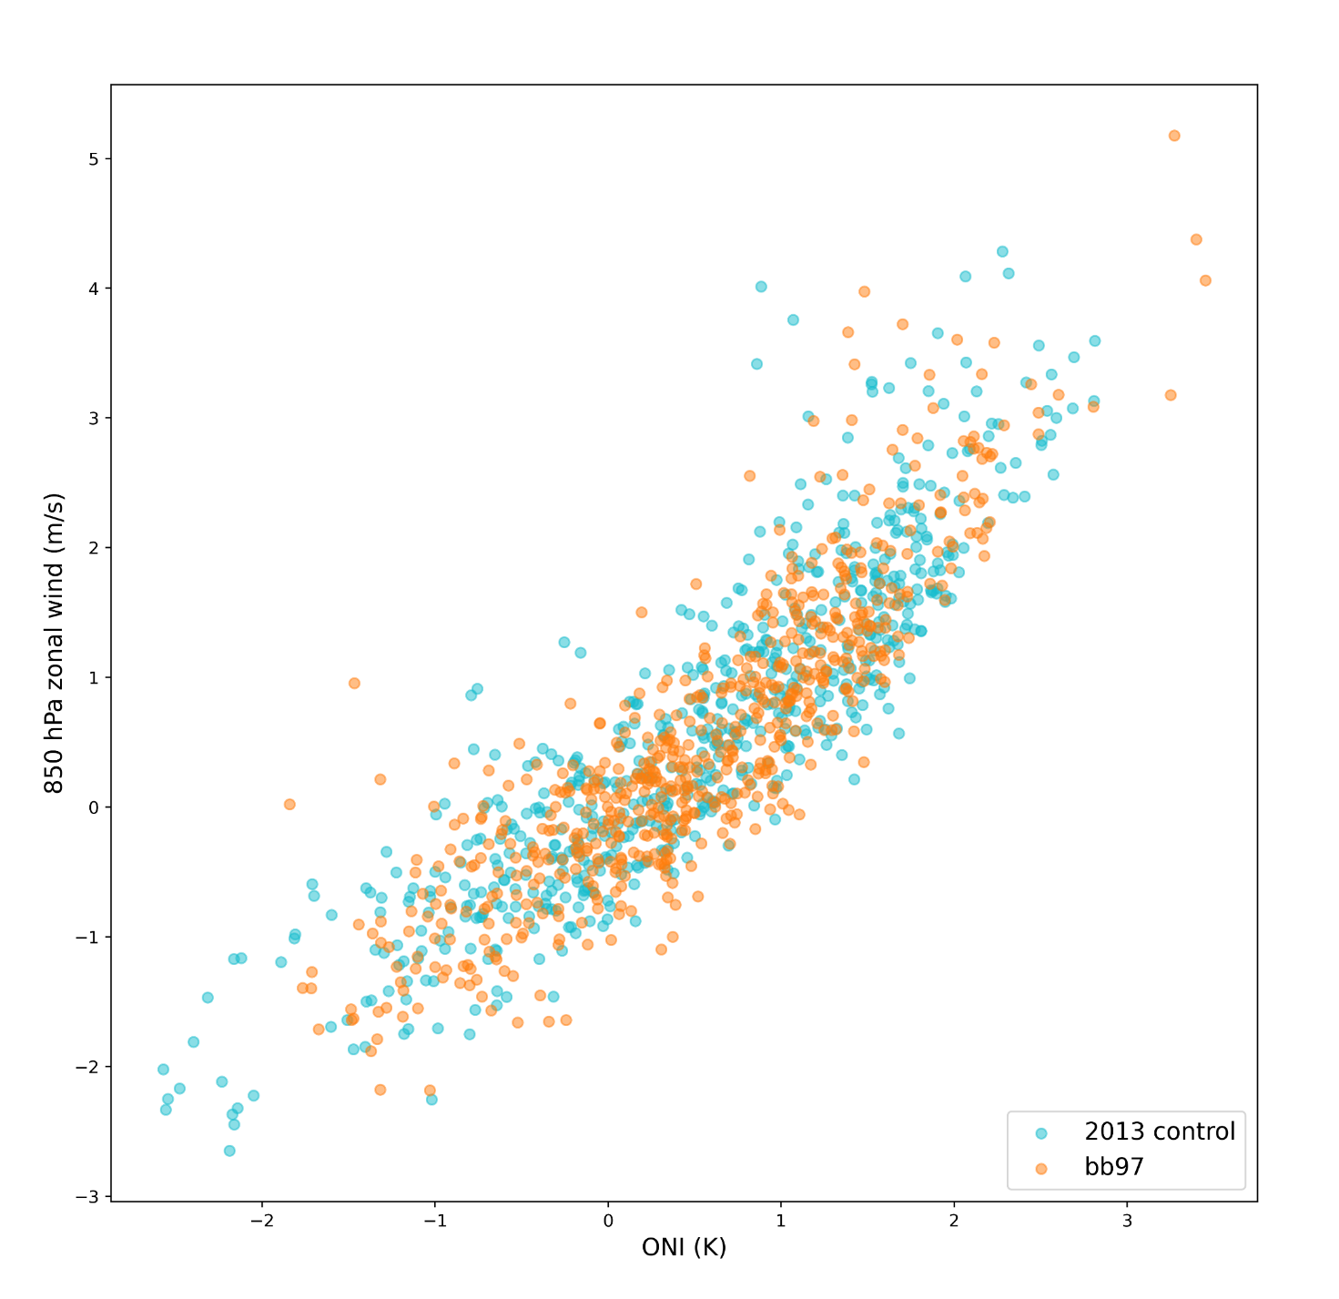
Supplementary Figure 9 | Scatter plot of seasonally averaged 850 hPa zonal wind anomalies over the Niño 3.4 region against the corresponding Oceanic Niño Index (ONI), for all 3-month periods in each of the 29 BB97 and Control13 ensemble members. UKESM1 reproduces a strong correlation between 850 hPa zonal wind and SST anomaly over the Niño 3.4 region, and the strength of this relationship is unchanged between the two ensembles.

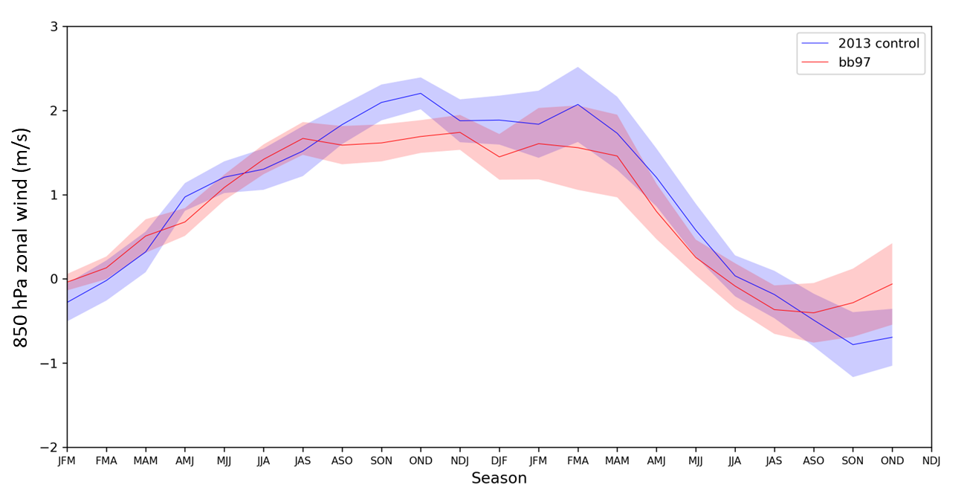
Supplementary Figure 10 | Seasonal evolution of 850 hPa zonal wind anomalies over the Niño 3.4 region in the BB97 (red line) and Control13 (blue line) ensemble means. Shading shows a ±1σ standard error range. Zonal wind anomalies are calculated as the 3-month running mean of the 850 hPa eastwards wind component in each ensemble member relative to a 200-year monthly climatology, and averaged over the 5°S-5°N, 120°W-170°W region of the Pacific.

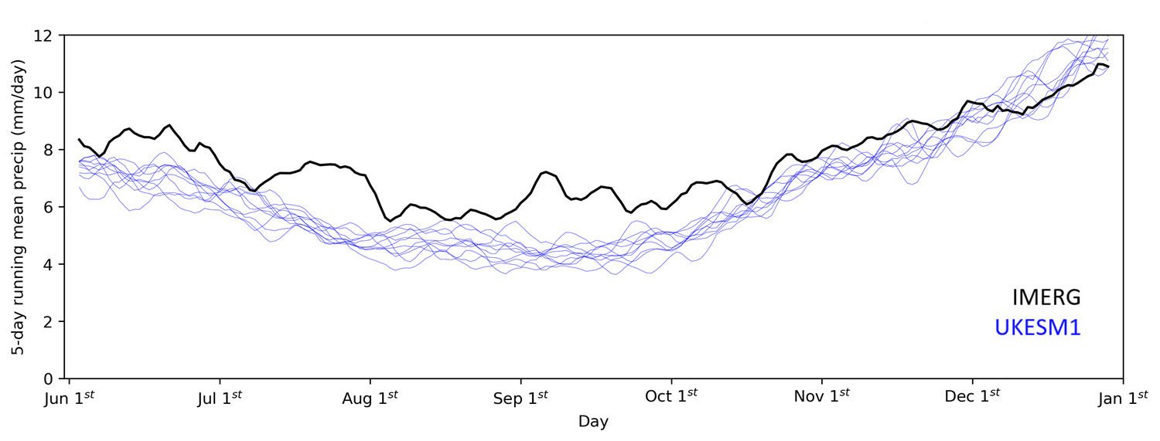
Supplementary Figure 11 | 20-year climatological precipitation seasonal cycle for June-December over the maritime continent (8°S-6°N, 95°E-150°E) in observations (black line) versus our UKESM1 present-day timeslice experiment (blue lines). We use daily accumulated precipitation observations from the NASA Integrated Multi-satellitE Retrievals for GPM (IMERG)¹ Version 06 merged satellite precipitation dataset over a 20-year period from 1st June 2000 to 31st May 2020. This is compared against daily mean precipitation from ten consecutive 20-year portions of our 1200-year present-day timeslice simulation. For each dataset, we compute a climatology for each day of the year by averaging over all 20 years for that day of the year. This daily climatology is then smoothed with a 5-day running mean.

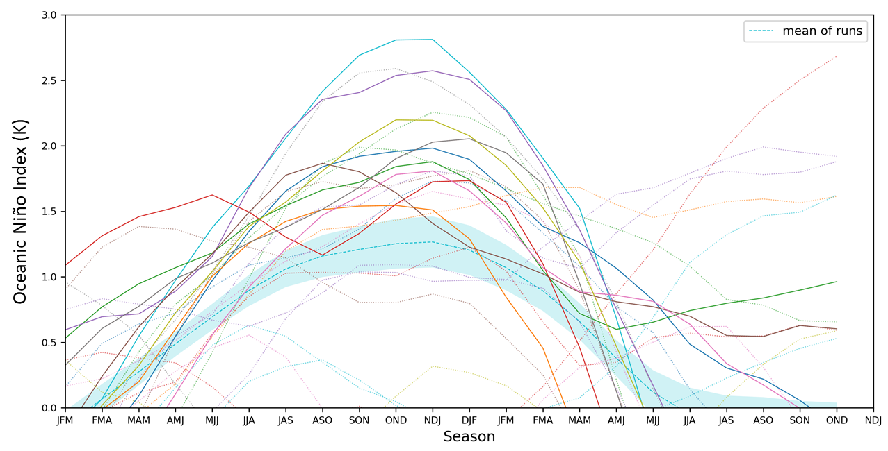
Supplementary Figure 12 | Seasonal evolution of the Oceanic Niño Index (ONI) in each of the 29 individual Control13 ensemble members. The 10 ensemble members which were used in the main analysis are shown with solid lines, and the remaining 19 ensembles members in light dotted lines. The cyan dashed line with shading shows the 29-member ensemble mean with a ±1σ standard error range.

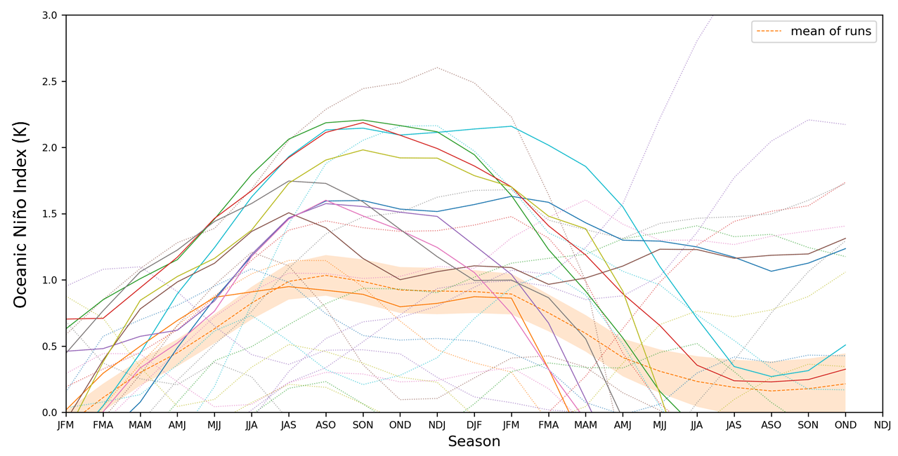
Supplementary Figure 13 | Seasonal evolution of the Oceanic Niño Index (ONI) in each of the 29 individual BB97 ensemble members. The 10 ensemble members which were used in the main analysis are shown with solid lines, and the remaining 19 ensembles members in light dotted lines. The orange dashed line with shading shows the 29-member ensemble mean with a ±1σ standard error range.

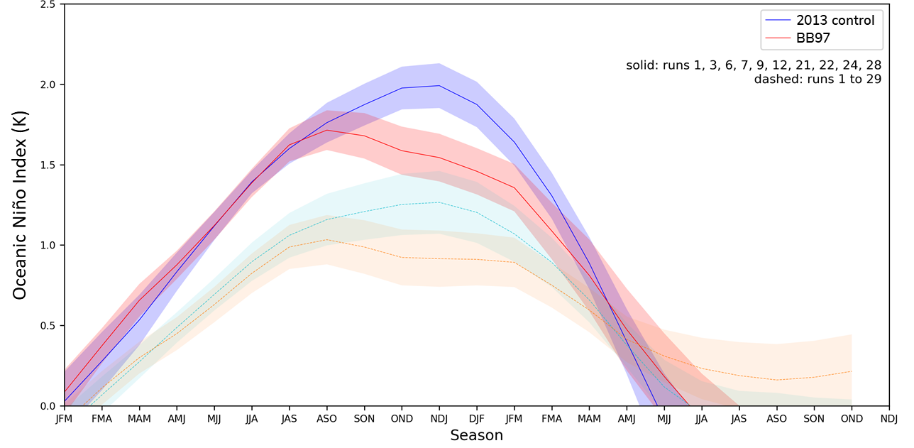
Supplementary Figure 14 | Seasonal evolution of the Oceanic Niño Index (ONI) in the BB97 (red/orange lines) lines) and Control13 (blue/cyan lines) ensemble means. Darker colours (red, blue) with solid lines show the reduced 10-member ensemble consisting only of paired members which still simulated a strong El Niño event in both cases. These are the ensemble members used for the analysis throughout the main text. Lighter colours with dashed lines (orange, cyan) show the full 29-member ensemble, including those ensemble members which no longer evolved into an El Niño state in one or both ensembles. Solid and dashed lines show the respective ensemble means, whilst the shading shows a ±1σ standard error range.

References
1 Huffman, G. J., Bolvin, D. T., Braithwaite, D., Hsu, K., Joyce, R., Kidd, C., Nelkin, E. J., Sorooshian, S., Tan, J., Xie, P. NASA Global Precipitation Measurement (GPM) Integrated Multi-satellitE Retrievals for GPM (IMERG) - Algorithm Theoretical Basis Document (ATBD) Version 06. (NASA/GSFC, Greenbelt, MD 20771, 2019).

