On-demand quadruple energy dissipative strategy for the nanoengineering of versatile bio-adhesive-based “tissue-alarm” for integrated wound therapy

Ouyang Yue^{a,#}, Xuechuan Wang^{a,*,#}, Mengdi Hou^{b,#}, Siwei Sun^{c}, Manhui Zhengª, Dongyu Haoª, Zhongxue Baiª, Xiaoliang Zouª, Boqiang Cuiª, Chunlin Liu^{d}, Huijie Zhangª, Jialing Liu^{e,f}, Junling Guo^{e,g,*}, Xinhua Liu^{a,*}

ª College of Bioresources Chemical and Materials Engineering, Shaanxi University of Science & Technology, Xi’an, Shaanxi 710021, China.
^{b} College of pharmacy, Shaanxi University of Chinese Medicine, Xi’an, Shaanxi 710021, China.
^{c} Institute of Basic and Translational Medicine, Xi’an Medical University, Xi’an, Shaanxi, 710021, China.
^{d} Key Laboratory of New Ceramics and Fine Processing, School of Materials Science and Engineering, Tsinghua University, Beijing 100084, China.
^{e} BMI Center for Biomass Materials and Nanointerfaces, College of Biomass Science and Engineering, Sichuan University, Chengdu, Sichuan 610065, China.
^{f} State Key Laboratory of Oral Diseases & National Clinical Research Center for Oral Diseases, West China Hospital of Stomatology, Sichuan University, Chengdu, Sichuan 610041, China.
^{g} Bioproducts Institute, Departments of Chemical and Biological Engineering, The University of British Columbia, Vancouver, British Columbia V6T1Z4, Canada.
*Corresponding author: wangxc@sust.edu.cn (X.W.); liuxinhua@sust.edu.cn (X.L.); junling.guo@scu.edu.cn, junling.guo@ubc.ca (J.G.).

Figure S1. Mechanistic diagram for the preparation of DLGel.

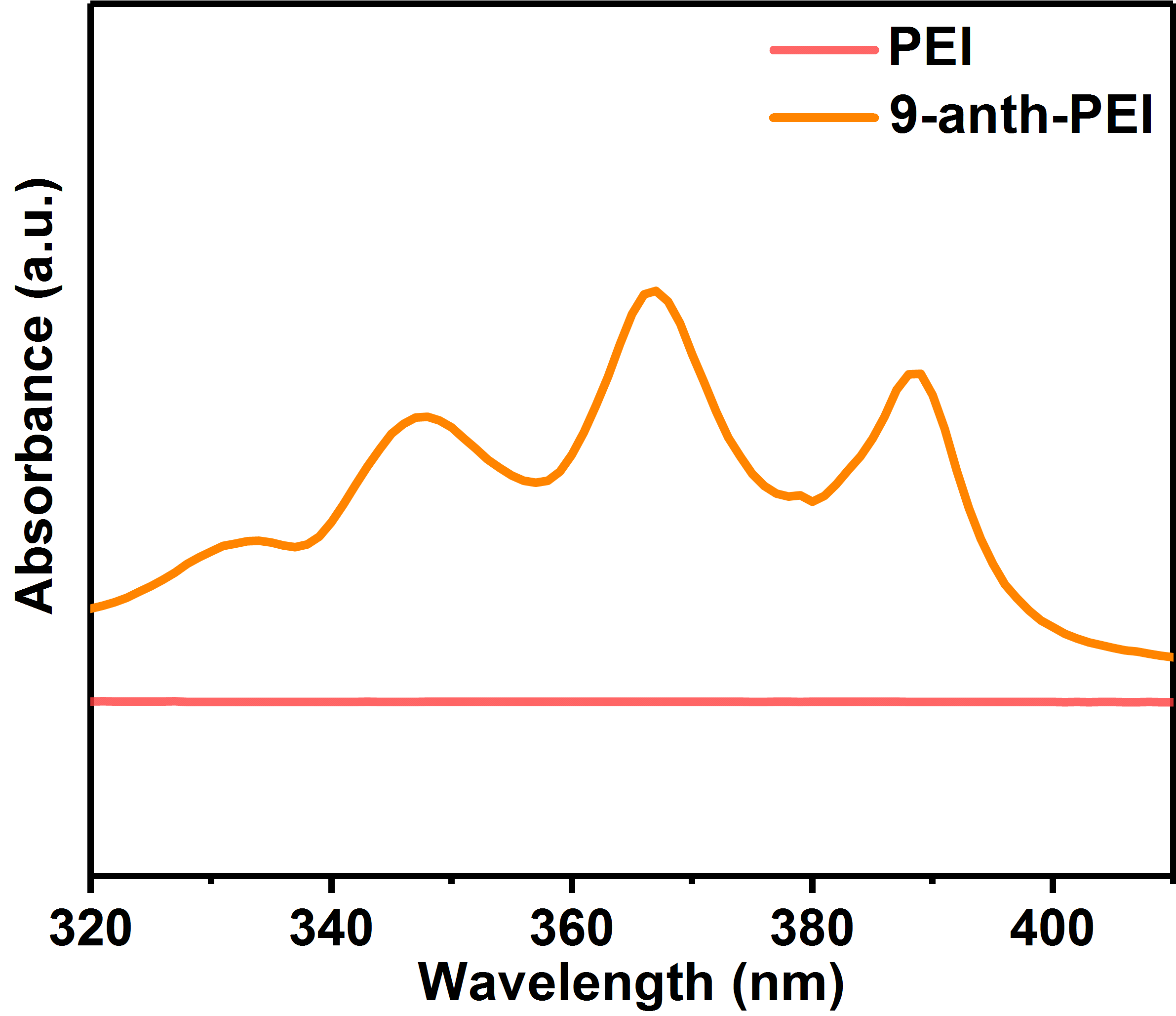
Figure S2. UV of PEI and 9-anth-PEI.

Figure S3. TG and DTG of DLGels with different components.
Figure S4. The schematic process of testing sample preparation and adhesion strength measurements.
Figure S5. Adhesive strength load-bearing test on glass, iron, and pigskin.
Figure S6. Adhesive strength test on pig heart.
Figure S7. Laser scanning confocal microscopy images of live/dead staining in different groups after 1, 3 and 5 days of incubation.
Figure S8. Flow cytometric of different experimental groups at day 1, 3 and 5.

Figure S9. Cell adhesion test of different experimental groups at day 1, 3 and 5.
Figure S10. Cell scratch test of different experimental groups at day 1, 3 and 5.
Figure S11. Cell penetration test of different experimental groups at day 1, 3 and 5.
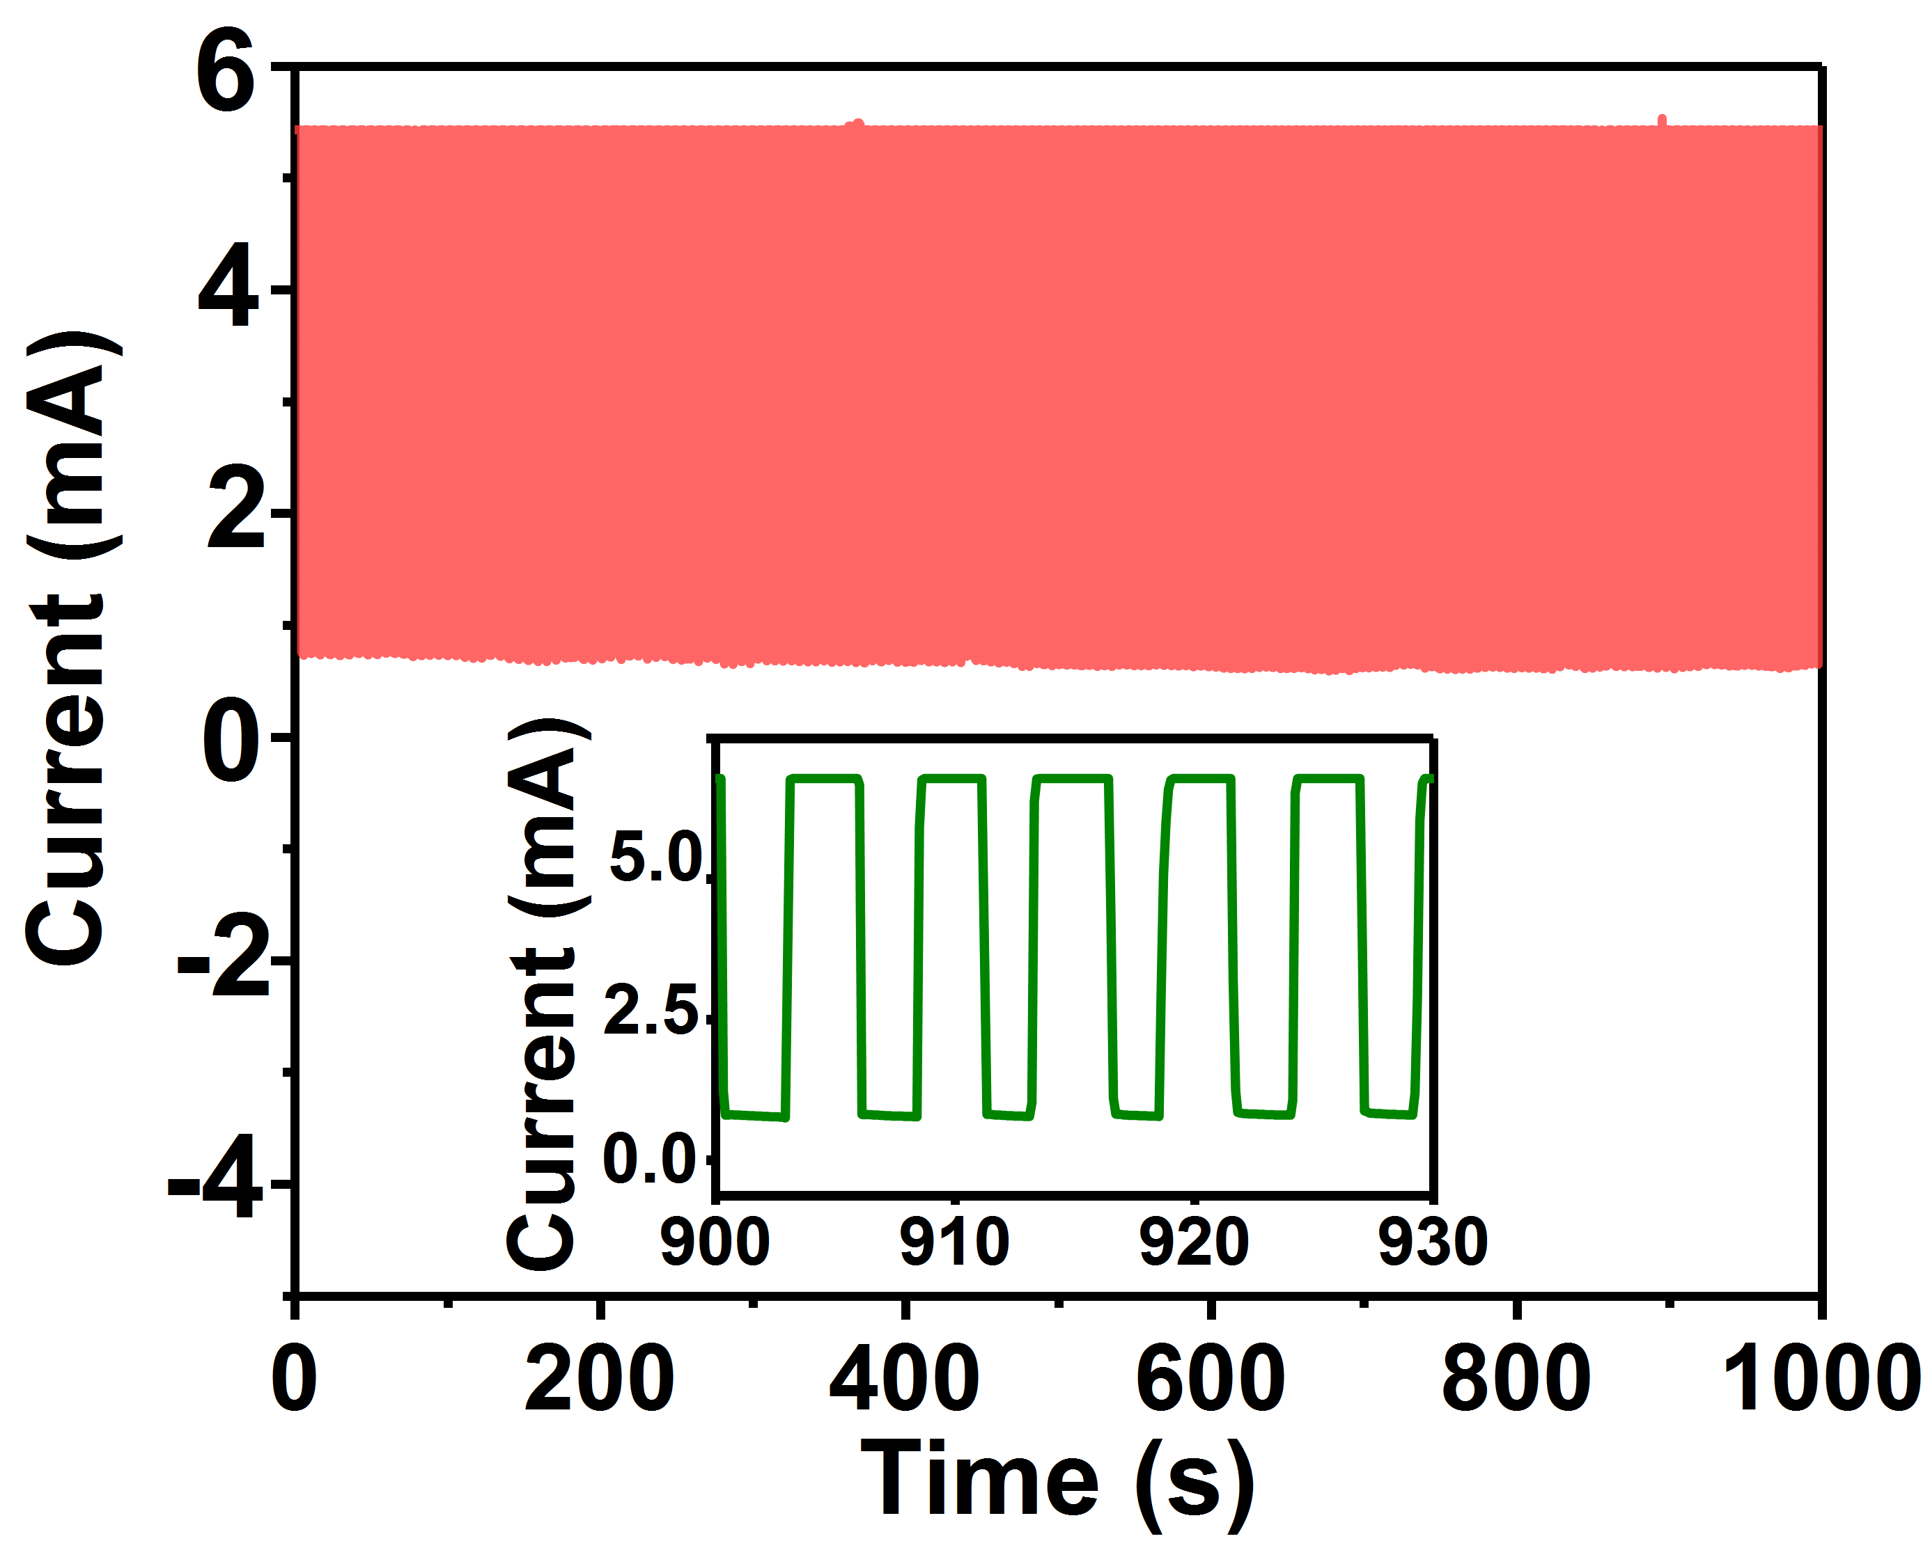
Figure S12. Electrical signals of DLGel under 300% strain for 1000 cycles.

Supporting Movie

Video S1. Closure of artificial wound on the lung by DLGel.
Video S2. Brightness change of LEDs via DLGel.
Video S3. Signals of the DLGel before/after wound tearing on skin.
Video S4. Signals of the DLGel before/after wound tearing on heart.

