APPENDICES
Association of Sperm Mitochondrial DNA Copy Number with Concentration of Urinary Cadmium and Selenium

Cindy Rahman Aisyah¹, Yuki Mizuno¹, Momoka Masuda¹, Teruaki Iwamoto^{2,3}, Kazumitsu Yamasaki^{3,4},
Masahiro Uchida⁴, Fumiko Kariya¹, Shogo Higaki⁵, Shoko Konishi¹

¹ Department of Human Ecology, The University of Tokyo, Japan, ² International University of Health and Welfare, ³ Sanno Hospital, ⁴ Tsukuba Gakuen Hospital, ⁵ Isotope Science Center, The University of Tokyo

16-digit ORCIDs
Cindy Rahman Aisyah (0000-0003-3915-9804)
Yuki Mizuno (0000-0002-7383-4706)
Momoka Masuda (0009-0009-7522-2664)
Kazumitsu Yamasaki (0000-0002-8414-2393)
Shogo Higaki (0000-0002-5098-6475)
Shoko Konishi (0000-0002-7282-0863)

Corresponding author
Correspondence to Shoko Konishi (email: moe@humeco.m.u-tokyo.ac.jp)

Appendix 1. Detection limit and inter- and intra-assay CVs (%) of urinary Cd and Se measurement
Elements | m/z | Detection limit (µg/L)ª | Intra-assay CV (%)^{b} | Inter-assay CV (%)^{b}
Cadmium (Cd) | 111 | 0.005 | 6.19, 1.09 | 48.3, 1.58
Selenium (Se) | 78 | 0.4 | 11.4, 1.31 | 3.44, 2.43
ªDetection limit obtained by calculating the mean of all detection limits in each measurement (n=5).
^{b}The values of intra- and inter-assay CV (%) were shown for each of Seronorm Trace Elements Urine L-1 and L-2, respectively.

Appendix 2. Ranges of observed and reference concentrations of Cd and Se in Seronorm Trace Elements Urine L-1 and L-2 (µg/L)

Elements | Seronorm L-1 |  | Seronorm L-2
Elements | Observed (µg/L) | Reference (µg/L) ª | Observed (µg/L) | Reference (µg/L)ª
Cadmium (Cd) | 0.06 – 0.17 | 0.05 – 0.07 | 4.41 – 4.65 | 3.7 – 5.6
Selenium (Se) | 11.3 – 12.4 | 8.4 – 12.6 | 61.9 – 66.7 | 51.9 – 80.6
ª Reference were analytical uncertainty 95% confidence interval as written in manual of Seronorm manufacturer.

Appendix 3. DNA sequences used for quantification of MinorArc and RNaseP by multiplex real-time quantitative polymerase chain reaction (qPCR)

Primer Sequences
Forward MinorArc | 5’-CTA AAT AGC CCA CAC GTT CCC-3’
Reverse MinorArc | 5’-AGA GCT CCC GTG AGT GGT TA-3’
Forward RNaseP | 5’-AGA TTT GGA CCT GCG AGC G-3’
Reverse RNaseP | 5’-GAG CGG CTG TCT CCA CAA GT-3’
Probe Sequences
MinorArc | FAM-CAT CAC GAT GGA TCA CAG GT-BHQ1-MGB
RNaseP | Cy-TTC TGA CCT GAA GGC GGC TCT GCG CG-BHQ1-MGB

MinorArc was targeted to quantify the control region in human mtDNA where no deletions have been reported.
The cycling conditions were set as follows: activation for 10 min at 95°C, followed by 40 cycles of 95°C for 15 s, 55°C for 15 s, and 60°C for 1 min.

Appendix 4. Scatter plots of sperm mtDNAcn vs (a) semen volume (b) sperm concentration (c) total motile sperm count and (d) total motility.
(a)  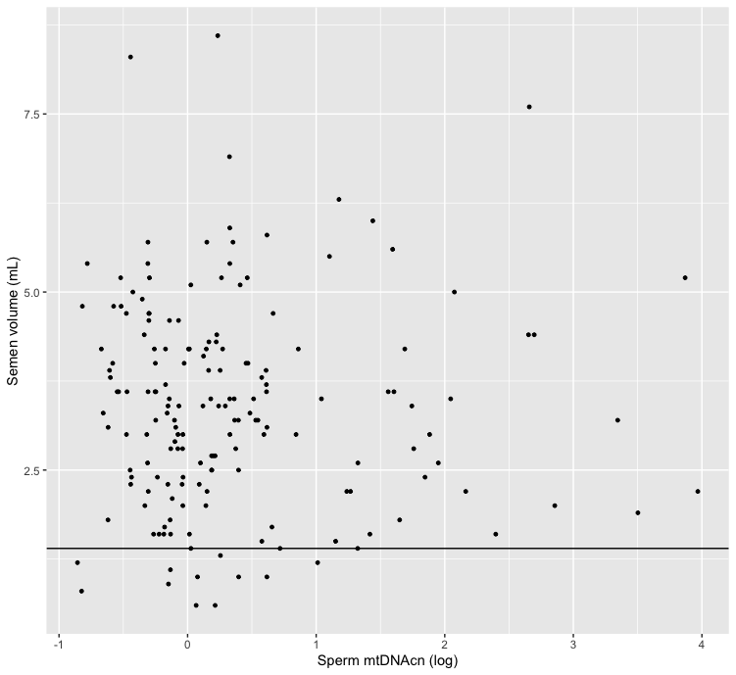  1.4  R=-0.05, p=49 | (b)  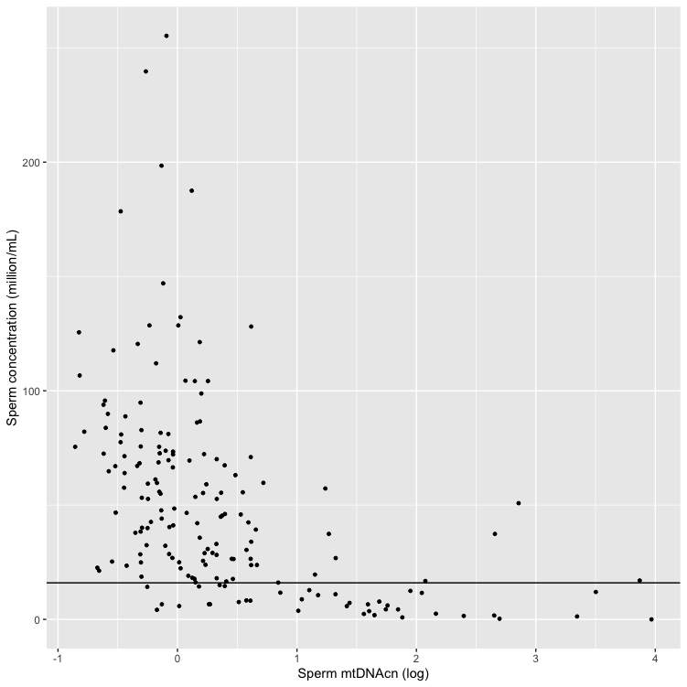  16  R=-0.6, p<0.001
(c)  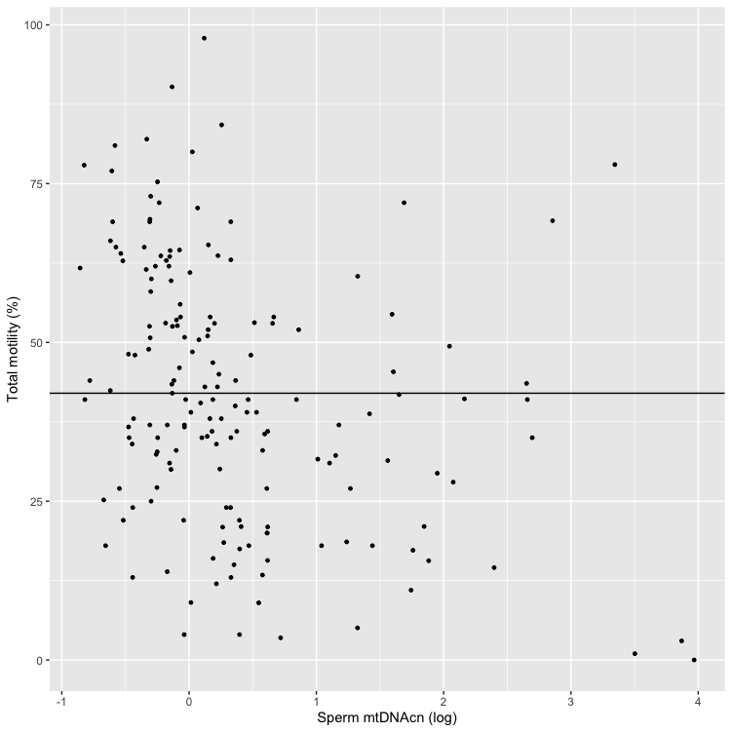  42  R=-0.37, p<0.001 | (d)  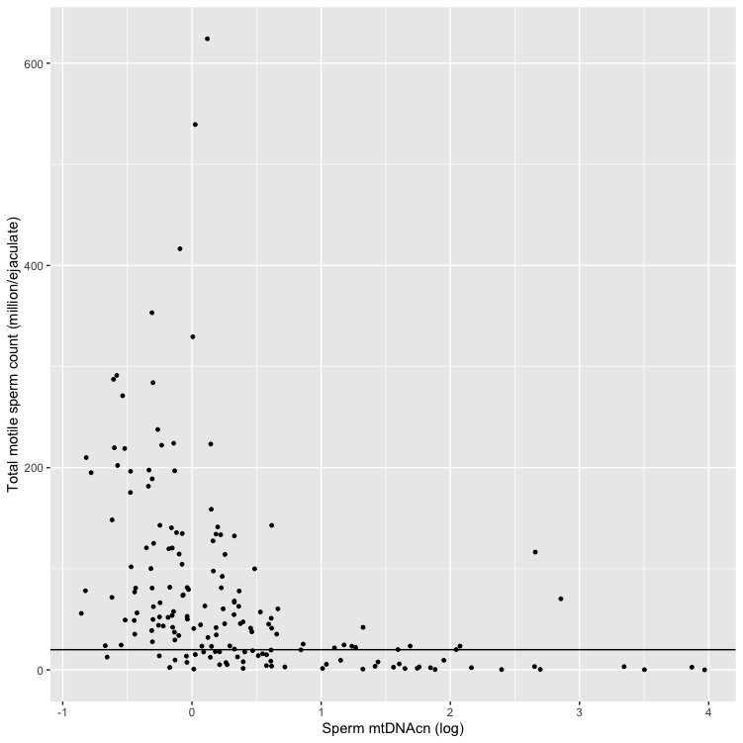  20  R=-0.61, p<0.001

Sperm mtDNAcn = sperm mitochondrial DNA copy number
Note: The horizontal line corresponds to the reference values by the WHO [7] for (a) semen volume, (b) sperm concentration, and (c) total motility. The horizontal line in (d) total motile sperm count corresponds to the reference by the study by Hamilton, 2015 [8].

