Appendix 1: Model calibration
The SIMO v.1.0 model was calibrated for Lake Kozjak using hourly observation data of the water temperature profile measured at the deepest point of the lake (44.8902°N, 15.6038°E). The water temperature was measured at 16 different depths, namely, 0.2, 0.5, 1, 1.5, 3, 5, 7, 9, 11, 13, 15, 17, 20, 23, 27 and 43 m. Meteorological input data used to force the calibration simulation were obtained from the Plitvicka Jezera automatic meteorological station (44.8811°N, 15.6197°E), located approximately 200 m from the Lake Kozjak shoreline and 1.6 km southeast of the water temperature measuring site. The simulation was initiated on 1.1.2019 with a measured water temperature profile and was run for the entire year of 2019. The results before and after the calibration are shown in Figs. 12 and 13.
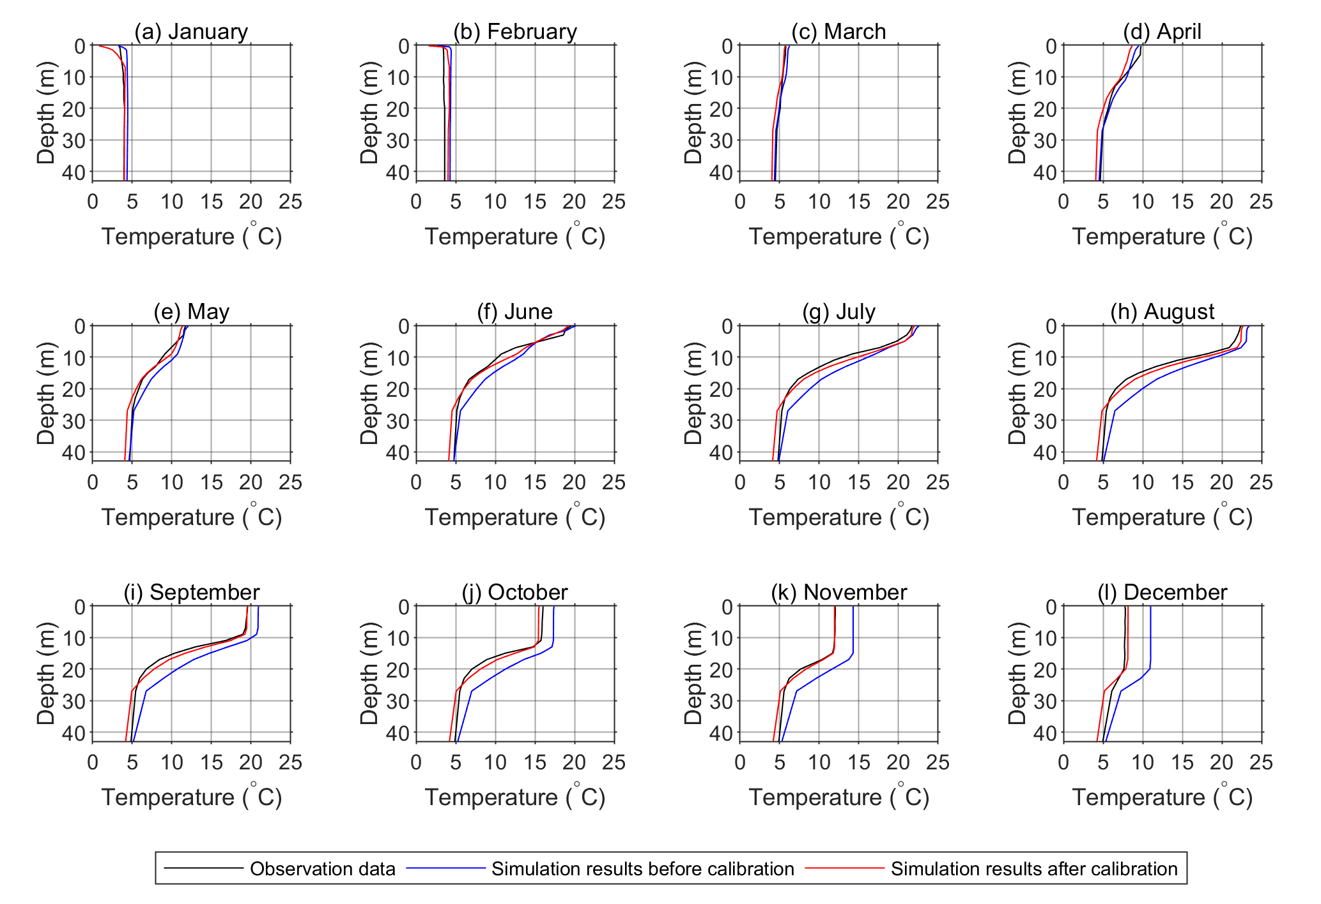
Fig. 12 Monthly means of the predicted water temperature vertical profiles for Lake Kozjak in 2019 before (blue) and after (red) model calibration compared to the observed values (black)
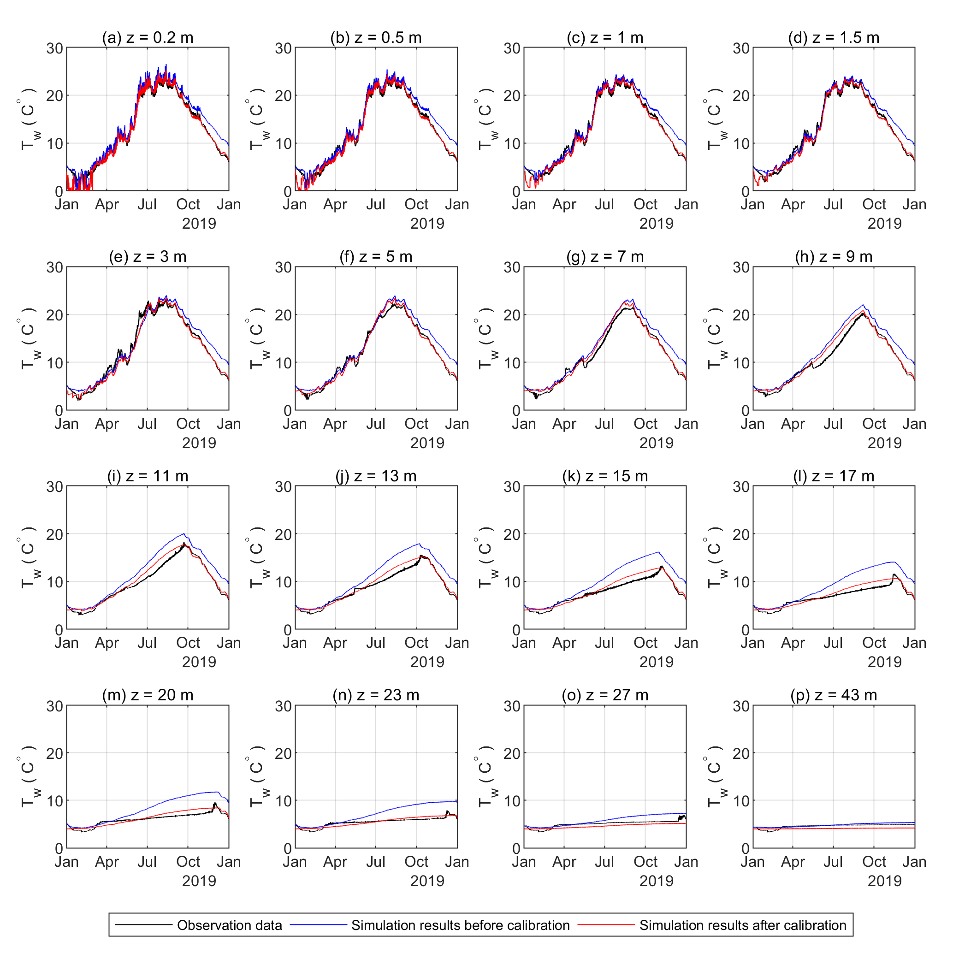
Fig. 13 Monthly means of the predicted water temperature vertical profiles for Lake Kozjak in 2019 before (blue) and after (red) model calibration compared to the observed values (black)

