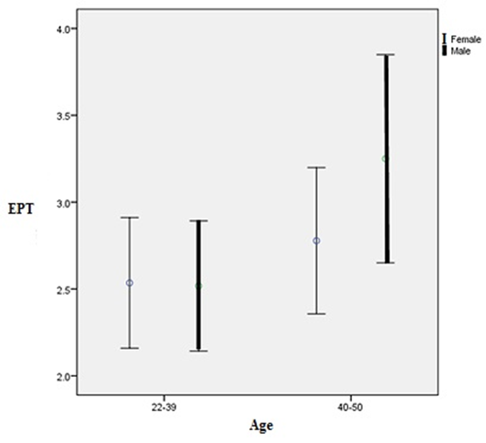
Chart 1. Relationship between age with EPT

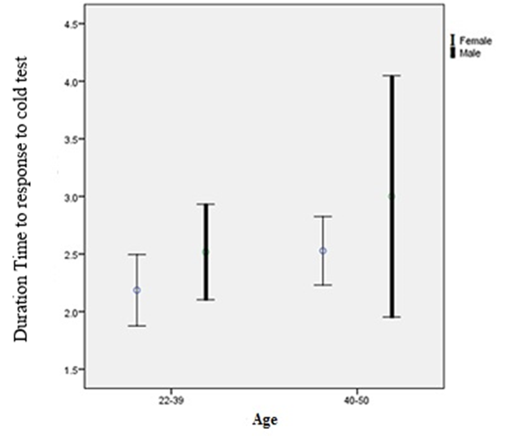

Chart 2. Relationship between age groups with a duration of delay in response to cold test

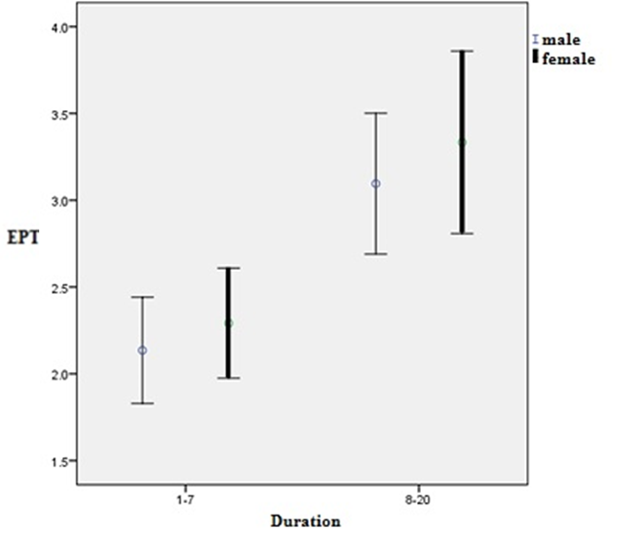

Chart 3. Relationship between duration of disease and EPT

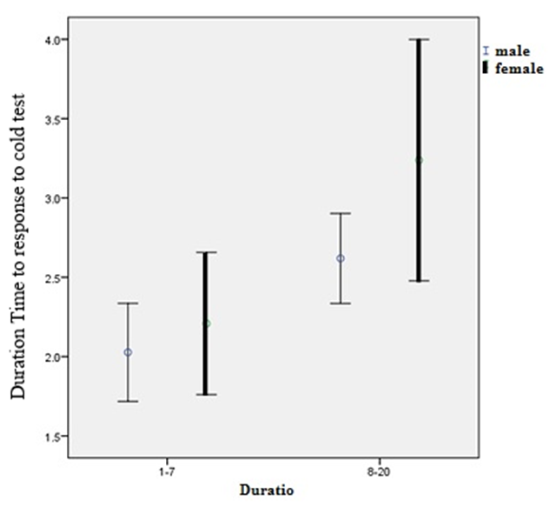

Chart 4. Relationship between duration of infection and duration of delay in response to cold test

