Supporting Information

Garlic exosomes alleviate dextran sodium sulfate-induced colitis: peu-MIR2916-p3 as a key component boosting the growth of anti-colitis Bacteroides thetaiotaomicron

Xiaoyuan Wang,† Yueyue Liu,† Xinyue Dong,† Tianchi Duan,† Chennan Wang,† Lu Wang,† Xingbin Yang,† Honglei Tian,† Ting Li,*, †

†Shaanxi Engineering Laboratory for Food Green Processing and Safety Control, and Shaanxi Key Laboratory for Hazard Factors Assessment in Processing and Storage of Agricultural Products, College of Food Engineering and Nutritional Science, Shaanxi Normal University, Xi’an 710119, China.
.
* Corresponding author
Tel.: +86-29-85310580, Fax: +86-29-85310517
Email address: tingli@snnu.edu.cn (T. Li)

Supplementary Figures
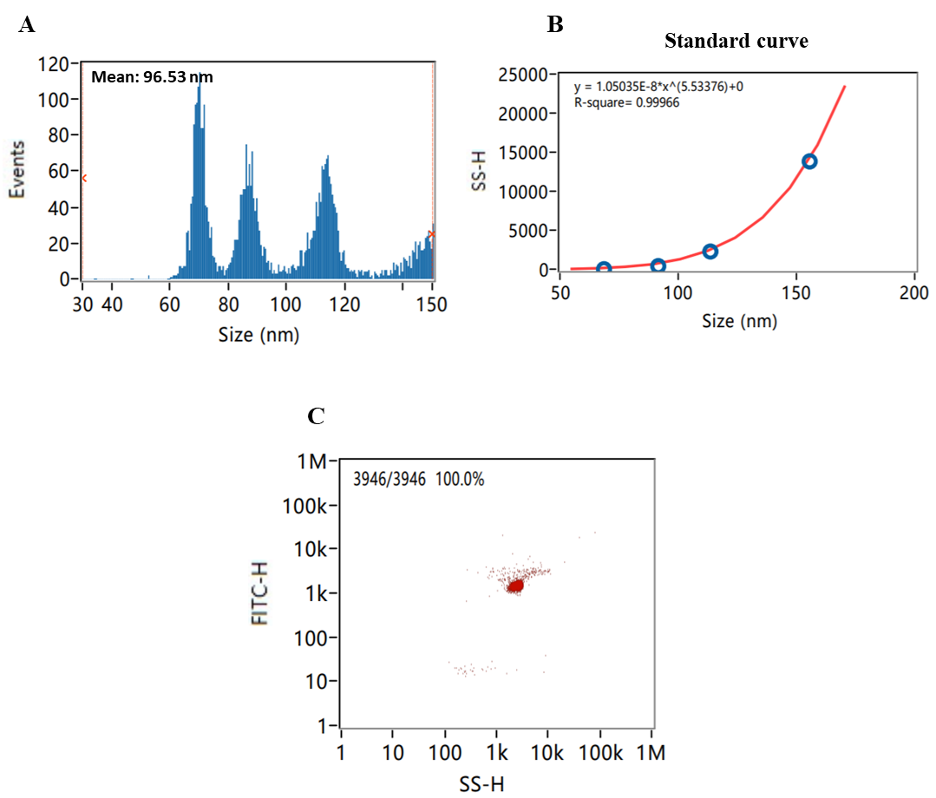
Figure S1 (related to Figure 1). Nanoparticle sizes and concentrations of standard samples analyzed by NanoFCM. (A) Nanoparticle size distribution, (B) standard curve, and (C) nanoparticle concentration of standard samples.

Figure S2 (related to Figure 2). GO annotations of GELNs proteins and miRNAs. (A) GO terms of GELNs proteins. The bar plots present the top 18 enriched GO terms. GO terms of peu-MIR2916-p3 (B) and peu-MIR2916-p5 (C). The bar plots present the top 10 enriched GO terms in biological process, cellular components and molecular functions.
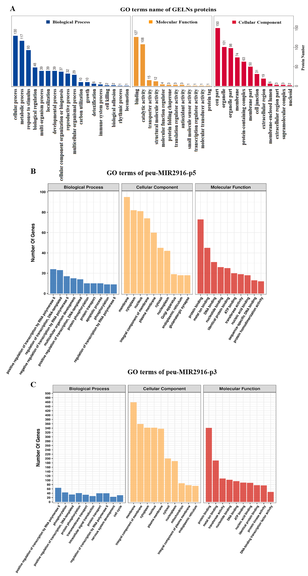
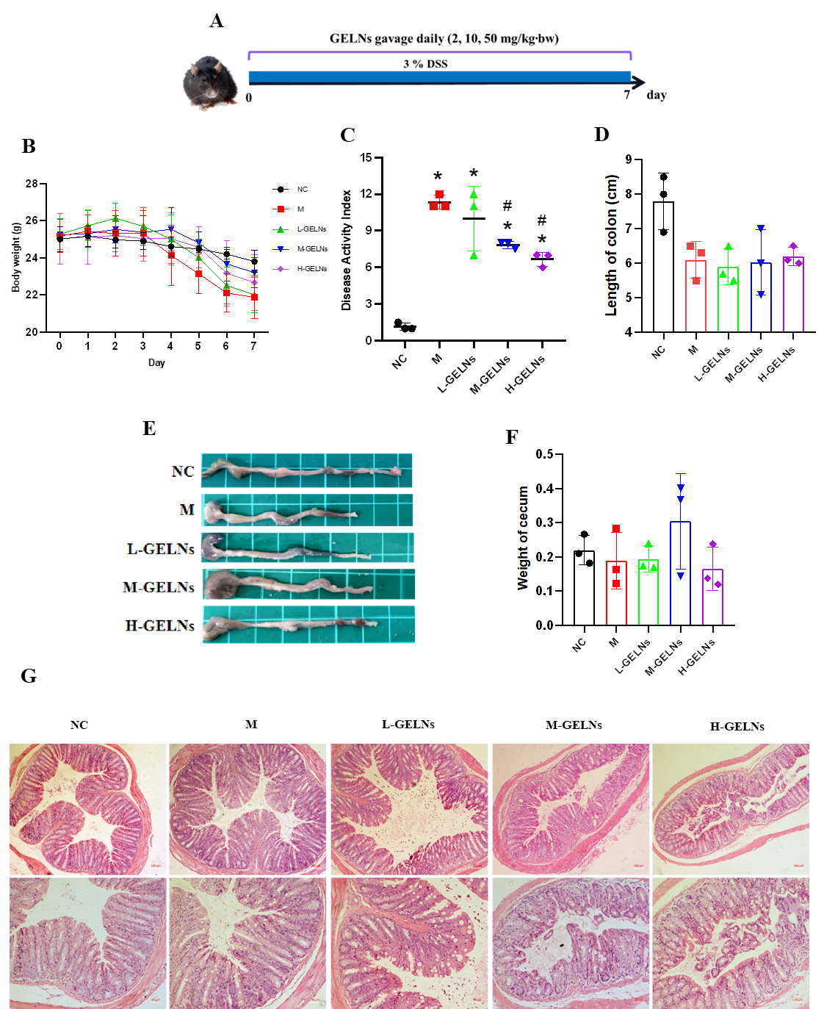
Figure S3 (related to Figure 4). 7-day acute colitis pre-experiment. (A) Schematic diagram for the treatment schedule in DSS-induced acute colitis in mice. (B) Body weight, (C) DAI, (D) colon length, (E) colon morphology and (F) weight of cecum. (G) H&E-stained colon sections which were observed at 10× and 20× of magnification. Scale bar, 100 μm (above panels) and 50 μm (below panels). Data are expressed as mean ± SD, *P<0.05 vs NC group, #P<0.05 vs M group (n=3).
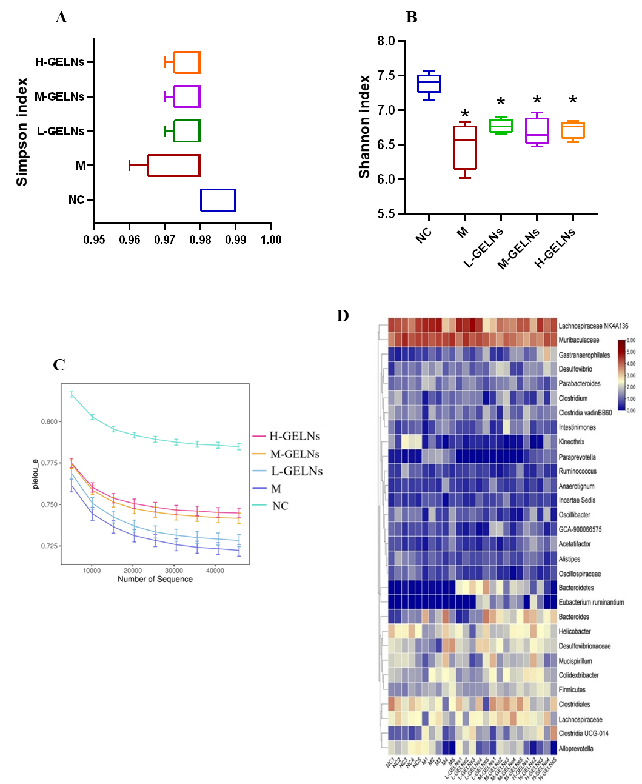
Figure S4 (related to Figure 5). α-diversity and heatmap of gut microbiota after GELNs administration. (A) Simpson index, (B) Shannon index, and (C) pielou-e index were used to describe the gut microbial α-diversity. (D) Heatmap of the top 30 genera that are shared by all samples at the genus level. Data are expressed as mean ± SD, *P < 0.05 vs NC group.
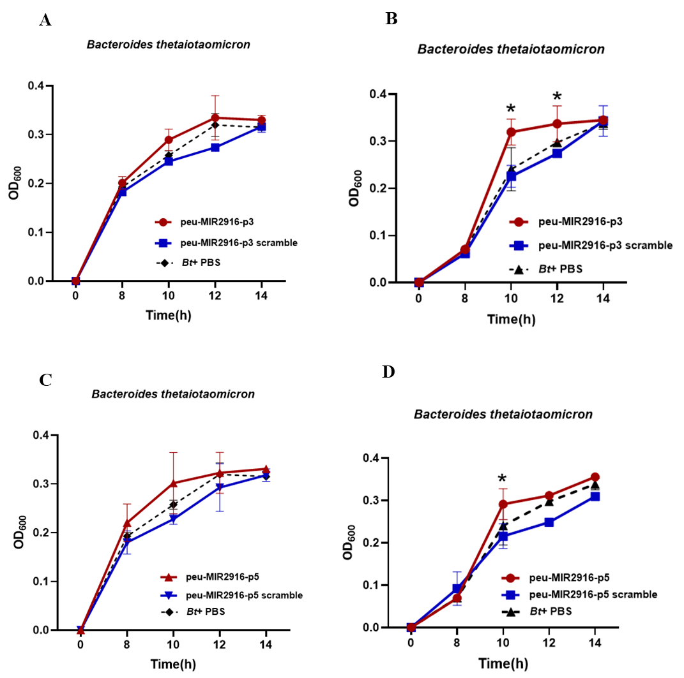
Figure S5 (related to Figure 6). Impact of peu-MIR2916-p3/p5 on the growth of B. thetaiotaomicron. (A) and (B) show the proliferation curves of B. thetaiotaomicron treated with 2.5 μM miRNA mimics of peu-MIR2916-p3 and peu-MIR2916-p3 scramble. (C) and (D) show the proliferation curves of B. thetaiotaomicron treated with 2.5 μM miRNA mimics of peu-MIR2916-p5 and peu-MIR2916-p5 scramble. Data are expressed as mean ± SD, *P < 0.05 vs PBS group.

Table S1 (related to Figure 2). Number of GELNs proteins involved in the immune/inflammation-related pathways
Map ID | Map name | Number of proteins
ko05010 | Alzheimer disease | 17
ko05020 | Prion disease | 17
ko01120 | Microbial metabolism in diverse environments | 16
ko05022 | Pathways of neurodegeneration - multiple diseases | 16
ko05415 | Diabetic cardiomyopathy | 12
ko05132 | Salmonella infection | 9
ko05130 | Pathogenic Escherichia coli infection | 8
ko05134 | Legionellosis | 7
ko05417 | Lipid and atherosclerosis | 6
ko04932 | Non-alcoholic fatty liver disease | 5
ko05034 | Alcoholism | 5
ko05131 | Shigellosis | 5
ko05322 | Systemic lupus erythematosus | 5
ko04066 | HIF-1 signaling pathway | 4
ko04010 | MAPK signaling pathway | 3
ko04217 | Necroptosis | 3
ko05171 | Coronavirus disease - COVID-19 | 3
ko04014 | Ras signaling pathway | 2
ko04024 | cAMP signaling pathway | 2
ko04150 | mTOR signaling pathway | 2
ko05110 | Vibrio cholerae infection | 2
ko05120 | Epithelial cell signaling in Helicobacter pylori infection | 2
ko05152 | Tuberculosis | 2
ko05165 | Human papillomavirus infection | 2
ko05167 | Kaposi sarcoma-associated herpesvirus infection | 2
ko05323 | Rheumatoid arthritis | 2
ko03320 | PPAR signaling pathway | 1
ko04013 | MAPK signaling pathway - fly | 1
ko04016 | MAPK signaling pathway - plant | 1
ko04112 | Cell cycle - Caulobacter | 1
ko04115 | p53 signaling pathway | 1
ko04151 | PI3K-Akt signaling pathway | 1
ko04621 | NOD-like receptor signaling pathway | 1
ko04657 | IL-17 signaling pathway | 1
ko04659 | Th17 cell differentiation | 1
ko05160 | Hepatitis C | 1
ko05161 | Hepatitis B | 1
ko05163 | Human cytomegalovirus infection | 1
ko05164 | Influenza A | 1
ko05168 | Herpes simplex virus 1 infection | 1
ko05210 | Colorectal cancer | 1
ko05416 | Viral myocarditis | 1
Total |  | 175

Table S2 (related to Figure 6). Sequences of miRNA mimics
MiRNA name | Sequence (5’-3’)
peu-MIR2916-p5 | CCGTCCTAGTCTCAACCATA
peu-MIR2916-p5 scramble | UUAGUUGCAGUGUGGUUGGC
peu-MIR2916-p3 | CCATAAACGATGCCGACCA
peu-MIR2916-p3 scramble | UGAGUUUGAGCGUGUGUUC

