Supporting Information

NHC-Catalyzed Enantioselective Access to β-Nitrile Carboxylic Esters via In Situ Substrate Alternation and Release
Qingyun Wang^{1, †}, Shuquan Wu^{3, †}, Juan Zou^{2, †}, Xuyang Liang¹, Chengli Mou², Pengcheng Zheng^{1,} *, and Yonggui Robin Chi^{1, 4,} *

¹National Key Laboratory of Green Pesticide, Key Laboratory of Green Pesticide and Agricultural Bioengineering, Ministry of Education, Center for R&D of Fine Chemicals, Guizhou University, Guiyang 550025, China.
²Guizhou University of Traditional Chinese Medicine, Guiyang 550025, China
³Guizhou Minzu University, Guiyang 550025, China
⁴School of Chemistry, Chemical Engineering and Biotechnology, Nanyang Technological University, Singapore 637371, Singapore.

Corresponding authors e-mails:
zhengpc1986@163.com
robinchi@ntu.edu.sg

†These authors contributed equally to this work.

Table of contents
Ⅰ. Supplementary Notes S3
General information……………………………………………………………………….….S3
II. Supplementary Methods S4
Preparation of substrates……………………………………………………………………S4
Initial studies and condition optimization for the synthesis of 3a………………………...S5
General procedure for the catalytic reactions………………………………………………S7
III. Supplementary Discussion S9
Mechanistic study experiments: GC-MS semi-quantitative analysis of reactions.............S9
LC-HRMS analysis of reaction systems……………………………………...…………….S10
IV. Characterization of substrates and products S14
V. Supplementary Figures S34
¹H NMR, ¹³C NMR and ¹⁹F NMR spectra………………………………………….……..S34
HPLC spectra………………………………………………………………...……………S104
HRMS spectra……………………………………………………………………...……...S139
X-Ray crystallography…………………………………………………………………….S176
VI. Supplementary References S177

Ⅰ. Supplementary Notes
General information
Commercially available materials and dry solvents purchased from Energy Chemical and Bidepharm were used as received. Unless otherwise specified, all reactions were prepared using 4 mL vial under N₂ atmosphere in glove-box from M Braun (UNILAB SP). Proton nuclear magnetic resonance (¹H NMR) spectra were recorded on a Bruker (AVANCE Ⅲ HD 400 MHz) spectrometer. Chemical shifts were recorded in parts per million (ppm, δ) relative to tetramethylsilane (δ 0.00) or chloroform (δ = 7.26, singlet). ¹H NMR splitting patterns are designated as singlet (s), doublet (d), triplet (t), quartet (q), dd (doublet of doublets); m (multiplets), and etc. All first-order splitting patterns were assigned on the basis of the appearance of the multiplet. Splitting patterns that could not be easily interpreted are designated as multiplet (m) or broad (br). Carbon nuclear magnetic resonance (¹³C NMR) spectra were recorded on a Bruker (AVANCE Ⅲ HD 101 MHz) spectrometer. Fluorine (¹⁹F) nuclear magnetic resonance (¹⁹F NMR) spectra were recorded on a Bruker (AVANCE Ⅲ HD 376 MHz) spectrometer. The melting points (m.p.) of the title compounds were determined when left untouched on an XT-4-MP apparatus from Beijing Tech. Instrument Co. (Beijing, China). High resolution mass spectrometer analysis (HRMS) was performed on Thermo Fisher Q Exactive mass spectrometer. The gas chromatography mass spectrometry (GC-MS) analyses were measured on Agilent systems, 7890B-5977B GC/MSD model. The liquid chromatography-high resolution mass spectrum (LC-HRMS) was performed on Waters Xevo G2-S QTOF system. Absolute configuration of the products was determined by X-ray crystallography (Bruker d8 quest). HPLC analyses were measured on Waters systems, Daicel Chemical Industries systems and Shimadzu systems with Empower3 system controller, Alliance 2695, and 2998 Diode Array Waters 2489 UV/Vis detector. Chiralcel brand chiral columns from Daicel Chemical Industries LC 20A QA&QC-HPLC were used with models IA, IG, IF, OD-H, AD-H or AS3RCD in 4.6 x 250 mm size. Optical rotations were measured on a Insmark IP-digi Polarimeter in a 1 dm cuvette at 25 ºC. The concentration (c) is given in g/100 mL. Analytical thin-layer chromatography (TLC) was carried out pre-coated silica gel plate (0.2 mm thickness). Visualization was performed using a UV lamp.

II. Supplementary Methods
Preparation of substrates
Substrates S3 and 1a were synthesized according to the reported method.¹

S4 (1.00 g, 3.51mmol) was dissolved in MeCN (50.0 mL), and TMSCN (5.26 mmol) was added at room temperature. After that, TBAF (5.26 mmol) was added at same temperature then the reaction system was heated up to 82℃ stirred for 5 h. After completion of the reaction, monitored by TLC. The mixture was rotary evaporated to remove solvent and unreacted TMSCN. Then the mixture was quenched with water and washed with 3×10.0 mL of ethyl acetate. The organic extracts were combined, dried over anhydrous sodium sulphate and concentrated. The crude product was purified by silica gel column chromatography using petroleum ether / ethyl acetate (10 / 1) as eluent to afford compound S5.²
Compound 1q can be synthesized with the same method that compound S1 to 1a from the compound S5.

Initial studies and condition optimization for the synthesis of 3a
Table S1. The initial studies of nucleophile^{[a]}

Entry | Nucleophile | NHC | Base | Solvent | Desired product 3a [%]^{[b]} | Homo-coupling 3a' [%]^{[b]}
1 | MeOH | A | DABCO | THF | 0 | 82
2 | MeOH | A | DABCO | DCM | 0 | 64
3 | MeOH | A | DABCO | EA | 0 | 72
4 | EtOH | A | DABCO | THF | 0 | 77
5 | EtOH | A | DABCO | DCM | 0 | 69
6 | EtOH | A | DABCO | EA | 0 | 70
7 | PhOH | A | DABCO | THF | 0 | 81
8 | PhOH | A | DABCO | DCM | 0 | 79
9 | PhOH | A | DABCO | EA | 0 | 66
10 | 2a | A | DABCO | THF | 80 | 0
11 | 2a | A | DABCO | DCM | 73 | 0
12 | 2a | A | DABCO | EA | 78 | 0
13 | 2a-1 | A | DABCO | THF | 0 | 75
14 | 2a-1 | A | DABCO | DCM | 0 | 81
15 | 2a-1 | A | DABCO | Toluene | 0 | 80
16 | 2a-2 | A | DABCO | THF | 0 | 79
17 | 2a-2 | A | DABCO | DCM | 0 | 65
18 | 2a-2 | A | DABCO | Toluene | 0 | 83
19 | 2a-3 | A | DABCO | THF | 0 | 77
20 | 2a-3 | A | DABCO | DCM | 0 | 78
21 | 2a-3 | A | DABCO | Toluene | 0 | 81
^{[a]}General conditions (unless otherwise specified): 1a (0.10 mmol), nucleophiles (0.10 mmol), pre-NHC A (0.01 mmol), base (0.02 mmol), solvents (2.0 mL), rt, 12 h. ^{[b]}Isolated yields of 3a and 3a'. DABCO = 1,4-Diazabicyclo [2.2.2]octane.

Table S2. The effects of catalysts, bases, solvents on the reaction outcome^{[a]}
Entry | NHC | Base | Solvent | Yield (%)^{[b]} | er^{[c]}
1 | A | K₂CO₃ | THF | 71 | 64:36
2 | B | K₂CO₃ | THF | 85 | 55:45
3 | C | K₂CO₃ | THF | 74 | 84:16
4 | D | K₂CO₃ | THF | 64 | 62:38
5 | E | K₂CO₃ | THF | 49 | 70:30
6 | F | K₂CO₃ | THF | 57 | 58:42
7 | G | K₂CO₃ | THF | 80 | 78:22
8 | H | K₂CO₃ | THF | 69 | 80:20
9 | I | K₂CO₃ | THF | 73 | 71:29
10 | J | K₂CO₃ | THF | 74 | 81:19
11 | C | Cs₂CO₃ | THF | 83 | 50:50
12 | C | Na₂CO₃ | THF | 80 | 66:34
13 | C | Et₃N | THF | 62 | 71:29
14 | C | DABCO | THF | 88 | 85:15
15 | C | DMAP | THF | 76 | 88:12
16 | C | DIPEA | THF | 79 | 68:32
17 | C | Quinecldine | THF | 80 | 94:6
18 | C | DABCO | DCM | 73 | 89:11
19 | C | DABCO | EtOAc | 78 | 94:6
20 | C | DABCO | MTBE | 56 | 91:9
21 | C | DABCO | Toluene | 81 | 94:6
22 | C | DABCO | Xylene | 86 | 91:9
23^{d} | C | DABCO | Toluene | 83 | 95:5
^{[a]}General conditions (unless otherwise specified): 1a (0.10 mmol), 2a (0.12 mmol), pre-NHCs (0.01 mmol), bases (0.02 mmol), solvents (2.0 mL), 30 ºC, 11 h. ^{[b]}Isolated yield of 3a. ^{[c]}The er values were determined via HPLC on chiral stationary phase. ^{d}Using 100 mg 4 Å MS as additive. DMAP = 4-Dimethylaminopyridine. DABCO = 1,4-Diazabicyclo [2.2.2]octane. DIEA = N,N-Diisopropylethylamine. Quinecldine= 1,4-ethanopiperidine .
General procedure for the catalytic reactions
General procedure for the catalytic reactions of enedial 1 and thiophenol 2 to synthesize product 3&4:
To a dry 4.0 mL vial equipped with a magnetic stir bar, was added β-nitrile cinnamaldehyde 1 (0.10 mmol), aromatic thiol 2 (0.12 mmol), NHC (0.01 mmol) and base (0.02 mmol). In glove-box, to the vial was added anhydrous toluene (2.0 mL), 4 Å MS (100 mg) follow by closure. The reaction mixture was then stirred at 30 ºC in oil bath till β-nitrile cinnamaldehyde 1 was completely consumed (monitored by TLC). The mixture was concentrated under reduced pressure. The resulting crude residue was purified via column chromatography on silica gel (petroleum ether / ethyl acetate = 15 / 1) to afford the desired products 3/4.

Synthetic transformations of chiral products:
Preparation of (R)-Phenibut and (R)-Baclofen from product 3a and 3f:
Compound 3a (2.81 g, 10.0 mmol) or 3f (3.16 g, 10.0 mmol) was dissolved in MeOH (15.0 mL) and 2 mL of H₂SO₄ (12 M) was added. The mixture was stirred at room temperature for over 12 hours until the consumption of the 3a or 3f (monitored by TLC). The reaction was then cooled to 0 °C and quenched by the slow addition of water, extracted with ethyl acetate. The combined organic phases were dried over Na₂SO₄, concentrated under reduced pressure. The crude product was purified via SiO₂ flash chromatography (petroleum ether / ethyl acetate = 10 / 1) to afford 7 (1.64 g, 87% yield, 95:5 er) or 8 (2.00 g, 90% yield, 87:13 er) as yellow solid.³⁻⁵ Compounds 7 and 8 can be converted to (R)-Phenibut and (R)-Baclofen according to literature procedure.³⁻⁵

Preparation of (R)-Rolipram from product 3z:
Compound 3q (3.60 g, 13.5 mmol) was dissolved in MeOH (40.0 mL) and 3.0 mL of H₂SO₄ (12 M) was added. The mixture was stirred at room temperature for over 12 hours until the consumption of the 3q (monitored by TLC). The reaction was then cooled to 0 °C and quenched by the slow addition of water, extracted with ethyl acetate. The combined organic phases were dried over Na₂SO₄, concentrated under reduced pressure. The crude product was purified via SiO₂ flash chromatography (petroleum ether / ethyl acetate = 10 / 1) to afford 5 (2.76 g, 91 % yield) as yellow solid.
Compound 5 (2.76 g, 8.25 mmol) was dissolved in MeOH (20.0 mL) and 5.0 equiv. of NaBH₄ (1.56 g, 41.21 mmol) was added. The mixture was stirred at room temperature then added 2.0 equiv. of NiCl₂ (2.14 g, 16.48 mmol), after that stirred at room temperature for 1 hour until the consumption of the 5 (monitored by TLC). The reaction was then cooled to 0 °C and quenched by the slow addition of a saturated NH₄Cl, extracted with dichloromethane. The combined organic phases were dried over Na₂SO₄, concentrated under reduced pressure. The crude product was purified via SiO₂ flash chromatography (dichloromethane / methanol = 20 / 1) to afford (R)-Rolipram (6) (2.16 g, 86% yield, 95:5 er) as a white solid.³⁻⁵

III. Supplementary Discussion
Mechanistic study experiments: GC-MS semi-quantitative analysis of reactions
To a dry Schlenk tube equipped with a magnetic stir bar, was added 1a (0.10 mmol), 2a (0.12 mmol), triazolium salt NHC-A (0.01 mmol) and DABCO (0.02 mmol). The vial was then sealed, purged and backfilled with N₂ three times in glovebox before adding anhydrous toluene (2.0 mL), using 100 mg 4 Å MS as additive. The reaction mixture was stirred in oil bath at 30 ℃. At the same time, we prepared a methanol solution of mes-trimethoxybenzene as standard (10.00 mg mes-trimethoxybenzene in 25.0 mL MeOH). During the subsequent reaction process, 50.0 μL of the reaction system was taken out and diluted in 600.0 μL of methanol solution at regular intervals which was determined by Gas chromatography mass spectrometry (GC-MS). In particular, the initial concentration of 1a was defined as the 100 % 1a concentration (a.u.), after the model reaction was complete, the concentration of product 3a was defined as 100 % 3a concentration (a.u.). Meanwhile, the reaction in Table S1, entry 15 was also detected by GC-MS with same methods. Each experiment had been repeated three times under the same conditions. These numbers are semi-quantitative, and can provide certain insights on the reaction mechanism.

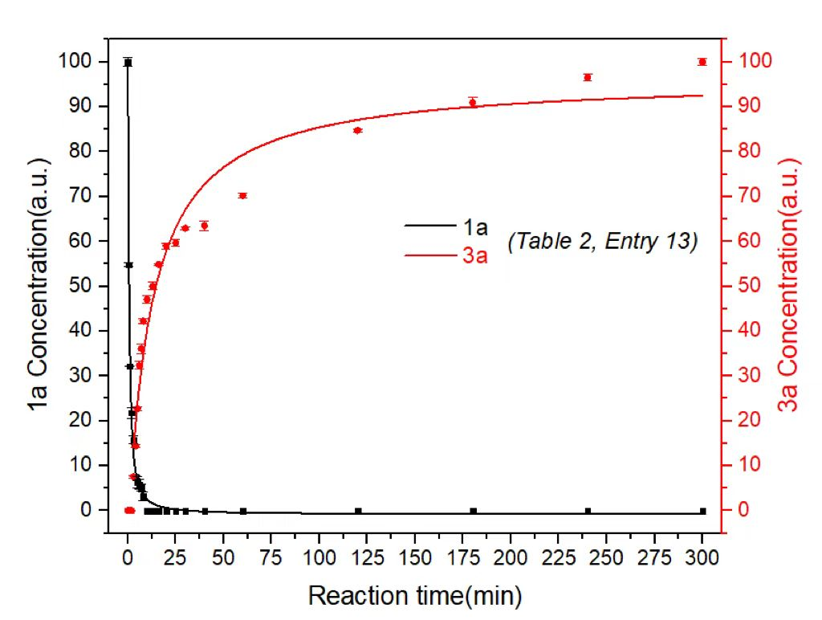
Table S2, Entry 23
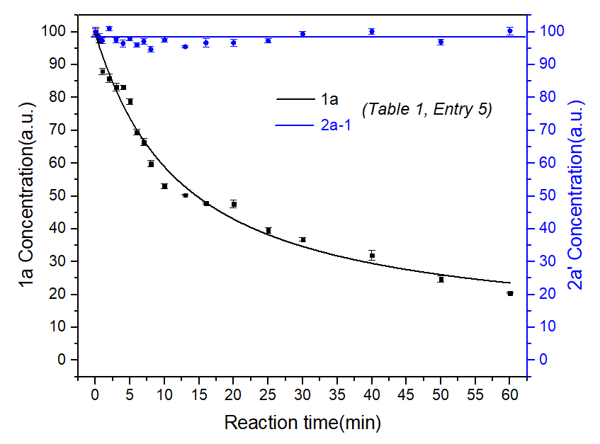
Table S1, Entry 15
Figure S1. GC-MS results of two reaction systems
LC-HRMS analysis of reaction systems
To a dry Schlenk tube equipped with a magnetic stir bar, was added 1a (0.10 mmol), triazolium salt NHC-A (0.01 mmol) and DBU (0.02 mmol) (Entry A). The vial was then sealed, purged and backfilled with N₂ three times in glovebox, using 100 mg 4 Å MS as additive and anhydrous toluene (2.0 mL) as solvent. The reaction mixture was then stirred at 30 ºC in oil bath for 3 hours. After the indicated time, the supernatant of the reaction mixture was taken out and diluted. The crude mixture was subjected to liquid chromatography-high resolution mass spectrum (LC-HRMS) analysis. Meanwhile, the model reaction was also detected by LC-HRMS with same method (Entry B).

LC-HRMS results of Entry A:
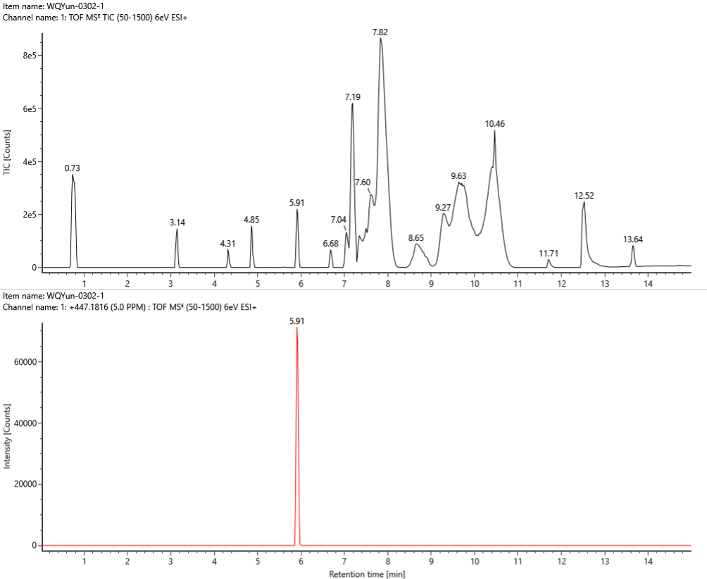
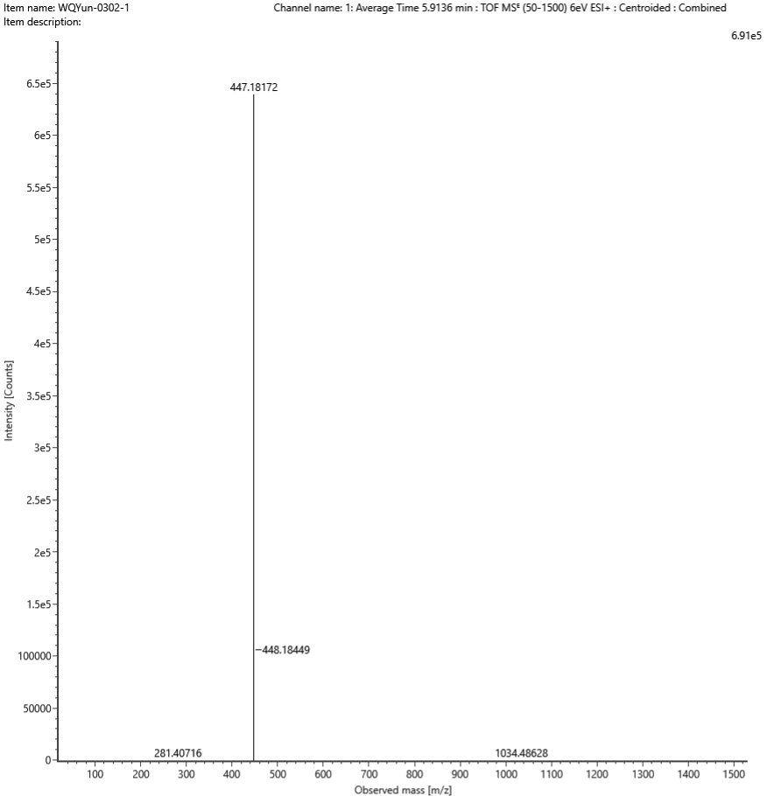

LC-HRMS results of Entry B:
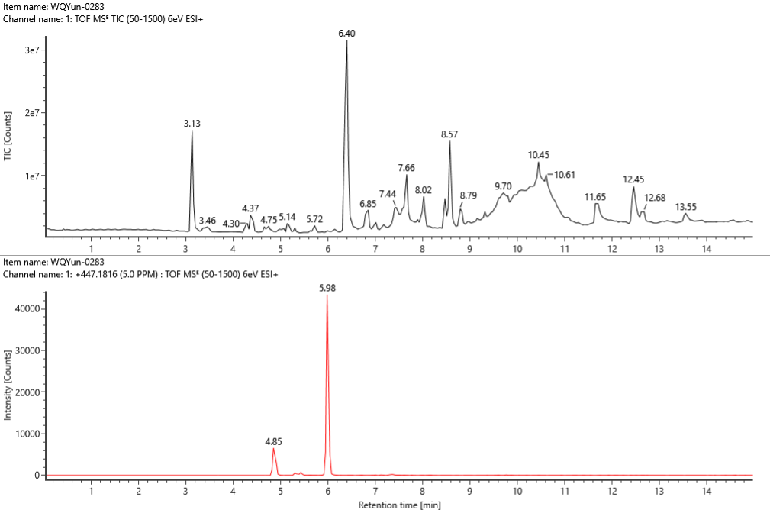
Area: 30425
Area: 147411
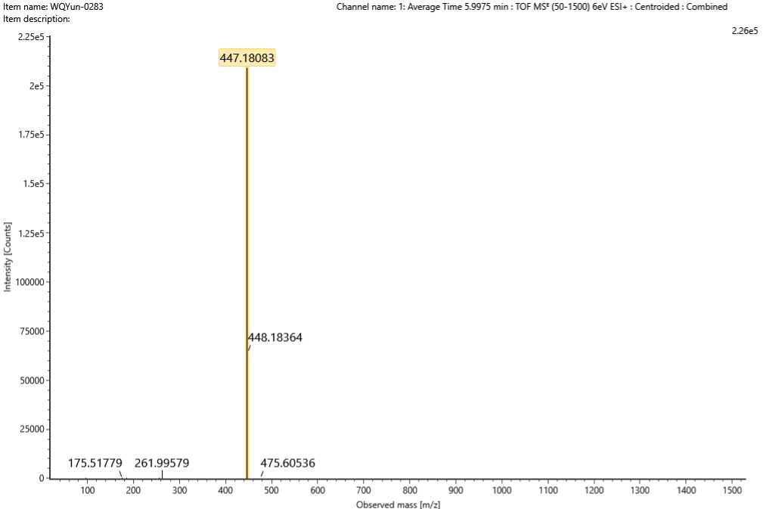

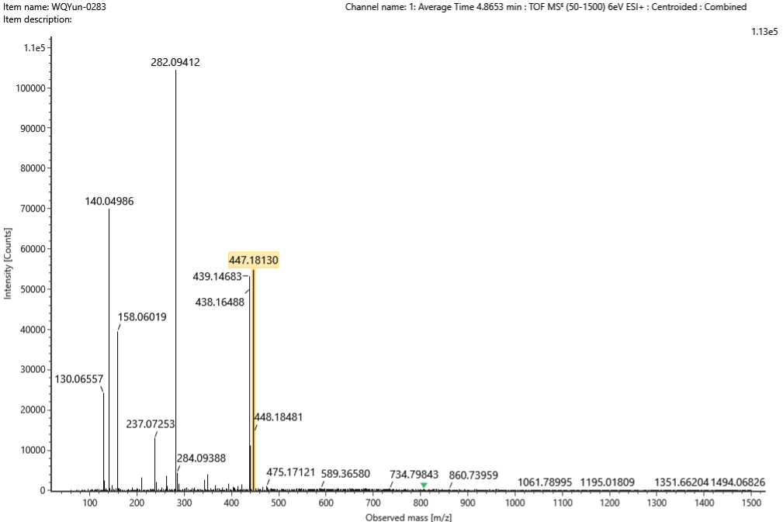
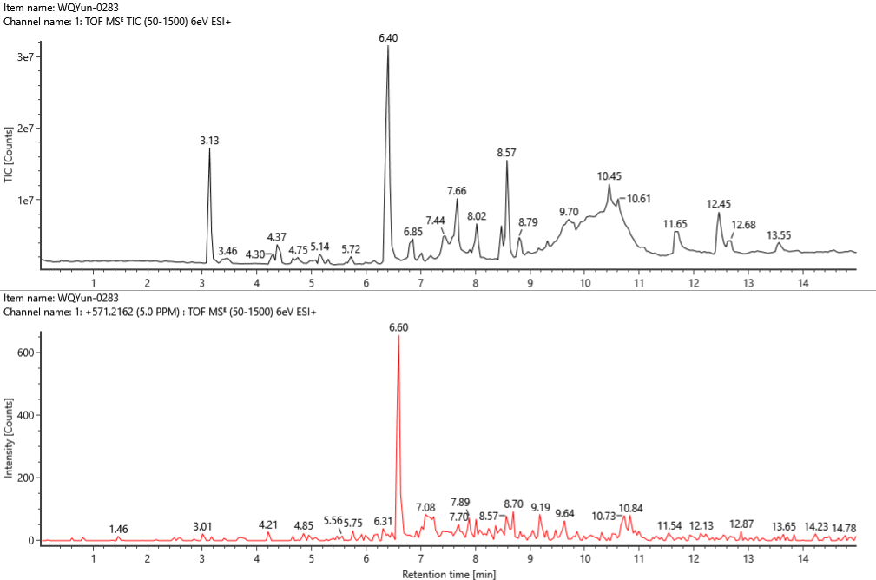
Area: 2519
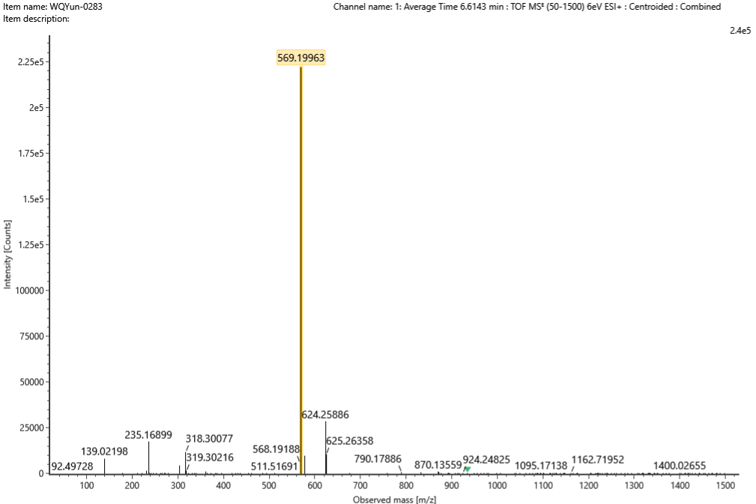
Figure S2. LC-HRMS spectra and results of reaction systems

IV. Characterization of substrates and products
1. Characterization of substrates
(Z)-4-oxo-2-phenylbut-2-enenitrile (1a)
Purification by flash column chromatography on silica gel (petroleum ether / ethyl acetate = 15 / 1). Yellow solid, 71% yield, 3.55 g, m.p. 53-54 ºC.
¹H NMR (400 MHz, CDCl₃) δ 10.28 – 10.22 (d, J = 7.64 Hz, 1H), 7.08 – 7.03 (d, J = 7.65 Hz, 1H).
¹³C NMR (101 MHz, CDCl₃) δ 188.8, 134.7, 131.5, 130.3, 129.4, 128.3, 125.8, 112.8.
HRMS (ESI, m/z): Mass calcd. for C₁₀H₇NOH⁺ [M+H]⁺, 158.0600, found 158.0608.

(Z)-4-oxo-2-(p-tolyl)but-2-enenitrile (1b)
Purification by flash column chromatography on silica gel (petroleum ether / ethyl acetate = 15 / 1). Yellow solid, 85% yield, 4.25 g. m.p. 76-77 ºC.
¹H NMR (400 MHz, CDCl₃) δ 10.25 – 10.21 (d, J = 7.69 Hz, 1H), 7.68 – 7.65 (d, J = 8.33 Hz, 2H), 7.34 – 7.31 (d, J = 8.08 Hz, 2H), 7.03 – 7.00 (d, J = 7.62 Hz, 1H), 2.44 – 2.43 (s, 3H).
¹³C NMR (101 MHz, CDCl₃) δ 190.3, 143.9, 134.9, 131.6, 130.4, 128.0, 127.1, 114.2, 21.6.
HRMS (ESI, m/z): Mass calcd. for C₁₁H₁₀NO⁺ [M+H]⁺, 172.0757; found 172.0760.

(Z)-2-(4-methoxyphenyl)-4-oxobut-2-enenitrile (1c)
Purification by flash column chromatography on silica gel (petroleum ether / ethyl acetate = 10 / 1). Yellow solid, 90% yield, 4.5 g. m.p. 115-117 ºC.
¹H NMR (400 MHz, CDCl₃) δ 10.22 – 10.17 (d, J = 7.71 Hz, 1H), 7.74 – 7.71 (d, J = 8.92 Hz, 2H), 7.03 – 6.99 (m, 2H), 6.95 – 6.93 (d, J = 7.77 Hz, 1H), 3.90 – 3.89 (s, 3H).
¹³C NMR (101 MHz, CDCl₃) δ 190.2, 163.4, 133.4, 131.2, 129.0, 123.1, 115.1, 114.3, 55.7.
HRMS (ESI, m/z): Mass calcd. for C₁₁H₁₀NO₂⁺ [M+H]⁺, 188.0706; found 188.0712.

(Z)-2-(4-(tert-butyl)phenyl)-4-oxobut-2-enenitrile (1d)
Purification by flash column chromatography on silica gel (petroleum ether / ethyl acetate = 5 / 1). Yellow solid, 91% yield, 4.6 g. m.p. 49-51 ºC.
¹H NMR (400 MHz, CDCl₃) δ 10.26 – 10.20 (d, J = 7.72 Hz, 1H), 7.73 – 7.70 (d, J = 8.57 Hz, 2H), 7.56 – 7.52 (d, J = 8.58 Hz, 2H), 7.05 – 7.02 (d, J = 7.72 Hz, 1H), 1.36 – 1.34 (s, 9H).
¹³C NMR (101 MHz, CDCl₃) δ 190.2, 156.9, 135.0, 131.5, 127.9, 127.0, 126.7, 114.2, 35.2, 31.0.
HRMS (ESI, m/z): Mass calcd. for C₁₄H₁₆NO⁺ [M+H]⁺, 214.1226; found 214.1228.

(Z)-2-(4-fluorophenyl)-4-oxobut-2-enenitrile (1e)
Purification by flash column chromatography on silica gel (petroleum ether / ethyl acetate = 10 / 1). Yellow solid, 80% yield, 4.0 g, m.p. 74-75 ºC.
¹H NMR (400 MHz, CDCl₃) δ 10.26 – 10.21 (d, J = 7.56 Hz, 1H), 7.81 – 7.76 (m, 2H), 7.27 – 7.21 (m, 2H), 7.01 – 6.98 (m, 1H).
¹³C NMR (101 MHz, CDCl₃) δ 189.9, 165.2 (d, J = 256.34 Hz), 135.7 (d, J = 2.50 Hz), 130.4, 129.4 (d, J = 9.07 Hz), 127.0 (d, J = 3.55 Hz), 117.1 (d, J = 22.49 Hz), 113.9.
¹⁹F NMR (376 MHz, CDCl₃) δ -104.87.
HRMS (ESI, m/z): Mass calcd. for C₁₀H₇FNO⁺ [M+H]⁺, 176.0506; found 176.0508.

(Z)-2-(4-chlorophenyl)-4-oxobut-2-enenitrile (1f)
Purification by flash column chromatography on silica gel (petroleum ether / ethyl acetate = 15 / 1). Yellow solid, 80% yield, 4.0 g, m.p. 99-100ºC.
¹H NMR (400 MHz, CDCl₃) δ 10.26 – 10.22 (d, J = 7.56 Hz, 1H), 7.73 – 7.70 (d, J = 8.77 Hz, 2H), 7.53 – 7.49 (d, J = 8.79 Hz, 2H), 7.05 – 7.02 (d, J = 7.57 Hz, 1H).
¹³C NMR (101 MHz, CDCl₃) δ 189.9, 139.3, 136.1, 130.3, 130.0, 129.1, 128.3, 113.8.
HRMS (ESI, m/z): Mass calcd. for C₁₀H₇ClNO⁺ [M+H]⁺, 192.0211; found 192.0212.

(Z)-2-(4-bromophenyl)-4-oxobut-2-enenitrile (1g)
Purification by flash column chromatography on silica gel (petroleum ether / ethyl acetate = 10 / 1). Yellow solid, 79% yield, 3.9 g, m.p. 101-103 ºC.
¹H NMR (400 MHz, CDCl₃) δ 10.27 – 10.21 (d, J = 7.56 Hz, 1H), 7.69 – 7.61 (m, 4H), 7.06 – 7.03 (d, J = 7.57 Hz, 1H).
¹³C NMR (101 MHz, CDCl₃) δ 188.7, 135.0, 131.9, 129.3, 128.5, 127.3, 126.6, 112.6.
HRMS (ESI, m/z): Mass calcd. for C₁₀H₇BrNO⁺ [M+H]⁺, 235.9706; found 235.9705.

(Z)-4-oxo-2-(4-(trifluoromethyl)phenyl)but-2-enenitrile (1h)
Purification by flash column chromatography on silica gel (petroleum ether / ethyl acetate = 10 / 1). Yellow solid, 83% yield, 4.2 g, m.p. 59-61 ºC.
¹H NMR (400 MHz, CDCl₃) δ 10.26 – 10.21 (d, J = 7.56 Hz, 1H), 7.81 – 7.76 (m, 2H), 7.27 – 7.21 (m, 2H), 7.01 – 6.98 (m, 1H).
¹³C NMR (101 MHz, CDCl₃) δ 189.7, 152.2 (q, J = 2.04 Hz), 136.5, 130.0, 129.0, 128.9, 122.8 (q, J = 274.7 Hz), 121.5, 113.8.
¹⁹F NMR (376 MHz, CDCl₃) δ -57.71.
HRMS (ESI, m/z): Mass calcd. for C₁₁H₇F₃NO⁺ [M+H]⁺, 226.0474; found 226.0474.

(Z)-2-(3-methoxyphenyl)-4-oxobut-2-enenitrile (1i)
Purification by flash column chromatography on silica gel (petroleum ether / ethyl acetate = 5 / 1). Yellow solid, 87% yield, 4.4 g, m.p. 73-74 ºC.
¹H NMR (400 MHz, CDCl₃) δ 10.27 – 10.22 (d, J = 7.67 Hz, 1H), 7.46 – 7.41 (t, J = 7.99 Hz, 1H), 7.38 – 7.35 (dt, J = 7.93, 1.28 Hz, 1H), 7.25 – 7.23 (s, 1H), 7.13 – 7.09 (m, 1H), 7.06 – 7.03 (d, J = 7.65 Hz, 1H), 3.89 – 3.87 (s, 3H).
¹³C NMR (101 MHz, CDCl₃) δ 190.2, 160.3, 136.2, 131.9, 131.5, 130.7, 119.6, 118.6, 114.1, 112.2, 55.6.
HRMS (ESI, m/z): Mass calcd. for C₁₁H₁₀NO₂⁺ [M+H]⁺, 188.0706; found 188.0709.

(Z)-2-(3-fluorophenyl)-4-oxobut-2-enenitrile (1j)
Purification by flash column chromatography on silica gel (petroleum ether / ethyl acetate = 15 / 1). Yellow solid, 80% yield, 4.0 g, m.p. 56-58 ºC.
¹H NMR (400 MHz, CDCl₃) δ 10.27 – 10.23 (d, J = 7.52 Hz, 1H), 7.60 – 7.44 (m, 3H), 7.31 – 7.26 (m, 1H), 7.07 – 7.04 (d, J = 7.52 Hz, 1H).
¹³C NMR (101 MHz, CDCl₃) δ 189.8, 163.0 (d, J = 249.55 Hz), 136.9, 132.8 (d, J = 7.93 Hz), 131.4 (d, J = 8.30 Hz), 130.2, 123.0 (d, J = 3.15 Hz), 119.8 (d, J = 21.38 Hz), 114.0 (d, J = 23.86 Hz), 113.7.
¹⁹F NMR (376 MHz, CDCl₃) δ -110.05.
HRMS (ESI, m/z): Mass calcd. for C₁₀H₇FNO⁺ [M+H]⁺, 176.0506; found 176.0511.

(Z)-2-(3-chlorophenyl)-4-oxobut-2-enenitrile (1k)
Purification by flash column chromatography on silica gel (petroleum ether / ethyl acetate = 15 / 1). Yellow solid, 53% yield, 2.7 g, m.p. 105-106 ºC.
¹H NMR (400 MHz, CDCl₃) δ 10.26 – 10.22 (d, J = 7.52 Hz, 1H), 7.75 – 7.73 (t, J = 1.92 Hz, 1H), 7.69 – 7.66 (dt, J = 7.76, 1.40 Hz, 1H), 7.57 – 7.54 (dt, J = 8.33, 1.41 Hz, 1H), 7.51 – 7.47 (t, J = 7.88 Hz, 1H), 7.08 – 7.06 (d, J = 7.51 Hz, 1H).
¹³C NMR (101 MHz, CDCl₃) δ 189.8, 137.0, 135.9, 132.7, 132.4, 130.9, 130.0, 127.0, 125.3, 113.7.
HRMS (ESI, m/z): Mass calcd. for C₁₀H₇ClNO⁺ [M+H]⁺, 192.0211; found 192.0217.

(Z)-2-(2-fluorophenyl)-4-oxobut-2-enenitrile (1l)
Purification by flash column chromatography on silica gel (petroleum ether / ethyl acetate = 15 / 1). Yellow solid, 77% yield, 3.9 g. m.p. 54-56 ºC.
¹H NMR (400 MHz, CDCl₃) δ 10.30 – 10.25 (d, J = 7.60 Hz, 1H), 7.80 – 7.75 (tt, J = 7.78, 1.57 Hz, 1H), 7.58 – 7.53 (m, 1H), 7.36 – 7.32 (td, J = 7.03, 6.42, 1.14 Hz, 1H), 7.26 – 7.21 (m, 2H).
¹³C NMR (101 MHz, CDCl₃) δ 190.5, 160.7 (d, J = 256.97 Hz), 140.6 (d, J = 13.43 Hz), 134.0 (d, J = 9.29 Hz), 130.5, 126.4 (d, J = 3.20 Hz), 125.3, 119.2 (d, J = 9.83 Hz), 117.2 (d, J = 22.16 Hz), 113.7.
¹⁹F NMR (376 MHz, CDCl₃) δ -109.98.
HRMS (ESI, m/z): Mass calcd. for C₁₀H₇FNO⁺ [M+H]⁺, 176.0506; found 176.0509.
(Z)-2-(2-methoxyphenyl)-4-oxobut-2-enenitrile (1m)
Purification by flash column chromatography on silica gel (petroleum ether / ethyl acetate = 10 / 1). Yellow solid, 89% yield, 4.5 g. m.p. 79-81 ºC.
¹H NMR (400 MHz, CDCl₃) δ 10.30 – 10.25 (d, J = 7.87 Hz, 1H), 7.71 – 7.68 (dd, J = 7.82, 1.69 Hz, 1H), 7.53 – 7.48 (m, 1H), 7.40 – 7.36 (d, J = 7.89 Hz, 1H), 7.12 – 7.08 (m, 1H), 7.04 – 7.01 (dd, J = 8.38, 1.11 Hz, 1H), 3.96 – 3.95 (s, 3H).
¹³C NMR (101 MHz, CDCl₃) δ 191.7, 158.4, 139.8, 133.5, 130.8, 129.1, 121.3, 120.0, 114.5, 111.9, 55.8.
HRMS (ESI, m/z): Mass calcd. for C₁₁H₁₀NO₂⁺ [M+H]⁺, 188.0706; found 188.0707.

(Z)-2-(3,5-dimethylphenyl)-4-oxobut-2-enenitrile (1n)
Purification by flash column chromatography on silica gel (petroleum ether / ethyl acetate = 5 / 1). Yellow solid, 92% yield, 4.6 g. m.p. 130-132 ºC.
¹H NMR (400 MHz, CDCl₃) δ 10.25 – 10.19 (d, J = 7.74 Hz, 1H), 7.39 – 7.34 (s, 2H), 7.22 – 7.17 (s, 1H), 7.06 – 6.99 (d, J = 7.68 Hz, 1H), 2.40 – 2.38 (s, 6H).
¹³C NMR (101 MHz, CDCl₃) δ 190.2, 139.4, 135.6, 134.6, 131.9, 130.6, 124.9, 114.3, 21.2.
HRMS (ESI, m/z): Mass calcd. for C₁₂H₁₂NO⁺ [M+H]⁺, 186.0913; found 186.0915.

(Z)-2-(3,4-dimethoxyphenyl)-4-oxobut-2-enenitrile (1o)
Purification by flash column chromatography on silica gel (petroleum ether / ethyl acetate = 5 / 1). Yellow solid, 97% yield, 4.9 g. m.p. 140-141 ºC.
¹H NMR (400 MHz, CDCl₃) δ 10.28 – 10.15 (d, J = 7.68 Hz, 1H), 7.49 – 7.42 (d, J = 8.65 Hz, 1H), 7.20 – 7.15 (s, 1H), 7.01 – 6.93 (t, J = 6.57 Hz, 2H), 4.01 – 3.93 (s, 6H).
¹³C NMR (101 MHz, CDCl₃) δ 190.2, 153.3, 149.7, 133.5, 131.3, 123.4, 121.9, 114.3, 111.4, 108.7, 56.2, 56.1.
HRMS (ESI, m/z): Mass calcd. for C₁₂H₁₄NO₃⁺ [M+H]⁺, 218.0812; found 218.0813.

(Z)-2-(benzo[d][1,3]dioxol-5-yl)-4-oxobut-2-enenitrile (1p)
Purification by flash column chromatography on silica gel (petroleum ether / ethyl acetate = 10 / 1). Yellow solid, 90% yield, 4.5 g. m.p. 173-175 ºC.
¹H NMR (400 MHz, CDCl₃) δ 10.22 – 10.18 (d, J = 7.64 Hz, 1H), 7.41 – 7.39 (dd, J = 8.25, 1.98 Hz, 1H), 7.17 – 7.15 (d, J = 1.95 Hz, 1H), 6.95 – 6.92 (d, J = 8.23 Hz, 1H), 6.90 – 6.88 (d, J = 7.66 Hz, 1H), 6.10 – 6.10 (s, 2H).
¹³C NMR (101 MHz, CDCl₃) δ 190.2, 151.9, 149.1, 133.9, 131.1, 125.0, 123.8, 114.2, 109.1, 105.9, 102.4.
HRMS (ESI, m/z): Mass calcd. for C₁₁H₈NO₃⁺ [M+Na]⁺, 202.0499; found 202.0499.
(Z)-2-(3-(cyclopentyloxy)-4-methoxyphenyl)-4-oxobut-2-enenitrile (1q)
Purification by flash column chromatography on silica gel (petroleum ether / ethyl acetate = 10 / 1). Yellow solid, 87% yield, 4.4 g. m.p. 135-136 ºC.
¹H NMR (400 MHz, CDCl₃) δ 10.23 – 10.17 (d, J = 7.71 Hz, 1H), 7.43 – 7.39 (dd, J = 8.50, 2.35 Hz, 1H), 7.20 – 7.18 (d, J = 2.36 Hz, 1H), 6.97 – 6.91 (dd, J = 12.28, 8.15 Hz, 2H), 4.85 – 4.80 (dt, J = 6.18, 3.18 Hz, 1H), 3.94 – 3.92 (s, 3H), 2.00 – 1.83 (m, 6H), 1.68 – 1.62 (m, 2H).
¹³C NMR (101 MHz, CDCl₃) δ 190.3, 154.3, 148.4, 133.3, 131.5, 123.3, 121.6, 114.3, 112.0, 111.7, 80.9, 56.2, 32.8, 24.1.
HRMS (ESI, m/z): Mass calcd. for C₁₆H₁₇NNaO₃⁺ [M+Na]⁺, 294.1101; found 294.1101.

(Z)-4-oxo-2-(3,4,5-trimethoxyphenyl)but-2-enenitrile (1r)
Purification by flash column chromatography on silica gel (petroleum ether / ethyl acetate = 8 / 1). Yellow solid, 90% yield, 4.5 g. m.p. 131-132 ºC.
¹H NMR (400 MHz, CDCl₃) δ 10.25 – 10.21 (d, J = 7.63 Hz, 1H), 7.02 – 6.98 (m, 3H), 3.96 – 3.94 (s, 9H).
¹³C NMR (101 MHz, CDCl₃) δ 190.1, 153.8, 142.2, 135.0, 131.3, 125.8, 114.2, 104.4, 61.2, 56.4.
HRMS (ESI, m/z): Mass calcd. for C₁₃H₁₄NO₄⁺ [M+H]⁺, 248.0917; found 248.0915.

(Z)-2-([1,1'-biphenyl]-4-yl)-4-oxobut-2-enenitrile (1s)
Purification by flash column chromatography on silica gel (petroleum ether / ethyl acetate = 10 / 1). Yellow solid, 83% yield, 4.2 g. m.p. 151-153 ºC.
¹H NMR (400 MHz, CDCl₃) δ 10.29 – 10.23 (d, J = 7.66 Hz, 1H), 7.86 – 7.82 (m, 2H), 7.76 – 7.73 (m, 2H), 7.65 – 7.62 (m, 2H), 7.51 – 7.40 (m, 3H), 7.10 – 7.06 (d, J = 7.64 Hz, 1H).
¹³C NMR (101 MHz, CDCl₃) δ 190.1, 145.6, 139.1, 135.4, 131.2, 129.5, 129.1, 128.7, 128.1, 127.7, 127.2, 114.1.
HRMS (ESI, m/z): Mass calcd. for C₁₆H₁₂NO⁺ [M+H]⁺, 234.0913; found 234.0910.

(Z)-2-(naphthalen-1-yl)-4-oxobut-2-enenitrile (1t)
Purification by flash column chromatography on silica gel (petroleum ether / ethyl acetate = 10 / 1). Yellow solid, 80% yield, 4.0 g. m.p. 74-76 ºC.
¹H NMR (400 MHz, CDCl₃) δ 10.41 – 10.25 (d, J = 7.74 Hz, 1H), 8.11 – 8.06 (m, 1H), 7.96 – 7.93 (dd, J = 8.26, 1.29 Hz, 1H), 7.90 – 7.87 (m, 1H), 7.59 – 7.54 (m, 3H), 7.50 – 7.46 (m, 1H), 6.90 – 6.86 (d, J = 7.74 Hz, 1H).
¹³C NMR (101 MHz, CDCl₃) δ 188.3, 140.8, 132.2, 130.7, 129.4, 128.3, 128.0, 127.6, 126.4, 126.2, 125.5, 123.6, 122.1, 113.4.
HRMS (ESI, m/z): Mass calcd. for C₁₄H₁₀NO⁺ [M+H]⁺, 208.0757; found 208.0760.

(Z)-2-(1-methyl-1H-indol-4-yl)-4-oxobut-2-enenitrile (1u)
Purification by flash column chromatography on silica gel (petroleum ether / ethyl acetate = 6 / 1). Yellow solid, 74% yield, 3.7 g. m.p. 138-140 ºC.
¹H NMR (400 MHz, CDCl₃) δ 10.18 – 10.14 (d, J = 7.95 Hz, 1H), 7.88 – 7.85 (d, J = 7.93 Hz, 1H), 7.81 – 7.79 (s, 1H), 7.43 – 7.34 (m, 3H), 7.02 – 6.99 (d, J = 7.97 Hz, 1H), 3.90 – 3.89 (s, 3H).
¹³C NMR (101 MHz, CDCl₃) δ 190.5, 138.8, 135.2, 129.0, 126.0, 124.4, 124.4, 123.1, 120.7, 114.9, 110.9, 110.5, 33.8.
HRMS (ESI, m/z): Mass calcd. for C₁₃H₁₀N₂NaO⁺ [M+Na]⁺, 233.0685; found 233.0683.

(E)-4-oxo-2-(thiophen-2-yl)but-2-enenitrile (1v)
Purification by flash column chromatography on silica gel (petroleum ether / ethyl acetate = 5 / 1). Yellow solid, 70% yield, 3.5 g. m.p. 82-83 ºC.
¹H NMR (400 MHz, CDCl₃) δ 10.16 – 10.11 (d, J = 7.60 Hz, 1H), 7.73 – 7.69 (dd, J = 3.84, 1.20 Hz, 1H), 7.66 – 7.60 (dd, J = 5.09, 1.21 Hz, 1H), 7.23 – 7.18 (dd, J = 5.07, 3.81 Hz, 1H), 6.84 – 6.79 (d, J = 7.65 Hz, 1H).
¹³C NMR (101 MHz, CDCl₃) δ 189.4, 136.2, 132.9, 132.3, 129.2, 125.1, 113.2.
HRMS (ESI, m/z): Mass calcd. for C₈H₆NOS⁺ [M+H]⁺, 164.0165; found 164.0169.

(Z)-2-(cyclohex-1-en-1-yl)-4-oxobut-2-enenitrile (1w)
Purification by flash column chromatography on silica gel (petroleum ether / ethyl acetate = 10 / 1). Yellow solid, 75% yield, 3.8 g. m.p. 51-52 ºC.
¹H NMR (400 MHz, CDCl₃) δ 10.16 – 10.12 (d, J = 7.81 Hz, 1H), 6.97 – 6.94 (t, J = 4.31 Hz, 1H), 6.46 – 6.43 (dd, J = 7.81, 1.00 Hz, 1H), 2.39 – 2.35 (m, 2H), 2.21 – 2.17 (ddt, J = 6.13, 3.97, 1.69 Hz, 2H), 1.80 – 1.75 (m, 2H), 1.70 – 1.65 (m, 2H).
¹³C NMR (101 MHz, CDCl₃) δ 190.8, 141.6, 133.3, 132.5, 132.2, 113.4, 26.7, 24.6, 21.7, 21.2.
HRMS (ESI, m/z): Mass calcd. for C₁₀H₁₂NO⁺ [M+H]⁺, 162.0913; found 162.0916.

2. Characterization of products
S-(p-tolyl) (R)-3-cyano-3-phenylpropanethioate (3a)
Purification by flash column chromatography on silica gel (petroleum ether / ethyl acetate = 10 / 1). Yellow solid, 83% yield, 23.4 mg, m.p. 94-96 ºC.
[α]²⁵_{D} = -15.1 (c = 0.4 in CHCl₃).
¹H NMR (400 MHz, CDCl₃) δ 7.45 – 7.36 (m, 5H), 7.28 – 7.24 (d, J = 1.07 Hz, 4H), 4.42 – 4.36 (t, J = 7.32 Hz, 1H), 3.38 – 3.31 (dd, J = 16.13, 7.75 Hz, 1H), 3.21 – 3.14 (dd, J = 16.19, 6.96 Hz, 1H), 2.41 – 2.39 (s, 3H).
¹³C NMR (101 MHz, CDCl₃) δ 193.9, 140.4, 134.5, 134.1, 130.3, 129.4, 128.7, 127.5, 122.9, 119.6, 47.9, 33.1, 21.4.
HRMS (ESI, m/z): Mass calcd. for C₁₇H₁₆NOS⁺ [M+H]⁺, 282.0947; found 282.0943.
HPLC analysis (Chiralcel IA; 25 ºC, IPA/Hexane = 05/95, 0.5 mL/min, 254 nm), Rt₁ (major) = 36.2 min, Rt₂ (minor) = 42.8 min; 95:5 er.

S-(p-tolyl) (R)-3-cyano-3-(p-tolyl)propanethioate (3b)
Purification by flash column chromatography on silica gel (petroleum ether / ethyl acetate = 10 / 1). White solid, 85% yield, 25.1 mg, m.p. 99-101 ºC.
[α]²⁵_{D} = -61.3 (c = 0.6 in CHCl₃).
¹H NMR (400 MHz, CDCl₃) δ 7.29 – 7.21 (m, 8H), 4.39 – 4.32 (t, J = 7.35 Hz, 1H), 3.36 – 3.29 (dd, J = 16.18, 7.78 Hz, 1H), 3.18 – 3.11 (dd, J = 16.15, 6.98 Hz, 1H), 2.43 – 2.37 (d, J = 8.14 Hz, 6H).
¹³C NMR (101 MHz, CDCl₃) δ 194.0, 140.4, 138.6, 134.5, 131.1, 130.3, 130.0, 127.3, 122.9, 119.8, 48.0, 32.7, 21.4, 21.2.
HRMS (ESI, m/z): Mass calcd. for C₁₈H₁₇NNaOS⁺ [M+H]⁺, 318.0923; found 318.0927.
HPLC analysis (Chiralcel IA; 25 ºC, IPA/Hexane = 05/95, 0.6 mL/min, 254 nm), Rt₁ (major) = 27.4 min, Rt₂ (minor) = 30.1 min; 96:4 er.

S-(p-tolyl) (R)-3-cyano-3-(4-methoxyphenyl)propanethioate (3c)
Purification by flash column chromatography on silica gel (petroleum ether / ethyl acetate = 10 / 1). White solid, 92% yield, 28.6 mg, m.p. 168-170 ºC.;
[α]²⁵_{D} = -71.5 (c = 0.6 in CHCl₃).
¹H NMR (400 MHz, CDCl₃) δ 7.31 – 7.28 (d, J = 8.58 Hz, 2H), 7.26 – 7.23 (s, 2H), 6.96 – 6.90 (d, J = 8.70 Hz, 2H), 4.37 – 4.31 (t, J = 7.33 Hz, 1H), 3.86 – 3.82 (s, 3H), 3.34 – 3.28 (dd, J = 16.09, 7.52 Hz, 1H), 3.18 – 3.11 (dd, J = 16.10, 7.16 Hz, 1H), 2.43 – 2.38 (s, 3H).
¹³C NMR (101 MHz, CDCl₃) δ 194.0, 159.7, 140.3, 134.4, 130.3, 128.7, 126.0, 122.9, 119.8, 114.6, 55.4, 48.1, 32.3, 21.4.
HRMS (ESI, m/z): Mass calcd. for C₁₈H₁₇NNaO₂S⁺ [M+Na]⁺, 334.0872; found 334.0872.
HPLC analysis (Chiralcel IA; 25 ºC, IPA/Hexane = 05/95, 0.6 mL/min, 254 nm), Rt₁ (major) = 44.2 min, Rt₂ (minor) = 47.3 min; 96:4 er.

S-(p-tolyl) (R)-3-(4-(tert-butyl)phenyl)-3-cyanopropanethioate (3d)
Purification by flash column chromatography on silica gel (petroleum ether / ethyl acetate = 10 / 1). White solid, 85% yield, 28.7mg, m.p. 81-82 ºC.
[α]²⁵_{D} = -37.0 (c = 0.6 in CHCl₃).
¹H NMR (400 MHz, CDCl₃) δ 7.45 – 7.41 (d, J = 8.43 Hz, 2H), 7.33 – 7.24 (m, 6H), 4.39 – 4.34 (dd, J = 8.06, 6.67 Hz, 1H), 3.37 – 3.30 (dd, J = 16.23, 8.09 Hz, 1H), 3.19 – 3.13 (dd, J = 16.23, 6.66 Hz, 1H), 2.42 – 2.39 (s, 3H), 1.36 – 1.33 (s, 9H).
¹³C NMR (101 MHz, CDCl₃) δ 194.0, 151.8, 140.3, 134.5, 131.0, 130.3, 127.1, 126.3, 122.9, 119.7, 47.9, 34.7, 32.6, 31.3, 21.4.
HRMS (ESI, m/z): Mass calcd. for C₂₁H₂₃NNaOS⁺ [M+Na]⁺, 360.1393; found 360.1393.
HPLC analysis (Chiralcel OD-H; 25 ºC, IPA/Hexane = 10/90, 0.5 mL/min, 254 nm), Rt₁ (major) = 44.4 min, Rt₂ (minor) = 59.3 min; 97:3 er.

S-(p-tolyl) (R)-3-cyano-3-(4-fluorophenyl)propanethioate (3e)
Purification by flash column chromatography on silica gel (petroleum ether / ethyl acetate = 10 / 1). Yellow oil, 89% yield, 26.6 mg.
[α]²⁵_{D} = -35.9 (c = 0.5 in CHCl₃).
¹H NMR (400 MHz, CDCl₃) δ 7.37 – 7.31 (m, 2H), 7.25 – 7.20 (s, 4H), 7.12 – 7.04 (m, 2H), 4.39 – 4.32 (t, J = 7.28 Hz, 1H), 3.34 – 3.27 (dd, J = 16.14, 7.25 Hz, 1H), 3.16 – 3.09 (dd, J = 16.16, 7.35 Hz, 1H), 2.40 – 2.35 (s, 3H).
¹³C NMR (101 MHz, CDCl₃) δ 193.8, 162.7 (d, J = 248.46 Hz), 140.5, 134.4, 130.3, 129.9 (d, J = 3.51 Hz), 129.4 (d, J = 8.37 Hz), 122.7, 119.4, 116.4 (d, J = 22.02 Hz), 47.8, 32.3, 21.4.
¹⁹F NMR (377 MHz, CDCl₃) δ -112.65.
HRMS (ESI, m/z): Mass calcd. for C₁₇H₁₄FNNaOS⁺ [M+Na]⁺, 322.0672; found 322.0668.
HPLC analysis (Chiralcel AD-H; 25 ºC, IPA/Hexane = 05/95, 0.5 mL/min, 254 nm), Rt₁ (major) = 41.8 min, Rt₂ (minor) = 51.7 min; 92:8 er.

S-(p-tolyl) (R)-3-(4-chlorophenyl)-3-cyanopropanethioate (3f )
Purification by flash column chromatography on silica gel (petroleum ether / ethyl acetate = 10 / 1). Yellow solid, 84% yield, 26.5 mg, m.p. 104-106 ºC.
[α]²⁵_{D} = -11.6 (c = 0.4 in CHCl₃).
¹H NMR (400 MHz, CDCl₃) δ 7.40 – 7.34 (d, J = 8.55 Hz, 2H), 7.32 – 7.28 (d, J = 8.53 Hz, 2H), 7.25 – 7.19 (s, 4H), 4.39 – 4.31 (t, J = 7.25 Hz, 1H), 3.34 – 3.27 (dd, J = 16.22, 7.23 Hz, 1H), 3.16 – 3.09 (dd, J = 16.23, 7.28 Hz, 1H), 2.41 – 2.34 (s, 3H).
¹³C NMR (101 MHz, CDCl₃) δ 193.7, 140.5, 134.8, 134.4, 132.6, 130.3, 129.5, 128.9, 122.7, 119.2, 47.7, 32.4, 21.4.
HRMS (ESI, m/z): Mass calcd. for C₁₇H₁₄ClNNaOS⁺ [M+Na]⁺, 338.0377; found 338.0377.
HPLC analysis (Chiralcel IA; 25 ºC, IPA/Hexane = 05/95, 0.6 mL/min, 254 nm), Rt₁ (major) = 36.0 min, Rt₂ (minor) = 45.6 min; 86:14 er.

S-(p-tolyl) (R)-3-(4-bromophenyl)-3-cyanopropanethioate (3g)
Purification by flash column chromatography on silica gel (petroleum ether / ethyl acetate = 15 / 1). Yellow solid, 88% yield, 31.7 mg, m.p. 94-96 ºC.
[α]²⁵_{D} = -76.3 (c = 0.5 in CHCl₃).
¹H NMR (400 MHz, CDCl₃) δ 7.58 – 7.53 (d, J = 8.47 Hz, 2H), 7.29 – 7.25 (d, J = 2.87 Hz, 6H), 4.39 – 4.33 (t, J = 7.25 Hz, 1H), 3.37 – 3.30 (dd, J = 16.26, 7.20 Hz, 1H), 3.19 – 3.12 (dd, J = 16.27, 7.33 Hz, 1H), 2.42 – 2.38 (s, 3H).
¹³C NMR (101 MHz, CDCl₃) δ 193.7, 140.5, 134.4, 133.1, 132.5, 130.3, 129.2, 122.9, 122.6, 119.1, 47.6, 32.5, 21.4.
HRMS (ESI, m/z): Mass calcd. for C₁₇H₁₄BrNNaOS⁺ [M+Na]⁺, 381.9872; found 381.9869.
HPLC analysis (Chiralcel IA; 25 ºC, IPA/Hexane = 05/95, 0.6 mL/min, 254 nm), Rt₁ (major) = 42.6 min, Rt₂ (minor) = 52.7 min; 80:20 er.

S-(p-tolyl) (R)-3-cyano-3-(4-(trifluoromethyl)phenyl) propanethioate (3h)
Purification by flash column chromatography on silica gel (petroleum ether / ethyl acetate = 3 / 1). Yellow oil, 72% yield, 25.2 mg.
[α]²⁵_{D} = -12.1 (c = 0.4 in CHCl₃).
¹H NMR (400 MHz, CDCl₃) δ 7.45 – 7.41 (d, J = 8.71 Hz, 2H), 7.29 – 7.24 (d, J = 11.22 Hz, 6H), 4.44 – 4.39 (t, J = 7.25 Hz, 1H), 3.39 – 3.32 (dd, J = 16.28, 7.32 Hz, 1H), 3.21 – 3.15 (dd, J = 16.26, 7.26 Hz, 1H), 2.43 – 2.39 (s, 3H).
¹³C NMR (101 MHz, CDCl₃) δ 193.8, 149.3 (q, J = 1.94 Hz), 140.5, 134.4, 132.8, 130.3, 129.2, 120.4 (q, J = 257.84 Hz), 122.6, 121.8, 119.2, 47.6, 32.4, 21.4.
¹⁹F NMR (377 MHz, CDCl₃) δ -57.87.
HRMS (ESI, m/z): Mass calcd. for C₁₈H₁₄F₃NNaOS⁺ [M+Na]⁺, 372.0640; found 372.0639.
HPLC analysis (Chiralcel IA; 25 ºC, IPA/Hexane = 05/95, 0.6 mL/min, 254 nm), Rt₁ (major) = 29.8 min, Rt₂ (minor) = 36.5 min; 77:23 er.

S-(p-tolyl) (R)-3-cyano-3-(3-methoxyphenyl)propanethioate (3i)
Purification by flash column chromatography on silica gel (petroleum ether / ethyl acetate = 10 / 1). White solid, 91% yield, 28.3 mg, m.p. 107-108 ºC.
[α]²⁵_{D} = -21.0 (c = 0.4 in CHCl₃).
¹H NMR (400 MHz, CDCl₃) δ 7.32 – 7.20 (m, 5H), 6.96 – 6.85 (m, 3H), 4.36 – 4.29 (dd, J = 7.90, 6.76 Hz, 1H), 3.83 – 3.79 (s, 3H), 3.33 – 3.26 (dd, J = 16.13, 7.88 Hz, 1H), 3.17 – 3.10 (dd, J = 16.14, 6.79 Hz, 1H), 2.39 – 2.35 (s, 3H).
¹³C NMR (101 MHz, CDCl₃) δ 193.9, 160.2, 140.4, 135.5, 134.5, 130.4, 130.3, 122.9, 119.6, 119.5, 114.2, 113.1, 55.4, 47.9, 33.1, 21.4.
HRMS (ESI, m/z): Mass calcd. for C₁₈H₁₇NNaO₂S⁺ [M+Na]⁺, 334.0872; found 334.0868.
HPLC analysis (Chiralcel IA; 25 ºC, IPA/Hexane = 10/90, 0.6 mL/min, 254 nm), Rt₁ (major) = 29.2 min, Rt₂ (minor) = 31.2 min; 95:5 er.

S-(p-tolyl) (R)-3-cyano-3-(3-fluorophenyl)propanethioate (3j)
Purification by flash column chromatography on silica gel (petroleum ether / ethyl acetate = 10 / 1). Yellow oil, 85% yield, 25.4 mg.
[α]²⁵_{D} = -26.5 (c = 0.8 in CHCl₃).
¹H NMR (400 MHz, CDCl₃) δ 7.40 – 7.35 (m, 1H), 7.26 – 7.20 (s, 4H), 7.17 – 7.14 (dt, J = 7.64, 1.34 Hz, 1H), 7.11 – 7.04 (m, 2H), 4.40 – 4.34 (t, J = 7.25 Hz, 1H), 3.35 – 3.29 (dd, J = 16.23, 7.43 Hz, 1H), 3.18 – 3.11 (dd, J = 16.20, 7.12 Hz, 1H), 2.40 – 2.36 (s, 3H).
¹³C NMR (101 MHz, CDCl₃) δ 193.7, 163.0 (d, J = 244.42 Hz), 140.5, 136.4 (d, J = 7.52 Hz), 134.4, 131.0 (d, J = 8.34 Hz), 130.3, 123.2 (d, J = 2.99 Hz), 122.7, 119.0, 115.8 (d, J = 20.87 Hz), 114.8 (d, J = 22.92 Hz). 47.6, 32.7, 21.4.
¹⁹F NMR (377 MHz, CDCl₃) δ -110.93.
HRMS (ESI, m/z): Mass calcd. for C₁₇H₁₄FNNaOS⁺ [M+Na]⁺, 322.0672; found 322.0671.
HPLC analysis (Chiralcel IA; 25 ºC, IPA/Hexane = 05/95, 0.6 mL/min, 254 nm), Rt₁ (major) = 39.2 min, Rt₂ (minor) = 45.6 min; 92:8 er.

S-(p-tolyl) (R)-3-(3-chlorophenyl)-3-cyanopropanethioate (3k)
Purification by flash column chromatography on silica gel (petroleum ether / ethyl acetate = 10 / 1). Yellow solid, 85% yield, 28.6 mg, m.p. 99-101 ºC.
[α]²⁵_{D} = -9.8 (c = 0.4 in CHCl₃).
¹H NMR (400 MHz, CDCl₃) δ 7.41 – 7.32 (m, 3H), 7.30 – 7.24 (m, 5H), 4.40 – 4.34 (t, J = 7.28 Hz, 1H), 3.37 – 3.30 (dd, J = 16.23, 7.44 Hz, 1H), 3.20 – 3.13 (dd, J = 16.25, 7.13 Hz, 1H), 2.42 – 2.38 (s, 3H).
¹³C NMR (101 MHz, CDCl₃) δ 193.7, 140.5, 136.0, 135.2, 134.5, 130.6, 130.3, 129.0, 127.8, 125.7, 122.7, 119.0, 47.6, 32.7, 21.4.
HRMS (ESI, m/z): Mass calcd. for C₁₇H₁₄ClNNaOS⁺ [M+Na]⁺, 338.0377; found 338.0369.
HPLC analysis (Chiralcel IA; 25 ºC, IPA/Hexane = 05/95, 0.6 mL/min, 254 nm), Rt₁ (major) = 36.0 min, Rt₂ (minor) = 45.6 min; 86:14 er.

S-(p-tolyl) (R)-3-cyano-3-(2-fluorophenyl)propanethioate (3l)
Purification by flash column chromatography on silica gel (petroleum ether / ethyl acetate = 15 / 1). Yellow oil, 93% yield, 27.8 mg.
[α]²⁵_{D} = -42.6 (c = 0.6 in CHCl₃).
¹H NMR (400 MHz, CDCl₃) δ 7.48 – 7.43 (td, J = 7.64, 1.76 Hz, 1H), 7.39 – 7.33 (m, 1H), 7.26 – 7.16 (m, 5H), 7.14 – 7.08 (m, 1H), 4.59 – 4.54 (dd, J = 8.23, 6.15 Hz, 1H), 3.34 – 3.28 (dd, J = 16.33, 8.21 Hz, 1H), 3.24 – 3.17 (dd, J = 16.33, 6.18 Hz, 1H), 2.38 – 2.36 (s, 3H).
¹³C NMR (101 MHz, CDCl₃) δ 193.5, 160.0 (d, J = 248.66 Hz), 140.4, 134.5, 130.8 (d, J = 8.33 Hz), 130.3, 129.5 (d, J = 3.06 Hz), 125.0 (d, J = 3.64 Hz), 122.8, 121.3 (d, J = 13.74 Hz), 118.5, 116.2 (d, J = 21.03 Hz), 45.8, 27.6, 21.4.
¹⁹F NMR (377 MHz, CDCl₃) δ -116.94.
HRMS (ESI, m/z): Mass calcd. for C₁₇H₁₄FNNaOS⁺ [M+Na]⁺, 322.0672; found 322.0668.
HPLC analysis (Chiralcel IA; 25 ºC, IPA/Hexane = 05/95, 0.6 mL/min, 254 nm), Rt₁ (major) = 48.8 min, Rt₂ (minor) = 65.7 min; 91:9 er.

S-(p-tolyl) (R)-3-cyano-3-(2-methoxyphenyl)propanethioate (3m)
Purification by flash column chromatography on silica gel (petroleum ether / ethyl acetate = 10 / 1). White solid, 88% yield, 27.4 mg, m.p. 108-109 ºC.
[α]²⁵_{D} = -31.8 (c = 0.4 in CHCl₃).
¹H NMR (400 MHz, CDCl₃) δ 7.41 – 7.36 (dd, J = 7.60, 1.68 Hz, 1H), 7.35 – 7.29 (ddd, J = 8.16, 7.49, 1.71 Hz, 1H), 7.28 – 7.25 (s, 1H), 7.23 – 7.18 (d, J = 8.20 Hz, 2H), 7.00 – 6.94 (td, J = 7.52, 1.11 Hz, 1H), 6.93 – 6.88 (dd, J = 8.32, 1.11 Hz, 1H), 4.65 – 4.51 (dd, J = 8.28, 6.03 Hz, 1H), 3.90 – 3.85 (s, 3H), 3.28 – 3.16 (m, 2H), 2.38 – 2.33 (s, 3H).
¹³C NMR (101 MHz, CDCl₃) δ 194.2, 156.3, 140.1, 134.5, 130.2, 130.1, 129.0, 123.2, 122.1, 121.1, 119.6, 111.0, 55.6, 45.5, 28.5, 21.4.
HRMS (ESI, m/z): Mass calcd. for C₁₈H₁₇NNaO₂S⁺ [M+Na]⁺, 334.0872; found 334.0884.
HPLC analysis (Chiralcel OD-H; 25 ºC, IPA/Hexane = 15/85, 0.6 mL/min, 254 nm), Rt₁ (major) = 49.2 min, Rt₂ (minor) = 79.0 min; 90:10 er.

S-(p-tolyl) (R)-3-cyano-3-(3,5-dimethylphenyl)propanethioate (3n)
Purification by flash column chromatography on silica gel (petroleum ether / ethyl acetate = 10 / 1). Yellow solid, 82% yield, 25.4 mg, m.p. 103-104 ºC.
[α]²⁵_{D} = -37.1 (c = 0.8 in CHCl₃).
¹H NMR (400 MHz, CDCl₃) δ 7.27 – 7.21 (m, 4H), 7.03 – 6.89 (d, J = 7.29 Hz, 3H), 4.31 – 4.23 (dd, J = 8.04, 6.65 Hz, 1H), 3.32 – 3.24 (dd, J = 16.08, 8.06 Hz, 1H), 3.14 – 3.07 (dd, J = 16.07, 6.64 Hz, 1H), 2.40 – 2.36 (s, 3H), 2.35 – 2.29 (s, 6H).
¹³C NMR (101 MHz, CDCl₃) δ 194.0, 140.3, 139.1, 134.5, 134.0, 130.2, 125.2, 123.0, 119.8, 48.0, 33.0, 21.4, 21.3.
HRMS (ESI, m/z): Mass calcd. for C₁₉H₁₉NNaOS⁺ [M+Na]⁺, 332.1080; found 332.1078.
HPLC analysis (Chiralcel IF; 25 ºC, IPA/Hexane = 05/95, 0.5 mL/min, 254 nm), Rt₁ (major) = 35.7 min, Rt₂ (minor) = 43.2 min; 96:4 er.

S-(p-tolyl) (R)-3-cyano-3-(3,4-dimethoxyphenyl)propanethioate (3o)
Purification by flash column chromatography on silica gel (petroleum ether / ethyl acetate = 5 / 1). Yellow solid, 90% yield, 30.7 mg, m.p. 121-122 ºC.
[α]²⁵_{D} = -23.1 (c = 0.6 in CHCl₃).
¹H NMR (400 MHz, CDCl₃) δ 7.28 – 7.23 (d, J = 1.08 Hz, 4H), 6.95 – 6.83 (m, 3H), 4.37 – 4.31 (t, J = 7.35 Hz, 1H), 3.93 – 3.88 (d, J = 1.72 Hz, 6H), 3.35 – 3.28 (dd, J = 16.03, 7.51 Hz, 1H), 3.19 – 3.12 (dd, J = 16.07, 7.17 Hz, 1H), 2.42 – 2.37 (s, 3H).
¹³C NMR (101 MHz, CDCl₃) δ 194.0, 149.4, 149.2, 140.4, 134.4, 130.3, 126.4, 122.9, 119.8, 119.8, 111.5, 110.3, 56.0, 56.0, 48.0, 32.7, 21.4.
HRMS (ESI, m/z): Mass calcd. for C₁₉H₁₉NNaO₃S+ [M+Na]⁺, 364.0978; found 364.0980.
HPLC analysis (Chiralcel IA; 25 ºC, IPA/Hexane = 05/95, 0.6 mL/min, 254 nm), Rt₁ (major) = 70.8 min, Rt₂ (minor) = 77.4 min; 97:3 er.

S-(p-tolyl) (R)-3-(benzo[d][1,3]dioxol-5-yl)-3-cyanopropanethioate (3p)
Purification by flash column chromatography on silica gel (petroleum ether / ethyl acetate = 10 / 1). Yellow solid, 86% yield, 28.0 mg, m.p. 125-127 ºC.
[α]²⁵_{D} = -36.0 (c = 0.4 in CHCl₃).
¹H NMR (400 MHz, CDCl₃) δ 7.26 – 7.20 (m, 4H), 6.88 – 6.70 (m, 3H), 6.01 – 5.97 (s, 2H), 4.31 – 4.24 (t, J = 7.31 Hz, 1H), 3.31 – 3.24 (dd, J = 16.13, 7.38 Hz, 1H), 3.14 – 3.07 (dd, J = 16.14, 7.23 Hz, 1H), 2.40 – 2.35 (s, 3H).
¹³C NMR (101 MHz, CDCl₃) δ 193.9, 148.4, 147.9, 140.4, 134.4, 130.3, 127.6, 122.9, 121.1, 119.6, 108.8, 107.8, 101.6, 48.0, 32.8, 21.4.
HRMS (ESI, m/z): Mass calcd. for C₁₈H₁₅NNaO₃S⁺ [M+Na]⁺, 348.0665; found 348.0664.
HPLC analysis (Chiralcel IA; 25 ºC, IPA/Hexane = 05/95, 0.5 mL/min, 254 nm), Rt₁ (major) = 87.9 min, Rt₂ (minor) = 95.7 min; 96:4 er.

S-(p-tolyl) (R)-3-cyano-3-(3-(cyclopentyloxy)-4-methoxyphenyl) propanethioate (3q)
Purification by flash column chromatography on silica gel (petroleum ether / ethyl acetate = 10/ 1). Yellow solid, 81% yield, 32.0 mg, m.p. 107-108 ºC.
[α]²⁵_{D} = -61.9 (c = 0.4 in CHCl₃).
¹H NMR (500 MHz, CDCl₃) δ 7.26 – 7.16 (s, 4H), 6.90 – 6.80 (m, 3H), 4.80 – 4.73 (tt, J = 6.30, 3.04 Hz, 1H), 4.33 – 4.25 (t, J = 7.34 Hz, 1H), 3.88 – 3.81 (s, 3H), 3.32 – 3.24 (dd, J = 16.00, 7.42 Hz, 1H), 3.16 – 3.08 (dd, J = 16.04, 7.26 Hz, 1H), 2.43 – 2.35 (s, 3H), 1.98 – 1.81 (m, 6H), 1.64 – 1.57 (m, 2H).
¹³C NMR (101 MHz, CDCl₃) δ 194.0, 150.2, 148.1, 140.3, 134.4, 130.2, 126.2, 122.9, 119.8, 119.6, 113.9, 112.2, 80.6, 56.1, 48.1, 32.8, 32.7, 32.7, 24.1, 21.4.
HRMS (ESI, m/z): Mass calcd. for C₂₃H₂₅NNaO₃S⁺ [M+Na]⁺, 418.1447; found 418.1447.
HPLC analysis (Chiralcel IA; 25 ºC, IPA/Hexane = 05/95, 0.6 mL/min, 254 nm), Rt₁ (major) = 49.4 min, Rt₂ (minor) = 40.0 min; 96:4 er.

S-(p-tolyl) (R)-3-cyano-3-(3,4,5-trimethoxyphenyl)propanethioate (3r)
Purification by flash column chromatography on silica gel (petroleum ether / ethyl acetate = 5 / 1). Yellow solid, 94% yield, 34.9 mg, m.p. 116-118 ºC.
[α]²⁵_{D} = -184.3 (c = 0.4 in CHCl₃).
¹H NMR (400 MHz, CDCl₃) δ 7.29 – 7.24 (d, J = 9.32 Hz, 4H), 6.60 – 6.53 (s, 2H), 4.36 – 4.30 (t, J = 7.32 Hz, 1H), 3.92 – 3.83 (d, J = 8.20 Hz, 9H), 3.37 – 3.29 (dd, J = 16.08, 7.67 Hz, 1H), 3.21 – 3.13 (dd, J = 16.06, 7.01 Hz, 1H), 2.43 – 2.37 (s, 3H).
¹³C NMR (101 MHz, CDCl₃) δ 194.0, 153.8, 140.5, 138.0, 134.4, 130.3, 129.6, 122.8, 119.5, 104.4, 60.9, 56.3, 48.0, 33.3, 21.4.
HRMS (ESI, m/z): C2₀H₂₁NNaO₄S⁺ [M+Na]⁺, 394.1083; found 394.1092.
HPLC analysis (Chiralcel IB; 25 ºC, IPA/Hexane = 10/90, 0.8 mL/min, 254 nm), Rt₁ (major) = 32.8 min, Rt₂ (minor) = 53.6 min; 96:4 er.

S-(p-tolyl) (R)-3-([1,1'-biphenyl]-4-yl)-3-cyanopropanethioate (3s)
Purification by flash column chromatography on silica gel (petroleum ether / ethyl acetate = 10/ 1). Yellow solid, 92% yield, 32.9 mg, m.p. 97-98 ºC.
[α]²⁵_{D} = -46.3 (c = 0.4 in CHCl₃).
¹H NMR (500 MHz, CDCl₃) δ 7.65 – 7.54 (dd, J = 14.00, 7.69 Hz, 4H), 7.49 – 7.35 (m, 5H), 7.28 – 7.21 (m, 5H), 4.45 – 4.38 (t, J = 7.29 Hz, 1H), 3.39 – 3.32 (dd, J = 16.19, 7.62 Hz, 1H), 3.23 – 3.16 (dd, J = 16.23, 6.99 Hz, 1H), 2.42 – 2.33 (s, 3H).
¹³C NMR (101 MHz, CDCl₃) δ 193.9, 141.7, 140.4, 140.1, 134.5, 133.0, 130.3, 128.9, 128.0, 127.9, 127.8, 127.1, 122.9, 119.5, 47.9, 32.7, 21.4.
HRMS (ESI, m/z): Mass calcd. for C₂₃H₁₉NNaOS⁺ [M+Na]⁺, 380.1080; found 380.1074.
HPLC analysis (Chiralcel OD-H; 25 ºC, IPA/Hexane = 20/80, 0.6 mL/min, 254 nm), Rt₁ (major) = 31.5 min, Rt₂ (minor) = 47.8 min; 96:4 er.

S-(p-tolyl) (R)-3-cyano-3-(naphthalen-1-yl)propanethioate (3t)
Purification by flash column chromatography on silica gel (petroleum ether / ethyl acetate = 10/ 1). Yellow solid, 90% yield, 29.7 mg, m.p. 84-85 ºC.
[α]²⁵_{D} = -16.3 (c = 0.4 in CHCl₃).
¹H NMR (500 MHz, CDCl₃) δ 7.97 – 7.84 (m, 3H), 7.75 – 7.69 (d, J = 6.12 Hz, 1H), 7.63 – 7.48 (m, 3H), 7.28 – 7.22 (q, J = 8.48, 8.08 Hz, 4H), 5.16 – 5.08 (dd, J = 9.23, 4.97 Hz, 1H), 3.46 – 3.38 (dd, J = 16.26, 9.25 Hz, 1H), 3.32 – 3.24 (dd, J = 16.31, 4.99 Hz, 1H), 2.44 – 2.34 (s, 3H).
¹³C NMR (101 MHz, CDCl₃) δ 194.2, 140.4, 134.5, 134.1, 130.3, 129.7, 129.6, 129.5, 127.4, 126.4, 126.0, 125.5, 122.9, 121.9, 119.6, 47.1, 30.3, 21.4.
HRMS (ESI, m/z): Mass calcd. for C₂₁H₁₇NNaOS⁺ [M+Na]⁺, 354.0923; found 354.0917.
HPLC analysis (Chiralcel IG; 25 ºC, IPA/Hexane = 10/90, 0.6 mL/min, 254 nm), Rt₁ (major) = 61.9 min, Rt₂ (minor) = 67.1 min; 94:6 er.

S-(p-tolyl) (R)-3-cyano-3-(1-methyl-1H-indol-3-yl)propanethioate (3u)
Purification by flash column chromatography on silica gel (petroleum ether / ethyl acetate = 5/ 1). Brown solid, 86% yield, 28.8 mg, m.p. 127-128 ºC.
[α]²⁵_{D} = -90.5 (c = 0.4 in CHCl₃).
¹H NMR (500 MHz, CDCl₃) δ 7.65 – 7.59 (d, J = 8.00 Hz, 1H), 7.35 – 7.26 (m, 2H), 7.24 – 7.15 (m, 5H), 7.12 – 7.07 (d, J = 0.60 Hz, 1H), 4.66 – 4.58 (ddd, J = 7.54, 6.75, 0.68 Hz, 1H), 3.78 – 3.73 (s, 3H), 3.38 – 3.25 (m, 2H), 2.38 – 2.34 (s, 3H).
¹³C NMR (101 MHz, CDCl₃) δ 194.3, 140.2, 137.3, 134.5, 130.2, 127.5, 125.4, 123.2, 122.5, 120.0, 119.8, 118.5, 109.9, 107.2, 46.9, 32.9, 24.9, 21.4.
HRMS (ESI, m/z): Mass calcd. for C₂₀H₁₈N₂NaOS⁺ [M+Na]⁺, 357.1032; found 357.1031.
HPLC analysis (Chiralcel AS-H; 25 ºC, IPA/Hexane = 30/70, 0.6 mL/min, 254 nm), Rt₁ (major) = 50.4 min, Rt₂ (minor) = 58.2min; 96:4 er.

S-(p-tolyl) (S)-3-cyano-3-(thiophen-2-yl)propanethioate (3v)
Purification by flash column chromatography on silica gel (petroleum ether / ethyl acetate =5/ 1). Yellow oil, 83% yield, 23.9 mg.
[α]²⁵_{D} = -8.7 (c = 0.4 in CHCl₃).
¹H NMR (400 MHz, CDCl₃) δ 7.31 – 7.22 (m, 5H), 7.12 – 7.08 (dt, J = 3.56, 1.07 Hz, 1H), 7.01 – 6.96 (dd, J = 5.17, 3.56 Hz, 1H), 4.70 – 4.62 (td, J = 7.25, 0.83 Hz, 1H), 3.39 – 3.33 (dd, J = 16.25, 7.35 Hz, 1H), 3.27 – 3.21 (dd, J = 16.25, 7.13 Hz, 1H), 2.39 – 2.37 (s, 3H).
¹³C NMR (101 MHz, CDCl₃) δ 193.5, 140.4, 135.8, 134.4, 130.3, 127.3, 127.0, 126.2, 122.8, 118.7, 48.0, 28.3, 21.4.
HRMS (ESI, m/z): Mass calcd. for C₁₅H₁₃NNaOS₂⁺ [M+Na]⁺, 310.0331; found 310.0330.
HPLC analysis (Chiralcel IA; 25 ºC, IPA/Hexane = 05/95, 0.5 mL/min, 254 nm), Rt₁ (major) = 42.9 min, Rt₂ (minor) = 46.3 min; 75:25 er.

S-(p-tolyl) (R)-3-cyano-3-(cyclohex-1-en-1-yl)propanethioate (3w)
Purification by flash column chromatography on silica gel (petroleum ether / ethyl acetate =5/ 1). Yellow soild, 47% yield, 13.4 mg, m.p. 68-70 ºC.
[α]²⁵_{D} = -11.4 (c = 0.4 in CHCl₃).
¹H NMR (400 MHz, CDCl₃) δ 7.33 – 7.18 (m, 4H), 5.89 – 5.75 (d, J = 1.08 Hz, 1H), 3.74 – 3.60 (t, J = 7.40 Hz, 1H), 3.08 – 2.95 (m, 2H), 2.44 – 2.33 (s, 3H), 2.14 – 1.97 (m, 4H), 1.73 – 1.66 (t, J = 6.05 Hz, 2H), 1.59 – 1.56 (t, J = 1.73 Hz, 2H).
¹³C NMR (101 MHz, CDCl₃) δ 194.1, 140.3, 134.4, 130.2, 130.0, 127.8, 123.1, 119.3, 44.2, 35.0, 25.9, 25.2, 22.4, 21.7, 21.4.
HRMS (ESI, m/z): Mass calcd. for C₁₇H₁₉NNaOS⁺ [M+Na]⁺, 308.1080; found 308.1078.
HPLC analysis (Chiralcel AS3RCD; 25 ºC, Ammonium bicarbonate/ Acetonitrile =30/70, 0.6 mL/min, 254 nm), Rt₁ (major) = 7.8 min, Rt₂ (minor) = 7.0 min; 80:20 er.

S-(4-methoxyphenyl) (R)-3-cyano-3-phenylpropanethioate (4a)
Purification by flash column chromatography on silica gel (petroleum ether / ethyl acetate = 5/1). Yellow solid, 88% yield, 26.2 mg, m.p. 112-114ºC.
[α]²⁵_{D} = -46.6 (c = 0.6 in CHCl₃).
¹H NMR (400 MHz, CDCl₃) δ 7.45 – 7.36 (m, 5H), 7.30 – 7.27 (m, 2H), 6.99 – 6.93 (d, J = 8.78 Hz, 2H), 4.42 – 4.36 (t, J = 7.35 Hz, 1H), 3.87 – 3.83 (s, 3H), 3.37 – 3.30 (dd, J = 16.15, 7.77 Hz, 1H), 3.19 – 3.13 (dd, J = 16.16, 6.93 Hz, 1H).
¹³C NMR (101 MHz, CDCl₃) δ 194.5, 161.0, 136.1, 134.1, 129.4, 128.7, 127.5, 119.6, 117.0, 115.1, 55.4, 47.8, 33.1.
HRMS (ESI, m/z): Mass calcd. for C₁₇H₁₆NO₂S⁺ [M+Na]⁺, 298.0896; found 298.0902.
HPLC analysis (Chiralcel IA; 25 ºC, IPA/Hexane = 05/95, 0.6 mL/min, 254 nm), Rt₁ (major) = 57.9 min, Rt₂ (minor) = 67.7 min; 96:4 er.

S-(4-fluorophenyl) (R)-3-cyano-3-phenylpropanethioate (4b)
Purification by flash column chromatography on silica gel (petroleum ether / ethyl acetate = 10 / 1). Yellow solid, 87% yield, 24.8 mg, m.p. 83-84 ºC.
[α]²⁵_{D} = -38.7 (c = 0.6 in CHCl₃).
¹H NMR (400 MHz, CDCl₃) δ 7.46 – 7.33 (m, 7H), 7.18 – 7.11 (m, 2H), 4.42 – 4.35 (dd, J = 7.89, 6.83 Hz, 1H), 3.39 – 3.32 (dd, J = 16.18, 7.96 Hz, 1H), 3.22 – 3.15 (dd, J = 16.15, 6.80 Hz, 1H).
¹³C NMR (101 MHz, CDCl₃) δ 193.4, 163.8 (d, J = 251.05 Hz), 136.6 (d, J = 8.72 Hz), 133.9, 129.4, 128.8, 127.5, 121.6 (d, J = 3.50 Hz), 119.5, 116.8 (d, J = 3.50 Hz), 48.0, 33.1.
¹⁹F NMR (377 MHz, CDCl₃) δ -110.05.
HRMS (ESI, m/z): Mass calcd. for C₁₆H₁₂FNNaOS⁺ [M+Na]⁺, 308.0516; found 308.0515.
HPLC analysis (Chiralcel IA; 25 ºC, IPA/Hexane = 05/95, 0.7 mL/min, 254 nm), Rt₁ (major) = 30.6 min, Rt₂ (minor) = 35.6 min; 93:7 er.

S-(m-tolyl) (R)-3-cyano-3-phenylpropanethioate (4c)
Purification by flash column chromatography on silica gel (petroleum ether / ethyl acetate = 10 / 1). Yellow solid, 86% yield, 24.2 mg, m.p. 95-97 ºC.
[α]²⁵_{D} = -78.2 (c = 0.6 in CHCl₃).
¹H NMR (400 MHz, CDCl₃) δ 7.42 – 7.34 (m, 5H), 7.32 – 7.27 (t, J = 7.50 Hz, 1H), 7.25 – 7.21 (m, 1H), 7.21 – 7.12 (m, 2H), 4.39 – 4.33 (dd, J = 7.87, 6.84 Hz, 1H), 3.35 – 3.28 (dd, J = 16.15, 7.87 Hz, 1H), 3.17 – 3.11 (dd, J = 16.17, 6.83 Hz, 1H), 2.37 – 2.34 (s, 3H).
¹³C NMR (101 MHz, CDCl₃) δ 193.6, 139.4, 135.0, 134.1, 131.5, 130.8, 129.4, 129.2, 128.7, 127.5, 126.0, 119.5, 48.0, 33.1, 21.3.
HRMS (ESI, m/z): Mass calcd. for C₁₇H₁₅NNaOS⁺ [M+Na]⁺, 304.0767; found 304.0763.
HPLC analysis (Chiralcel IA; 25 ºC, IPA/Hexane = 05/95, 0.6 mL/min, 254 nm), Rt₁ (major) = 28.3 min, Rt₂ (minor) = 34.6 min; 95:5 er.

S-(o-tolyl) (R)-3-cyano-3-phenylpropanethioate (4d)
Purification by flash column chromatography on silica gel (petroleum ether / ethyl acetate = 10 / 1). Yellow solid, 81% yield, 22.8 mg, m.p. 98-99 ºC.
[α]²⁵_{D} = -10.6 (c = 0.4 in CHCl₃).
¹H NMR (400 MHz, CDCl₃) δ 7.46 – 7.32 (m, 8H), 7.27 – 7.22 (m, 1H), 4.43 – 4.36 (t, J = 7.43 Hz, 1H), 3.39 – 3.33 (dd, J = 15.95, 7.71 Hz, 1H), 3.23 – 3.17 (dd, J = 15.93, 7.20 Hz, 1H), 2.30 – 2.23 (s, 3H).
¹³C NMR (101 MHz, CDCl₃) δ 192.9, 142.1, 135.8, 134.0, 131.0, 130.6, 129.4, 128.7, 127.5, 126.8, 119.5, 47.9, 33.2, 20.6.
HRMS (ESI, m/z): Mass calcd. for C₁₇H₁₅NNaOS⁺ [M+Na]⁺, 304.0767; found 304.0766.
HPLC analysis (Chiralcel IA; 25 ºC, IPA/Hexane = 05/95, 0.6 mL/min, 254 nm), Rt₁ (major) = 27.7 min, Rt₂ (minor) = 30.3 min; 94:6 er.
S-(2-methoxyphenyl) (R)-3-cyano-3-phenylpropanethioate (4e)
Purification by flash column chromatography on silica gel (petroleum ether / ethyl acetate = 5 / 1). Yellow solid, 74% yield, 22.0 mg, m.p. 104-106ºC.
[α]²⁵_{D} = -41.1 (c = 0.5 in CHCl₃).
¹H NMR (400 MHz, CDCl₃) δ 7.48 – 7.34 (m, 7H), 7.04 – 6.97 (m, 2H), 4.44 – 4.37 (t, J = 7.32 Hz, 1H), 3.86 – 3.83 (s, 3H), 3.40 – 3.33 (dd, J = 16.23, 7.75 Hz, 1H), 3.23 – 3.16 (dd, J = 16.22, 6.91 Hz, 1H).
¹³C NMR (101 MHz, CDCl₃) δ 192.7, 159.2, 136.6, 134.2, 132.3, 129.3, 128.6, 127.5, 121.2, 119.6, 114.6, 111.7, 56.0, 47.7, 33.0.
HRMS (ESI, m/z): Mass calcd. for C₁₇H₁₅NNaO₂S⁺ [M+Na]⁺, 320.0716; found 320.0728.
HPLC analysis (Chiralcel IA; 25 ºC, IPA/Hexane = 05/95, 0.6 mL/min, 254 nm), Rt₁ (major) = 44.3 min, Rt₂ (minor) = 51.2 min; 94:6 er.

S-(2,6-dimethylphenyl) (R)-3-cyano-3-phenylpropanethioate (4f)
Purification by flash column chromatography on silica gel (petroleum ether / ethyl acetate = 6 / 1). Yellow solid, 78% yield, 23.0 mg, m.p. 88-90 ºC.
[α]²⁵_{D} = -28.2 (c = 0.8 in CHCl₃).
¹H NMR (400 MHz, CDCl₃) δ 7.46 – 7.36 (m, 5H), 7.29 – 7.24 (m, 1H), 7.21 – 7.13 (d, J = 7.55 Hz, 2H), 4.44 – 4.37 (t, J = 7.49 Hz, 1H), 3.39 – 3.33 (dd, J = 15.78, 7.55 Hz, 1H), 3.26 – 3.19 (dd, J = 15.79, 7.39 Hz, 1H), 2.44 – 2.10 (s, 6H).
¹³C NMR (101 MHz, CDCl₃) δ 192.4, 142.8, 134.0, 130.4, 129.4, 128.7, 128.4, 127.6, 125.9, 119.6, 47.9, 33.2, 21.6.
HRMS (ESI, m/z): Mass calcd. for C₁₈H₁₇NNaOS⁺ [M+Na]⁺, 318.0923; found 318.0929.
HPLC analysis (Chiralcel IA; 25 ºC, IPA/Hexane = 05/95, 0.6 mL/min, 254 nm), Rt₁ (major) = 42.7 min, Rt₂ (minor) = 50.1 min; 94:6 er.

S-(naphthalen-2-yl) (R)-3-cyano-3-phenylpropanethioate (4g)
Purification by flash column chromatography on silica gel (petroleum ether / ethyl acetate = 15 / 1). White solid, 81% yield, 25.7 mg, m.p. 104-105 ºC.
[α]²⁵_{D} = -50.2 (c = 0.8 in CHCl₃).
¹H NMR (400 MHz, CDCl₃) δ 7.94 – 7.84 (m, 4H), 7.61 – 7.54 (ddd, J = 7.10, 4.65, 1.75 Hz, 2H), 7.46 – 7.38 (q, J = 4.59, 3.63 Hz, 6H), 4.45 – 4.39 (dd, J = 7.83, 6.87 Hz, 1H), 3.44 – 3.37 (dd, J = 16.16, 7.90 Hz, 1H), 3.26 – 3.20 (dd, J = 16.19, 6.81 Hz, 1H).
¹³C NMR (101 MHz, CDCl₃) δ 193.6, 134.6, 134.1, 133.5, 133.5, 130.6, 129.4, 129.1, 128.7, 128.1, 127.9, 127.5, 127.5, 126.8, 123.7, 119.6, 48.1, 33.1.
HRMS (ESI, m/z): Mass calcd. for C₂₀H₁₅NNaOS⁺ [M+Na]⁺, 340.0767; found 340.0768.
HPLC analysis (Chiralcel IA; 25 ºC, IPA/Hexane = 05/95, 0.6 mL/min, 254 nm), Rt₁ (major) = 64.5 min, Rt₂ (minor) = 71.9 min; 94:6 er.
methyl (R)-3-cyano-3-(3-(cyclopentyloxy)-4- methoxyphenyl) propanoate (5)
Purification by flash column chromatography on silica gel (petroleum ether / ethyl acetate = 10 / 1). White solid, 91% yield, 2.51 g, m.p. 98-99 ºC.
¹H NMR (400 MHz, CDCl₃) δ 6.90 – 6.81 (m, 3H), 4.81 – 4.74 (tt, J = 6.39, 3.12 Hz, 1H), 4.27 – 4.19 (dd, J = 8.04, 6.85 Hz, 1H), 3.86 – 3.81 (s, 3H), 3.76 – 3.68 (s, 3H), 3.04 – 2.96 (dd, J = 16.51, 8.10 Hz, 1H), 2.87 – 2.79 (dd, J = 16.51, 6.84 Hz, 1H), 1.98 – 1.80 (m, 6H), 1.67 – 1.56 (m, 2H).
¹³C NMR (101 MHz, CDCl₃) δ 169.8, 150.1, 148.1, 126.6, 120.2, 119.5, 113.8, 112.2, 80.6, 56.1, 52.3, 40.0, 32.8, 32.8, 32.7, 24.1.
HRMS (ESI, m/z): Mass calcd. for C₁₇H₂₁NNaO₄⁺ [M+Na]⁺, 326.1363; found 326.1364.

(R)-Rolipram (6)
Purification by flash column chromatography on silica gel (Dichloromethane / Methanol = 20 / 1). white solid, 86% yield, 2.2 g, m.p. 133-134 ºC.
[α]²⁵_{D} = -30.7 (c = 0.6 in CHCl₃).
¹H NMR (400 MHz, CDCl₃) δ 6.84 – 6.75 (m, 3H), 6.69 – 6.50 (s, 1H), 4.81 – 4.74 (tt, J = 5.79, 3.46 Hz, 1H), 3.86 – 3.81 (s, 3H), 3.79 – 3.73 (ddd, J = 9.30, 8.07, 1.04 Hz, 1H), 3.67 – 3.59 (m, 1H), 3.42 – 3.35 (dd, J = 9.47, 7.35 Hz, 1H), 2.75 – 2.67 (dd, J = 16.89, 8.90 Hz, 1H), 2.51 – 2.44 (dd, J = 16.88, 8.94 Hz, 1H), 1.95 – 1.81 (m, 6H), 1.67 – 1.56 (m, 2H).
¹³C NMR (101 MHz, CDCl₃) δ 177.9, 149.2, 147.9, 134.6, 118.8, 113.9, 112.2, 80.6, 56.2, 49.8, 40.0, 38.2, 32.8, 24.0.
HRMS (ESI, m/z): Mass calcd. for C₁₆H₂₁NNaO₃⁺ [M+Na]⁺, 298.1414; found 298.1415.
HPLC analysis (Chiralcel IA; 25 ºC, IPA/Hexane = 05/95, 0.5 mL/min, 254 nm), Rt₁ (major) = 18.1 min, Rt₂ (minor) = 22.5 min; 95:5 er.

methyl (R)-3-cyano-3-phenylpropanoate (7)
Purification by flash column chromatography on silica gel (petroleum ether / ethyl acetate = 5 / 1). White solid, 87% yield, 56.9 mg, m.p. 92-94 ºC.
[α]²⁵_{D} = 15.6 (c = 0.6 in CHCl₃).
¹H NMR (400 MHz, CDCl₃) δ 7.40 – 7.32 (m, 5H), 4.32 – 4.26 (dd, J = 8.39, 6.52 Hz, 1H), 3.70 – 3.67 (s, 3H), 3.04 – 2.97 (dd, J = 16.67, 8.38 Hz, 1H), 2.87 – 2.81 (dd, J = 16.68, 6.58 Hz, 1H).
¹³C NMR (101 MHz, CDCl₃) δ 169.7, 134.5, 129.3, 128.6, 127.4, 120.0, 52.3, 39.7, 33.1.
HRMS (ESI, m/z): Mass calcd. for C₁₁H₁₁NNaO₂⁺ [M+Na]⁺, 212.0682; found 212.0685.
HPLC analysis (Chiralcel AD-H; 25 ºC, IPA/Hexane = 05/95, 0.5 mL/min, 254 nm), Rt₁ (major) = 33.8 min, Rt₂ (minor) = 37.2 min; 95:5 er.

methyl (R)-3-(4-chlorophenyl)-3-cyanopropanoate (8)
Purification by flash column chromatography on silica gel (petroleum ether / ethyl acetate = 5 / 1). Yellow solid, 90% yield, 77.8 mg, m.p. 93-95 ºC.
[α]²⁵_{D} = 10.2 (c = 0.6 in CHCl₃).
¹H NMR (400 MHz, CDCl₃) δ 7.41 – 7.35 (m, 2H), 7.34 – 7.29 (m, 2H), 4.32 – 4.25 (t, J = 7.41 Hz, 1H), 3.75 – 3.69 (s, 3H), 3.05 – 2.99 (dd, J = 16.66, 7.75 Hz, 1H), 2.87 – 2.80 (dd, J = 16.69, 7.07 Hz, 1H).
¹³C NMR (101 MHz, CDCl₃) δ 169.4, 134.8, 132.9, 129.5, 128.8, 119.5, 52.5, 39.7, 32.6.
HRMS (ESI, m/z): Mass calcd. for C₁₁H₁₀ClNNaO₂⁺ [M+Na]⁺, 246.0292; found 246.0288.
HPLC analysis (Chiralcel AD-H; 25 ºC, IPA/Hexane = 05/95, 0.5 mL/min, 254 nm), Rt₁ (major) = 33.9 min, Rt₂ (minor) = 40.1 min; 87:13 er.

(Z)-2-(2-cyano-2-phenylvinyl)-5-oxo-3-phenyltetrahydrofuran
-3-carbonitrile (3a’)
Purification by flash column chromatography on silica gel (petroleum ether / ethyl acetate = 5 / 1). Yellow solid, 88% yield, 27.7 mg, m.p. 107-109 ºC.
¹H NMR (400 MHz, CDCl₃) δ 7.62 – 7.43 (m, 10H), 6.99 – 6.93 (d, J = 9.24 Hz, 1H), 5.61 – 5.55 (d, J = 9.25 Hz, 1H), 3.47 – 3.43 (s, 2H).
¹³C NMR (101 MHz, CDCl₃) δ 170.1, 133.6, 131.2, 131.0, 130.9, 130.2, 130.1, 129.4, 126.6, 126.0, 123.2, 117.8, 114.3, 84.0, 51.6, 41.3.
HRMS (ESI, m/z): Mass calcd. for C₂₀H₁₄N₂NaO₂⁺ [M+Na]⁺, 337.0947; found 337.0948.

4-oxo-2-phenyl-3-(p-tolylthio)butanenitrile (I)
Purification by flash column chromatography on silica gel (petroleum ether / ethyl acetate = 5 / 1). Yellow oil, 36% yield, 10.1 mg. 2:1 dr (reaction mixture)
¹H NMR (400 MHz, CDCl₃) δ 9.68 – 9.63 (d, J = 1.90 Hz, 0.33H, minor), 9.42 – 9.40 (d, J = 1.48 Hz, 0.69H, majorff), 7.40 – 7.31 (m, 6H), 7.18 – 7.08 (m, 3H), 4.20 – 4.15 (t, J = 9.00 Hz, 1H), 3.97 – 3.94 (dd, J = 8.13, 1.96 Hz, 0.33H, minor), 3.91 – 3.87 (dd, J = 9.82, 1.53 Hz, 0.69H, major), 2.36 – 2.35 (s,2H, major), 2.33 – 2.32 (s, 1H, fminor).
¹³C NMR (101 MHz, CDCl₃) δ 188.4, 140.6, 136.0, 133.0, 130.4, 129.2, 128.9, 128.6, 124.5, 119.0, 59.8, 36.9, 21.3.
HRMS (ESI, m/z): Mass calcd. for C₁₇H₁₅NNaOS⁺ [M+Na]⁺, 304.0767; found 304.0762.

2-(4-chlorophenyl)-4-oxo-3-(p-tolylthio)butanenitrile (I')
Purification by flash column chromatography on silica gel (petroleum ether / ethyl acetate = 5 / 1). Yellow soild, 42% yield, 18.2 mg. m.p. 110-111 ºC. 2:1 dr (reaction mixture)
¹H NMR (400 MHz, CDCl₃) δ 9.67 – 9.65 (d, J = 1.59 Hz, 0.33H, minor), 9.43 – 9.41 (d, J = 1.26 Hz, 0.69H, major), 7.41 – 7.36 (m, 1.65H, minor), 7.33 – 7.26 (m, 3.62H, major), 7.19 – 7.15 (m, 1.92H, major), 7.12 – 7.10 (m, 0.64H, minor), 4.17 – 4.14 (dd, J = 8.98, 3.87 Hz, 1H), 3.97 – 3.94 (dd, J = 8.11, 1.62 Hz, 0.33H, minor), 3.88 – 3.85 (dd, J = 9.84, 1.31 Hz, 0.69H, major), 2.37 – 2.36 (s, 2H), 2.34 – 2.33 (s, 2H).
¹³C NMR (101 MHz, CDCl₃) δ 188.3, 140.8, 136.1, 134.6, 131.5, 130.5, 130.0, 129.4, 124.1, 118.7, 59.6, 36.3, 21.3.
HRMS (ESI, m/z): Mass calcd. for C₁₇H₁₄ClNNaOS⁺ [M+Na]⁺, 338.0377; found 338.0371.

V. Supplementary Figures
¹H NMR, ¹³C NMR and ¹⁹F NMR spectra
¹H NMR (400 MHz, CDCl₃)
¹³C NMR (101 MHz, CDCl₃)

¹H NMR (400 MHz, CDCl₃)
¹³C NMR (101 MHz, CDCl₃)

¹H NMR (400 MHz, CDCl₃)
¹³C NMR (101 MHz, CDCl₃)

¹H NMR (400 MHz, CDCl₃)
¹³C NMR (101 MHz, CDCl₃)

¹H NMR (400 MHz, CDCl₃)
¹³C NMR (101 MHz, CDCl₃)
¹⁹F NMR (376 MHz, CDCl₃)

¹H NMR (400 MHz, CDCl₃)
¹³C NMR (101 MHz, CDCl₃)

¹H NMR (400 MHz, CDCl₃)
¹³C NMR (101 MHz, CDCl₃)

¹H NMR (400 MHz, CDCl₃)
¹³C NMR (101 MHz, CDCl₃)
¹⁹F NMR (376 MHz, CDCl₃)

¹H NMR (400 MHz, CDCl₃)
¹³C NMR (101 MHz, CDCl₃)
¹H NMR (400 MHz, CDCl₃)
¹³C NMR (101 MHz, CDCl₃)
¹⁹F NMR (376 MHz, CDCl₃)

¹H NMR (400 MHz, CDCl₃)
¹³C NMR (101 MHz, CDCl₃)
¹H NMR (400 MHz, CDCl₃)
¹³C NMR (101 MHz, CDCl₃)
¹⁹F NMR (376 MHz, CDCl₃)

¹H NMR (400 MHz, CDCl₃)
¹³C NMR (101 MHz, CDCl₃)
¹H NMR (400 MHz, CDCl₃)
¹³C NMR (101 MHz, CDCl₃)
¹H NMR (400 MHz, CDCl₃)
¹³C NMR (101 MHz, CDCl₃)
¹H NMR (400 MHz, CDCl₃)
¹³C NMR (101 MHz, CDCl₃)
¹H NMR (400 MHz, CDCl₃)
¹³C NMR (101 MHz, CDCl₃)
¹H NMR (400 MHz, CDCl₃)
¹³C NMR (101 MHz, CDCl₃)
¹H NMR (400 MHz, CDCl₃)
¹³C NMR (101 MHz, CDCl₃)
¹H NMR (400 MHz, CDCl₃)
¹³C NMR (101 MHz, CDCl₃)
¹H NMR (400 MHz, CDCl₃)
¹³C NMR (101 MHz, CDCl₃)
¹H NMR (400 MHz, CDCl₃)
¹³C NMR (101 MHz, CDCl₃)
¹H NMR (400 MHz, CDCl₃)
¹³C NMR (101 MHz, CDCl₃)
¹H NMR (400 MHz, CDCl₃)
¹³C NMR (101 MHz, CDCl₃)
¹H NMR (400 MHz, CDCl₃)
¹³C NMR (101 MHz, CDCl₃)
¹H NMR (400 MHz, CDCl₃)
¹³C NMR (101 MHz, CDCl₃)
¹H NMR (400 MHz, CDCl₃)
¹³C NMR (101 MHz, CDCl₃)
¹H NMR (400 MHz, CDCl₃)
¹³C NMR (101 MHz, CDCl₃)
¹⁹F NMR (376 MHz, CDCl₃)

¹H NMR (400 MHz, CDCl₃)
¹³C NMR (101 MHz, CDCl₃)
¹H NMR (400 MHz, CDCl₃)
¹³C NMR (101 MHz, CDCl₃)
¹H NMR (400 MHz, CDCl₃)
¹³C NMR (101 MHz, CDCl₃)
¹⁹F NMR (376 MHz, CDCl₃)

¹H NMR (400 MHz, CDCl₃)
¹³C NMR (101 MHz, CDCl₃)
¹H NMR (400 MHz, CDCl₃)
¹³C NMR (101 MHz, CDCl₃)
¹⁹F NMR (376 MHz, CDCl₃)

¹H NMR (400 MHz, CDCl₃)
¹³C NMR (101 MHz, CDCl₃)
¹H NMR (400 MHz, CDCl₃)
¹³C NMR (101 MHz, CDCl₃)

¹⁹F NMR (376 MHz, CDCl₃)

¹H NMR (400 MHz, CDCl₃)
¹³C NMR (101 MHz, CDCl₃)
¹H NMR (400 MHz, CDCl₃)
¹³C NMR (101 MHz, CDCl₃)
¹H NMR (400 MHz, CDCl₃)
¹³C NMR (101 MHz, CDCl₃)
¹H NMR (400 MHz, CDCl₃)
¹³C NMR (101 MHz, CDCl₃)
¹H NMR (400 MHz, CDCl₃)
¹³C NMR (101 MHz, CDCl₃)
¹H NMR (400 MHz, CDCl₃)
¹³C NMR (101 MHz, CDCl₃)
¹H NMR (400 MHz, CDCl₃)
¹³C NMR (101 MHz, CDCl₃)
¹H NMR (400 MHz, CDCl₃)
¹³C NMR (101 MHz, CDCl₃)
¹H NMR (400 MHz, CDCl₃)
¹³C NMR (101 MHz, CDCl₃)
¹H NMR (400 MHz, CDCl₃)
¹³C NMR (101 MHz, CDCl₃)
¹H NMR (400 MHz, CDCl₃)
¹³C NMR (101 MHz, CDCl₃)
¹H NMR (400 MHz, CDCl₃)
¹³C NMR (101 MHz, CDCl₃)
¹H NMR (400 MHz, CDCl₃)
¹³C NMR (101 MHz, CDCl₃)
¹⁹F NMR (376 MHz, CDCl₃)

¹H NMR (400 MHz, CDCl₃)
¹³C NMR (101 MHz, CDCl₃)
¹H NMR (400 MHz, CDCl₃)
¹³C NMR (101 MHz, CDCl₃)
¹H NMR (400 MHz, CDCl₃)
¹³C NMR (101 MHz, CDCl₃)
¹H NMR (400 MHz, CDCl₃)
¹³C NMR (101 MHz, CDCl₃)

¹H NMR (400 MHz, CDCl₃)
¹³C NMR (101 MHz, CDCl₃)
¹H NMR (400 MHz, CDCl₃)
¹³C NMR (101 MHz, CDCl₃)
¹H NMR (400 MHz, CDCl₃)
¹³C NMR (101 MHz, CDCl₃)
¹H NMR (400 MHz, CDCl₃)
¹³C NMR (101 MHz, CDCl₃)
¹H NMR (400 MHz, CDCl₃)
¹³C NMR (101 MHz, CDCl₃)
¹H NMR (400 MHz, CDCl₃)
¹³C NMR (101 MHz, CDCl₃)
¹H NMR (400 MHz, CDCl₃)
¹³C NMR (101 MHz, CDCl₃)
¹H NMR (400 MHz, CDCl₃)
¹³C NMR (101 MHz, CDCl₃)
HPLC spectra
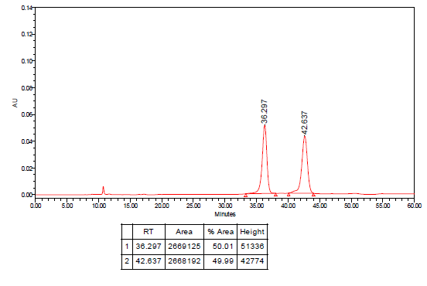
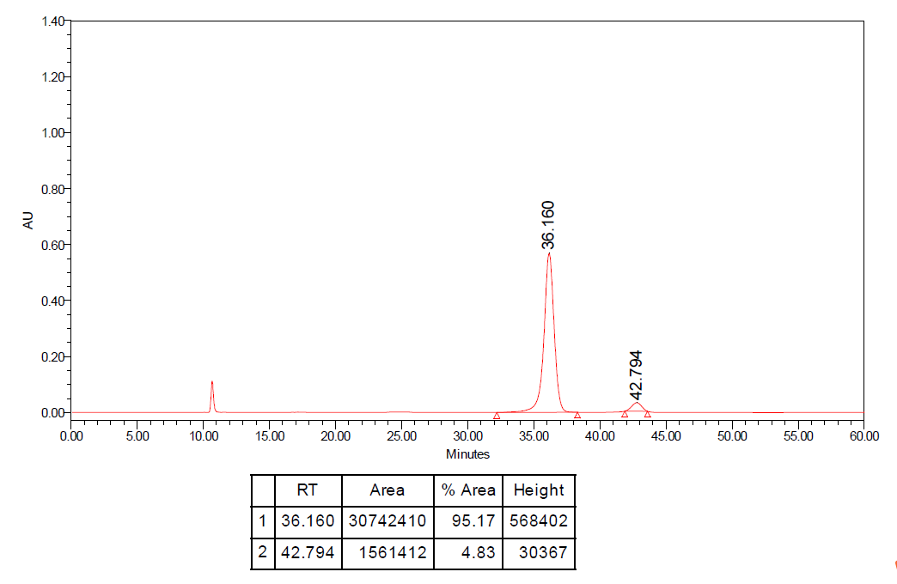

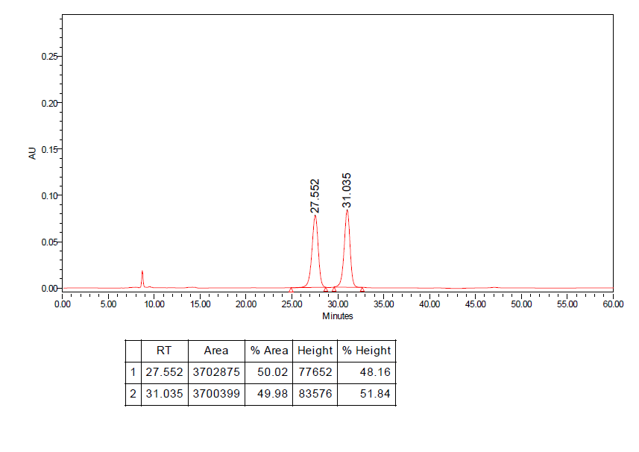
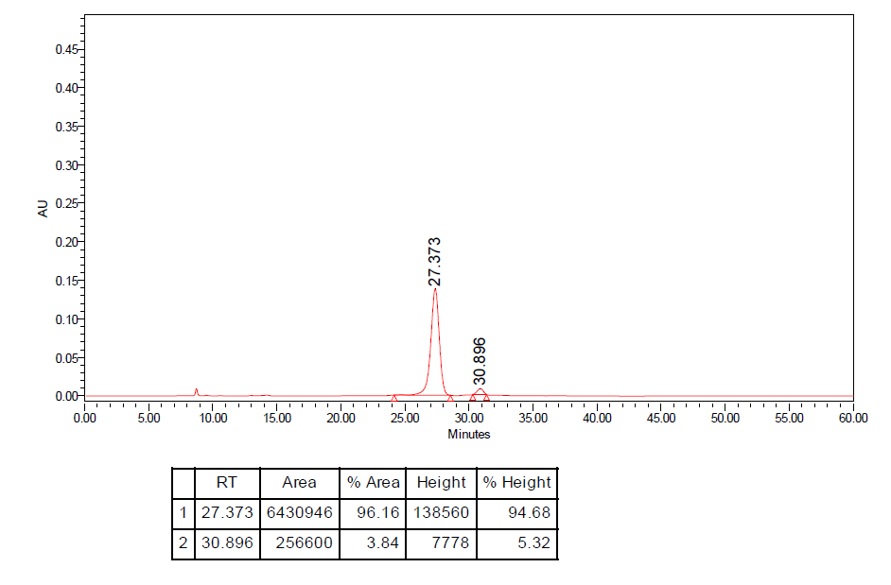

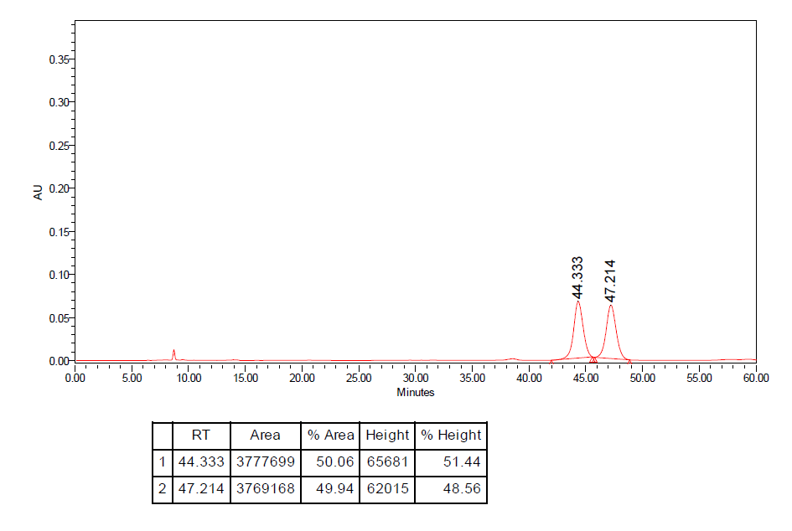
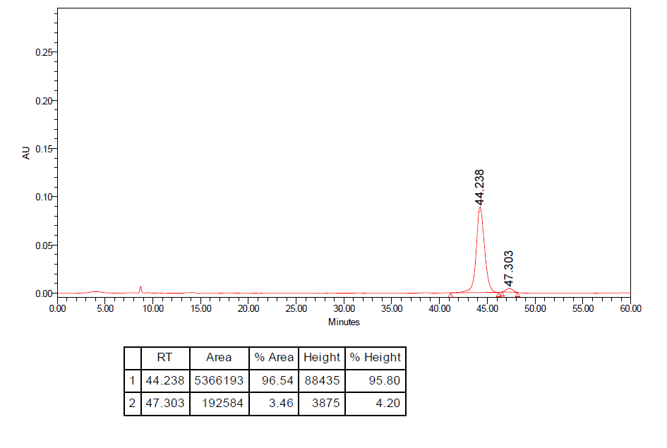

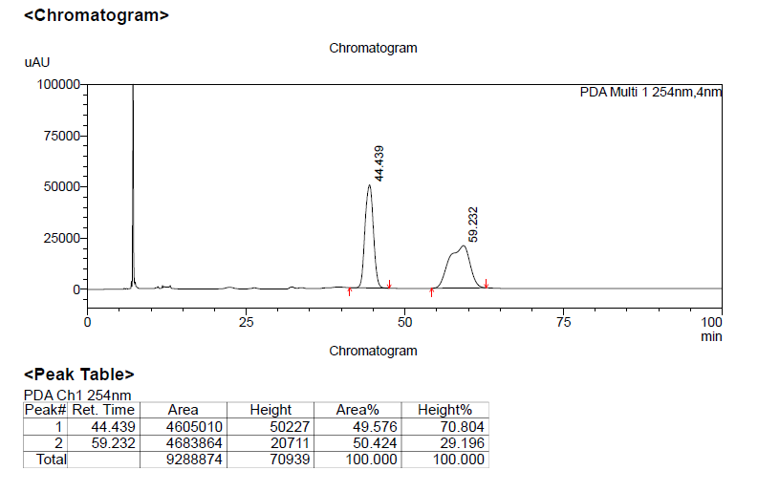
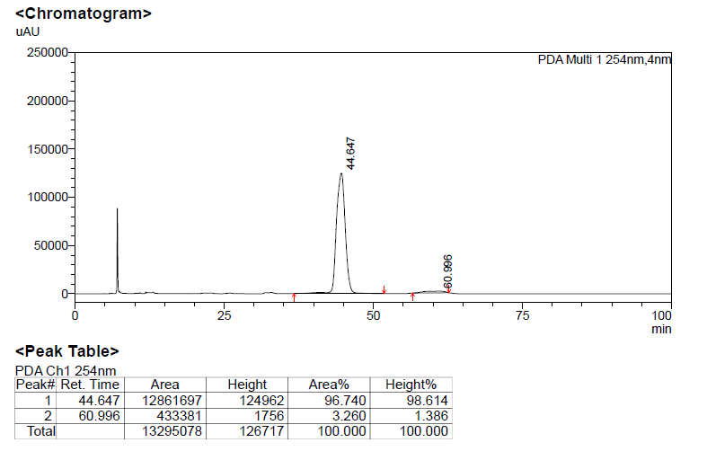

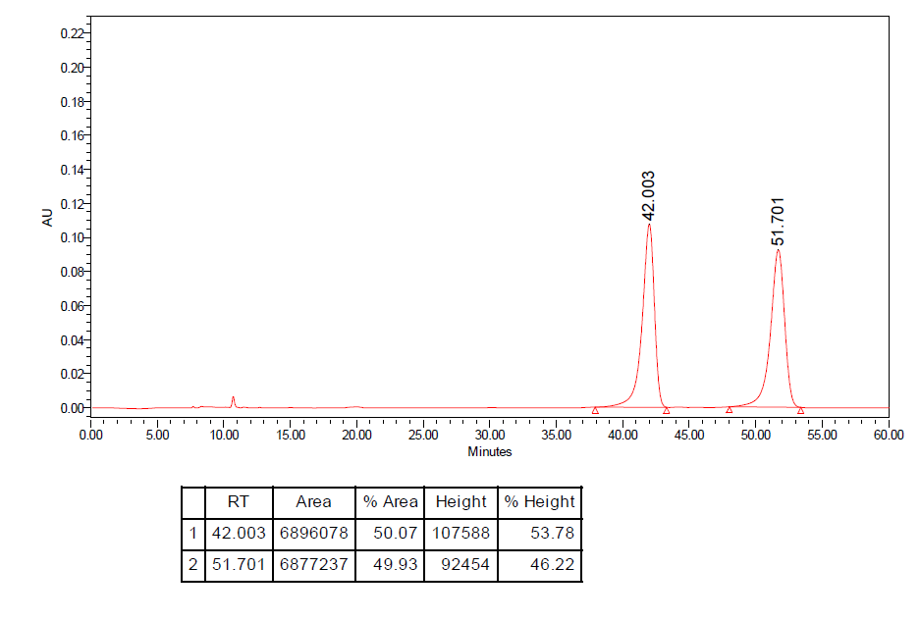
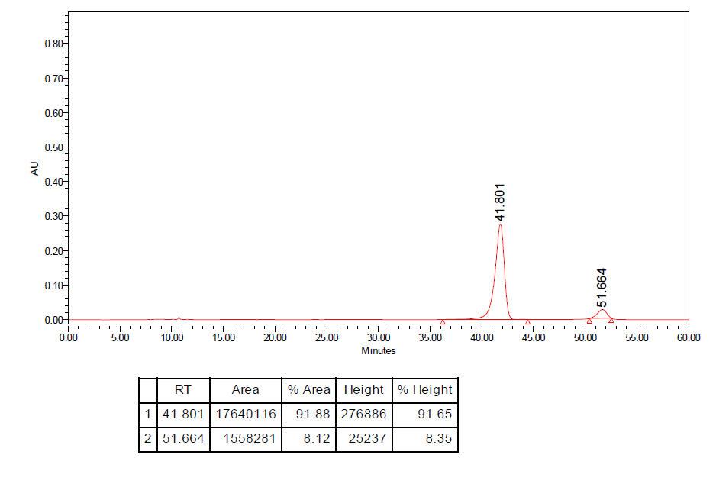

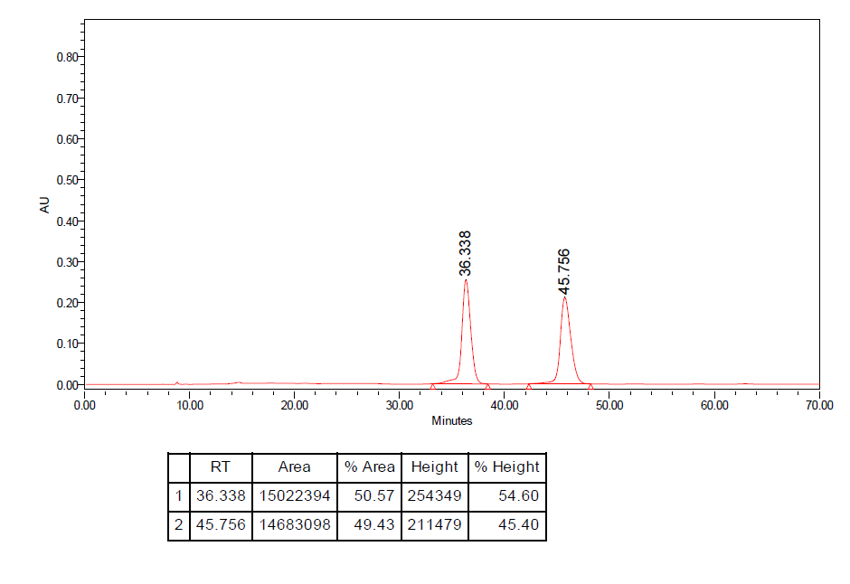
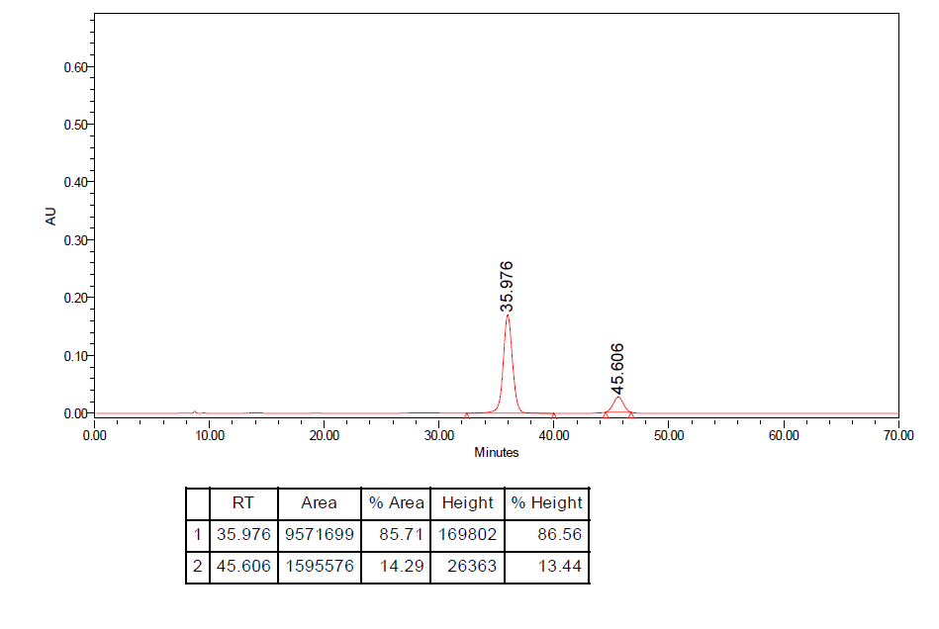

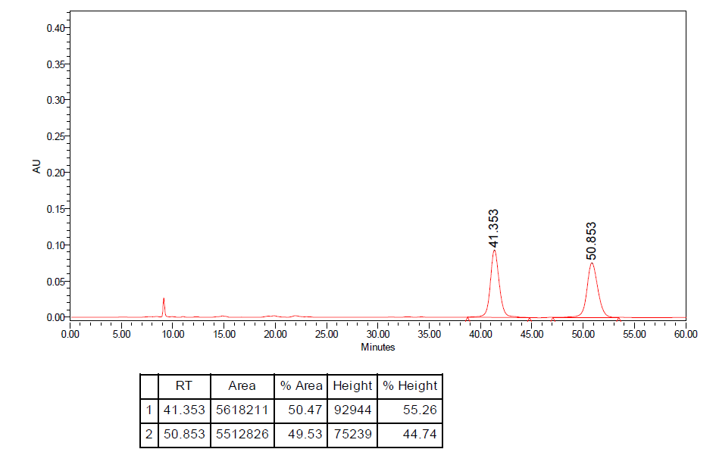
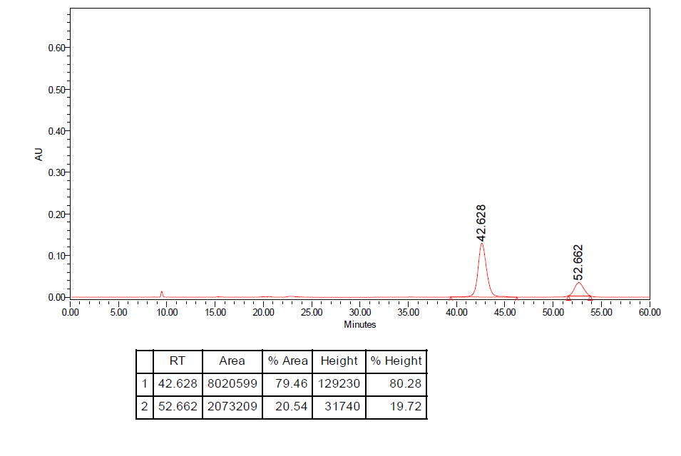

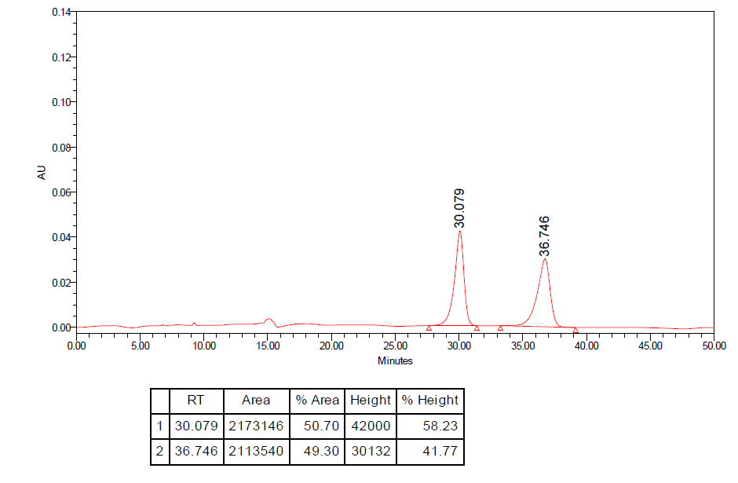
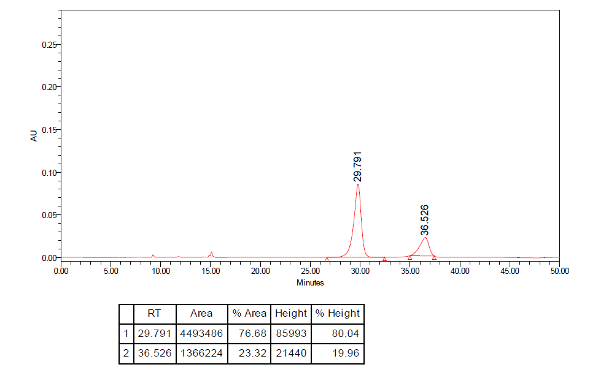

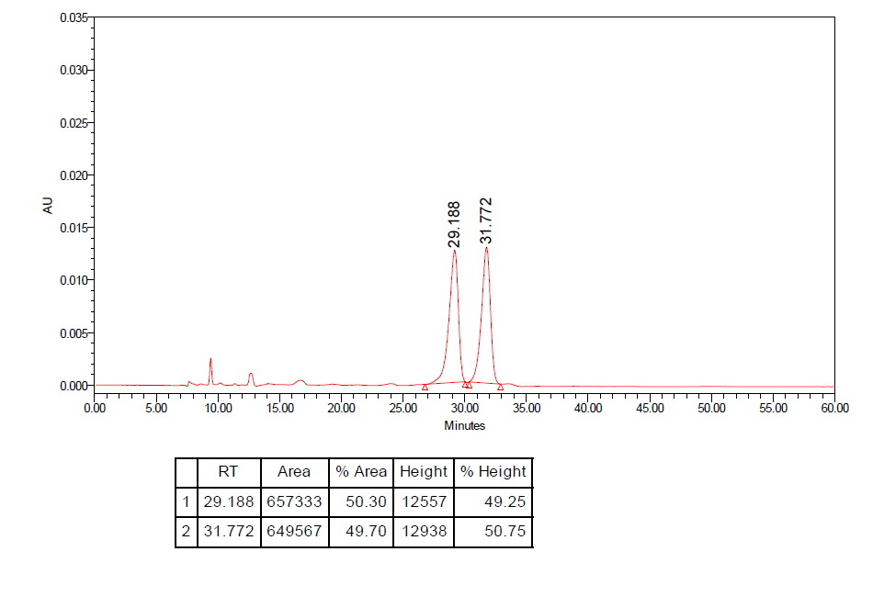
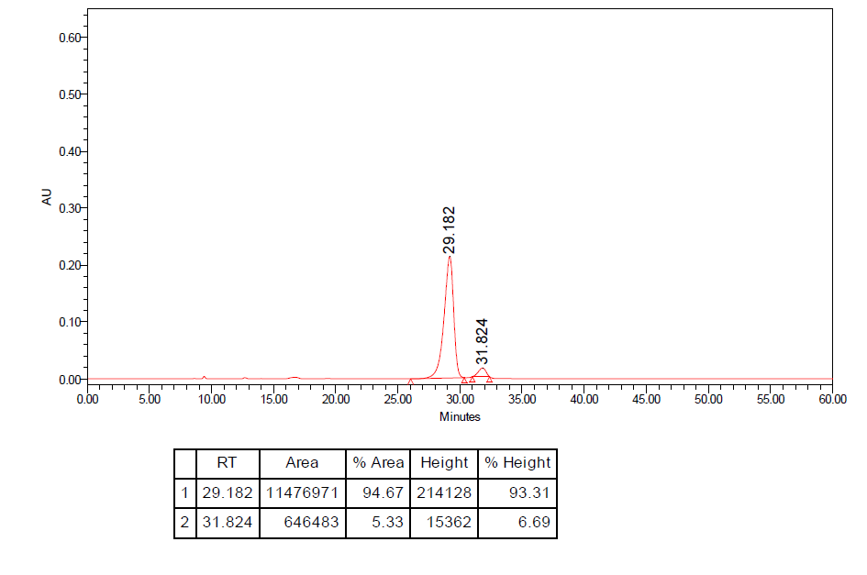

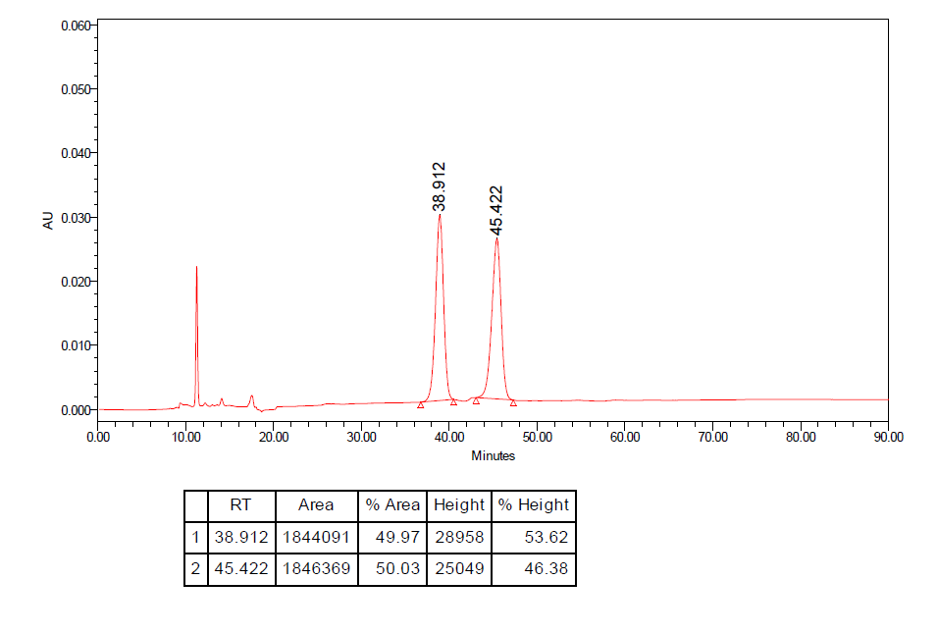
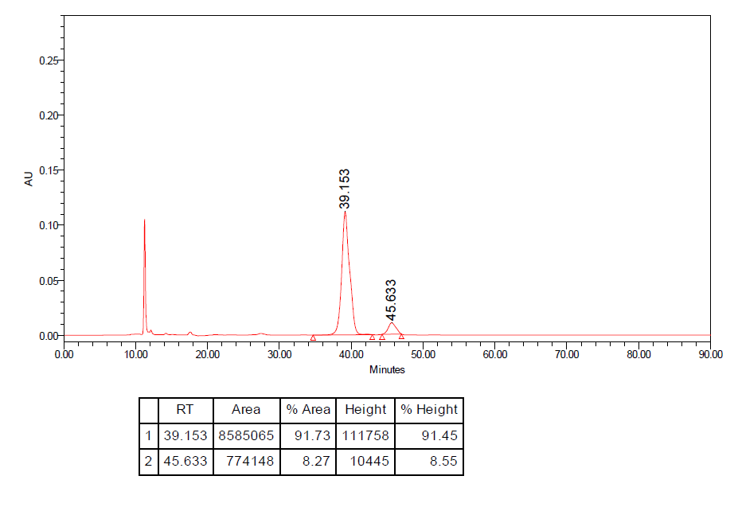

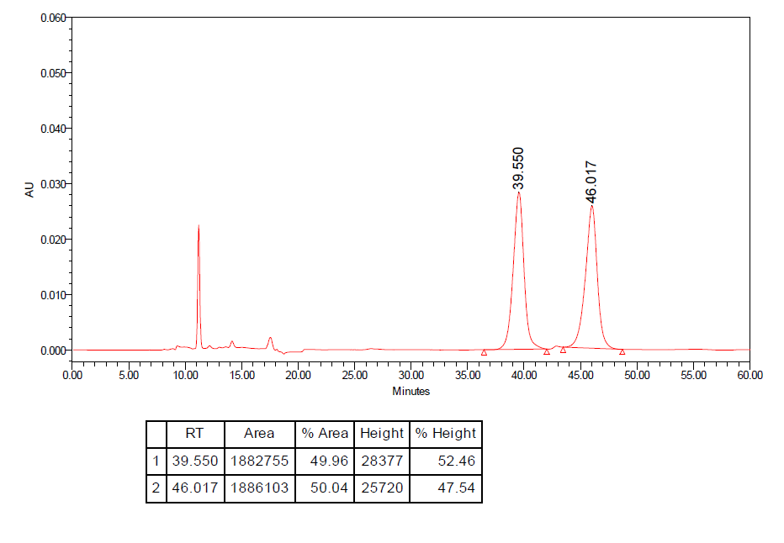
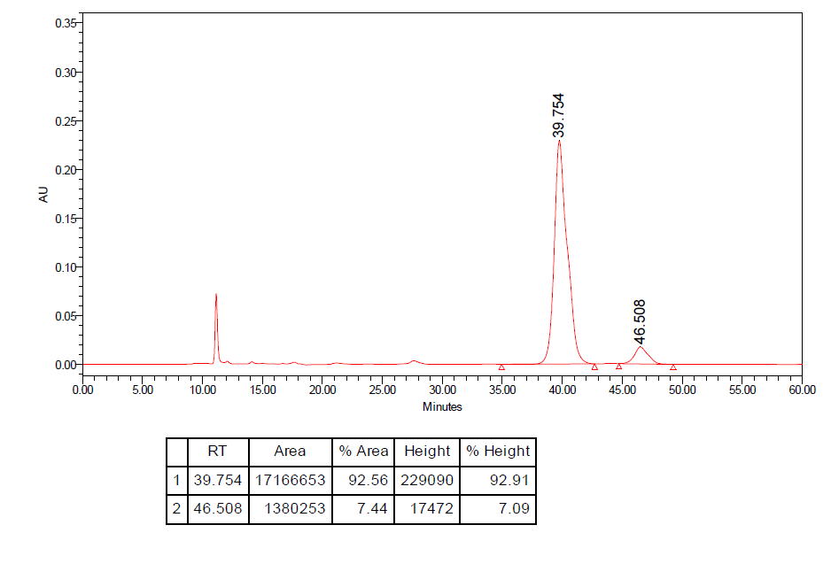

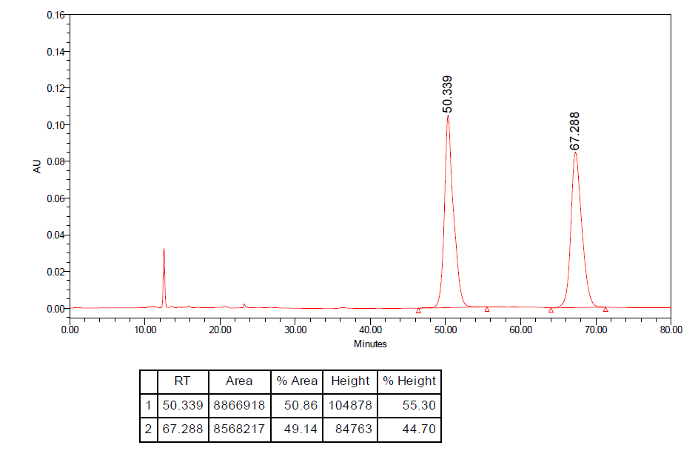
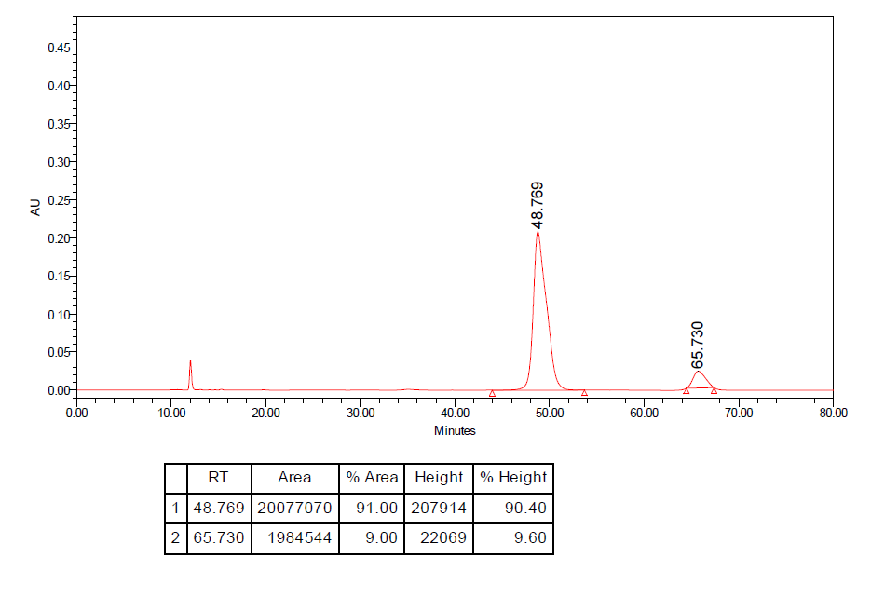

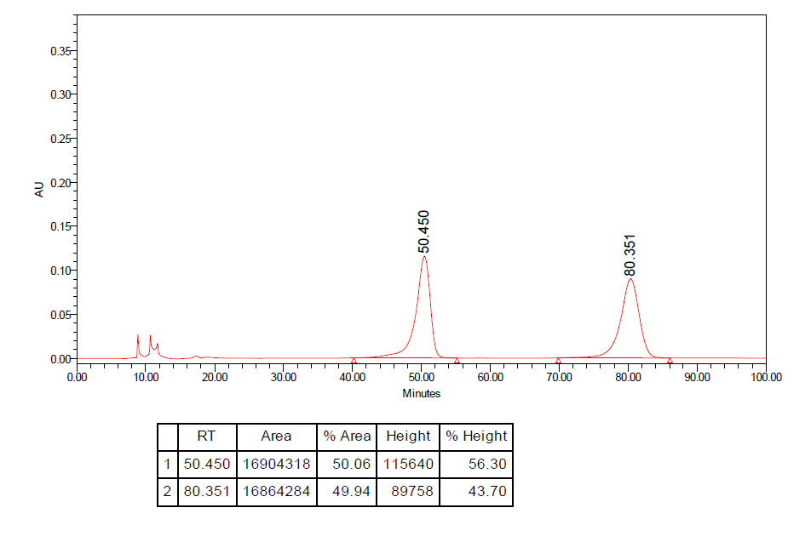
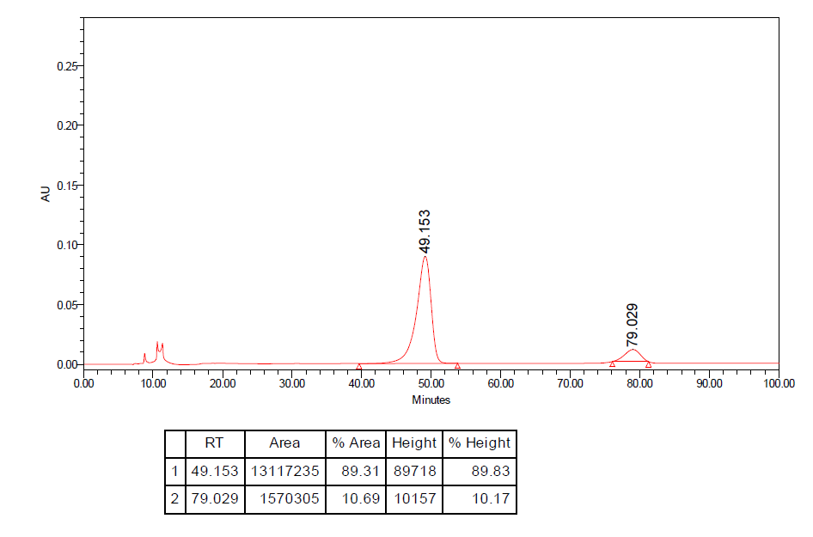

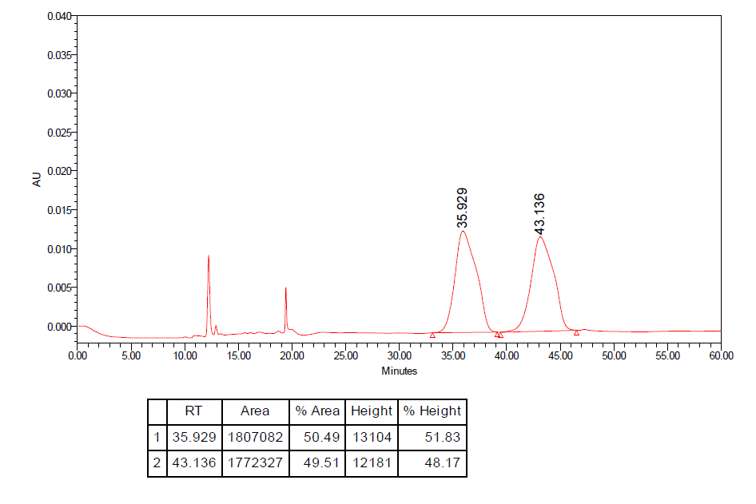
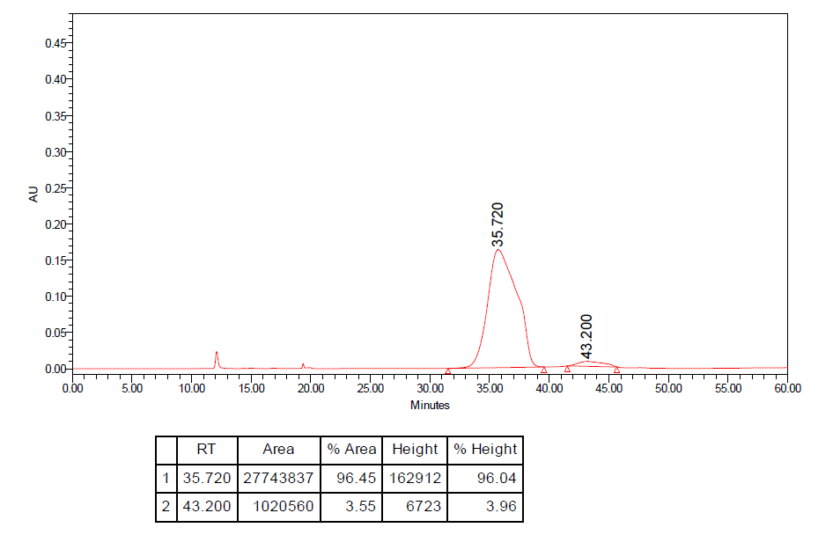

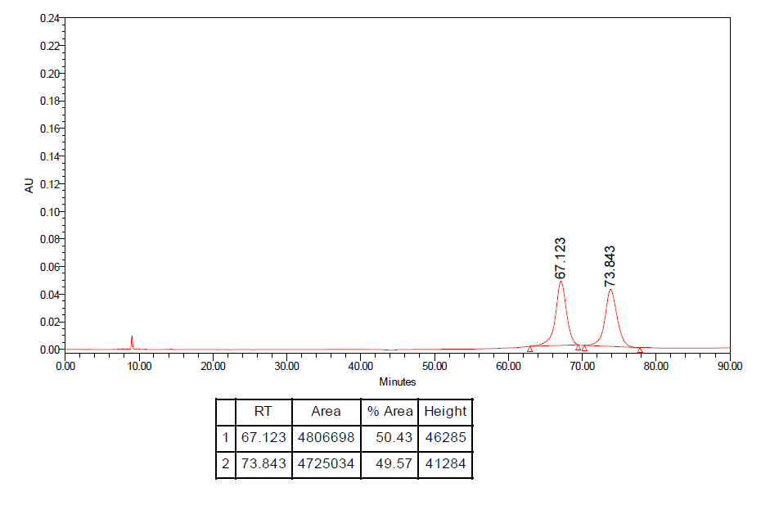
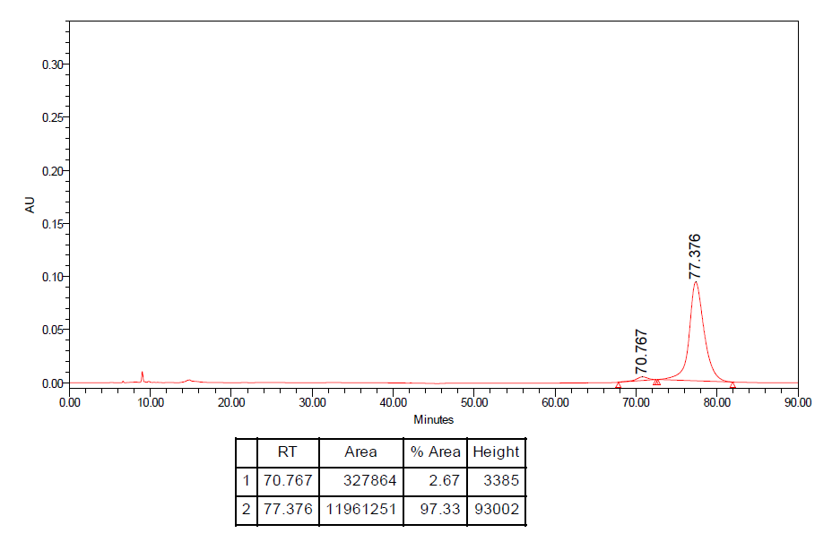

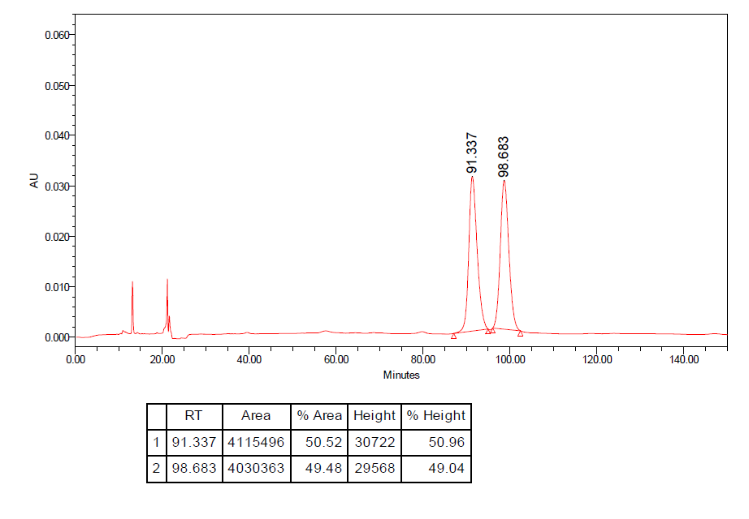
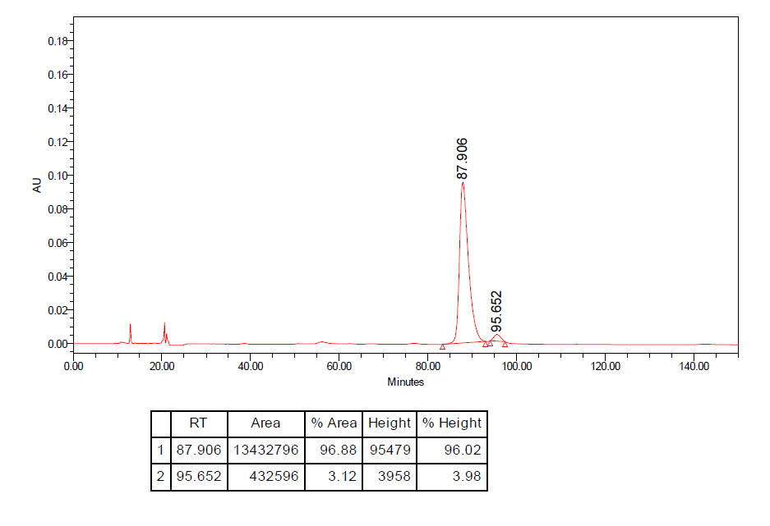

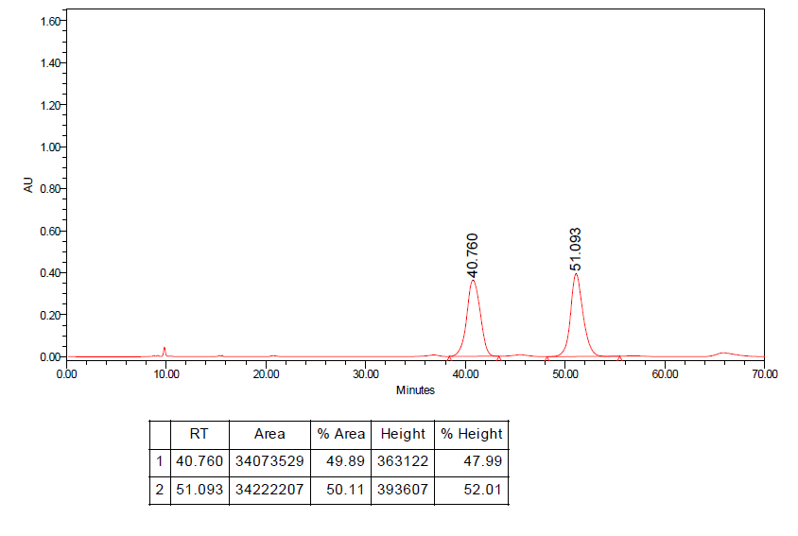
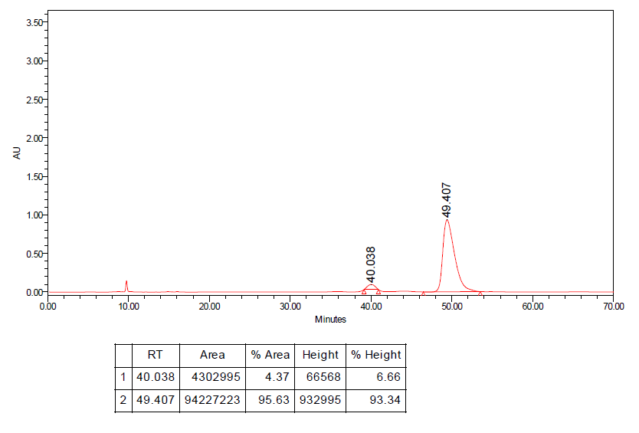

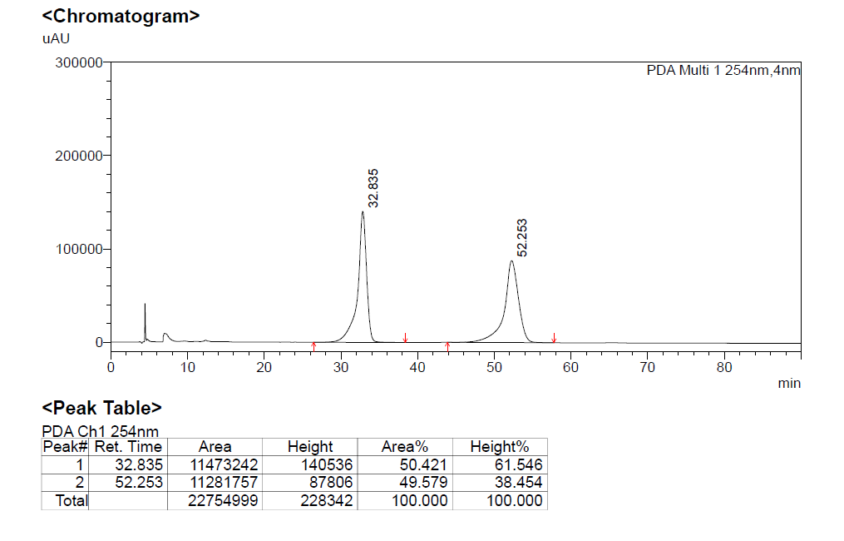

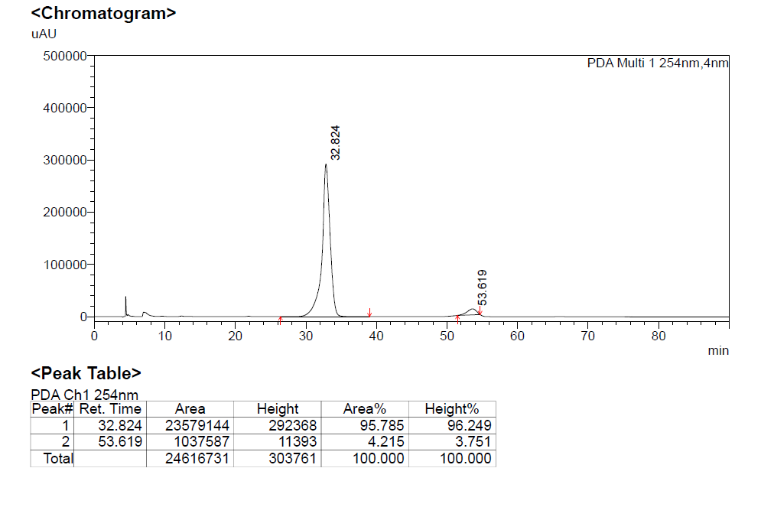

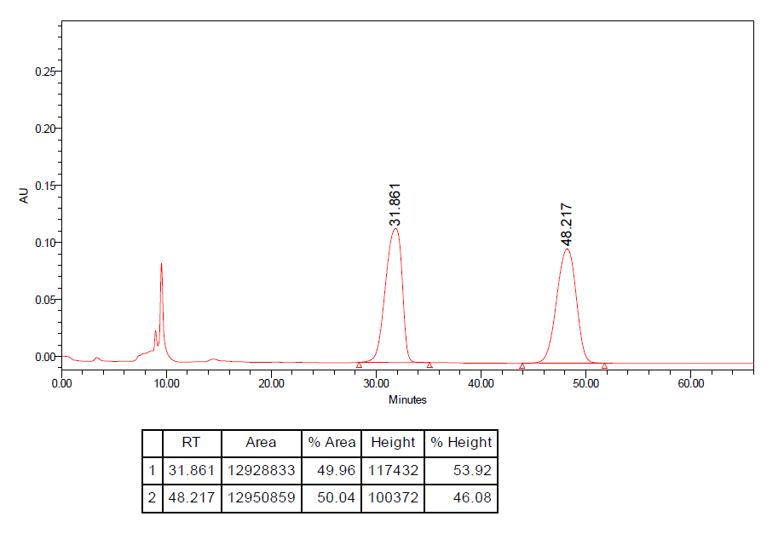
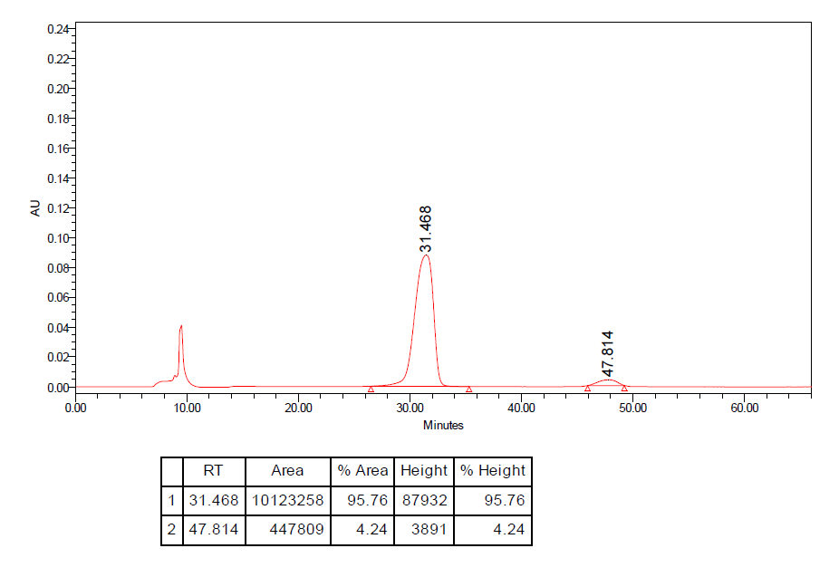

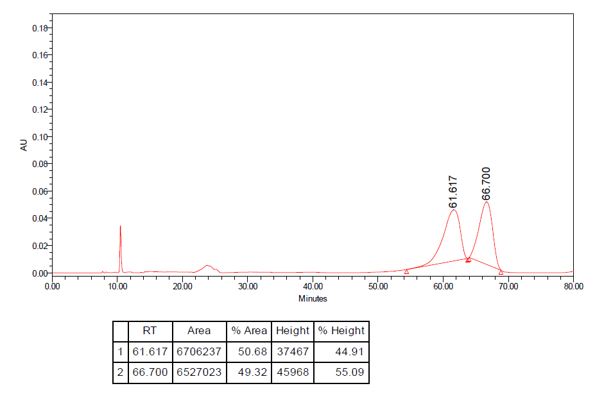
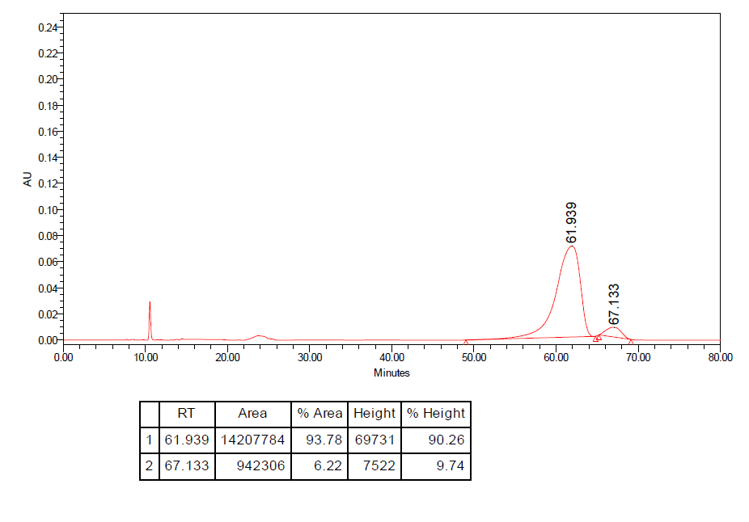

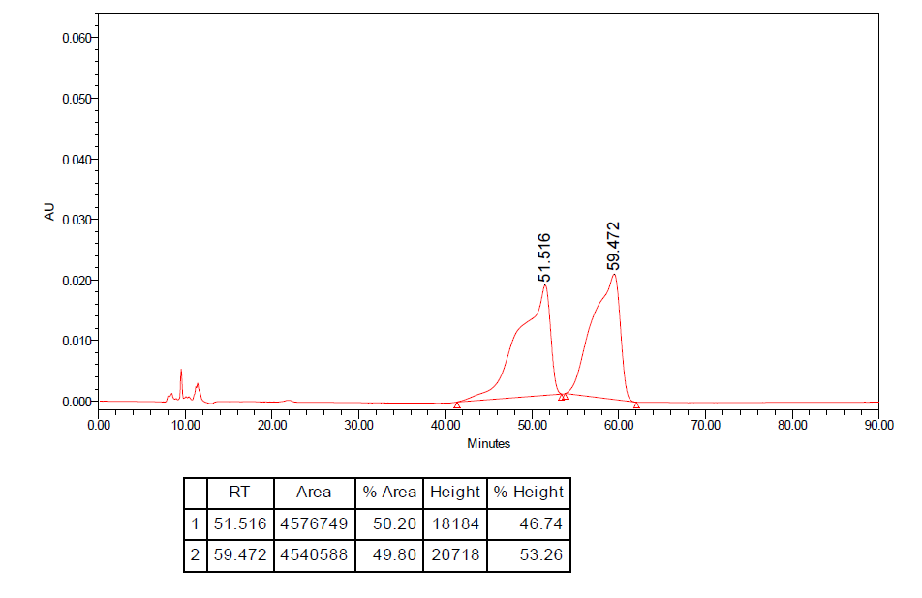
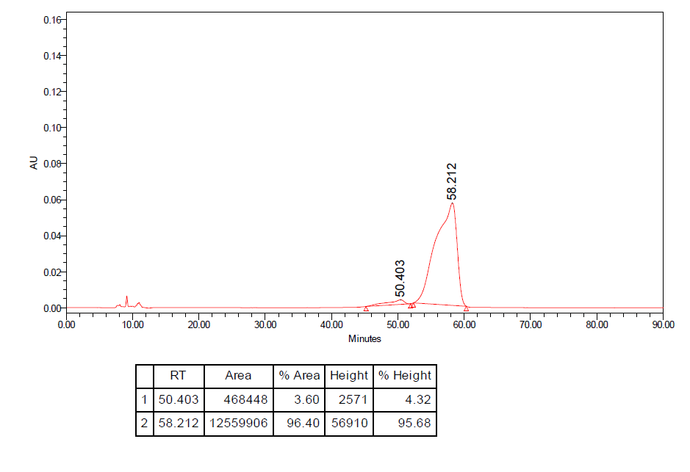

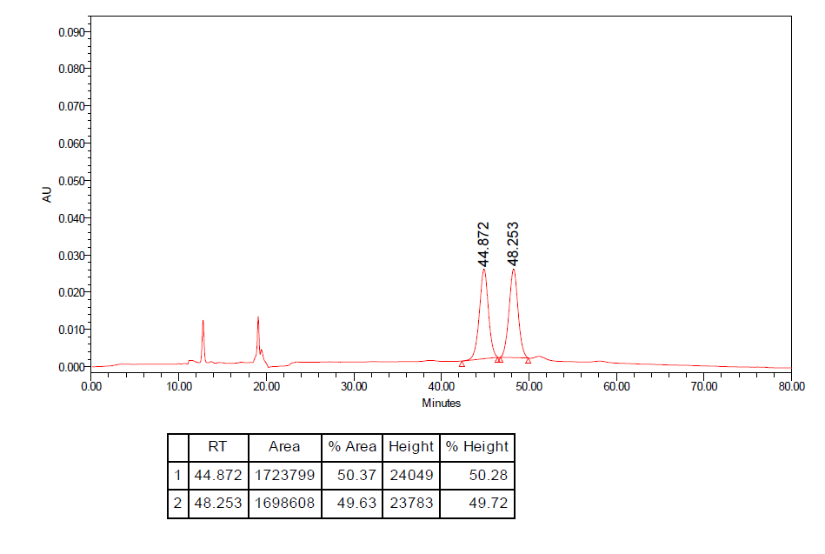
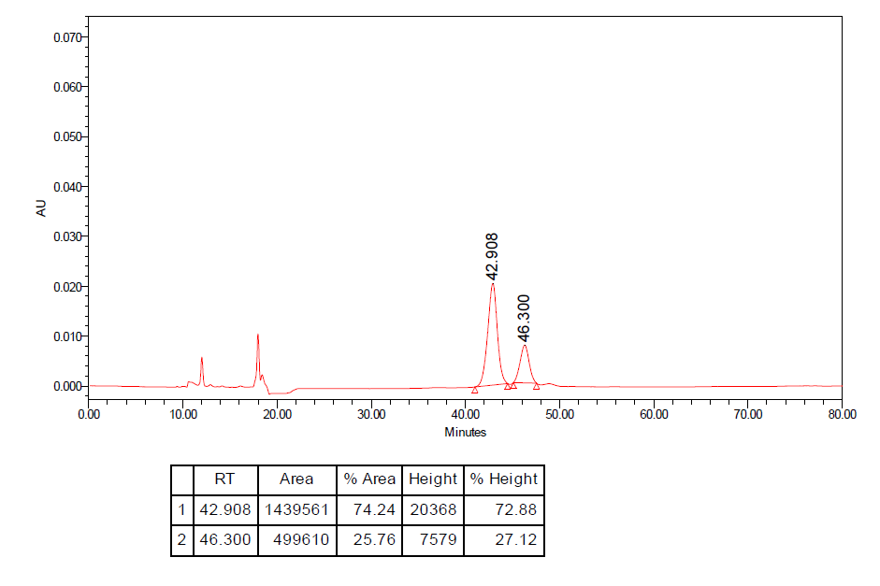

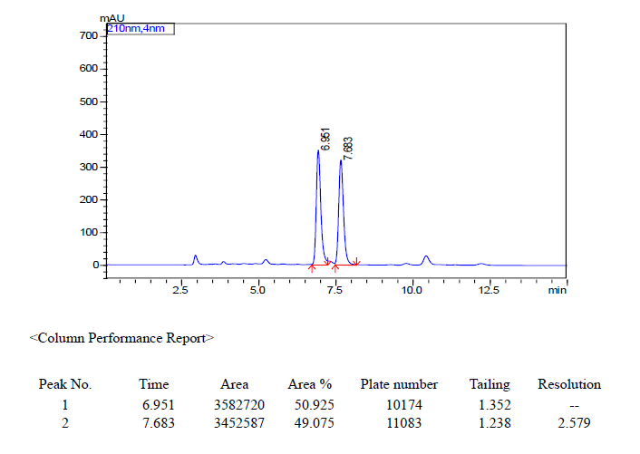
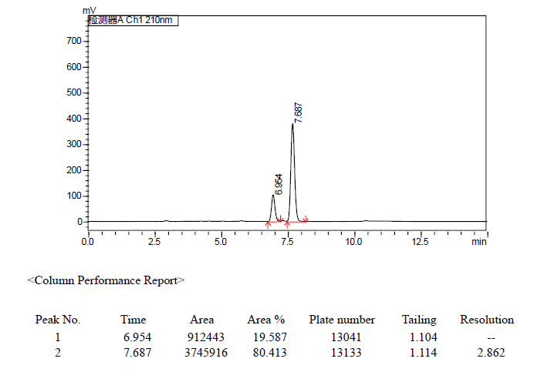

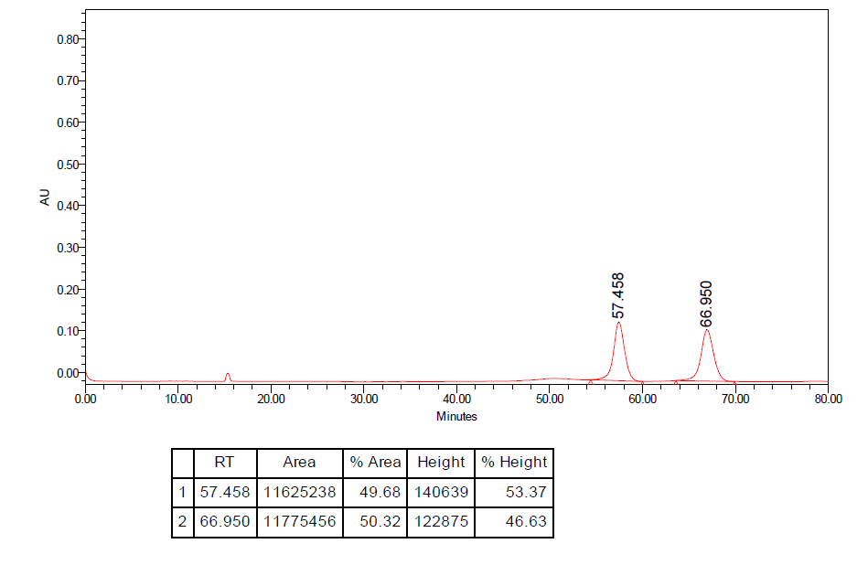
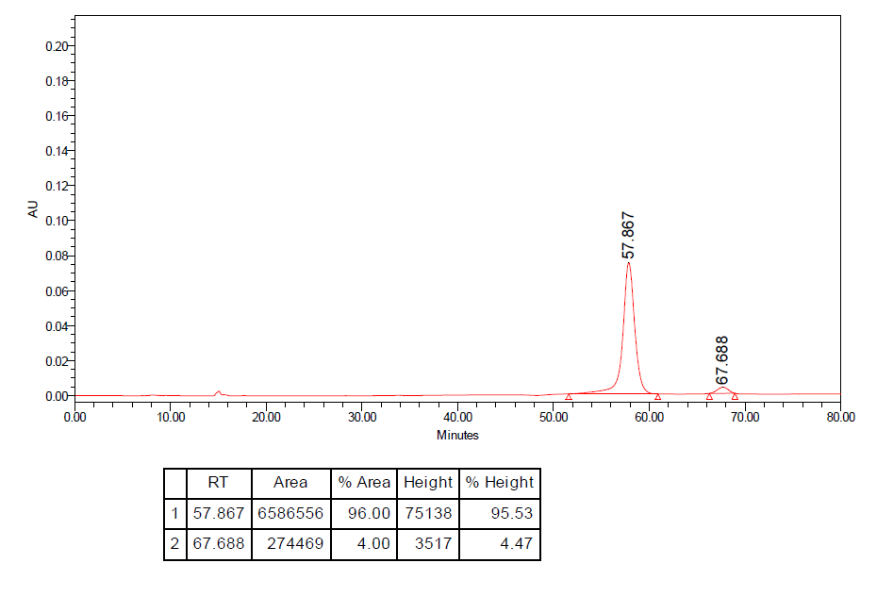

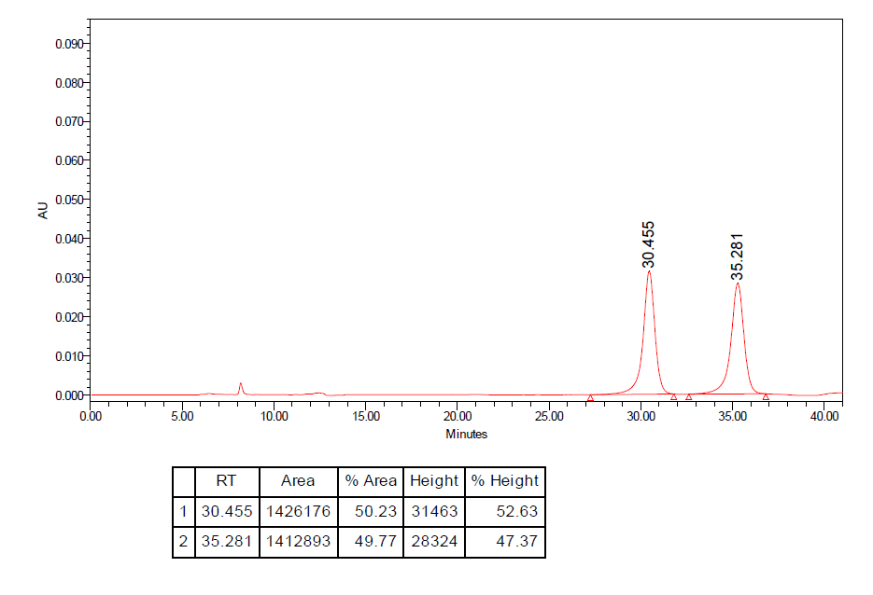
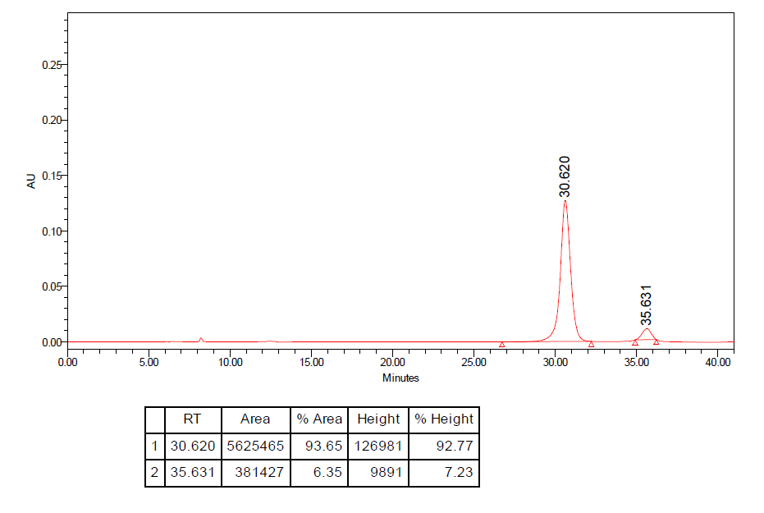

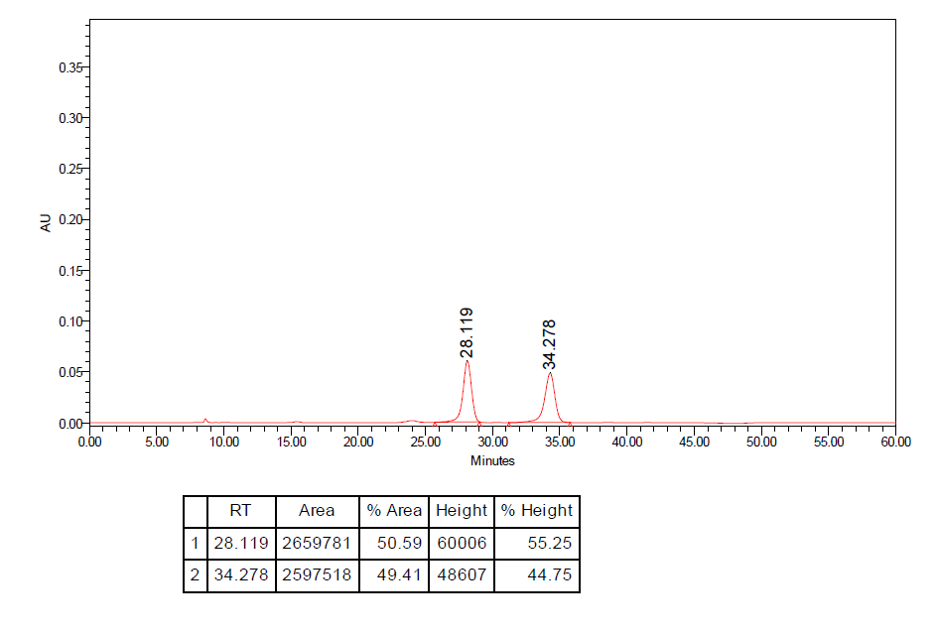
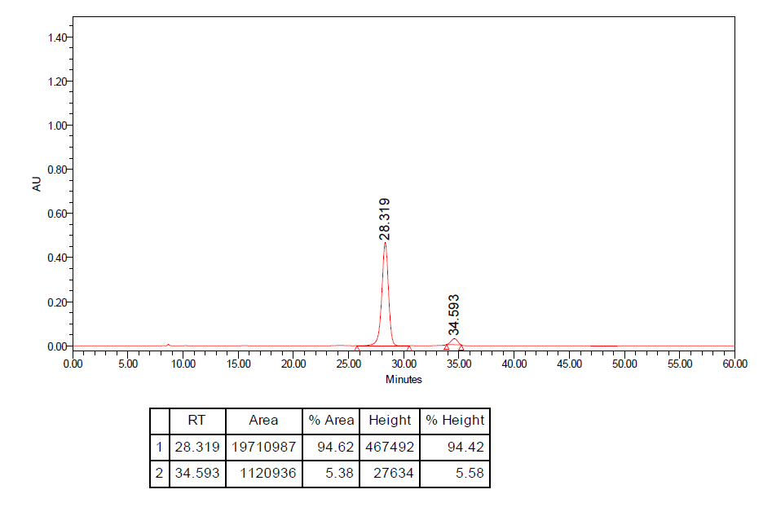

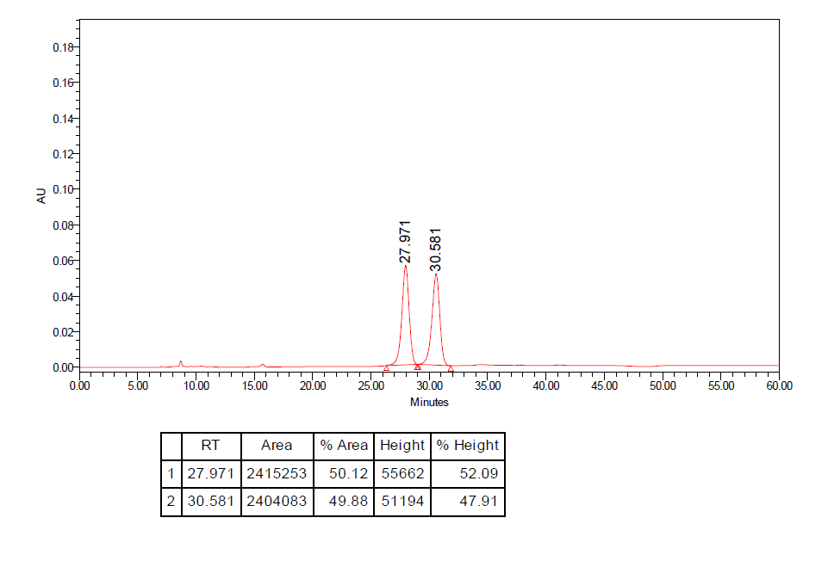
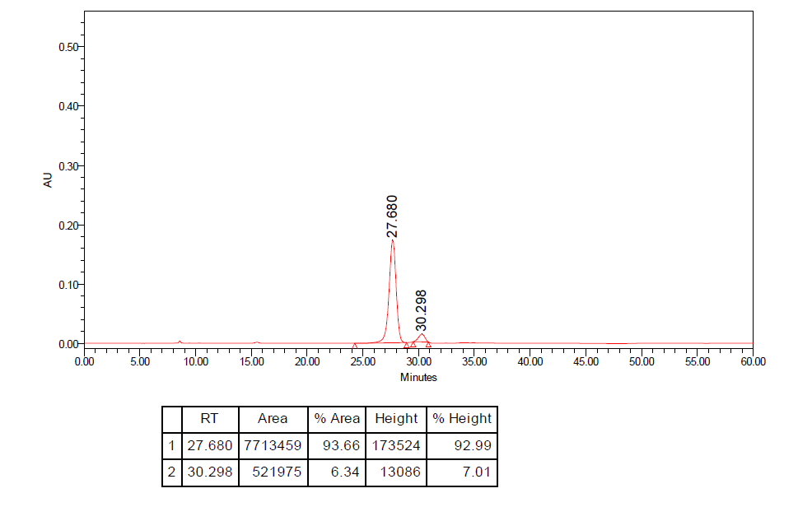

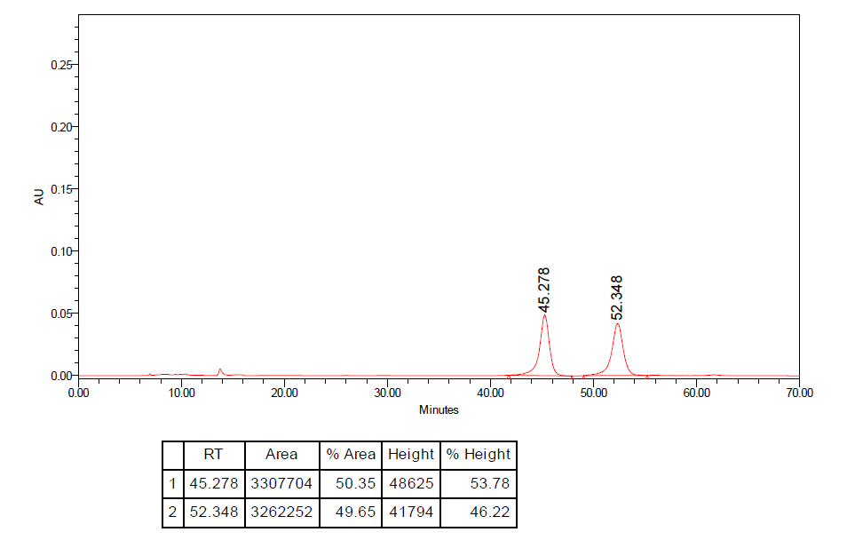
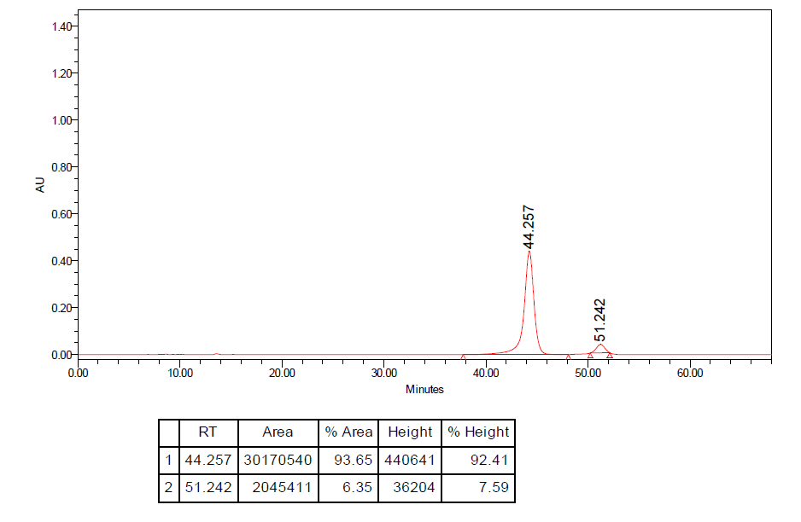

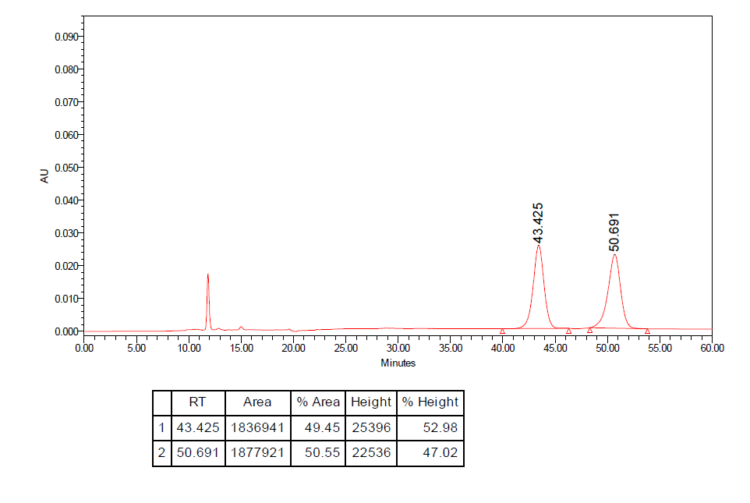
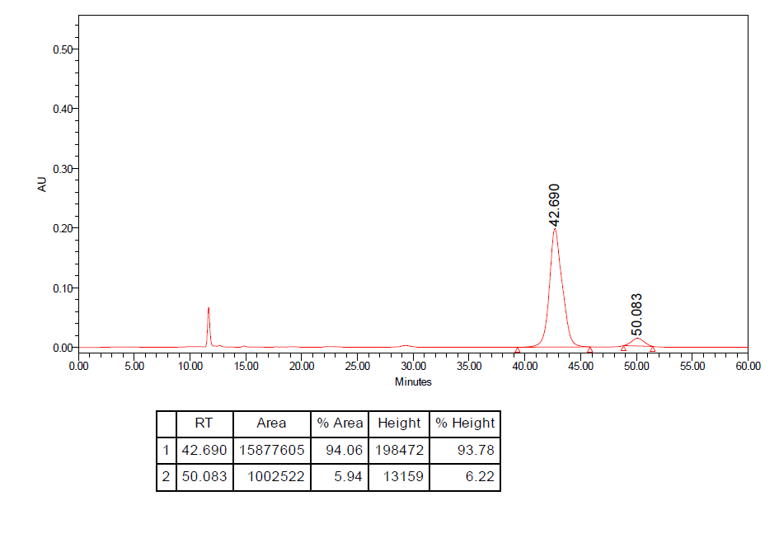

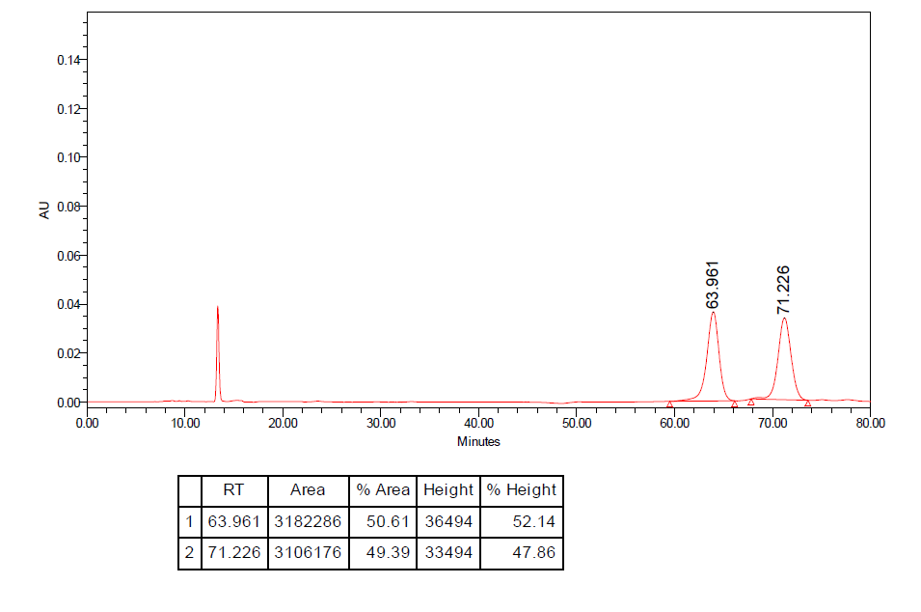
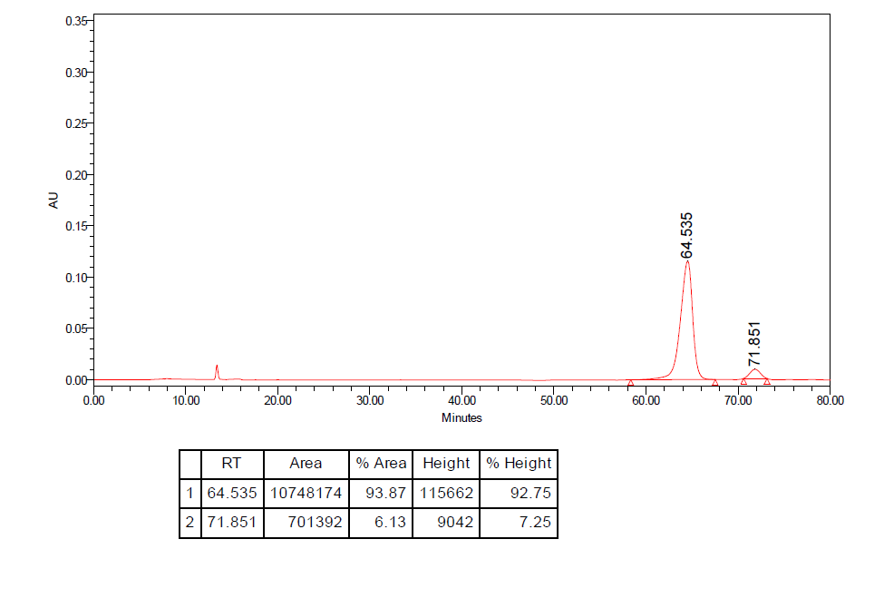

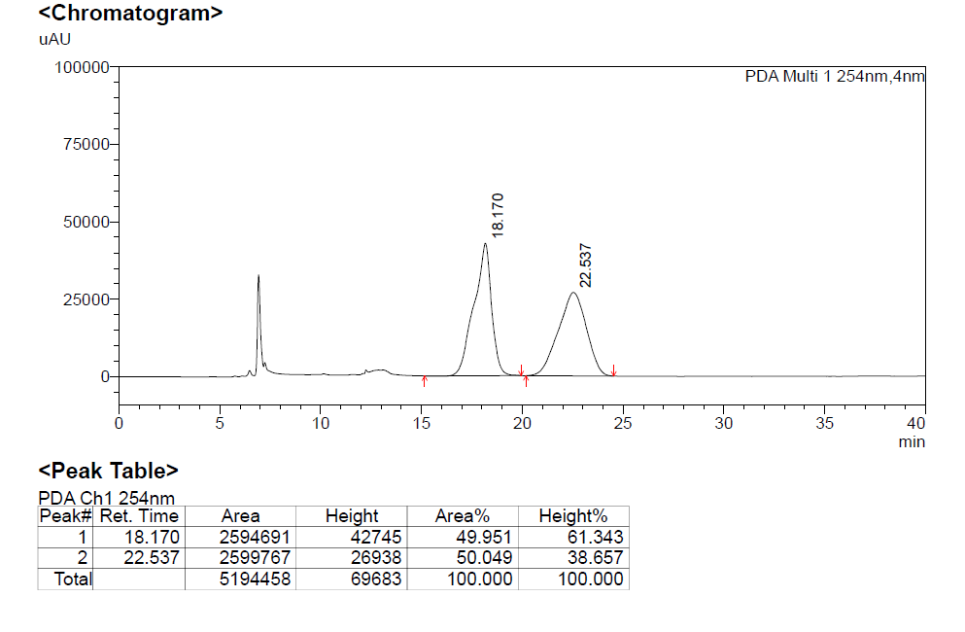

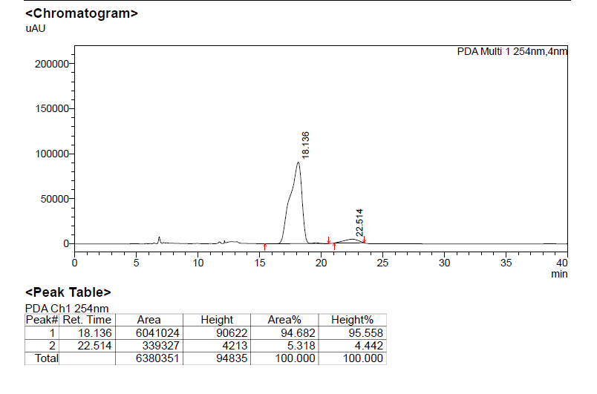

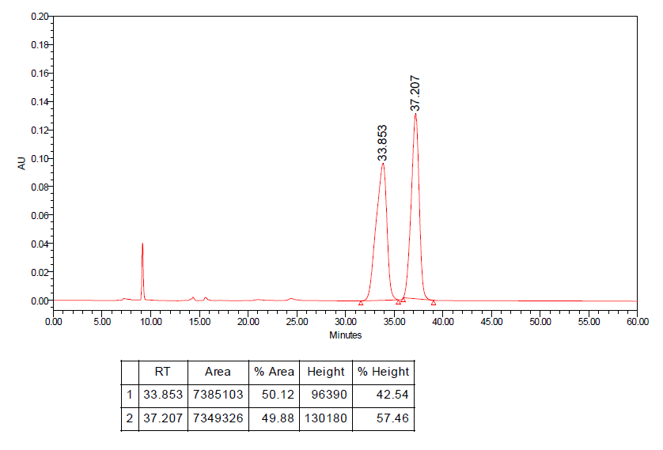
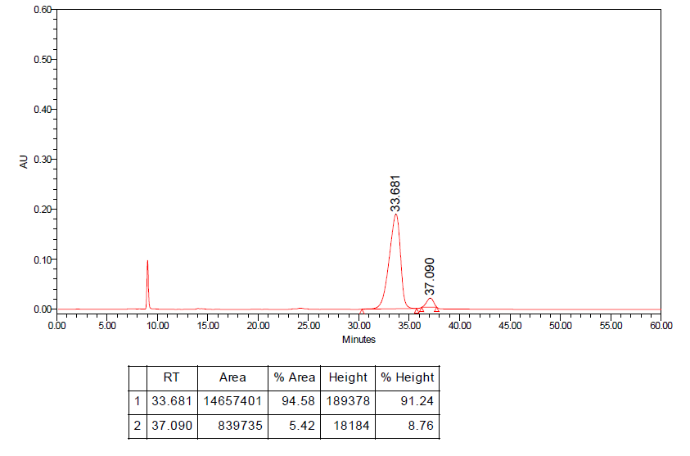

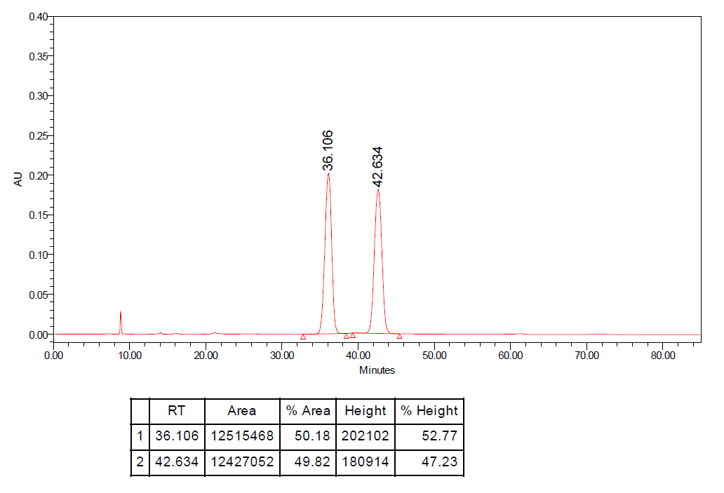
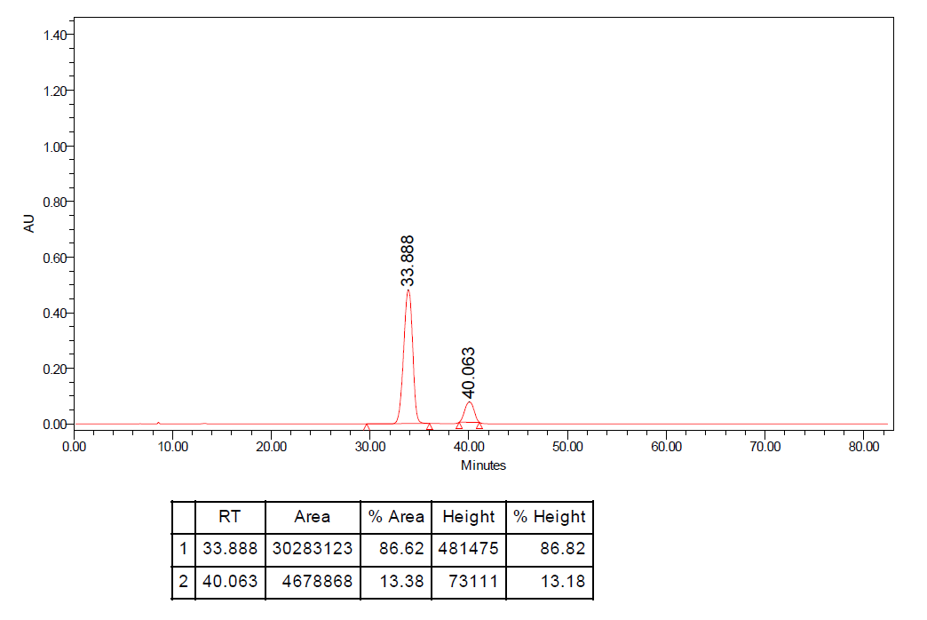

Scale-Up Synthesis of 3a.
HPLC analysis: (Chiralcel IA; 25 ºC, IPA/Hexane = 05/95, 0.5 mL/min, 254 nm), Rt₁ (major) = 36.5 min, Rt₂ (minor) = 42.3 min; 92:8 er.

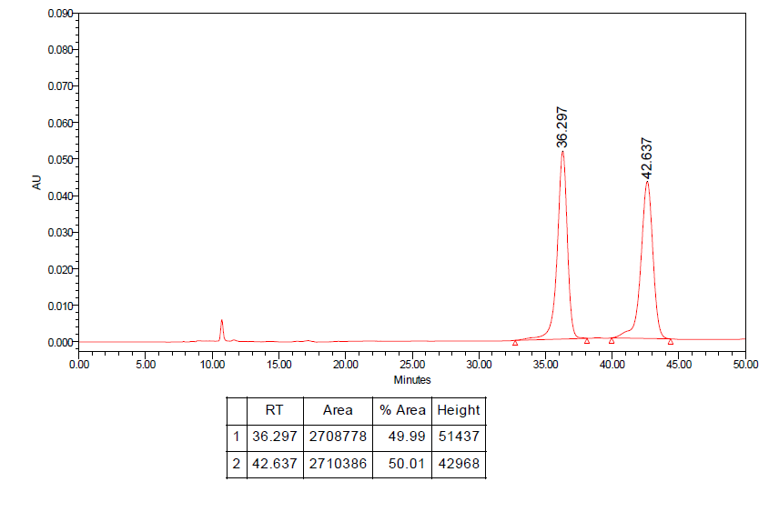
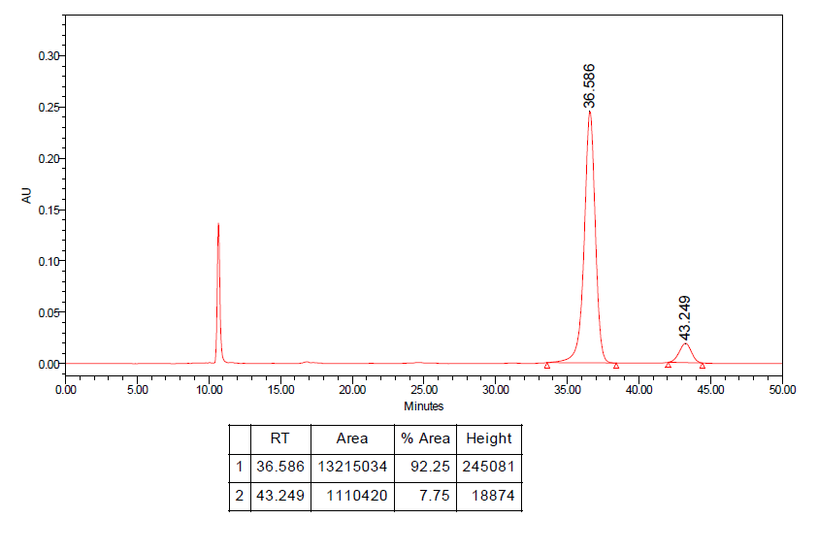

Scale-Up Synthesis of 3q.
HPLC analysis: (Chiralcel IA; 25 ºC, IPA/Hexane = 05/95, 0.5 mL/min, 254 nm), Rt₁ (major) = 51.1 min, Rt₂ (minor) = 40.8 min; 95:5 er.

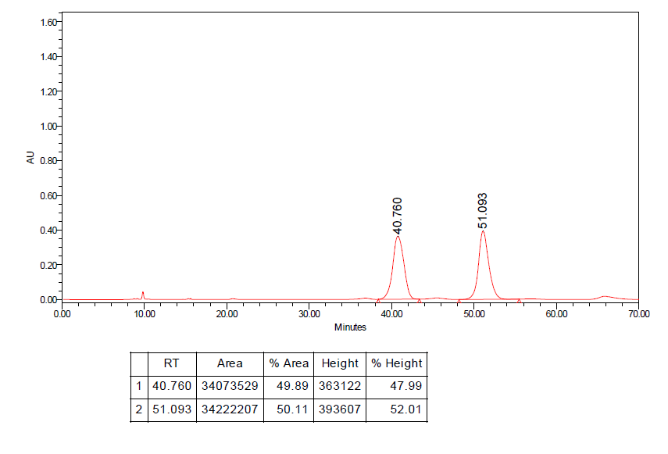
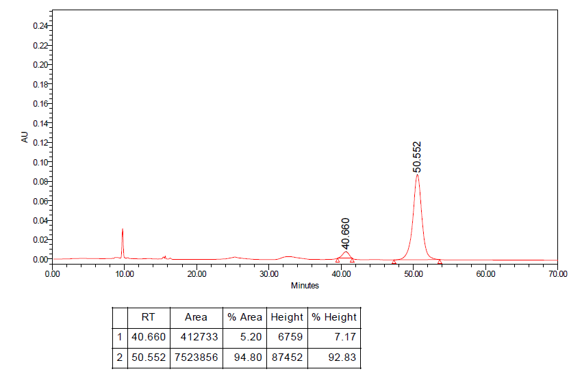
HRMS spectra

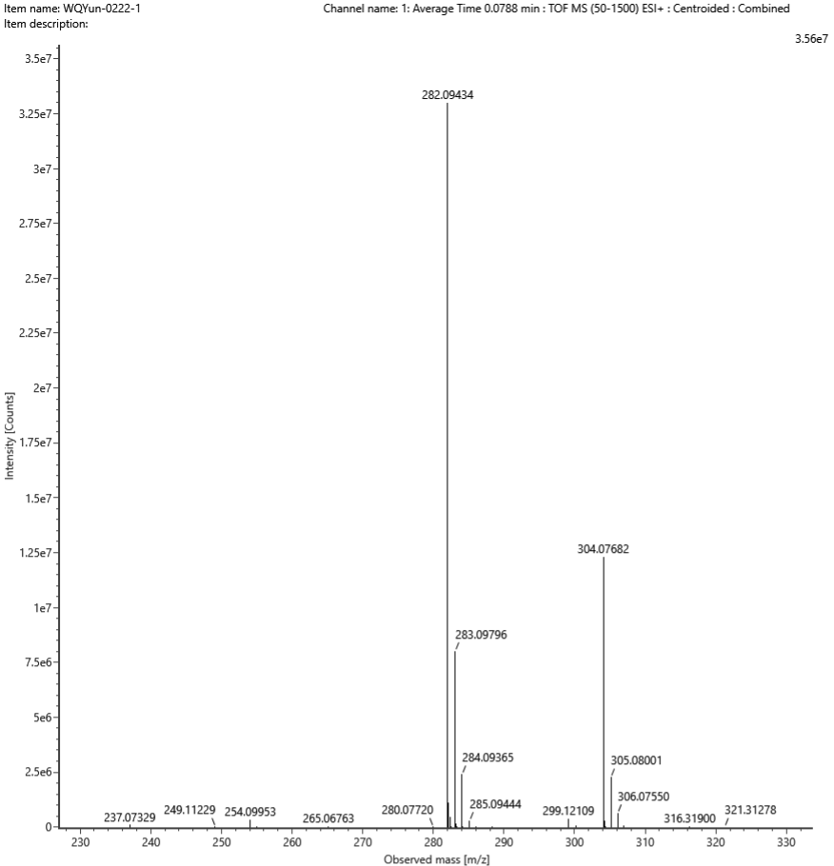Add:H⁺
Composition | i-FIT Confidence (%) | Predicted m/z | m/z error (PPM)
C17H15NOS | 100.000000 | 282.094711 | -1.320908

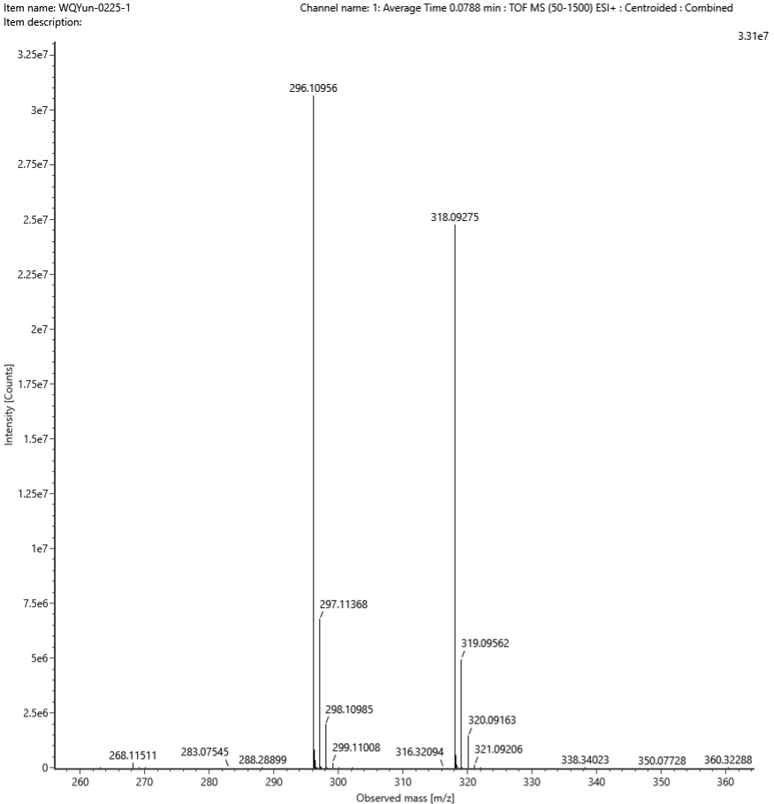Add:H⁺
Composition | i-FIT Confidence (%) | Predicted m/z | m/z error (PPM)
C18H17NOS | 100.000000 | 296.110361 | -2.715513

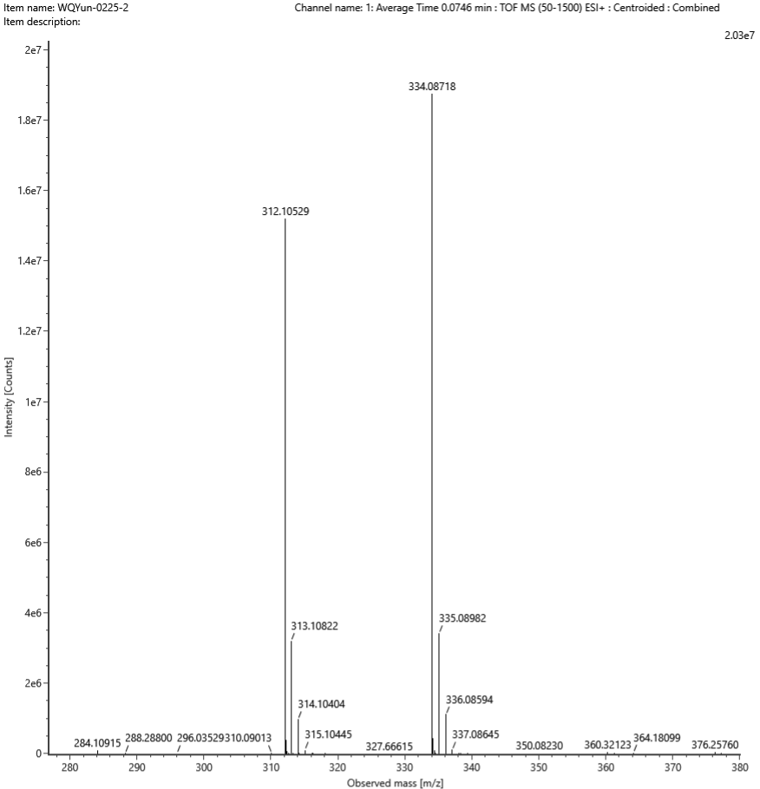Add:Na⁺
Composition | i-FIT Confidence (%) | Predicted m/z | m/z error (PPM)
C18H17NO2S | 100.000000 | 334.087221 | -0.121906

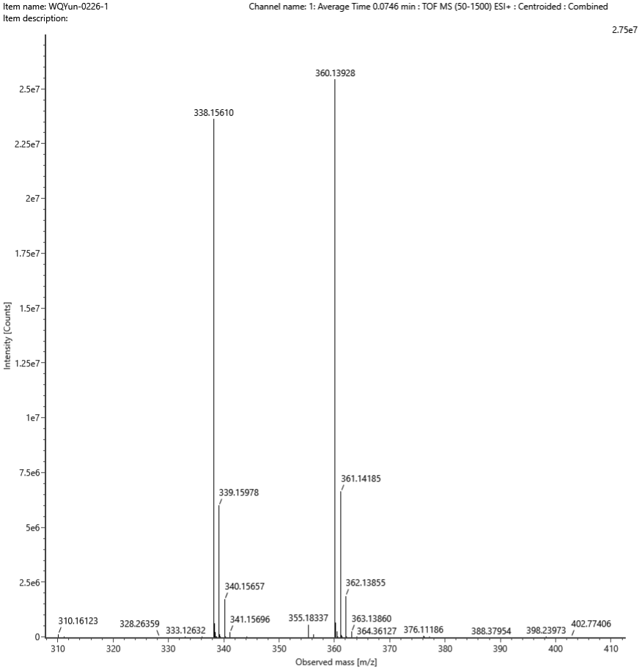Add:Na⁺
Composition | i-FIT Confidence (%) | Predicted m/z | m/z error (PPM)
C21H23NOS | 100.000000 | 360.139256 | 0.066345

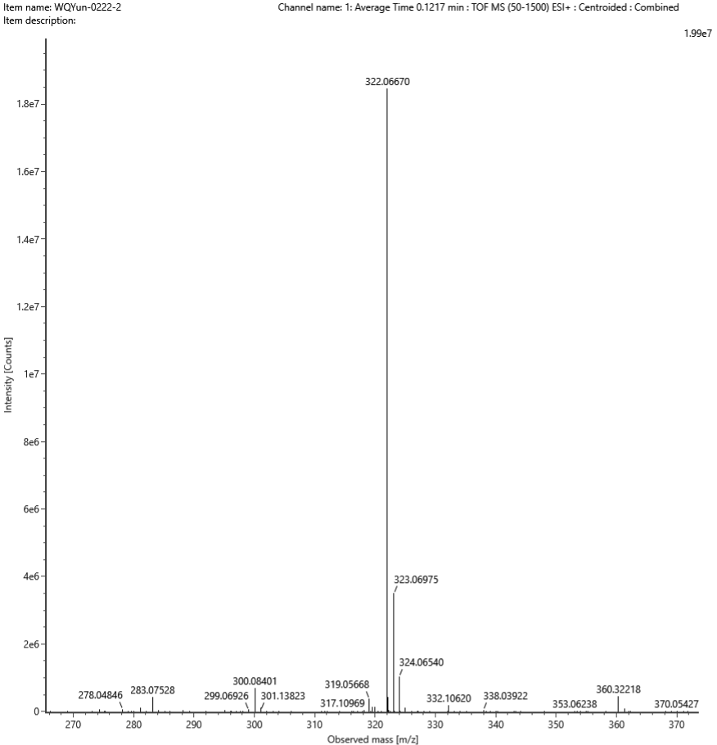Add:Na⁺
Composition | i-FIT Confidence (%) | Predicted m/z | m/z error (PPM)
C17H14FNOS | 100.000000 | 322.067234 | -1.663513

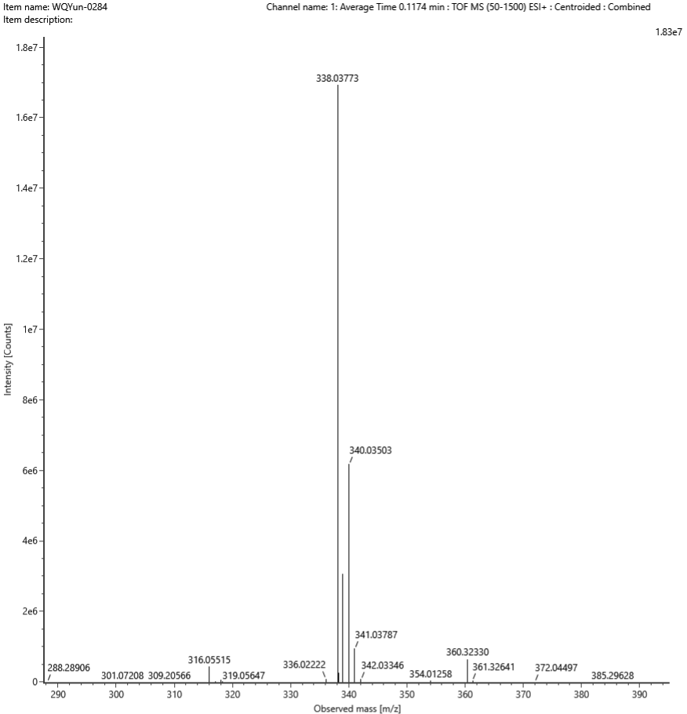Add:Na⁺
Composition | i-FIT Confidence (%) | Predicted m/z | m/z error (PPM)
C17H14ClNOS | 100.000000 | 338.037684 | 0.137684

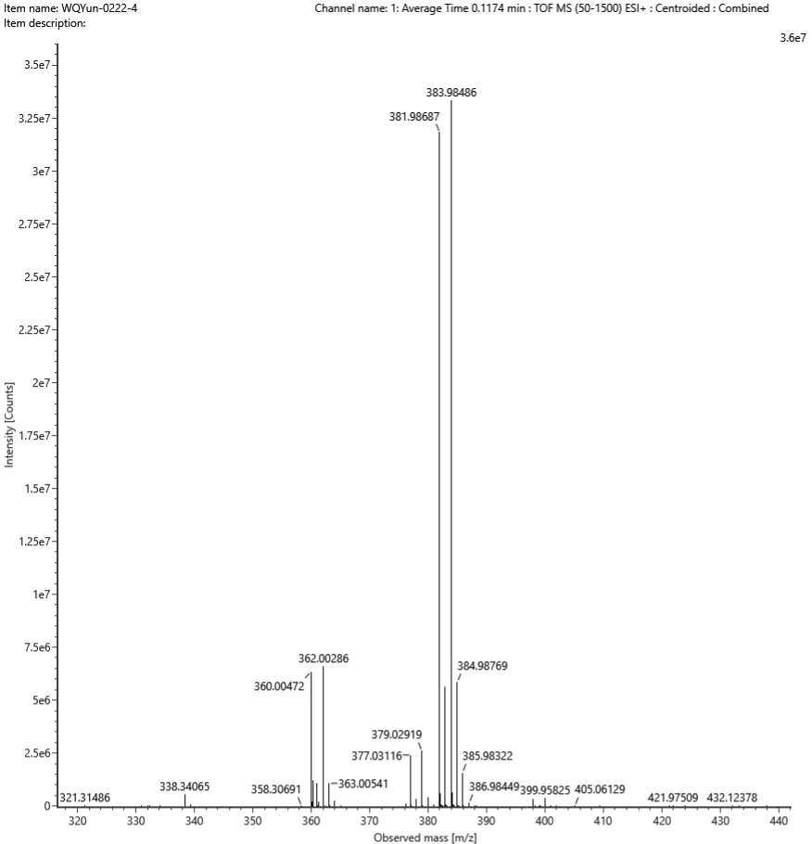Add:Na⁺
Composition | i-FIT Confidence (%) | Predicted m/z | m/z error (PPM)
C17H14BrNOS | 100.000000 | 381.987169 | -0.832280

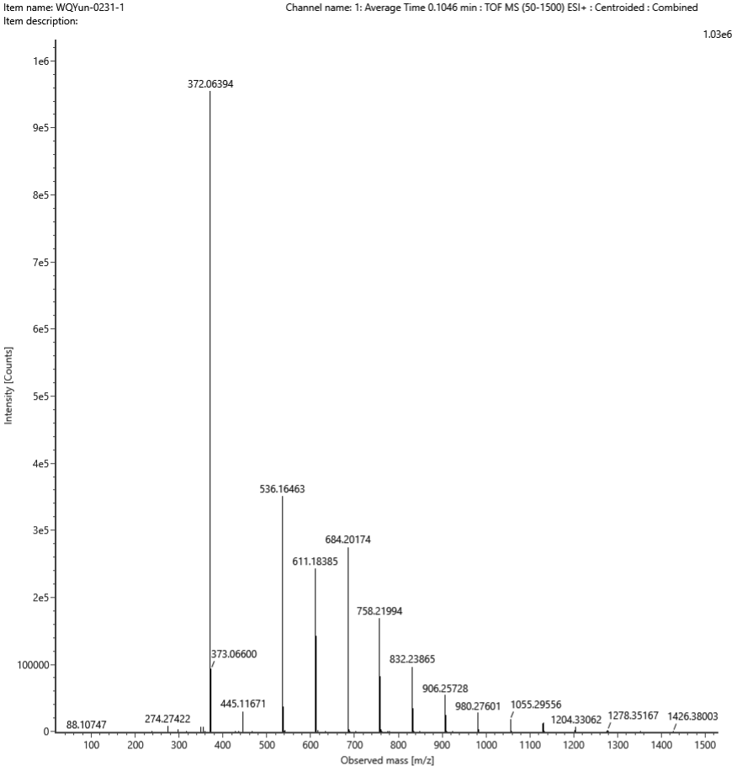
Add:Na⁺
Composition | i-FIT Confidence (%) | Predicted m/z | m/z error (PPM)
C18H14F3NOS | 100.000000 | 372.064040 | -0.270811

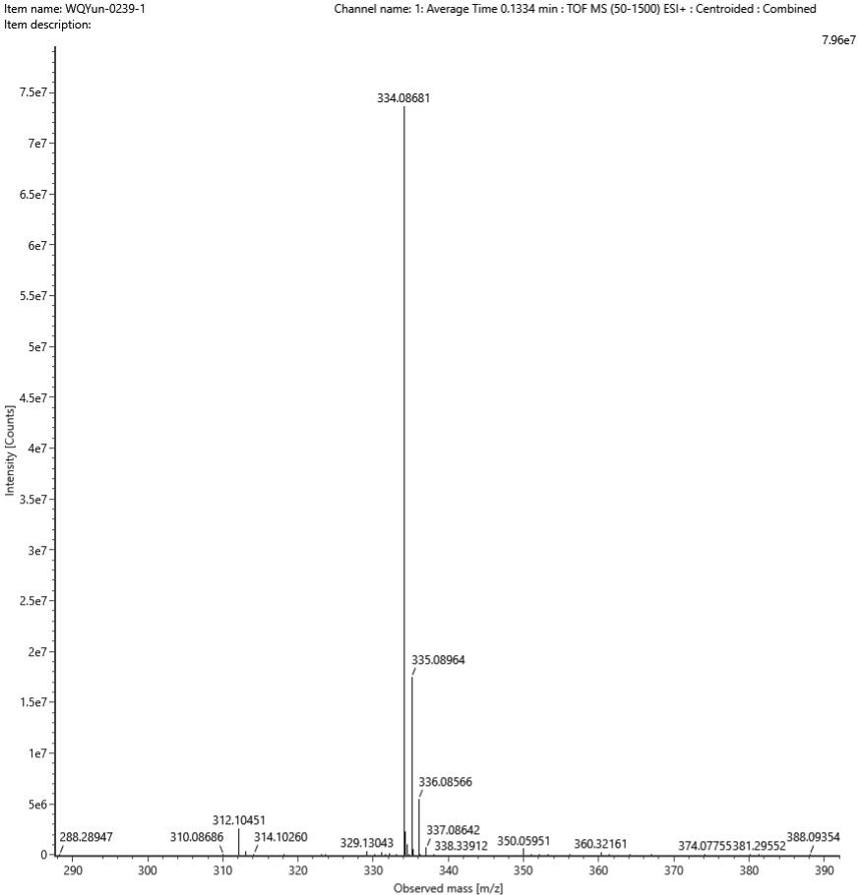Add:Na⁺
Composition | i-FIT Confidence (%) | Predicted m/z | m/z error (PPM)
C18H17NO2S | 99.999999 | 334.087221 | -1.232752

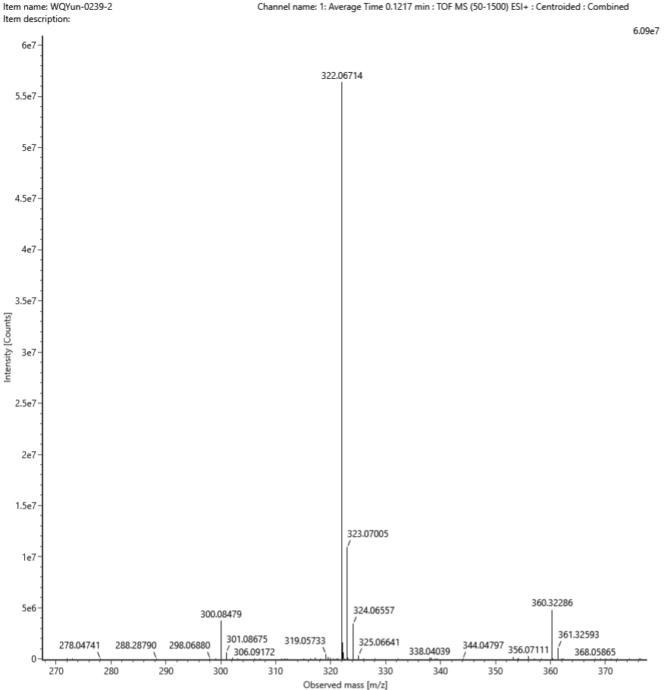Add:Na⁺
Composition | i-FIT Confidence (%) | Predicted m/z | m/z error (PPM)
C17H14FNOS | 100.000000 | 322.067234 | -0.293049

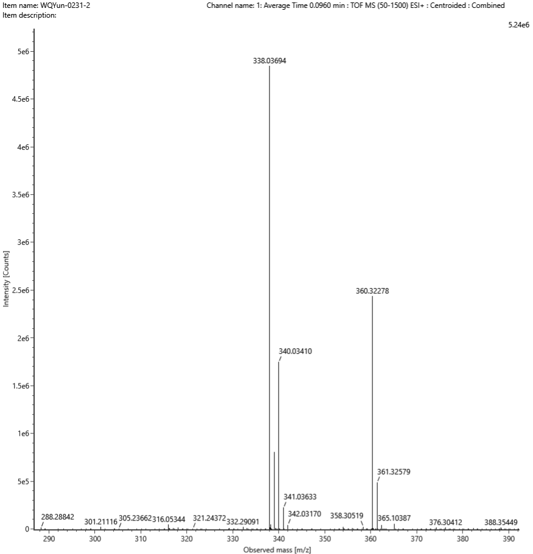Add:Na⁺
Composition | i-FIT Confidence (%) | Predicted m/z | m/z error (PPM)
C17H14ClNOS | 100.000000 | 338.037684 | -2.206323

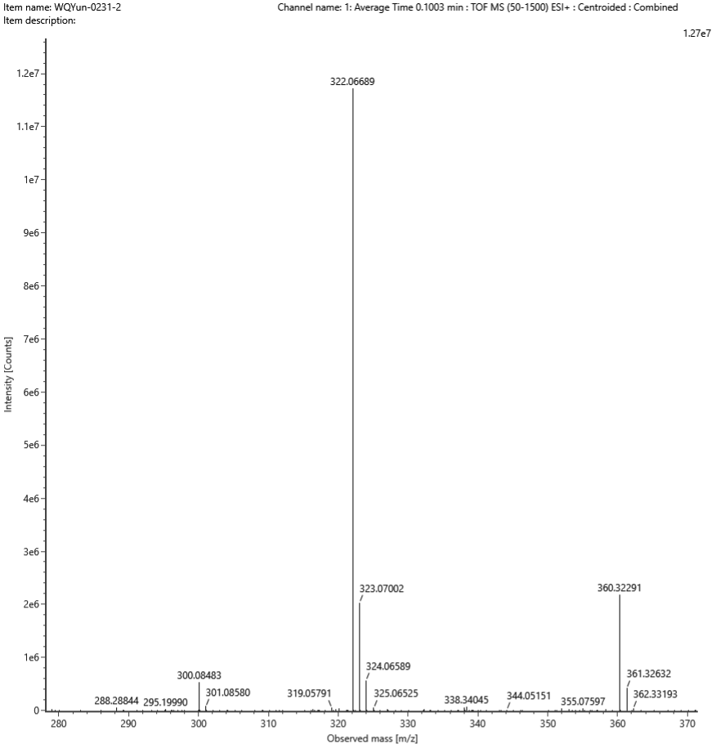Add:Na⁺
Composition | i-FIT Confidence (%) | Predicted m/z | m/z error (PPM)
C17H14FNOS | 99.951274 | 322.067234 | -1.071721

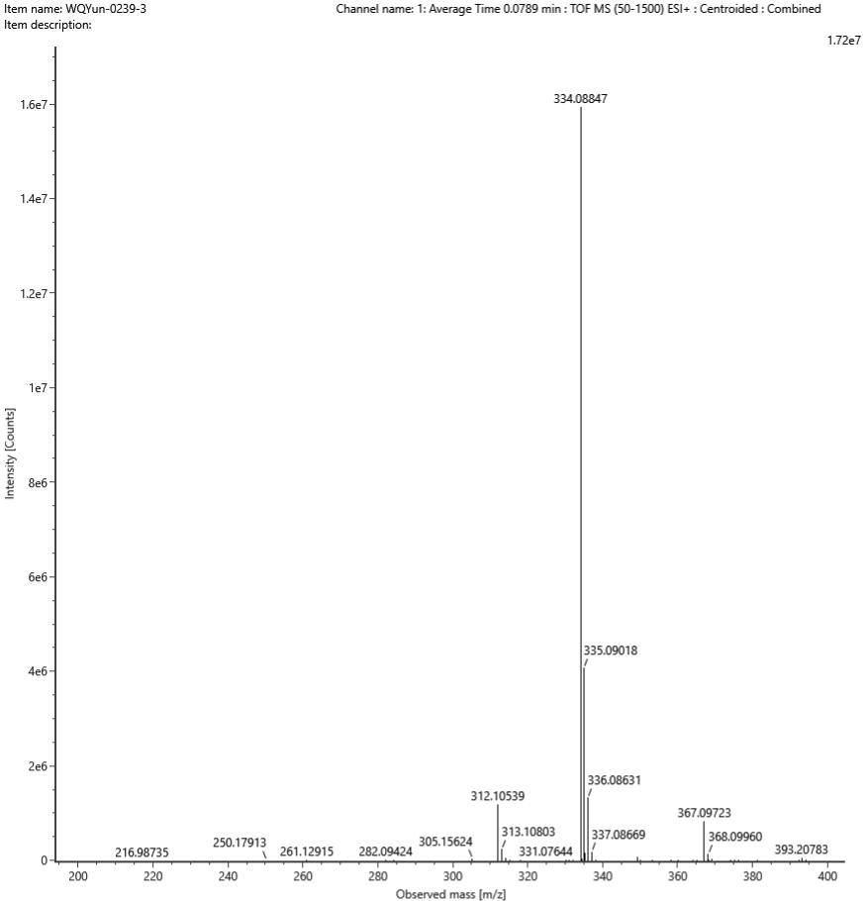Add:Na⁺
Composition | i-FIT Confidence (%) | Predicted m/z | m/z RMS (PPM)
C18H17NO2S | 95.181724 | 334.087221 | 3.316037

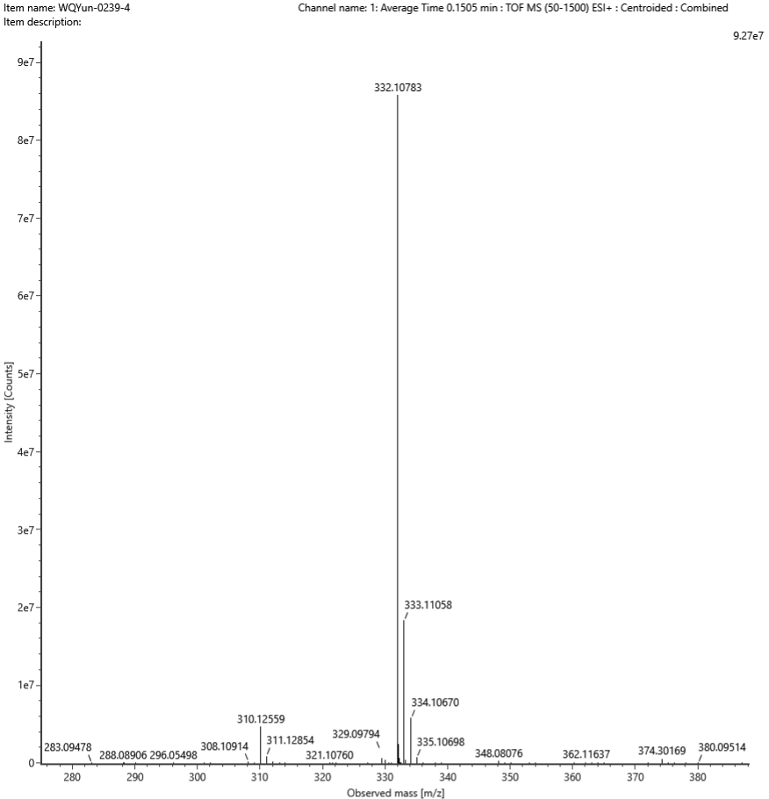Add:Na⁺
Composition | i-FIT Confidence (%) | Predicted m/z | m/z error (PPM)
C19H19NOS | 100.000000 | 332.107956 | -0.380688

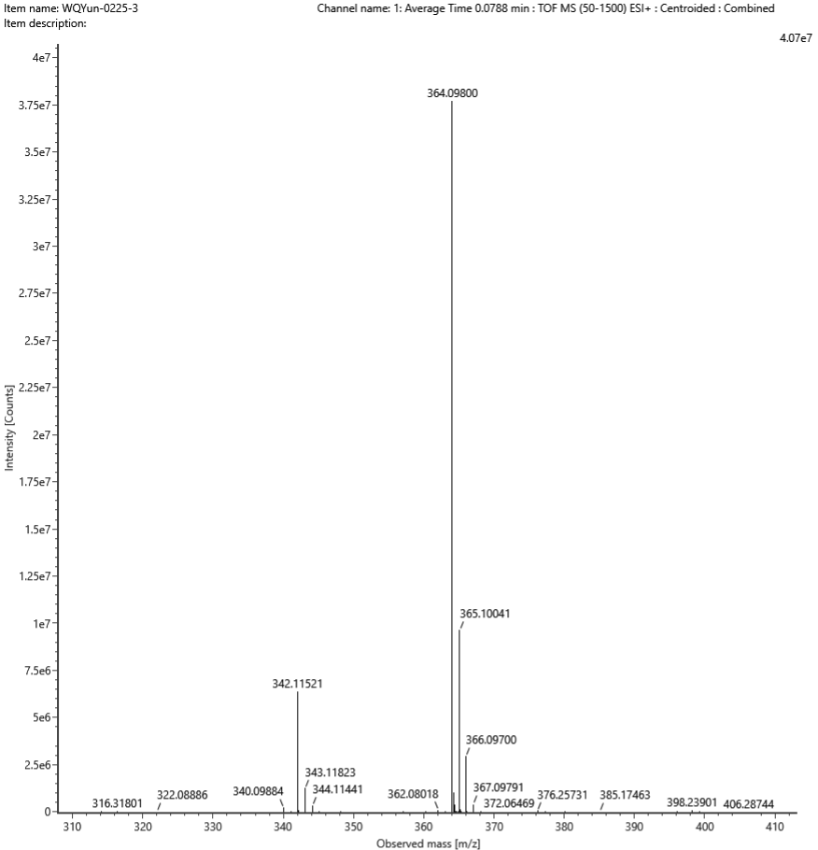Add:Na⁺
Composition | i-FIT Confidence (%) | Predicted m/z | m/z error (PPM)
C19H19NO3S | 100.000000 | 364.097785 | 0.591338

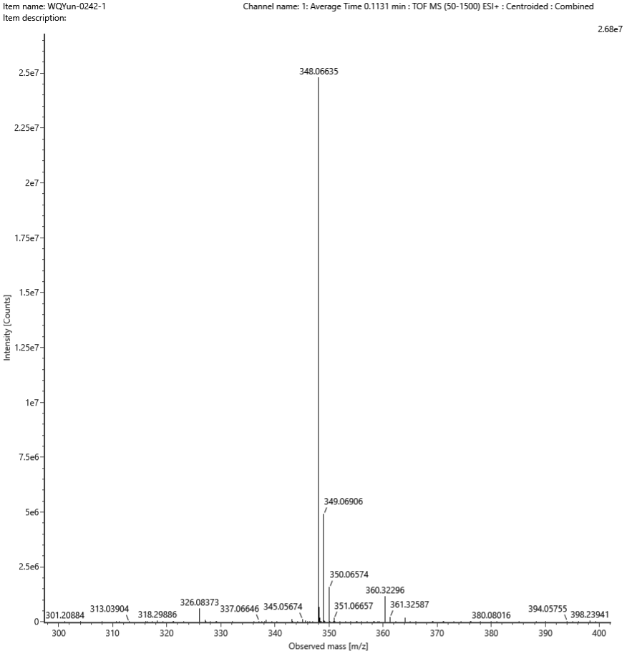Add:Na⁺
Composition | i-FIT Confidence (%) | Predicted m/z | m/z error (PPM)
C18H15NO3S | 99.998276 | 348.066485 | -0.415787

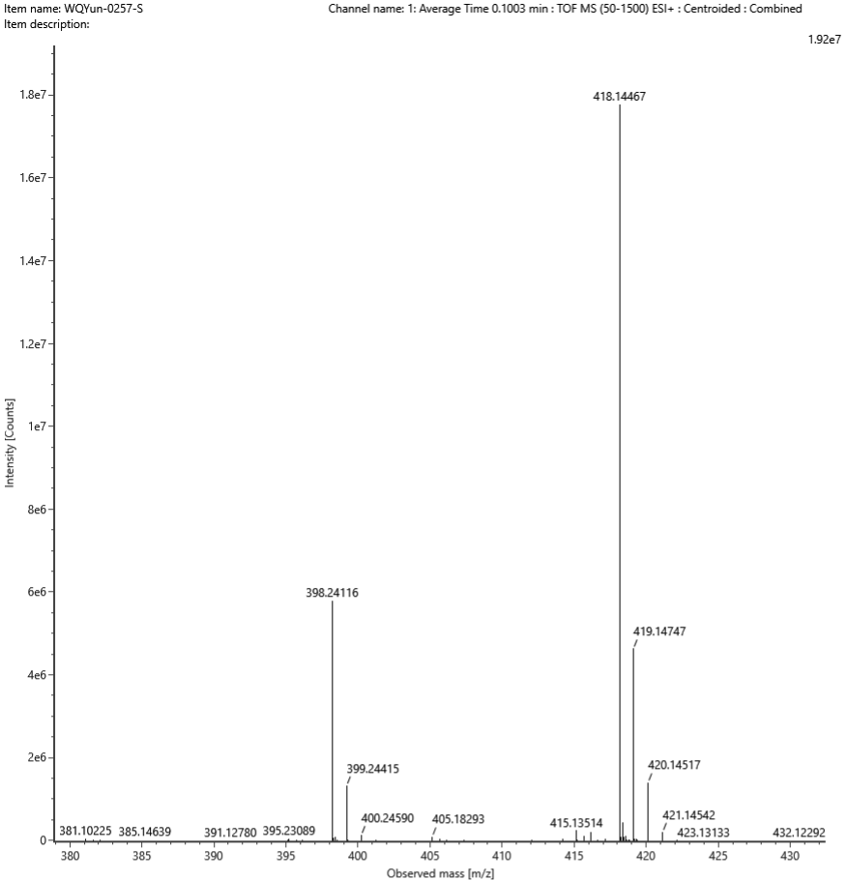Add: Na⁺
Composition | i-FIT Confidence (%) | Predicted m/z | m/z error (PPM)
C23H25NO3S | 99.999991 | 418.144735 | -0.156979

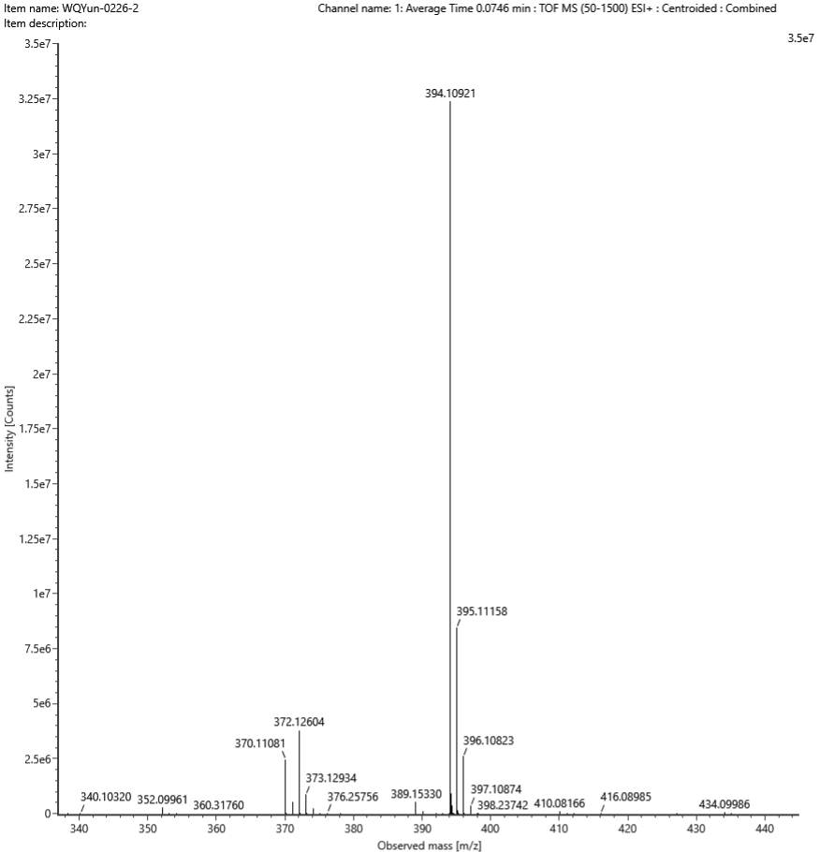Add:Na⁺
Composition | i-FIT Confidence (%) | Predicted m/z | m/z error (PPM)
C20H20NO4S | 100.000000 | 394.108350 | 2.187787

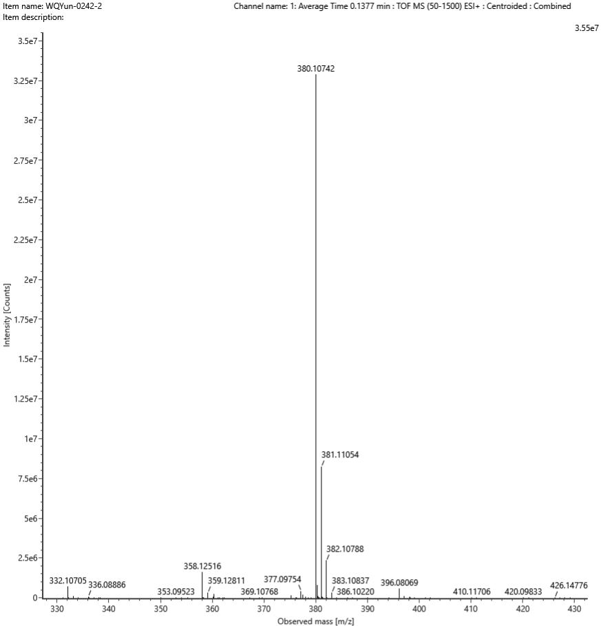Add:Na⁺
Composition | i-FIT Confidence (%) | Predicted m/z | m/z error (PPM)
C23H19NOS | 100.000000 | 380.107956 | -1.413995

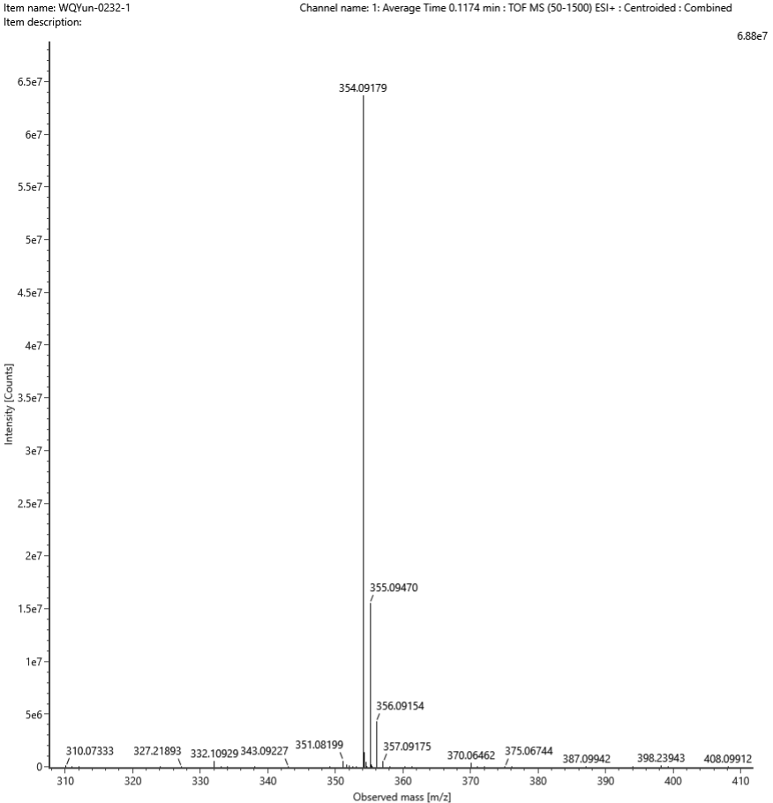Add:Na⁺
Composition | i-FIT Confidence (%) | Predicted m/z | m/z error (PPM)
C21H17NOS | 99.999999 | 354.092306 | -1.558375

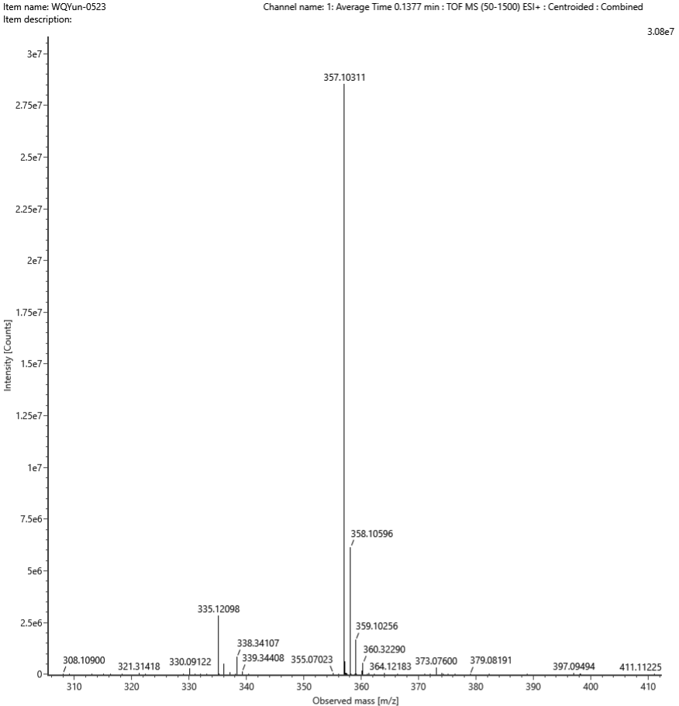Add:Na⁺
Composition | i-FIT Confidence (%) | Predicted m/z | m/z error (PPM)
C20H18N2OS | 100.000000 | 357.103205 | -0.266842

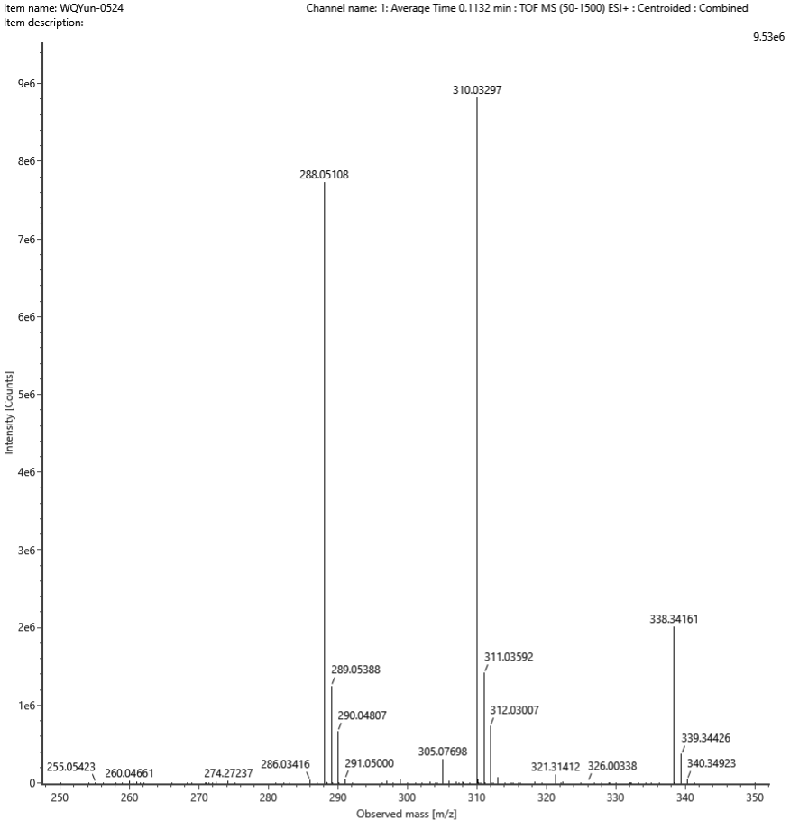Add:Na⁺
Composition | i-FIT Confidence (%) | Predicted m/z | m/z error (PPM)
C15H13NOS2 | 100.000000 | 310.033077 | -0.344905

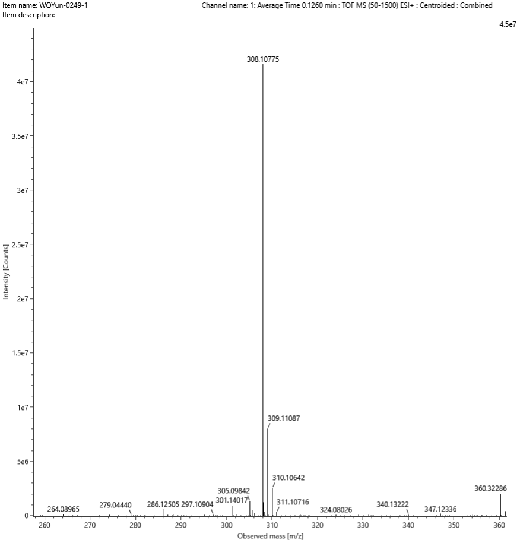Add:Na⁺
Composition | i-FIT Confidence (%) | Predicted m/z | m/z error (PPM)
C17H19NOS | 100.000000 | 308.107956 | -0.722667

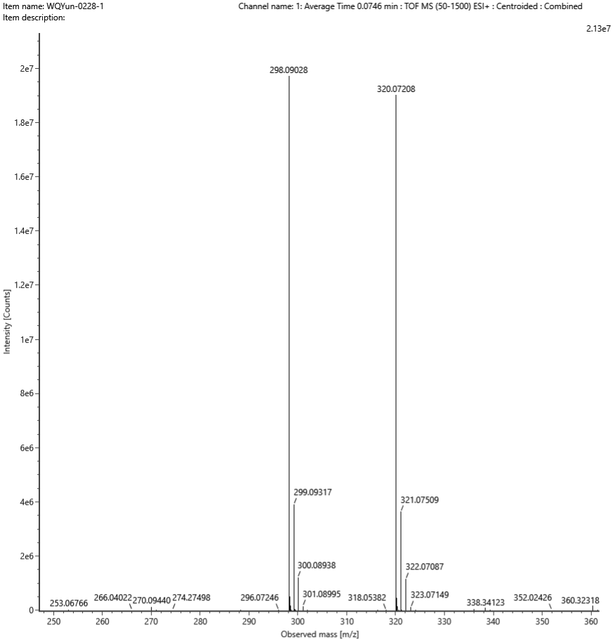Add:H⁺
Composition | i-FIT Confidence (%) | Predicted m/z | m/z error (PPM)
C17H15NO2S | 100.000000 | 298.089626 | 2.201700

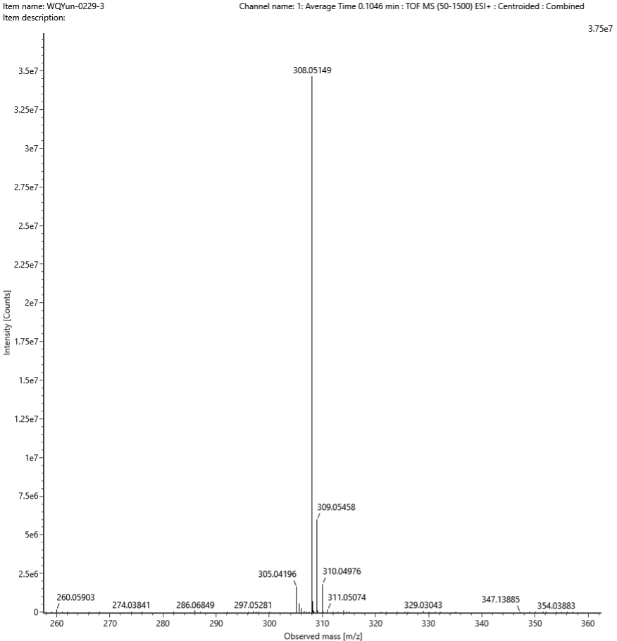Add:Na⁺
Composition | i-FIT Confidence (%) | Predicted m/z | m/z error (PPM)
C16H12FNOS | 100.000000 | 308.051584 | -0.306218

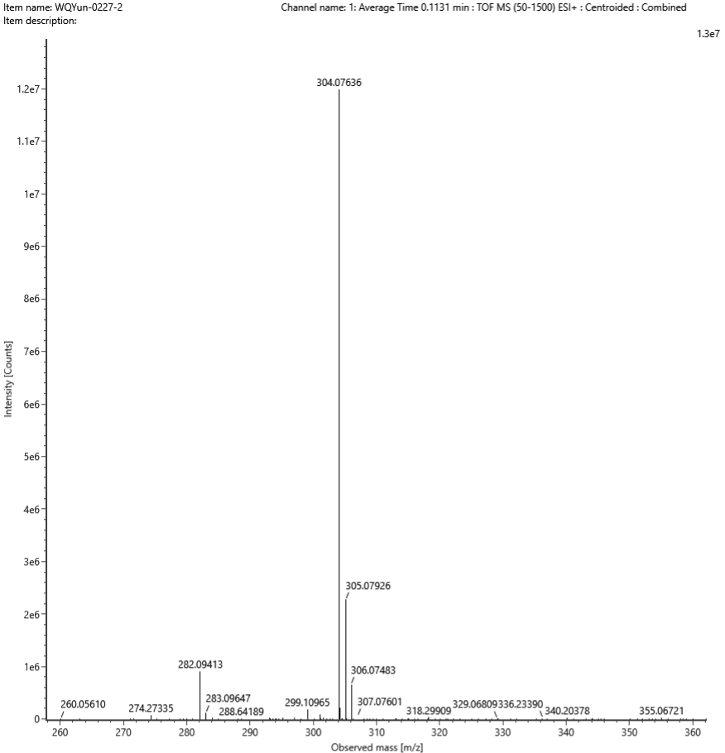Add:Na⁺
Composition | i-FIT Confidence (%) | Predicted m/z | m/z error (PPM)
C17H15NOS | 100.000000 | 304.076656 | -0.976405

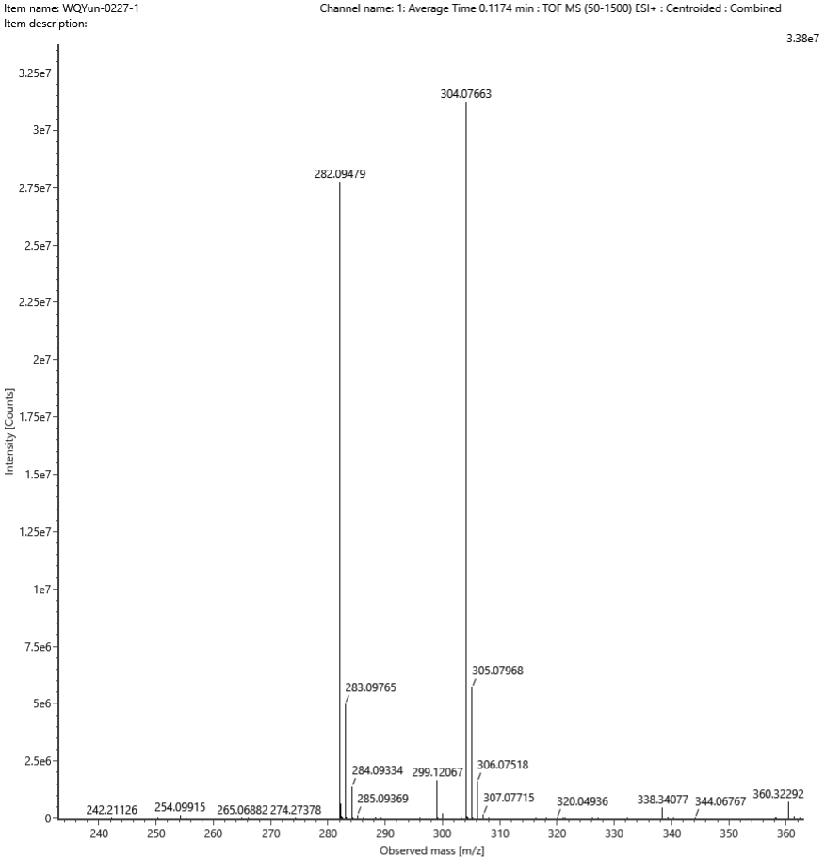Add:Na⁺
Composition | i-FIT Confidence (%) | Predicted m/z | m/z error (PPM)
C17H15NOS | 100.000000 | 304.076656 | -0.085519

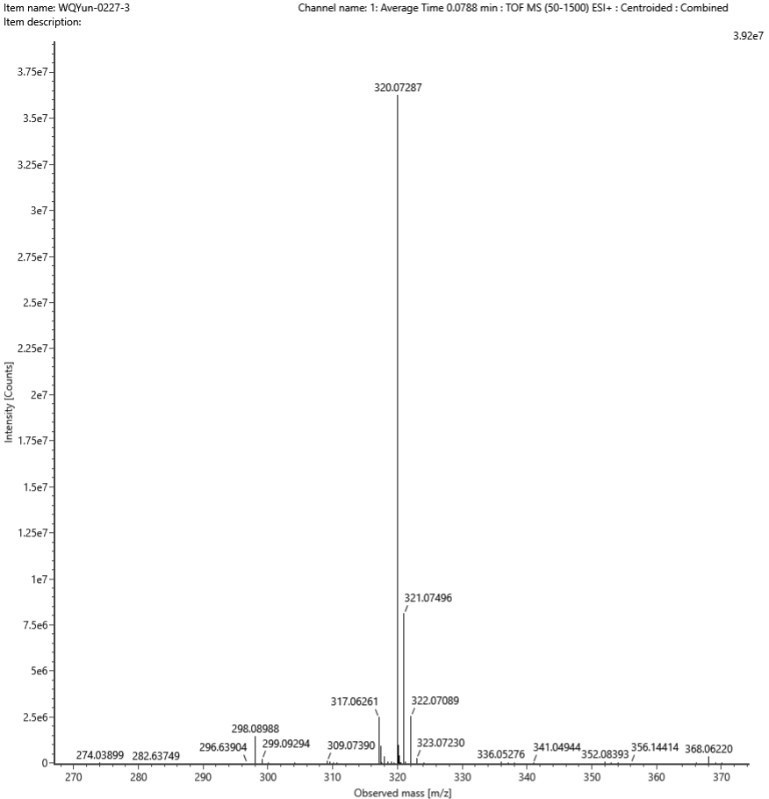Add:Na⁺
Composition | i-FIT Confidence (%) | Predicted m/z | m/z error (PPM)
C17H15NO2S | 100.000000 | 320.071571 | 4.072703

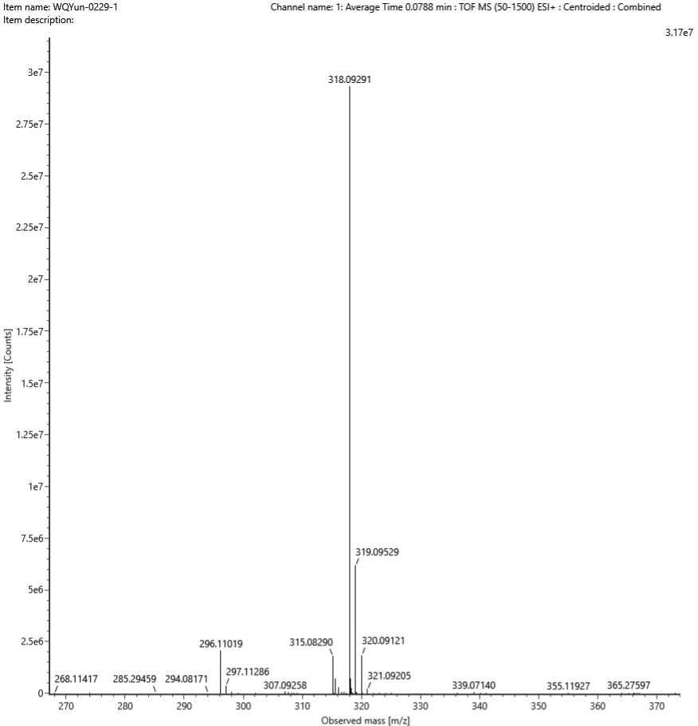Add:Na⁺
Composition | i-FIT Confidence (%) | Predicted m/z | m/z error (PPM)
C18H17NOS | 100.000000 | 318.092306 | 1.904905

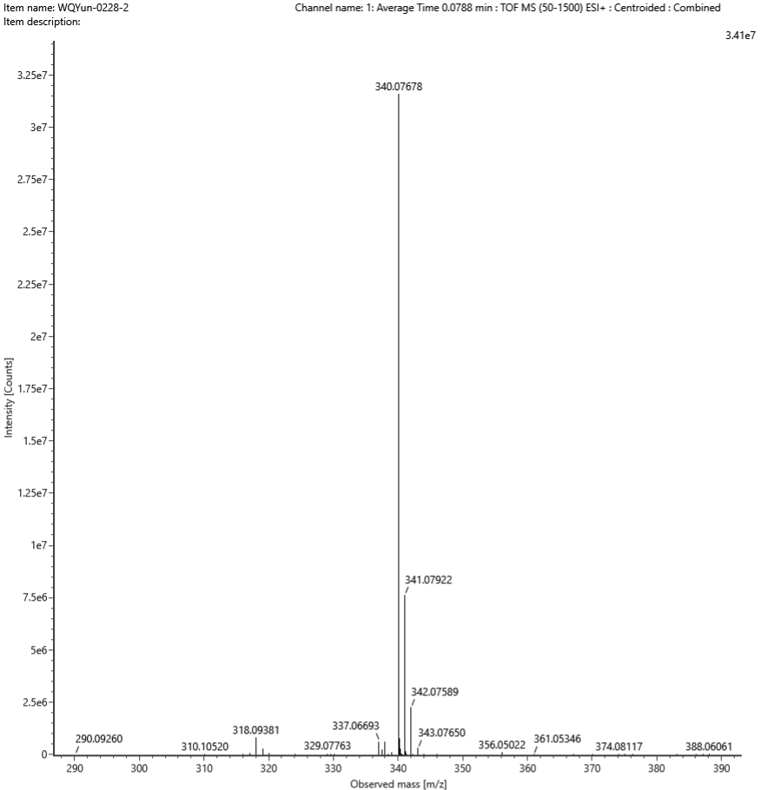Add:Na⁺
Composition | i-FIT Confidence (%) | Predicted m/z | m/z error (PPM)
C20H15NOS | 100.000000 | 340.076656 | 0.365948

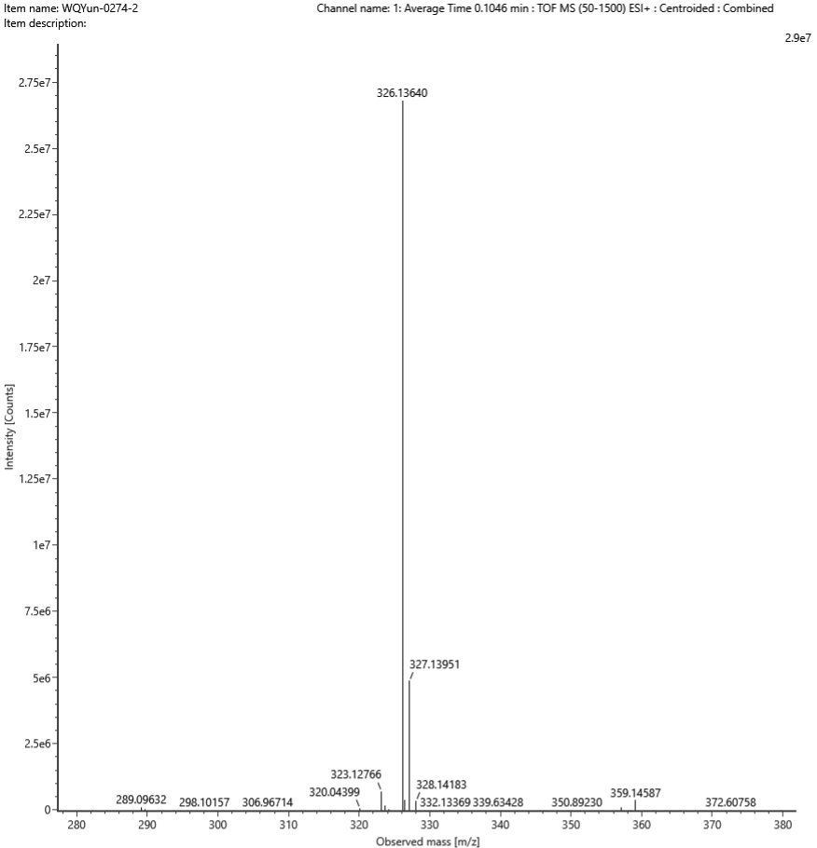Add:Na⁺
Composition | i-FIT Confidence (%) | Predicted m/z | m/z error (PPM)
C17H21NO4 | 100.000000 | 326.136279 | 0.371401

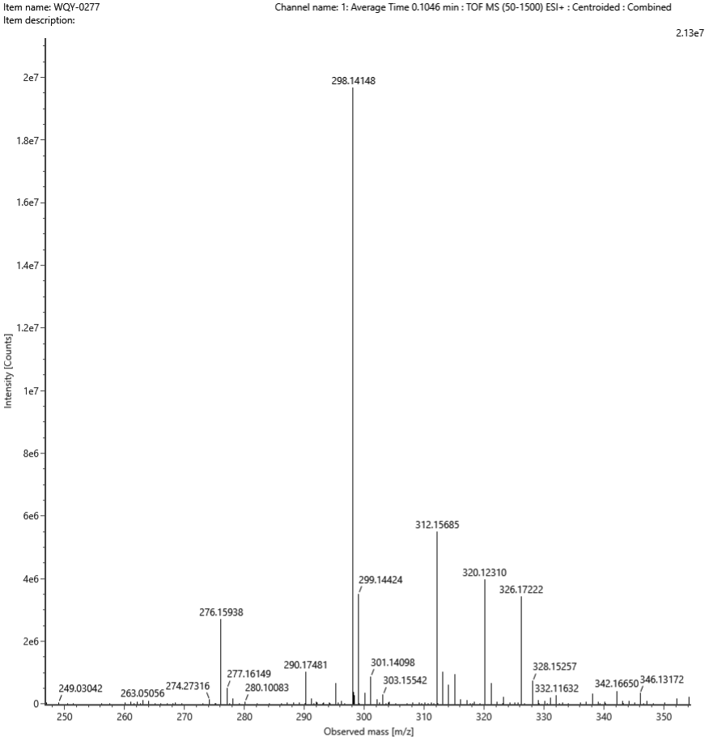Add:Na⁺
Composition | i-FIT Confidence (%) | Predicted m/z | m/z error (PPM)
C16H21NO3 | 100.000000 | 298.141365 | 0.388295

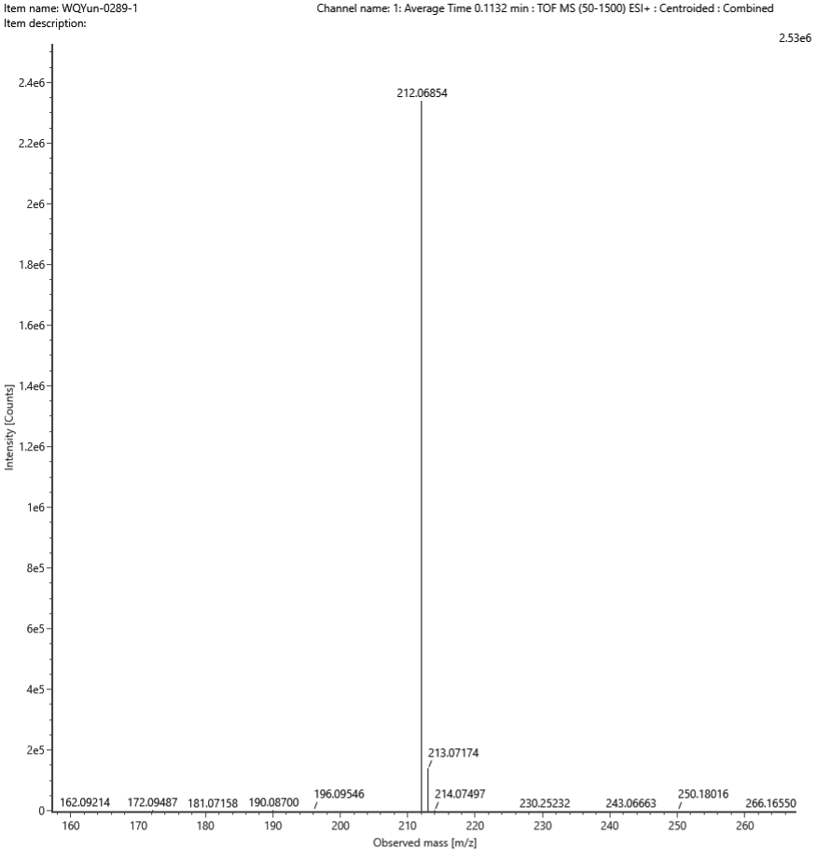Add:Na⁺
Composition | i-FIT Confidence (%) | Predicted m/z | m/z error (PPM)
C11H11NO2 | 100.000000 | 212.068200 | 1.612409

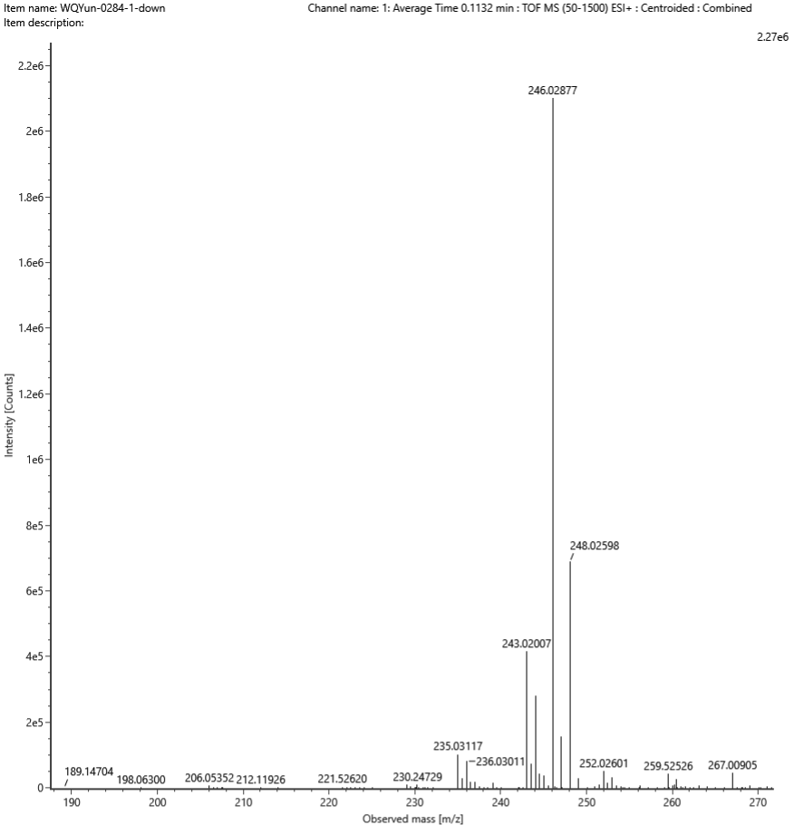Add:Na⁺
Composition | i-FIT Confidence (%) | Predicted m/z | m/z error (PPM)
C11H10ClNO2 | 99.999994 | 246.029227 | -1.866616

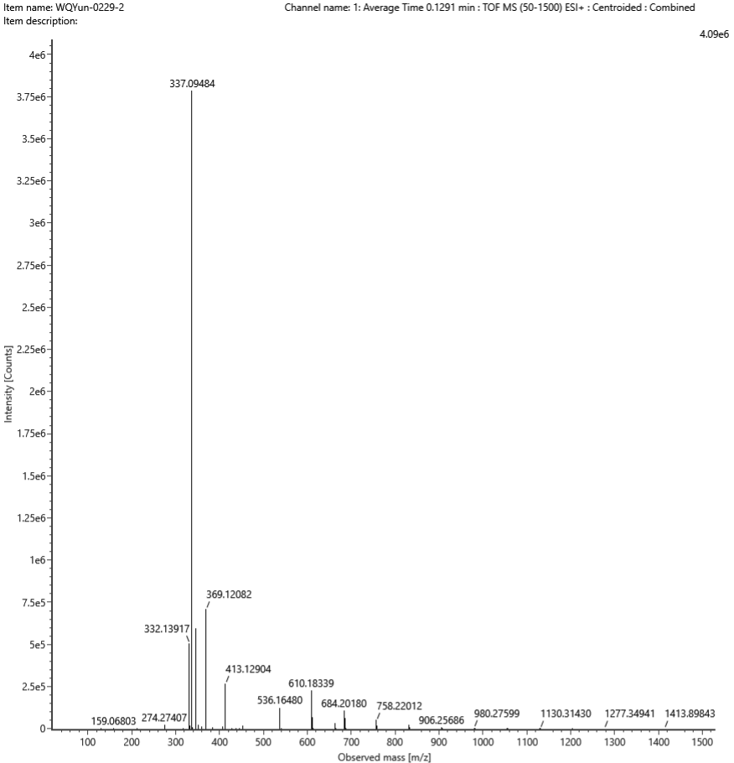
Add:Na⁺
Composition | i-FIT Confidence (%) | Predicted m/z | m/z error (PPM)
C20H14N2O2 | 100.000000 | 337.094749 | 0.271399

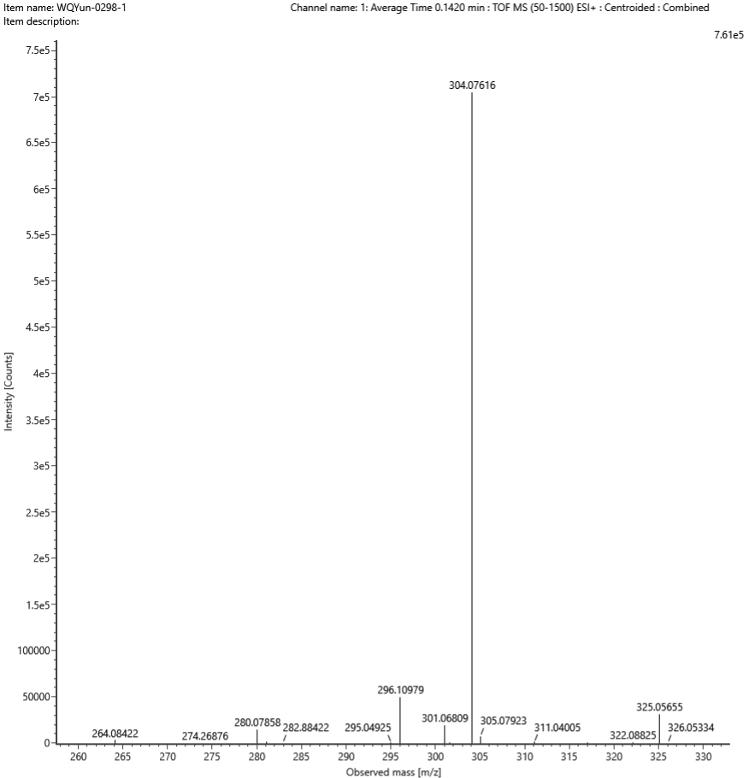Add:Na⁺
Composition | i-FIT Confidence (%) | Predicted m/z | m/z error (PPM)
C17H15NOS | 100.000000 | 304.076656 | -1.636322

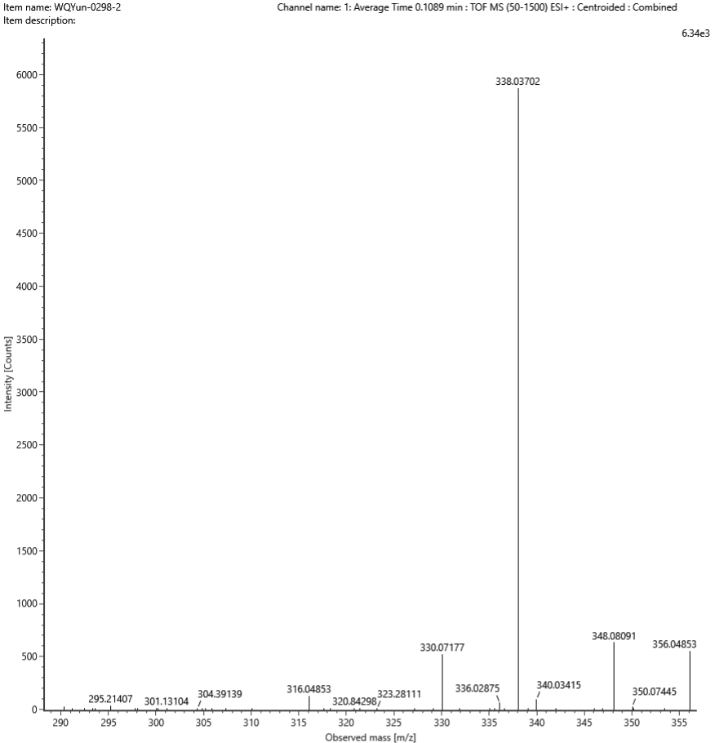Add:Na⁺
Composition | i-FIT Confidence (%) | Predicted m/z | m/z error (PPM)
C17H14ClNOS | 100.000000 | 338.037684 | -1.968955

X-Ray crystallography
The absolute stereochemistry was determined by the X-ray diffraction. These crystals were deposited in the Cambridge Crystallographic Data Centre and assigned.
www.ccdc.cam.ac.uk/data request/cif.
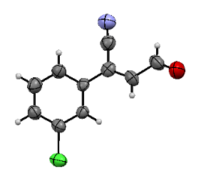
CCDC: 2220606
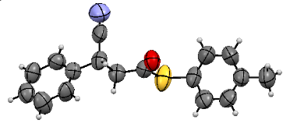
CCDC: 2220572
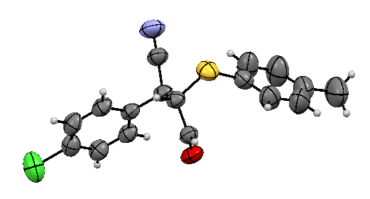
CCDC：2221058

VI. Supplementary References
(1) Wu, Q. et al. Nhc-catalyzed enantioselective synthesis of dihydropyran-4-carbonitriles bearing all-carbon quaternary centers. Org. Chem. Front. 4, 2323-2326 (2017).
(2) Soli, E. D. et al. Azide and cyanide displacements via hypervalent silicate intermediates. J. Org. Chem. 64, 3171-3177 (1999).
(3) Li, X. et al. Rhodium-catalyzed asymmetric hydrogenation of β-cyanocinnamic esters with the assistance of a single hydrogen bond in a precise position. Chem. Sci. 9, 1919-1924 (2018).
(4) Langlois, N., Dahuron, N. & Wang, H. S. Enantioselective syntheses of (R)-3-phenyl gaba, (R)-baclofen and 4-arylpyrrolidin-2-ones. Tetrahedron 52, 15117-15126 (1996).
(5) Brenna, E. et al. Opposite enantioselectivity in the bioreduction of (Z)-β-aryl-β-cyanoacrylates mediated by the tryptophan 116 mutants of old yellow enzyme 1: Synthetic approach to (R)- and (S)-β-aryl-γ-lactams. Adv. Synth. Catal. 357, 1849-1860 (2015).

