Microbiome and metabolome analysis outlines circulatory predictors of poor outcomes in ALF
Sushmita Pandey ^{2#}, Neha Sharma ^{2#}, Nupur Sharma², Gaurav Tripathi², Babu Mathew², Manisha Yadav ², Vasundhra Bindal ², Sadam H. Bhat², Rakhi maiwall ¹, and Jaswinder Singh Maras ^{2*}
¹Department of Hepatology, Institute of Liver and Biliary Sciences, New Delhi
2 Departments of Molecular and Cellular Medicine, Institute of Liver and Biliary Sciences,
New Delhi.
Supplementary Figure 1: Overview of the study design for metaproteome (with red arrows) (ALF; n=40), and metabolome (with green arrows) (ALF; n=40) (ALF; n=160) done in training cohort and test cohort (plasma and one drop blood)
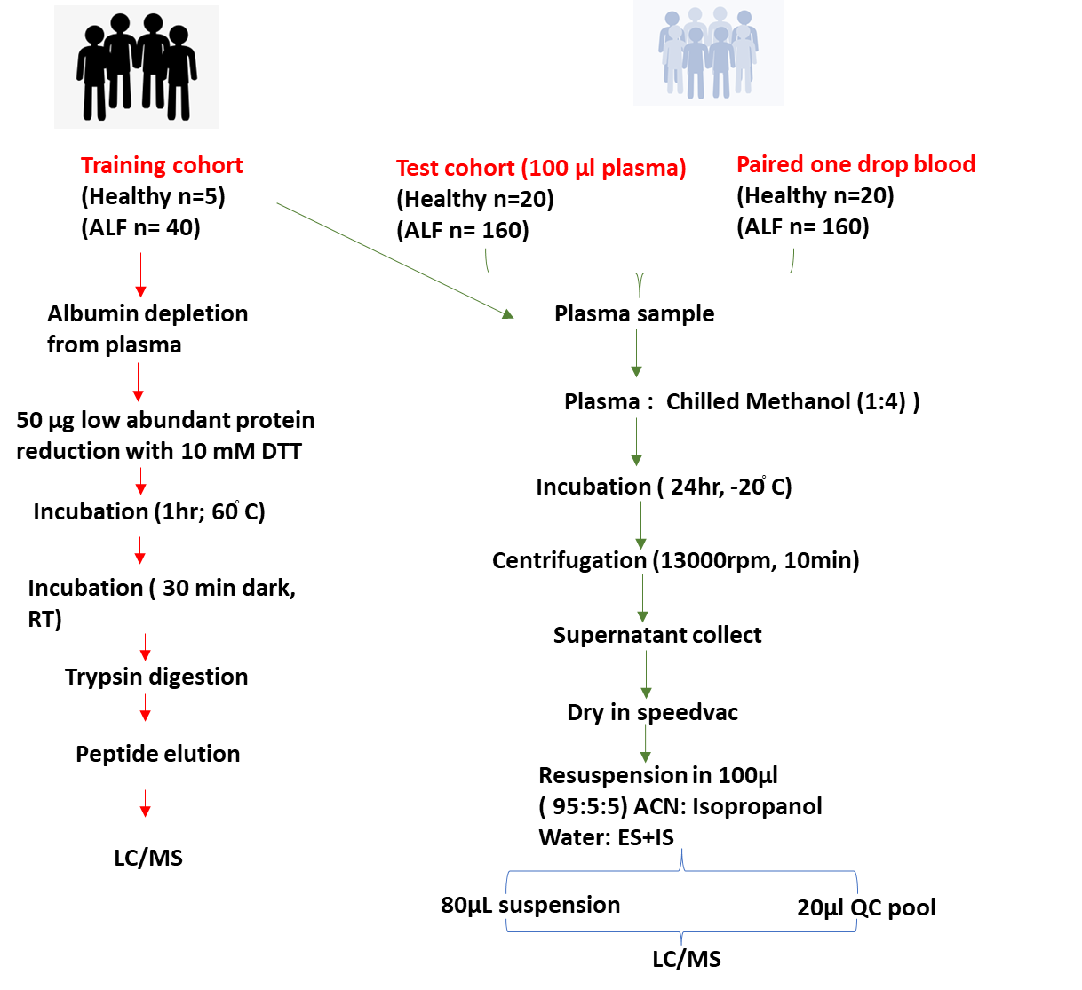

Supplementary Figure 2: Flow chart of statistical analysis performed for Integrated Analysis of Plasma Metabolome and Meta-Proteome in Baseline Plasma and also to elucidate key Metabolome Indicators of Poor outcomes in Acute Liver Failure Patients.
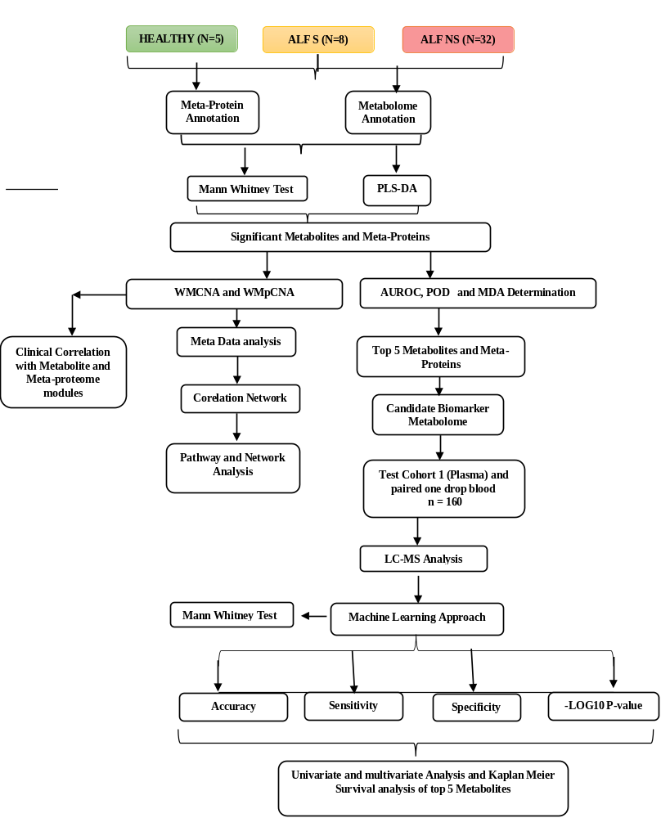
Supplementary Figure 3: Partial Least Squares - Discriminant Analysis (PLS-DA) Plot showing clear separation of metabolome in acute liver failure and healthy albumin samples with ALF; HC and NS; S revealing component variance along with the VIP scores of important features identified by PLS-DA and loading plot between the selected components.
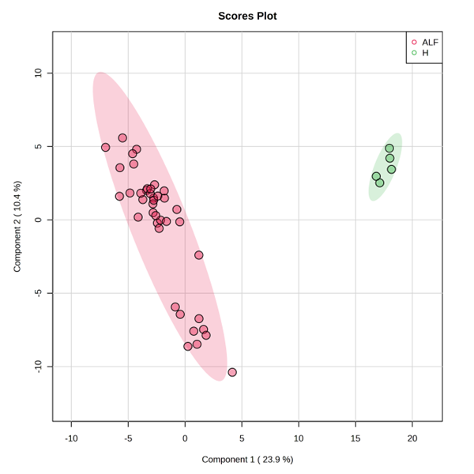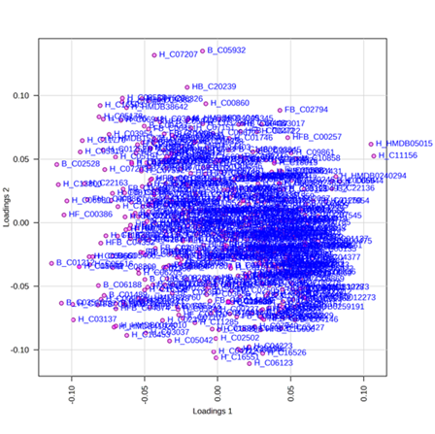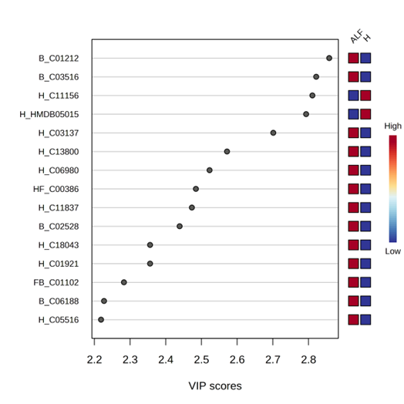
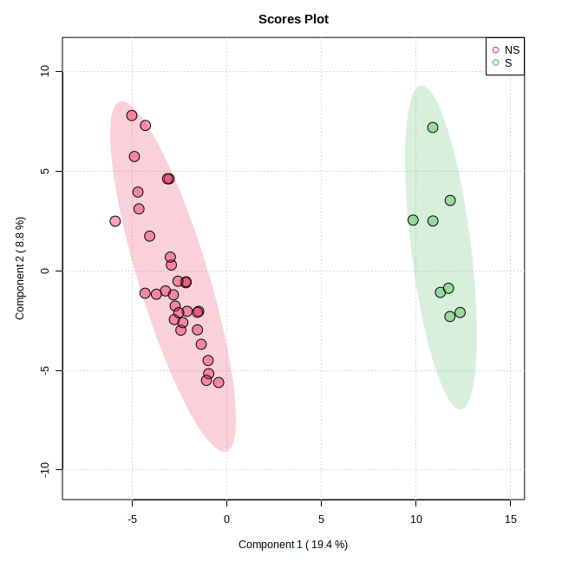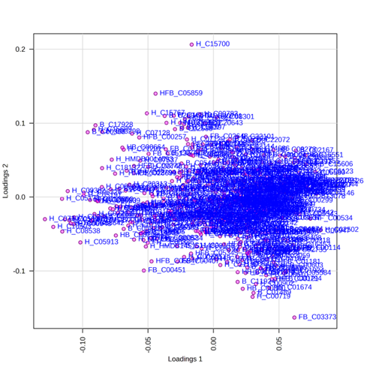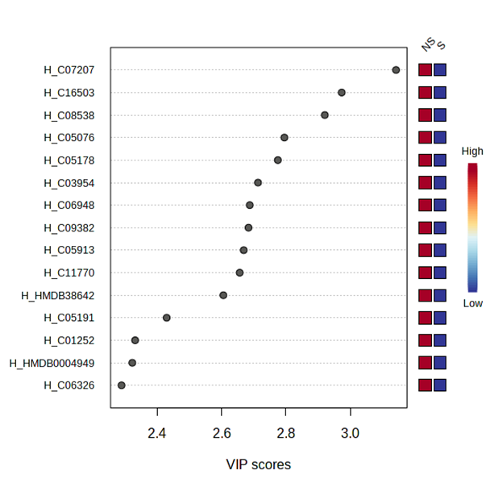

Supplementary Figure 4: Heat map showing hierarchical clustering of 50 different metabolome from ALF vs Healthy and NS VS S (distance measure using Euclidean, and clustering algorithm using ward D.
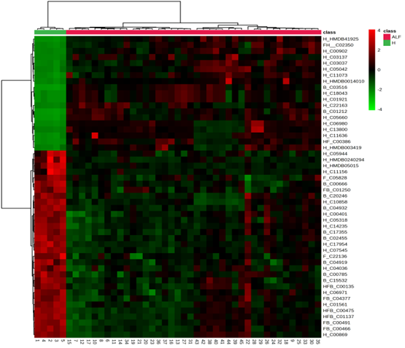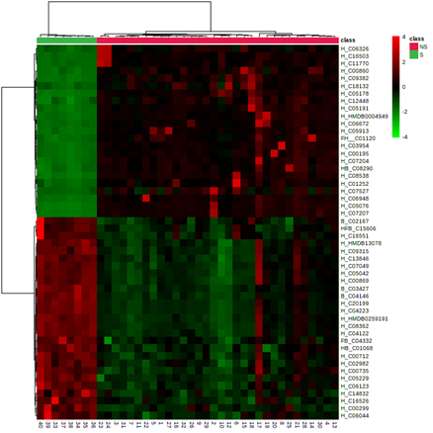
Supplementary figure 5: different metabolome features identified by Random Forest and ranked by the mean decrease in classification accuracy from ALF VS H and NS VS S

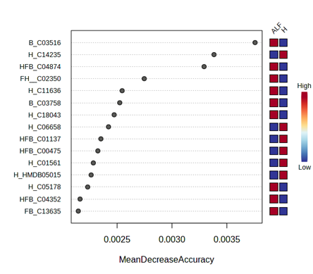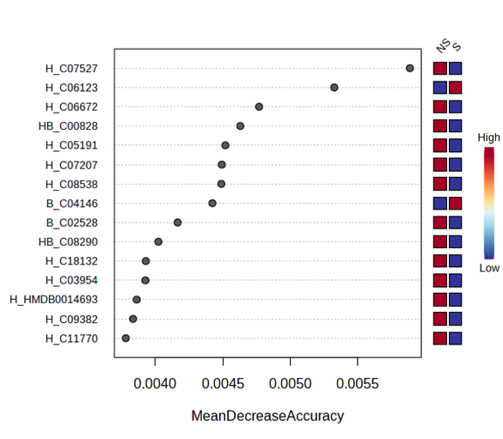

Supplementary figure 6: Metaproteome abundance in the study group at the phylum level (p<0.05).

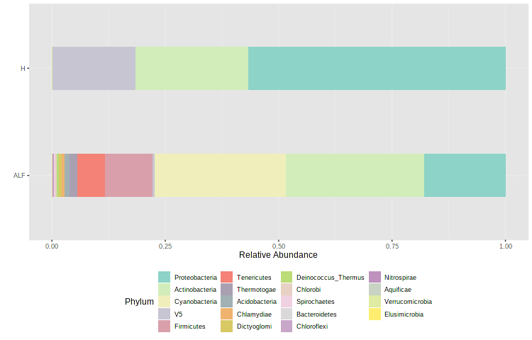

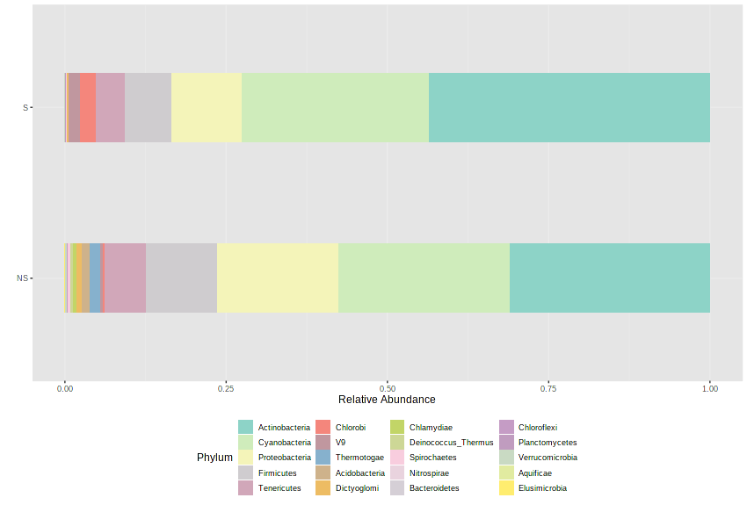

Supplementary Figure 7: Alpha diversity indices (Shannon/Simpson index) and Principal coordinate analysis (PCoA; beta diversity) in baseline plasma metaproteome of ALF VS Healthy and NS VS S.

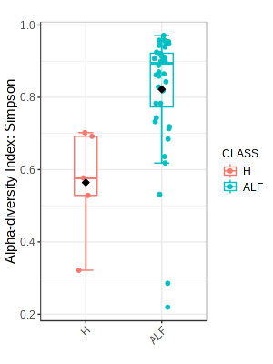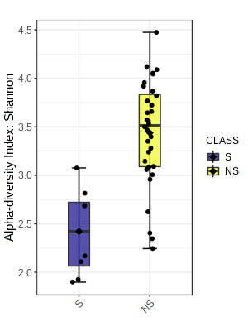

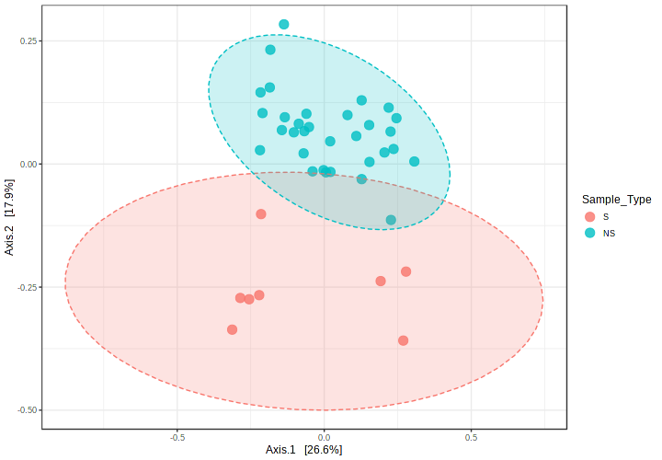
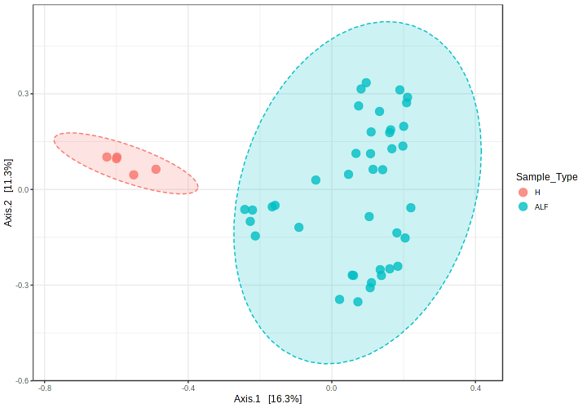

Supplementary Figure 8: Partial Component Analysis (PCA) plot showing clear separation of metaproteome in ALF VS H and NS VS S.
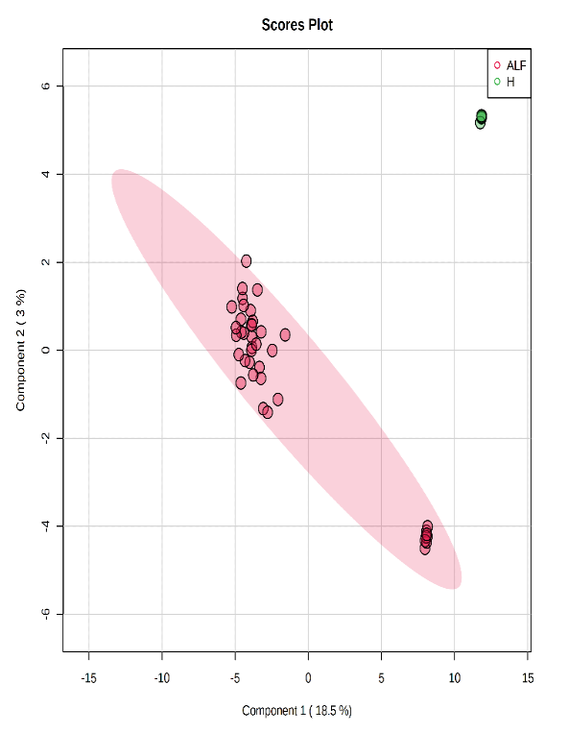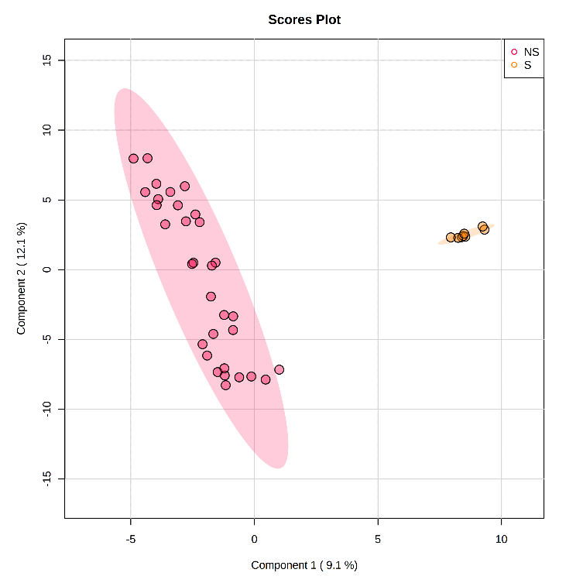

Supplementary Figure 9: LDA scores for bacterial peptides in NS VS S.

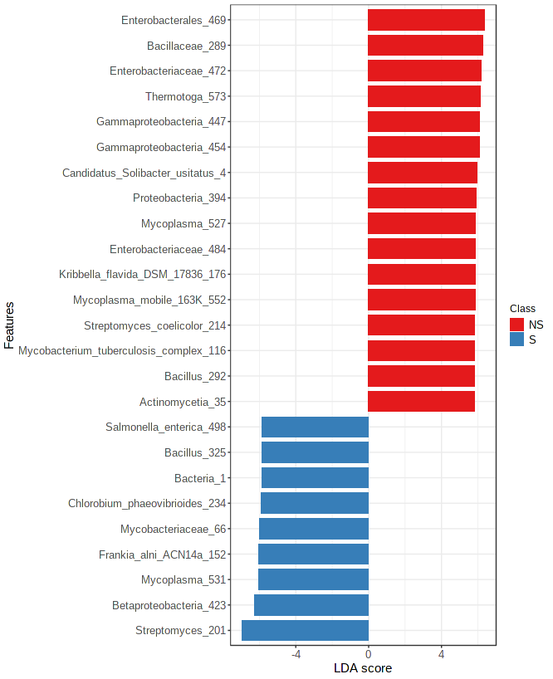

Supplementary figure 10: Random Forest analysis for non-survival, survival, and Healthy with 500 classification trees for bacterial peptides.

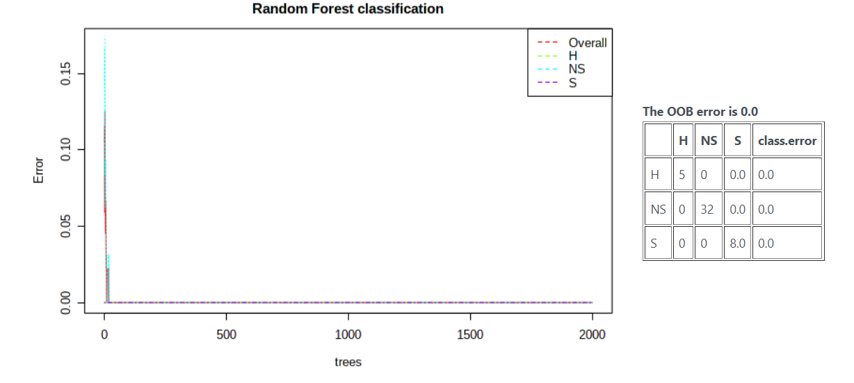

Supplementary figure 11: 15 different Bacterial features identified by Random Forest and ranked by the mean decrease in classification accuracy from ALF VS H and NS VS S.
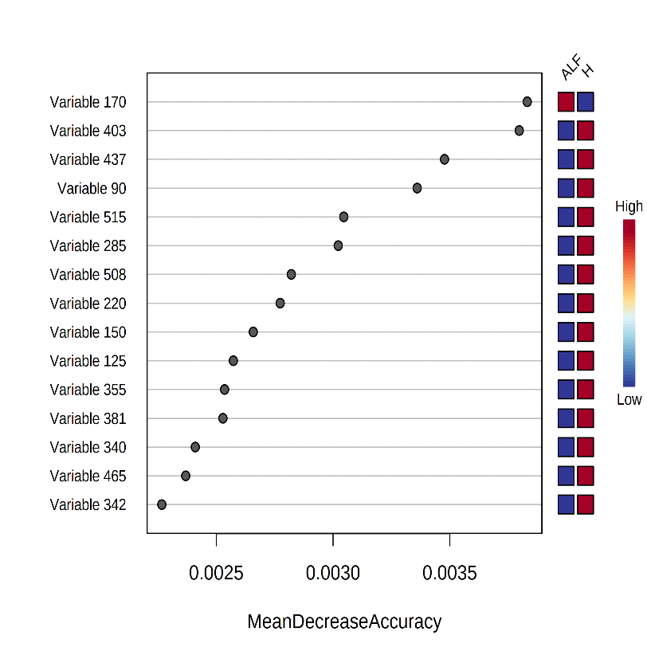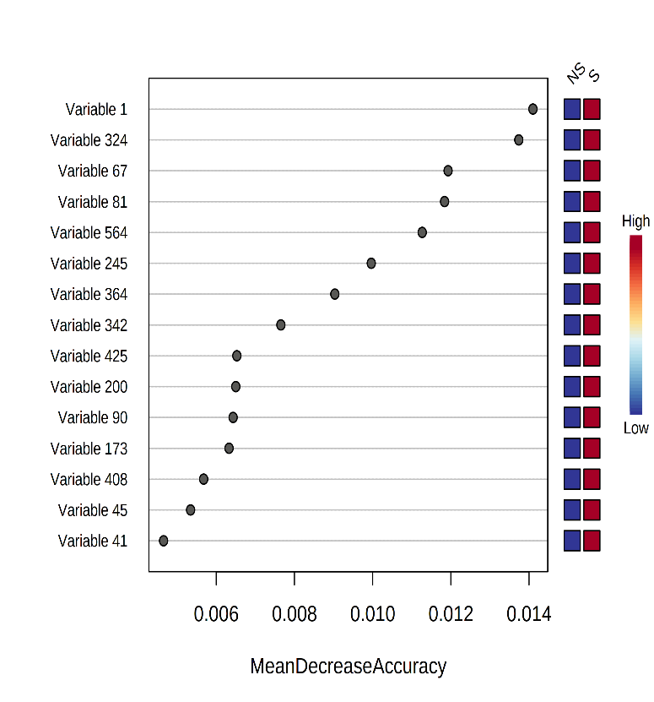

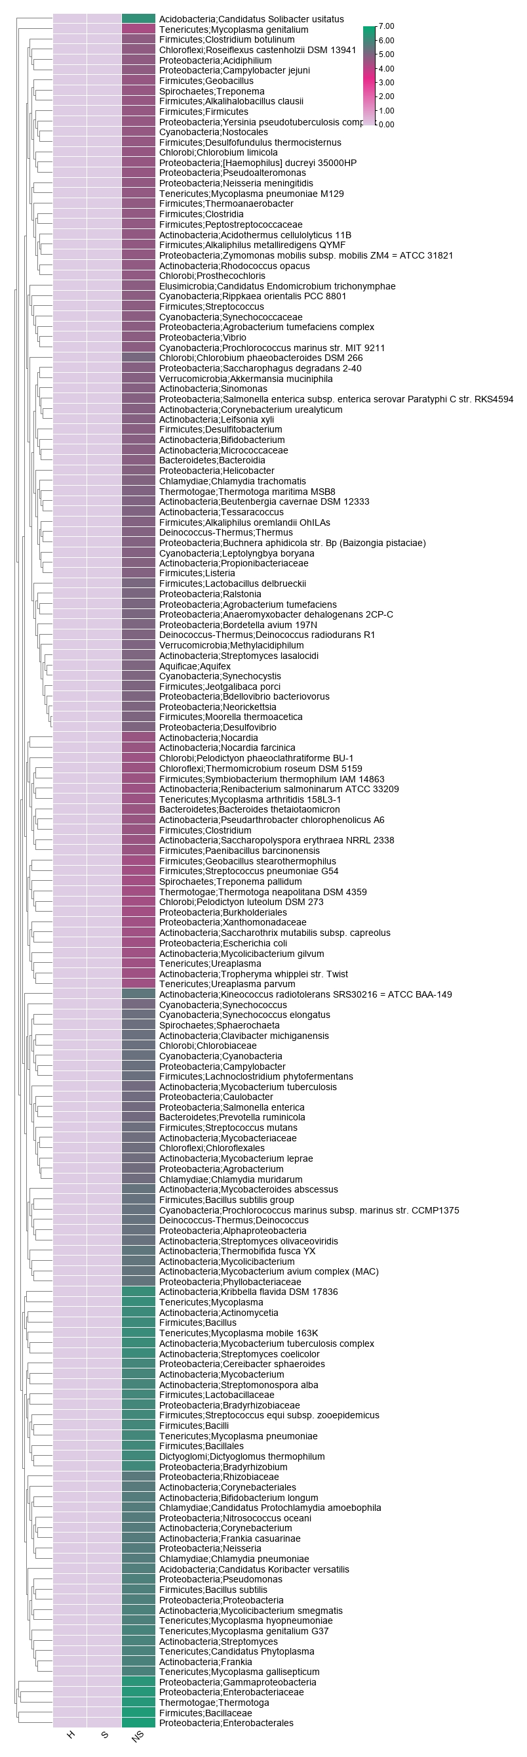
Supplementary figure 12: Bacterial features associated with different WMpCNA module
Turquoise
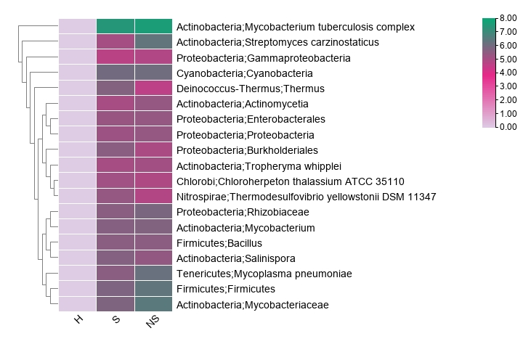
Yellow

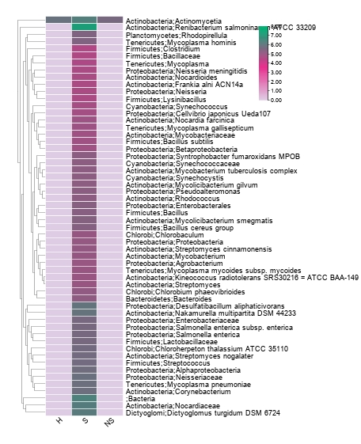
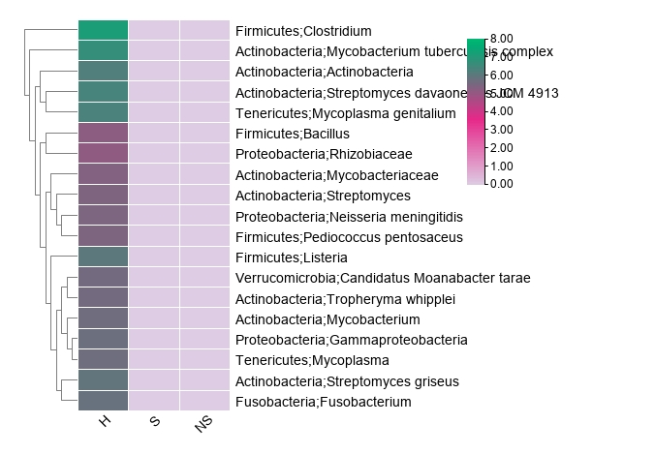
Blue
Brown
Supplementary Figure 13: Correlation plot of functions annotated from directly correlating Mp functionality and metabolome modules
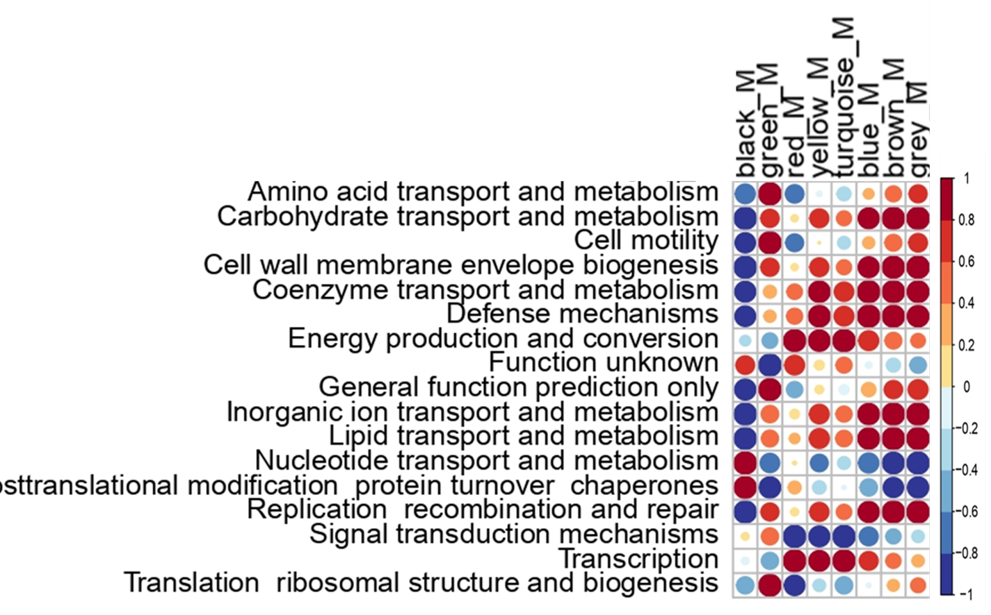
Supplementary Figure 14: Linear regression of the meta-protein’s turquoise module with the clinical complication of ALF
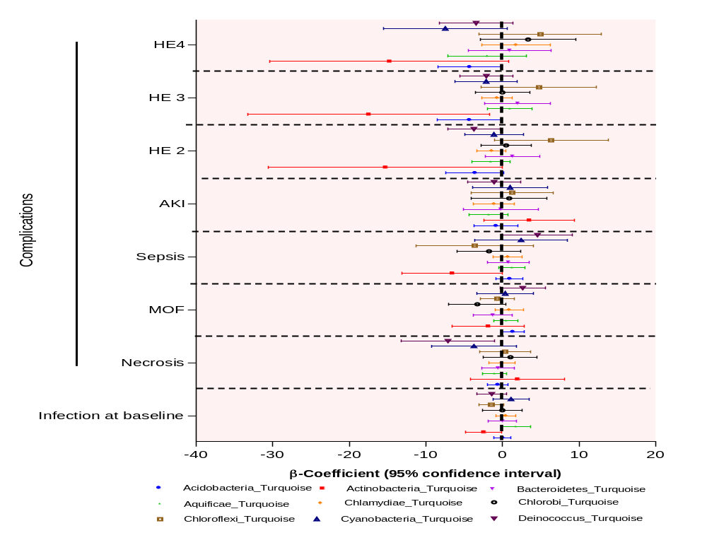
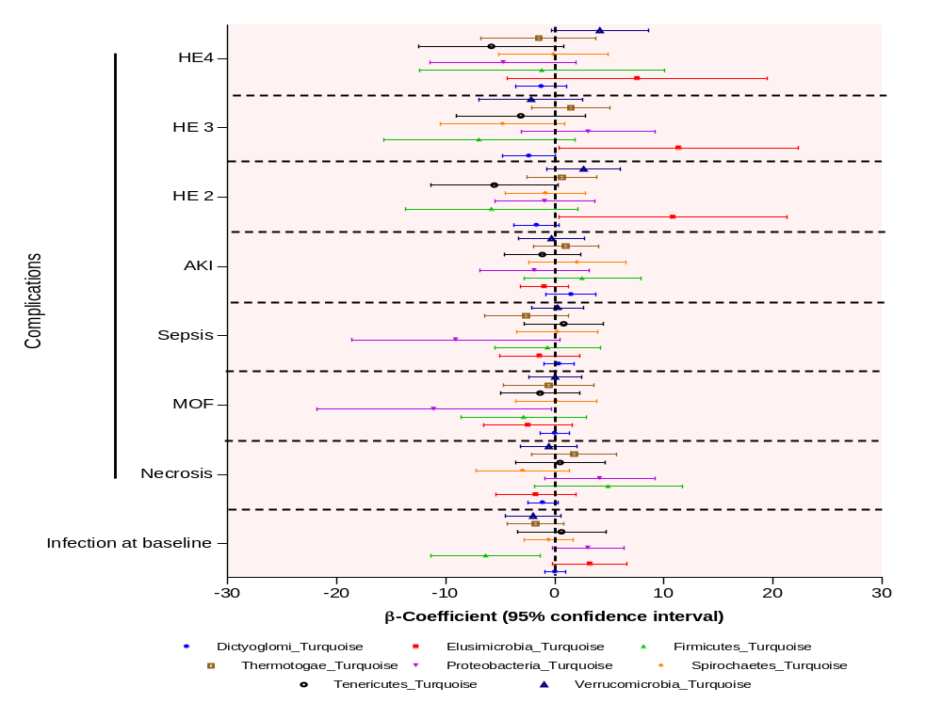

Supplementary Figure 15: Expression of the metabolic pathway’s metabolites in Survivors and Non-survivors

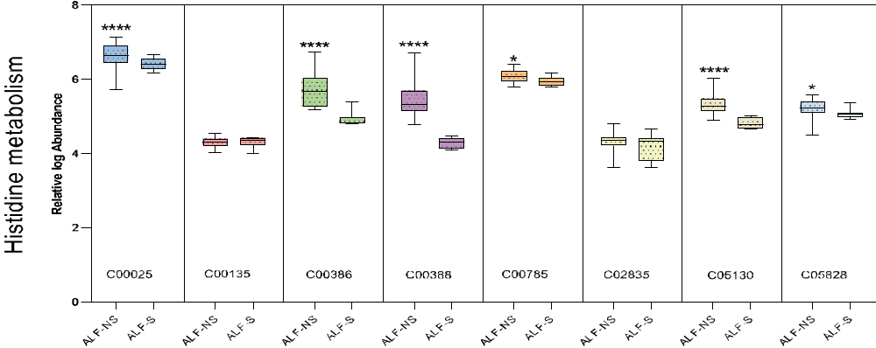

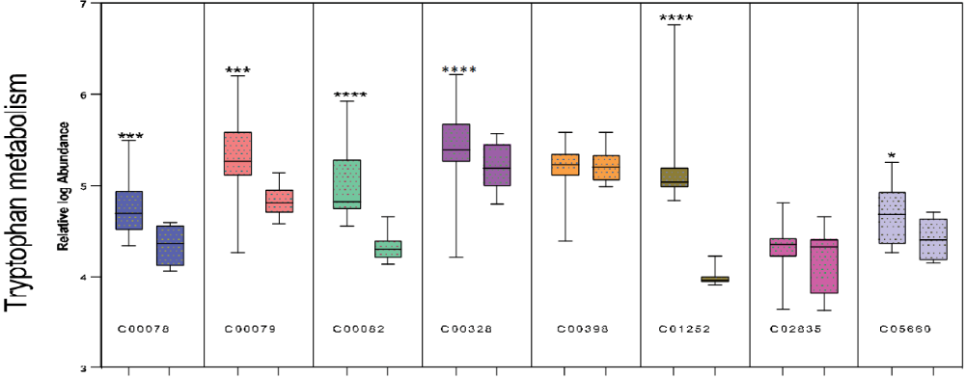
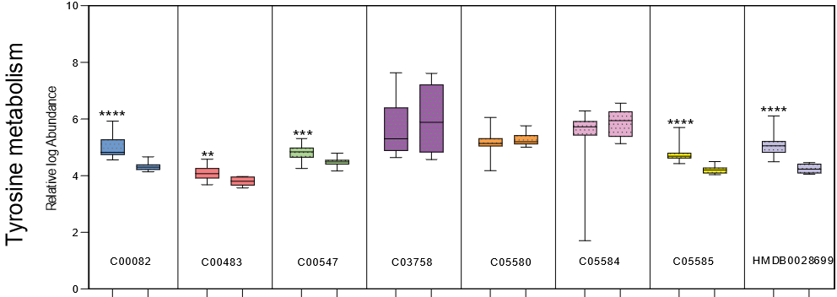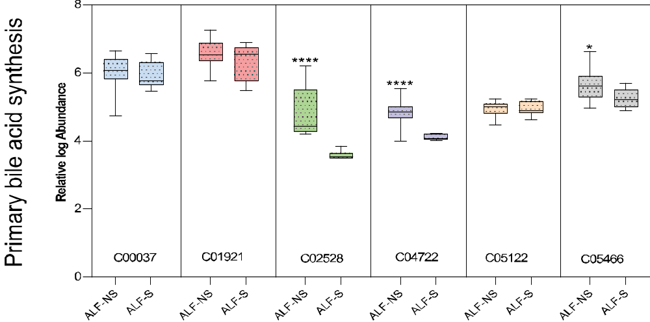
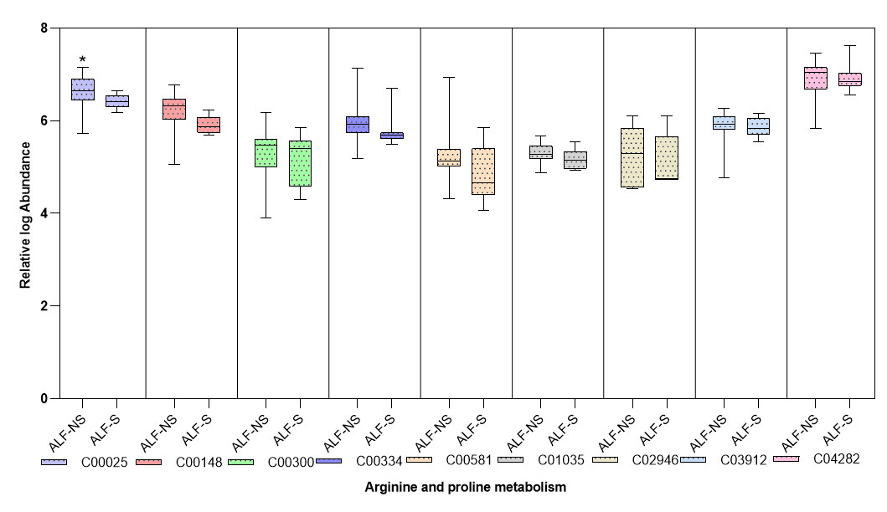
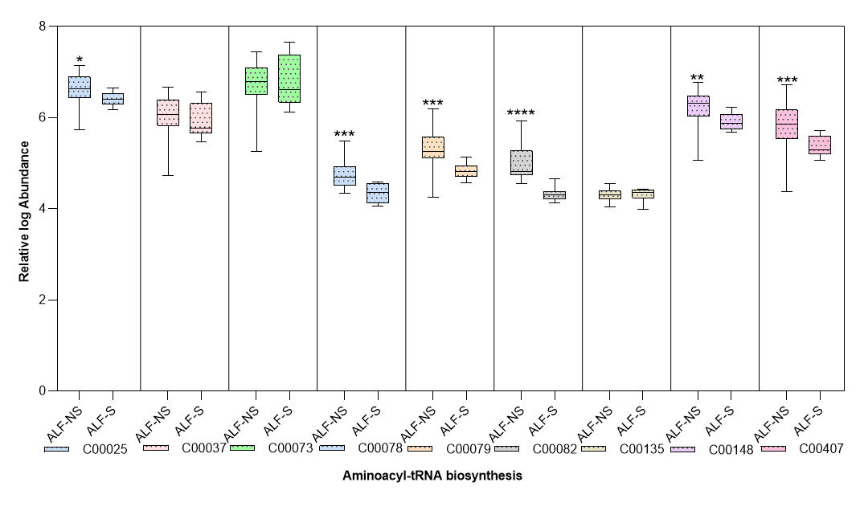
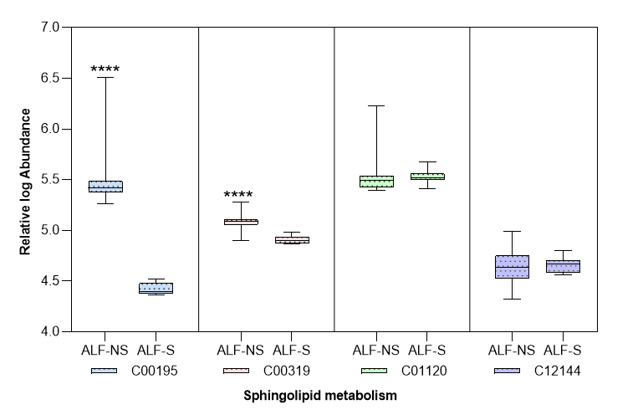
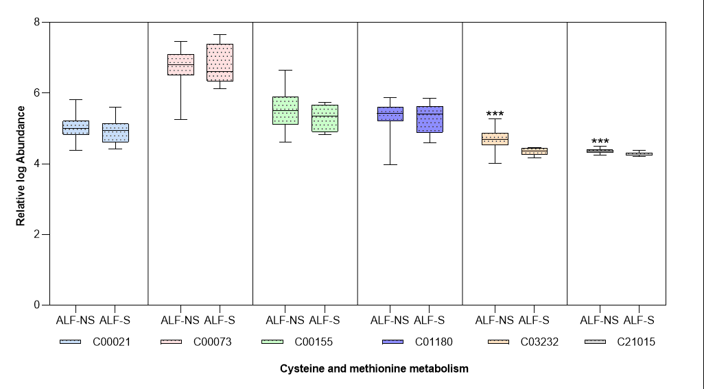

Supplementary Figure 16: POD of top 5 meta-proteome LCA AUC=1 (POD>80%)
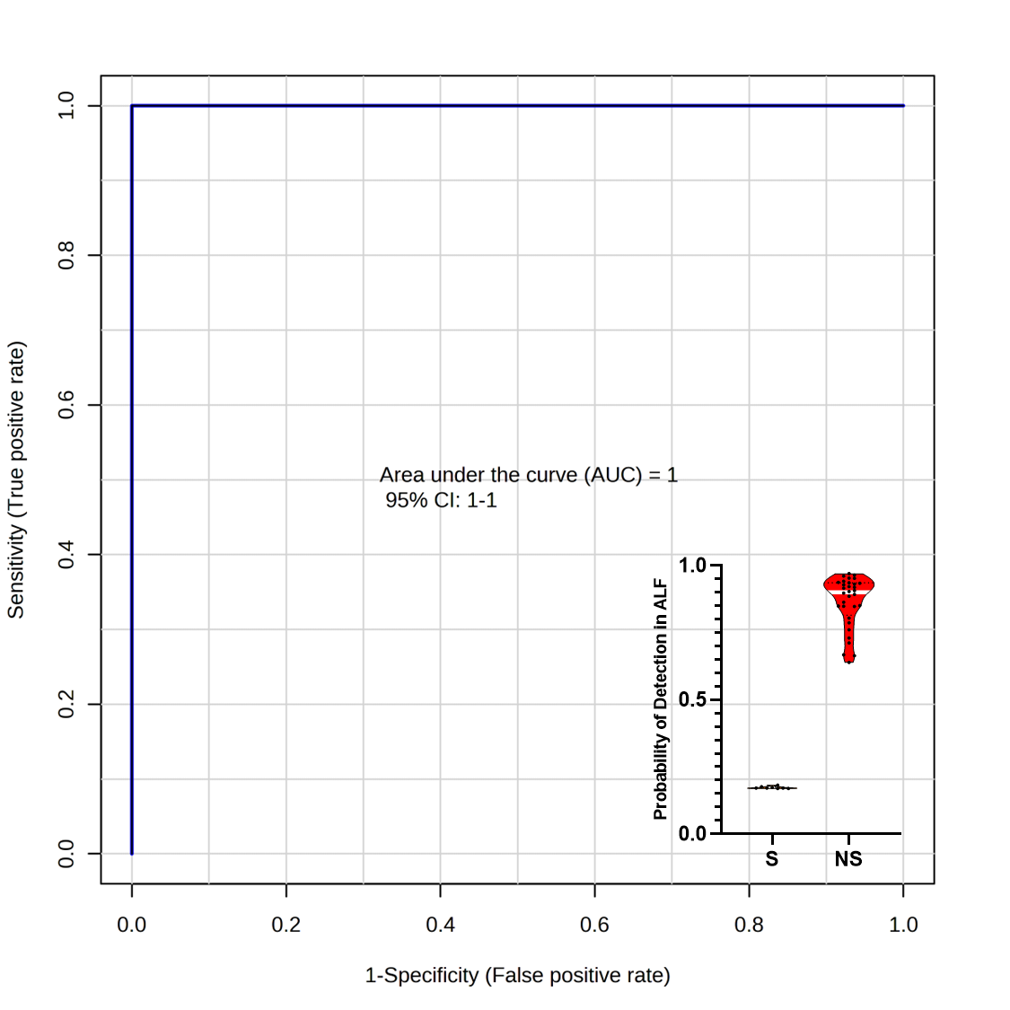

Supplementary Figure 17: Univariate and multivariate cox regression analysis
