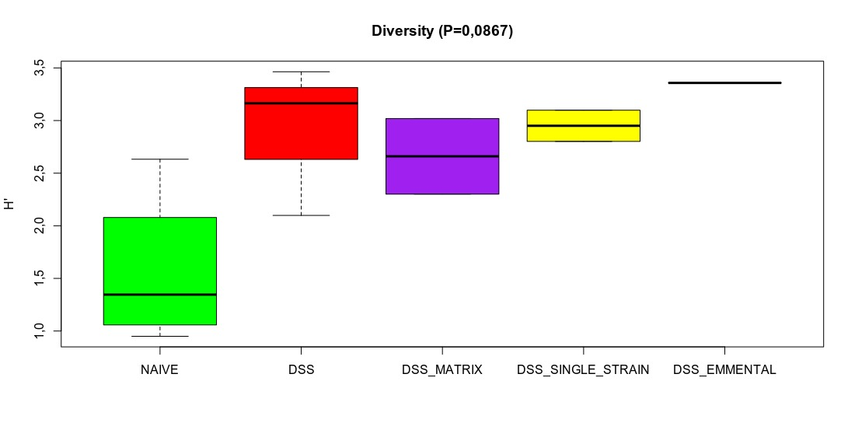

Figure S2. Beta-diversity analysis of microbiome in mice with colitis treated with cheeses. Beta-diversity analysis based on Shannon index (H’). The line inside the box plot represents the median of H′. The length of the whiskers represents 1,5 times the inter-quartile range (H′±IQR×1.5). White circles in the graph represent outliers (>1,5xIQR). One-way ANOVA followed by Tukey Pos hoc test. No statistical significance, P-value > 0.05.. The line inside the box plot represents the median of Shannon index (H′). The length of the whiskers represents 1,5 times the inter-quartile range (H′±IQR×1.5). White circles in the graph represent outliers (>1,5xIQR). One-way ANOVA followed by Tukey Pos hoc test. No statistical significance, P-value > 0.05.

