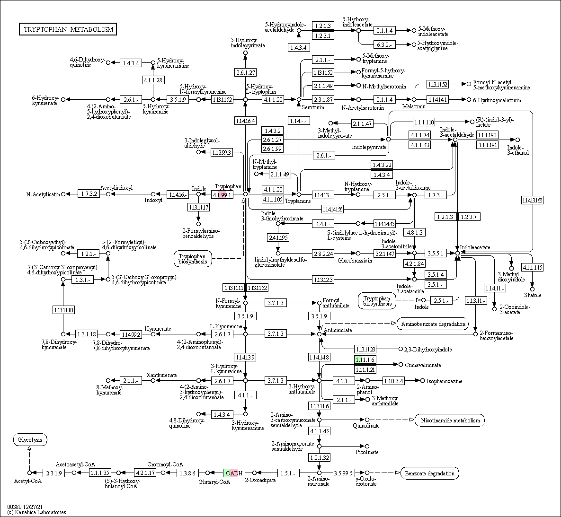
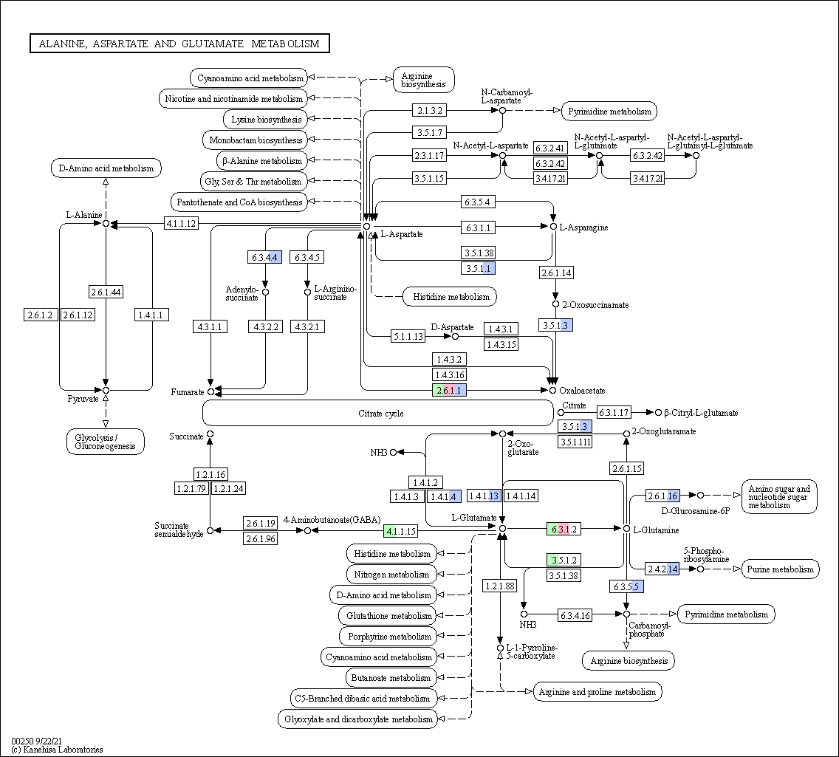
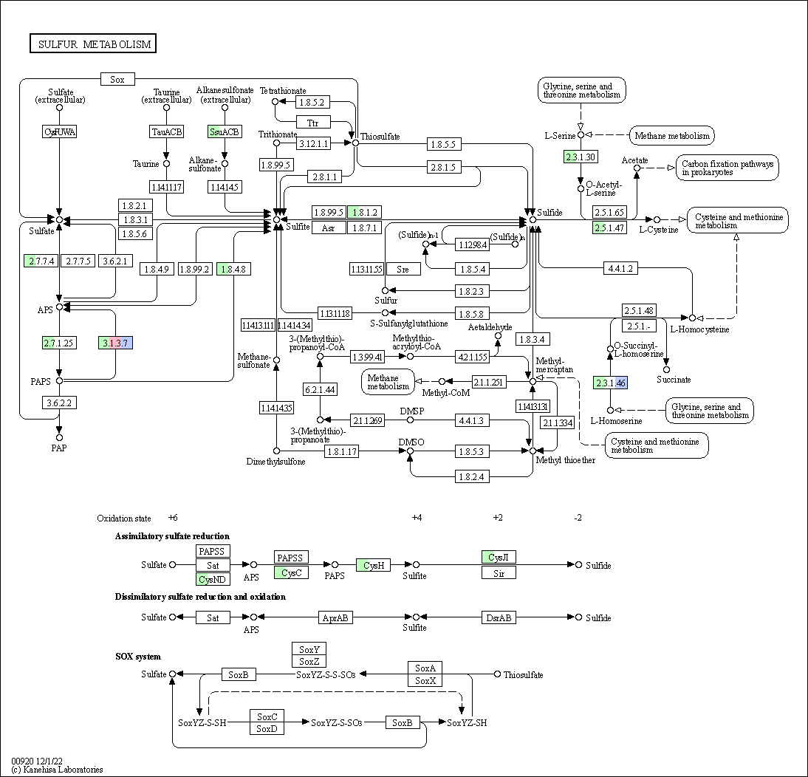

Figure S6. Other metabolic pathway reconstruction of MAGs recovered from Emmental group. The colors inside EC number boxes represent the following taxa: A. mucinlphila in green; At. dubossi in pink and M. intestinale in blue

