A
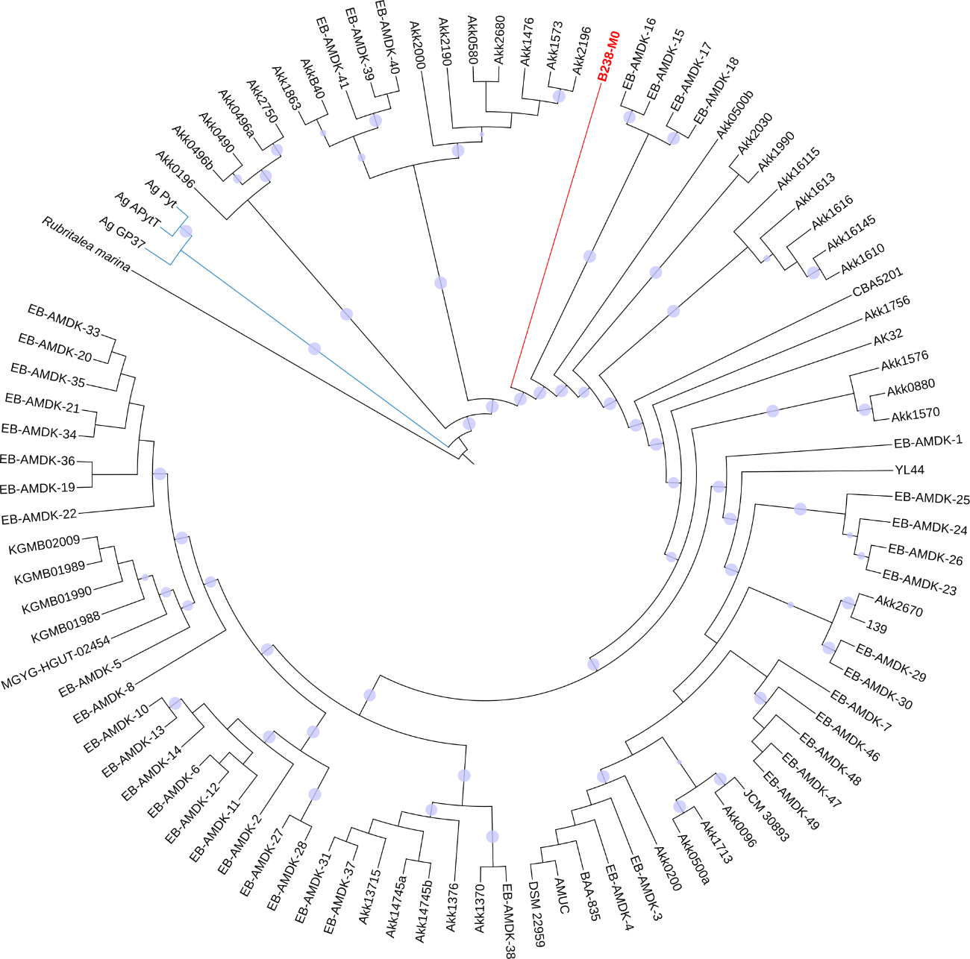

B
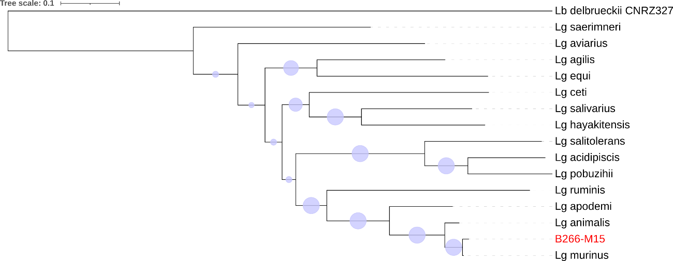

Figure S4. Maximum likelihood phylogenetic tree of selected MAGs. (A) MAG0 from Emmental group (sample B238) and a dataset of 95 Akkermansia muciniphila strains and three A. glycaniphila strains from GenBank (NCBI). Rubritalea marina was used as an outgroup. (B) Maximum likelihood phylogenetic tree of MAG15 reconstructed from DSS+Emmental group (sample B266) and 14 species from Ligilactobacillus genus from GenBank (NCBI). Lb. delbruekii CNRZ327 was used as an outgroup. The trees represents concatenated sequences of 92 bacterial orthologous gens. Bootstrap support values between 85 and 100 are represented by blue circles below the branches.

