A
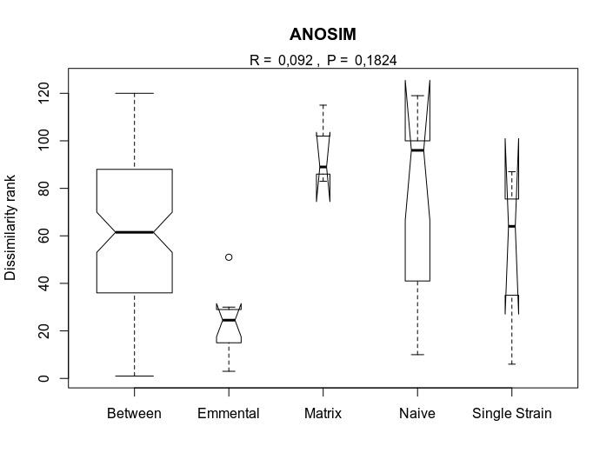
B
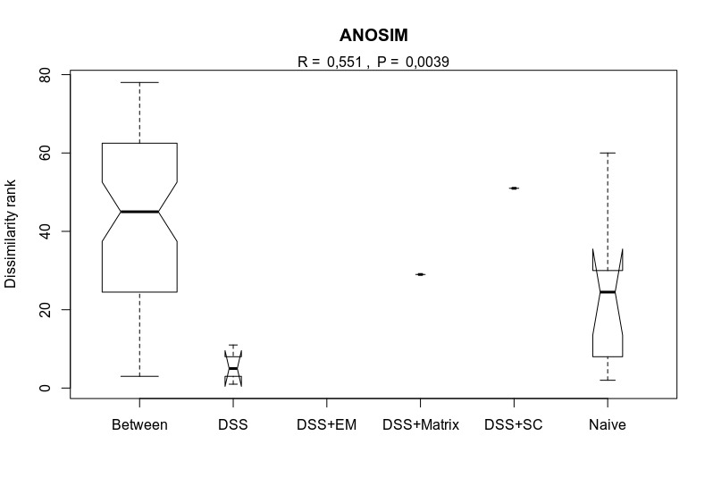
Figure S1. Analysis of similarities (ANOSIM) of number of genes in each KEEG pathway among the groups. Dissimilarity rank based on Bray-Curtis distance estimated for health mice samples in (A) and mice with colitis in (B). White circles in the graph represent outliers. R value is a ratio of the between groups variation to the within group variation. Statistical significance when P-value < 0.05.

