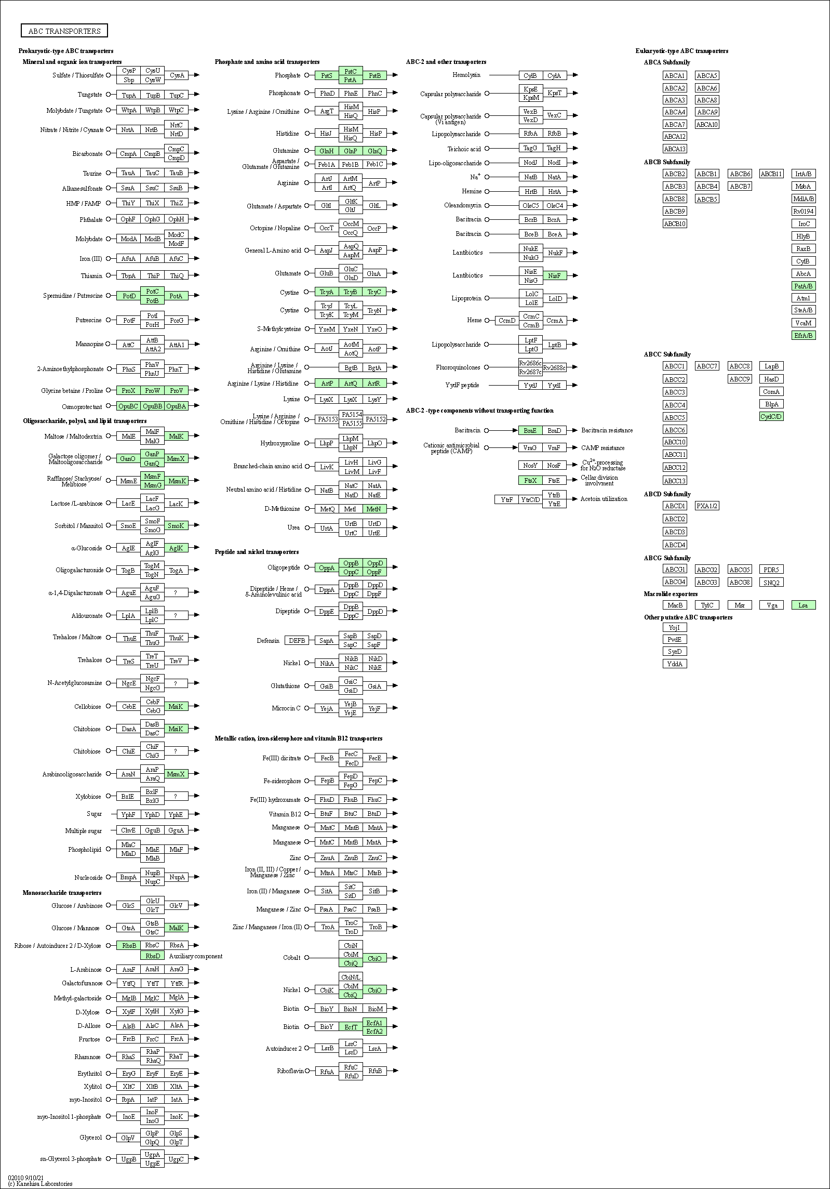

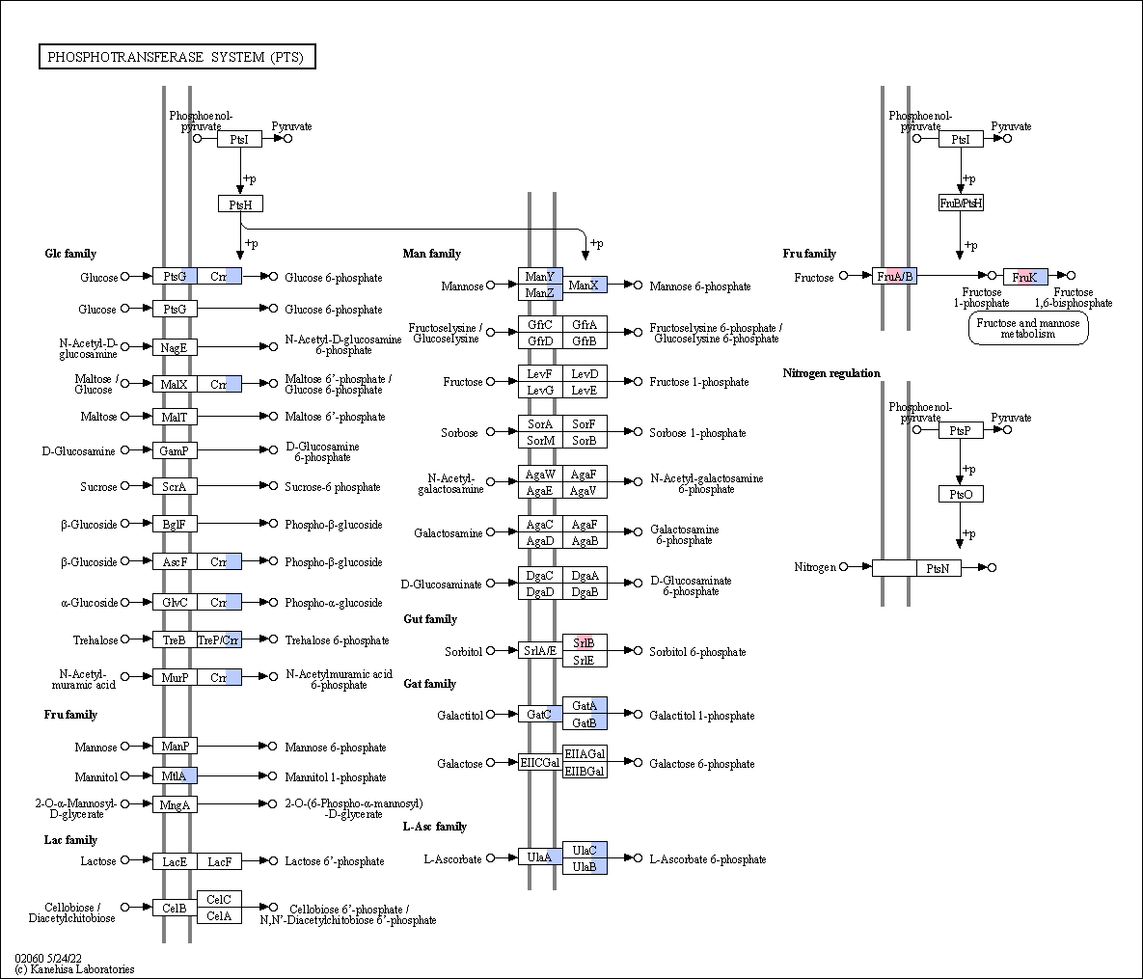

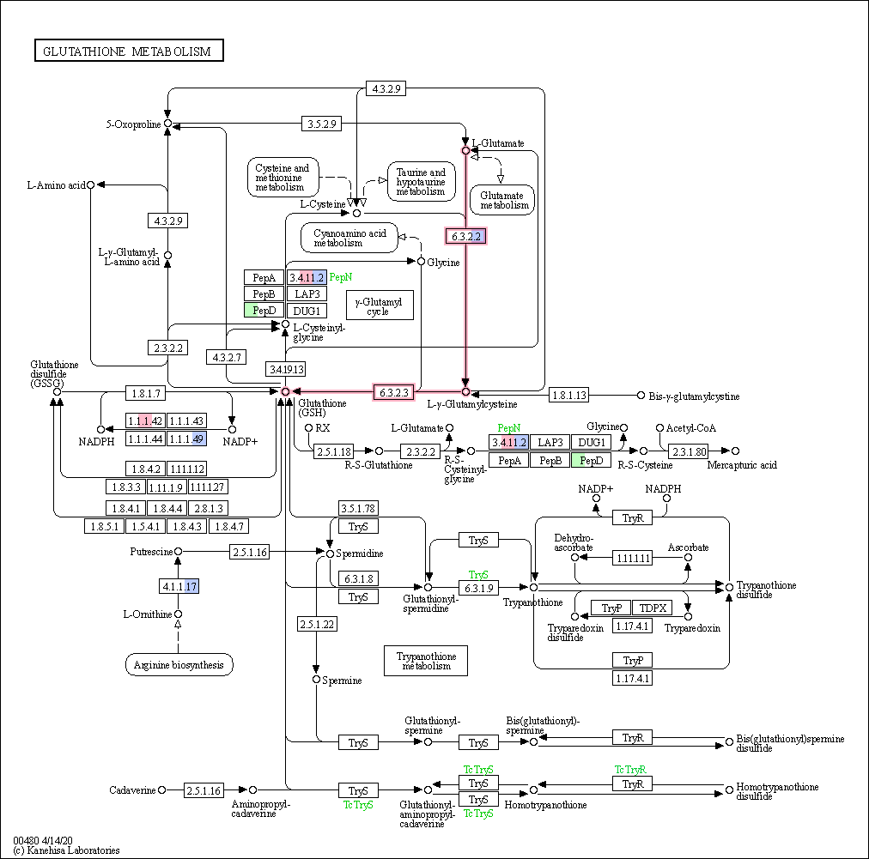
Supplementary Fig 7. Other metabolic pathway reconstruction of MAGs recovered from Emmental group. The colors inside EC number boxes represent the following taxa: D. dubossi in green; H. apodemus in pink and Lg. murinus in blue

