A
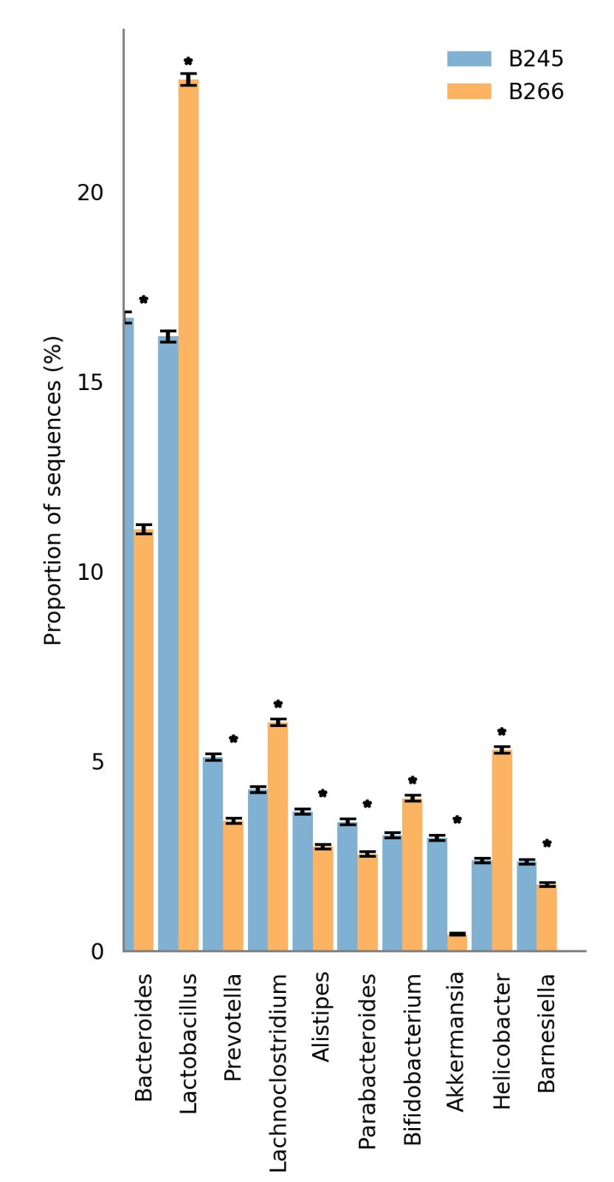

B
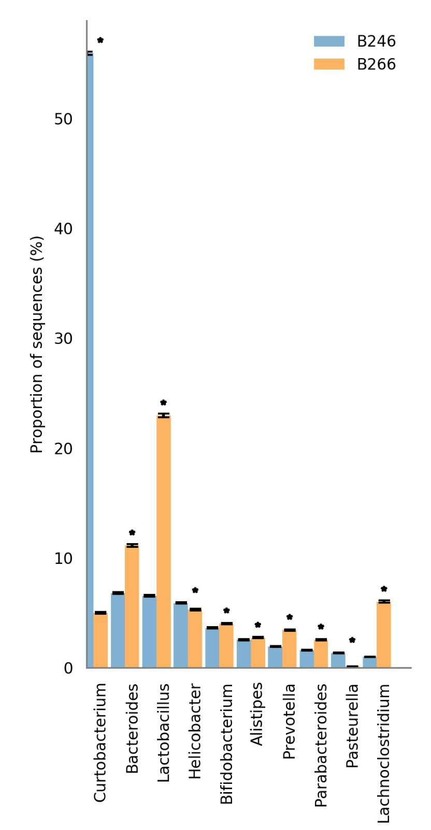
C
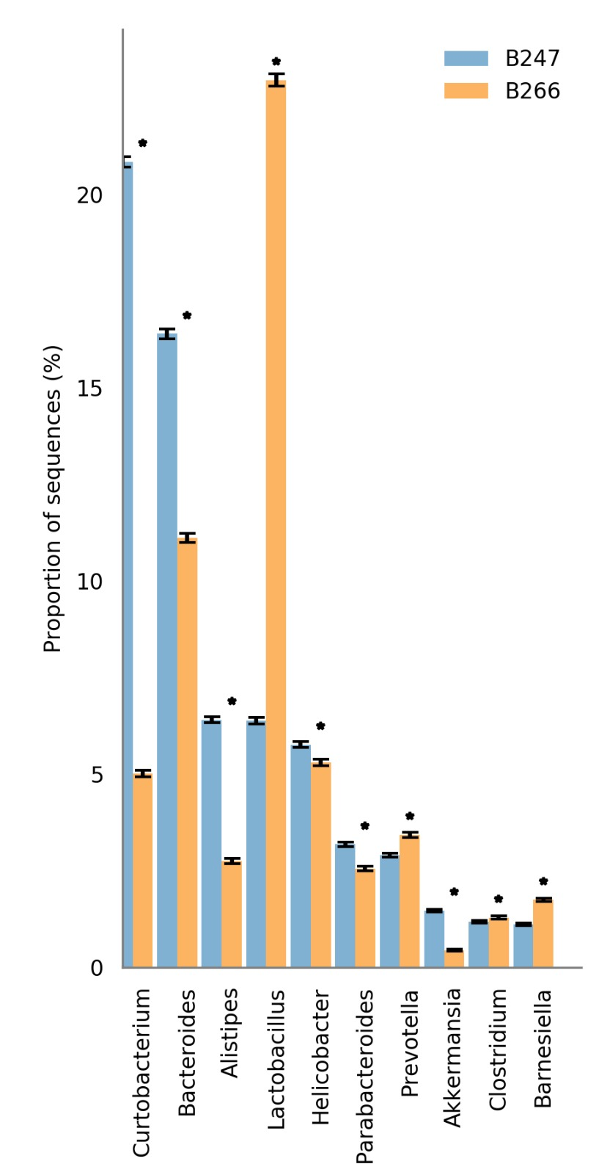
Figure S3. Microbiome taxonomy profile in mice with colitis treated with the Emmental cheese. Barplot of bacterial taxonomy showing the relative abundance between samples from DSS group and one sample from the DSS+Emmental group as follows: B245 (DSS) and B266 (DSS+Emmental) in (A); B246 (DSS) and B266 (DSS+Emmental) in (B); B247 (DSS) and B266 (DSS+Emmental) in (C). Chi-square test. Statistical significance when P-value > 0,05.

