A
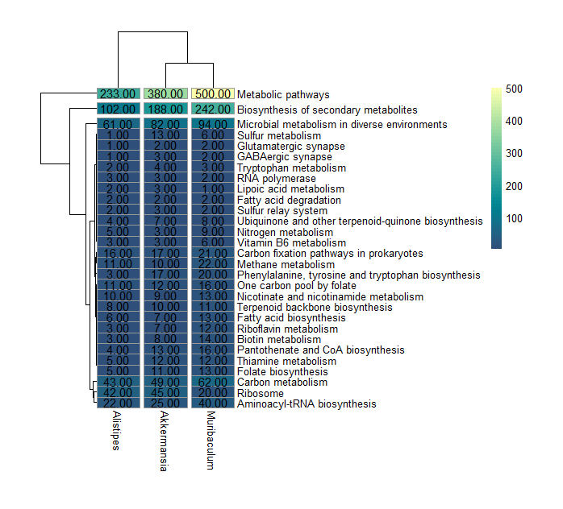

B
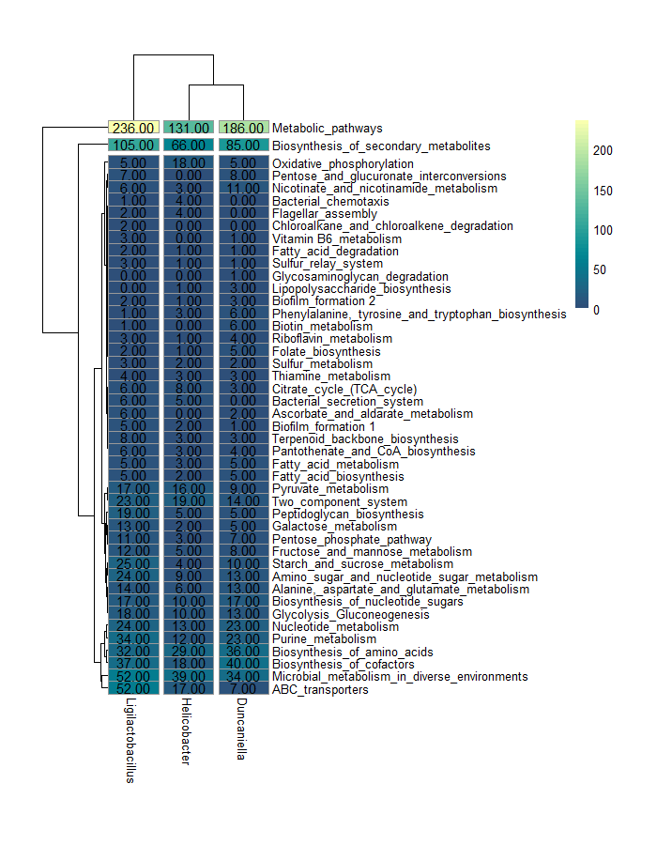

Figure S5. Heatmap plot showing the individual taxa contribution analysis. Data in the graph represents the number of genes per KEEG pathway estimated for recovered Metagenomes-assembled Genomes (MAG) in one sample from the Emmental group (A) and DSS+Emmetal group (B). Dendrogram represents a hierarchical clustering based on UPGMA method.

