TABLES
Table 1. Characteristics of subjects with ESCC.
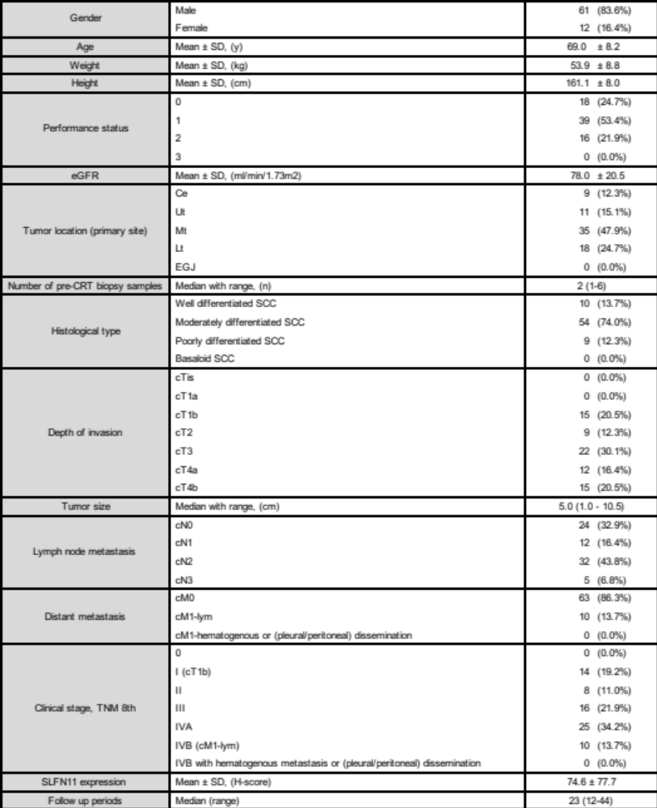Abbreviations: SD, standard deviation; eGFR, estimated glomerular filtration rate; CE, cervical esophagus; Ut, upper thoracic esophagus; Mt, middle thoracic esophagus; Lt, lower thoracic esophagus; EGJ, esophago-gastric junction; cT1a, tumor invasion to the muscularis mucosa; cT1b, tumor invasion to the submucosa; cT2, tumor invasion to the muscularis propria; cT3, tumor invasion to the adventitia; cT4a, tumor invasion to the pleura, pericardium, azygos vein, diaphragm, or peritoneum; cT4b, tumor invasion to other adjacent structures, such as the aorta, vertebral body, or trachea; cN0, no regional lymph node metastasis; cN1, metastasis in 1–2 regional lymph nodes; cN2, metastasis in 3–6 regional lymph nodes; cN3, metastasis in 7 or more regional lymph nodes; cM0, no distant metastasis; cM1-lym, distant lymph node metastasis; CRT, chemoradiotherapy; H-score, histo-score.
All values indicate n (%) unless otherwise indicated.

Table 2. Relationship between overall survival and clinicopathological variables.
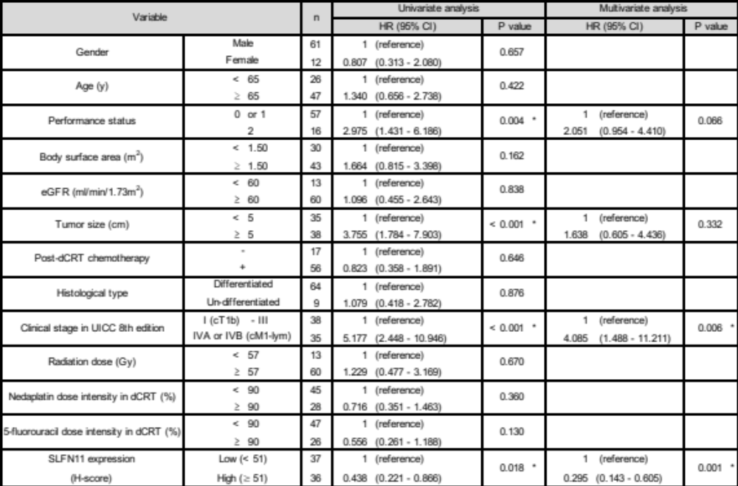Abbreviations: HR, hazard ratio; CI, confidence interval; eGFR, estimated glomerular filtration rate; cM1-lym, distant lymph node metastasis; dCRT, definitive chemoradiotherapy; H-score, histo-score.
*statistically significant.

Table 3. Relationship between SLFN11 expression level and clinicopathological variables.
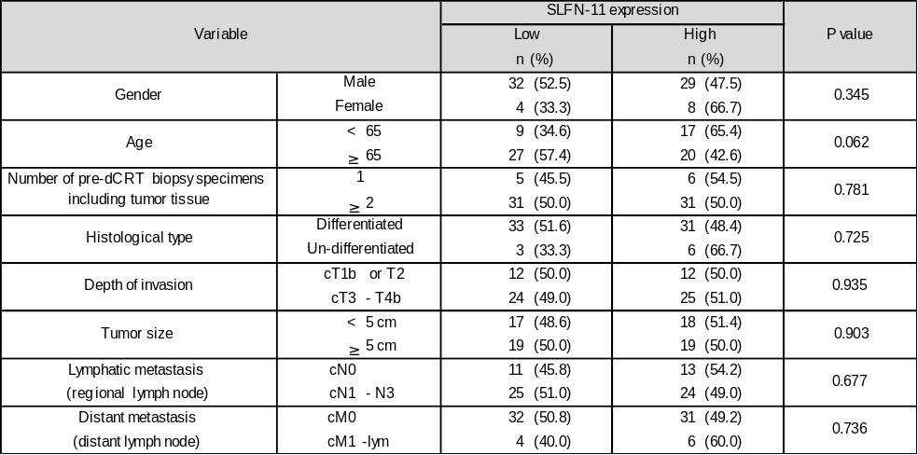
Abbreviations: CI, confidence interval; cT1b, tumor invasion to the submucosa; cT2, tumor invasion to the muscularis propria; cT3, tumor invasion to the adventitia; cT4b, tumor invades adjacent structures, such as the aorta, vertebral body, or trachea; cN0, no regional lymph node metastasis; cN1, metastasis in 1–2 regional lymph nodes; cN3, metastasis in 7 or more regional lymph nodes; cM0, no distant metastasis; cM1-lym, distant lymph node metastasis; dCRT, definitive chemoradiotherapy.

