METTL16 Mediated LncRNA TIALD m6A Modification contribute to hepatocellular carcinoma metastasis via inducing AURKA lysosomal degradation

Supplementary information

Supplementary Figure

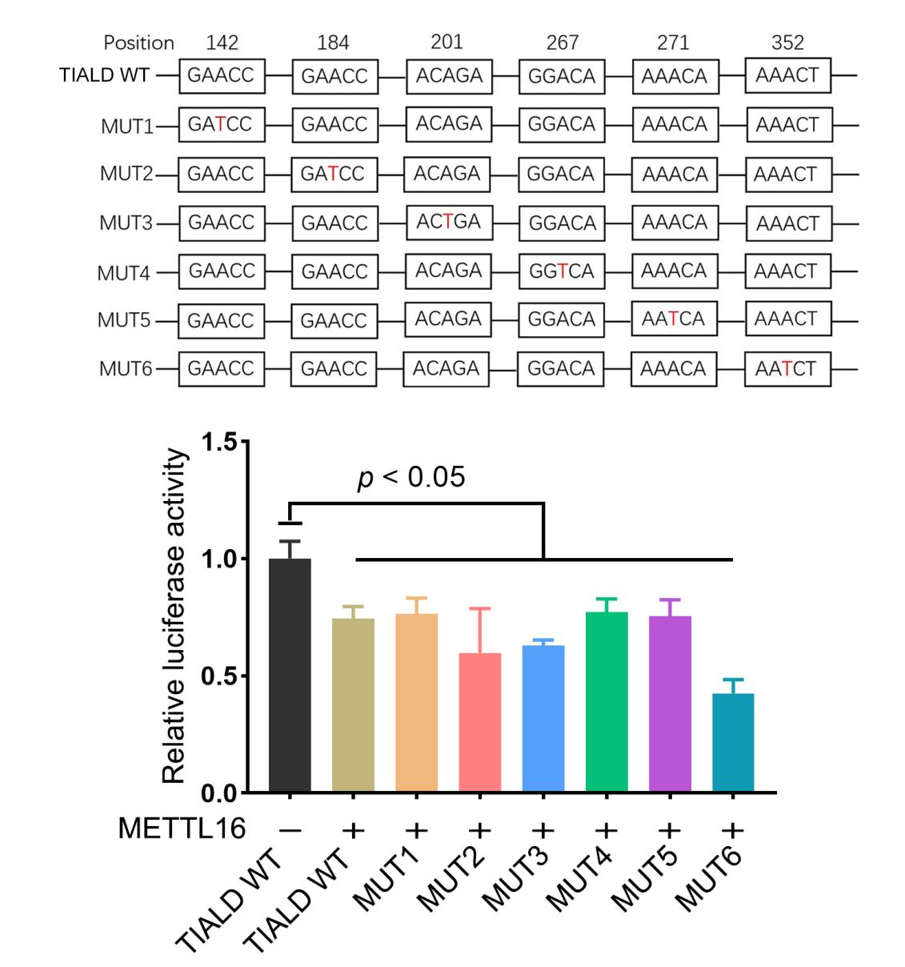
Supplementary Figure S1. Luciferase reporter assay to validate the interaction between MTTL16 and TIALD point mutations. Wild-type TIALD and with a mutation at the m6A consensus sequence were cloned into a luciferase reporter. Relative luciferase activity of the wild-type and 6 mutant TIALD reporter vectors catalyzed by METTL16.

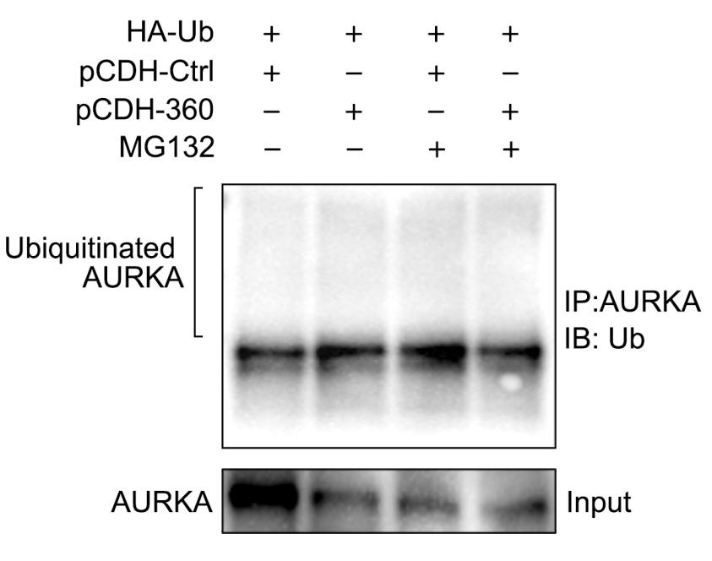

Supplementary Figure S2. Effects of TIALD on AURKA ubiquitination.

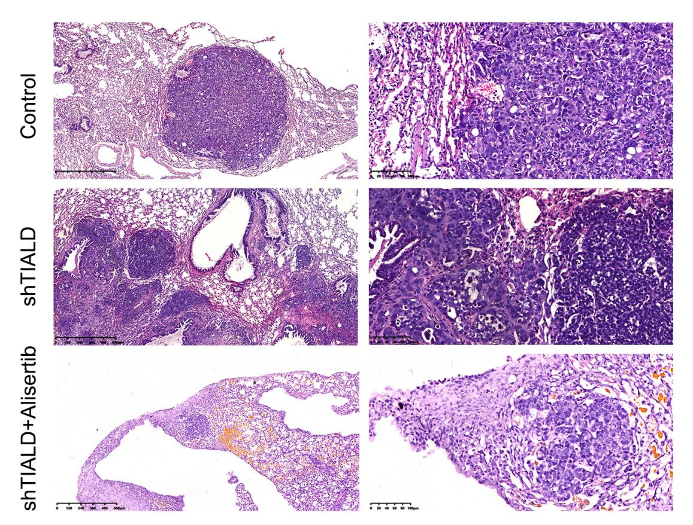
Supplementary Figure S3. Representative images of lung metastatic nodules stained with H&E.

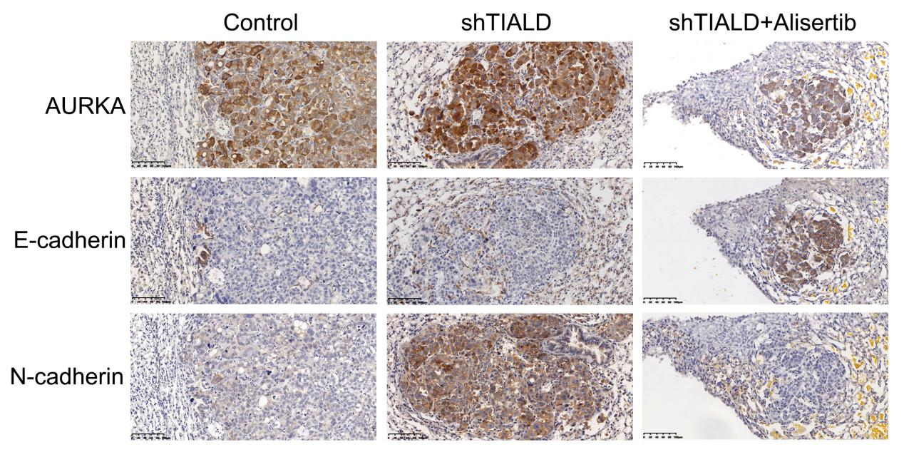
Supplementary Figure S4. Representative images of IHC staining in lung metastasis nodules of mice.

Supplementary Table

Supplementary Table S1. qPCR primer sequences

Gene symbol | Sequences (from 5’ to 3’)
TIALD | F: ATCTTCCACCTCGAACGCAA
 | R: AGGTGAGGGGACCTAGACTC
AURKA | F: GAGGTCCAAAACGTGTTCTCG
 | R: ACAGGATGAGGTACACTGGTTG
METTL16 | F: CTCTGACGTGTACTCTCCTAAGG
 | R: TACCAGCCATTCAAGGTTGCT
ALKBH5 | F: CGGCGAAGGCTACACTTACG
 | R: CCACCAGCTTTTGGATCACCA
YTHDF2 | F: GTTGGTAGCGGGTCCATTACT
 | R: GGTCTTCAGTTTAGGTTGCTGT
YTHDC1 | F: CTTCTGATGAGCAAGGGAACAA
 | R: GGCCTCACTTCGAGTGTCATAA
18S | F: AGAAACGGCTACCACATCC  R: CACCAGACTTGCCCTCCA

Gene symbol | Sequences (from 5’ to 3’)
shTIALD | Top Strand: GATCCCACCGAGGAAACGAAACTAGGAATCAAGAGTTCCTAGTTTCGTTTCCTCTTTTTG
 | Bottom Strand: AATTCAAAAAGAGGAAACGAGGAAAAACTCTCTTGATTCCTAGTTTCGTTTCCTCGGTGG
shAURKA | Top Strand:  CCGGGATGCCCTGTCTTACTGTCACTCGAGTGACAGTAAGACAGGGCATTTTTTG
Bottom Strand:
AATTCAAAAAATGCCCTGTCTTACTGTCACTCGAGTGACAGTAAGACAGGGCAT
shMETTL16 | Top Strand:  GATCCGCAACAGAAGTGGATGATATGTTCAAGAGACATATCATCCACTTCTGTTGCTTTTTT
Bottom Strand:
AGCTAAAAAAGCAACAGAAGTGGATGATATGTCTCTTGAACATATCATCCACTTCTGTTGCG
shYTHDF2 | Top Strand:  CCGGCGGTCCATTAATAACTATAACCTCGAGGTTATAGTTATTAATGGACCGTTTTTG
Bottom Strand:
AATTCAAAAACGGTCCATTAATAACTATAACCTCGAGGTTATAGTTATTAATGGACCG
shYTHDC1 | Top Strand:  CCGGTGCCTCCAGAGAACCTTATAACTCGAGTTATAAGGTTCTCTGGAGGCA TTTTTG  Bottom Strand:  AATTCAAAAATGCCTCCAGAGAACCTTATAACTCGAGTTATAAGGTTCTCTGGAGGCA
Supplementary Table S2. shRNA sequence

Gene symbol | Probe Sequences (from 5’ to 3’)
TIALD | CAACAAAAACATATAATTCAGCTCCCACCGACCC (ttt CATCATCAT ACATCATCAT)
Supplementary Table S3. FISH probe sequence

Supplementary Table S4. Univariate and multivariate cox regression analysis affecting overall survival of HCC patients
Variable | Case number | HR | 95% CI | P value
Univariate analysis
TIALD (high vs. low) | 55/55 | 2.026 | 1.053-3.899 | 0.034
Gender(female vs. male) | 20/90 | 0.532 | 0.258-1.096 | 0.087
Age, years (≥55 vs.＜55) | 51/59 | 0.518 | 0.266-1.010 | 0.054
Tumor size, cm (≥5 vs.＜5) | 52/58 | 3.996 | 1.985-8.044 | <0.001
Tumor number (multiple vs. single) | 3/107 | 0.844 | 0.116-6.150 | 0.867
AFP, ng/mL (≥400 vs.＜400) | 33/77 | 2.541 | 1 .349-4.788 | 0.004
Vascular invasion (yes vs. no) | 55/55 | 4.234 | 2.008-8.925 | <0.001
Tumor capsule (complete vs. none) | 92/18 | 3.830 | 1.956-7.500 | <0.001
TNM stage(III-IV vs. I-II) | 25/85 | 3.845 | 2.020-7.319 | <0.001
Tumor differentiation (III-IV vs. I-II) | 78/32 | 2.871 | 1.202-6.859 | 0.018
Multivariate analysis
TIALD (high vs. low) | 55/55 | 2.237 | 1.105-4.528 | 0.025
Tumor size, cm (≥5 vs.＜5) | 52/58 | 2.699 | 1.221-5.694 | 0.014
Vascular invasion (yes vs. no) | 55/55 | 2.382 | 0.986-5.754 | 0.054
Tumor capsule (complete vs. none) | 92/18 | 2.679 | 1.318-5.447 | 0.006

