Supplementary information for
Reg family proteins contribute to inflammation and pancreatic stellate cells activation in chronic pancreatitis
Wenting Chen, Mai Imasaka, Miyu Lee, Hirokazu Fukui, Hiroshi Nishiura, Masaki Ohmuraya

Corresponding author: Masaki Ohmuraya
Email: ohmuraya@hyo-med.ac.jp

Supplementary Table 1. Primer Sequences for qRT-PCR
Genes | Forward primer (5′-3′) | Reverse primer (5′-3′)
Il1b  Il6  Rps3  Tnfa | AGGTCGCTCAGGGTCACAAG  CCACTTCACAAGTCGGAGGCTTA  ATCAGAGAGTTGACCGCAGTTG  CATCTTCTCAAAATTCGAGTGACAA | GTGCTGCCTAATGTCCCCTTGAATC  GCAAGTGCATCATCGTTGTTCATAC  AATGAACCGAAGCACACCATAG  TGGGAGTAGACAAGGTACAACCC

Supplementary Table 1. Primer Sequences for qRT-PCR. Interleukin (Il), tumor necrosis factor (Tnf), ribosomal protein S (Rps).

Supplementary Figures and Figure legends
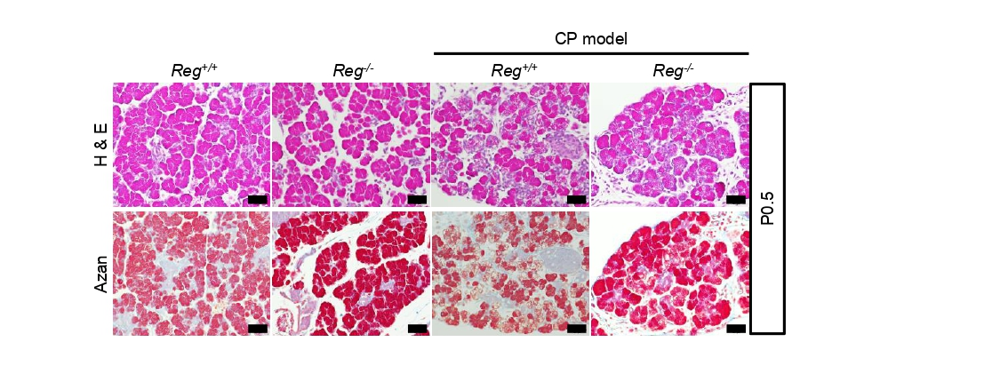
Supplementary Fig.1 Hematoxylin and eosin （H&E）or Azan (for collagen) stained pancreatic tissue sections at 0.5 day after birth（P0.5）from mice of indicated genotype (n=3-4 mice). Scale bar:50μm.

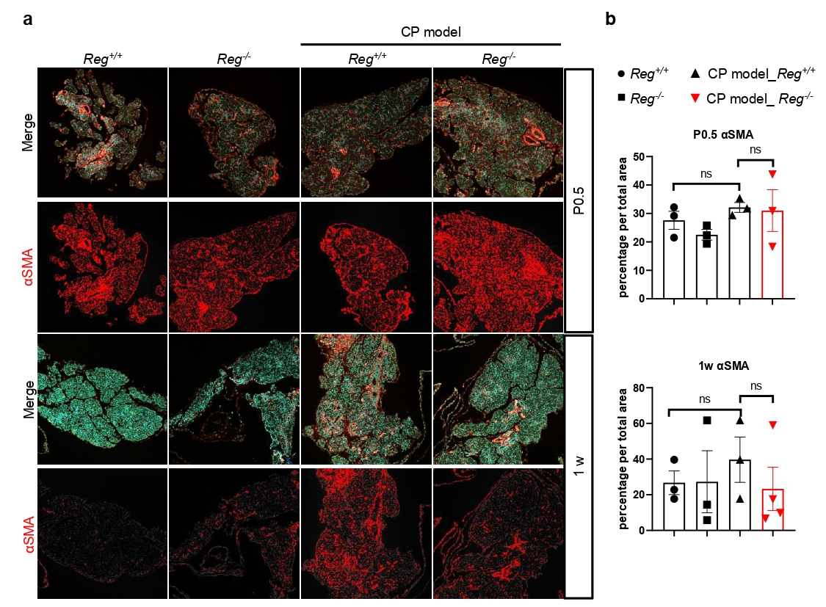
Supplementary Fig.2 (a)Immunofluorescence analysis of alpha-smooth muscle actin (αSMA, an activated PSCs marker, red) in the pancreas sections of indicated genotypes at 0.5 day after birth (P0.5) and 1 week (n=3-4 mice). Nuclei were counterstained by DAPI (blue). (b)The percentage of epithelial cells with αSMA positive signals. Results represent mean ± SEM (n=3-4 mice). Statistical analysis was performed by one-way ANOVA with Tukey’s multiple comparison tests among four groups. ns: not significant

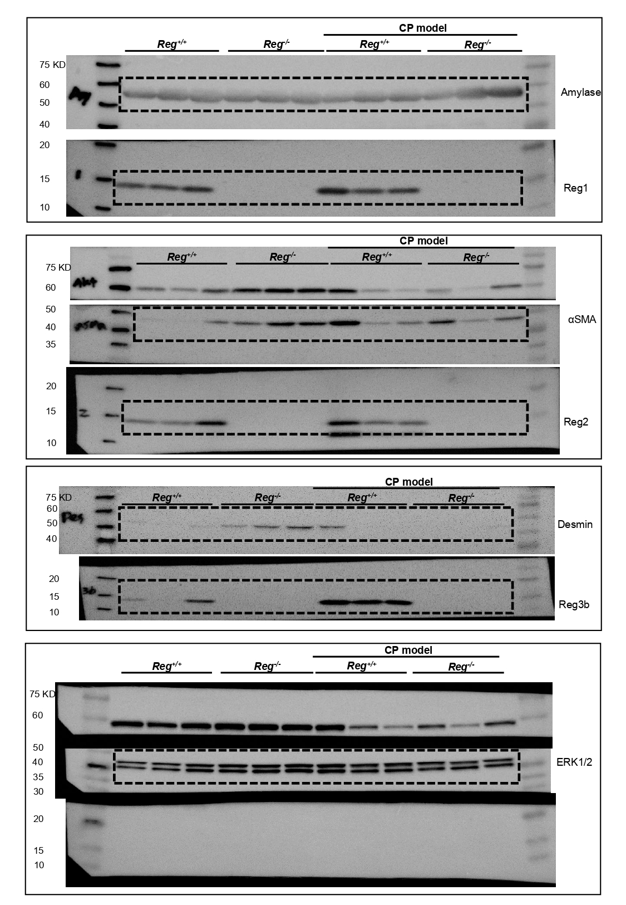
Supplementary Fig.3 Images of the entire western blots for Fig.5c at P0.5. Dashed line indicated cropped part of each protein.

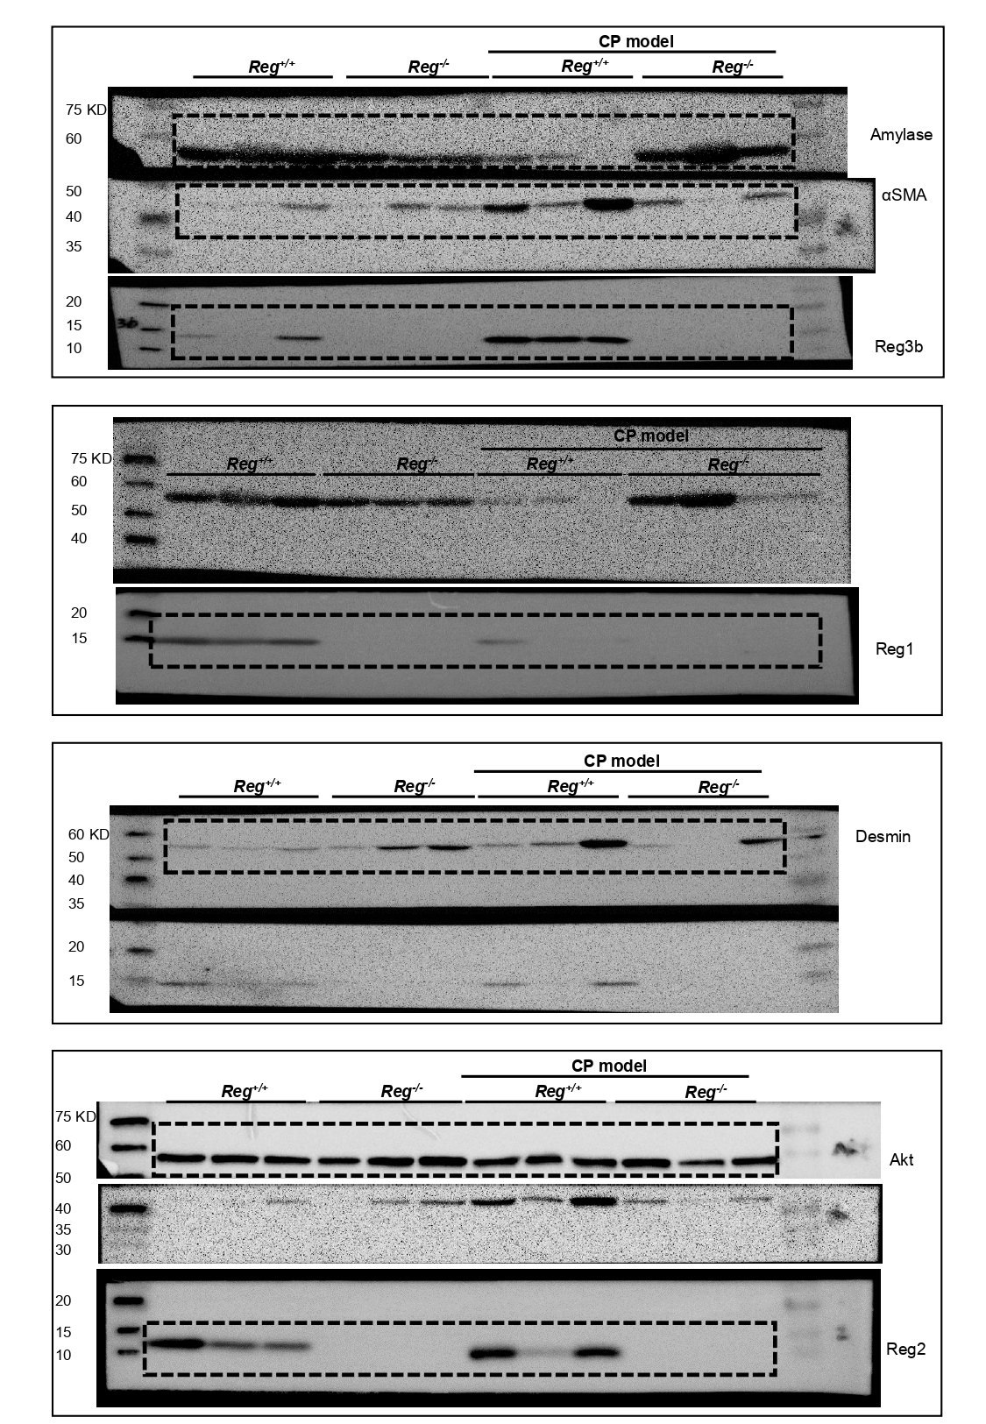
Supplementary Fig.4 Images of the entire western blots for Fig.5c at 1w. Dashed line indicated cropped part of each protein.
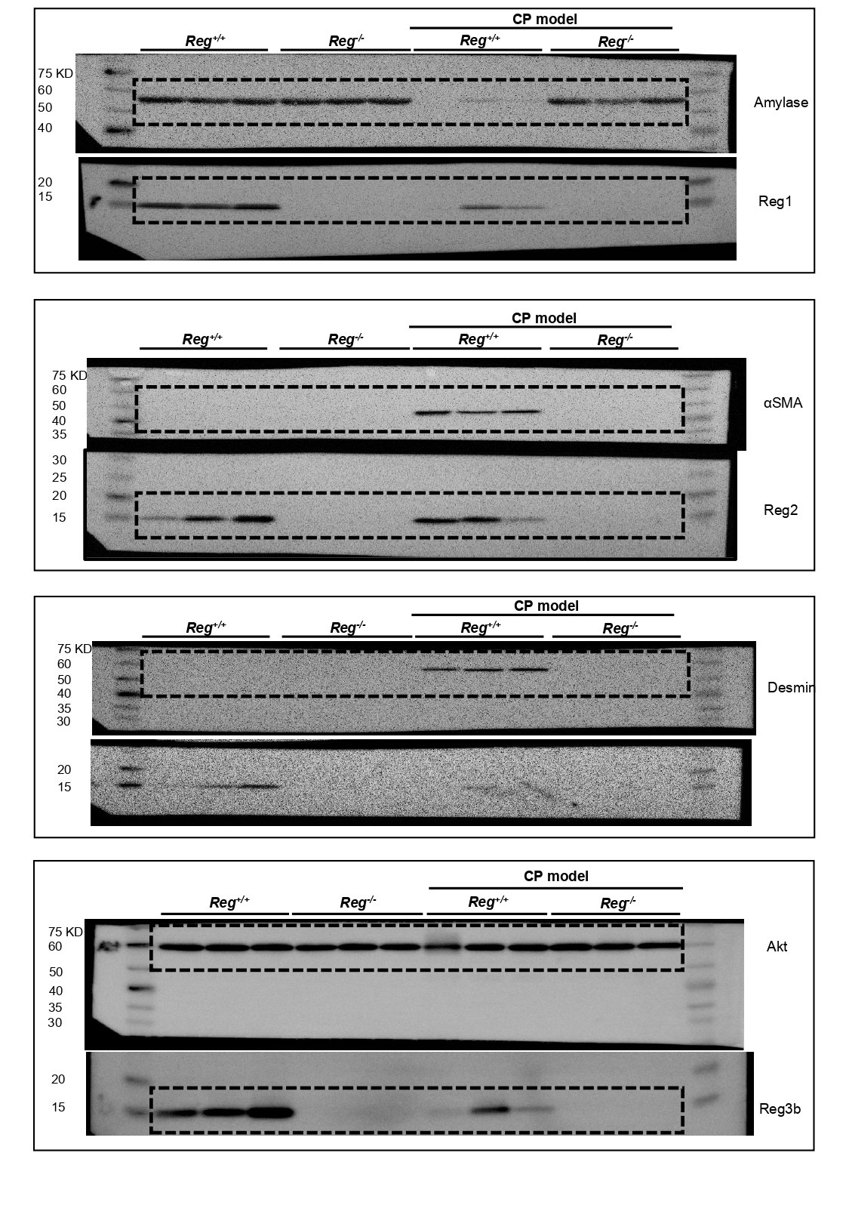
Supplementary Fig.5 Images of the entire western blots for Fig.5c at 4w. Dashed line indicated cropped part of each protein.

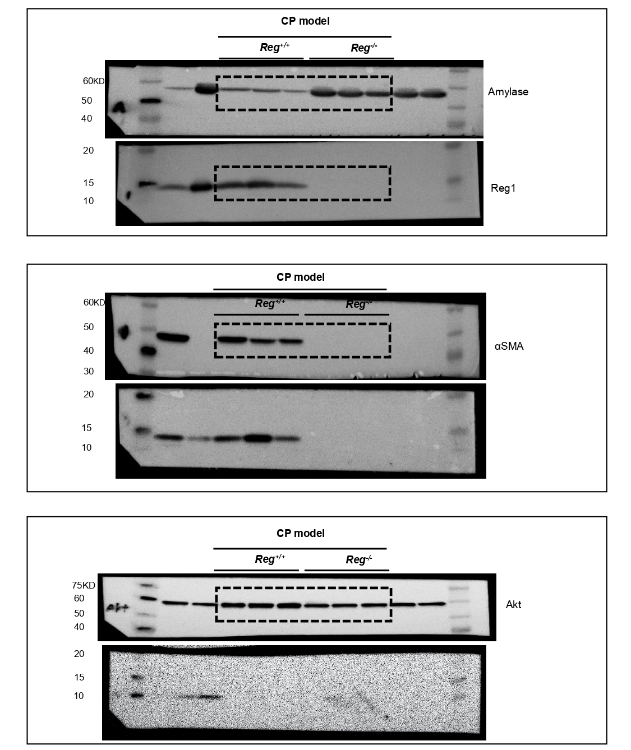
Supplementary Fig.6 Images of the entire western blots for Fig.6c. Dashed line indicated cropped part of each protein.

