Extended data

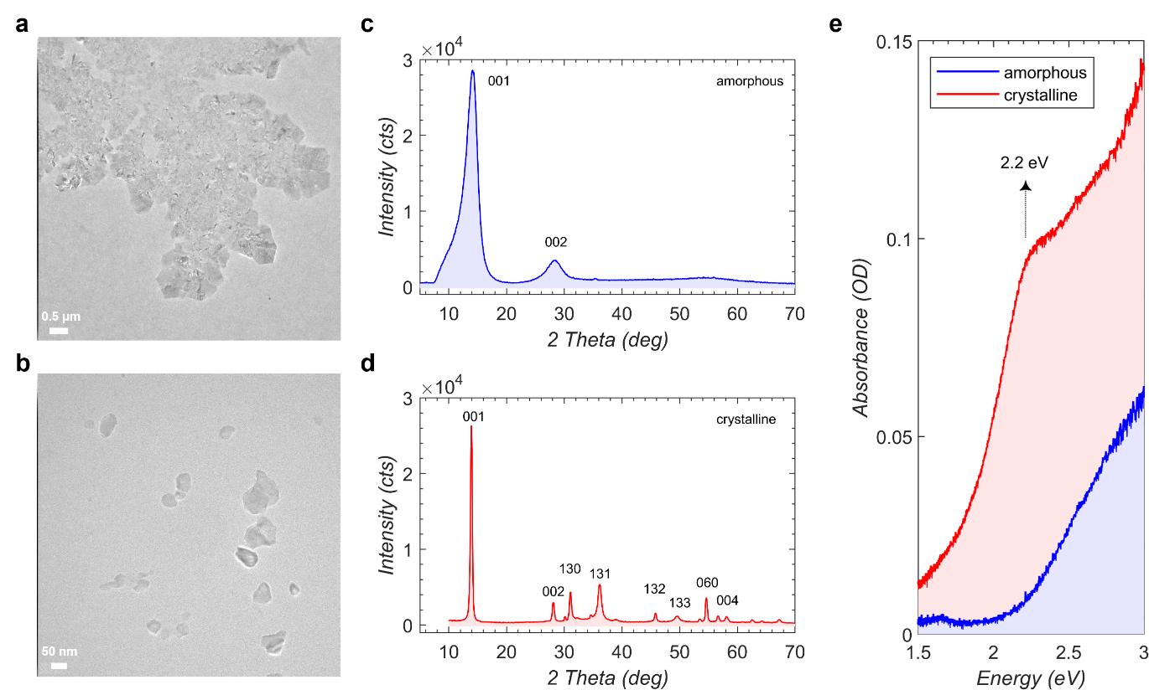
Extended Data Fig. 1 TEM, XRD and absorption spectra of amorphous and crystalline nanoflakes.
(a,b) TEM images of nanoflakes in amorphous and crystalline phases respectively. Size range of crystalline nanoflakes is 20-100 nm. (c,d) XRD obtained from amorphous and crystalline nanoflakes of NiPS₃. (e) Absorption spectra of amorphous and crystalline nanoflakes of NiPS₃. Crystalline sample shows a pronounced peak around 2.2 eV.

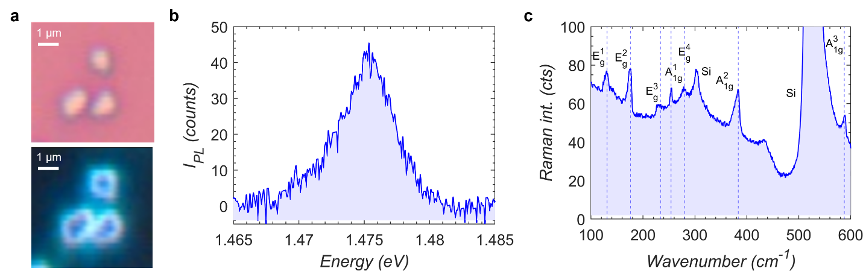
Extended Data Fig. 2 Spin-orbit entangled exciton emission in micrometer-sized flakes.
(a) Bright field and dark field images of ~1 μm lateral size bulk flakes of NiPS₃ prepared by micro-mechanical exfoliation technique. (b) PL of the flake showing the spin-orbit entangled exciton emission at ~1.475 eV. (c) Raman signal of respective flake.

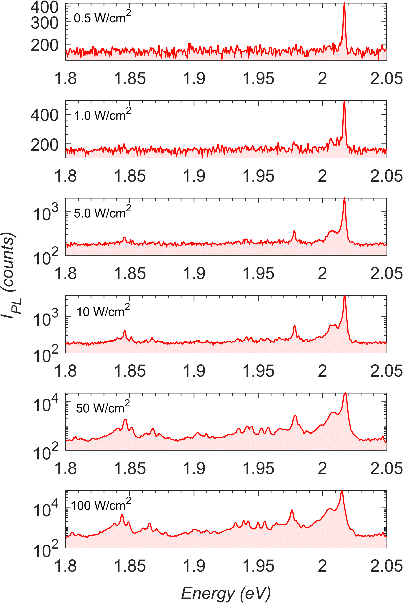
Extended Data Fig. 3 Excitation power dependence of PL in a nanoflake.
PL from a nanoflake under different excitation power density. Low energy tail peaks become visible at higher excitation power density.

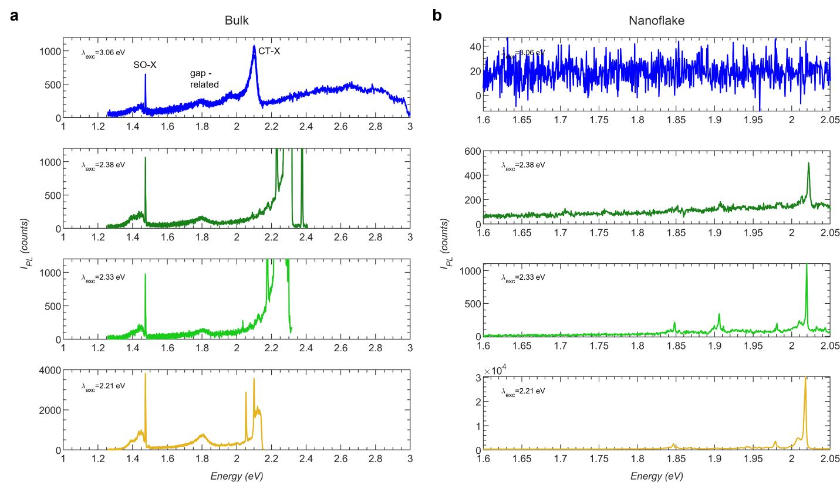
Extended Data Fig. 4 Excitation laser energy dependence of PL in bulk & a nanoflake.
PL collected with different excitation laser energies under confocal excitation with a diffraction limited spot size for (a) bulk and (b) a nanoflake NiPS₃ with the same power density of about 70 W/cm². Higher energy excitation at 3.06 eV for bulk has the SO-X exciton at 1.47 eV whose peak PL intensity is weaker than another peak at 2.1 eV. Since this peak energy falls in the charge-transfer peak region reported for NiPS₃, we assign it to a charge-transfer exciton (CT-X). CT-X has a side peak at 1.95 eV. Another peak at 1.8 eV is also observed which we assign to an exciton related to bandgap of NiPS₃. Under lower energy excitations between 2.38 eV and 2.21 eV, the CT-X peak at 2.1 eV is vanished leaving the SO-X at 1.47 eV and gap-related peak at 1.8 eV. Nanoflakes do not have SO-X exciton but only has the peak in visible region that becomes stronger for near-resonant excitation closer to charge-transfer state at 2.2 eV.

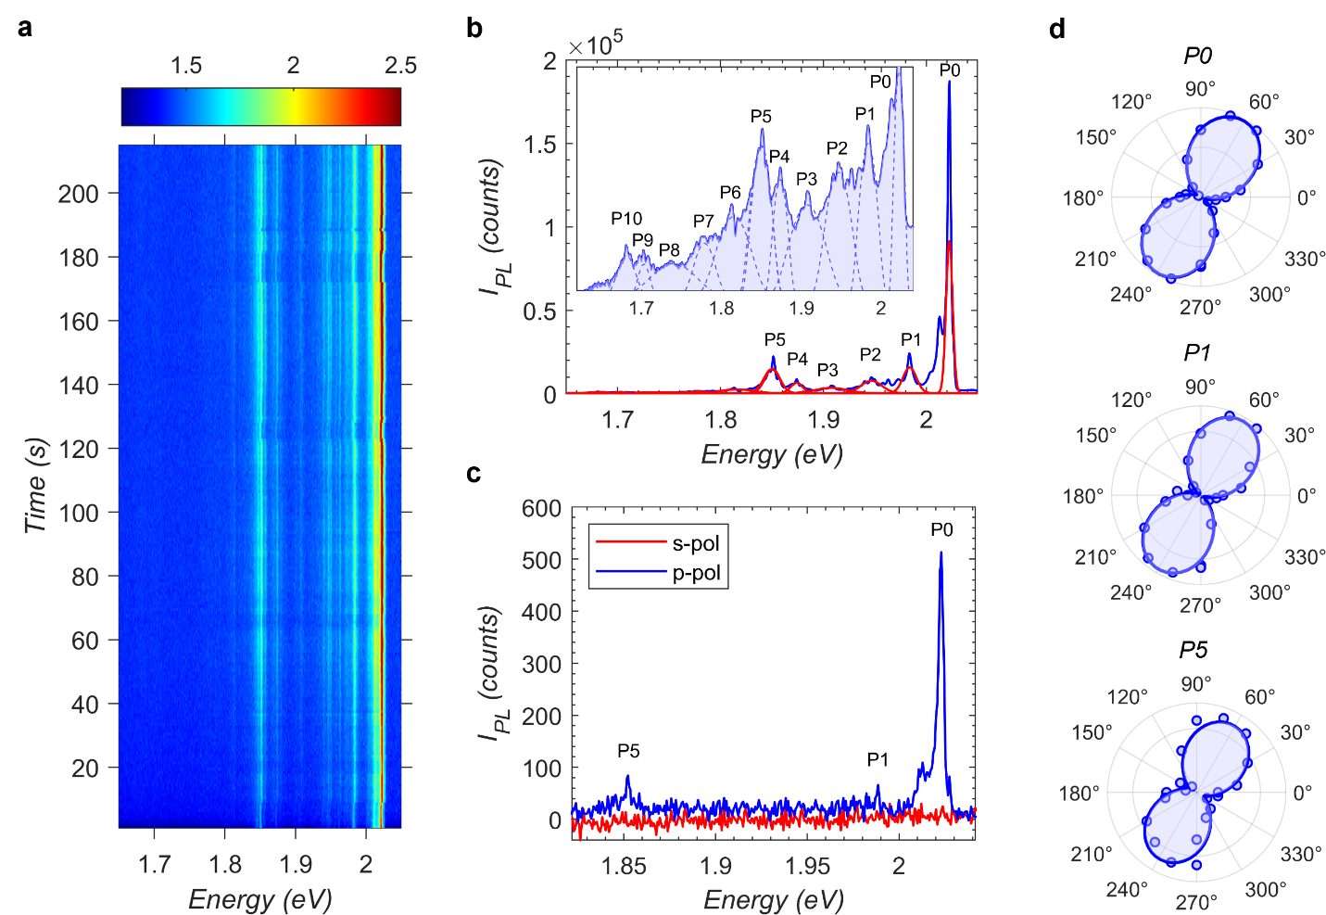
Extended Data Fig. 5 Low energy tail PL peaks follow the main PL peak in a nanoflake.
(a) A time dependent spectral image sequence of PL collected from a nanoflake with 1s each acquisition. This shows the low energy tail peaks following the direction of main peak. (b) Integrated spectrum of the same nanoflake showing the main peak P0 and 10 low energy tail peaks labelled from P1 to P10. Inset shown in log plot. (c) Polarization resolved spectra of the same nanoflake with 3 peaks P0, P1 and P5 visible. (d) Polarplot of the respective peaks displaying a strong linear polarization oriented in the same direction.

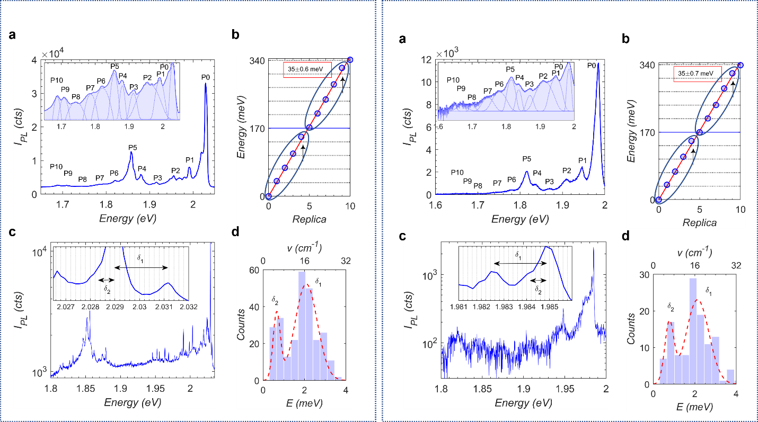
Extended Data Fig. 6 Low- and high-resolution spectra of 2 different nanoflakes.
(a) Low-resolution spectrum of a nanoflake showing the main peak P0 and 10 low energy tail peaks labelled from P1 to P10. Inset shown in log plot. (b) Tail peak positions from the central emission energy of P0 fitted with a linear function giving a slope of ~35 meV. Arrows show that P4 and P9 slightly deviate from the linear function. Ellipsoid shows the pattern of P0-P4 repeats at P5-P9. (c) High-resolution spectrum of the same nanoflake. Inset shows a zoomed-in portion with noticeable equidistant consecutive peak separations marked as δ1 and δ2. (d) Histogram of consecutive peak difference gives a value of ~2 meV for δ1 and ~0.7 meV for δ2.

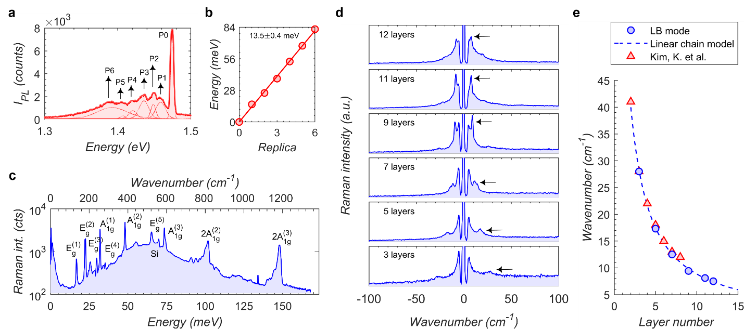
Extended Data Fig. 7 Exciton-phonon bound states & Raman phonon modes in bulk NiPS₃.
(a) PL spectrum from a bulk NiPS₃ showing the spin-orbit entangled exciton peak P0 at 1.475 eV and 6 low energy tail peaks marked as P1 to P6. (b) Tail peak positions from the central emission energy of P0 fitted with a linear function giving a slope of ~13.5 meV. (c) High frequency Raman phonon modes from a 12-layer thick NiPS₃. (d) Low frequency Raman phonon mode for specified layer thicknesses. Arrows point the position of LB mode. (e) LB mode dependence to layer number is fitted with a linear chain model. All data are collected at 4.2 K. Data of Kim, K. et al. obtained from Nat Commun 10, 345 (2019).

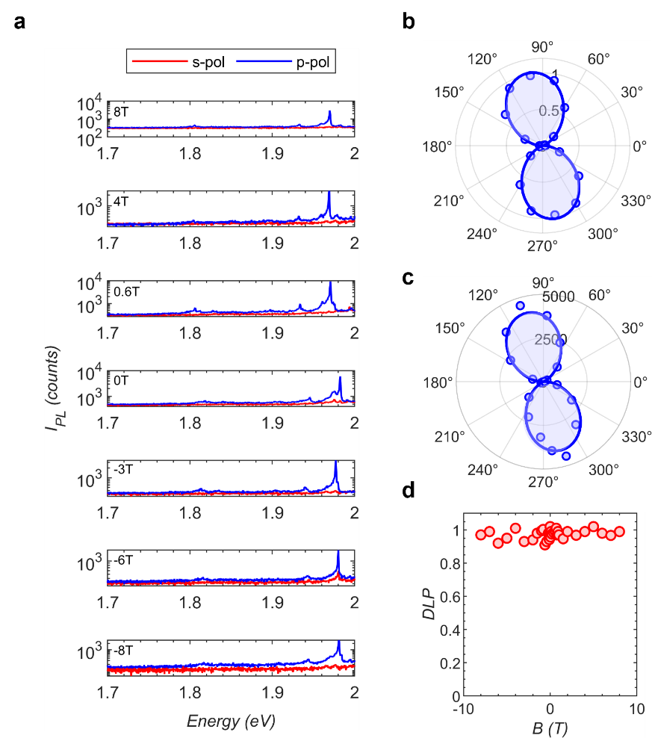
Extended Data Fig. 8 Magnetic field dependence of PL in a nanoflake.
(a) Polarization resolved spectra of a nanoflake at different magnetic fields from -8T to 8T under Faraday geometry. Polar plot showing strong linear degree of polarization under both (b) detection & (c) excitation polarization analysis. (d) Linear polarized emission is observed from -8T to 8T.

