Supplementary Materials for

Impact of Climate on Tea Production: A Study of the Dooars Region in India
Piyashee Mallik* and Tuhin Ghosh
School of Oceanographic Studies, Jadavpur University, Kolkata 700032, India
*Corresponding author: piyasheemallik@gmail.com, (+91) 9123329175, ORCID id: 0000-0003-4127-9733

Supplementary Fig. 1 Marginal effects of (a) monthly minimum average temperature; and (b) monthly precipitation on tea yield (logarithmic scale) for summer season. X-axis on each graph spans the range of minimum temperature and precipitation values observed during the summer months (March-May). (c) Marginal effect of monthly precipitation on tea yield (logarithmic scale) for monsoon season. The X-axis covers the range of values for total precipitation observed during the monsoon months (June-August). Marginal effects of (d) monthly precipitation; (e) monthly maximum average temperature; and (f) monthly minimum average temperature on tea yield (logarithmic scale) for winter season. The X-axis on each graph covers the range of maximum and minimum temperature and precipitation values observed during the winter months (October-December). In (a)-(f), the Y-axis shows the predicted log yield and the shaded regions represent 95% confidence interval. Three lines corresponding to different values of square of temperature and precipitation ranges are displayed

Supplementary Fig. 2 Marginal effects of one month-lagged climatic variables - (a) maximum average temperature; (b) minimum average temperature; and (c) precipitation on tea yield (logarithmic scale) for summer season. X-axis on each graph spans the range of maximum and minimum temperature and precipitation values observed during the summer months. Marginal effects of one month-lagged climatic variables - (d) precipitation; and (e) maximum average temperature on tea yield (logarithmic scale) for monsoon season. The X-axis covers the range of values for total precipitation and maximum temperature observed during the monsoon months (June-August). Marginal effects of one month-lagged climatic variables - (f) maximum average temperature; (g) monthly minimum average temperature; and (h) precipitation on tea yield (logarithmic scale) for winter season. The X-axis on each graph covers the range of maximum and minimum temperature and precipitation values observed during the winter months. In (a)-(h), the Y-axis shows the predicted log yield, and the shaded regions represent 95% confidence interval. Three lines corresponding to different values of square of temperature and precipitation ranges are displayed
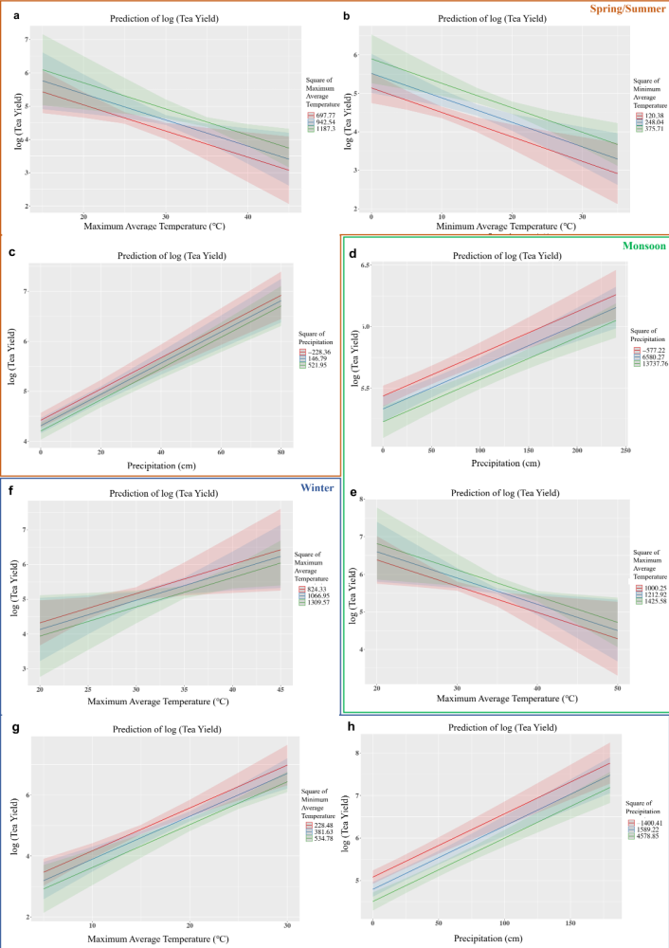

Supplementary Table 1: Regression coefficients to analyze the impact of drought intensity on the monthly tea yield (logarithmic scale)
Parameter | Pooled | April | May | June | July | August | September | October
Drought  Index | 1.592e-03 (3.475e-03) | -0.00894 (0.02441) | -0.03370 * (0.01575) | -0.007272 (0.01062) | -0.0019537 (0.0057745) | 0.007535 (0.009352) | 0.005718 (0.005696) | -0.002439 (0.00792)
Standard errors in parentheses
Notes: ‘***’ P < 0.001, ‘**’ P < 0.01, ‘*’ P < 0.05, ‘^’ P < 0.1

Supplementary Table 2: Projected change in seasonal average maximum and minimum temperature, and precipitation compared to current values

Time  Period | Parameter | Season | MIROC5 |  |  | CCSM4 |  |  | CESM1(CAM5)
Time  Period | Parameter | Season | RCP  2.6 | RCP  4.5 | RCP  8.5 | RCP  2.6 | RCP  4.5 | RCP  8.5 | RCP  2.6 | RCP  4.5 | RCP 8.5
2021-2039 | Maximum Temperature (°C) | Summer | 32.32 | 31.53 | 31.84 | 32.75 | 32.3 | 32.56 | 31.7 | 32.26 | 31.81
2021-2039 | Maximum Temperature (°C) | Monsoon | 32.03 | 31.64 | 32.24 | 31.92 | 32.05 | 31.89 | 32.35 | 32.15 | 31.93
2021-2039 | Maximum Temperature (°C) | Winter | 25.07 | 24.81 | 25.29 | 24.33 | 25.08 | 24.79 | 20.79 | 24.88 | 25.36
2021-2039 | Minimum Temperature  (°C) | Summer | 20.23 | 20.09 | 20.41 | 21.23 | 21.23 | 20.41 | 21.14 | 21.55 | 20.49
2021-2039 | Minimum Temperature  (°C) | Monsoon | 25.19 | 25.25 | 25.36 | 25.48 | 25.53 | 25.62 | 25.5 | 25.51 | 25.13
2021-2039 | Minimum Temperature  (°C) | Winter | 17.29 | 17.58 | 17.87 | 17.99 | 18.43 | 17.81 | 18.31 | 18.42 | 18.16
2021-2039 | Precipitation  (cm) | Summer | 11.12 | 12.62 | 11.79 | 8.81 | 14.45 | 8.14 | 10.4 | 13.08 | 13.84
2021-2039 | Precipitation  (cm) | Monsoon | 46.15 | 45.99 | 35.92 | 47.31 | 46.33 | 48.43 | 51.31 | 49.85 | 126.04
2021-2039 | Precipitation  (cm) | Winter | 3.59 | 4.69 | 6.30 | 4.32 | 4.59 | 5.39 | 5.58 | 4.69 | 5.05
2040-2059 | Maximum Temperature (°C) | Summer | 32.79 | 31.84 | 32.38 | 32.72 | 32.65 | 33.79 | 32.04 | 33.17 | 33.78
2040-2059 | Maximum Temperature (°C) | Monsoon | 32.64 | 32.06 | 32.94 | 31.96 | 32.68 | 32.63 | 32.72 | 32.77 | 33.27
2040-2059 | Maximum Temperature (°C) | Winter | 25.34 | 25.68 | 26.19 | 24.29 | 25.61 | 25.91 | 25.09 | 25.92 | 26.16
2040-2059 | Minimum Temperature  (°C) | Summer | 20.51 | 20.57 | 21.05 | 21.51 | 21.49 | 21.12 | 21.67 | 21.93 | 21.23
2040-2059 | Minimum Temperature  (°C) | Monsoon | 25.61 | 25.62 | 26.04 | 25.61 | 25.9 | 25.96 | 25.74 | 25.99 | 26.28
2040-2059 | Minimum Temperature  (°C) | Winter | 17.74 | 17.93 | 18.63 | 18.35 | 18.50 | 18.75 | 18.88 | 19.18 | 19.11
2040-2059 | Precipitation  (cm) | Summer | 11.19 | 14.28 | 12.71 | 9.98 | 13.18 | 8.47 | 11.54 | 11.98 | 10.58
2040-2059 | Precipitation  (cm) | Monsoon | 36.14 | 48.68 | 33.13 | 53 | 46.78 | 52.51 | 51.45 | 50.90 | 124.87
2040-2059 | Precipitation  (cm) | Winter | 6.07 | 3.41 | 4.02 | 4.21 | 4.46 | 4.62 | 4.75 | 5.13 | 5.27
2060-2079 | Maximum Temperature (°C) | Summer | 33.03 | 32.71 | 32.74 | 32.5 | 33.22 | 34.62 | 32.69 | 33.67 | 34.59
2060-2079 | Maximum Temperature (°C) | Monsoon | 32.98 | 32.88 | 33.64 | 31.88 | 33.22 | 33.66 | 32.9 | 33.34 | 34.2
2060-2079 | Maximum Temperature (°C) | Winter | 25.55 | 26.33 | 27.14 | 24.39 | 26.53 | 26.56 | 25.08 | 26.91 | 27.72
2060-2079 | Minimum Temperature  (°C) | Summer | 20.75 | 21.12 | 21.77 | 21.12 | 21.18 | 22.51 | 21.59 | 21.63 | 22.32
2060-2079 | Minimum Temperature  (°C) | Monsoon | 25.73 | 26.05 | 26.79 | 25.57 | 26.06 | 26.88 | 25.99 | 26.38 | 27.01
2060-2079 | Minimum Temperature  (°C) | Winter | 17.79 | 18.85 | 19.89 | 18.04 | 18.38 | 19.79 | 19.1 | 18.96 | 20.35
2060-2079 | Precipitation  (cm) | Summer | 11.44 | 12.77 | 13.57 | 9.20 | 14.25 | 10.32 | 10.39 | 12.92 | 9.78
2060-2079 | Precipitation  (cm) | Monsoon | 34.5 | 45.96 | 33.55 | 49.00 | 52.8 | 51.71 | 55.28 | 58.62 | 126
2060-2079 | Precipitation  (cm) | Winter | 4.43 | 5.42 | 6.15 | 4.23 | 4.26 | 5.61 | 5.02 | 4.89 | 5.25
Current | Maximum Temperature (°C) | Summer | 31.76
Current | Maximum Temperature (°C) | Monsoon | 31.6
Current | Maximum Temperature (°C) | Winter | 24.43
Current | Minimum Temperature  (°C) | Summer | 19.88
Current | Minimum Temperature  (°C) | Monsoon | 24.83
Current | Minimum Temperature  (°C) | Winter | 16.98
Current | Precipitation  (cm) | Summer | 12.06
Current | Precipitation  (cm) | Monsoon | 46.39
Current | Precipitation  (cm) | Winter | 4.57

