Supplementary Information for “Household Transmission of SARS-CoV-2 along the Evolution of Pandemic”

Supplement A: Parameter settings
Parameter | Meaning | Onset data: Jan 11-24 | Onset data: Jan 25-Feb 24
$$b$$ | Transmission rate of for symptomatic cases in community | $$b_{1}$$ | $$b_{2}$$
$$b_{small}$$ | Transmission rate for symptomatic cases within small household | $$b_{small}$$ | $$b_{small}$$
$$b_{large}$$ | Transmission rate for symptomatic cases within large household | $$b_{large}$$ | $$b_{large}$$
$$p_{s}$$ | Proportions of infectious cases got detected and isolated via contact tracing within small household in the second period | 0 | $$p_{s}$$
$$p_{l}$$ | Proportions of infectious cases got detected and isolated via contact tracing within large household in the second period | 0 | $$p_{l}$$
$$ρ$$ | Fraction of symptomatic cases or general ascertainable ratio | $$ρ$$ | $$ρ$$
$$Δρ$$ | Additional ascertainable ratio for infections living in a small or large household due to the extra awareness of household members | $$Δρ$$ | $$Δρ$$
$$α$$ | ratio of the transmission rate of presymptomatic/asymptomatic/mild cases to that of symptomatic cases | 0.55 | 0.55
$$D_{e}$$ | Latent period | 2.9 | 2.9
$$D_{p}$$ | Presymptomatic infectious period | 2.3 | 2.3
$$D_{i}$$ | Symptomatic infectious period | 10 | 10
$$D_{q}$$ | Duration from symptoms onset to isolation | 16, 12, 9, 7, 6, 5, 5, 4, 2
$$M_{small}$$ | Average sizes of small households | 2.5 | 2.5
$$M_{large}$$ | Average sizes of large households | 5.1 | 5.1
$$N$$ | Population size | 4,000,000 | 4,000,000
Table S1. Parameter settings for two periods. The parameters with numbers indicated in the last two columns in the table were prefixed, otherwise were to be inferred from the model. Note that $D_{q}$ were estimated every 5 days from our data between 11 January to 24 February 2020 (onset date).

Supplement B: Sensitivity Analyses
For each of the sensitivity analyses, we fixed parameters and initial states to be the same as the ones in the subsection of Parameter settings and initial states and Table S1, except for those mentioned below.
- As explained in Supplement A, $α$ and $D_{e}$ were prefixed and obtained from the highly cited studies^{15,18}, however, there is still no consensus on the true value of $α$ and $D_{e}$. We hence conducted sensitivity analyses on $α$ and $D_{e}$ with $α= 0.3, 0.4, 0.5, 0.6$ and $0.7$ and $D_{e}=2, 4$ and 5. These different choices of $α$ and $D_{e}$ were combined and formed the sensitivity analyses (S1) -- (S15), see Table S2.
- To assess the robustness of the model estimates due to the different choices of the initial values of compartment, we reset the initial values of $E_{\left(single\right)}$, $P_{\left(single\right)}$, $I_{\left(single\right)}$, $A_{\left(small\right)}$, $A_{\left(large\right)}$, $E_{\left(small\right)}$, $P_{\left(small\right)}$, $I_{\left(small\right)}$, $E_{\left(large\right)}$, $P_{\left(large\right)}$ and $I_{\left(large\right)}$. Note that we have explained in the subsection of Parameter settings and initial states, the initial values of the first five compartments should be small while the rest should be relatively large. We hence conducted sensitivity analyses by setting small initial values as 1, 2 and 3, while setting large initial values as 6, 9 and 12. These different choices of initial values were combined and formed the sensitivity analyses (S16) -- (S23), see Table S3.
- For (S24), all prefixed parameters and initial states were unchanged, but a new data was generated through randomly adding or subtracting the onset date by one day for all cases (except for those cases whose onset date was on the same day as the diagnosis date) to assess the effect of recall error on the robustness of the model.
The estimates of parameters of interest in (S1)—(S24) were given in Table S4.

Table S2. Prefixed values of $α$ and $D_{e}$ in the sensitivity analyses (S1)—(S15). The Main model here refers to model with the parameter setting and initial states described in the main body of the study.
Parameter  Models | Main | S1 | S2 | S3 | S4 | S5 | S6 | S7 | S8 | S9 | S10 | S11 | S12 | S13 | S14 | S15
De | 2.9 | 2 | 2 | 2 | 2 | 2 | 4 | 4 | 4 | 4 | 4 | 5 | 5 | 5 | 5 | 5
$$α$$ | 0.55 | 0.3 | 0.4 | 0.5 | 0.6 | 0.7 | 0.3 | 0.4 | 0.5 | 0.6 | 0.7 | 0.3 | 0.4 | 0.5 | 0.6 | 0.7
Table S3. Choices of the initial states of the compartments in the sensitivity analyses (S16)—(S23). The Main model here refers to model with the parameter setting and initial states described in the main body of the study.
Initial state of the compartment  Model | Main | S16 | S17 | S18 | S19 | S20 | S21 | S22 | S23
$E_{\left(single\right)}$, $P_{\left(single\right)}$, $I_{\left(single\right)}$, $A_{\left(small\right)}$, $A_{\left(large\right)}$ | 1 | 1 | 1 | 2 | 2 | 2 | 3 | 3 | 3
$E_{\left(small\right)}$, $P_{\left(small\right)}$, $I_{\left(small\right)}$, $E_{\left(large\right)}$, $P_{\left(large\right)}$, $I_{\left(large\right)}$ | 9 | 6 | 12 | 6 | 9 | 12 | 6 | 9 | 12

Table S4. The estimates of parameters of interest in the main model as well as (S1)—(S24). Here $C_{1}$ and $C_{2}$ stands for the contribution of household transmission to the pandemic in the first and second period respectively.
Parameter  Model | $$b_{1}$$ | $$b_{2}$$ | $$ρ$$ | $$ρ_{h}$$ | $$b_{small}$$ | $$p_{s}$$ | $$b_{large}$$ | $$p_{l}$$ | $$C_{1}$$ | $$C_{2}$$ | SAR | loglik
Main | 0.49 (0.39 - 0.55) | 0.04 (0.03 - 0.06) | 0.79 (0.68 - 0.85) | 0.91 (0.78 - 0.99) | 0.4 (0.18 - 0.69) | 0.81 (0.62 - 0.92) | 0.17 (0.03 - 0.33) | 0.97(0.88-1) | 0.256 (0.145-  0.400) | 0.385(0.222-  0.532) | 0.149 (0.086-  0.238) | -278.5128
S1 | 0.49 (0.39 - 0.55) | 0.07 (0.05 - 0.08) | 0.8 (0.72 - 0.85) | 0.9 (0.8 - 0.99) | 0.48 (0.26 - 0.78) | 0.81(0.67 - 0.91) | 0.23 (0.09 - 0.43) | 0.96(0.84-1) | 0.297 (0.201-  0.430) | 0.342(0.197-  0.505) | 0.163(0.107-  0.237) | -282.5887
S2 | 0.5 (0.41 - 0.55) | 0.06 (0.05 - 0.08) | 0.8 (0.7 - 0.84) | 0.91 (0.82 - 0.99) | 0.31 (0.15 - 0.54) | 0.75 (0.55 - 0.88) | 0.13 (0.01 - 0.29) | 0.92(0.64-1) | 0.214(0.120-0.352) | 0.326(0.208-  0.476) | 0.121(0.077-  0.190) | -282.7107
S3 | 0.5 (0.44 - 0.55) | 0.06 (0.04 - 0.07) | 0.79 (0.71 - 0.85) | 0.94 (0.8 - 1) | 0.18 (0.08 - 0.37) | 0.57 (0.06 - 0.84) | 0.06 (0 - 0.16) | 0.84(0.35-1) | 0.139(0.058-  0.259) | 0.341 (0.234-  0.488) | 0.093 (0.056-  0.146) | -281.9596
S4 | 0.48 (0.39 - 0.52) | 0.06 (0.04 - 0.07) | 0.78 (0.67 - 0.85) | 0.92 (0.8 - 0.99) | 0.15 (0.06 - 0.36) | 0.53 (0.11 - 0.85) | 0.05 (0 - 0.18) | 0.81(0.2-1) | 0.120(0.055-  0.301) | 0.321(0.209-  0.433) | 0.083(0.048-  0.156) | -282.0551
S5 | 0.44 (0.35 - 0.5) | 0.05 (0.04 - 0.07) | 0.78 (0.66 - 0.85) | 0.94 (0.82 - 1) | 0.16 (0.07 - 0.37) | 0.54 (0.05 - 0.84) | 0.04 (0 - 0.15) | 0.82(0.23-0.99) | 0.130 (0.047-  0.294) | 0.339 (0.200-  0.488) | 0.090 (0.048-  0.169) | -282.4626
S6 | 0.53 (0.5 - 0.55) | 0.04 (0.02 - 0.05) | 0.82 (0.77 - 0.85) | 0.94 (0.87 - 1) | 0.91 (0.78 - 1) | 0.9 (0.85 - 0.94) | 0.45 (0.33 - 0.59) | 0.99(0.97-1) | 0.405 (0.372-  0.445) | 0.448 (0.257-  0.628) | 0.251 (0.202-  0.306) | -278.5922
S7 | 0.52 (0.48 - 0.55) | 0.03 (0.02 - 0.04) | 0.81 (0.74 - 0.85) | 0.92 (0.81 - 0.99) | 0.84 (0.62 - 0.99) | 0.9 (0.84 - 0.94) | 0.37 (0.25 - 0.54) | 0.99(0.95-1) | 0.381 (0.335-  0.435) | 0.458(0.285-  0.621) | 0.235(0.186-  0.287) | -278.3592
S8 | 0.51 (0.44 - 0.55) | 0.03 (0.02 - 0.04) | 0.8 (0.71 - 0.85) | 0.91 (0.81 - 0.99) | 0.72 (0.47 - 0.96) | 0.9 (0.84 - 0.95) | 0.31 (0.19 - 0.45) | 0.98(0.95-1) | 0.354 (0.292-  0.422) | 0.447 (0.275-  0.616) | 0.213(0.163-  0.274) | -278.5415
S9 | 0.49 (0.41 - 0.55) | 0.03 (0.02 - 0.04) | 0.8 (0.68 - 0.85) | 0.91 (0.8 - 1) | 0.62 (0.37 - 0.95) | 0.89 (0.79 - 0.94) | 0.25 (0.11 - 0.39) | 0.98(0.95-1) | 0.327 (0.237-  0.429) | 0.446(0.269-  0.617) | 0.196(0.133-  0.275) | -278.5364
S10 | 0.49 (0.4 - 0.55) | 0.03 (0.02 - 0.04) | 0.79 (0.68 - 0.85) | 0.92 (0.8 - 1) | 0.49 (0.26 - 0.86) | 0.87 (0.76 - 0.94) | 0.18 (0.06 - 0.32) | 0.98(0.92-1) | 0.279(0.177-  0.404) | 0.445(0.302-  0.606) | 0.165 (0.103-  0.257) | -278.3882
S11 | 0.54 (0.52 - 0.55) | 0.03 (0.01 - 0.04) | 0.83 (0.8 - 0.85) | 0.97 (0.92 - 1) | 0.96 (0.88 - 1) | 0.9 (0.85 - 0.94) | 0.6 (0.47 - 0.75) | 0.99(0.98-1) | 0.438(0.410-  0.468) | 0.537 (0.333-  0.744) | 0.297(0.241-  0.356) | -287.1849
S12 | 0.54 (0.5 - 0.55) | 0.02 (0.01 - 0.03) | 0.83 (0.78 - 0.85) | 0.96 (0.89 - 1) | 0.93 (0.81 - 1) | 0.91(0.86 - 0.95) | 0.48 (0.36 - 0.6) | 0.99(0.98-1) | 0.410 (0.383-  0.442 | 0.535 (0.345-  0.735) | 0.269 (0.226-  0.319) | -283.0827
S13 | 0.53 (0.49 - 0.55) | 0.02 (0.01 - 0.03) | 0.81 (0.73 - 0.85) | 0.94 (0.86 - 1) | 0.89 (0.72 - 0.99) | 0.92(0.88 - 0.96) | 0.37 (0.26 - 0.5) | 0.99(0.97-1) | 0.383 (0.347-  0.430) | 0.526 (0.305-  0.754) | 0.243(0.198-  0.305) | -281.683
S14 | 0.52 (0.46 - 0.55) | 0.02 (0.01 - 0.03) | 0.81 (0.72 - 0.85) | 0.94 (0.83 - 1) | 0.81 (0.59 - 0.98) | 0.92 (0.87 - 0.96) | 0.31 (0.19 - 0.45) | 0.99(0.96-1) | 0.360 (0.312-  0.421) | 0.526(0.309-  0.720) | 0.224 (0.175-  0.288) | -281.3328
S15 | 0.5 (0.44 - 0.55) | 0.02 (0.01 - 0.03) | 0.8 (0.71 - 0.85) | 0.92 (0.82 - 1) | 0.73 (0.51 - 0.96) | 0.92 (0.87 - 0.96) | 0.26 (0.14 - 0.42) | 0.99(0.96-1) | 0.343(0.271-  0.419) | 0.517 (0.295-  0.728) | 0.210 (0.151-  0.283) | -281.655
S16 | 0.49 (0.42 - 0.55) | 0.04 (0.03 - 0.06) | 0.8 (0.7 - 0.85) | 0.94 (0.83 - 1) | 0.65 (0.41 - 0.93) | 0.88 (0.82 - 0.94) | 0.3 (0.17 - 0.46) | 0.98(0.95-1) | 0.345 (0.264-  0.438) | 0.376(0.228-  0.526) | 0.196(0.140-  0.273) | -279.23
S17 | 0.51 (0.39 - 0.55) | 0.04 (0.03 - 0.05) | 0.77 (0.6 - 0.84) | 0.88 (0.76 - 1) | 0.2 (0.08 - 0.47) | 0.63 (0.16 - 0.85) | 0.06 (0 - 0.2) | 0.88(0.58-1) | 0.141(0.065-  0.333) | 0.380 (0.280-  0.530) | 0.095(0.052-  0.193) | -280.1919
S18 | 0.49 (0.41 - 0.55) | 0.04 (0.03 - 0.05) | 0.8 (0.66 - 0.84) | 0.94 (0.84 - 1) | 0.58 (0.33 - 0.88) | 0.86(0.74 - 0.92) | 0.26 (0.15 - 0.39) | 0.98(0.92-1) | 0.323(0.244-  0.424) | 0.389 (0.261-  0.548) | 0.185 (0.132-  0.247) | -278.7885
S19 | 0.5 (0.34 - 0.55) | 0.04 (0.03 - 0.05) | 0.77 (0.66 - 0.84) | 0.91 (0.79 - 0.99) | 0.34 (0.13 - 0.84) | 0.75(0.35 - 0.9) | 0.13 (0.01 - 0.41) | 0.95(0.79-1) | 0.218 (0.092-  0.468) | 0.401(0.268-  0.548) | 0.135 (0.074-  0.278) | -278.8317
S20 | 0.5 (0.42 - 0.55) | 0.04 (0.03 - 0.06) | 0.77 (0.64 - 0.84) | 0.88 (0.73 - 0.99) | 0.19 (0.07 - 0.35) | 0.58 (0.11 - 0.85) | 0.06 (0 - 0.25) | 0.8(0.29-1) | 0.135(0.043-  0.276) | 0.404 (0.278-  0.532) | 0.097(0.057-  0.186) | -281.3405
S21 | 0.49 (0.39 - 0.55) | 0.04 (0.03 - 0.06) | 0.79 (0.71 - 0.85) | 0.94 (0.83 - 1) | 0.54 (0.31 - 0.88) | 0.85 (0.74 - 0.93) | 0.23 (0.1 - 0.39) | 0.98(0.92-1) | 0.305(0.210-  0.430) | 0.396 (0.247-  0.532) | 0.177(0.117-  0.278) | -279.191
S22 | 0.5 (0.4 - 0.55) | 0.04 (0.03 - 0.05) | 0.79 (0.68 - 0.85) | 0.91 (0.79 - 0.99) | 0.28 (0.13 - 0.6) | 0.73(0.51 - 0.89) | 0.1 (0.01 - 0.23) | 0.9(0.48-1) | 0.185(0.079-  0.339) | 0.394(0.271-  0.544) | 0.116(0.064-  0.184) | -279.1528
S23 | 0.5 (0.43 - 0.55) | 0.04 (0.03 - 0.05) | 0.75 (0.62 - 0.84) | 0.85 (0.72 - 0.98) | 0.19 (0.08 - 0.34) | 0.61 (0.24 - 0.85) | 0.05 (0 - 0.17) | 0.8(0.2-1) | 0.132 (0.057-  0.266) | 0.394 (0.259-  0.529) | 0.093 (0.054-  0.156) | -281.9309
S24 | 0.46 (0.34 - 0.55) | 0.04 (0.03 - 0.05) | 0.79 (0.68 - 0.85) | 0.95 (0.89 - 1) | 0.46 (0.15 - 0.81) | 0.82 (0.63 - 0.92) | 0.19 (0.05 - 0.35) | 0.97(0.92-1) | 0.285(0.154-  0.452) | 0.413 (0.273-  0.576) | 0.166 (0.094-  0.312) | -283.8492

Supplement C: Simulations
Based on stochastic simulations using the ER-household model, we investigated the development of the pandemic under four different NPIs and hence assessed the impact of the corresponding NPIs: (1) no containment measure was implemented, namely, the trend of the first period was retained in the second period; (2) extremely strict community containment was implemented, namely, no community transmission in the second period; (3) no household contact tracing was implemented in the second period; (4) additional household containment measures, such as mask wearing and social distancing, were adopted in the second period, namely, the household transmission rate declines as much as community transmission rate in the second period (an average reduction of ~90%). Furthermore, we assessed the development of the pandemic in the context of (5) universal vaccination. The protection rate against symptoms was $\sim$70% for Sinovac¹⁹ while the exact protection rate against transmission was unclear due to the design of the clinical trials of COVID vaccines. By considering a likely overconservative estimate of protection rate against transmission based on the clinical trial of Pfizer²⁰, as well as the protection rate of influenza for its corresponding vaccines²¹, we set the protection rate of transmission into 20%, 40% and 60% in the simulations. In addition, the development of the pandemic under (6), a hypothetic and more contagious virus strain instead of the original one, was also assessed by assuming that the new virus strain doubled the risk of transmission and shortened the latent period and presymptomatic infectious period by 20%, and in addition had a longer symptomatic infectious period to 18 days, an equal transmission rate for presymptomatic/asymptomatic/ mild cases and symptomatic cases. Note that the parameters set in (5) and (6) can be replaced by more realistic parameters if detailed characteristics of vaccines and new virus strains become available; while we for the time being were focusing on qualitative results. See Table S5 for SAR, active infection clearance time, total number of infections in each of six simulations and Figure S1 -- S6 for predictions and the corresponding estimates of effective reproductive number.

Table S5. SAR, active infection clearance time, total number of infections in four simulation settings. Note that the active infection clearance time was reported using the median value. The clearance times for Simulation 1 and 6 was not reported as the pandemic would not stop after 700 days from 11 January 2020. Note that 700 was the pre-set maximum number of days for all simulations to run in this study.
 | SAR | Active Infection Clearance Time (2020) | Total Number of Infections by 24 February 2020
Simulation 1 | 0.136 (0.066-0.246) | - | 153,797  (89,399-305,210)
Simulation 2 | 0.176 (0.097-0.298) | Mar 15 (Feb 26 to Apr 18) | 1,048  (831-1,495)
Simulation 3 | 0.514 (0.259-0.855) | Jun 7 (Apr 2 to Dec 26) | 2,827  (1,593-4,914)
Simulation 4 | 0.120 (0.052-0.234) | Mar 21 (Mar 1 to Apr 28) | 1,218  (961-1,718)
Simulation 5.1  (protection rate of transmission = 20%) | 0.148 (0.083-0.243) | Aug 27 (Jun 26 to Dec 16) | 630  (528-802)
Simulation 5.2  (protection rate of transmission = 40%) | 0.150 (0.081-0.257) | Jul 28 (Jun 16 to Sep 26) | 359  (306-445)
Simulation 5.3  (protection rate of transmission = 60%) | 0.154 (0.079-0.281) | Jun 29 (Jun 4 to Jul 30) | 184  (161- 223)
Simulation 6 | 0.177(0.104-0.255) | - | 83,903  (63,660-120,097)
Under (1), no containment measure was implemented, the pandemic would soar with 152,501 more infections up to 24 February 2020 and an effective reproductive number of 2.13 (1.81-2.65) on 24 February 2020 (see Figure S1). This is to say, the lockdown policy (as well as other containment measures implemented at the same time) in Yichang reduced 99.2% of the total infection. Under (2), extremely strict community containment was implemented, the total infections would be reduced by 248 cases up to 24 February 2020, and the clearance of all active infections would occur on Mar 15 (Feb 26 to Apr 18) which was only 12 days earlier compared to the date based on the observed data (see Figure S2). That means the community control measures implemented in Yichang was sufficiently effective enough, extra effort on the community control measures would not help too much on the pandemic. Under (3), no household contact tracing was implemented in the second period, the total infections would be increased by amount of 118.1% up to 24 February 2020 and the average effective reproductive number was 0.62 (0.41-0.78) which shows that contact tracing did reduce the size of pandemic significantly (see Figure S3). Under (4), additional household containment measures, the total infections would be reduced by 78 up to 24 February 2020 (see Figure S4), and the clearance of all active infections would occur on Mar 21 (Mar 1 to Apr 28). Hence, we would say that the impact of potentially extra household containment measures was limited. Under (5), universal vaccination, the total infection size would reduce significantly but the clearance of all active infections would be postponed to 27 August, 28 July, and 29 June 2020 respectively. To see this seemingly counterintuitive point, we note that vaccine against COVID-19 is generally believed to be more effective at preventing symptoms than infection. Thus, under the protection of vaccines, cases are much more likely to be asymptomatic and hence hard to be detected and subsequently quarantined to prevent further transmission. Under (6), with a more contagious virus strain, the reproductive number could be as high as 11.07 in the beginning of the pandemic and the pandemic would not stop before December 2021. That implies stronger containment measures, or vaccines, or preferably the combination of both, are needed to defeat a more threatening virus strain.

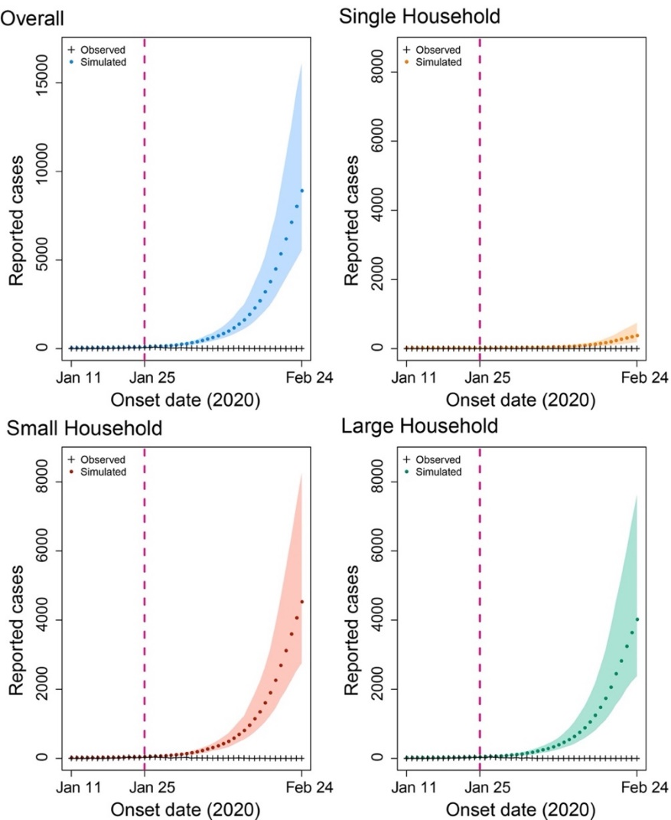
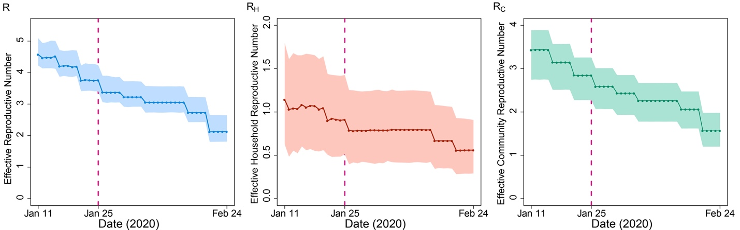
Figure S1 Prediction of the number of the reported cases and the corresponding estimation of $R_{H}$, $R_{c}$ and $R$ using parameters estimated from the first period (11–24 January), namely, no containment measure was implemented for the entire studying period. The pandemic would soar with 152,501 more infections up to 24 February 2020 and an effective reproductive number of 2.13 (1.81-2.65) on 24 February 2020.
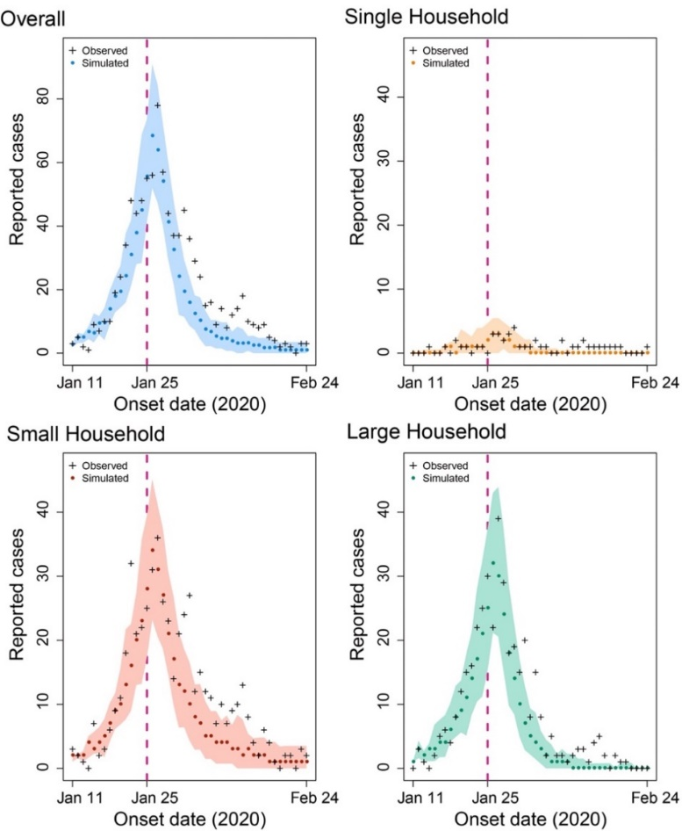
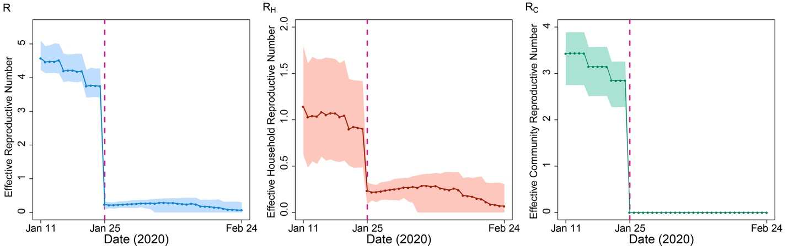
Figure S2. Prediction of the number of the reported cases and the corresponding estimation of $R_{H}$, $R_{c}$ and $R$ if extremely strict community containment was implemented, namely, no community transmission in the second period. The total infections would be reduced by 248 cases up to 24 February 2020, and the clearance of all active infections would occur on Mar 15 (Feb 26 to Apr 18).
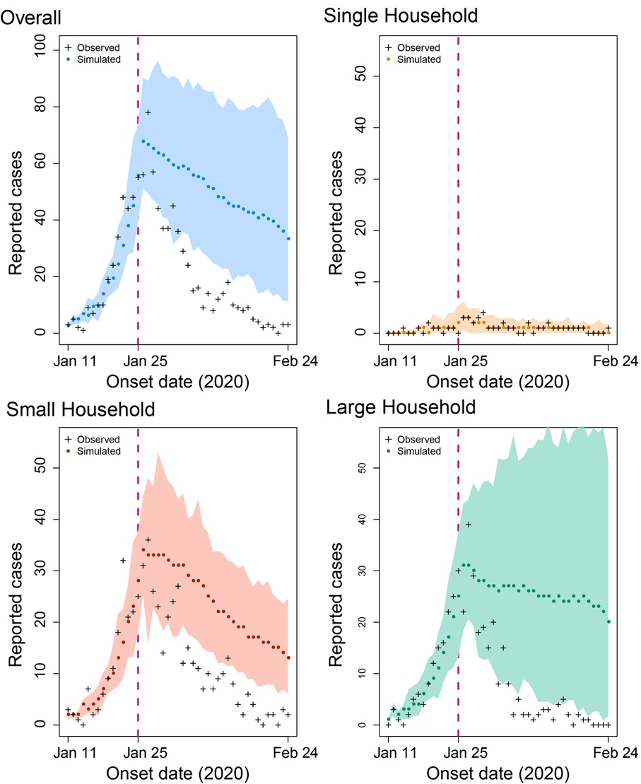
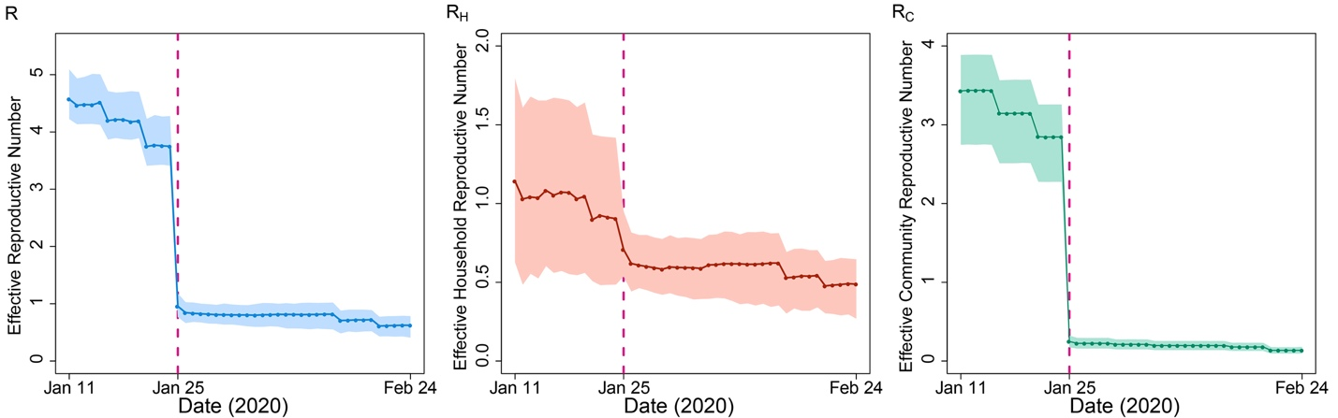
Figure S3. Prediction of the number of the reported cases and the corresponding estimation of $R_{H}$, $R_{c}$ and $R$ if no household containment measure, such as household social distancing, mask wearing and household contact tracing, was implemented in the second period. The total infections would be increased by amount of 118.1% up to 24 February 2020.
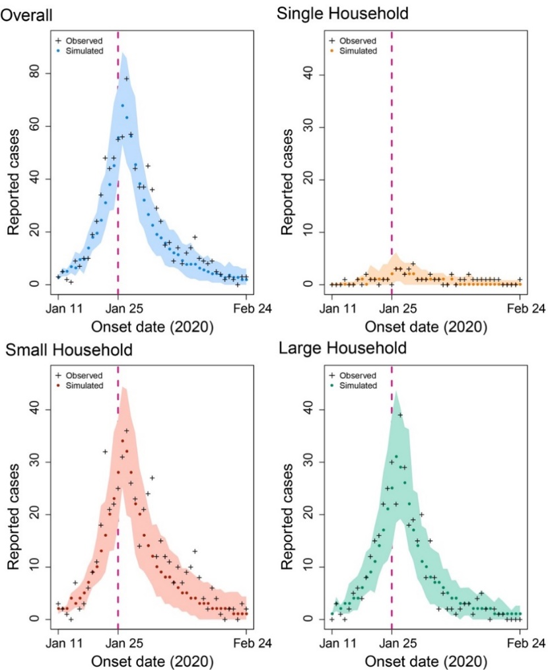
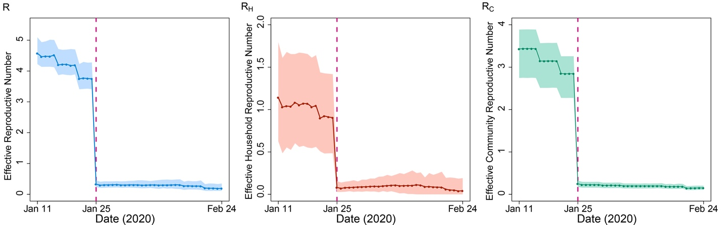
Figure S4. Prediction of the number of the reported cases and the corresponding estimation of $R_{H}$, $R_{c}$ and $R$ if stronger household containment measures were adopted in the second period, namely, the household transmission rate declines as much as community transmission rate in the second period (an average reduction of ~90%). The total infections would be reduced by 78 up to 24 February 2020, and the clearance of all active infections would occur on Mar 21 (Mar 1 to Apr 28).
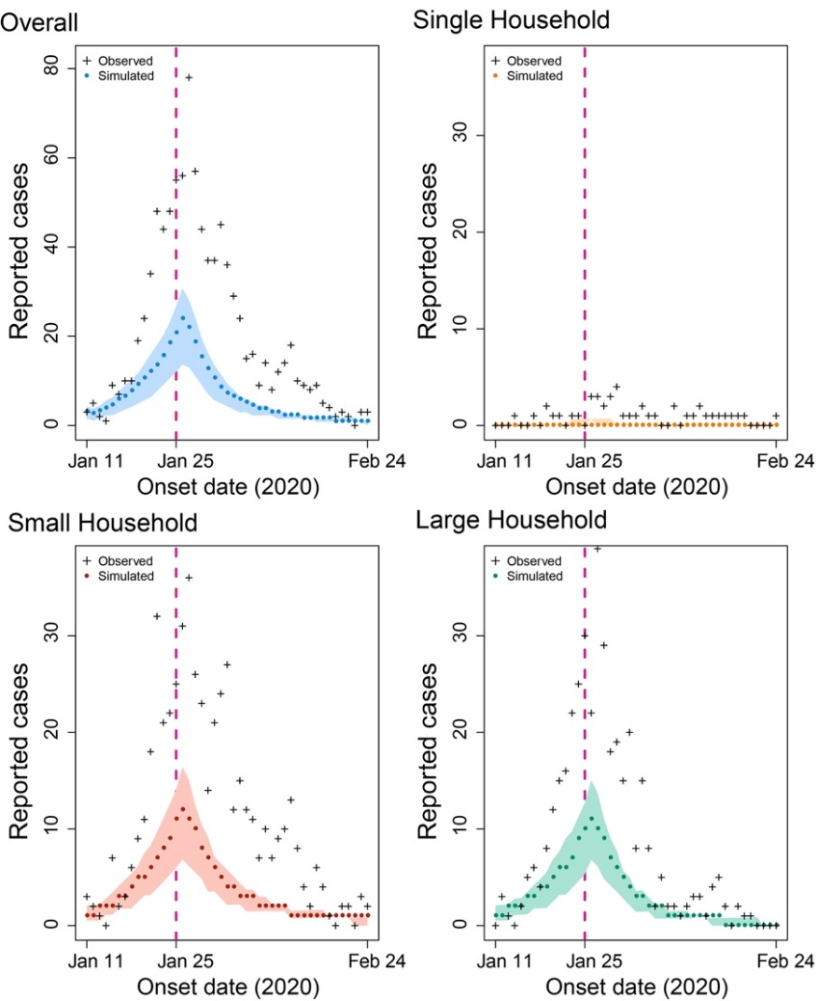
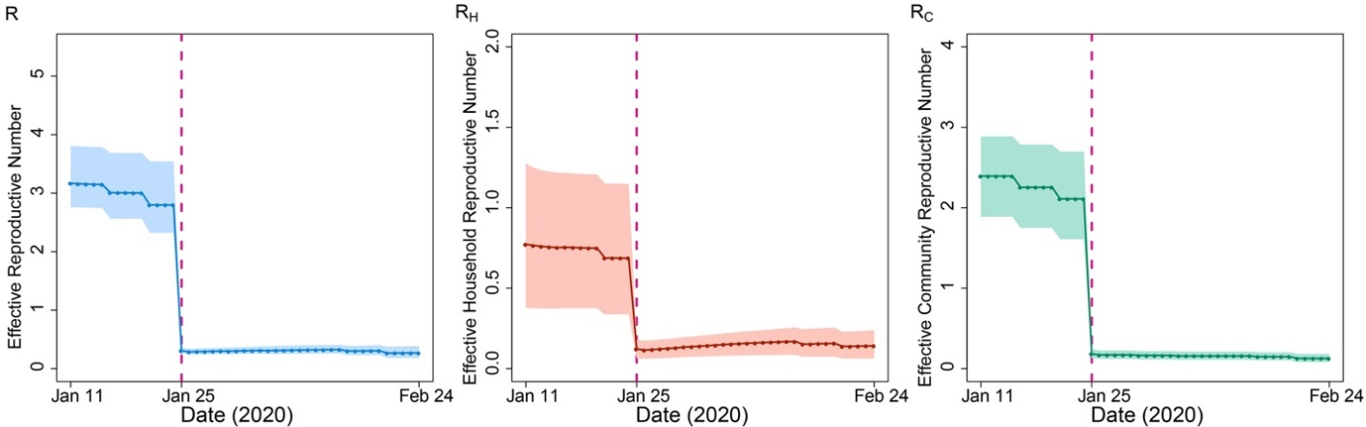
Figure S5.1 Prediction of the number of the reported cases and the corresponding estimation of $R_{H}$, $R_{c}$ and $R$ under the context of universal vaccination with the 20% protection rate against transmission. The total infections would be reduced to 630 up to 24 February 2020. However, the clearance of all active infections was postponed to 27 August 2020.
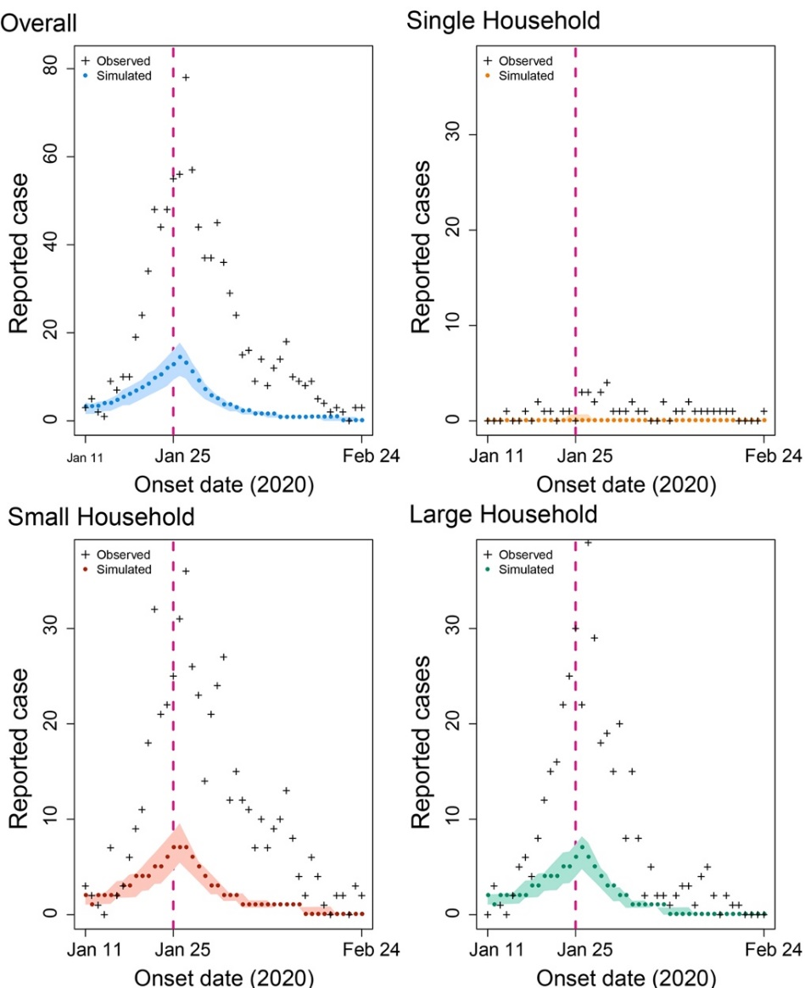
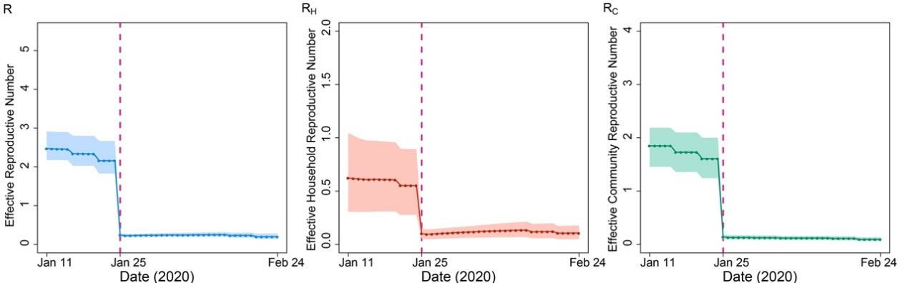
Figure S5.2 Prediction of the number of the reported cases and the corresponding estimation of $R_{H}$, $R_{c}$ and $R$ under the context of universal vaccination with the 40% protection rate against transmission. The total infections would be reduced to 359 up to 24 February 2020. However, the clearance of all active infections was postponed to 28 July 2020.
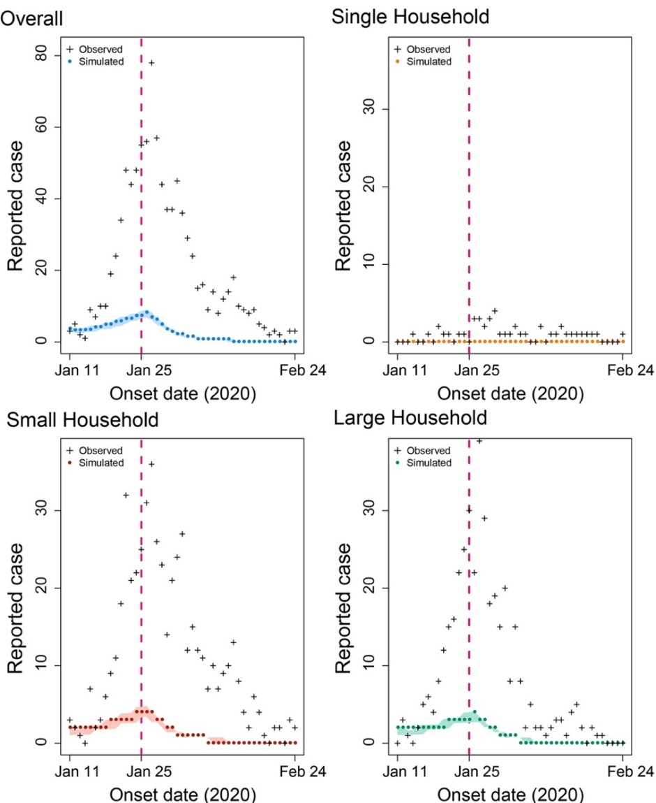
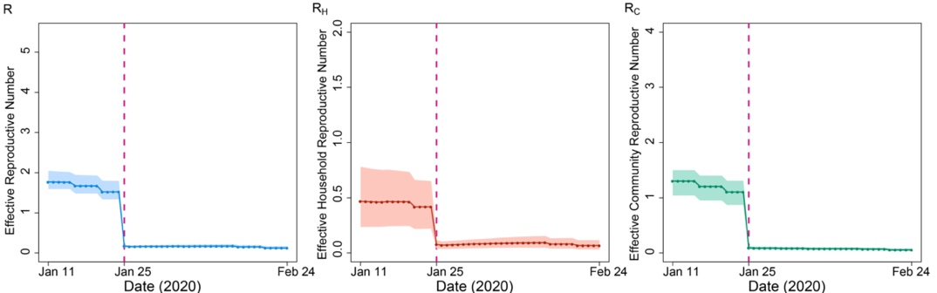
Figure S5.3 Prediction of the number of the reported cases and the corresponding estimation of $R_{H}$, $R_{c}$ and $R$ under the context of universal vaccination with the 60% protection rate against transmission. The total infections would be reduced to 184 up to 24 February 2020. However, the clearance of all active infections was postponed to 29 June 2020.
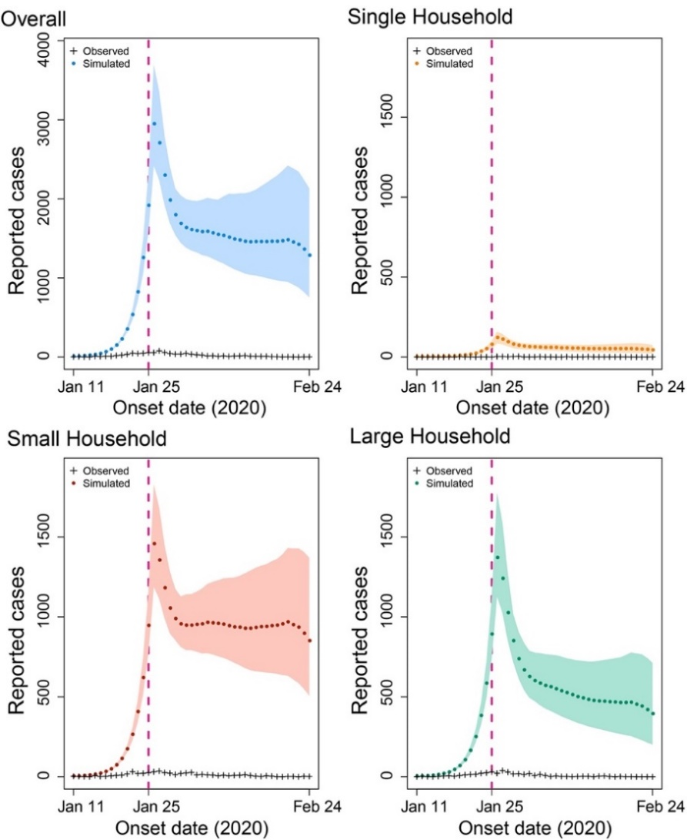
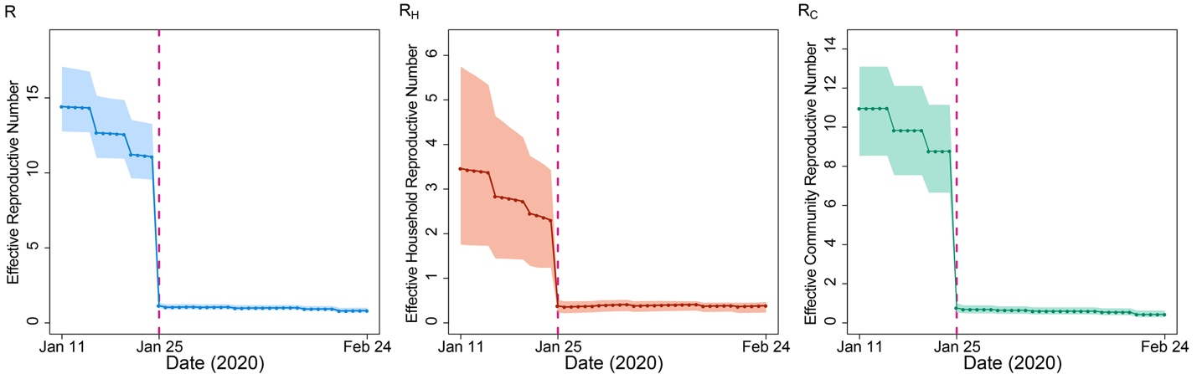
Figure S6. Prediction of the number of the reported cases and the corresponding estimation of $R_{H}$, $R_{c}$ and $R$ if a more threatening virus strain emerged. The total infections would be increased to 83,903 up to 24 February 2020, the clearance of all active infections would not occur in the near future, and the reproductive number could be as high as 11.07 in the beginning of the pandemic (as of 24 January 2020).

