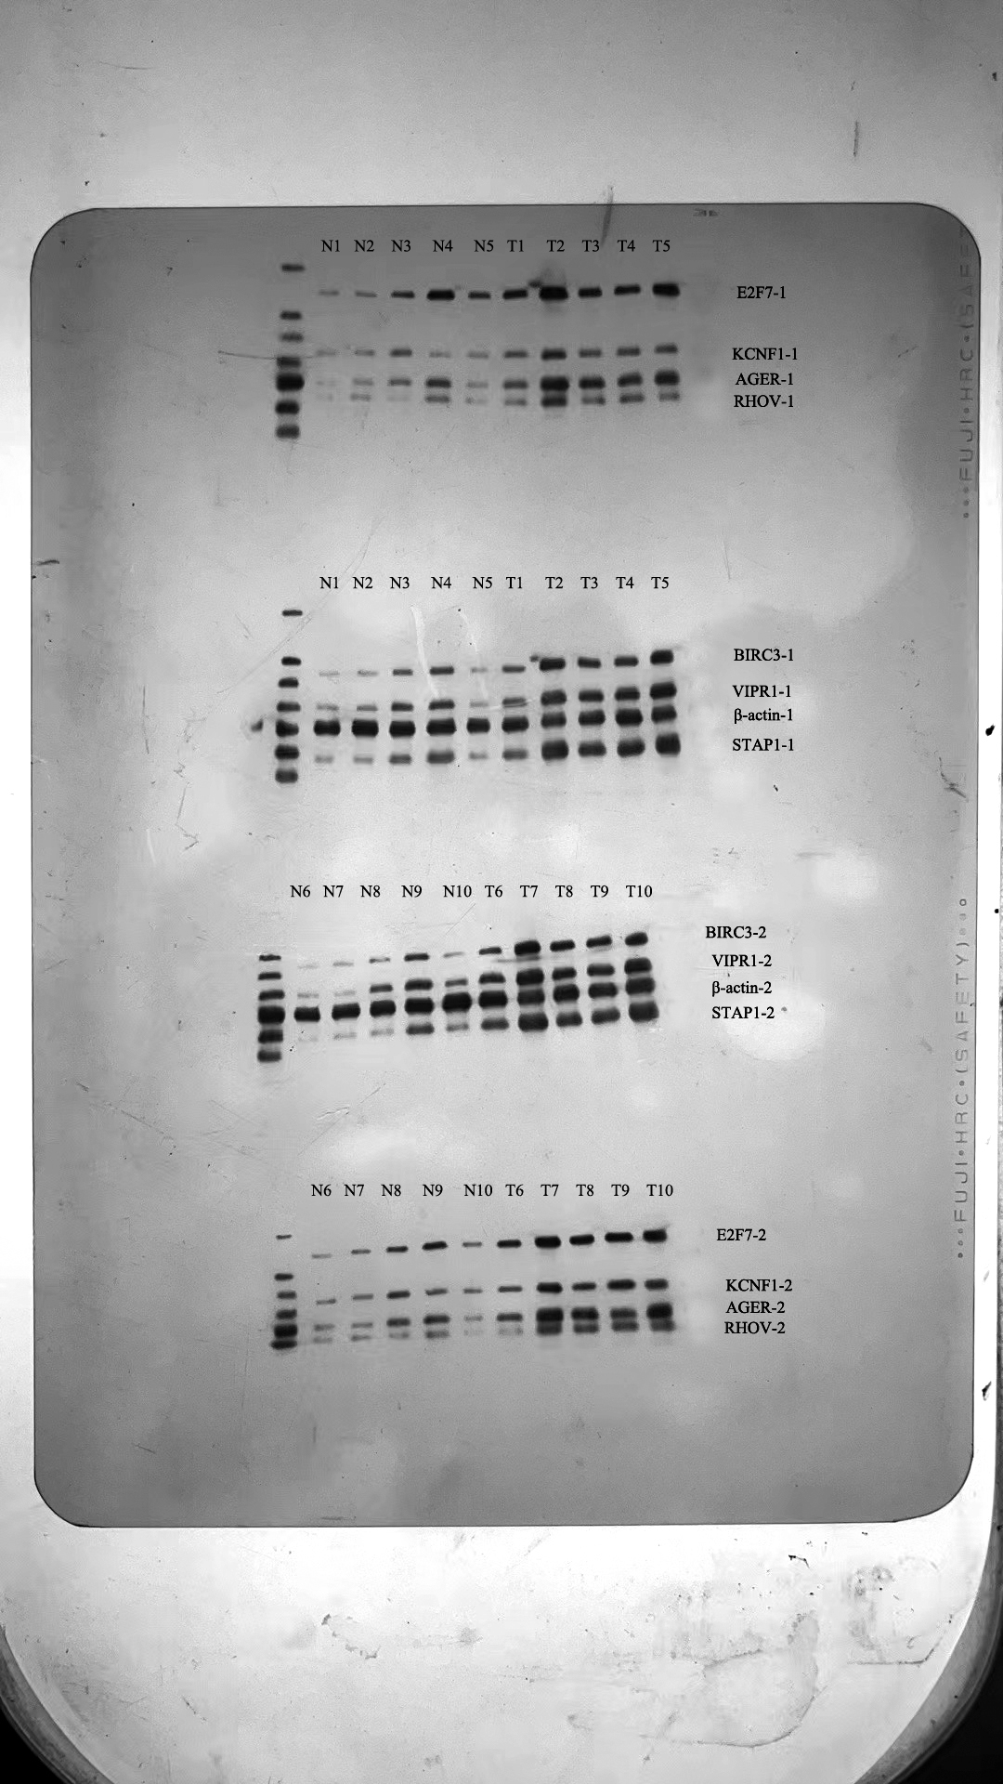
Figure1.Fuller-length, original, unprocessed blot and of replicate blots of WB
Figure2.AGER-1
Figure3.AGER-2
Figure4.BIRC3-1
Figure5.BIRC3-2
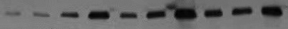
Figure6.E2F7-1
Figure7.E2F7-2
Figure8.KCNF1-1
Figure9.KCNF1-2
Figure10.RHOV-1
Figure11.RHOV-2
Figure12.STAP1-1
Figure13.STAP1-2
Figure14.VIPR1-1
Figure15.VIPR1-2
Figure16.β-actin-1
Figure17.β-actin-2

