Tab.1 Analysis of domestic treadmills
Type | Properties
Type Ⅰ  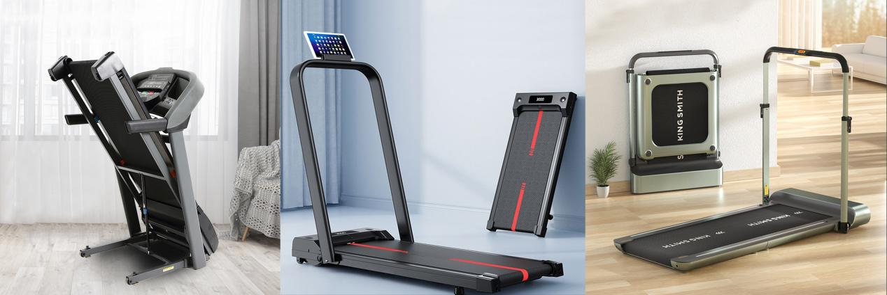 | Appearance and function | Basically the same as a commercial treadmill
 | Space | Reduced footprint, cannot be stored and takes up a lot of space in the home
 | Home space adaptability | Less distinctive from commercial treadmills and very prominent in the home environment
Type II | Appearance and function | Streamlined appearance and functionality, with only basic functional components such as the runway mechanism and the rotatable control console
 | Space | Can be stored in hidden locations such as under sofas or beds, greatly reducing the amount of space it takes up
 | Home space adaptability | A clear difference compared to commercial treadmills, more suitable for domestic spaces
Type Ⅲ | Appearance and function | Addition of foldable runway design to Type II
 | Space | More space to be stored
 | Service life | Repeated folding tends to loosen the tracks, resulting in a relatively short service life
 | Home space adaptability | Suitable for domestic spaces

Tab.2 Analysis of domestic rowing machines
Type | Properties
Wind-resistance type  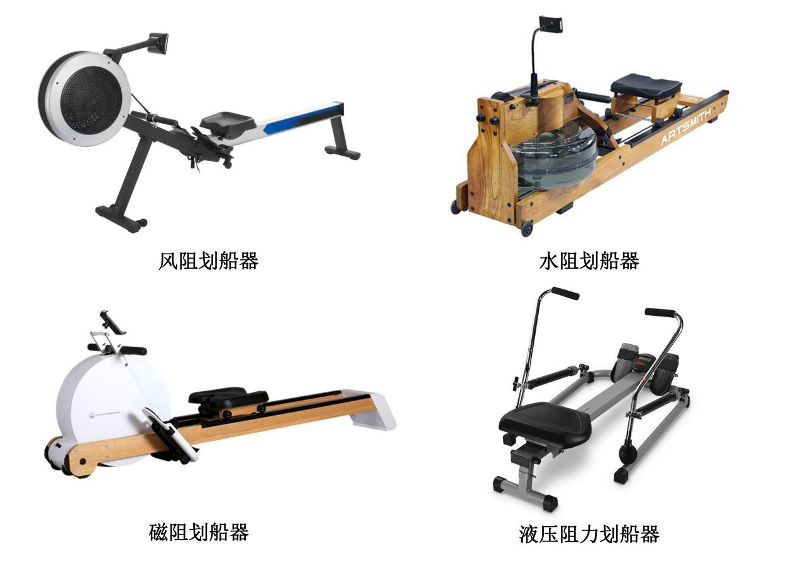 | Sources of resistance | Wind resistance during rotation of the wind wheel in the wind box
 | Amount of resistance | The amount of resistance is positively related to the amount of force applied by the user
 | Noise | Loud noise
 | Space | Takes up a lot of space and is not storable
 | Home space adaptability | Not suitable for domestic spaces
Water-resistive type | Sources of resistance | Water resistance during rotation of the paddles in the closed tank
 | Amount of resistance | Affected by the volume of water, the angle of the paddles and the amount of force applied by the user
 | Noise | Loud noise
 | Space | Takes up a lot of space and is not storable
 | Features | Resistance and water sound close to real paddling for a great experience
 | Home space adaptability | Not suitable for domestic spaces
Magneto-resistive type | Sources of resistance | Electromagnetic brake system generates resistance
 | Amount of resistance | Manual adjustment of the distance between the metal flywheel and its nearby magnet to control resistance
 | Noise | Virtually no noise
 | Space | Relatively small size, not storable
 | Home space adaptability | More suitable for domestic spaces
Hydraulic-resistance type | Sources of resistance | Hydraulic lever provides resistance
 | Noise | Quiet
 | Space | Takes up a lot of space and is not storable
 | Features | The resistance of both hands can be adjusted separately, which is different from the feeling of rowing, and the experience is poor
 | Home space adaptability | Not suitable for domestic spaces

Tab.3 Analysis of crotch openers
Type | Properties
Type Ⅰ  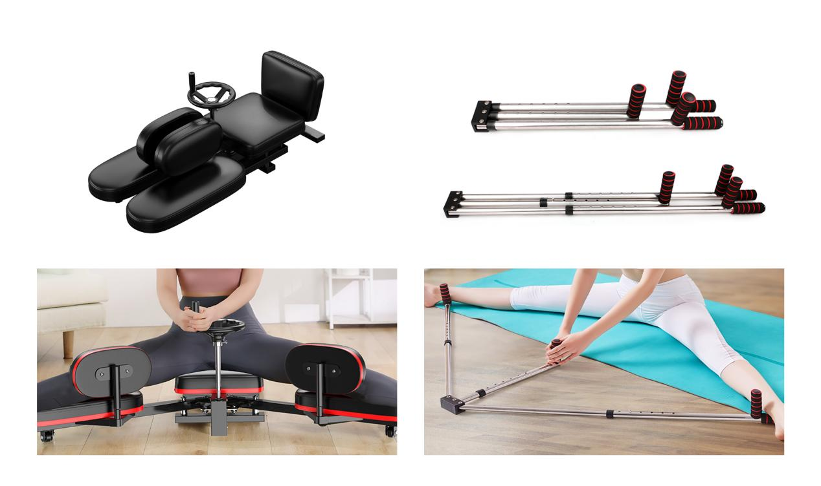 | Usage | The rotation of the compass drives the gearing and controls the angle of the long rods on both sides
 | Space | Takes up a lot of space and is not easy to store
 | Home space adaptability | Not suitable for domestic spaces
Type Ⅱ | Usage | Pulling the long bar in the middle opens the user's legs in a horizontal plane
 | Space | Small footprint for storage
 | Features | Freely retractable to fit users with different leg lengths
 | Home space adaptability | Suitable for domestic spaces

Tab.4 Analysis of domestic dumbbells
Type | Properties
Type Ⅰ  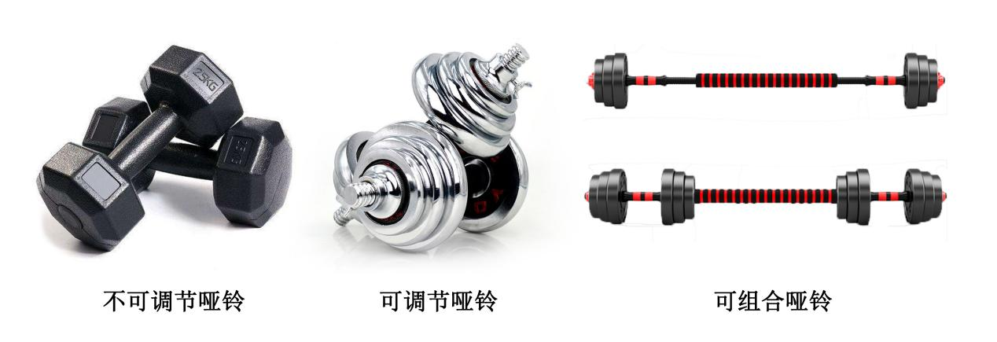 | Appearance and function | Non-adjustable
 | Space | Small size for storage
 | Home space adaptability | Difficult for family members to use together, less suitable for domestic spaces
Type Ⅱ | Appearance and function | Adjusting the weight of the dumbbell by removing the counterweight
 | Space | Small size for storage
 | Home space adaptability | Suitable for domestic spaces
Type Ⅲ | Appearance and function | On the basis of Type II, the connection of a pair of dumbbells becomes a barbell
 | Space | Small size for storage
 | Home space adaptability | Suitable for domestic spaces

Tab.5 Analysis of domestic pullers
Type | Properties
Type Ⅰ  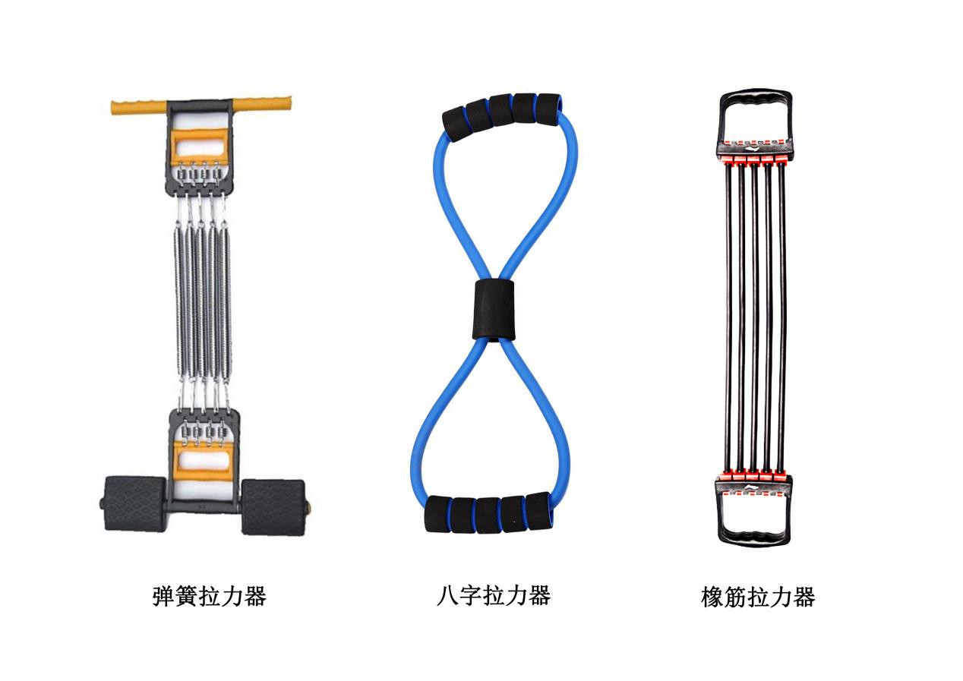 | Sources of resistance | Spring
 | Amount of resistance | Adjustment of the number of springs
 | Space | Small size for storage
 | Features | Cold metal springs exposed, risk of pinching skin or hair
 | Home space adaptability | Suitable for domestic spaces
Type Ⅱ | Sources of resistance | Annular elastic rubber hose
 | Amount of resistance | Non-adjustable
 | Space | Small size for storage
 | Features | High degree of freedom, low resistance and light weight.  Rubber material is not cold and can be used close to the skin
 | Home space adaptability | Suitable for domestic spaces
Type Ⅲ | Sources of resistance | Flexible rubber hose
 | Amount of resistance | Adjustment of the number of flexible rubber hoses
 | Space | Small size for storage
 | Features | Lightweight; rubber material is not cold and can be used close to the skin
 | Home space adaptability | Suitable for domestic spaces

