Supplementary Figure and Tables

Supplementary Figure 1 A-F: Representative electropherogram of ESBL genes in E. coli and K. pneumoniae isolates on 1.5 %Agarose gel
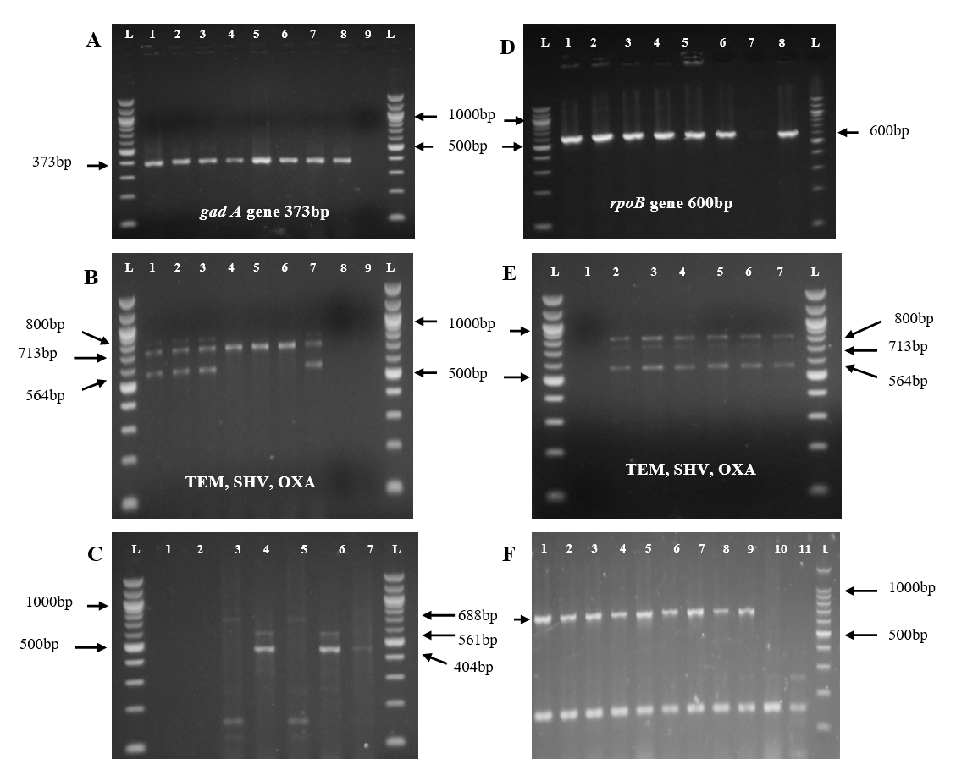
Supplementary Figure 1: Representative electropherogram of ESBL genes in E. coli and K. pneumoniae isolates on 1.5 %Agarose gel
(A) L-100bp: Molecular ladder; Wells 1 to 7: E. coli positive samples; Well 8: Standard E. coli (ATCC 25922; positive control); Well 9: Nuclease-free water (negative control). (B) L-100bp: Molecular ladder; Wells 1 to 7: E. coli samples showing TEM (800bp), SHV (713bp), and OXA (564bp) genes; Well 8: Nuclease-free water (negative control); Well 9: Standard E. coli (ATCC 25922; positive control). (C) L-100bp: Molecular ladder; Wells 1 to 7: E. coli samples showing CTX_{M group-1}(688bp), CTX_{M group-2} (561bp), and CTX_{M group-9} (404bp) genes; Well 1: Nuclease-free water (negative control); Well 2: Standard E. coli (ATCC 25922; positive control). (D) L-100bp: Molecular ladder; Wells 1 to 6: K. pneumoniae positive samples; Well 7: Nuclease-free water (negative control); Well 8: Standard K. pneumoniae (ATCC 700603; positive control). (E) L-100bp: Molecular ladder; Wells 2 to 6: K. pneumoniae isolates showing TEM (800bp), SHV (713bp), and OXA (564bp) genes; Well 1: Nuclease-free water (negative control); Well 7: Standard K. pneumoniae (ATCC 700603; positive control). (F) L-100bp: Molecular ladder; Wells 1 to 10: K. pneumoniae isolates showing CTX_{M group-1}(688bp) gene; Well 11: Nuclease-free water (negative control); Well 12: Standard K. pneumoniae (ATCC 700603; positive control).

Supplementary Table 1: Selected E. coli isolates with percentage identities and accession numbers
Isolate ID | Target gene | Accession no./LOCUS | Homologue
ECE3 | gadA | OL743740 | Escherichia coli strain ECken5 glutamate decarboxylase (gadA) gene, partial cds.
ECE33 | gadA | OL743741 | Escherichia coli strain ECken6 glutamate decarboxylase (gadA) gene, partial cds.
ECK16 | gadA | OL743742 | Escherichia coli strain ECken8 glutamate decarboxylase (gadA) gene, partial cds.
ECK49 | gadA | OL743743 | Escherichia coli strain ECken10 glutamate decarboxylase (gadA) gene, partial cds.
ECK30 | gadA | OL743744 | Escherichia coli strain ECken13 glutamate decarboxylase (gadA) gene, partial cds
ECK23 | gadA | OL743745 | Escherichia coli strain ECken16 glutamate decarboxylase (gadA) gene, partial cds.
ECK96 | gadA | OL743746 | Escherichia coli strain ECken17 glutamate decarboxylase (gadA) gene, partial cds
ECE1 | gadA | OL743747 | Escherichia coli strain ECken1 glutamate decarboxylase (gadA) gene, partial cds
ECK9 | gadA | OL743748 | Escherichia coli strain ECken7 glutamate decarboxylase (gadA) gene, partial cds
ECK95 | gadA | OL743749 | Escherichia coli strain ECken12 glutamate decarboxylase (gadA) gene, partial cds
ECK60 | gadA | OL743750 | Escherichia coli strain ECken3 glutamate decarboxylase (gadA) gene, partial cds
ECE9 | gadA | OL743751 | Escherichia coli strain ECken2 glutamate decarboxylase (gadA) gene, partial cds
ECE6 | gadA | OL743752 | Escherichia coli strain ECken11 glutamate decarboxylase (gadA) gene, partial cds
ECK53 | gadA | OL743753 | Escherichia coli strain ECken15 glutamate decarboxylase (gadA) gene, partial cds
ECK44 | gadA | OL743754 | Escherichia coli strain ECken14 glutamate decarboxylase (gadA) gene, partial cds
ECE36 | gadA | OL743755 | Escherichia coli strain ECken4 glutamate decarboxylase (gadA) gene, partial cds
ECK20 | gadA | OL743756 | Escherichia coli strain ECken9 glutamate decarboxylase (gadA) gene, partial cds

Supplementary Table 2: Selected K. pneumoniae isolates with percentage identities and accession numbers
Isolate ID | Target gene | Accession no./LOCUS | Homologue
KPE5 | rpoB | OL743757 | Klebsiella pneumoniae strain klrpken4 RNA polymerase beta subunit (rpoB) gene, partial cds.
KPE3 | rpoB | OL743758 | Klebsiella pneumoniae strain klrpken2 RNA polymerase beta subunit (rpoB) gene, partial cds
KPK53 | rpoB | OL743759 | Klebsiella pneumoniae strain klrpken9 RNA polymerase beta subunit (rpoB) gene, partial cds
KPK55 | rpoB | OL743760 | Klebsiella pneumoniae strain klrpken10 RNA polymerase beta subunit (rpoB) gene, partial cds
KPE9 | rpoB | OL743761 | Klebsiella pneumoniae strain klrpken6 RNA polymerase beta subunit (rpoB) gene, partial cds
KPK85 | rpoB | OL743762 | Klebsiella pneumoniae strain klrpken13 RNA polymerase beta subunit (rpoB) gene, partial cds
KPK81 | rpoB | OL743763 | Klebsiella pneumoniae strain klrpken11 RNA polymerase beta subunit (rpoB) gene, partial cds
KPK51 | rpoB | OL743764 | Klebsiella pneumoniae strain klrpken8 RNA polymerase beta subunit (rpoB) gene, partial cds
KPK83 | rpoB | OL743765 | Klebsiella pneumoniae strain klrpken12RNA polymerase beta subunit (rpoB) gene, partial cds
KPE6 | rpoB | OM310867 | Escherichia coli strain klrpken5 DNA-directed RNA polymerase subunit beta (rpoB) gene, partial cds
KPE12 | rpoB | OM310868 | Escherichia coli strain klrpken7 DNA-directed RNA polymerase subunit beta (rpoB) gene, partial cds.
KPE2 | rpoB | OM310869 | Escherichia coli strain klrpken1 DNA-directed RNA polymerase subunit beta (rpoB) gene, partial cds.
KPE4 | rpoB | OM310870 | Klebsiella pneumoniae strain klrpken3 DNA-directed RNA polymerase subunit beta (rpoB) gene, partial cds.

Supplementary Table 3: ESBL genes detected in K. pneumoniae isolates and accession numbers
Isolate ID | Target gene | Accession no/LOCUS | Homologue
KPE2 | bla_{TEM} | OM310856 | Klebsiella pneumoniae strain Kptemken4 TEM family class A beta-lactamase (blaTEM) gene, partial cds.
KPE1 | blaTEM | OM310857 | Klebsiella pneumoniae strain Kptemken1 TEM family class A beta-lactamase (blaTEM) gene, partial cds.
KPE4 | blaTEM | OM310858 | Klebsiella pneumoniae strain Kptemken5 TEM family class A beta-lactamase (blaTEM) gene, partial cds.
ECK30 | blaTEM | OM310859 | Escherichia coli strain Kptemken3 TEM family class A beta-lactamase (blaTEM) gene, partial cds.. coli
KPE5 | blaTEM | OM310860 | lebsiella pneumoniae strain Kptemken7 TEM family class A beta-lactamase (blaTEM) gene, partial cds.
KPE6 | blaTEM | OM310861 | Klebsiella pneumoniae strain Kptemken8 TEM family class A beta-lactamase (blaTEM) gene, partial cds.
KPK83 | blaTEM | OM310862 | Klebsiella pneumoniae strain Kptemken11 TEM family class A beta-lactamase (blaTEM) gene, partial cds.
KPK85 | blaTEM | OM310863 | Klebsiella pneumoniae strain Kptemken9 TEM family class A beta-lactamase (blaTEM) gene, partial cds.
ECK44 | blaTEM | OM310864 | Escherichia coli strain Kptemken10 TEM family class A beta-lactamase (blaTEM) gene, partial cds
KPE 12 | blaTEM | OM310865 | Klebsiella pneumoniae strain Kptemken2 TEM family class A beta-lactamase (blaTEM) gene, partial cds.
KPK53 | blaTEM | OM310866 | Escherichia coli strain Kptemken6 TEM family class A beta-lactamase (blaTEM) gene, partial cds.
KPE5 | blaSHV | OM310830 | Escherichia coli strain SHVke1 SHV family beta-lactamase(blaSHV) gene, partial cds.
KPK53 | blaSHV | OM310831 | Escherichia coli strain SHVke2 SHV family beta-lactamase(blaSHV) gene, partial cds
ECE3 | blaSHV | OM310832 | Klebsiella pneumoniae strain SHVke3 SHV family beta-lactamase (blaSHV) gene, partial cds.
KPK83 | blaSHV | OM310833 | Klebsiella pneumoniae strain SHVke4 SHV family beta-lactamase (blaSHV) gene, partial cds
KPE12 | bla_{SHV} | OM310834 | Klebsiella pneumoniae strain SHVke5 SHV family beta-lactamase (blaSHV) gene, partial cds.
KPK53 | blaSHV | OM310835 | Klebsiella pneumoniae strain SHVke6 SHV family beta-lactamase (blaSHV) gene, partial cds.
KPK85 | blaSHV | OM310836 | Klebsiella pneumoniae strain SHVke7 SHV family beta-lactamase (blaSHV) gene, partial cds.
ECK95 | blaSHV | OM310837 | Klebsiella pneumoniae strain SHVke8 SHV family beta-lactamase (blaSHV) gene, partial cds.

Supplementary Table 4: ESBL genes detected in E. coli isolates and accession numbers
Isolate ID | Target gene | Accession no/LOCUS | Homologue
ECE6 | blaOXA | OM310838 | Escherichia coli strain OXAke1 OXA-1 family class D beta-lactamase (blaOXA) gene, partial cds.
ECE36 | blaOXA | OM310839 | Escherichia coli strain OXAke2 OXA-1 family class D beta-lactamase (blaOXA) gene, partial cds.
ECE9 | blaOXA | OM310840 | Escherichia coli strain OXAke3 OXA-1 family class D beta-lactamase(blaOXA) gene, partial cds.
ECK16 | blaOXA | OM310841 | Escherichia coli strain OXAke4 OXA-1 family class D beta-lactamase (blaOXA) gene, partial cds.
KPK51 | blaOXA | OM310842 | Escherichia coli strain OXAke5 OXA-1 family class D beta-lactamase (blaOXA) gene, partial cds.
KPK53 | blaOXA | OM310843 | Escherichia coli strain OXAke6 OXA-1 family class D beta-lactamase(blaOXA) gene, partial cds.
ECK9 | blaOXA | OM310844 | Klebsiella pneumoniae strain OXAke7 OXA-1 family class D  beta-lactamase (blaOXA) gene, partial cds.
KPK83 | blaOXA | OM310845 | Klebsiella pneumoniae strain OXAke8 OXA-1 family class D beta-lactamase (blaOXA) gene, partial cds.
ECE1 | blaOXA | OM310846 | Klebsiella pneumoniae strain OXAke9 OXA-1 family class D  beta-lactamase (blaOXA) gene, partial cds.
KPK85 | blaOXA | OM310847 | Klebsiella pneumoniae strain OXAke10 OXA-1 family class D  beta-lactamase (blaOXA) gene, partial cds.
KPK81 | blaOXA | OM310848 | Klebsiella pneumoniae strain OXAke11 OXA-1 family class D  beta-lactamase (blaOXA) gene, partial cds.
ECK23 | blaCTXMgp1 | OM310849 | Escherichia coli strain CTXMpg1ke1 CTX-M family beta-lactamase(blaCTX-M) gene, partial cds.
ECE20 | blaCTXMgp1 | OM310850 | Escherichia coli strain CTXMpg1ke2 CTX-M family beta-lactamase (blaCTX-M) gene, partial cds.
KPK60 | blaCTXMgp2 | OM310851 | Klebsiella pneumoniae strain CTXMpg2ke1 CTX-M family beta-lactamase(blaCTX-M) gene, partial cds.
ECK96 | blaCTXMgp9 | OM310852 | Escherichia coli strain CTXMpg9ke1 CTX-M family extended-spectrum class A beta-lactamase (blaCTX-M) gene, partial cds.
ECK60 | blaCTXMgp9 | OM310853 | Escherichia coli strain CTXMpg9ke2 CTX-M family extended-spectrum class A beta-lactamase (blaCTX-M) gene, partial cds.
ECK34 | blaCTXMgp9 | OM310854 | Escherichia coli strain CTXMpg9ke4 CTX-M family extended-spectrum class A beta-lactamase (blaCTX-M) gene, partial cds.
ECE33 | blaCTXMgp9 | OM310855 | Escherichia coli strain CTXMpg9ke3 CTX-M family extended-spectrum class A beta-lactamase (blaCTX-M) gene, partial cds

