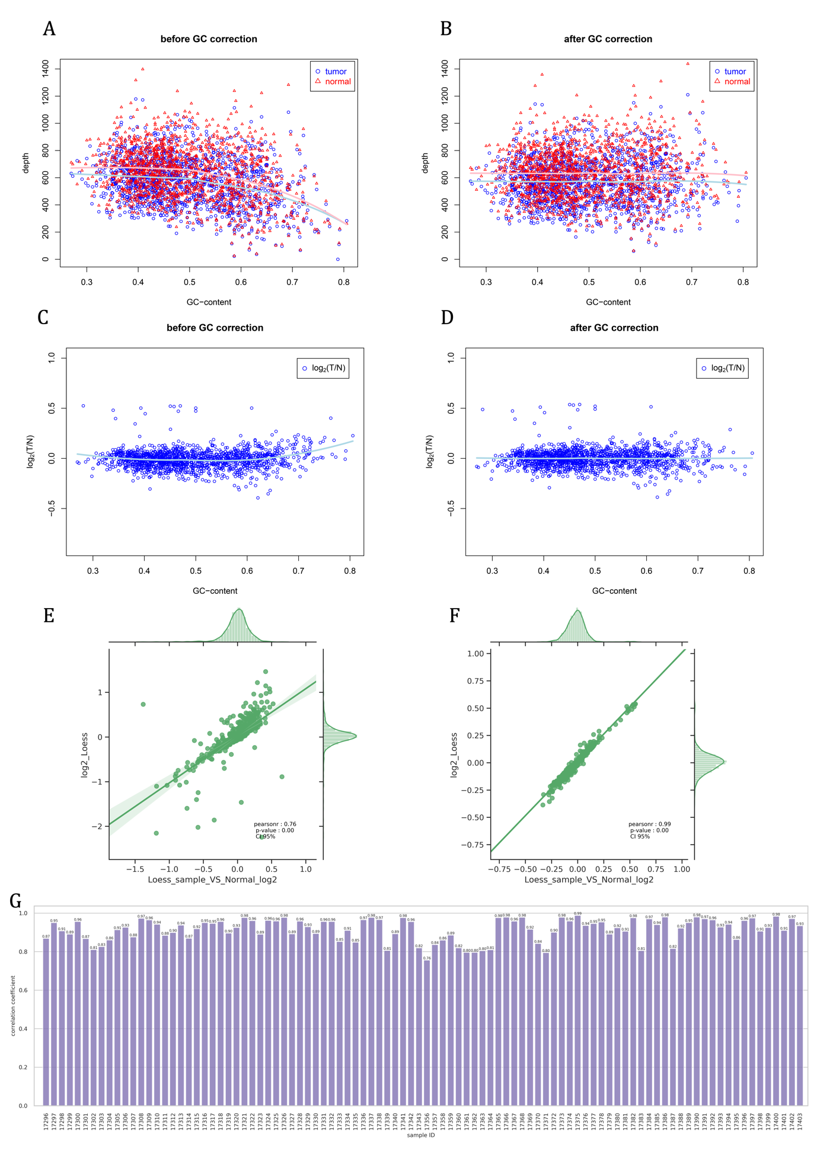
Supplementary Figure S1 LOESS used in GC-content correction
(A, B) Light blue curve and pink curve were the LOESS predict for original read depth in sample 17375 (blue dots) and control sample (red triangles) over GC content, respectively. (C, D) Light blue cure was the LOESS predict on log2 value of tumor and normal ratio (blue dots) over GC content. (E) The pearson correlation between two different LOESS strategies in sample 17356, yielded a minimum coeffiecient among 96 samples in ICR96 dataset. (F) The pearson correlation between two different LOESS strategies in sample 17375, yielded a maximum coeffiecient among 96 samples in ICR96 dataset. (G) The LOESS test on two strategies in all samples in ICR96 dataset showed high correlated with average coefficient r=0.91.
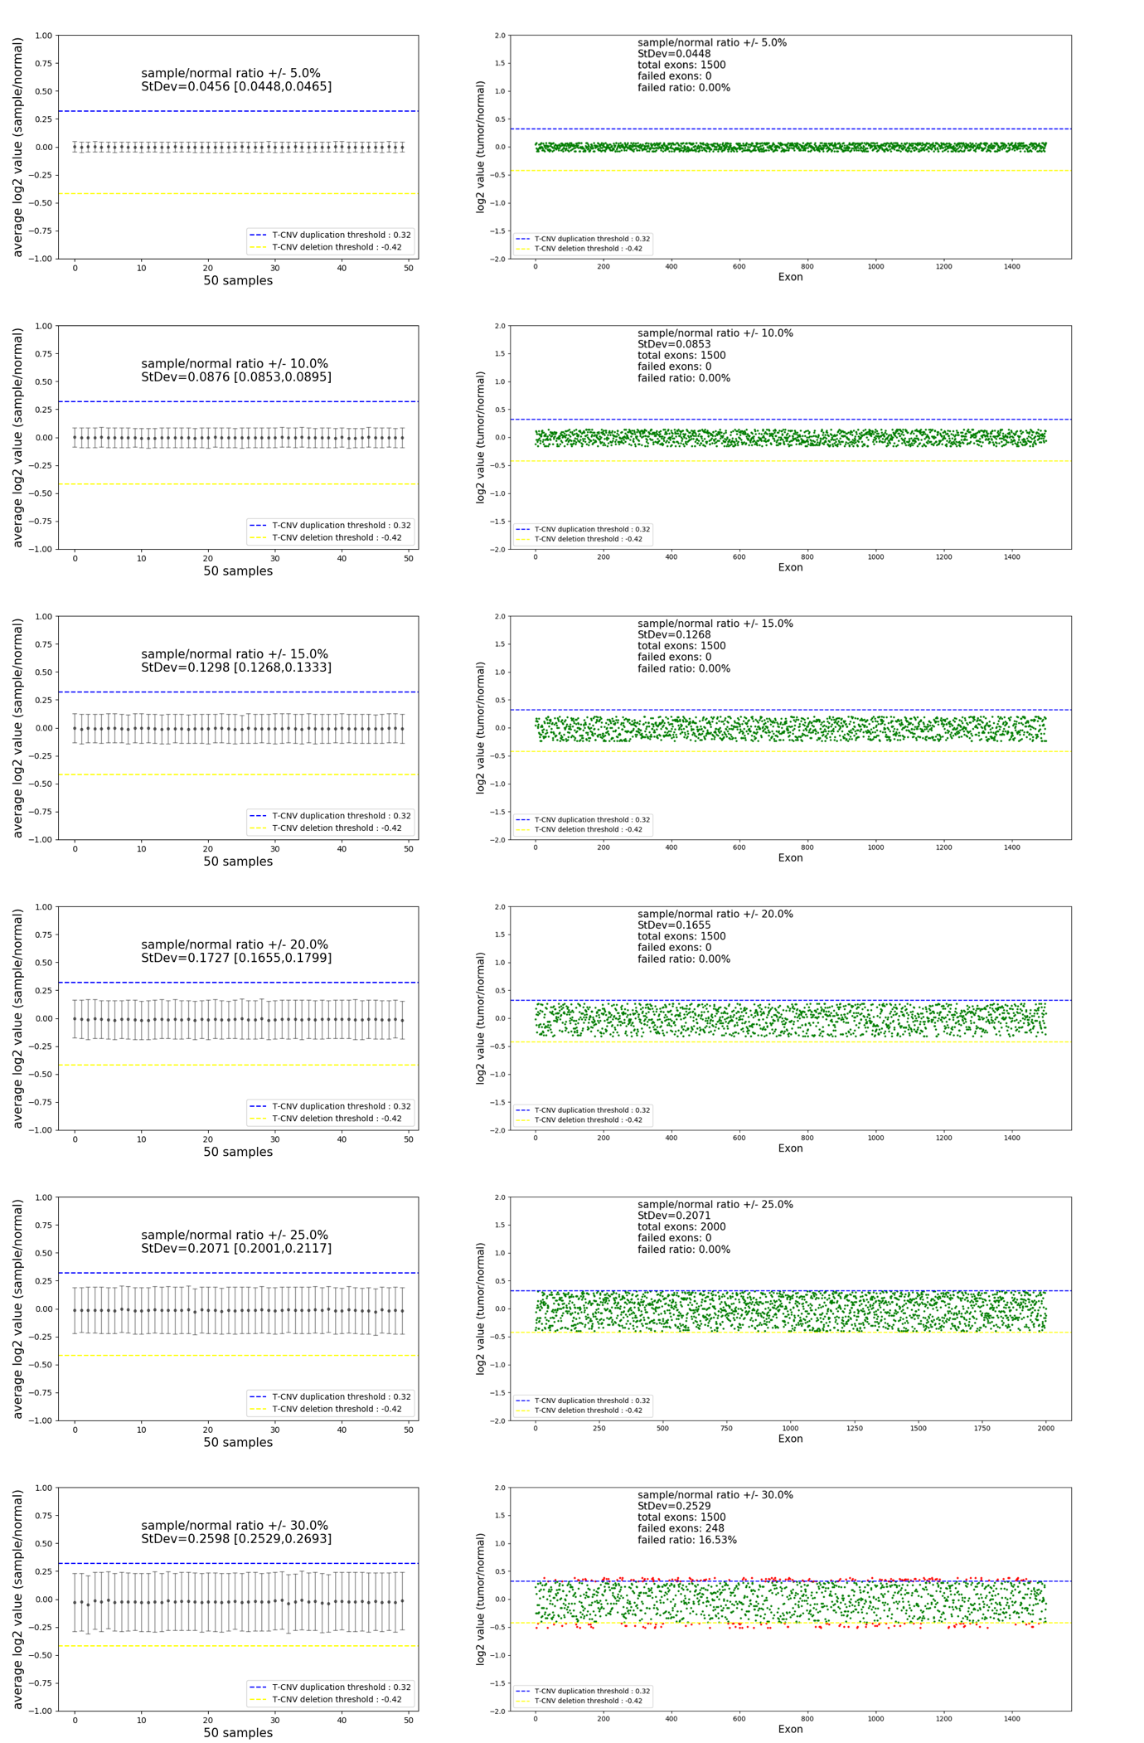
Supplementary Figure S2 Random noise test
We assumed 50 pairs of tumor and normal samples in a pool were tested for 1500 exons. We assumed the log2 values were 0 without any noise. Then, we introduced noise ($y$) from 5% to 30%, 5% increment to each sample randomly. In this case, the noise introduced in exon $x_{i}$ followed uniform distribution ( $x_{i} \sim U(0,y)$). The log2 value distribution of 50 samples were presented in the left, while the log2 value distribution of 1500 exons in an example sample at different noise level were presented in the right.

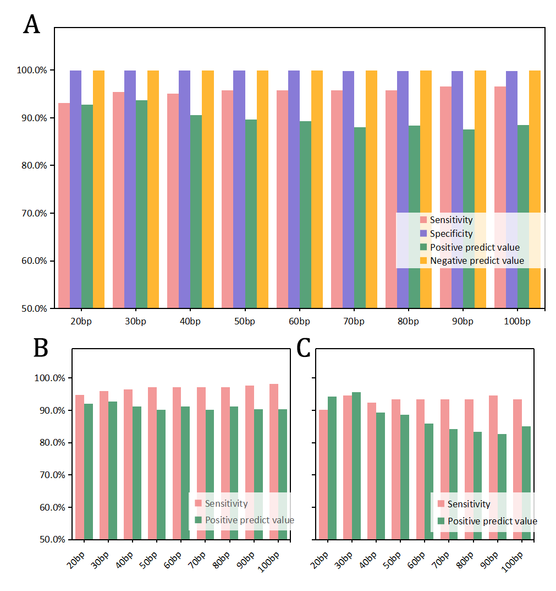
Supplementary Figure S3 Optimazation of bins method
(A) The overall performance of bin size from 20bp to 100bp in bins method was optimized by assessing sensitivity, specificity, positive predict value and negative predict value using ICR96 dataset. (B) The performance of bin size from 20bp to 100bp in deletions prediction were presented with sensitivity and positive predict value. (C) The performance of bin size in duplications prediction were presented with sensitivity and positive predict value.

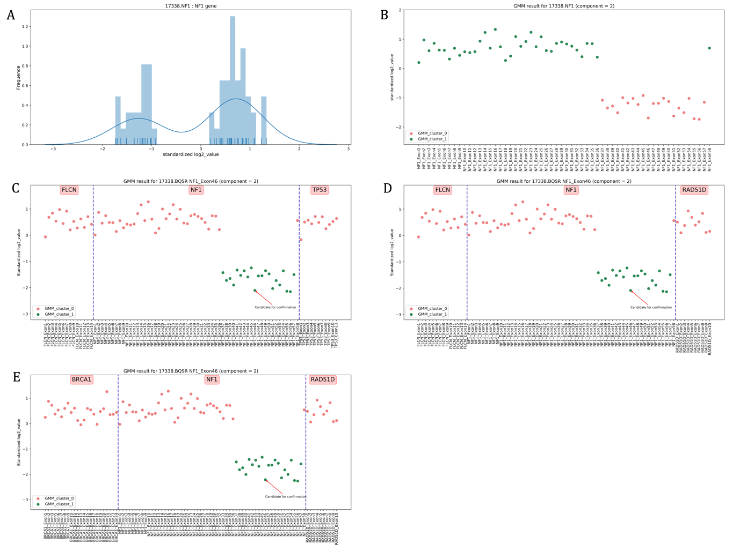
Supplementary Figure S4 An example of GMM clustering result on sample 17338 NF1 exon 37-57 delietion
(A) The log2 value of exons in NF1 gene in sample 17338 showed two distinguished peaks in frequence distrubution. Blue line indicated the GMM prediction on distribution with one feature and two clusters. (B) Single feature GMM clustering result for log2 value of exons in NF1 gene in 17338 demonstrated two clusters (green dots and red dots). (C,D,E) According to the sampling plan of GMM clustering in T-CNV, this approach included two random negative gene in the same chromosome and ran clustering in triplicate. Three GMM results indicated the possible CNV candidate was clustered as positive.

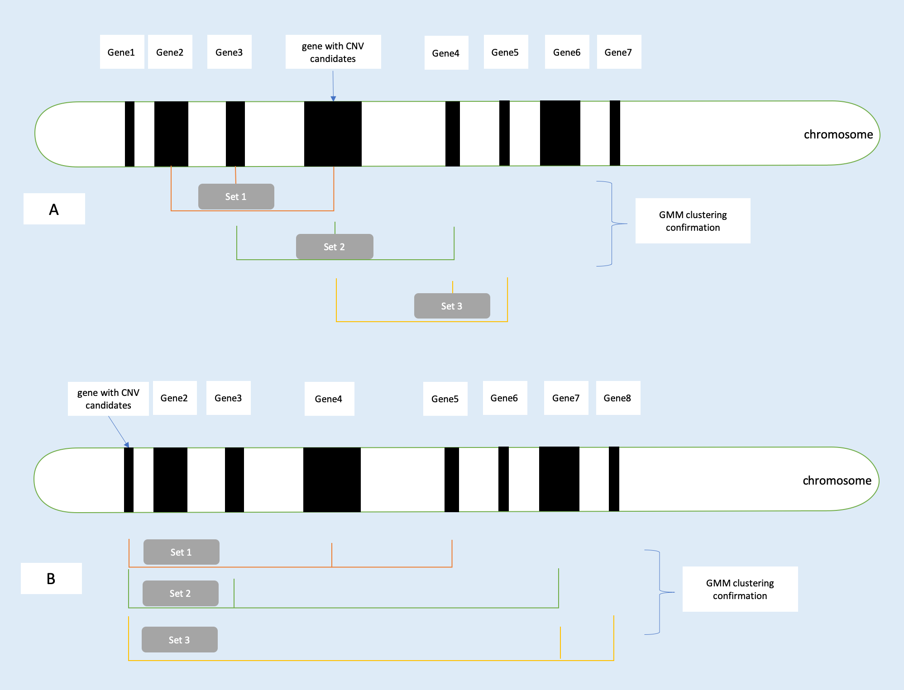
Supplementary Figure S5 Sampling plan for GMM clustering in T-CNV
For each possible CNV candidate, we selected two other Non-CNV gene in the same chromosome as a set and ran the single feature GMM clustering on log2 value of exons. The clustering was performed in triplicate. (A) When the gene with possible CNV candidate located in between genes in chromosome, we prefered to selected the gene next to the candidate. (B) When the previous situation didn’t fit, we selected random genes.
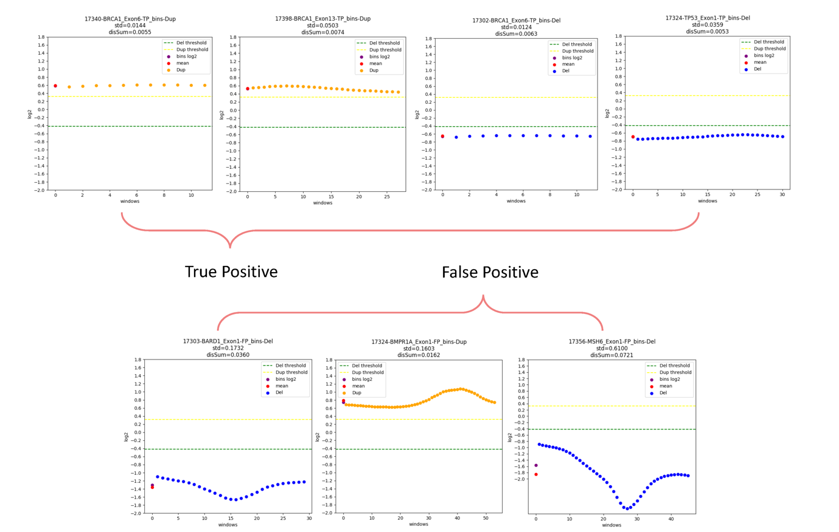
Supplementary Figure S6 True positive and false positive in T-CNV window-sliding method
When we splited the possible CNV candidates into smaller windows (10bp size) with overlapped (6bp step), We observed larger fluctuation in false positive exons in windows log2 value than that in true positives.
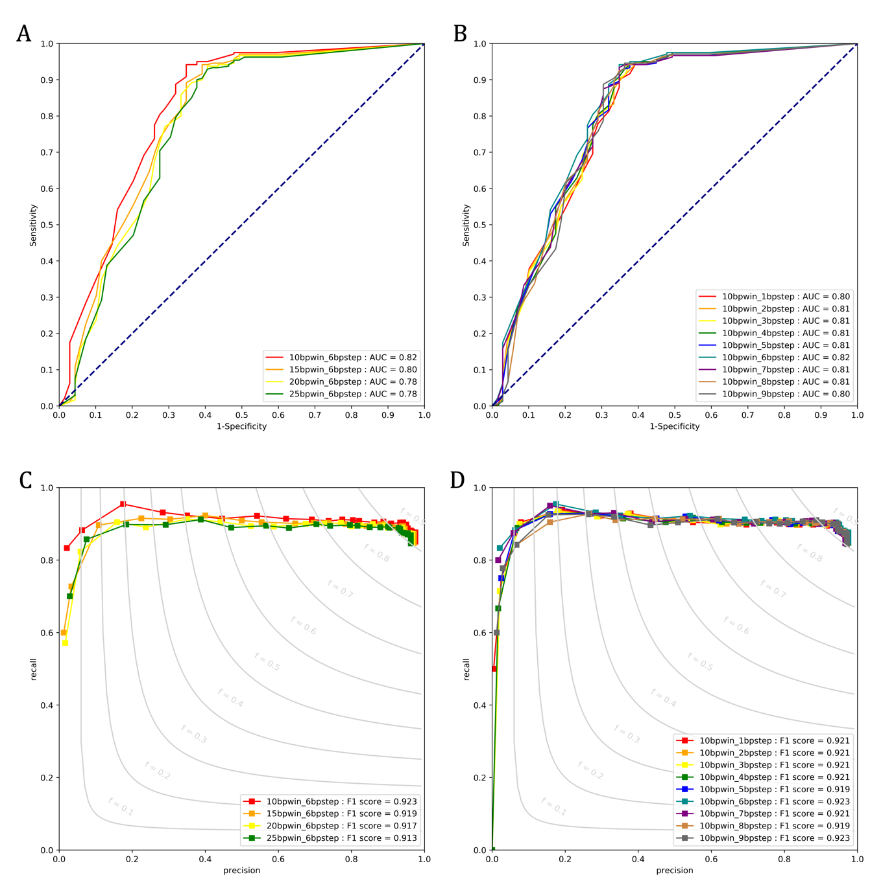
Supplementary Figure S7 ROC curve and PR curve for optimization of window-sliding method
(A) Window sizes from 10bp to 25bp were optimized using CNV candidates after confirmation by bins method and GMM clustering method in ROC curve. (B) Step lengths from 1 to 9 were optimized in ROC curve. (C) Window sizes from 10bp to 25bp were optimized in PR curve. (D) Step lengths from 1 to 9 were optimized in PR curve.

Supplementary Figure S8 The visulization result of sample 17375 from pool2 in ICR96 dataset
The visulization result showed the log2 value distribution of all targeted exons. Green dot line and red dot line represented for the upper threhold and lower threhold in T-CNV. Positive CNVs were indicated as green stars or red circles regards to duplications or deletions, respectively. The average copy number of the positive CNVs was shown under the graph. A PMS2 exon 13-15 duplication and CHEK2 exon 3-15 duplication were identified by T-CNV.

