Multilevel characteristics of TiO_{x} transparent non-volatile resistive switching device by embedding SiO₂ nanoparticles

Sera Kwon¹, Min-Jung Kim¹, Kwun-Bum Chung^{1,*}
¹Division of Physics and Semiconductor Science, Dongguk University, Seoul, 04620, Republic of Korea
e-mail: kbchung@dongguk.edu

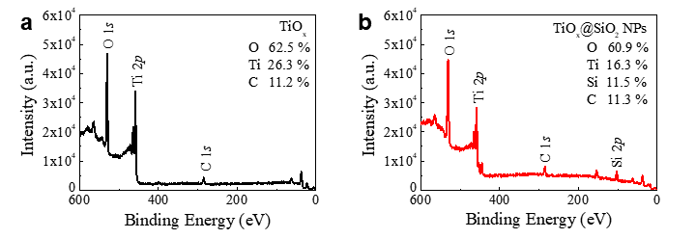
Figure S1. Survey spectra and compositions of (a) TiO_{x} and (b) TiO_{x}@SiO₂ NPs films.

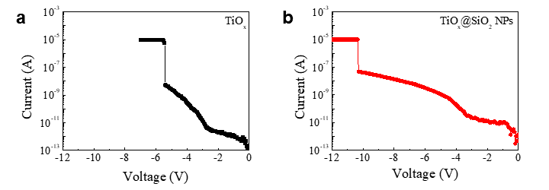
Figure S2. Electro-forming process of (a) TiO_{x} and (b) TiO_{x}@SiO₂ NPs switching devices.

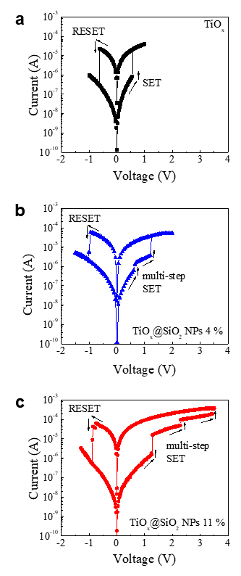
Figure S3. The resistive switching characteristics as a function of the composition of SiO₂ NPs with (a) 0 %, (b) 4 %, and (c) 11 %.

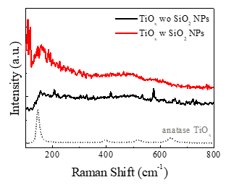
Figure S4. Raman spectra of TiO_{x} and TiO_{x}@SiO₂ NPs films. Dotted lines indicate anatase TiO_{x}.

