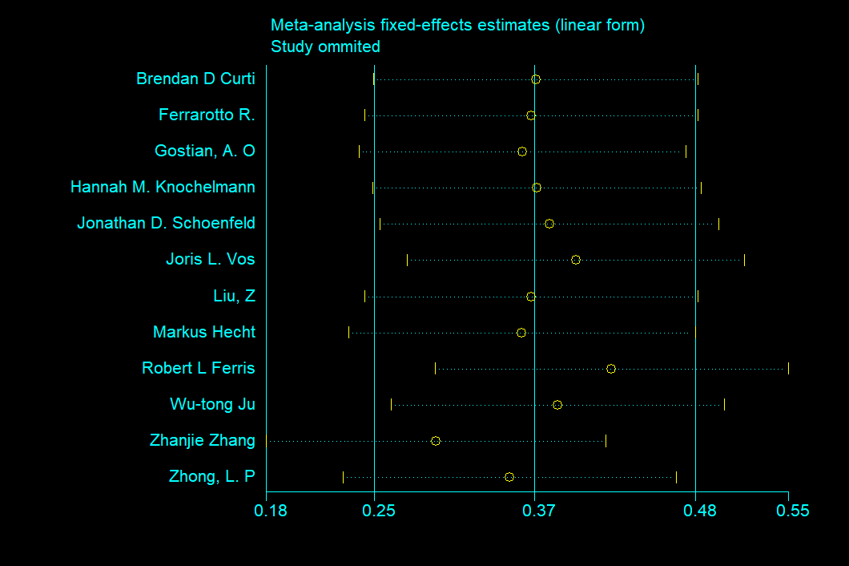
Supplementary Figure 1 ORR sensitivity analysis based on 12 studies. None study deletion could influence the result significantly.

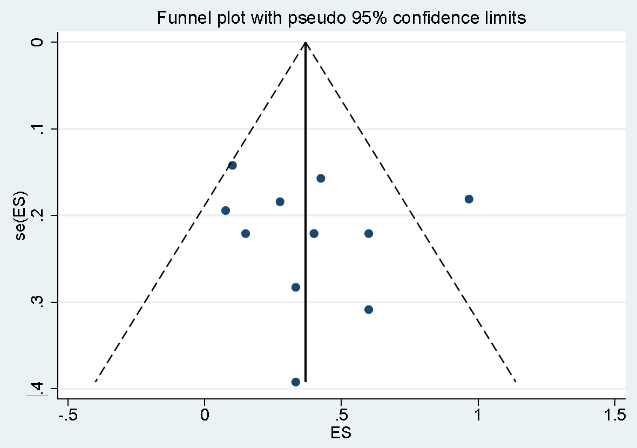
Supplementary Figure 2 ORR publication bias

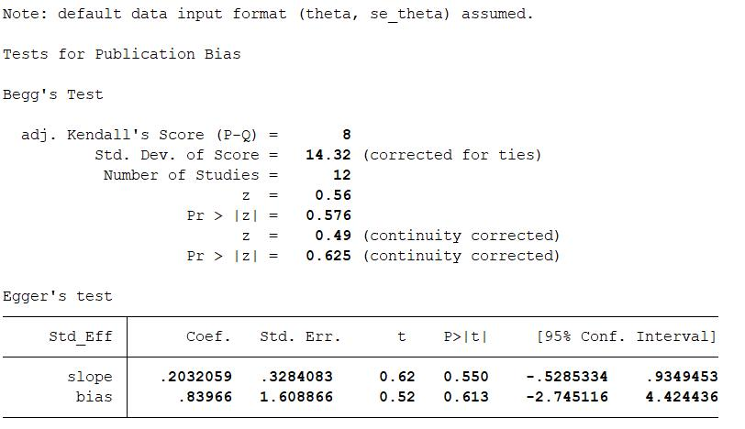
Supplementary Figure 3 ORR publication bias test via Begg’s test on Stata. As p value more than 0.05, no publication bias was found.

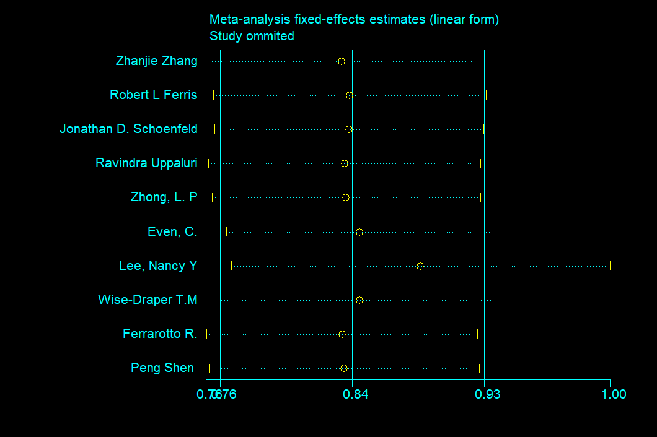
Supplementary Figure 4 1-year OS sensitivity analysis based on 10 studies. None study deletion could influence the result significantly.

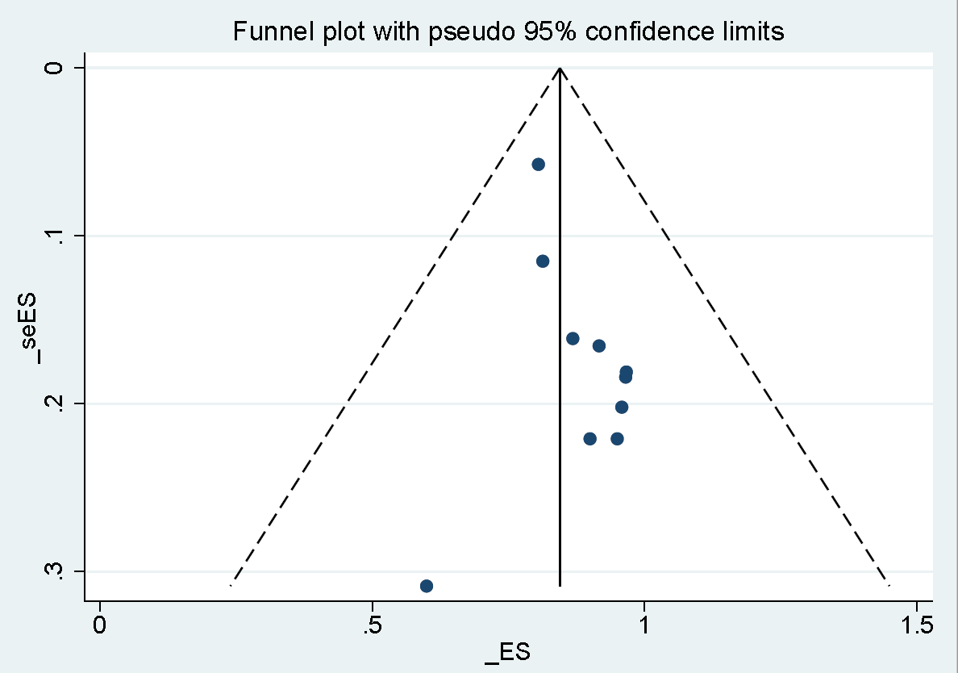
Supplementary Figure 5 1-year OS publication bias

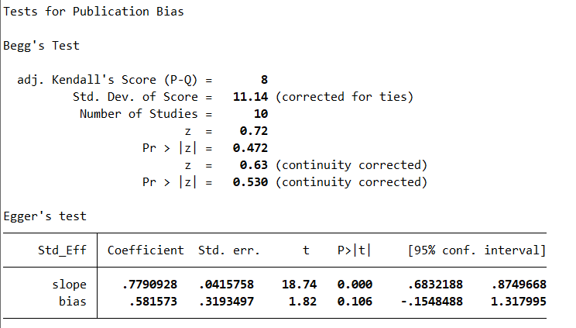
Supplementary Figure 6 1-year OS publication bias test via Begg’s test on Stata. As p value more than 0.05, no publication bias was found.

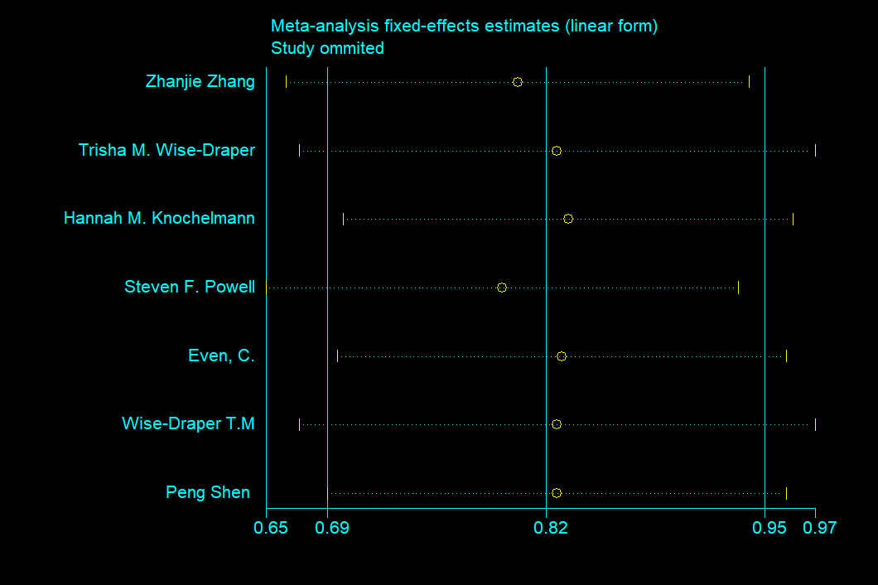
Supplementary Figure 7 1-year OS sensitivity analysis based on 7 studies. None study deletion could influence the result significantly.

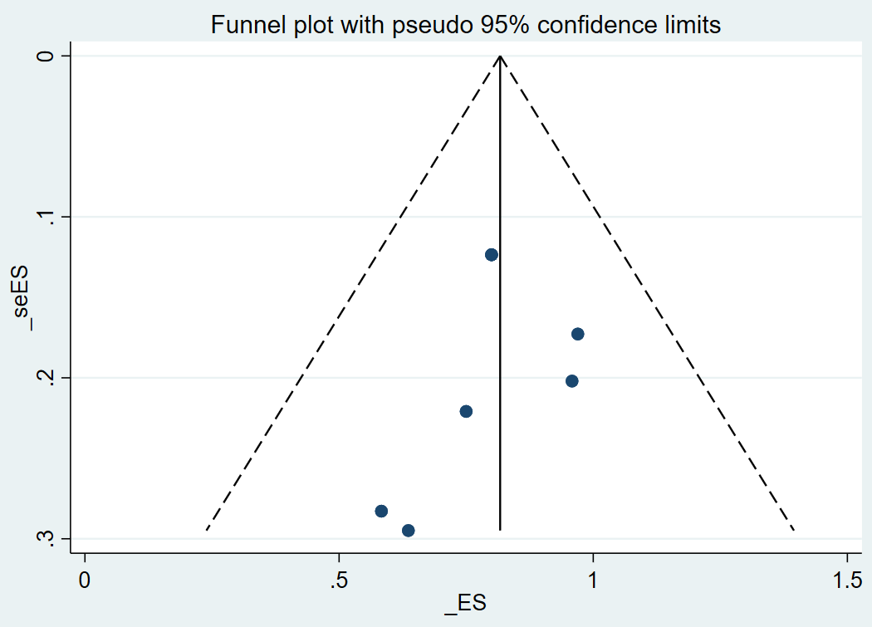
Supplementary Figure 8 1-year PFS publication bias

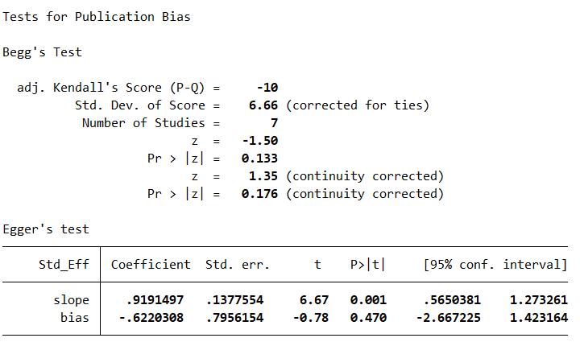
Supplementary Figure 9 1-year PFS publication bias test via Begg’s test on Stata. As p value more than 0.05, no publication bias was found.

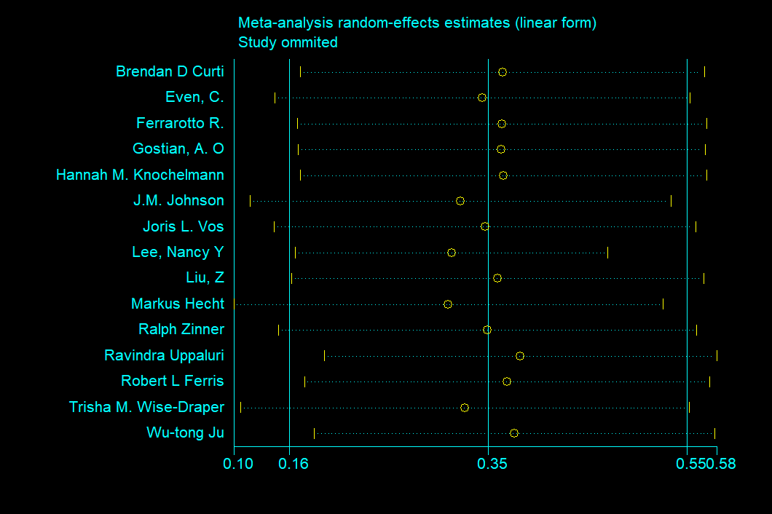
Supplementary Figure 10 Adverse Reaction sensitivity analysis based on 15 studies. None study deletion could influence the result significantly.

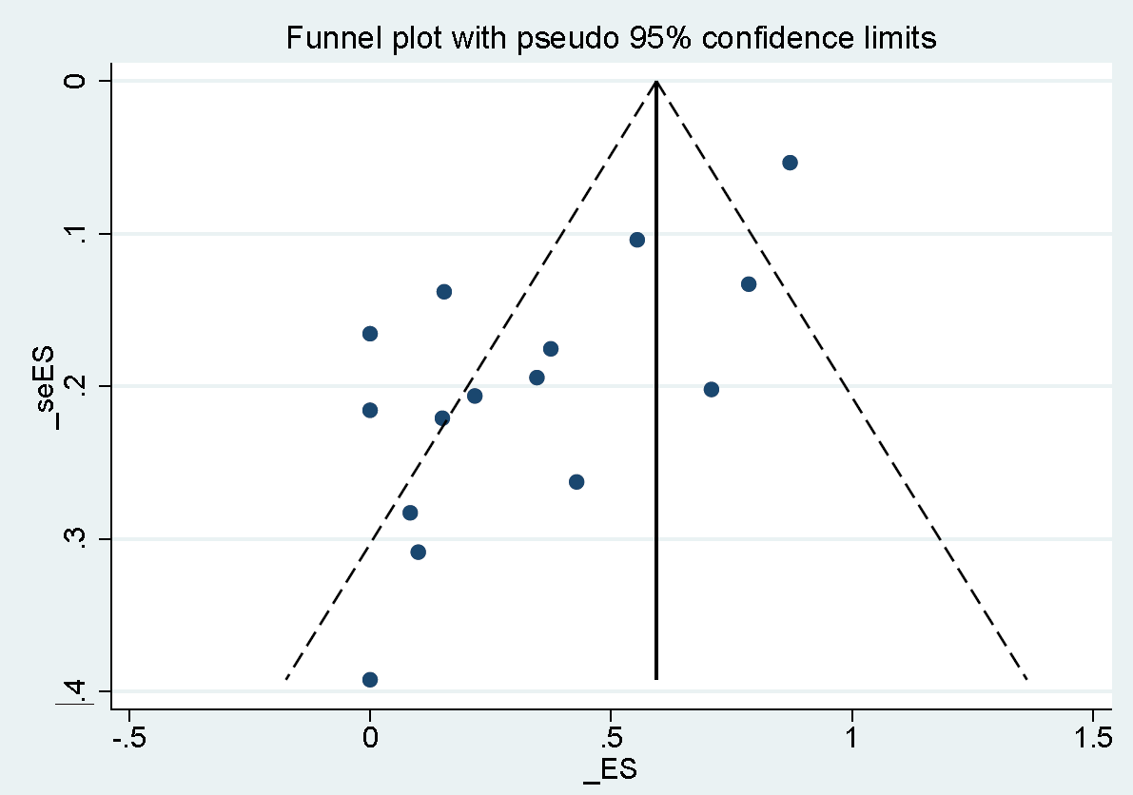
Supplementary Figure 11 Adverse Reaction publication bias

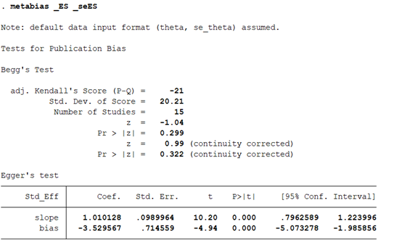
Supplementary Figure 12 Adverse Reaction publication bias test via Begg’s test on Stata. As p value less than 0.05, there was publication bias.

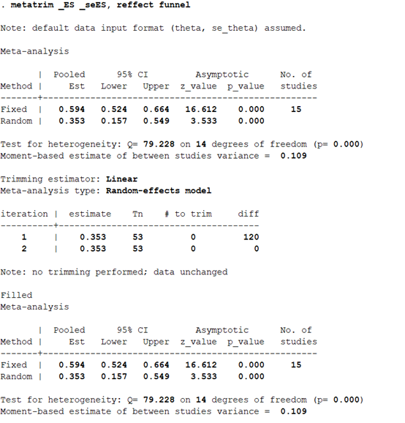
Supplementary Figure 13 Trim and Fill analysis of Adverse Reaction. The publication showed a bias, so the result was proceeded into Trim and Fill analysis. This analysis indicated no trimming performed and the result would not change.

