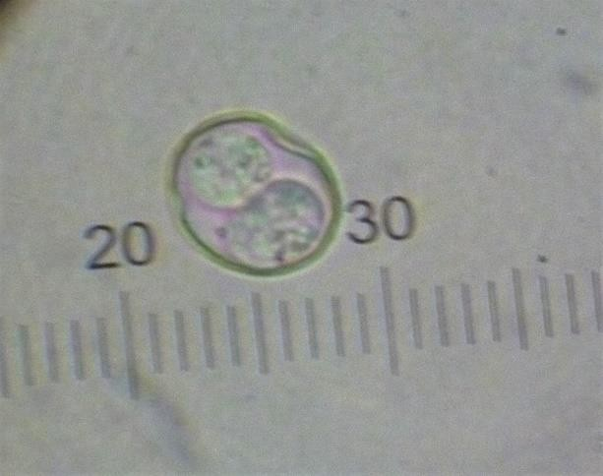
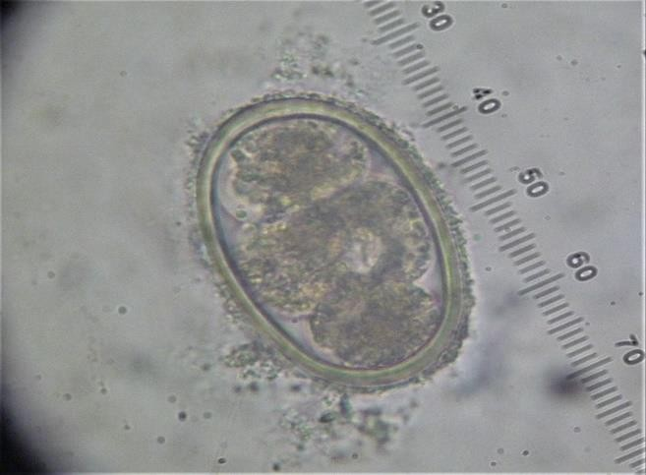

Photo 2: Ascaridia sp. egg (78x54 µm) Photo 1: Oocyst of Eimeria sp. (20.7x18 µm)

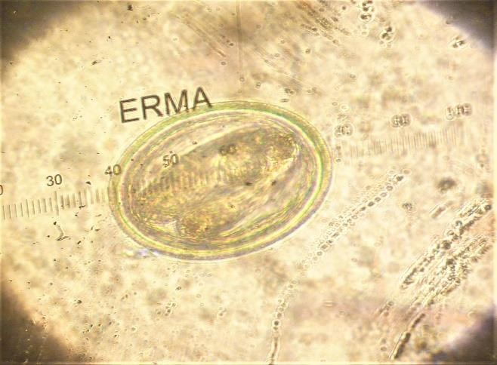
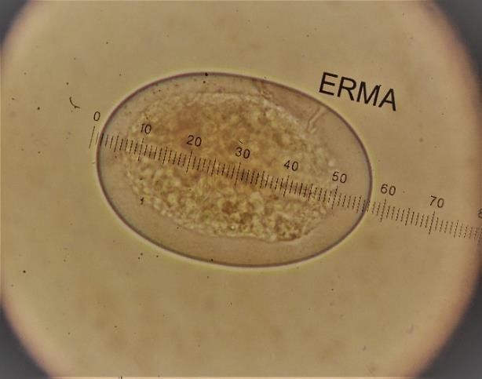

Photo 3: Trichostrongylus sp. egg (115-62.4 µm) Photo 4: Strongyloides sp. egg (71x66 µm)

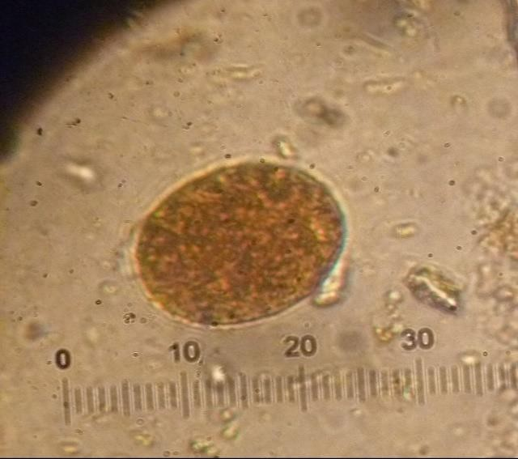
Photo 5: Codiostomum sp. egg (38x29 µm)

