Supporting Information for
The 2021 Melamchi Flood: A massive erosional cascade in the Himalayan Mountains of central Nepal

This PDF file includes:
Methods
Figures S1 to S7
Tables S1 to S4
References

Methods

Satellite imagery
To assess the impacts of the 2015 Gorkha earthquake and 2021 Melamchi Floods, three sets of Pléiades stereo satellite images (2014, 2020, 2021) and one set of Worldview-2 images (2017) have been analyzed (Figure S1). The Pléiades data used in this study contained 0.5 m resolution panchromatic and 2.0 m resolution multi-spectral images, which were pansharpened and orthorectified using the NASA open-sourced algorithm Ames Stereo Pipeline (ASP) version 3.0.0 (Beyer et al., 2018). Worldview imagery used here only contained a 1 m resolution panchromatic band. These images were orthorectified via ASP.

Landslide and river channel mapping
For each orthoimage, we manually mapped the margins of active river channels, which were defined by the absence of vegetation, and then measured their width along the river’s central line. We also mapped landslides and other kinds of mass movements associated with the time interval between each set of images (Figure S2). The size distribution of landslides is shown in Figure S3. The 2020 and 2021 images were compared to determine the mass movements associated with the 2021 Melamchi Floods (Figure S4). The 2014 Pléiades imagery and 2013 Google Earth imagery were used for identifying pre-existing landslides. We superimposed previously-mapped Gorkha co-seismic landslides (Roback et al., 2018) on the 2017 Worldview and 2020 Pleiades imagery to recognize post-seismic landslides. We note that because the 2014 Pléiades imagery only covers the headwater and middle-lower reach of the Melamchi Valley (Figure S1a), our mapping of post-seismic landslides is incomplete. Landslides with formation time that could not be determined were categorized into ‘other landslides’ (Figure 1).

DEM generation, co-registration, and comparison
To quantify flood-related erosion and deposition, we took the 2020 and 2021 Pléiades imagery and used the parallel_stereo function in ASP to generate digital elevation models (DEMs) before and after the flood. To increase the accuracy of elevation values in steep, mountainous terrain, raw images were registered with a smoothed reference DEM before running the stereo algorithm. For the reference DEM, we used the ALOS Global Digital Surface Model (AW3D30) and smoothed it by average downsampling to 300 m resolution and cubicspline upsampling to 30 m resolution. To further improving data quality and ensure precise triangulation, several filtering procedures were invoked in the stereo process, as shown in Table S1. The resulting DEMs have 1 m resolution.

To ensure measurements of true topographic changes, we co-registered the DEM pairs before differencing them. Shapefiles of the post-flood landslides and river channels (areas modified by the flood) were used as mask layers during the co-registration procedure (i.e., these change areas were not included in the co-registration). Areas with elevation errors due to cloud cover, shadow, or image distortion (37 km²; 11.4% of the catchment area of 324.4 km²) were also excluded in the process. To test whether the two DEMs were accurately co-registered, we computed the statistics of the differencing results over stable regions of the study area (Figure S4). Although some hillslopes (A1-A7 in Figure S5) have larger errors (Table S2) plausibly related to the effect of steep and rugged landscapes in the upland, their influences are local and do not significantly extend to our targeted river segments. Overall, the catchment-scale results have small values of the mean (-0.27 m), mean absolute deviation (-0.11 m), and median absolute deviation (0.003 m), suggesting that the co-registration performed well (Table S2).

For volume estimation of erosion and aggradation at each targeted river segment (Table S4), we used the standard deviation of their surrounding stable areas (in a radius of ~350 m) to estimate the volume uncertainty, u(V).

$u\left(V\right)= \sqrt{{(y∙x)}^{2}∙u^{2}\left(x\right)+{\left(x∙z\right)}^{2}∙u^{2}\left(y\right)+{\left(x∙y\right)}^{2}∙u^{2}\left(z\right)}$ (1)

where x,y,z are the average dimensions of the volume. In our case, the area is calculated from a shapefile, so we assume there is no error from the area. Thus, we can simplify equation (1) as:

$u\left(V\right)= \sqrt{{\left(x∙y\right)}^{2}∙u^{2}\left(z\right)}$ (2)

This approach assumes that the errors in x, y, and z are not correlated, which we expect to be the case for our DEMs. Our error estimation based on the standard deviation of differences across all stable areas likely sets the upper limit on actual uncertainty because the data distribution of the differencing results is not perfectly normal. A small number of large magnitude outliers strongly impact the standard deviation values. Therefore, we also compute the statistics of values in the stable areas which lie between the 10th and 90th quantiles, which reduces the calculated uncertainty by 65% to 90% (Table S3). We use this standard deviation for the region unaffected by outliers as the lower estimate of the volume uncertainty. In Table S4, we report both the upper and lower limits of the uncertainty.

Following co-registration of the DEMs (using the pc_align tool in ASP), we conducted river profile analysis using TopoToolBox 2.4 (Schwanghart & Scherler, 2014) to quantify how the Melamchi Floods changed the topography of the mainstem (Figure 1d). We compared the DEMs to calculate erosion and deposition at each river segment using SAGA raster volume function in qGIS.

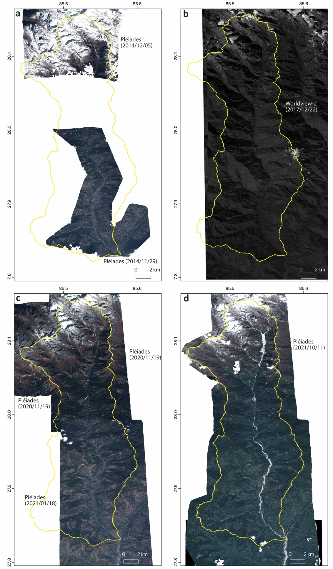
Figure S1. Satellite imagery analyzed in this study.
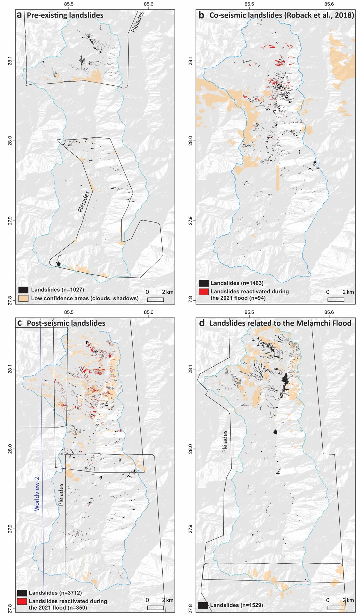
Figure S2. Landslides and mass movements in different periods.
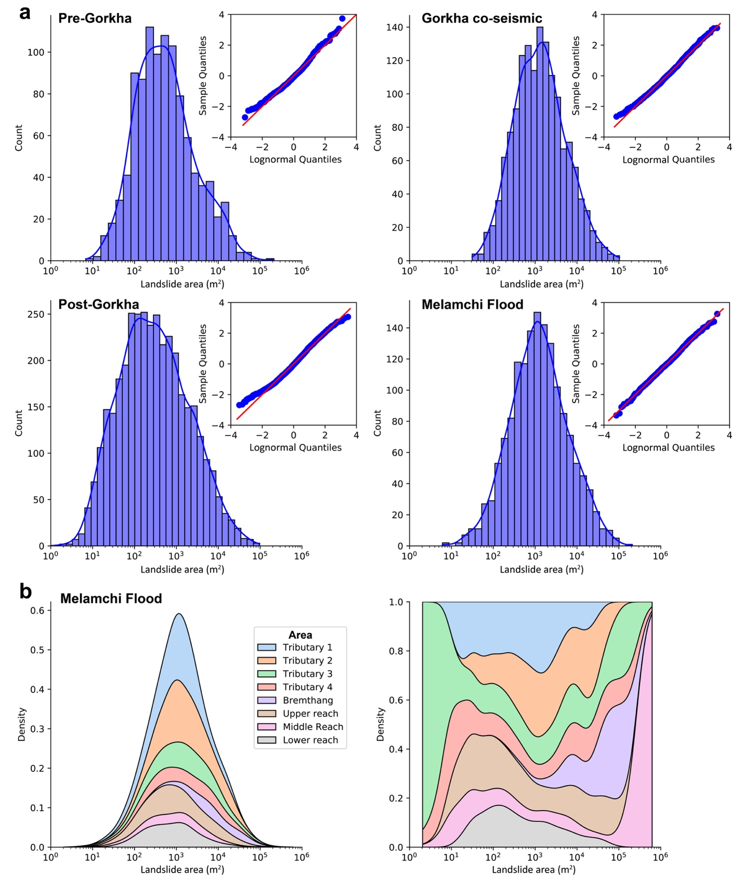
Figure S3. Landslide size distributions. (a) Landslide size distributions before, during, and after the Gorkha earthquake and the Melamchi Floods; all appear to be “characteristic” distributions (Medwedeff et al., 2021). (b) Landslide size distribution in each fluvial segment for the Melamchi Floods. This shows that most of large landslides were from the high-elevation valley of Bremthang, as a result of incision of ancient valley fills.
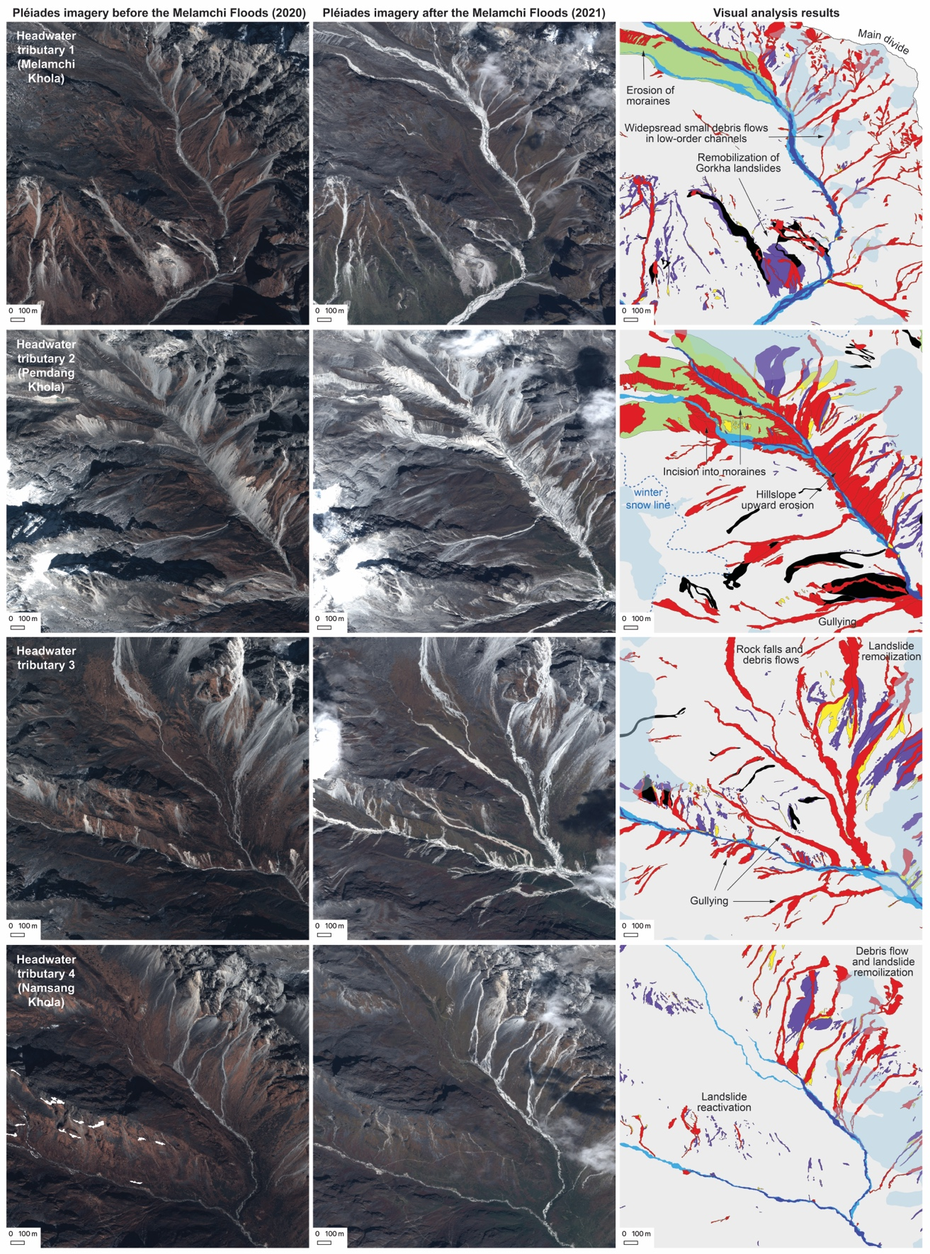
Figure S4. Examples of erosion in the headwater tributaries by the Melamchi Floods. Yellow – landslides existing before 2014; Black – Gorkha co-seismic landslides; Purple – post-seismic landslides; Red – mass movements during the Melamchi Floods; Green – glacial deposits; Deep blue – river channels in November 2020; Blue – river channels in October 2021; Light blue – low-confidence areas due to cloud cover.
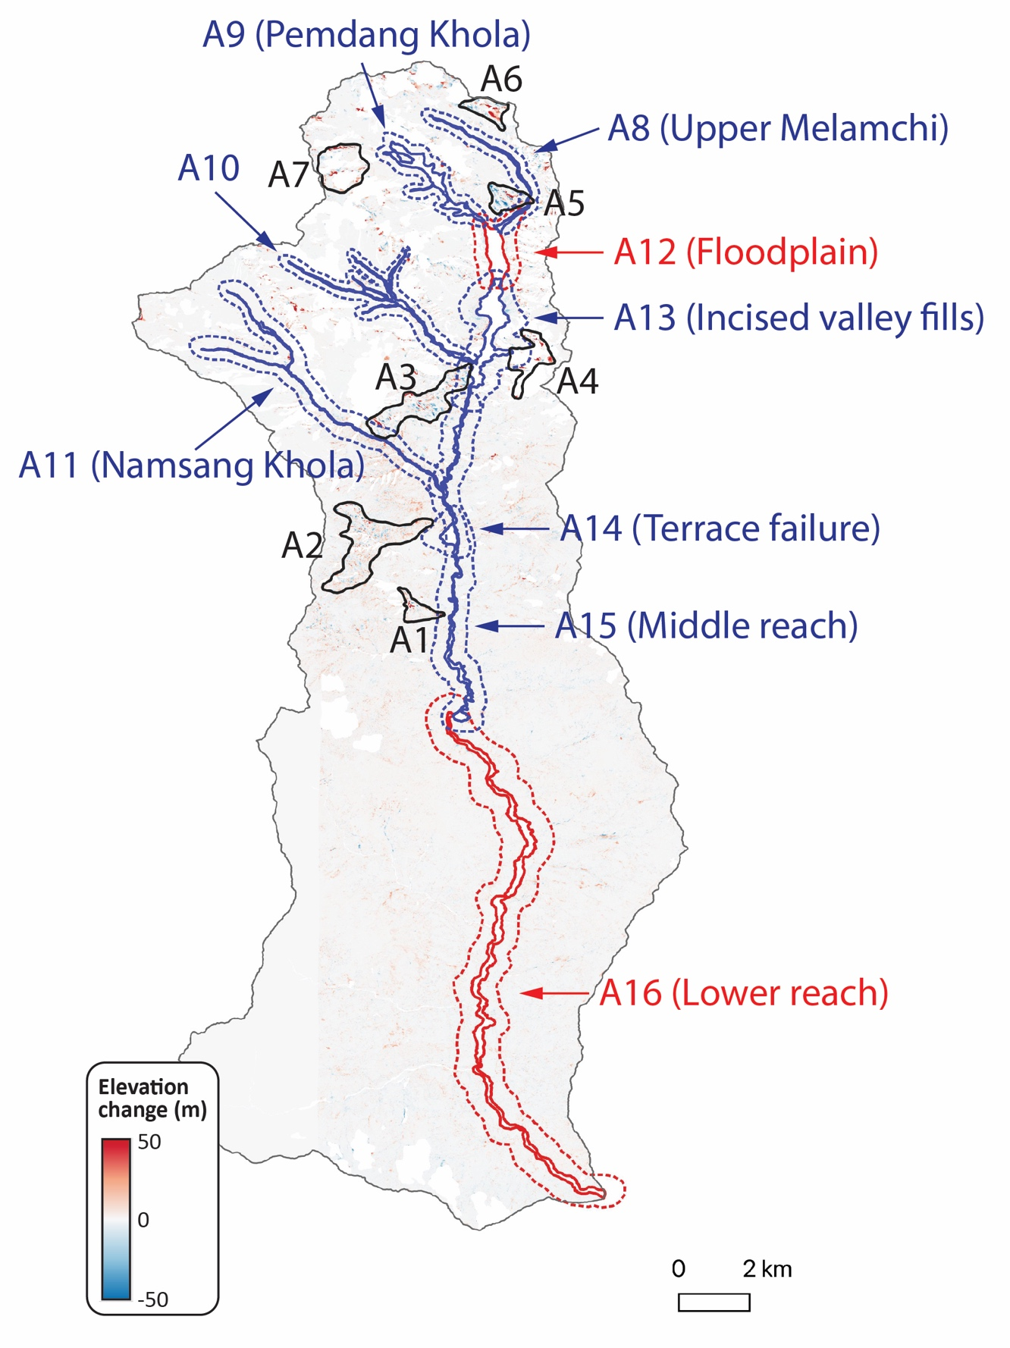
Figure S5. 1-m resolution DEM differencing results for the stable areas. Black polygons indicate the hillslopes with relatively large errors (Table S2). Red and blue polygons are the river segments which erosion and deposition volumes have been quantified. Volumetric uncertainties have been calculated based on the standard deviation of DEM differencing results of the surrounding stable areas (inside the dashed areas).
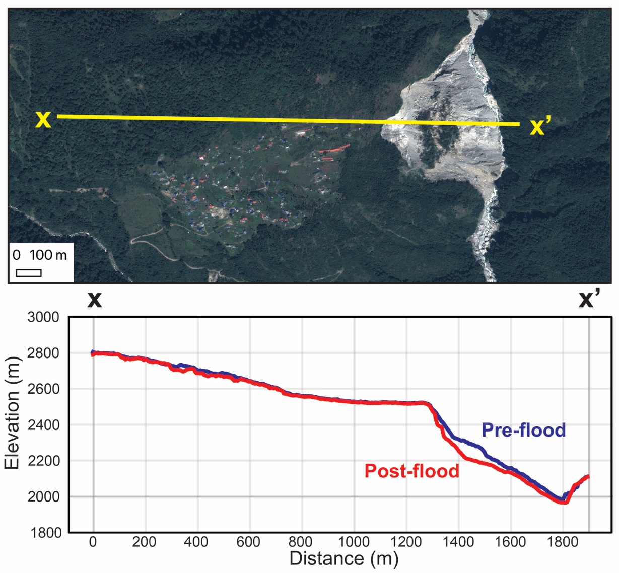
Figure S6. Slope stability analysis of the Melamchigaon Terrace failure. We use the method of slices (Low et al., 1998) to calculate the factor of safety. The slope geometry (i.e., height and slope angle) is based on the real terrace. Following previous rock strength survey and modeling in this region (Medwedeff et al., 2022), the rock cohesion is set to 18 kPa and the fraction angle is set to 33 degree. The analysis suggests that downcutting of 70 feet (21.336 m) at the terrace foot, similar to that observed as a result of the flood, could cause slope failure as the factor of safety changes from 1.04 to 0.69.
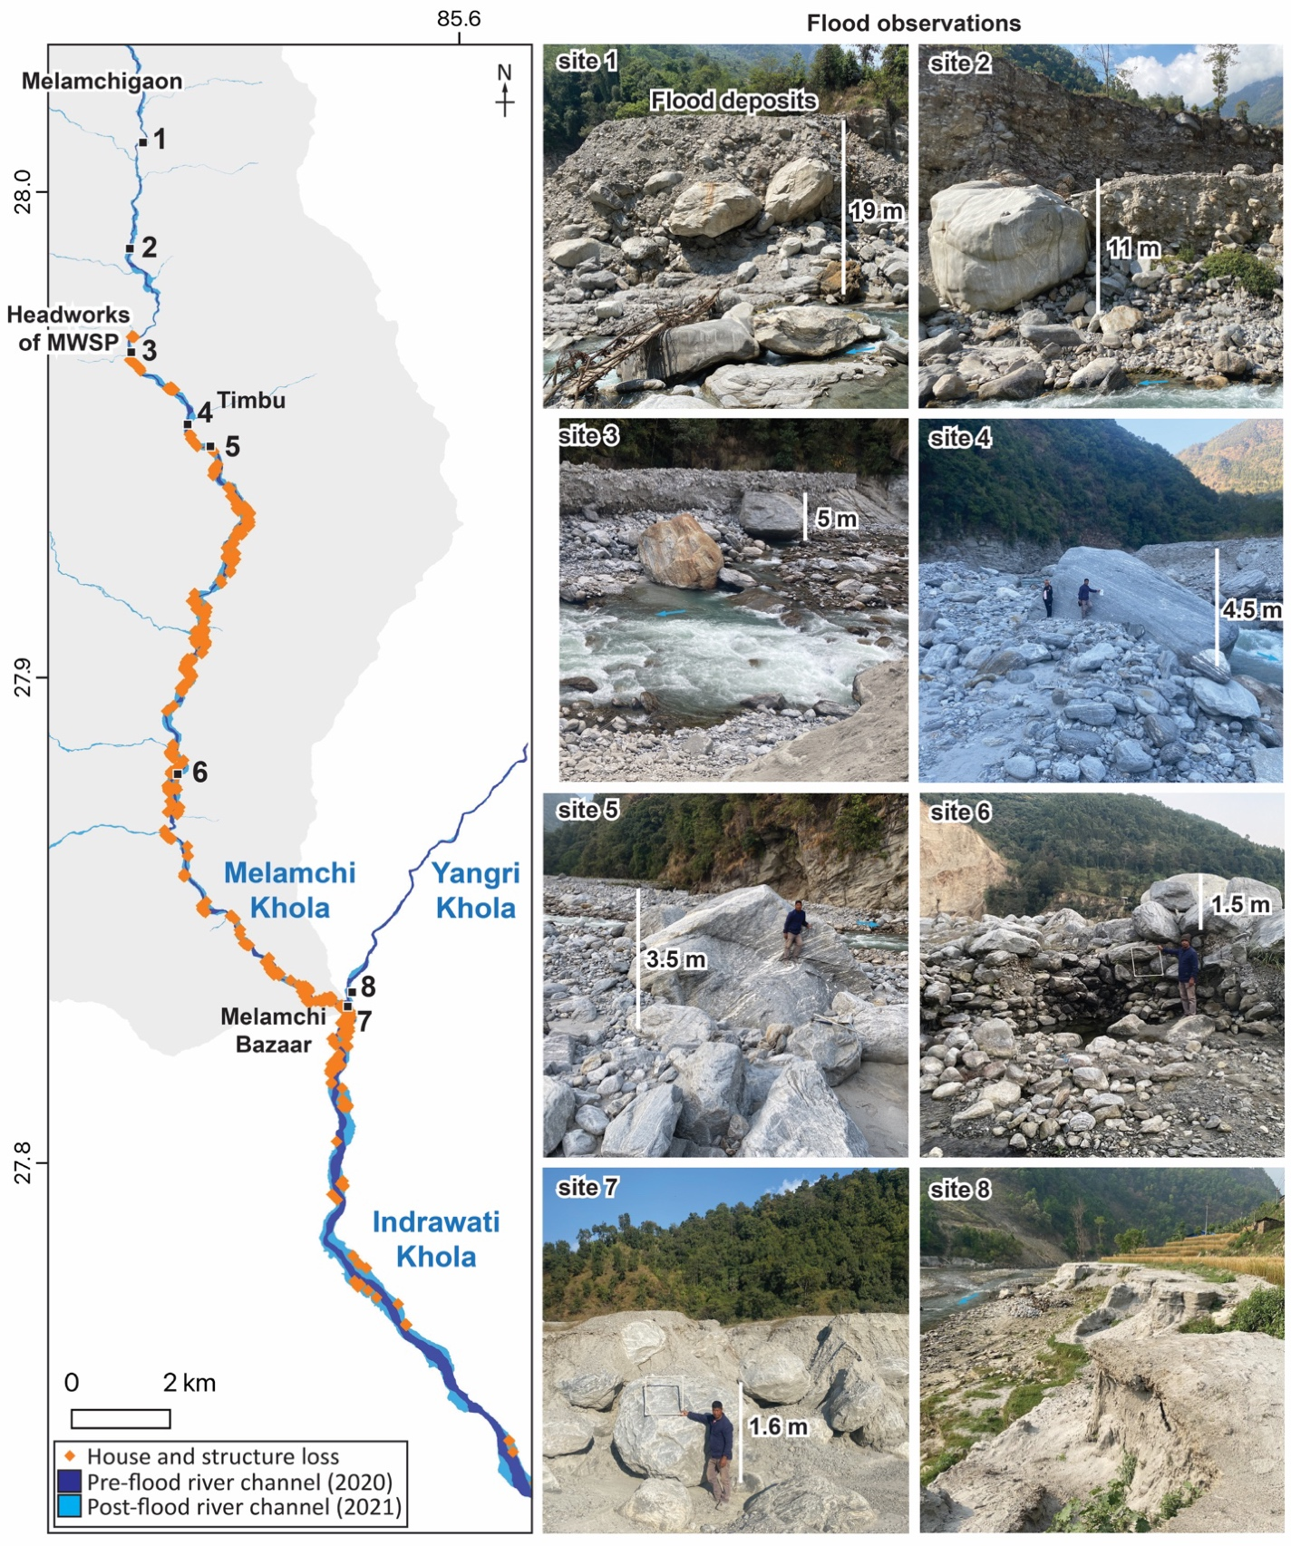
Figure S7. Post-flood damage analysis and field reconnaissance. From comparison of the 2020 and 2021 Pléiades images, we identify 708 damaged or destroyed houses and structures and up to 3 km² of farmland loss. Our field surveys in April and November 2022 observed that large boulders (1-10 m in diameter) are commonly enfolded in flood deposits, suggesting a strong sediment transport capacity of the Melamchi Floods. We also observed that sediment aggradation at the Melamchi-Indrawati confluence caused 4-5 m of blackwater deposition in the Yangri Khola (site 8; Figure 3i).
Table S1. ASP parameters used in DEM generation.
Parameter | Value
--stereo-algorithm | asp_final_mgm
--corr-kernel | 9 9
--cost-mode | 3
--subpixel-mode | 12
--rm-cleanup-passes | 1
--filter-mode | 2
--rm-threshold | 3.5
--rm-min-matches | 50
--rm-half-kernel | 9 9
--threads-multiprocess | 8
--processes | 2
--xcorr-threshold | -1
--min-xcorr-level | 1
--corr-memory-limit-mb | 4096
--sgm-collar-size | 512
--corr-tile-size | 2048

Table S2. Statistics of DEM differencing results on the stable areas.
Area Name  (Figure S4) |  | Average Slope (degree) | Statistics of DEM Differencing
 |  | Average Slope (degree) | Mean (m) | Median (m) | Standard Deviation (m) | Mean Absolute Deviation (m) | Median Absolute Deviation (m)
Whole Melamchi catchment |  | 36.59 | -0.27 | -0.14 | 4.21 | -0.11 | 0.003
Areas with larger errors | A1 | 46.5 | -3.25 | 0 | 15.84 | -3.01 | 0
Areas with larger errors | A2 | 45.42 | -1.34 | -0.32 | 8.68 | -1.02 | 0.074
Areas with larger errors | A3 | 49.26 | 0.12 | -0.75 | 13.29 | 0.87 | 0.75
Areas with larger errors | A4 | 41.1 | -11.47 | -0.27 | 28.67 | -11.2 | -0.477
Areas with larger errors | A5 | 46.83 | 2.33 | 0 | 18.82 | 2.33 | 0
Areas with larger errors | A6 | 37.16 | -3.48 | 0 | 18.53 | -3.48 | 0
Areas with larger errors | A7 | 35.02 | -3.36 | 0.68 | 13.88 | -4.04 | -0.887
Areas surrounding the target river segments | A8 | 26.75 | 0.11 | 0.03 | 4.2 | 0.08 | 0.003
Areas surrounding the target river segments | A9 | 35.6 | -0.39 | -0.19 | 4.19 | -0.2 | 0.002
Areas surrounding the target river segments | A10 | 35.83 | -0.24 | -0.04 | 3.4 | -0.2 | -0.004
Areas surrounding the target river segments | A11 | 35.73 | -0.61 | -0.04 | 4.71 | -0.57 | -0.004
Areas surrounding the target river segments | A12 | 34.46 | 0.44 | 0.27 | 3.55 | 0.17 | 0.003
Areas surrounding the target river segments | A13 | 42.09 | 0.03 | 0.06 | 6.99 | -0.03 | -0.004
Areas surrounding the target river segments | A14 | 40.84 | -0.46 | 0 | 4.74 | -0.48 | 0
Areas surrounding the target river segments | A15 | 40.68 | -0.17 | 0.08 | 4.1 | -0.25 | 0.003
Areas surrounding the target river segments | A16 | 34.34 | -0.003 | 0.17 | 2.75 | -0.17 | -0.004

Table S3. Statistics of DEM differencing results on the stable areas (10th - 90th quantiles).
Area Name  (Figure S4) |  | 10th quantile value (m) | 90th quantile value (m) | Mean (m) | Median (m) | Standard Deviation (m)
Areas surrounding the target river segments | A8 | -0.834961 | 1.214844 | 0.0491 | 0 | 0.4148
Areas surrounding the target river segments | A9 | -1.162109 | 0.701172 | -0.1597 | -0.0215 | 0.4021
Areas surrounding the target river segments | A10 | -1.033203 | 0.797852 | -0.0523 | 0 | 0.3546
Areas surrounding the target river segments | A11 | -3.210938 | 1.418945 | -0.1243 | 0 | 0.6999
Areas surrounding the target river segments | A12 | -0.759766 | 2.78418 | 0.3143 | 0.1074 | 0.6076
Areas surrounding the target river segments | A13 | -3.93457 | 4.289062 | 0.1156 | 0 | 1.3125
Areas surrounding the target river segments | A14 | -3.875 | 2.3125 | -0.081 | 0 | 1.073
Areas surrounding the target river segments | A15 | -3.223633 | 2.643555 | 0.0299 | 0 | 1.093
Areas surrounding the target river segments | A16 | -2.387695 | 2.145508 | 0.102 | 0 | 0.8832

Table S4. Erosion and aggradation in the targeted river segments.
River  Segment | Average Slope (degree) | Erosion |  |  |  | Aggradation
River  Segment | Average Slope (degree) | Area (m²) | Max Depth (m) | Average Depth (m) | Volume (m³) * | Area (m²) | Max Depth (m) | Average Depth (m) | Volume (m³) *
Tributary 1 (Melamchi Khola) | 19.25 | 279,921 | 17.55 | -1.41 | 394,051  ($±$297.9%)  ($±$29.4%) | neglectable
Tributary 2 (Pemdang Khola) | 37.52 | 905,355 | 44.99 | -8.39 | 7,448,770  ($±$49.9%)  ($±$4.8%) | neglectable
Tributary 3 | 31.02 | 557,317 | 43.91 | -2.84 | 1,582,369  ($±$119.7%)  ($±12$.5%) | neglectable
Tributary 4  (Namsang Khola) | 27.26 | 280,619 | 15.1 | -2.37 | 667,403  ($±$198.7%)  ($±$29.5%) | neglectable
Bremthang floodplain | 9.72 | neglectable |  |  |  | 855,942 | 33.3 | 6.72 | 5,753,690  ($±$52.8%)  ($±$9.0%)
Bremthang incised valley fills | 38.07 | 1,393,994 | 133.32 | -36.06 | 50,271,285  ($±$19.4%)  ($±$3.6%) | neglectable
Melamchigaon Terrace failure | 40.39 | 215,005 | 98.06 | -28.97 | 6,229,236  ($±$16.4%)  ($±$3.7%) | neglectable
Melamchi Khola (middle reach) | 36.18 | 894,819 | 69.18 | -12.63 | 11,797,596  ($±$32.5%)  ($±$8.7%) | neglectable
Melamchi Khola (lower reach) | 12.8 | 852,523 | 59.25 | 6.27 | 5,342,429  ($±$43.9%)  ($±$14.1%) | 2,265,777 | 23.02 | 7.54 | 17,079,946  ($±$36.5%)  ($±$11.7%)
* volume uncertainties are calculated from the standard deviation of DEM differencing values in the surrounding stable areas using equation (2). Green is based on calculation of all values (Table S2), whereas blue is based on calculation of values between the 10th and 90th quantiles (Table S3).
Reference
Beyer, R. A., Alexandrov, O., & McMichael, S. (2018). The Ames Stereo Pipeline: NASA's open source software for deriving and processing terrain data. Earth and Space Science, 5(9), 537-548.
Low, B., Gilbert, R., & Wright, S. (1998). Slope reliability analysis using generalized method of slices. Moment, 1, 2.
Medwedeff, W. G., Clark, M. K., Zekkos, D., West, A. J., & Chamlagain, D. (2022). Near‐surface geomechanical properties and weathering characteristics across a tectonic and climatic gradient in the Central Nepal Himalaya. Journal of Geophysical Research: Earth Surface, 127(2), e2021JF006240.
Roback, K., Clark, M. K., West, A. J., Zekkos, D., Li, G., Gallen, S. F., Chamlagain, D., & Godt, J. W. (2018). The size, distribution, and mobility of landslides caused by the 2015 Mw7. 8 Gorkha earthquake, Nepal. Geomorphology, 301, 121-138.
Schwanghart, W., & Scherler, D. (2014). TopoToolbox 2–MATLAB-based software for topographic analysis and modeling in Earth surface sciences. Earth Surface Dynamics, 2(1), 1-7.

