Supplementary Information
Deciphering the lithium ion conduction mechanism in solid-electrolyte-interphase
Jinran Sun^{1,} ^{2†}, Jitong Yan^{3†}, Fan Li^{4†}, Jiedong Li¹, Jun Ma¹, Shu Zhang¹, Guangjin Hou^{4,} *, Yongfu Tang^{3,5}*, Shanmu Dong^{1,} *, Jianyu Huang⁵ and Guanglei Cui^{1,2,} *

¹Qingdao Industrial Energy Storage Research Institute, Qingdao Institute of Bioenergy and Bioprocess Technology, Chinese Academy of Sciences, Qingdao, 266101, P. R. China
²Center of Materials Science and Optoelectronics Engineering, University of Chinese Academy of Sciences, Beijing 100049, P. R. China
³Hebei Key Laboratory of Applied Chemistry, College of Environmental and Chemical Engineering, Yanshan University, Qinhuangdao 066004, P. R. China
⁴State Key Laboratory of Catalysis, Dalian National Laboratory for Clean Energy, Collaborative Innovation Center of Chemistry for Energy Materials, Dalian Institute of Chemical Physics, Chinese Academy of Sciences, Dalian 116023, P. R. China
⁵Clean Nano Energy Center, State Key Laboratory of Metastable Materials Science and Technology, Yanshan University, Qinhuangdao 066004, P. R. China
†These authors contributed equally to this work.
*To whom correspondence should be addressed. E-mail: tangyongfu@ysu.edu.cn; ghou@dicp.ac.cn; dongsm@qibebt.ac.cn; cuigl@qibebt.ac.cn

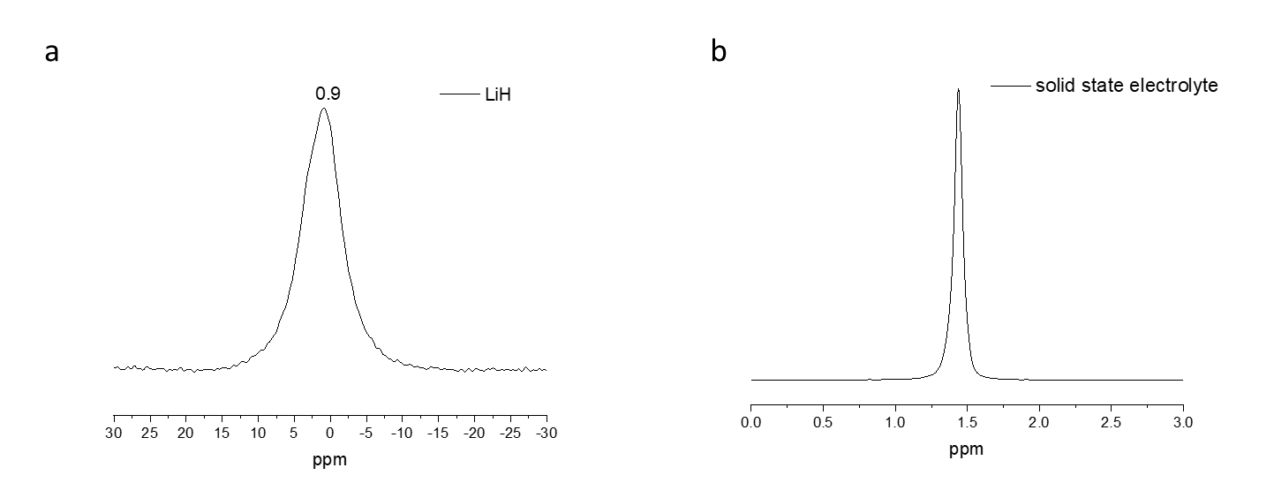
Fig S1. The single-pulse Li MAS NMR spectrum of the LiH (a) and solid-state electrolyte (b).
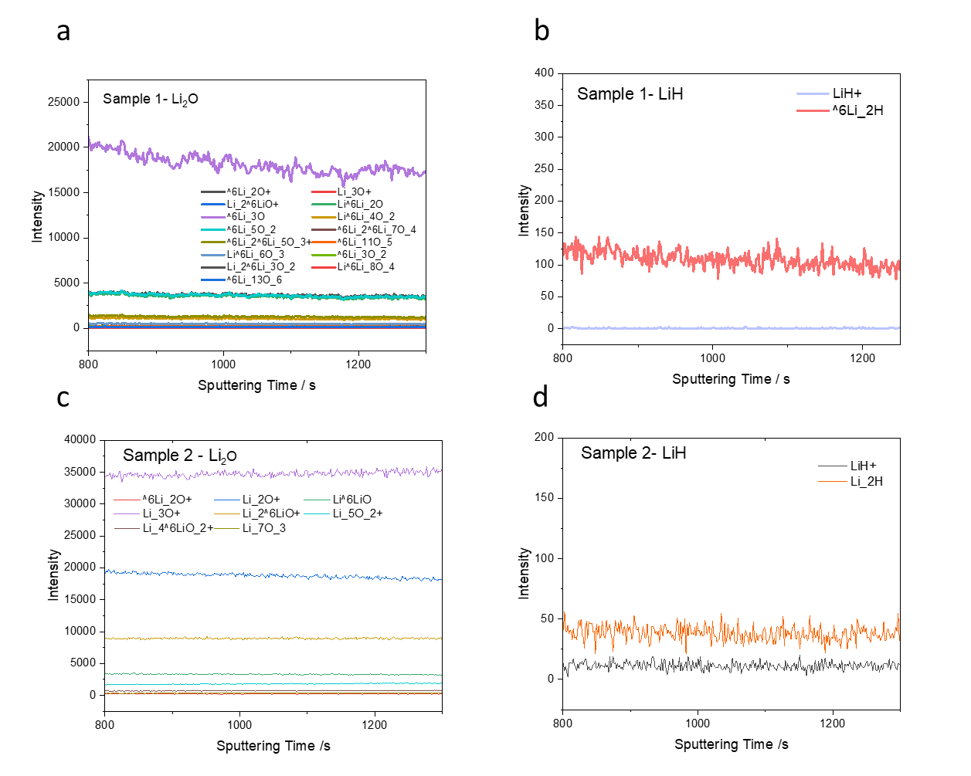
Fig S2. The TOF SIMS spectra of sample 1 and sample 2. a, the signal related to Li₂O in sample 1. b, the signal related to LiH in sample 1. c, the signal related to Li₂O in sample 2. d, the signal related to LiH in sample 2.

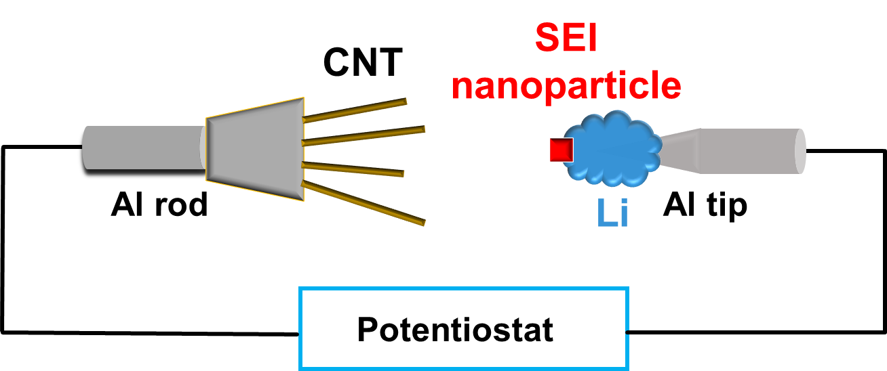
Fig S3. The schematic of the nanobattery (CNT-electrolyte-Li). The nanobattery (CNT-electrolyte-Al) can be set up via removing Li.

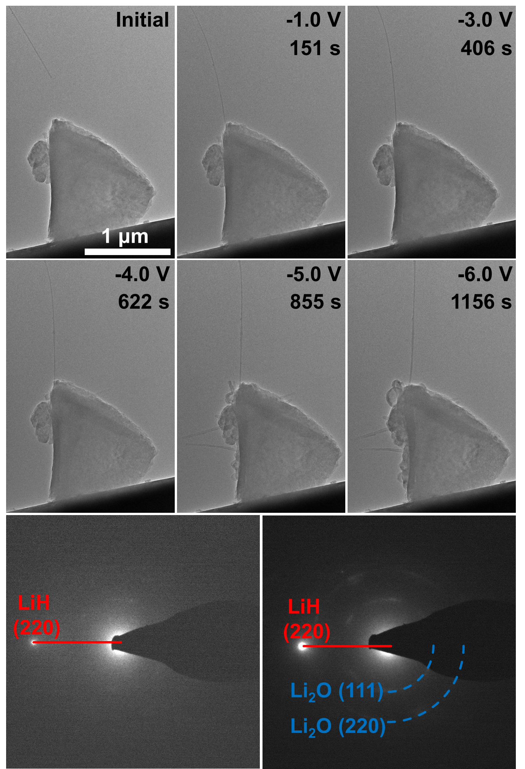
Fig S4. Characterization of the CNT-LiH-Al nanobattery during the discharge process, and corresponding electron diffraction patterns (EDP).

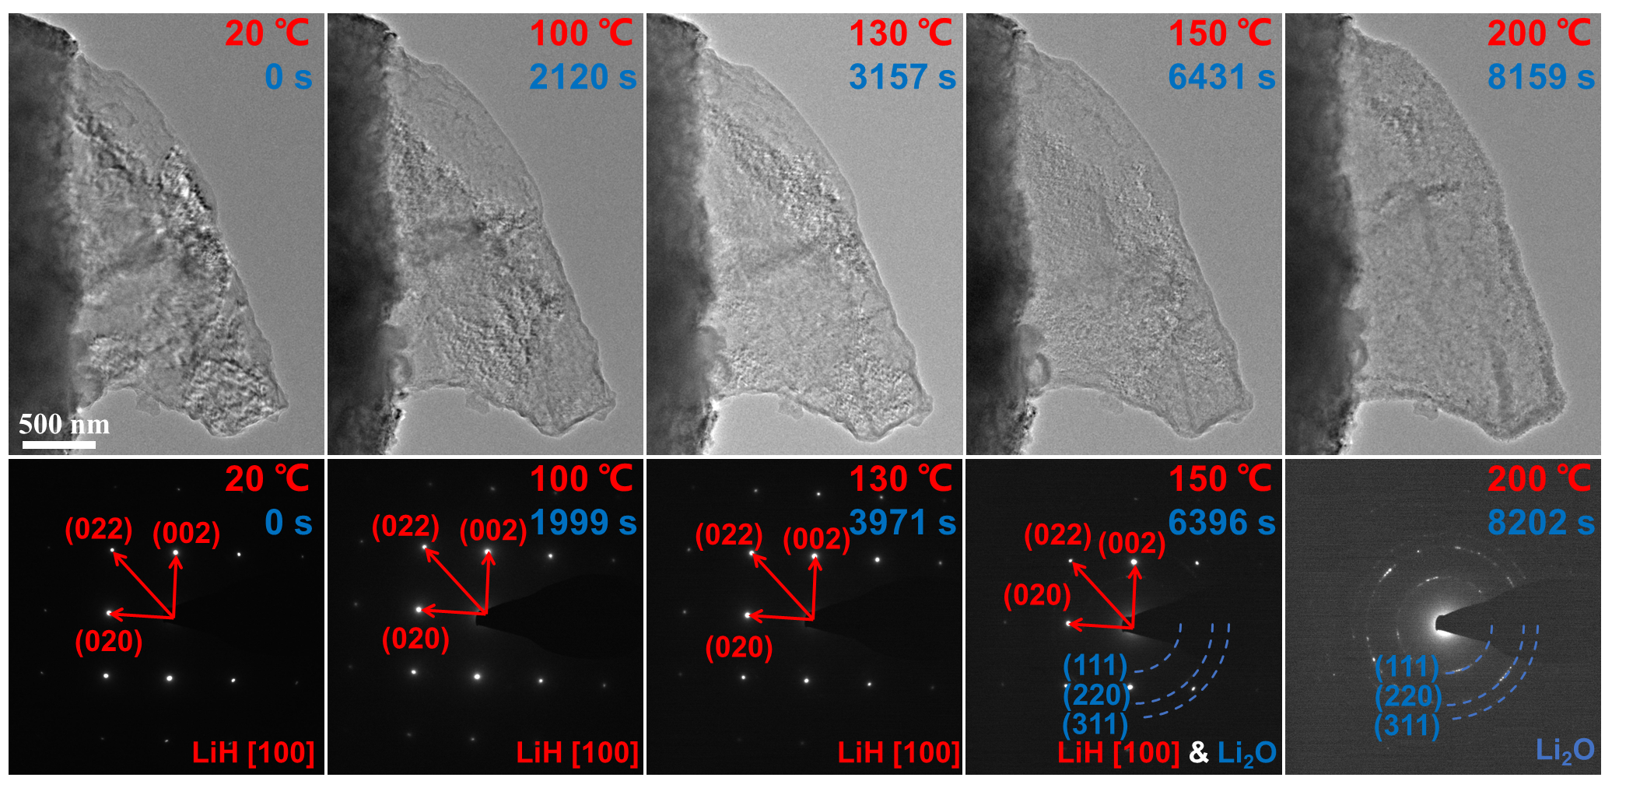
Fig S5. Stability characterization of LiH during the heating process, and corresponding electron diffraction patterns (EDP).

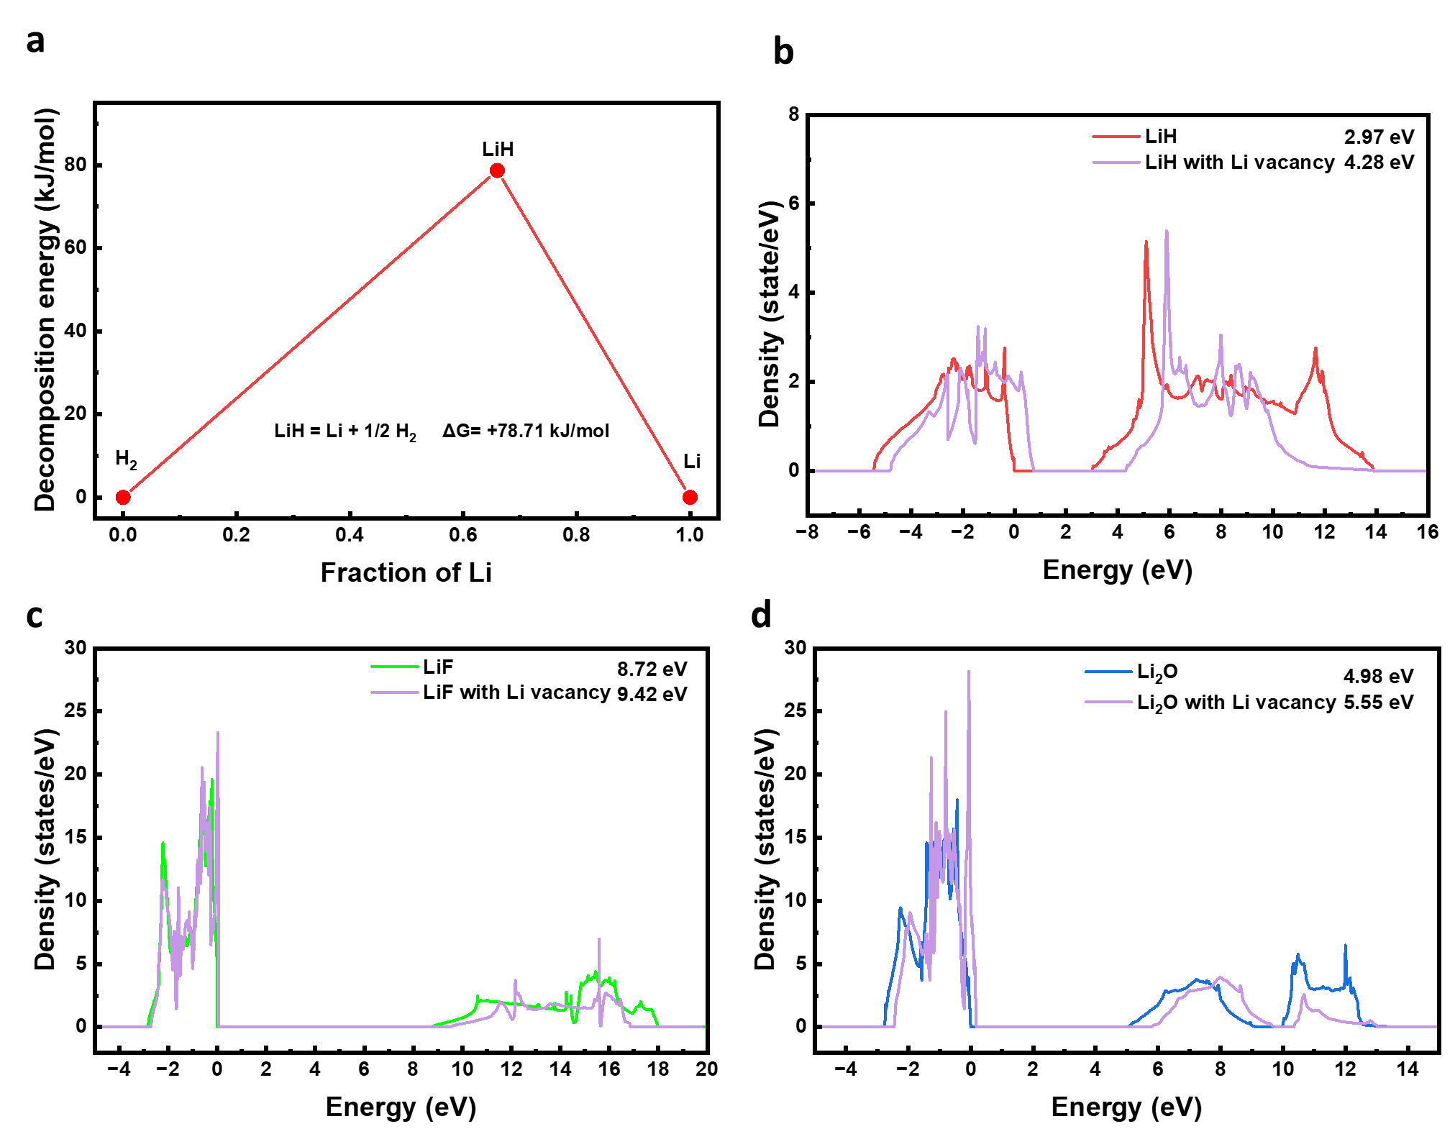
Fig S6. The calculation results related to LiH. a, The Gibbs free energy (ΔG) of the decomposition reaction. b, The band gap of LiH. c, The band gap of LiF. d, The band gap of Li₂O.

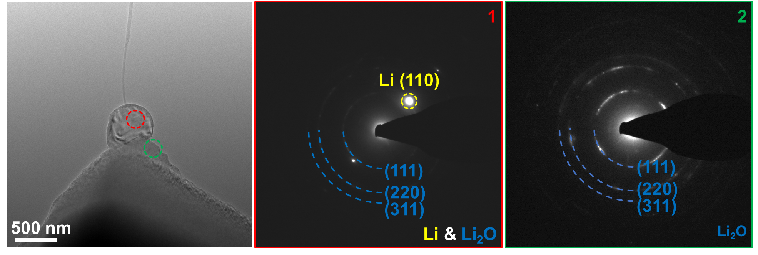
Fig S7. The electron diffraction patterns of Li and Li₂O which was captured from CNT-LiF-Li nanobattery.

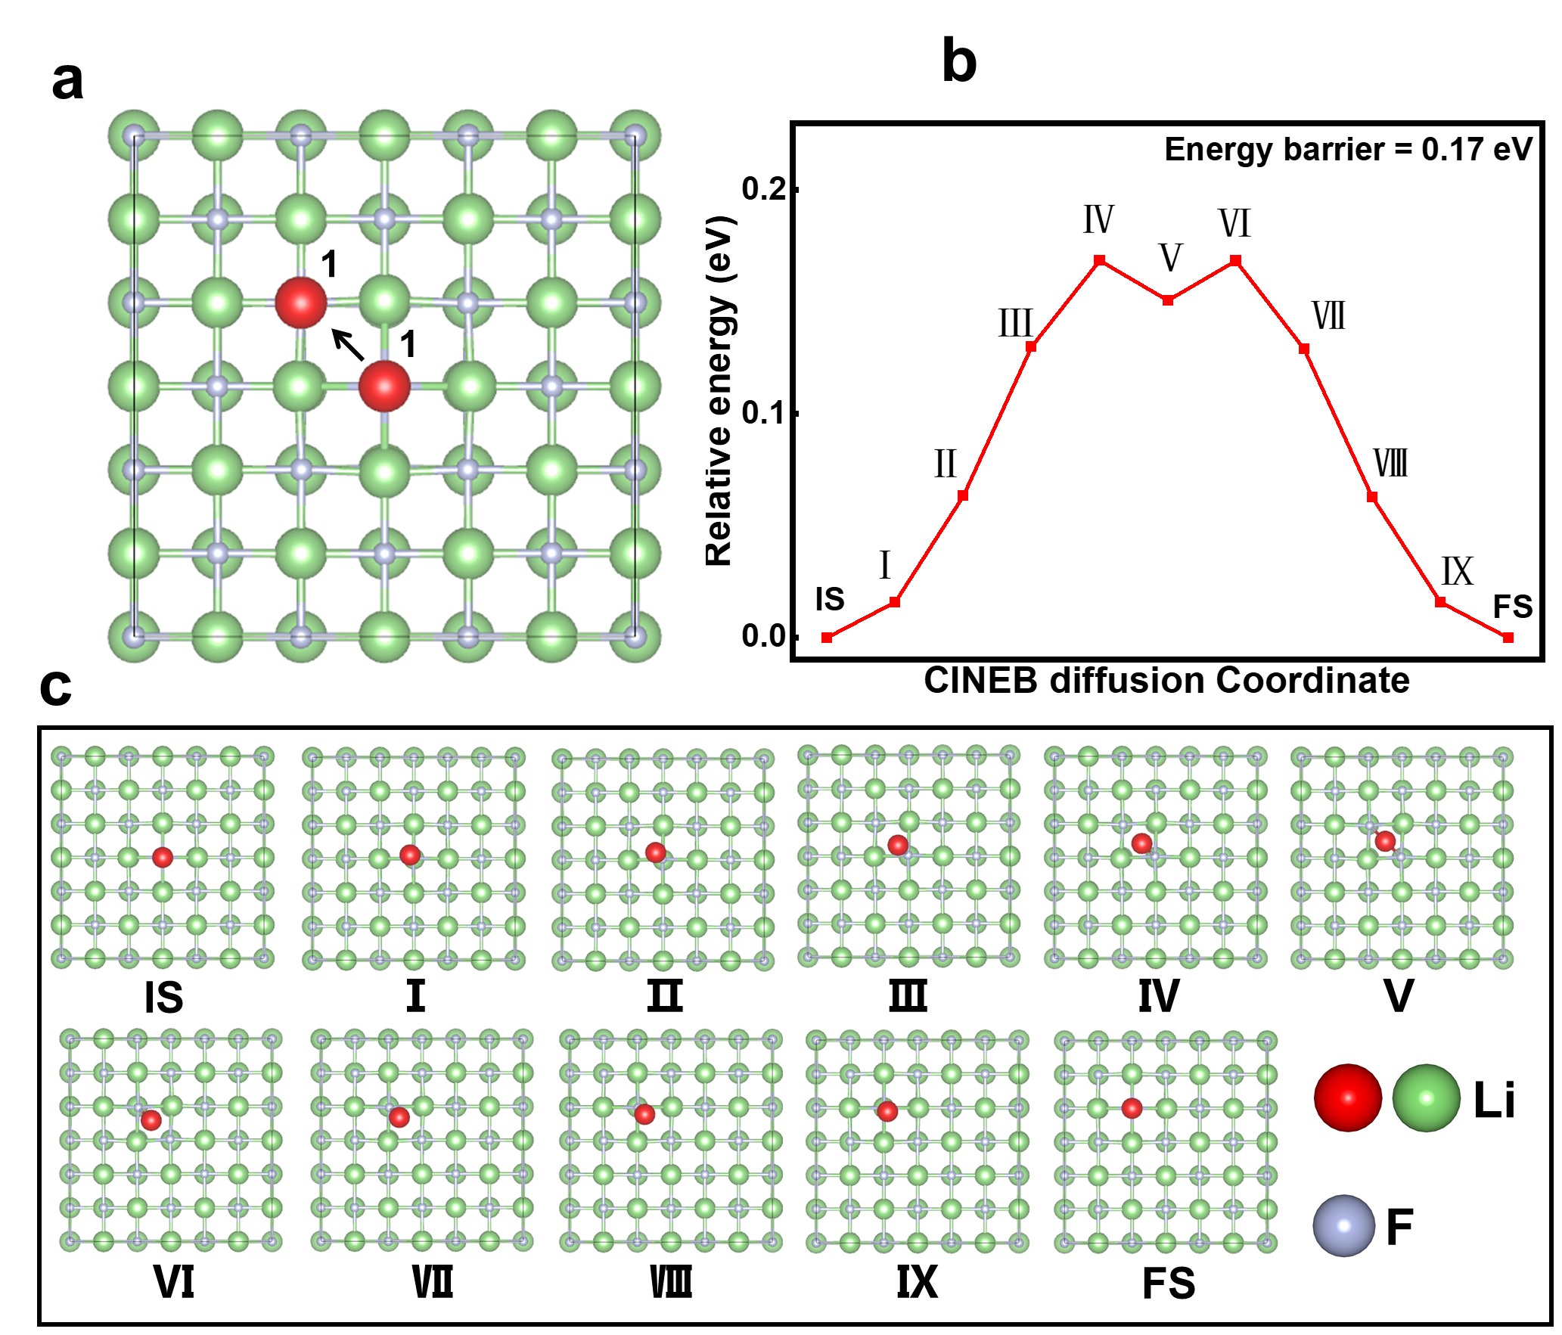
Fig S8. (a) CINEB simulation of the Li⁺ conduction pathway on LiF (100), surface conduction. (b) Relative energy of the Li⁺ conduction process shown in Figure a. (c) Detail structure images during the Li⁺ conduction shown in Figure a.

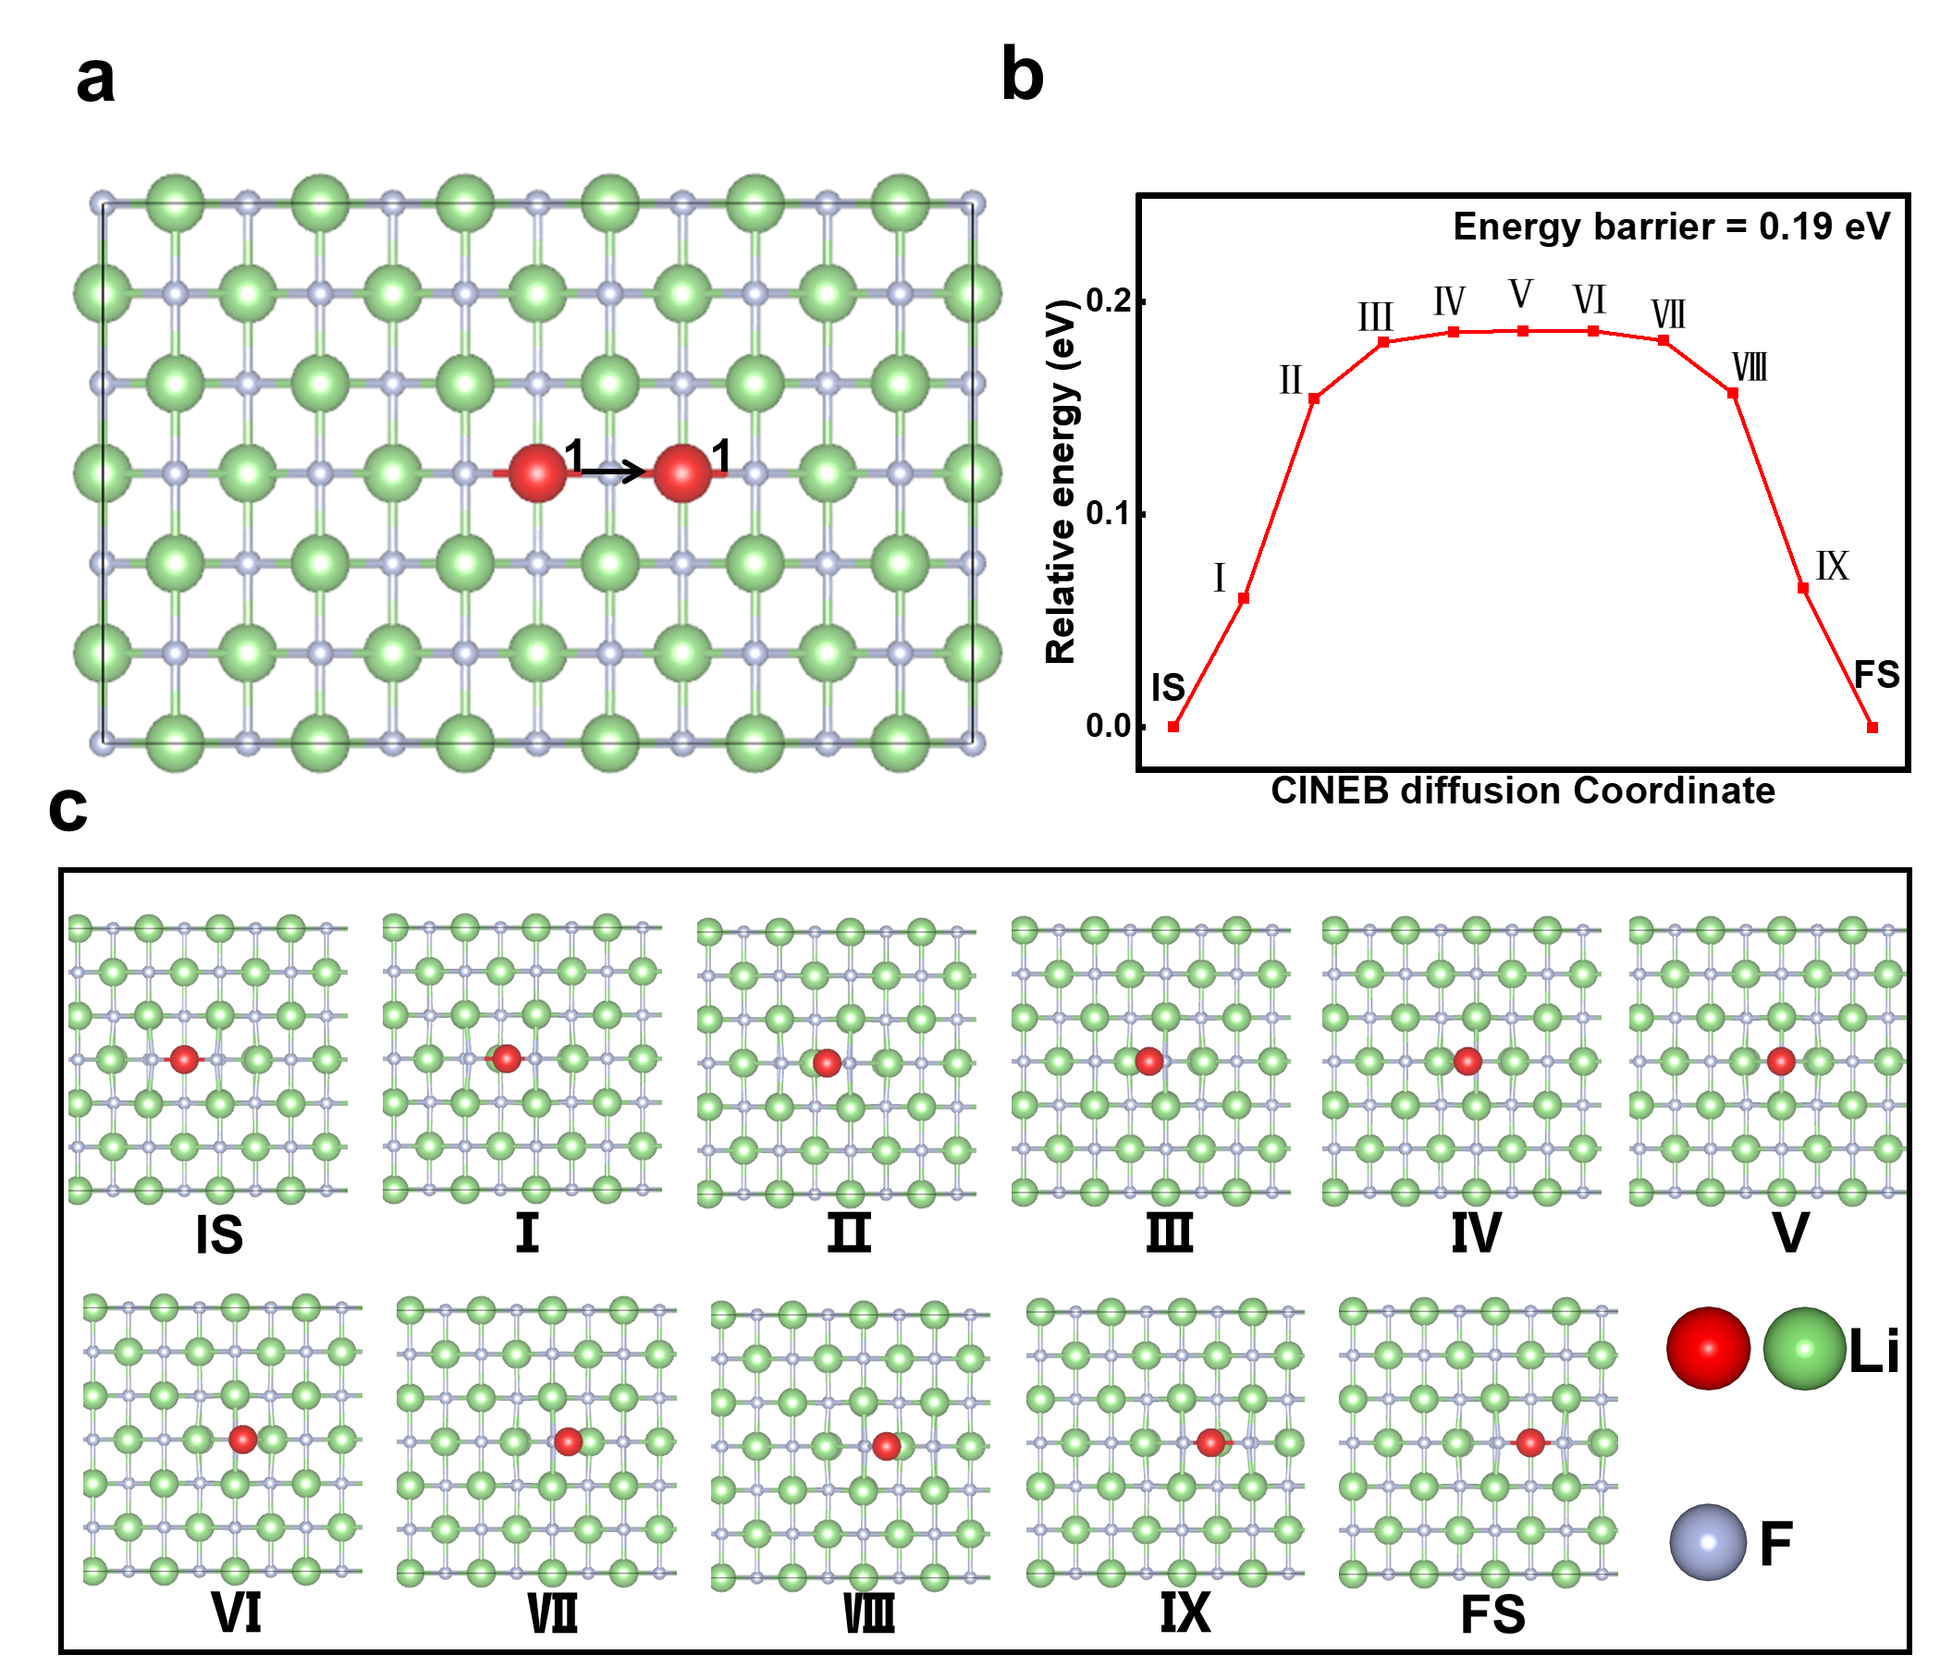

Fig S9. (a) CINEB simulation of the Li⁺ conduction pathway on LiF (110), surface conduction. (b) Relative energy of the Li⁺ conduction process shown in Figure a. (c) Detail structure images during the Li⁺ conduction shown in Figure a.

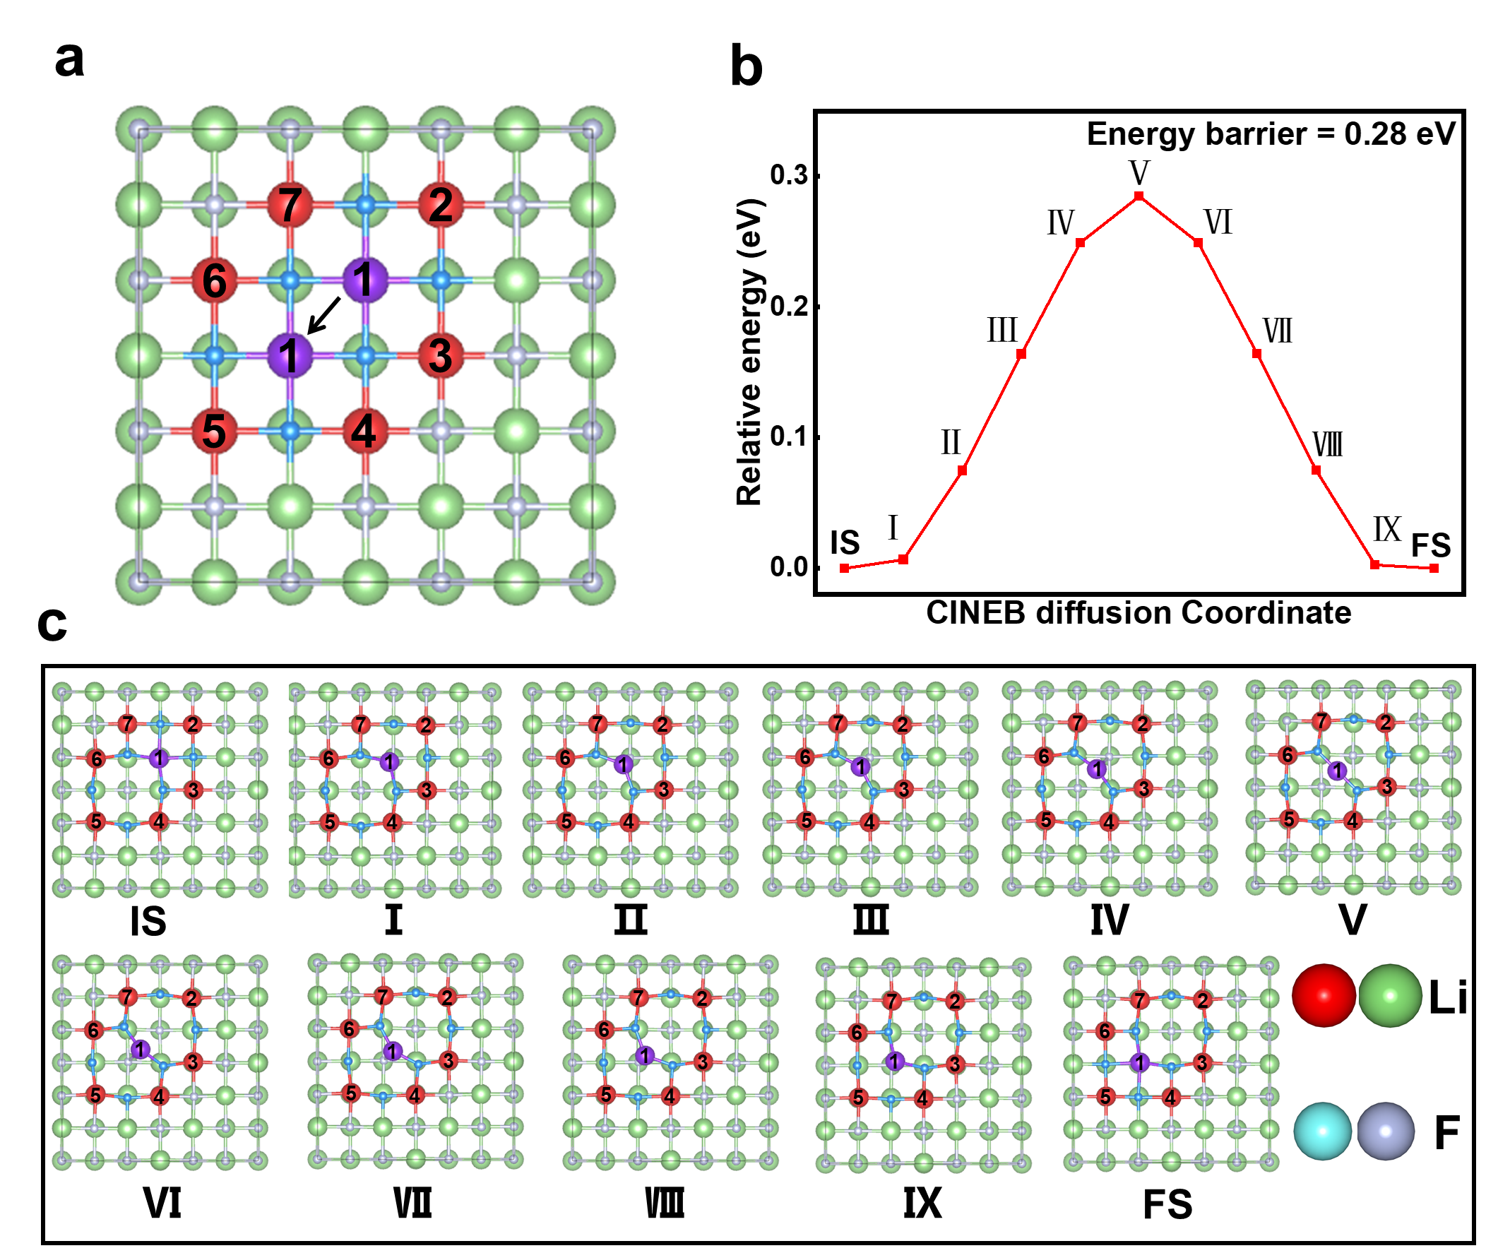
Fig S10. (a)CINEB simulation of the Li⁺ conduction pathway on the LiF (100), surface vacancy conduction. (b) Relative energy of the Li⁺ conduction process shown in Figure a. (c) Detail structure images during the Li+ conduction shown in Figure a.

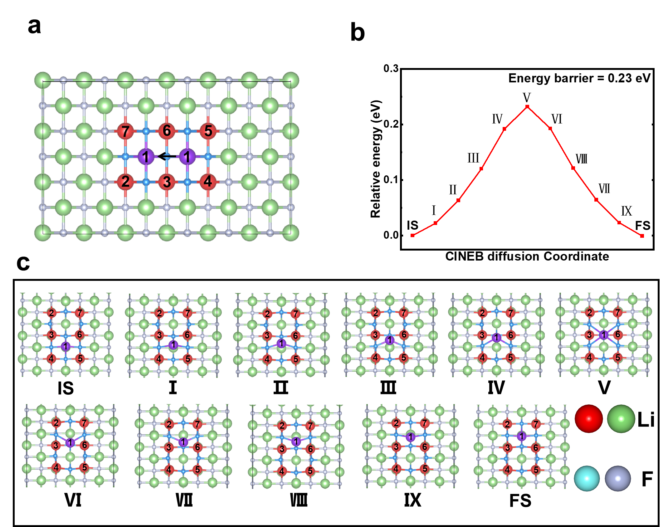
Fig S11. (a)CINEB simulation of the Li⁺ conduction pathway in LiF (110), surface vacancy conduction. (b) Relative energy of the Li⁺ conduction process shown in Figure a. (c) Detail structure images during the Li+ conduction shown in Figure a.

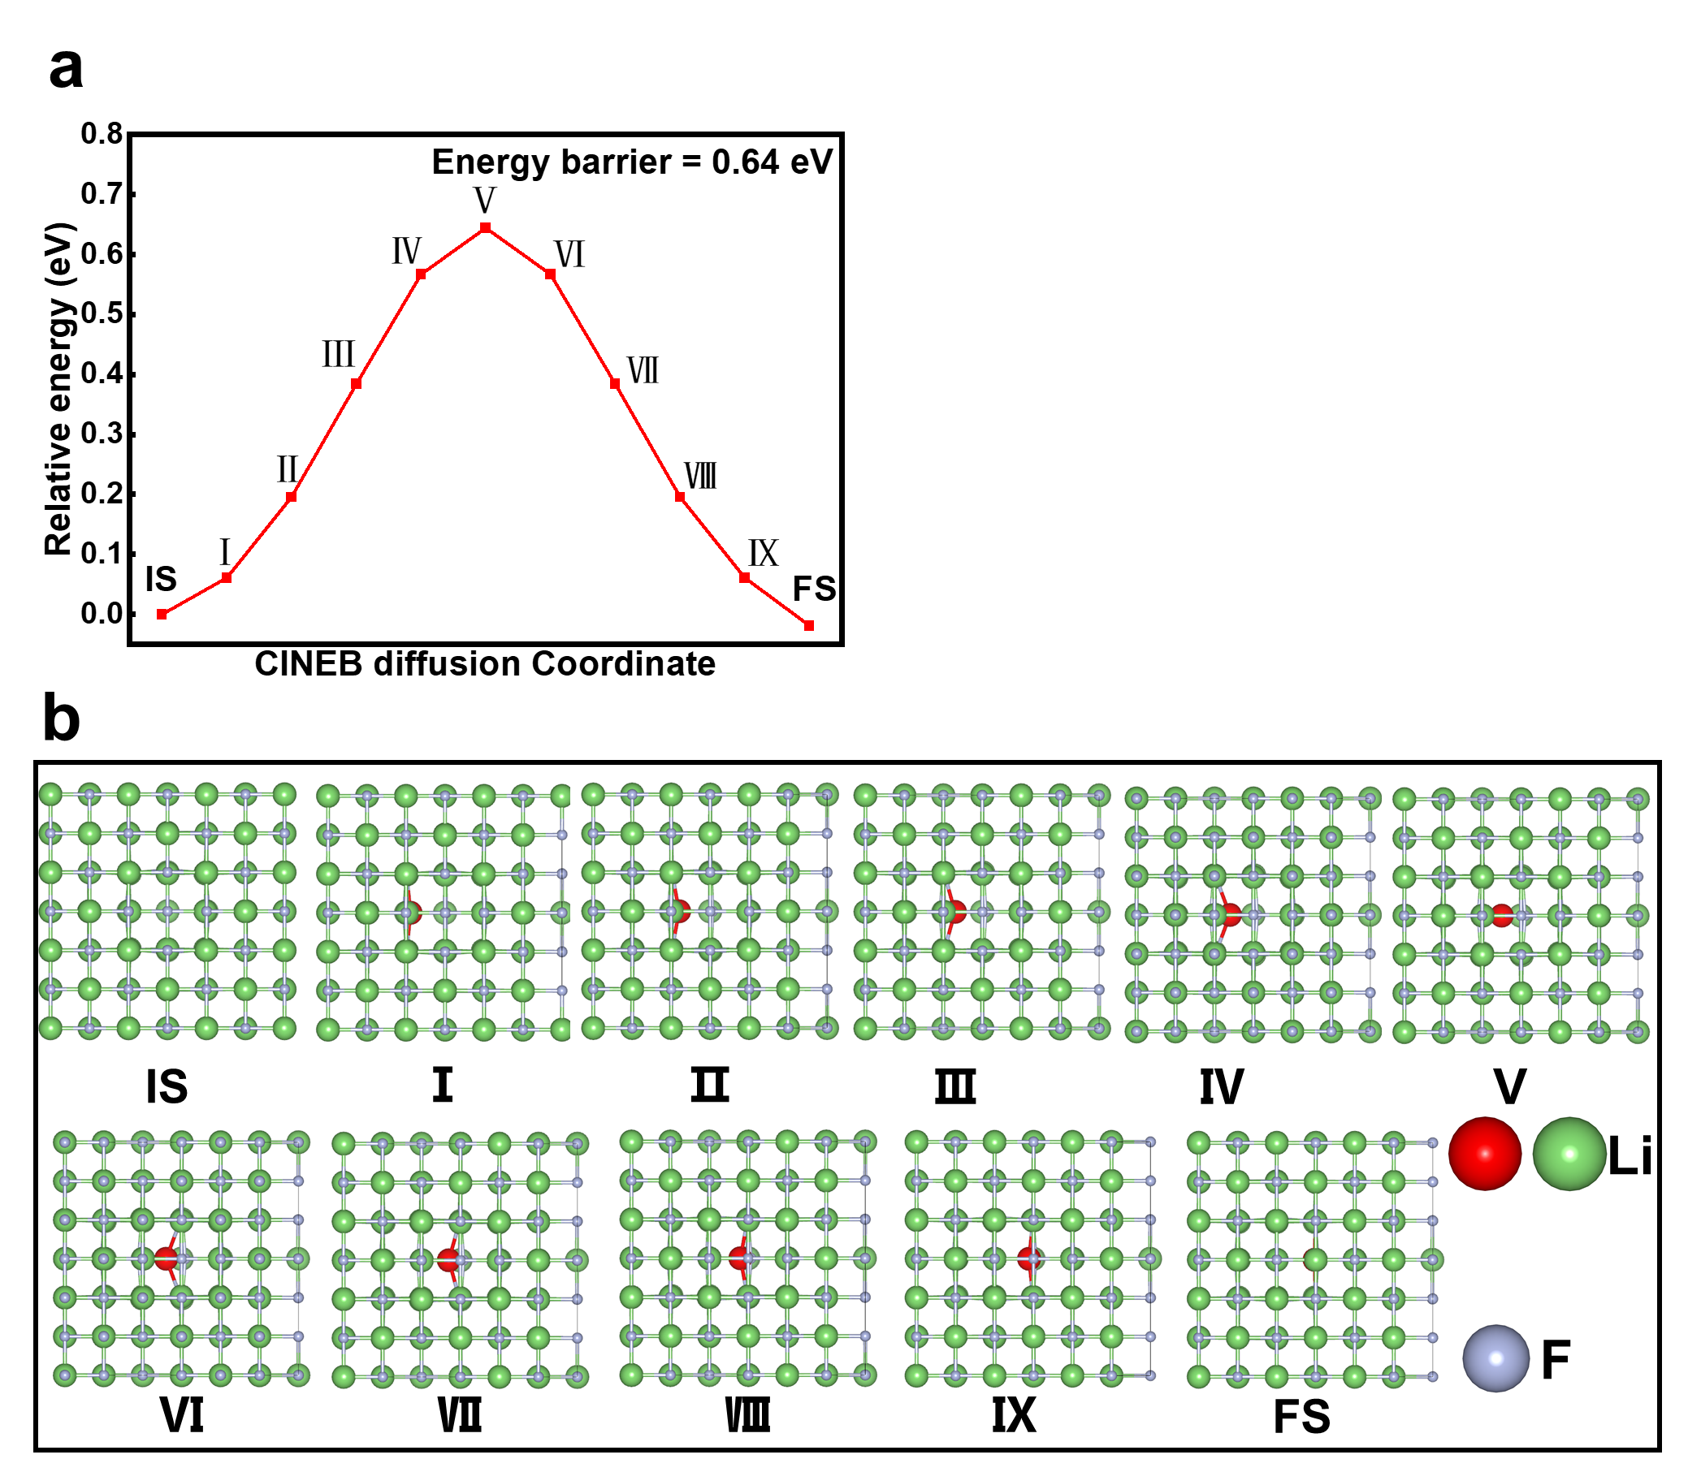
Fig S12. (a)CINEB simulation of the Li⁺ conduction pathway in LiF, bulk vacancy conduction. (b) Relative energy of the Li⁺ conduction process shown in Figure a. (c) Detail structure images during the Li⁺ conduction shown in Figure a.

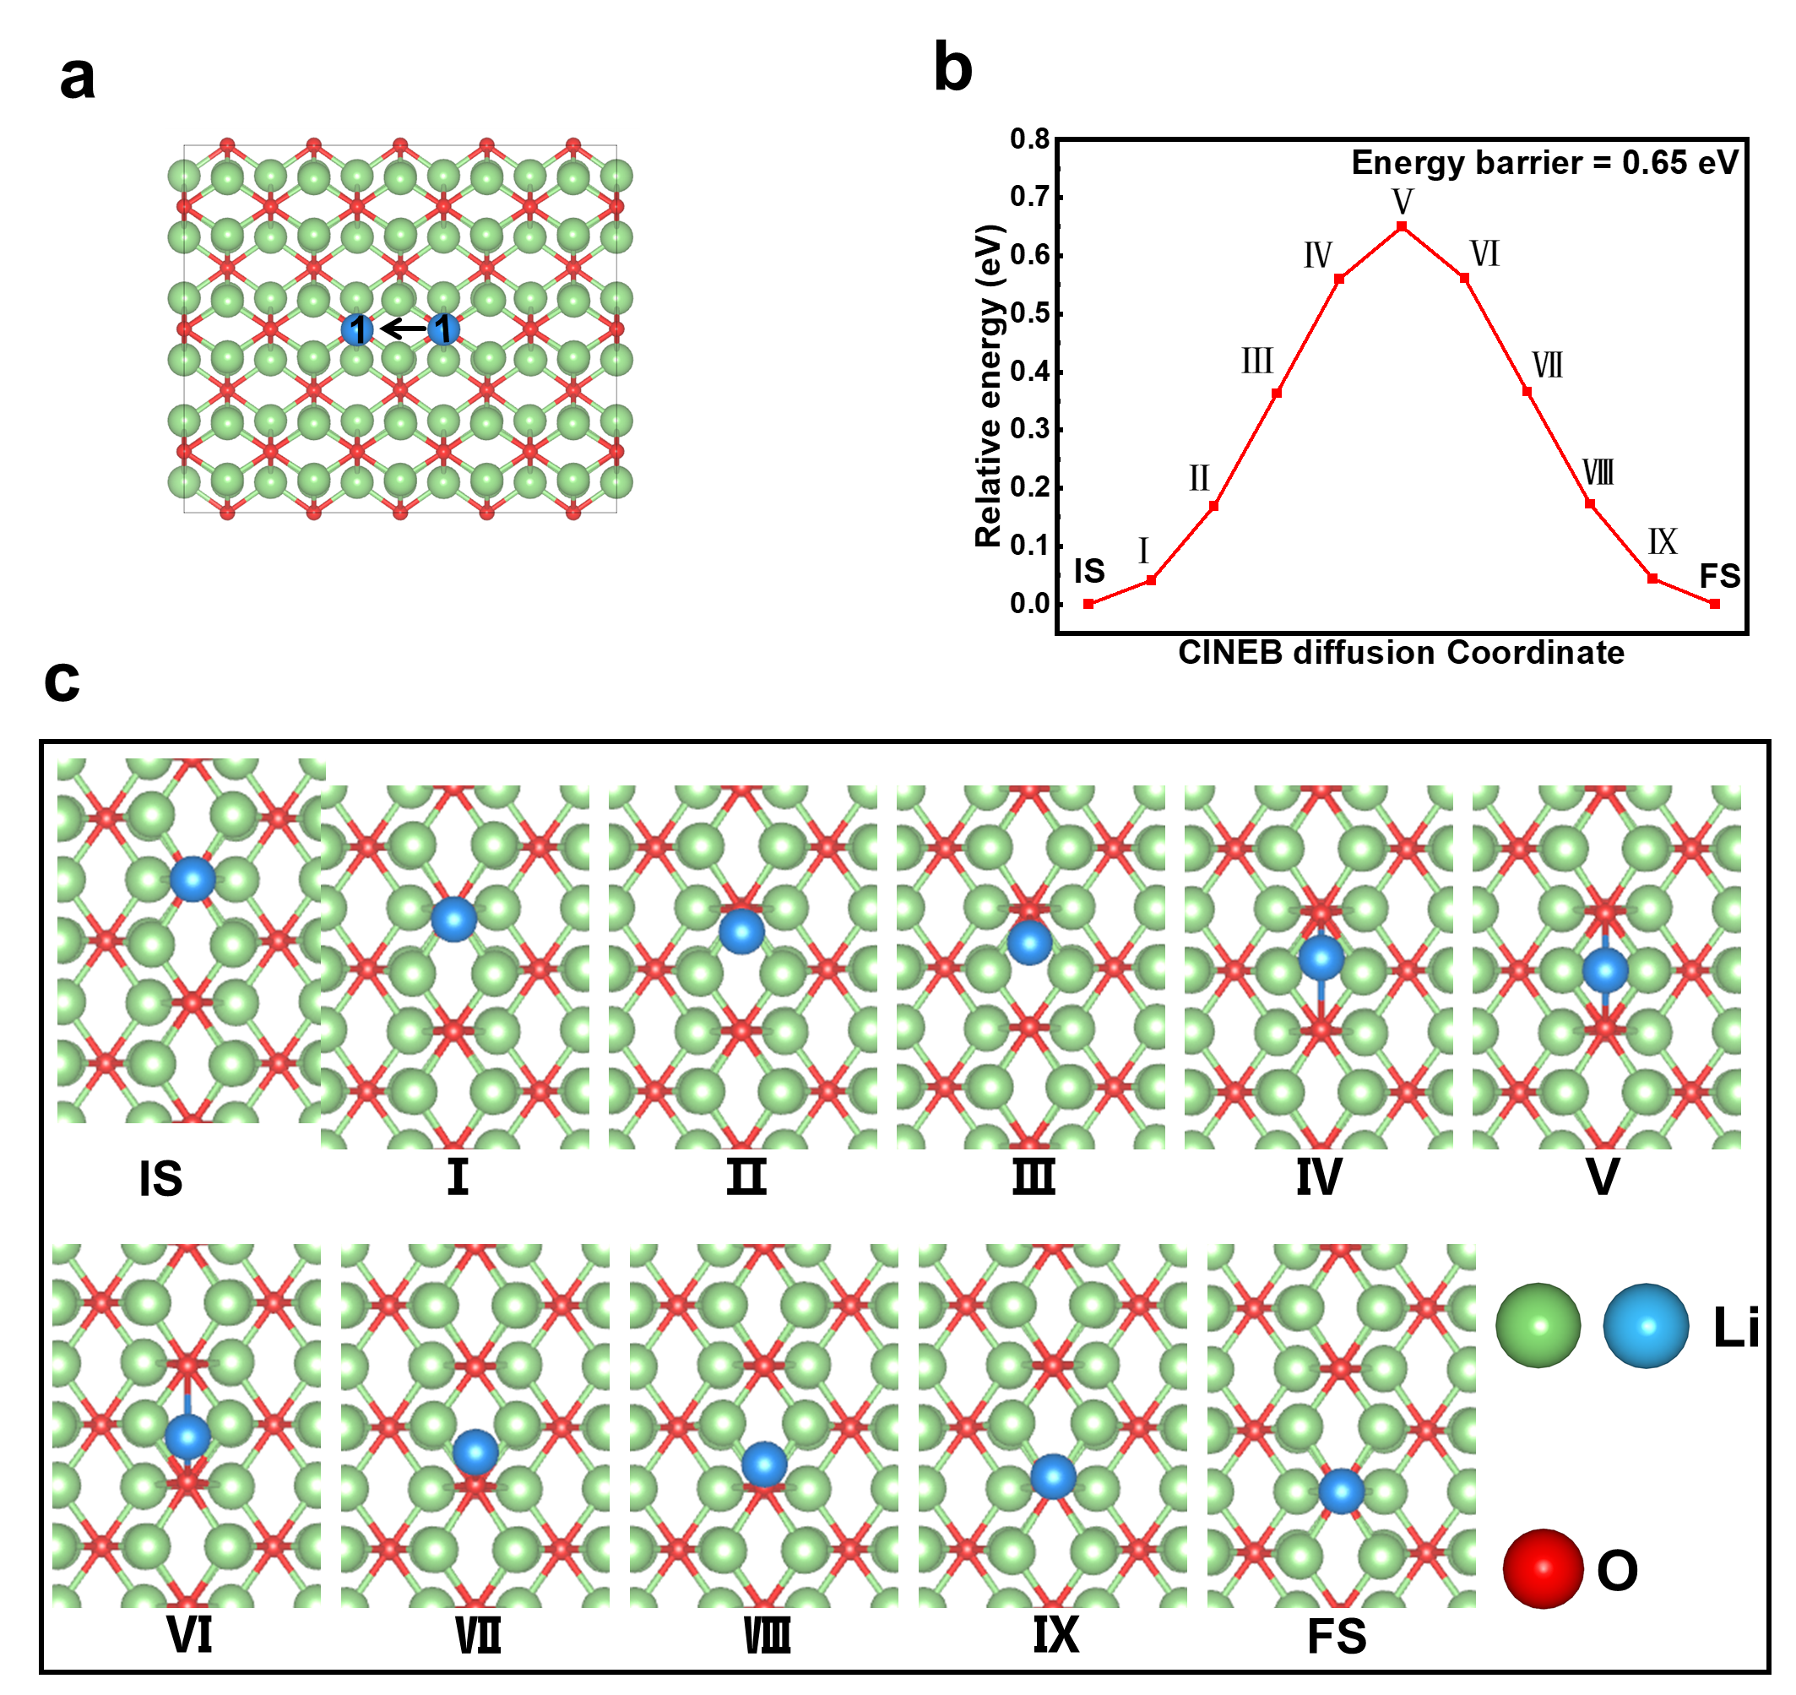
Fig S13. (a)CINEB simulation of the Li⁺ conduction pathway on the Li₂O surface (110), surface conduction. (b) Relative energy of the Li⁺ conduction process shown in Figure a. (c) Detail structure images during the Li⁺ conduction shown in Figure a.

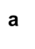
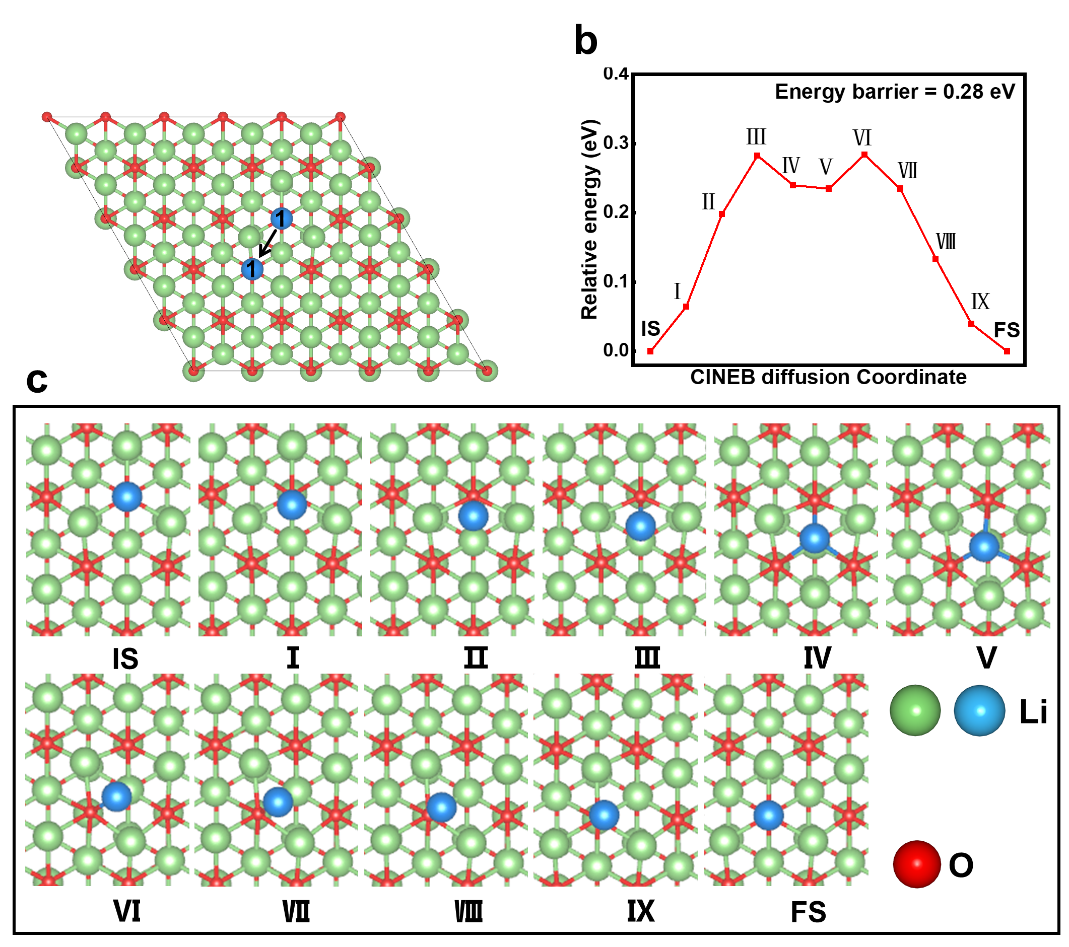
Fig S14. (a)CINEB simulation of the Li⁺ conduction pathway on the Li₂O surface (111), surface conduction. (b) Relative energy of the Li⁺ conduction process shown in Figure a. (c) Detail structure images during the Li⁺ conduction shown in Figure a.

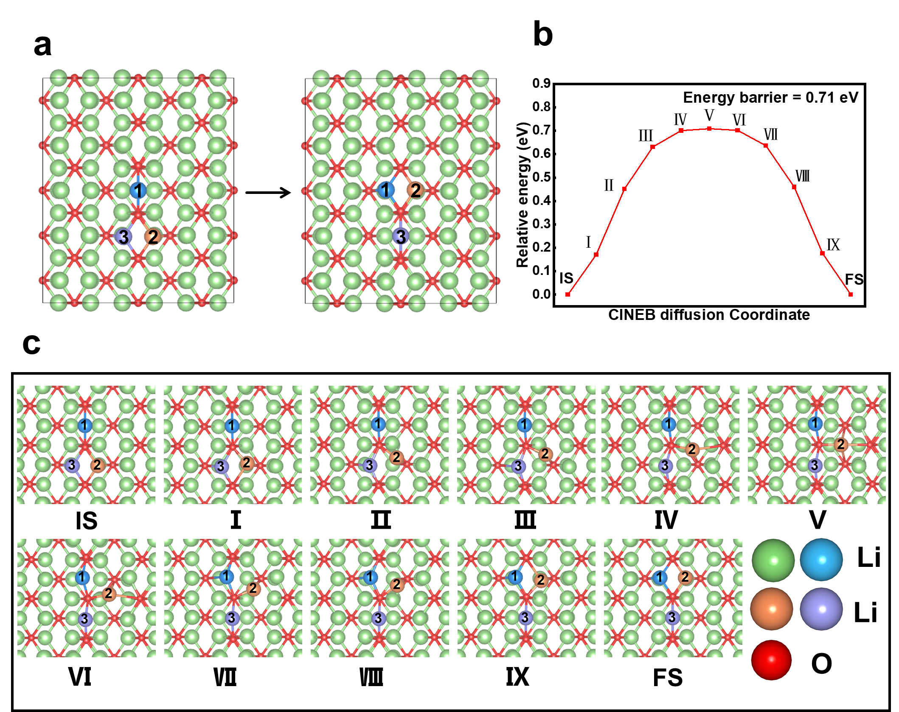
Fig S15. (a)CINEB simulation of the Li⁺ conduction pathway on the Li₂O surface (110), surface vacancy conduction. (b) Relative energy of the Li⁺ conduction process shown in Figure a. (c) Detail structure images during the Li⁺ conduction shown in Figure a.

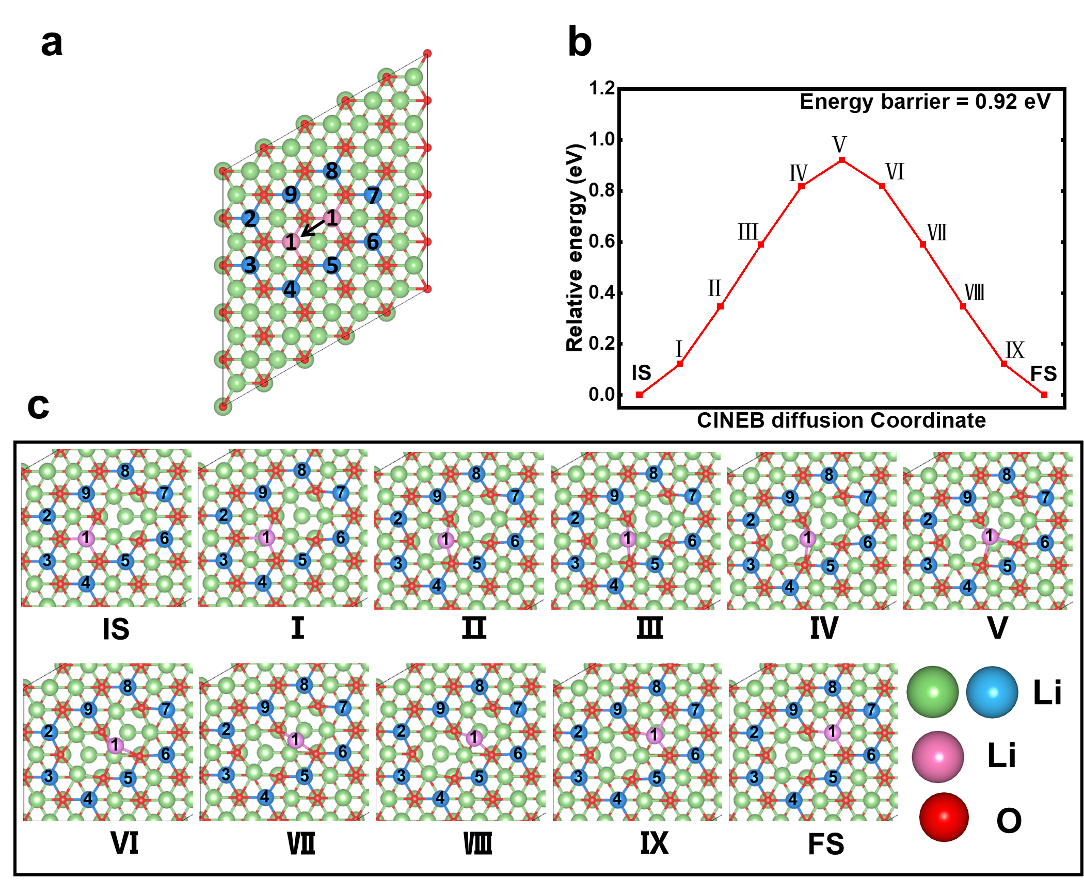
Fig S16. (a)CINEB simulation of the Li⁺ conduction pathway on the Li₂O surface (111), surface vacancy conduction. (b) Relative energy of the Li⁺ conduction process shown in Figure a. (c) Detail structure images during the Li⁺ conduction shown in Figure a.

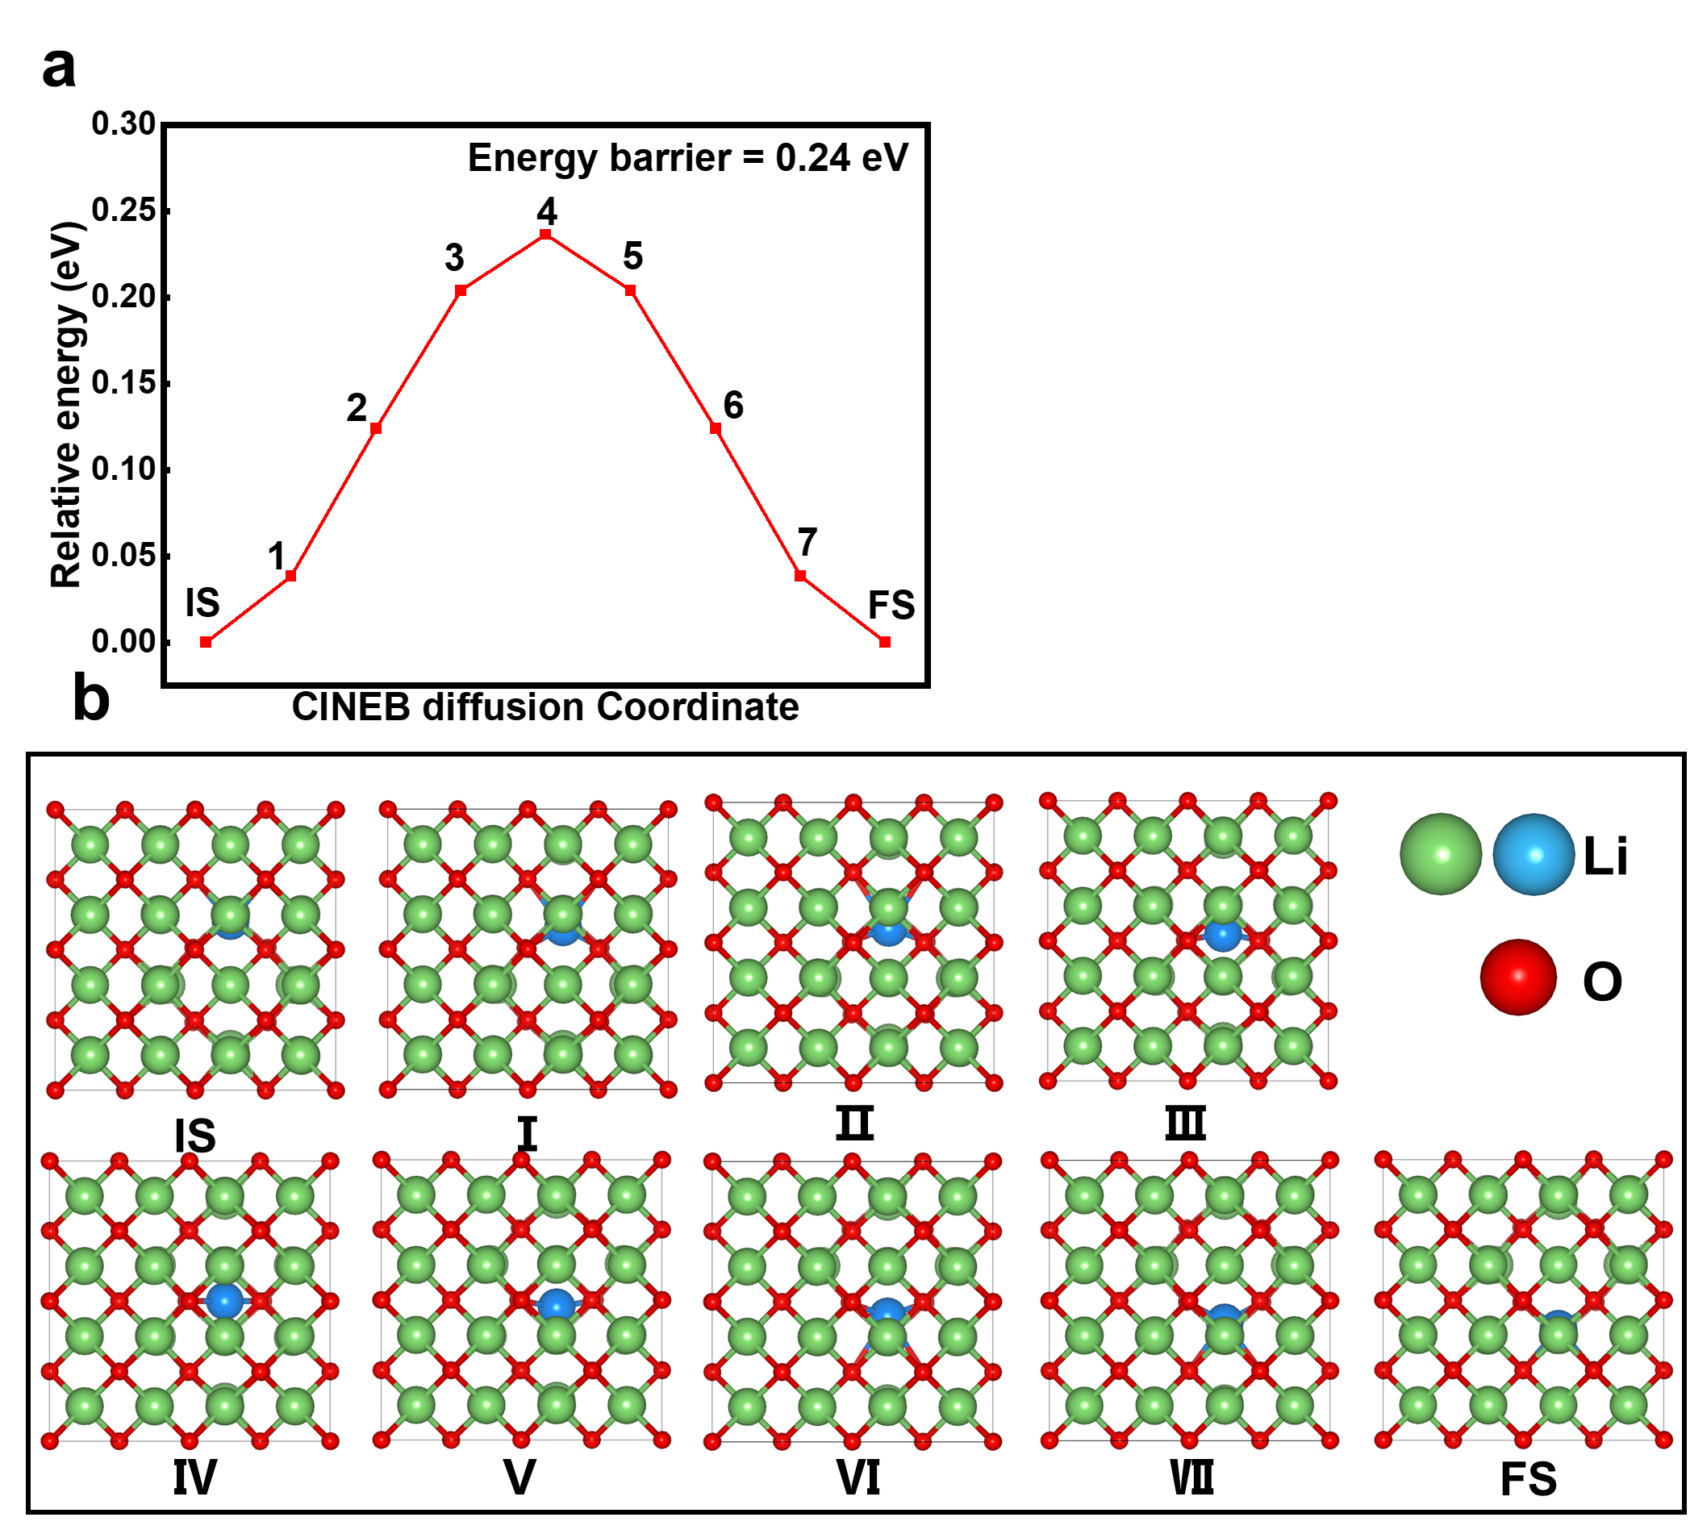
Fig S17. (a) Relative energy of the Li⁺ conduction process of the Li⁺ conduction pathway on the bulk Li₂O (bulk vacancy conduction). (b) Detail structure images during the Li⁺ conduction.
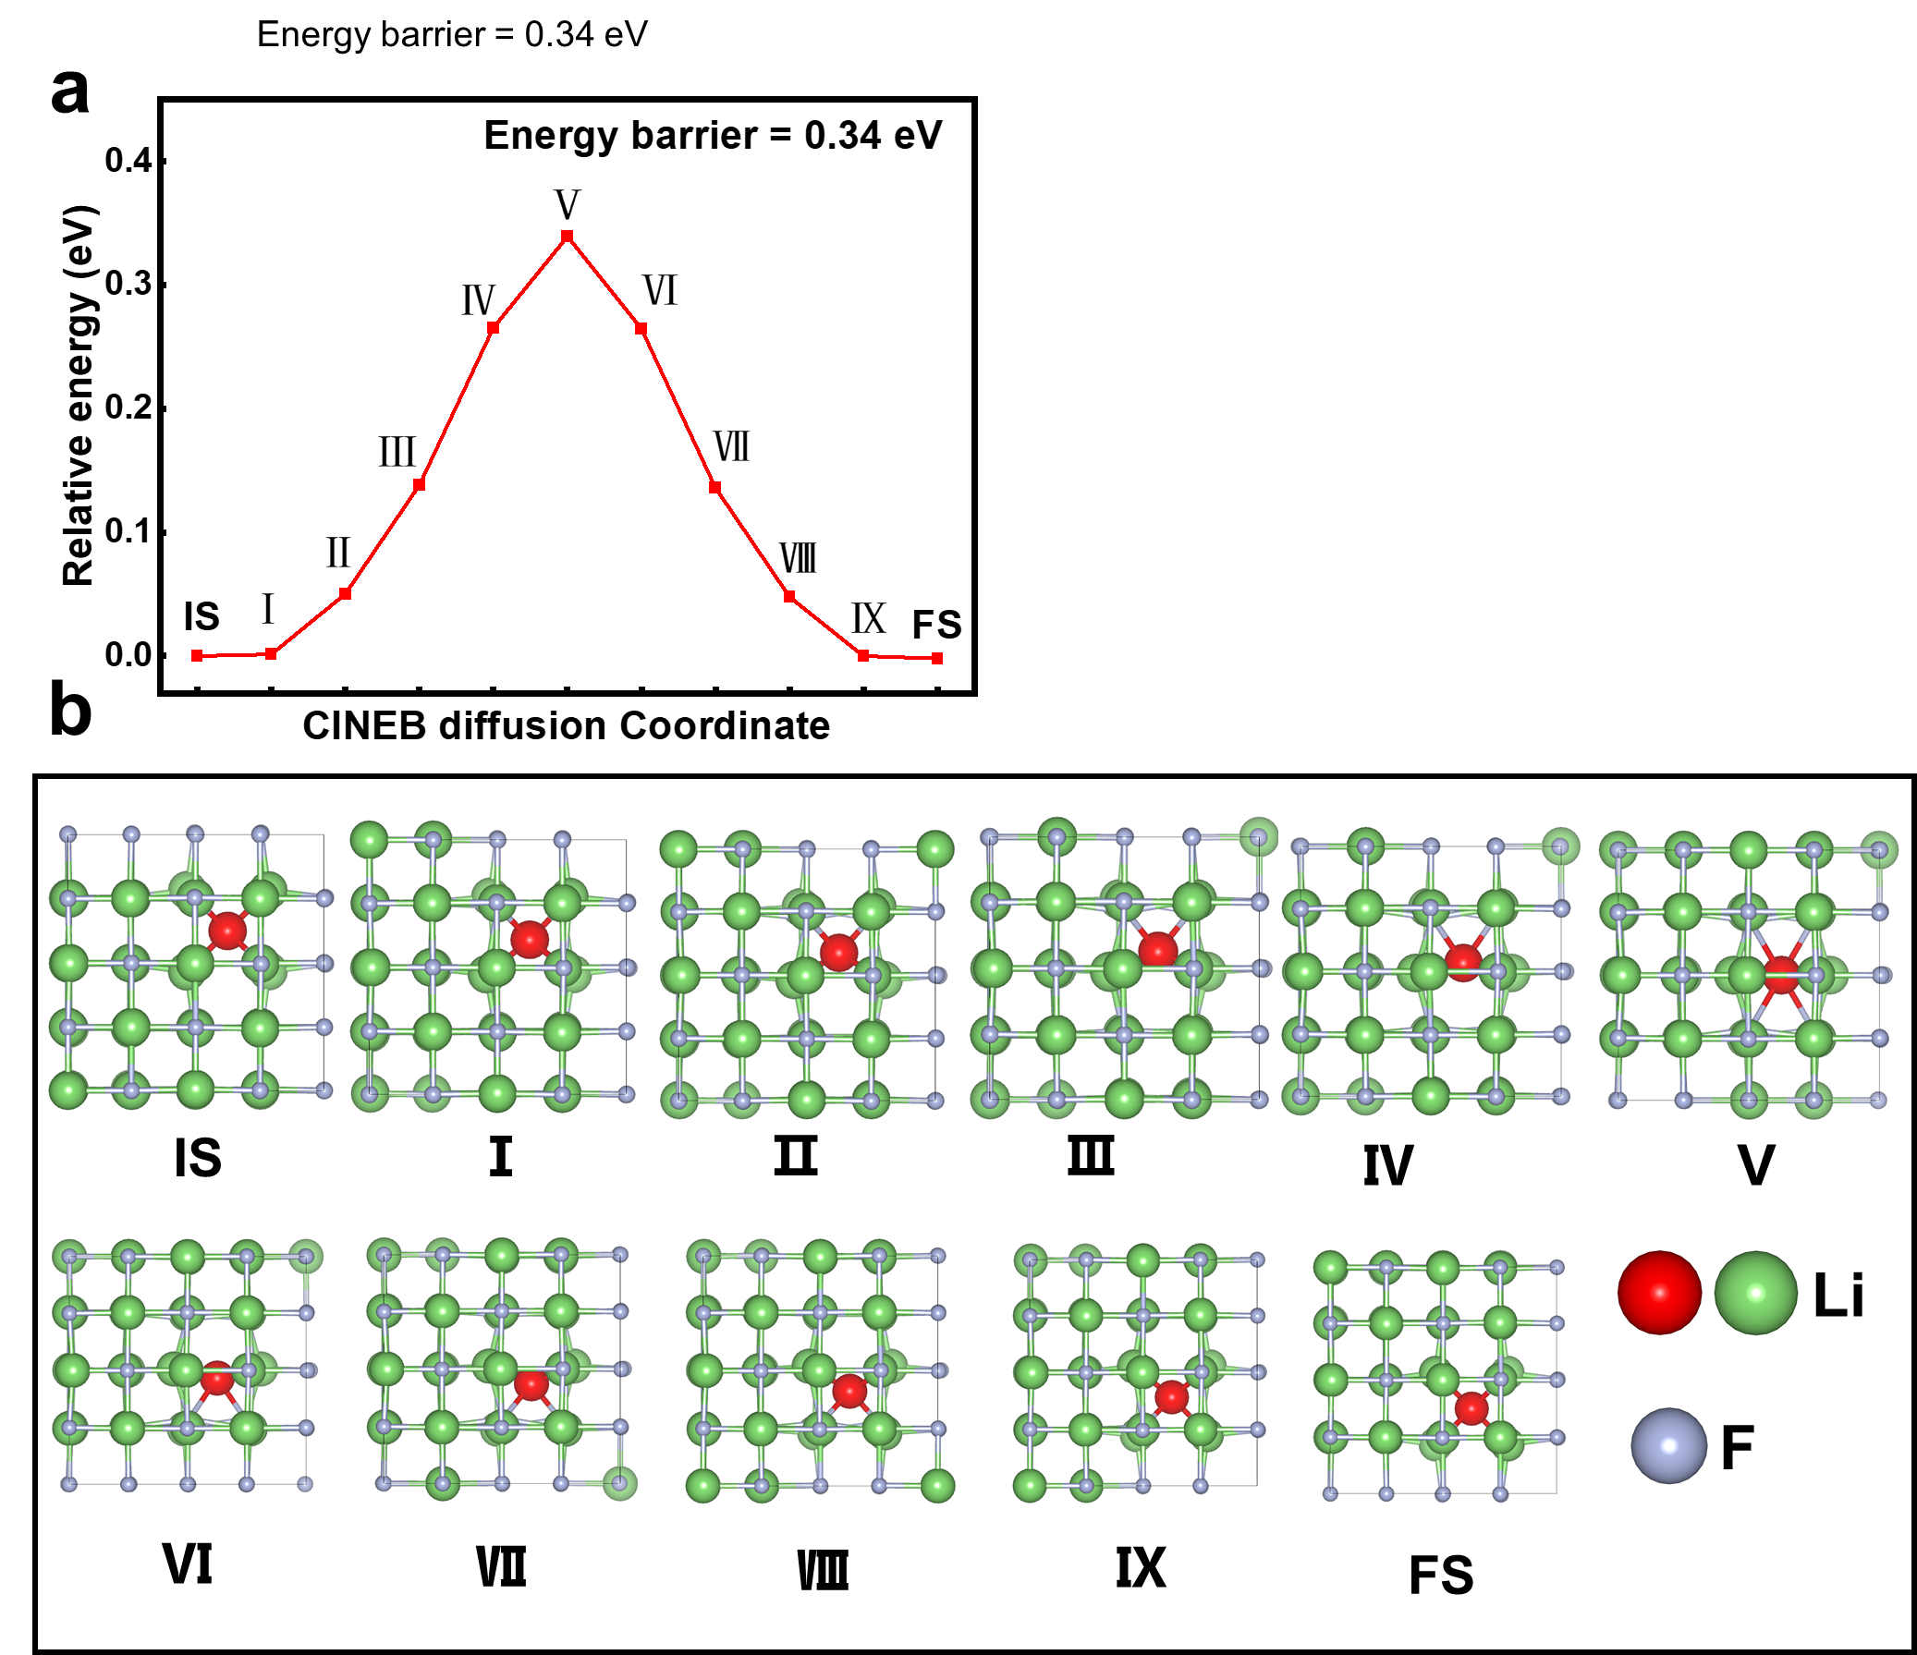
Fig S18. (a) Relative energy of the Li⁺ conduction process of the Li⁺ conduction pathway on the bulk LiF (bulk direct interstitial). (b) Detail structure images during the Li⁺ conduction.

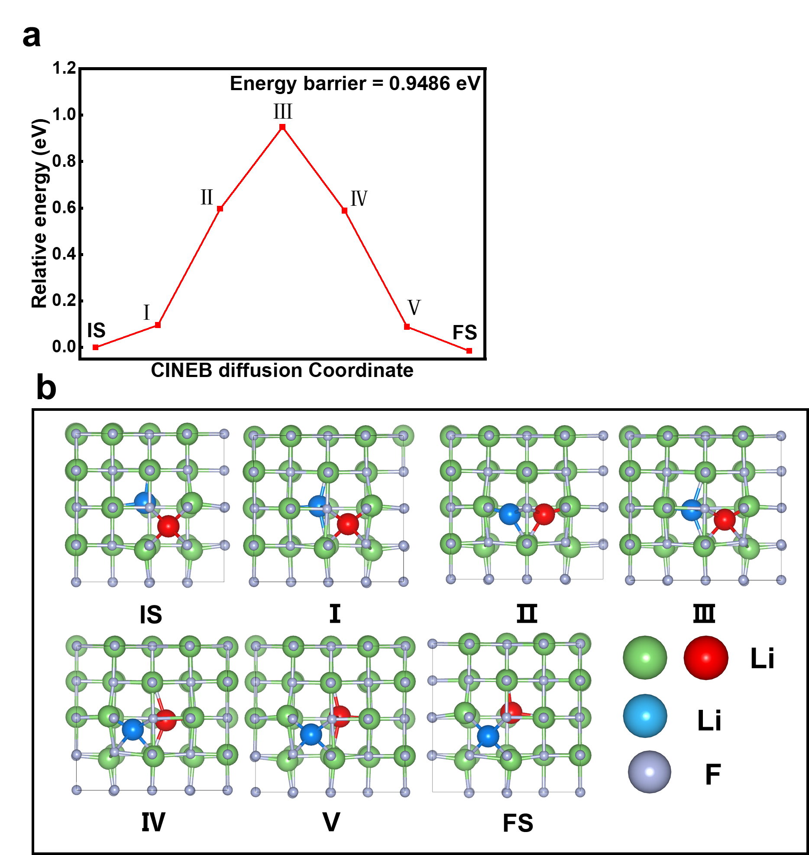
Fig S19. (a) Relative energy of the Li⁺ conduction process of the Li⁺ conduction pathway on the bulk LiF (bulk indirect interstitial). (b) Detail structure images during the Li⁺ conduction.

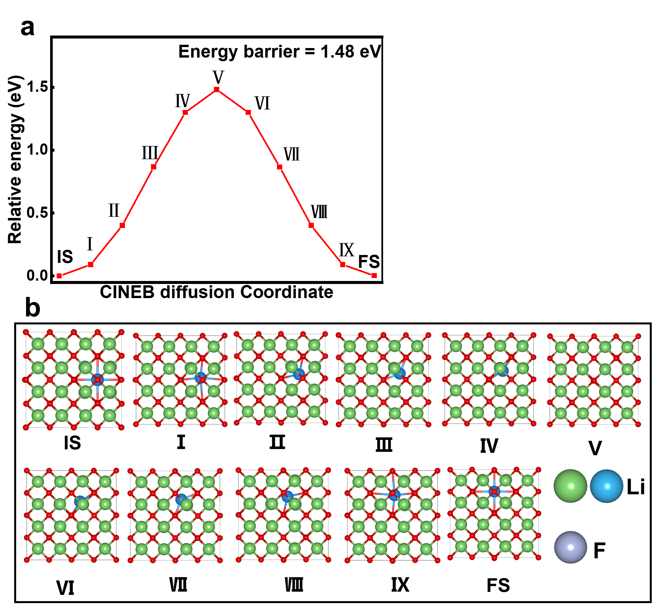
Fig S20. (a) Relative energy of the Li⁺ conduction process of the Li⁺ conduction pathway on the bulk Li₂O (bulk direct interstitial). (b) Detail structure images during the Li⁺ conduction.

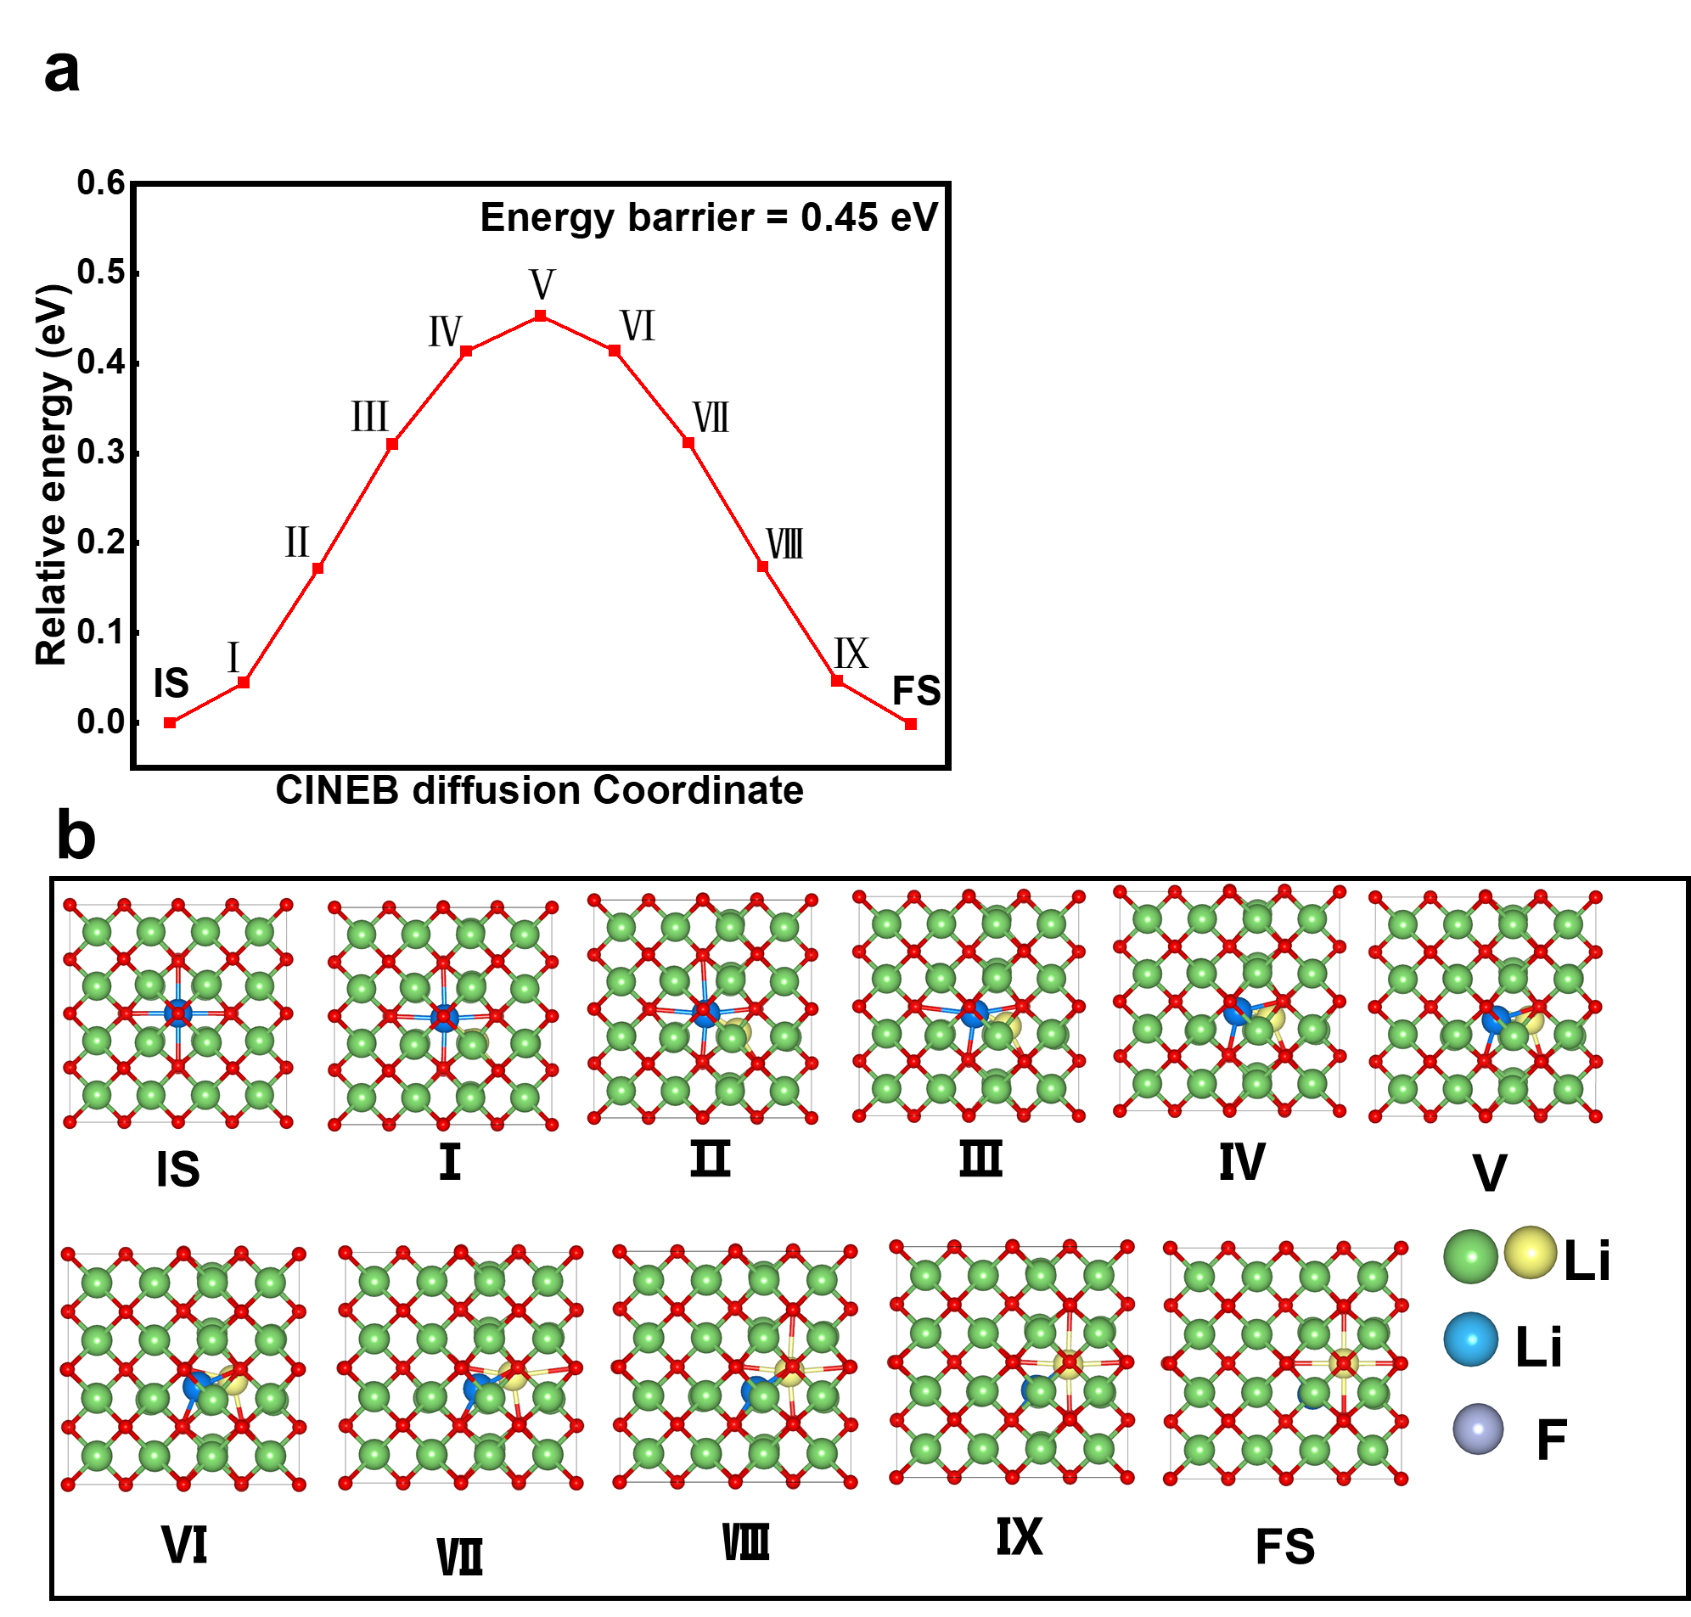
Fig S21. (a) Relative energy of the Li⁺ conduction process of the Li⁺ conduction pathway on the bulk Li₂O (bulk indirect interstitial). (b) Detail structure images during the Li⁺ conduction.

Table S1. The information of the secondary ion fragments containing only Li-O or Li-H
