Supplementary file of Figures

Figure 2: Change in trust once SURE-P was introduced (% of women)
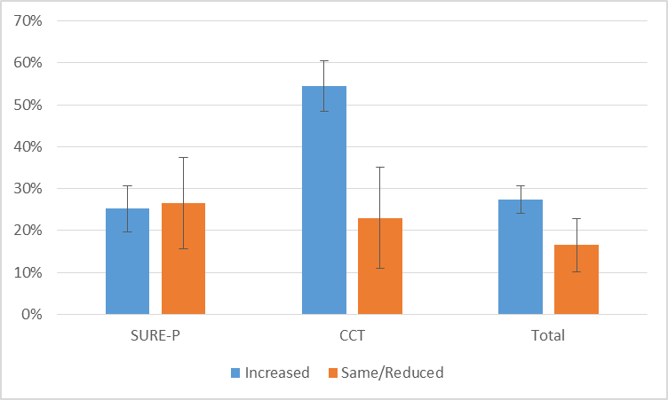
Note: Error bars represent 95% confidence intervals
(Retain colour for print in figure 2)

