Supplementary appendix
Manuscript: Effect of onchocerciasis elimination measures on the incidence of epilepsy in Maridi, South Sudan: a three-year prospective study
Table of contents
Questionnaire S1. Household questionnaire used to screen for suspected epilepsy (Page 2)
Questionnaire S2. Neurology questionnaire used by clinicians (Page 3)
Figure S1. Annual incidence of epilepsy in the eight areas of Maridi (Page 11)
Table S1. Prevalence of epilepsy per ethnicity in 2021 (Page 10)

SUPPLEMENT: Questionnaire S1.
Questionnaire S1. Screening questionnaire to detect persons with suspected epilepsy
SUPPLEMENT: Questionnaire S2. Neurology questionnaire used by clinicians

DATE: _____ / _____ / ________

PARTICIPANT IDENTIFICATION
- Participant ID: Number AS (3 capital letters) number village (2 capital letters) number household (3 digits) number family member (2 digits)
- First name: __________________________________________________
- Surname name:_______________________________________________
- Age years (if less 1year put 0)
- If less than 1 year …………….month
- Gender male Female

- Ethnic group:_______________________________________________

- Was the person living in the village since birth YES NO DON’T KNOW

- If not, since how long does the person live in the village
________ years (if less than 1 year put 0)
- What is the interviewed participant’s duration of stay in the survey area __________years
HISTORY OF EPILEPSY
SEIZURE TYPOLOGY
- Has the participant ever suddenly lost consciousness YES NO DON’T KNOW
If yes, did s/he experience any of the following?
    - Loss of bladder control? YES NO DON’T KNOW
    - Foam at the mouth? YES NO DON’T KNOW
    - Biting of the tongue? YES NO DON’T KNOW
- Has the participant ever experienced absence(s) or sudden loss(es) of contact with the surroundings, for a short duration of time?
YES NO DON’T KNOW
- Does the participant have a history of head nodding? YES, in the past YES, still ongoing NO DON’T KNOW
IF YES, specify age of the participant at onset of head nodding ______ years (if less than 1 year put 0)
- Has the participant ever experienced sudden, uncontrollable twitching or shaking of arms, legs or head, for a period of a few minutes with amnesia (deficit of memory)?
YES NO DON’T KNOW
- Does the participant sometimes experience sudden and brief bodily sensations, see or hear things that are not there, or smell strange odours? YES NO DON’T KNOW
- Has the participant ever been told that he / she is suffering from epilepsy or that he / she has had epileptic fits? YES NO DON’T KNOW
If so was the diagnosis confirmed by a medical doctor? YES NO DON’T KNOW?
- Of what type are the most frequent seizures?
Generalized tonic-clonic seizures
Generalized myoclonic seizures
Atonic seizures (drop attacks)
Absences
Nodding seizures
Focal motoric seizures without loss of consciousness
Focal motoric seizures with decreased consciousness
Secondarily generalized partial seizures
Focal non-motor seizures (e.g. hallucinations)
One seizure
Others, specify:_____________________________
No seizure. If no, skip to other diagnosis (Qn66)

- At what age the seizures started? ____ year DON’T KNOW (999) NA (Not applicable)(888)
- Did the seizures started less than one year ago? YES NO DON’T KNOW
- If yes, since how many months? __________________Months
- What triggers the seizures / head nodding? (tick all that apply)
Spontaneous (no obvious trigger)
Sight of food Cold weather
Nothing DON’T KNOW
Other, specify_______________________
SEIZURE HISTORY
- What is the number of epileptic seizures since onset? One Two Three or more seizures
If only two seizures, were they more than 24h apart? YES NO DON’T KNOW NA
- Has the participant had a seizure in the last 5 years? YES NO DON’T KNOW
- Has the participant had a seizure in the last 12 month? YES NO DON’T KNOW
- What is the current frequency of the seizures?
yearly (if less than 1 per month)
monthly (if less than 4 per month)
weekly (if less than 7 per week)
daily (if more than 7 per week)
NA
Specify number: _____________per ______________(day, week, month, year)
- a. How many seizures did you have LAST WEEK?
None 1-4 episodes More than 4 DON’T KNOW
b. What is the average duration of a seizure episode?
less than a minute 1-5 minutes more than 5 minutes DON’T KNOW

MEDICAL HISTORY
- Family history of seizures YES NO DON’T KNOW
IF YES, specify who these are (tick all that apply)
Siblings (brother/sister); No. of affected siblings ______
Father Mother Grandparent(s)
Other, Specify _________________________________
Pregnancy and Birth:
- Did the pregnancy of the mother of the participant proceed normally? YES NO DON’T KNOW
If NO, specify: ___________________________________
- Was the participant born at term (pregnancy had completed 9 months)? YES NO DON’T KNOW
- Was there a delayed cry at birth? YES NO DON’T KNOW

Psychomotor Development during Childhood:
Prior to onset of seizures
- Was the child growing normally prior to the onset of the seizures? Yes No DON’T KNOW
IF NO, at what age did the abnormal growing appear? ______ years
- Did the child learn to do things like other children of his/her age prior to the onset of the seizures? Yes No DON’T KNOW
IF NO, at what age did the learning difficulty start? ______ year
- Compared with other children of his/her age, did the child appear in any way mentally backward, dull or slow before the onset of the seizures?
Yes No DON’T KNOW
IF YES, at what age did it start? ______ years

Occurrence of severe disease in the past:
- Has the interviewed participant suffered from severe measles preceding the onset of epileptic seizures? YES NO DON’T KNOW
If yes how long before the onset of seizures ……………………Years
- Has the interviewed participant suffered from a severe form of malaria preceding the onset of epileptic seizures? YES NO DON’T KNOW
If yes how long before the onset of seizures ……………………Years
- Has the interviewed participant suffered from encephalitis/meningitis preceding the onset of epileptic seizures? YES NO DON’T KNOW
If yes how long before the onset of seizures ……………………Years
- Has the participant had a head injury with loss of consciousness preceding the onset of epileptic seizures? YES NO DON’T KNOW
If yes how long before the onset of seizures ……………………Years
- Has the participant had a prolonged posttraumatic coma before the onset of epileptic seizures YES NO DON’T KNOW
If yes how long before the onset of seizures ……………………Years
- Was the onset of epilepsy following another illness? YES NO DON’T KNOW
If YES, specify the illness:______________________________________
- PHYSICAL EXAMINATION Done YES NO if no go to 62
- Thoracic/spinal abnormalities YES NO DON’T KNOW
IF YES, specify _________________________________________________________
- Facial abnormalities YES NO
IF YES, specify ____________________________________________
- Does the adolescent (> 16years old) /adult looks like a child? YES NO NA
If yes, external signs of sexual development conform to age: YES NO EXAMINATION DECLINED NA
If NO, specify:
- girls: breast not developed NA
- girls and boys: no pubic hear NA

- Cervical Lymph nodes YES NO
- Onchocerciasis nodules YES NO
- Itching YES NO

- Burn lesions YES NO

- If yes how many? ______________________

- Dermatological lesions NORMAL papular/nodular pruritic skin itching without skin lesions leopard skin dry, thickened, wrinkled skin burns other skin abnormality

Other dermatological lesion specify ________________________

NEUROLOGICAL EXAMINATION
- Is the participant alert? YES NO
- Fully oriented in place/time/person YES NO
- Is the participant’s mentally impaired? YES NO
- Ophthalmology NORMAL ABNORMAL VISION
BLIND, one eye affected BLIND, both eyes affected

- Generalised muscle wasting YES NO
- Paresis YES NO
- Is the participant walking normally? YES NO DON’T KNOW
- If no specify_____________________________________

Psychiatric symptoms
- Does to participant suffer from another neuro-psychiatric / psychological problem? abnormal aggressive behaviour depression other
IF other, specify: _____________________________________________________________
- Physical / Functional Indices
Modified Rankin Scale: Please mark the most accurate description of the current functional state of the person with epilepsy, as observed during the evaluation

1 | No significant disability despite symptoms; able to carry out all usual duties and activities
2 | Slight disability; unable to carry out all previous activities, but able to look after own affairs without assistance
3 | Moderate disability; requiring some help, but able to walk without assistance
4 | Moderately severe disability; unable to walk without assistance and unable to attend to own bodily needs without assistance
5 | Severe disability; bedridden, incontinent and requiring constant nursing care and attention

- Epilepsy CASE CLASSIFICATION Epilepsy
Head nodding syndrome
Head nodding syndrome plus
Other diagnosis

- If NO epilepsy: other diagnosis? One seizure
Recurrent febrile convulsions
Dizziness / syncope
Paroxysmal vertigo
Alcohol/drug use
Severe anaemia
Severe protein malnutrition
Psychogenic non-epileptic seizure (PNES)
Mental retardation without epilepsy
Psychiatric illness without epilepsy
Classic migraine
Other, specify______________________
ANTI-EPILEPTIC TREATMENT

- What is or was the type of seizure medication taken by the participant?
No treatment DON’T KNOW
Traditional anti-epileptic drug
Mixed NA
If No treatment or Traditional or Don’t know or NA: Go to Ivermectin use (68)
- If anti-epileptic drug treatment or Mixed: Which substance is taken by the participant?
Phenobarbital
Sodium valproate
Phenytoin
Carbamazepine
Other anti-epileptic
If other, specify: _____________________________________________
- Is the participant taking the treatment?
currently every day currently but with interruptions only in the past DON’T KNOW
If interruptions or only in the past, why?
(Temporary) non-availability of medication
Lack of financial means to buy medication
DON’T KNOW
Other, specify ______________________________
IVERMECTIN USE
- Has the participant ever received ivermectin? YES NO DON’T KNOW NA
IF YES: Has the participant taken ivermectin during the last CDTi in 2021 YES NO DON’T KNOW

Full physician name ________________________________-

SUPPLEMENT: Table S1. Prevalence of epilepsy per ethnicity in 2022.
The prevalence of epilepsy was higher in the Avokaya, Baka, Mundo and Muro ethnic groups than in Zande and minor ethnicities (Table 1). The latter had a higher proportion of the population located in sites further away from the Maridi dam and did less farming, while Baka and Mundu were concentrated in Kazana-1 and Kazana-2. Ethnicity significantly correlated with study site, farming family and immigrant family (p<0·0001).
Ethnic group | Number of persons screened | Number of persons with epilepsy | Prevalence of epilepsy  Per 1,000 (95% CI) | Main study sites of residence  (>10% of total study participants) | Farming family | Immigrant family
Avokaya | 1112 | 38 | 34·2 (24·6-47·1) | Hai-Tarawa (35·6%)  Hai-Gabat (34·1%)  Hai-Matara (13·1%) | 84·9% | 21.0%
Baka | 5724 | 257 | 44·9 (39·8-50·7) | Hai-Matara (23·8%)  Kazana-1 (20·9%)  Hai-Tarawa (14·5%)  Kwanga (13·4%)  Kazana-2 (13·2%) | 87·9% | 13.5%
Mundu | 1858 | 92 | 49·5 (40·3-60·6) | Kazana-1 (33·9%)  Hai-Matara (21·6%)  Kwanga (15·1%)  Hai-Tarawa (11·3%) | 87·2% | 16.0%
Muro | 2552 | 100 | 39·2 (32·2-47·7) | Mudubai (39·3%)  Hai-Gabat (26·9%)  Hai-Tarawa (14·8%)  Hai-Matara (14·3%) | 82·5% | 15.7%
Zande | 2065 | 49 | 23·7 (17·8-31·5) | Hai-Matara (42·9%)  Nagbaka (42·8%) | 80·5% | 18.6%
Minorities | 1046 | 25 | 23·9 (15·9-35·6) | Hai-Gabat (25·4%)  Hai-Matara (20·1%)  Mudubai (22·2%)  Kazana-1 (13·3%) | 82·1% | 37.7%

SUPPLEMENT: Figure S1.
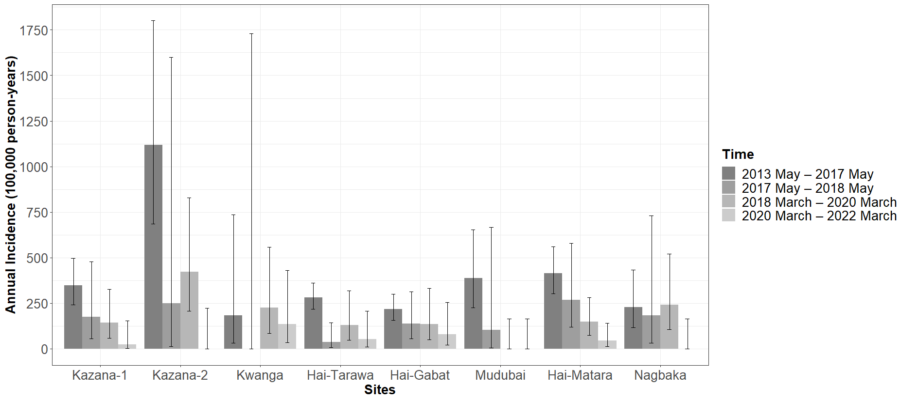Figure S1. Annual incidence of epilepsy in the eight areas of Maridi without onchocerciasis control (2013 May – 2016 May), under annual CDTi (2017 May – 2018 May and 2018 March – 2020 March) and under biannual CDTi and potential impact of the Slash and Clear vector control (2020 March – 2022 March

