Supplementary Figures
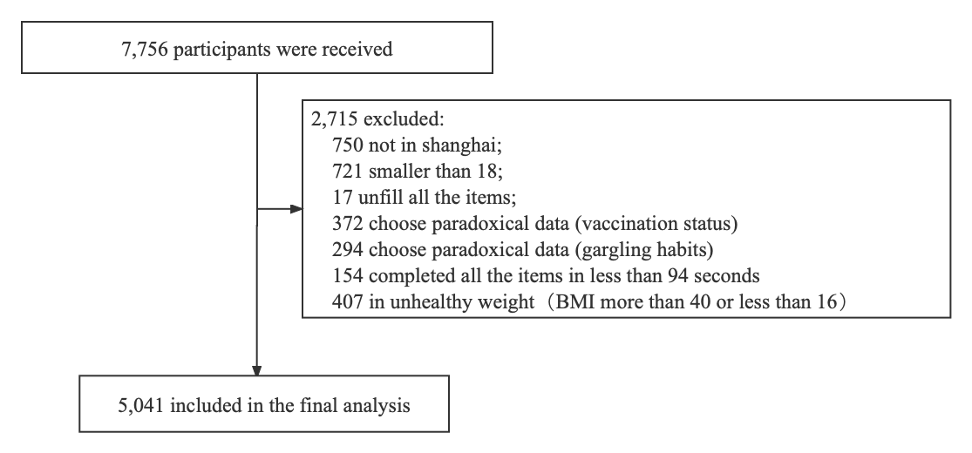
Figure S1. The data analysis screening flow chart.

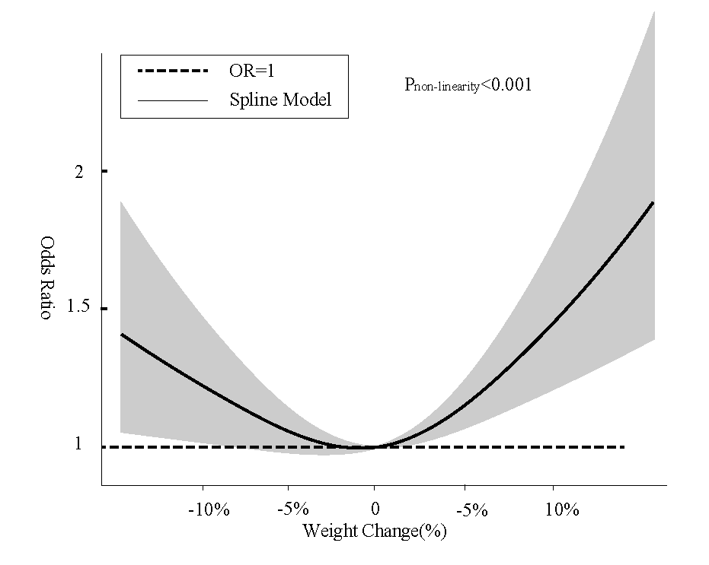
Figure S2. The restricted cubic spline for the association between weight change and augmentation in OHIP-14 during social distancing. The lines represent adjusted odds ratios based on restricted cubic splines for the weight change in the multivariable-adjusted regression model with all variables.

