The receptor for advanced glycation end products is involved in Campylobacter jejuni cytolethal distending toxin intracellular trafficking

Supplemental materials
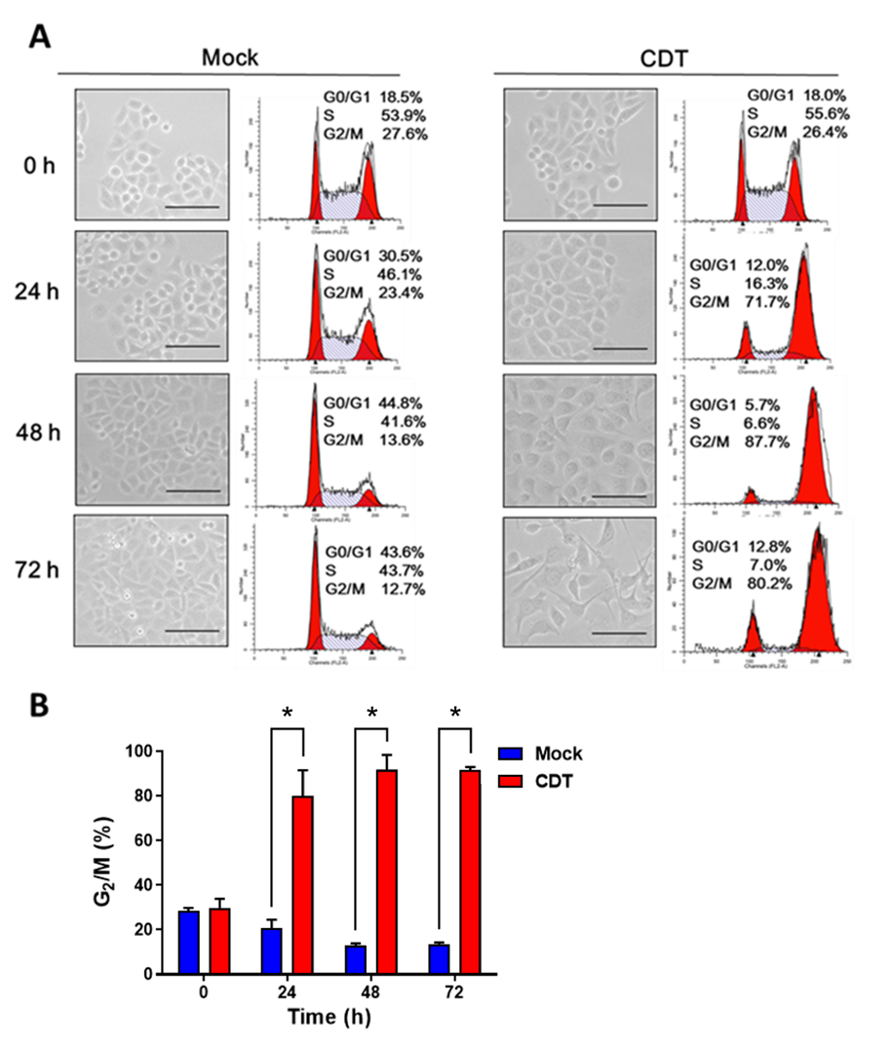

Figure S1. Recombinant CDT induces cell cycle arrest. (A) AGS cells were treated with recombinant CDT holotoxin (100 nM) for 0, 24, 48, and 72 h, respectively. The percentage of cell population in each stage was analyzed by flow cytometry. Morphology of cell distention was visualized by light microscopy. Scale bars, 100 μm. (B) The percentage of cells at G2/M was calculated and plotted. Statistical analysis was processed by Student’s t-test. *, P < 0.05 was considered statistically significant upon compared to mock-treated group.

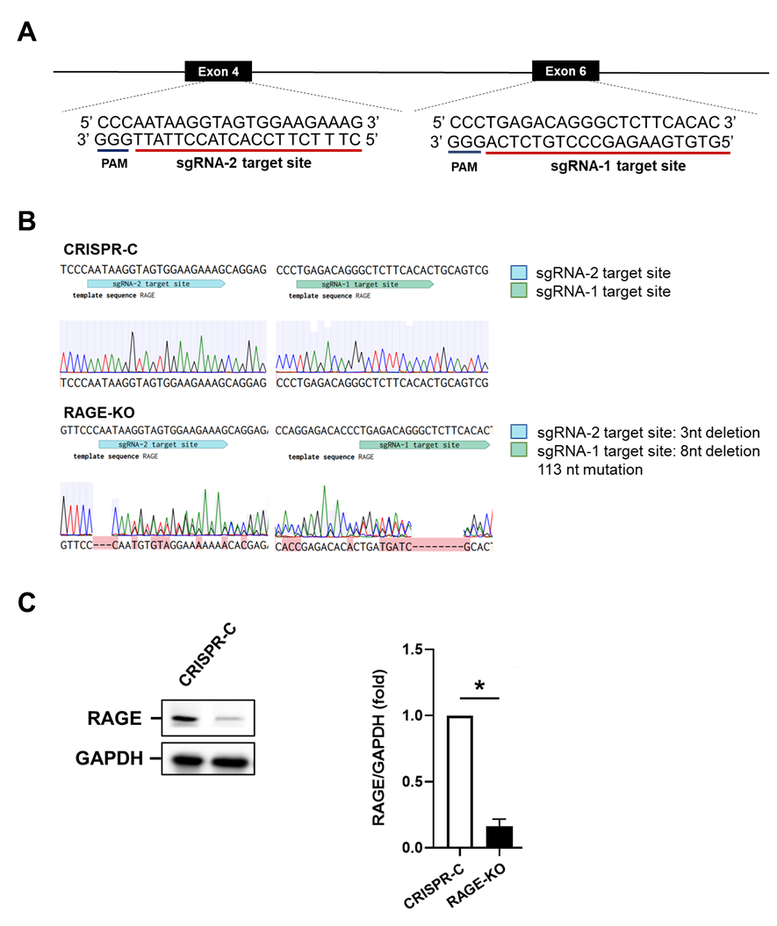

Figure S2. AGER-knockout using CRISPR/Cas9 system. (A) The target sites of sgRNAs were showed in the RAGE. (B) CRISPR-control (CRISPR-C) and AGER-knockout (RAGE-KO) cells were sequenced and analyzed by Benchling as described in the Methods section. (C) RAGE was depleted by using CRISPR-Cas9 system in AGS cells. The expression levels of RAGE and GAPDH were analyzed by western blotting. The relative fold change of RAGE/GAPDH expression was calculated and plotted. Statistical analysis was performed by Student’s t-test. *, P < 0.05 was considered statistically significant upon compared to the control group.

