Supplement Figure 5 Association between dietary riboflavin intake and low cognitive performance odds ratio in Z test.

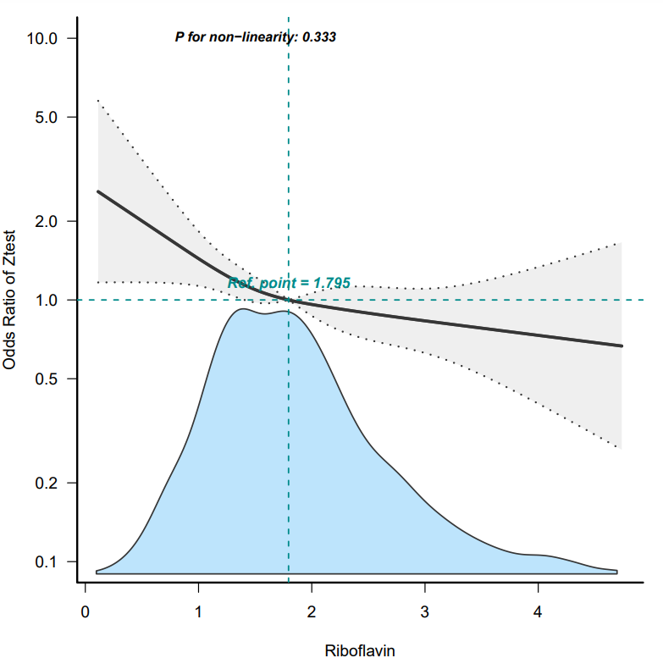

Solid and dashed lines represent the predicted value and 95% confidence intervals.
Adjusted for age，race，gender，Poverty-income ratio，education，Body mass index，Heart failure，coronary disease，angina，stroke，Hypertension，Smoking，Stroke ，Alcohol，Diabetes. Only 99% of the data is shown.
Abbreviations: Z test is average of IR,DR,AFT,DSST: CI:confidence interval；OR：odds ratios，Ref:reference

